Resource: Familiarization, Internalization, Articulation (Fia) Images
Familiarization, Internalization, Articulation (FIA) Images © 2023 SRV Partners Released under CC BY-SA 4.0 license. Familiarization, Internalization, Articulation (FIA) Images has been adapted in the following languages Tok Pisin, عربي, Français, हिंदी, Bahasa Indonesia, Português, Русский, Español, Kiswahili, 简体中文 from Familiarization, Internalization, Articulation (FIA) © 2023 SRV Partners. Released under CC BY-SA 4.0 license by Mission Mutual

Familiarization, Internalization, Articulation (Fia) Images

P

Palo

Image Content

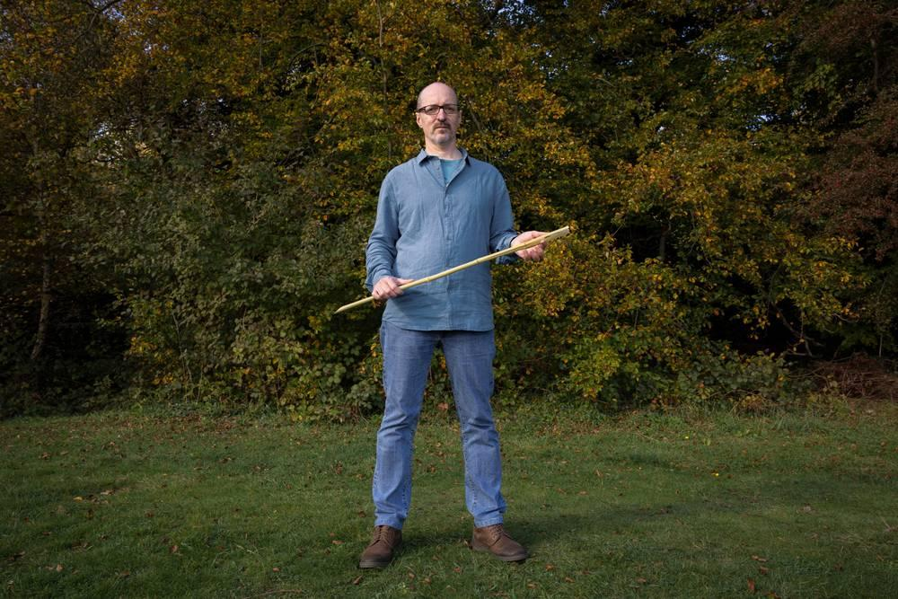
link

Palo

Image Content

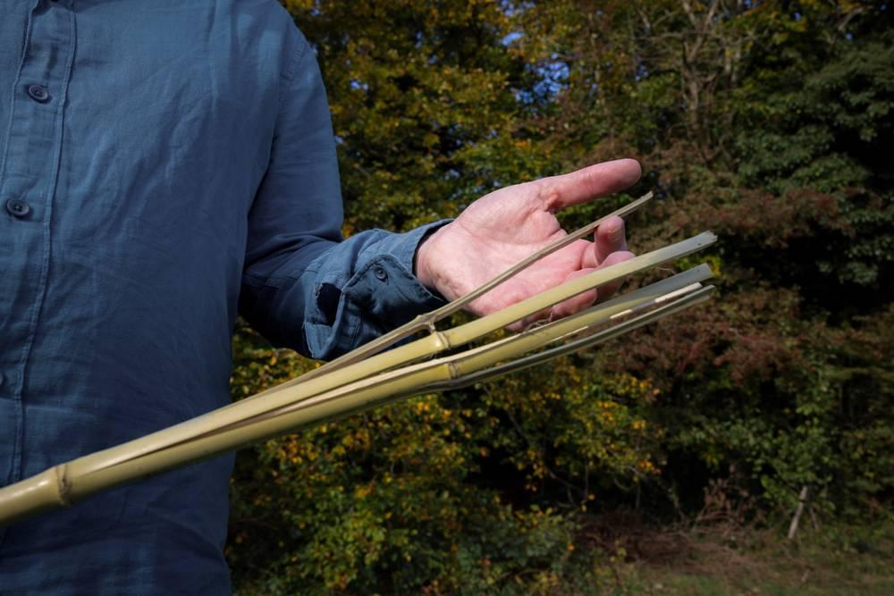
link

Paloma

Image Content

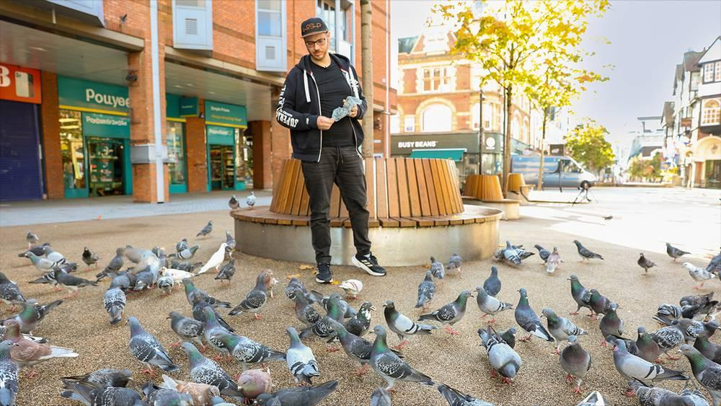
link

Paloma

Image Content

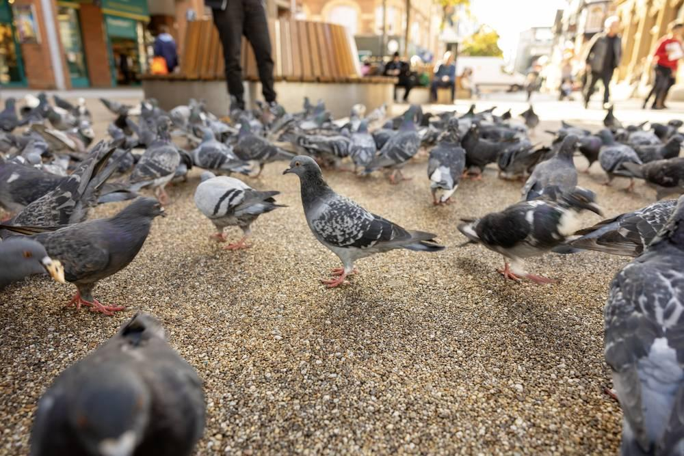
link

Pan

Image Content

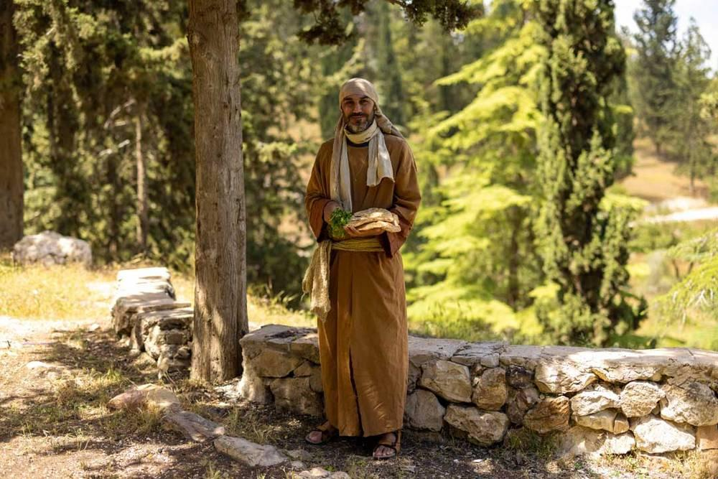
link

Pan

Image Content

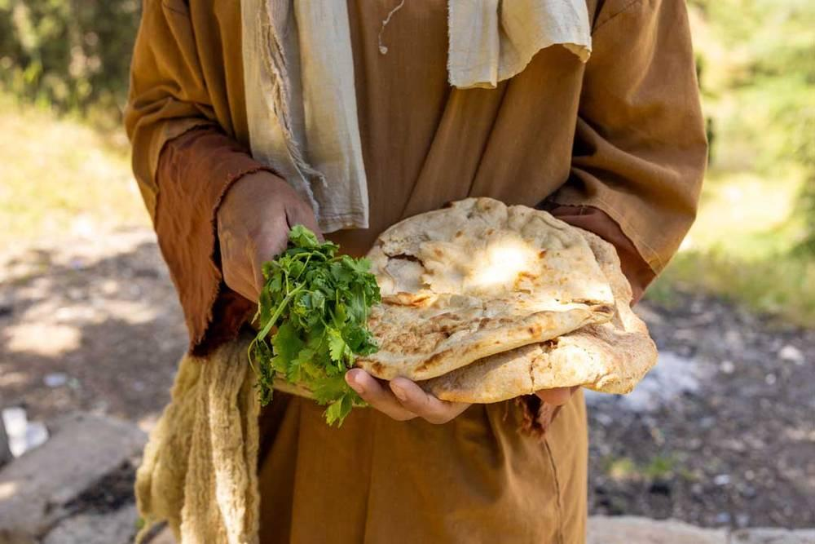
link

Pan sin levadura

Image Content

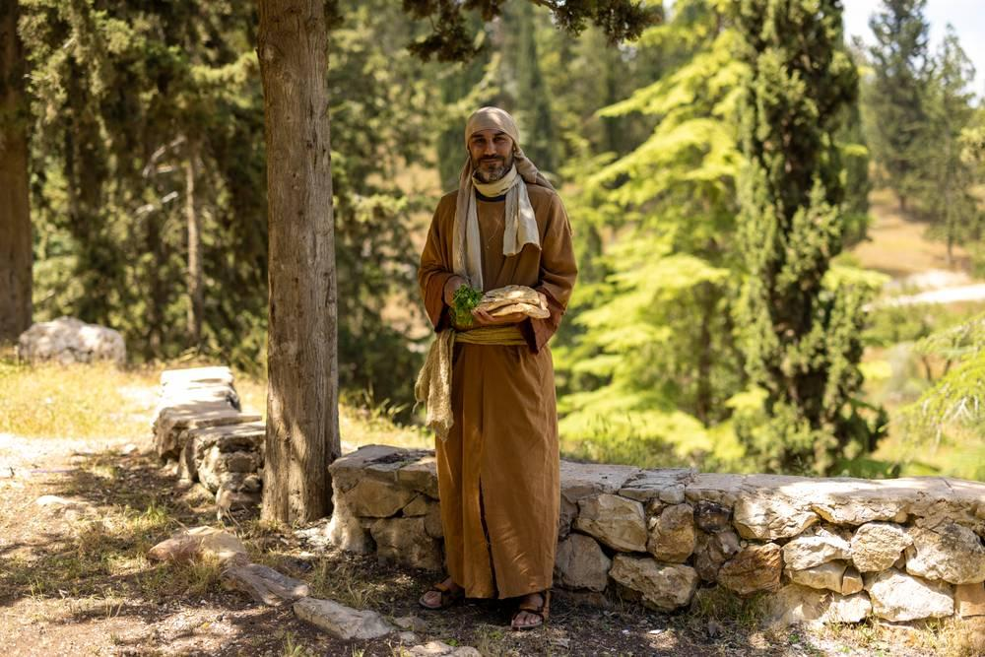
link

Pan sin levadura

Image Content

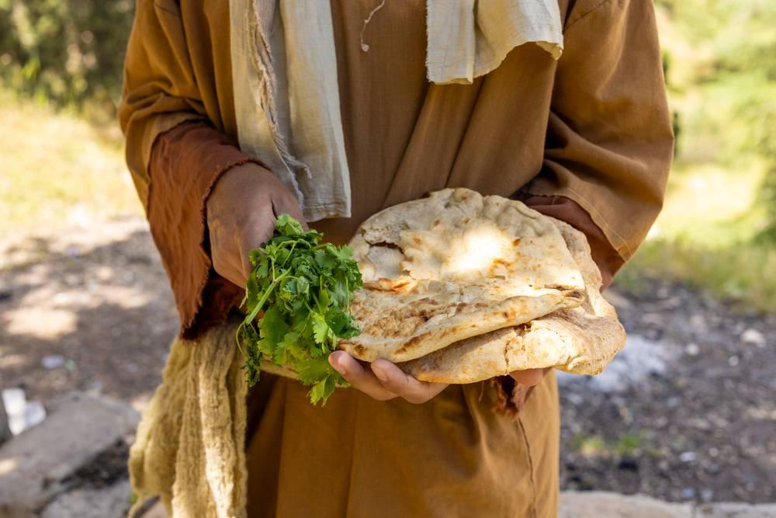
link

Pan sin levadura

Image Content

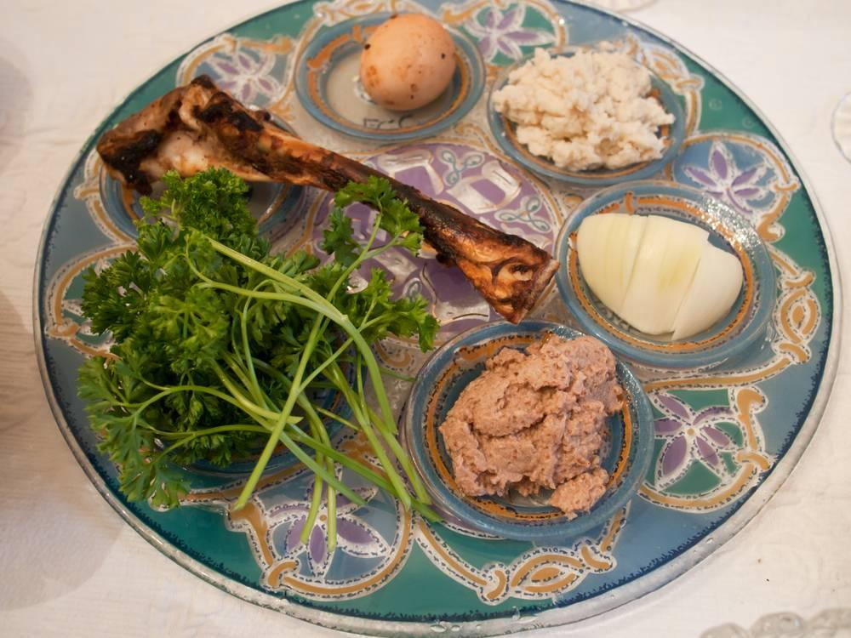
link

Pastores

Image Content

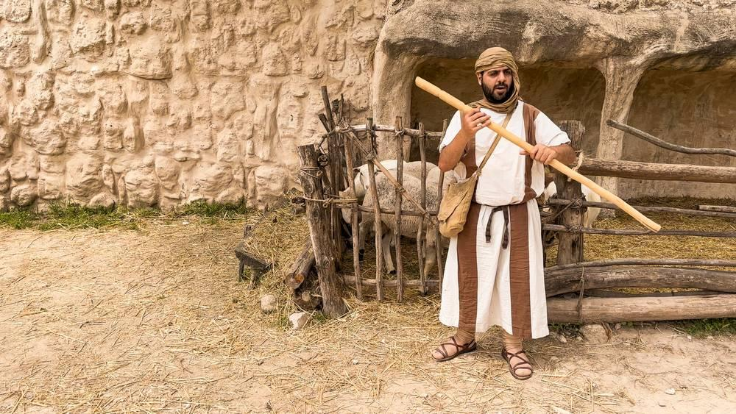
link

Pastores

Image Content

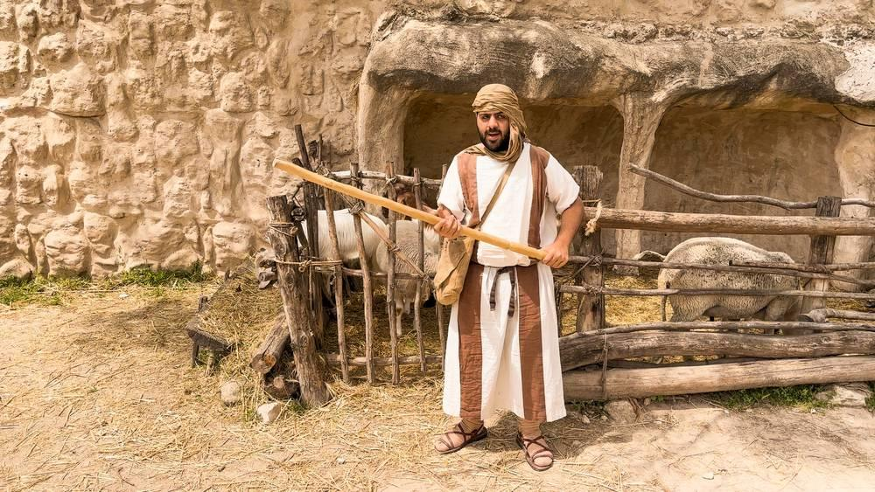
link

Pastores

Image Content

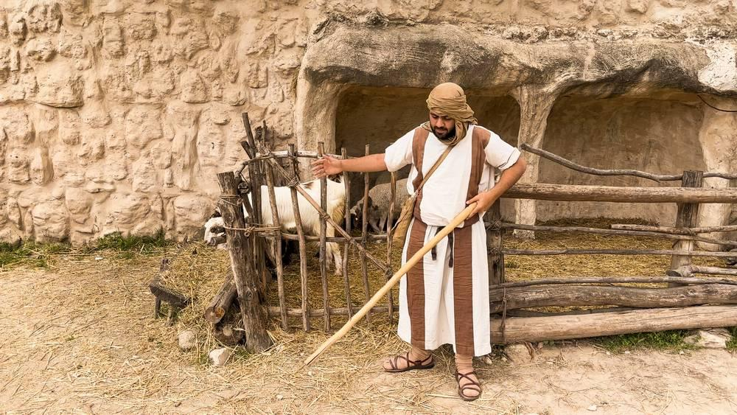
link

Personas que están en el suelo comiendo

Image Content

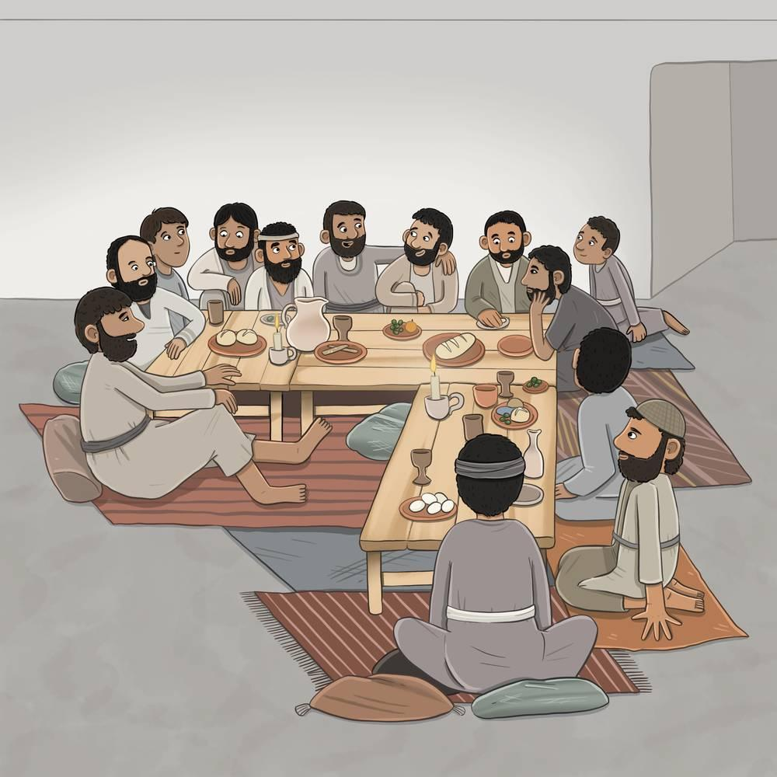
link

Pescado cocido

Image Content

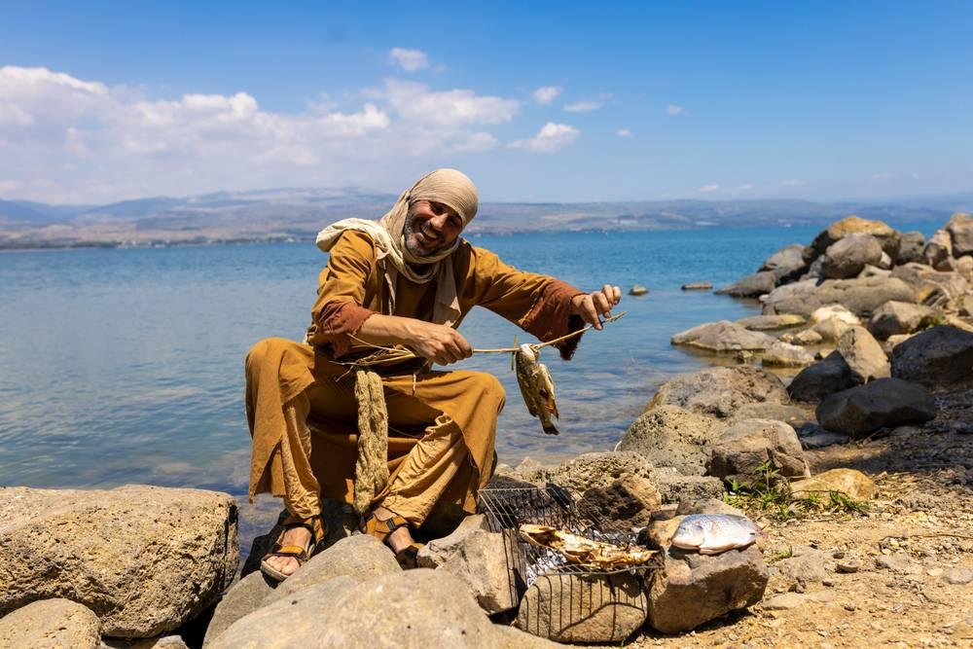
link

Pez

Image Content

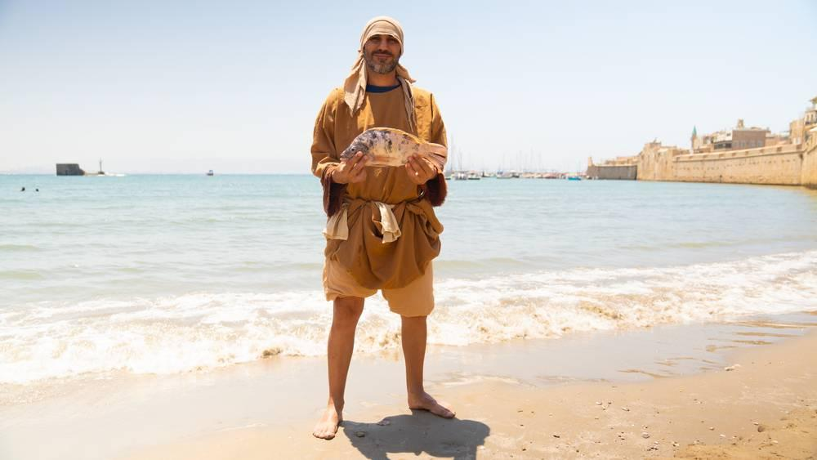
link

Piedra angular

Image Content

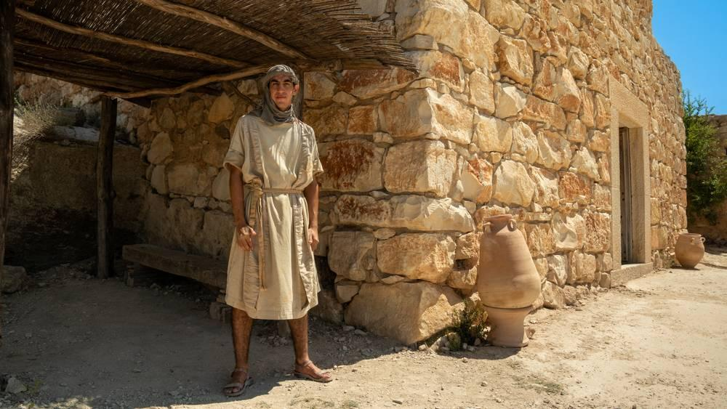
link

Piedra angular

Image Content

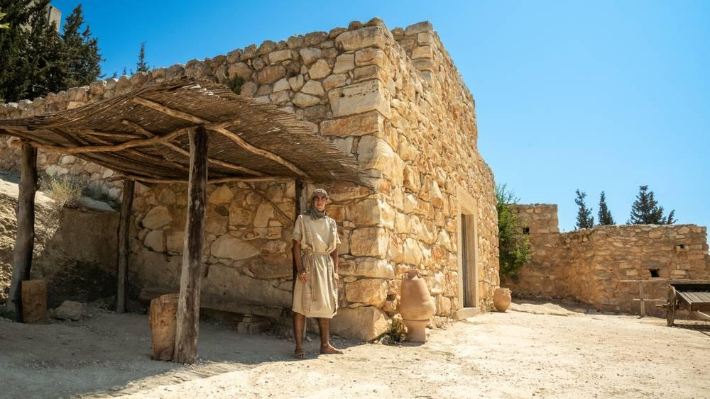
link

Piedra angular

Image Content

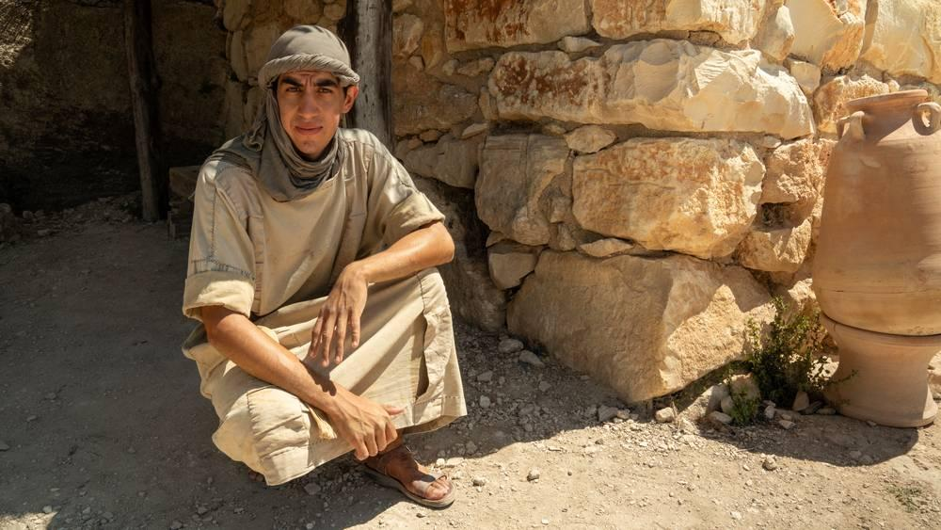
link

Piedra de molino

Image Content

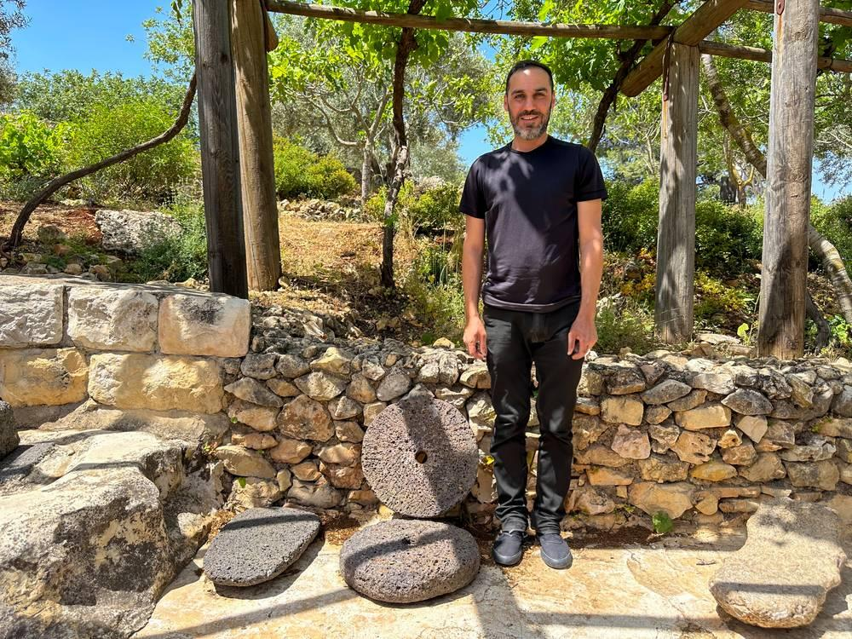
link

Piedra de molino

Image Content

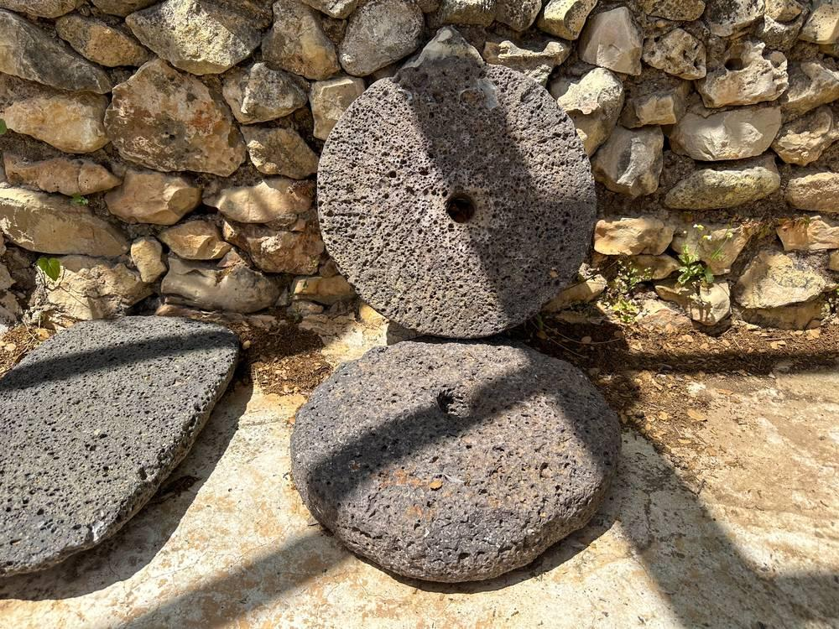
link

Piedra de molino

Image Content

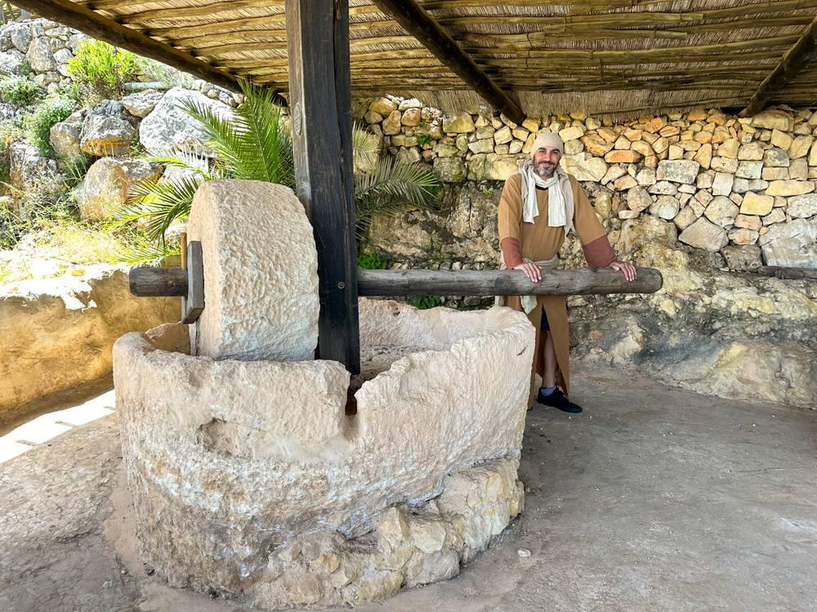
link

Piedra del Templo

Image Content

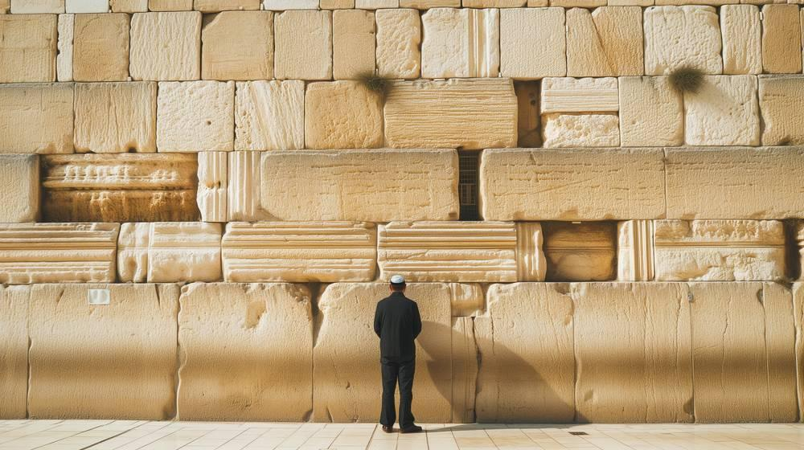
link

Planta de Nardo

Image Content

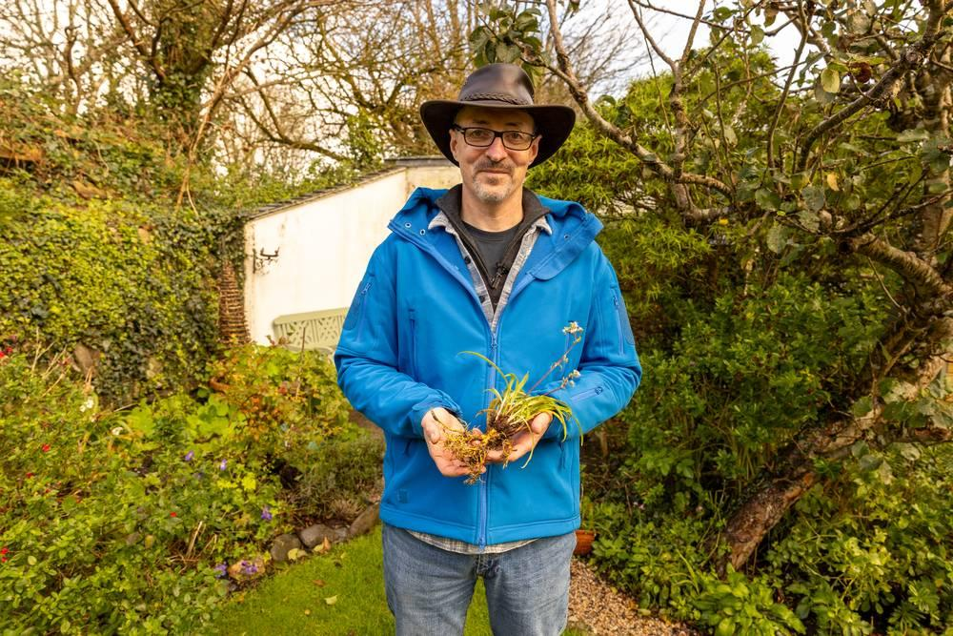
link

Planta de Nardo

Image Content

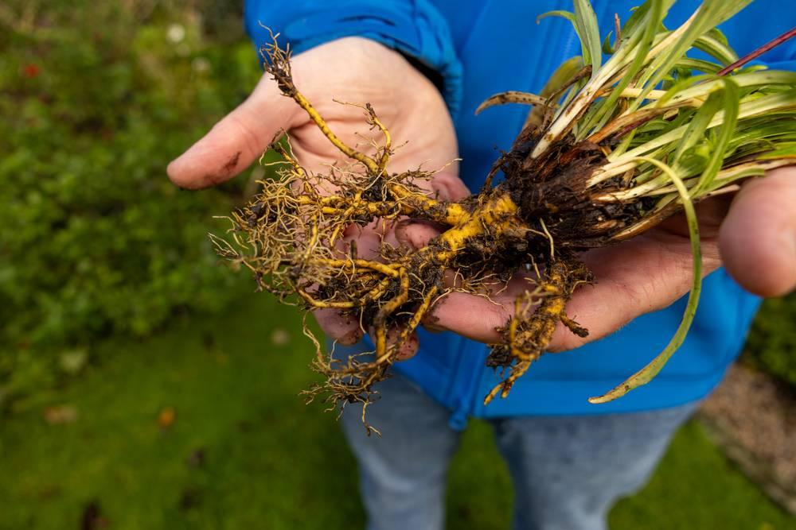
link

Planta espinosa

Image Content

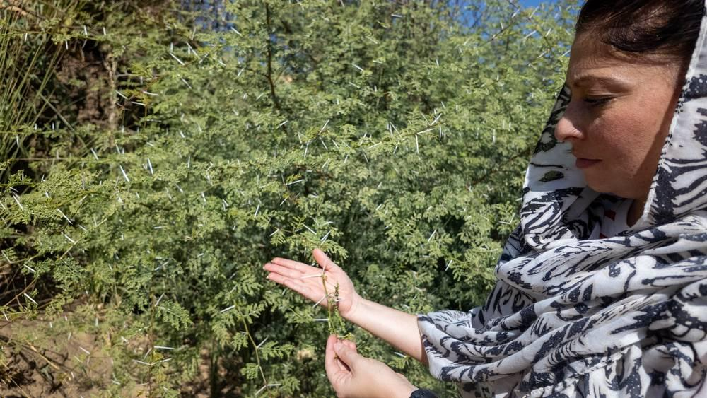
link

Planta espinosa

Image Content

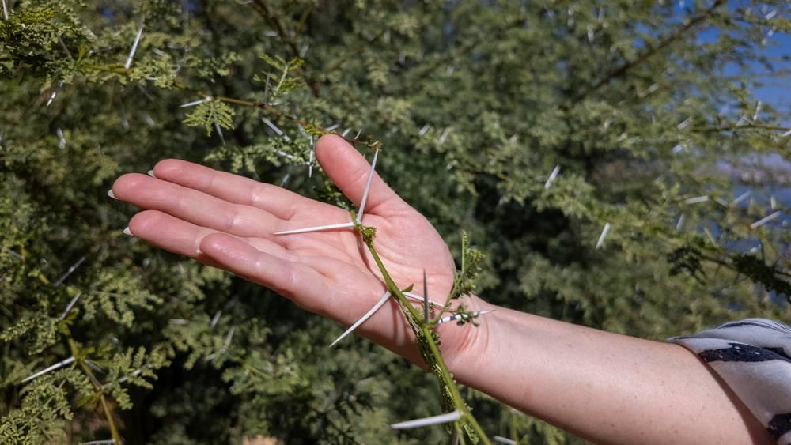
link

Planta/Árbol de mostaza

Image Content


link

Prensa de vino

Image Content

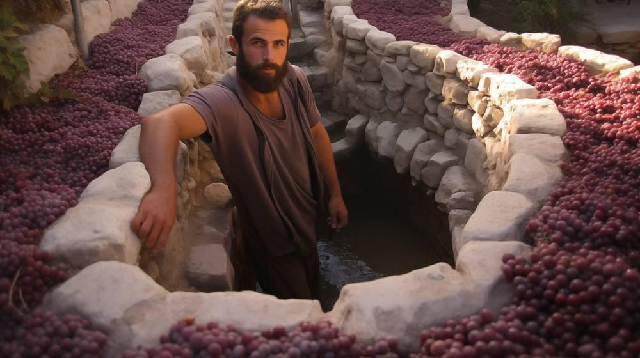
link

