Resource: Familiarization, Internalization, Articulation (Fia) Images
Familiarization, Internalization, Articulation (FIA) Images © 2023 SRV Partners Released under CC BY-SA 4.0 license. Familiarization, Internalization, Articulation (FIA) Images has been adapted in the following languages Tok Pisin, عربي, Français, हिंदी, Bahasa Indonesia, Português, Русский, Español, Kiswahili, 简体中文 from Familiarization, Internalization, Articulation (FIA) © 2023 SRV Partners. Released under CC BY-SA 4.0 license by Mission Mutual

Familiarization, Internalization, Articulation (Fia) Images

R

Ramas de olivo y de palma

Image Content

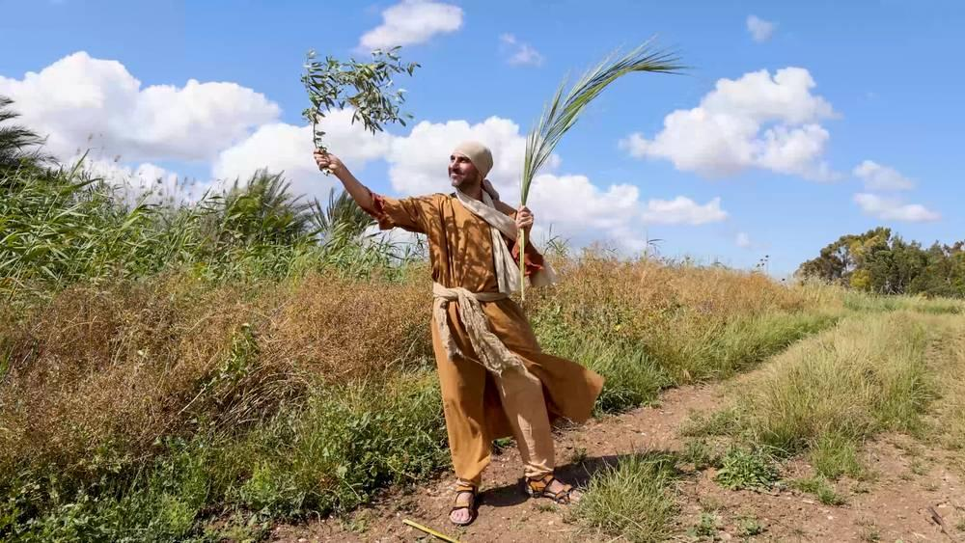
link

Ramas de olivo y de palma

Image Content

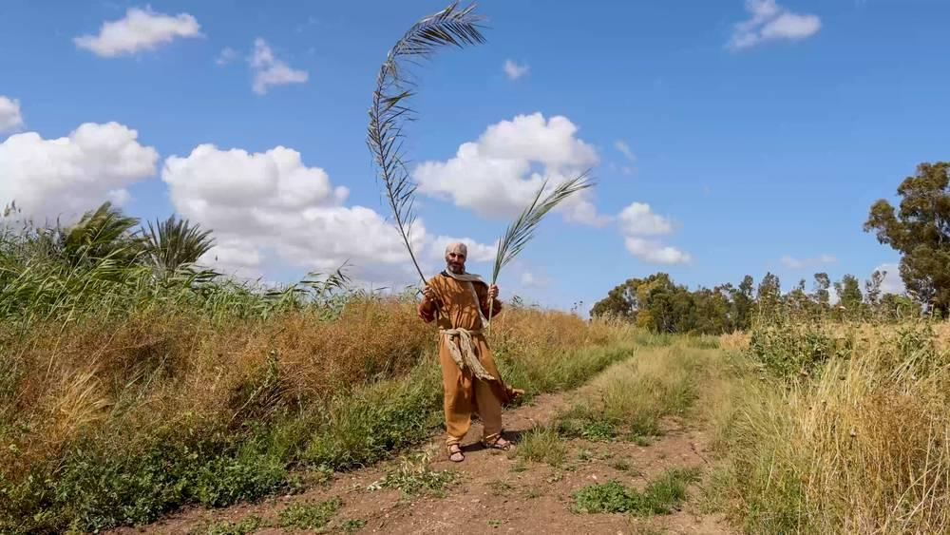
link

Red de pesca

Image Content

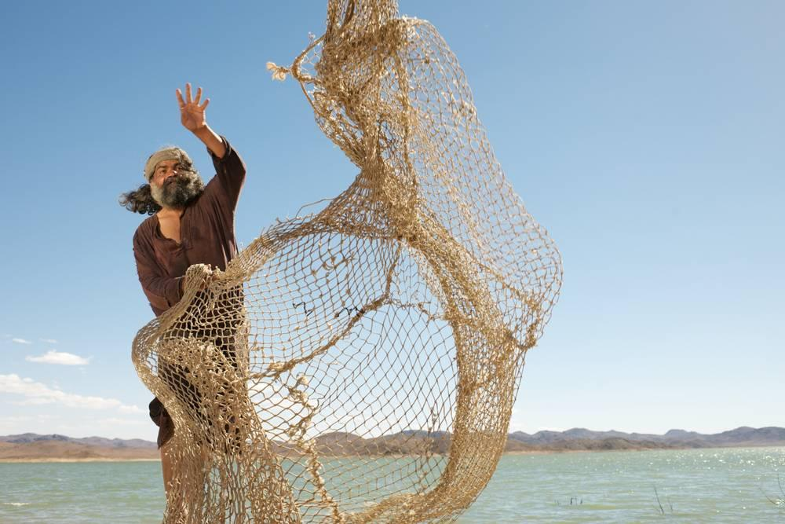
link

Red de pesca

Image Content

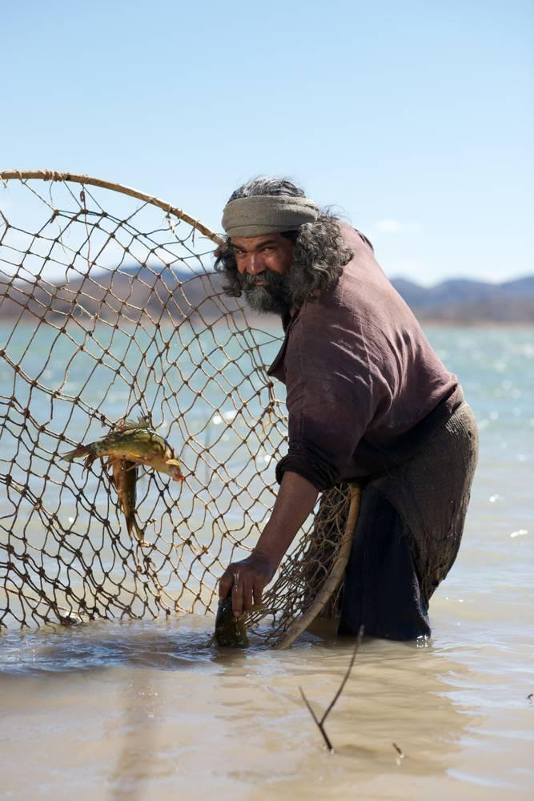
link

Red de pesca

Image Content

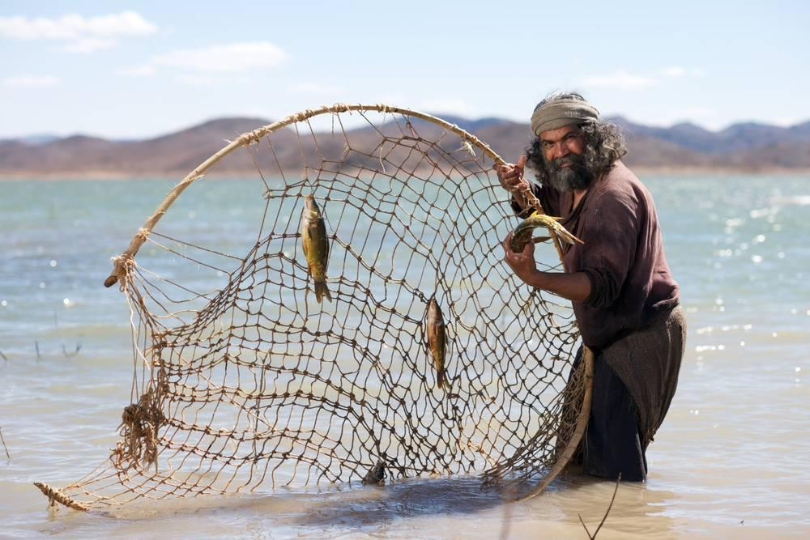
link

Red de pesca

Image Content

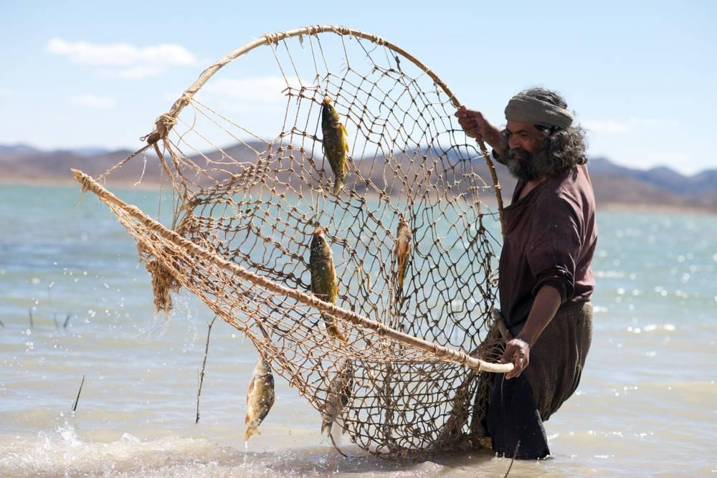
link

Red de pesca

Image Content

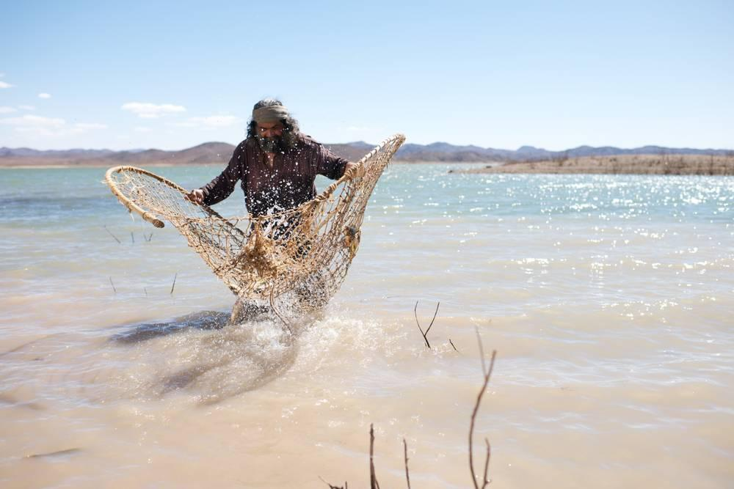
link

Refugios

Image Content

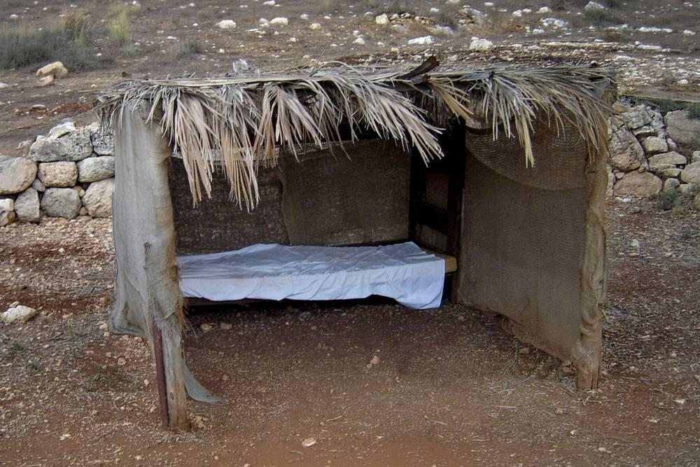
link

Río Jordán

Image Content

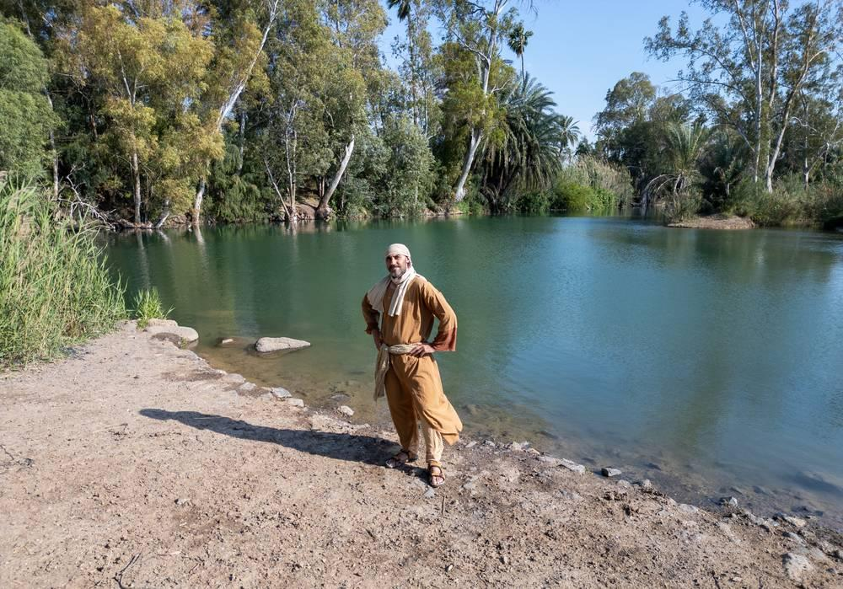
link

