Resource: Familiarization, Internalization, Articulation (Fia) Images
Familiarization, Internalization, Articulation (FIA) Images © 2023 SRV Partners Released under CC BY-SA 4.0 license. Familiarization, Internalization, Articulation (FIA) Images has been adapted in the following languages Tok Pisin, عربي, Français, हिंदी, Bahasa Indonesia, Português, Русский, Español, Kiswahili, 简体中文 from Familiarization, Internalization, Articulation (FIA) © 2023 SRV Partners. Released under CC BY-SA 4.0 license by Mission Mutual

Familiarization, Internalization, Articulation (Fia) Images

S

Sandalias

Image Content

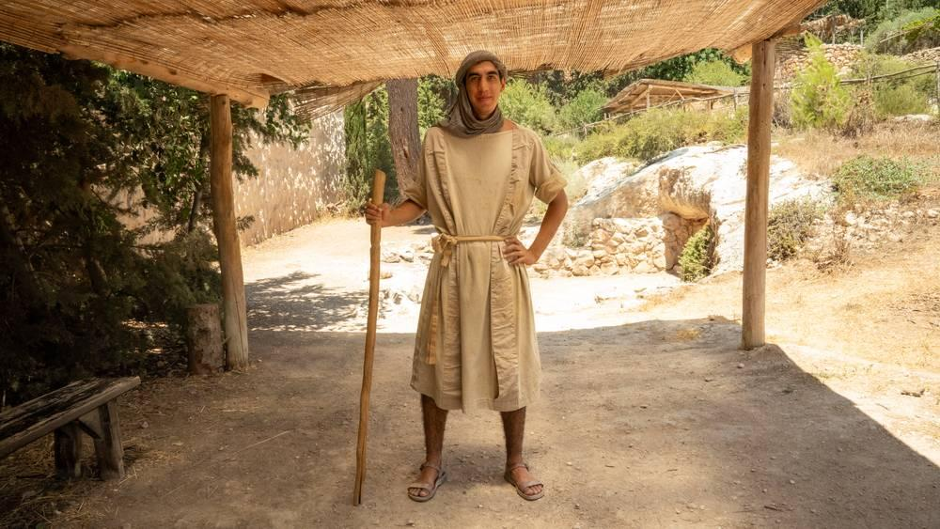
link

Sandalias

Image Content

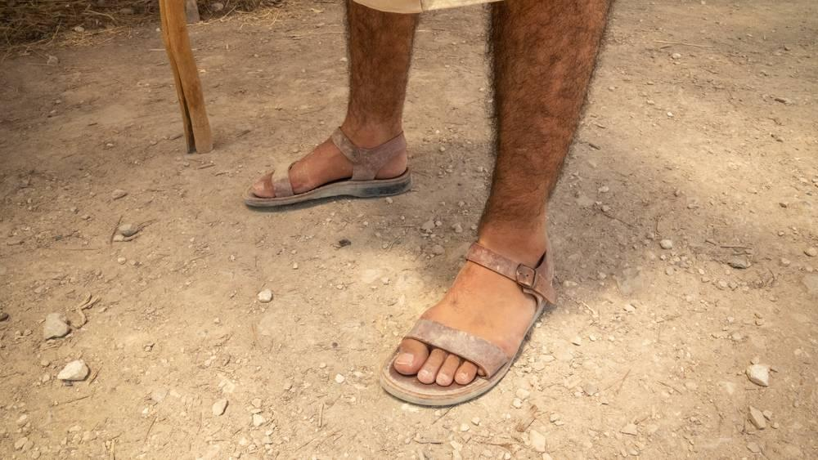
link

Sembrador

Image Content

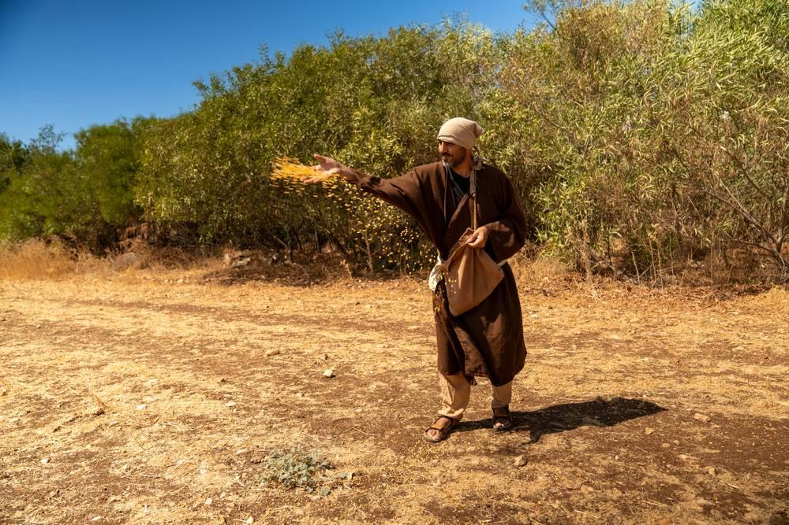
link

Sembrador

Image Content

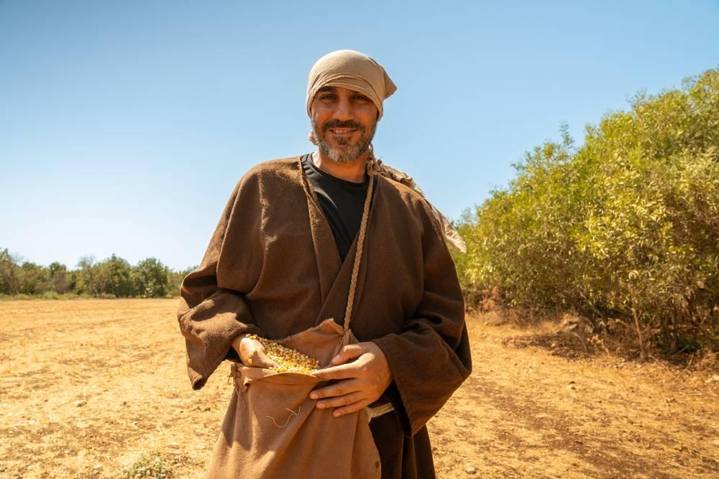
link

Semilla de mostaza

Image Content

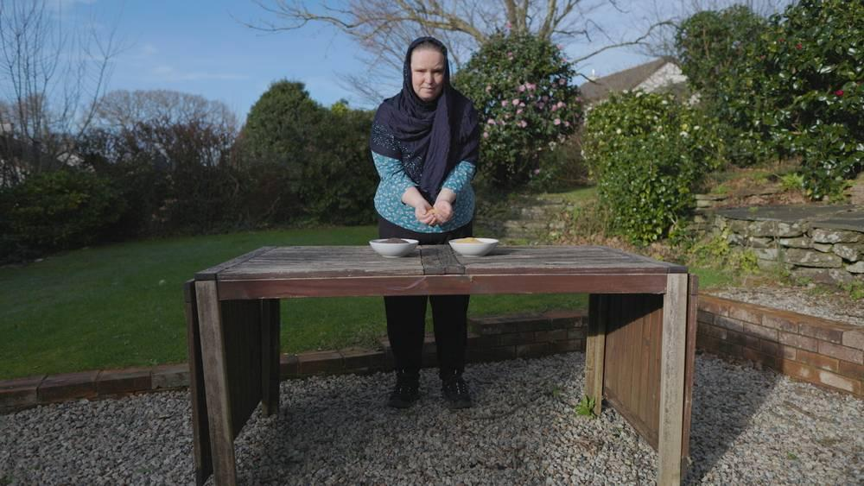
link

Semilla de mostaza

Image Content

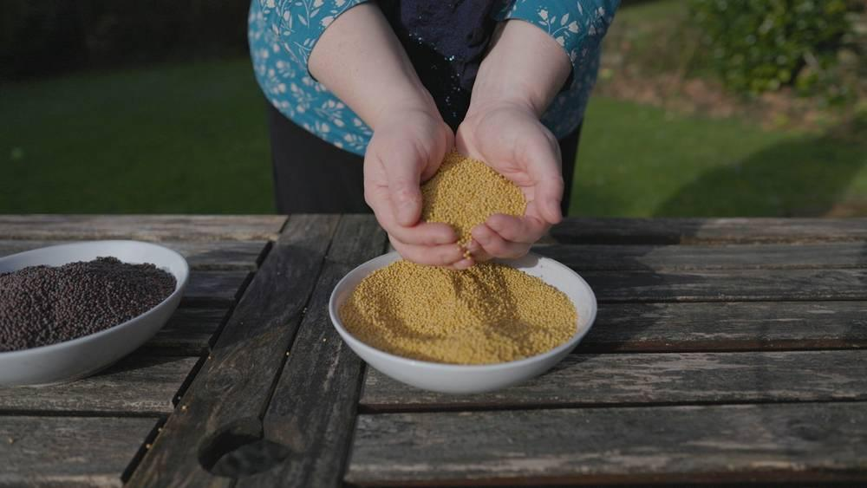
link

Semilla de mostaza

Image Content

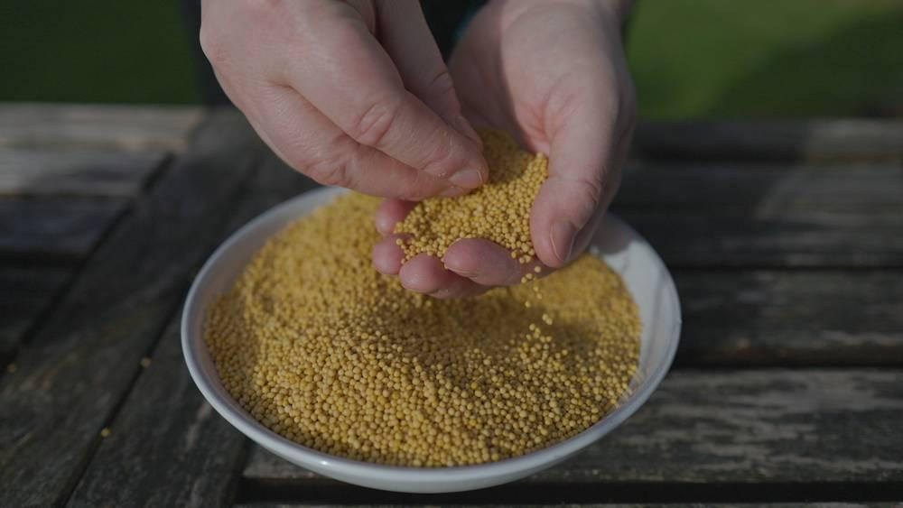
link

Semilla de mostaza

Image Content

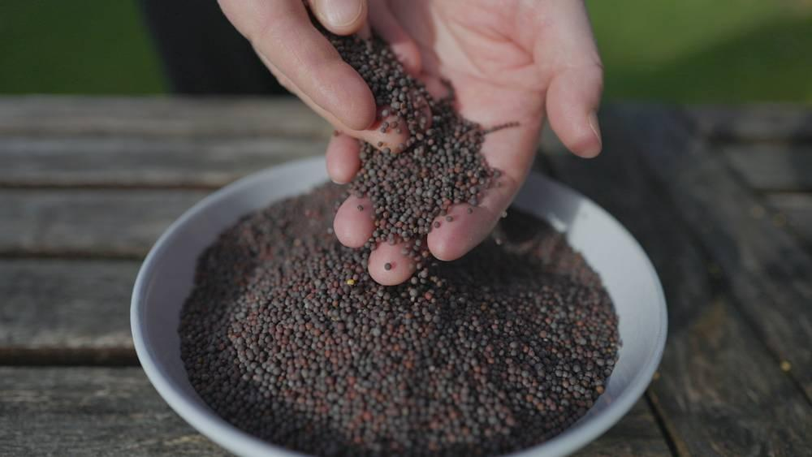
link

Serpiente

Image Content

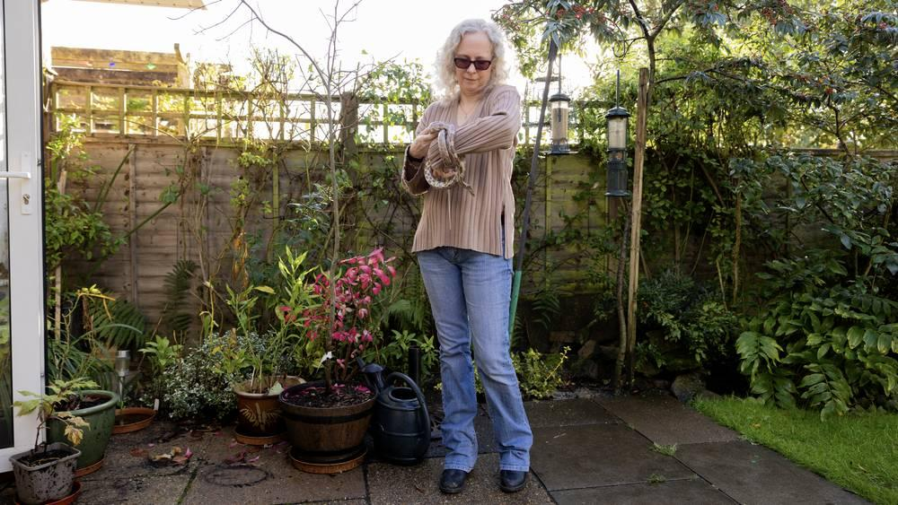
link

Serpiente

Image Content

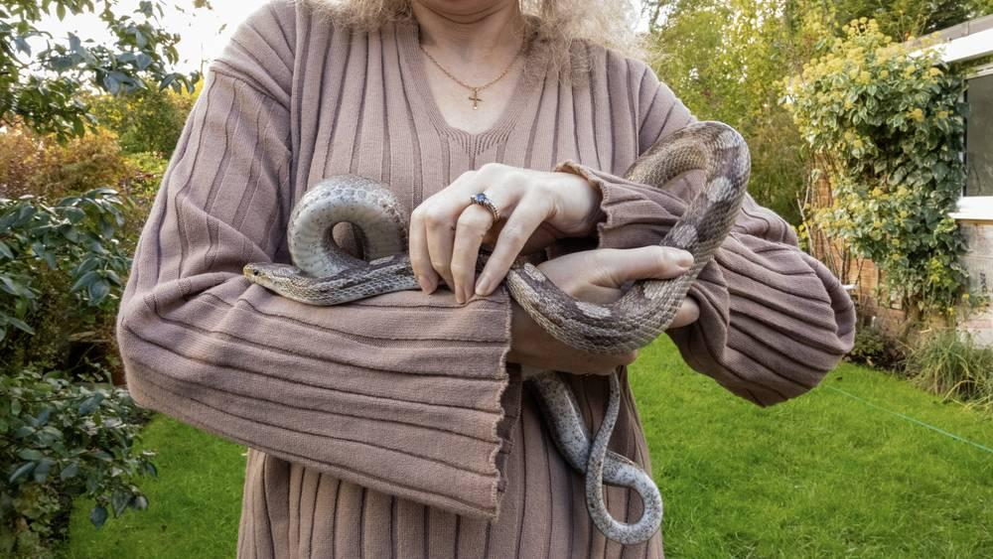
link

Serpiente

Image Content

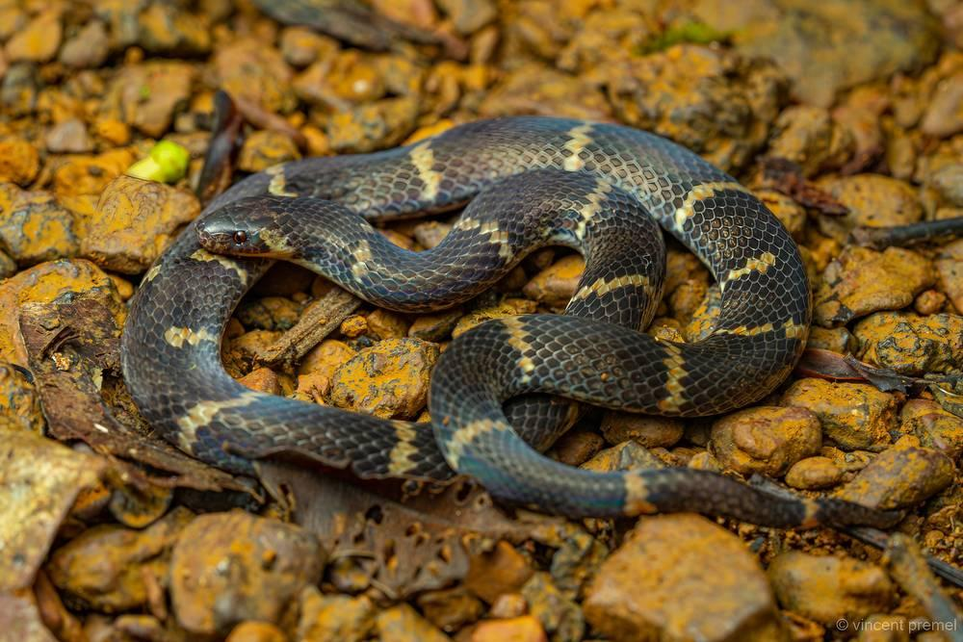
link

Serpiente

Image Content

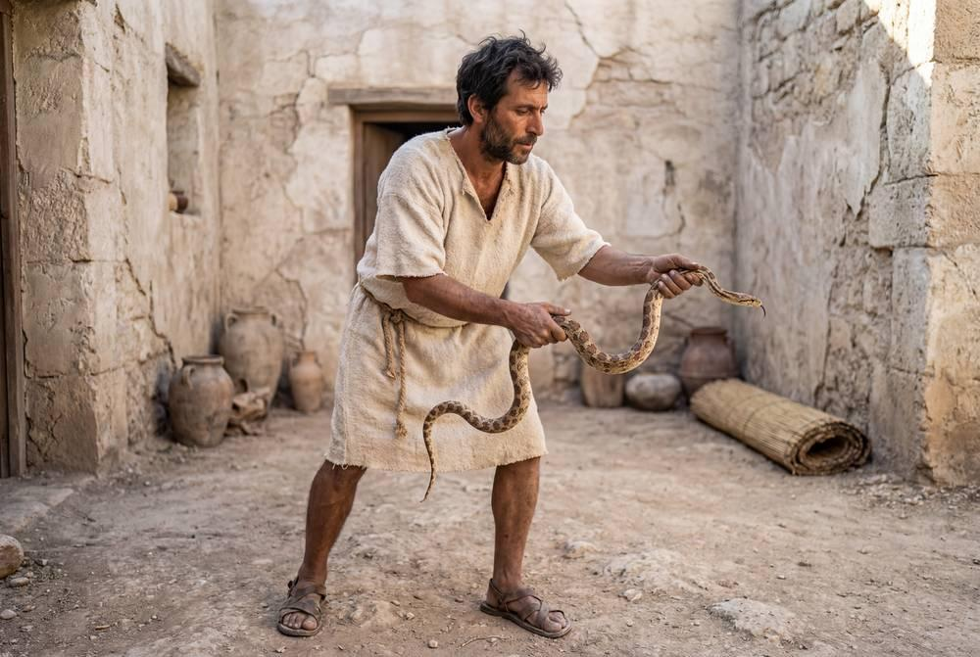
link

Serpiente

Image Content

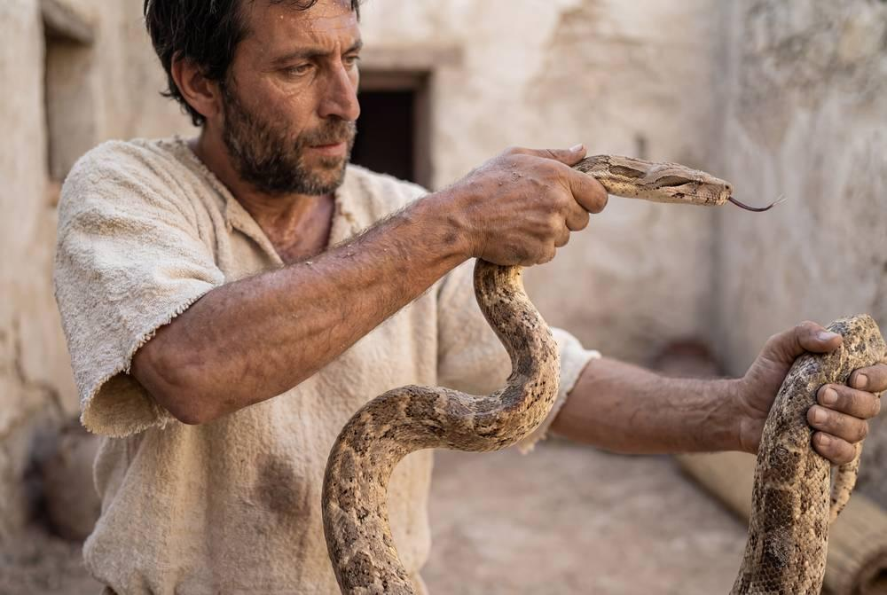
link

Serpiente

Image Content

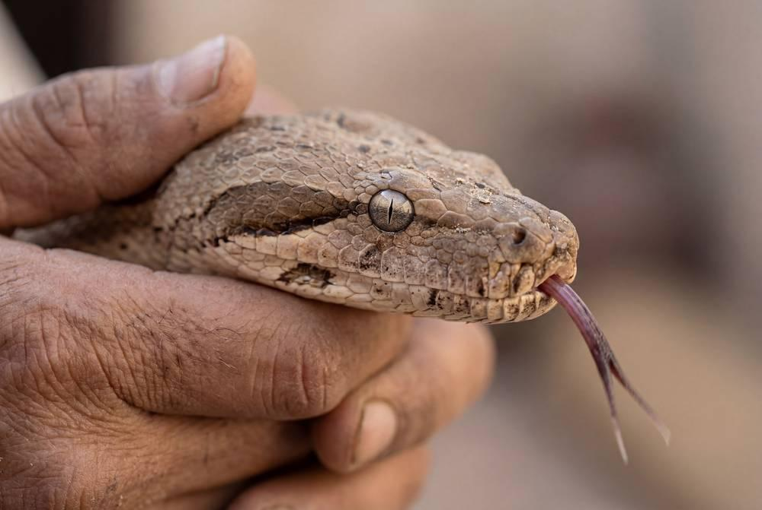
link

Sinagoga

Image Content

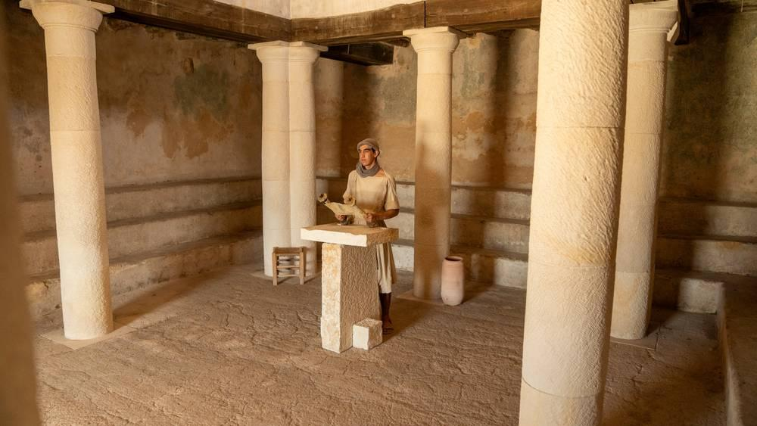
link

Sinagoga

Image Content

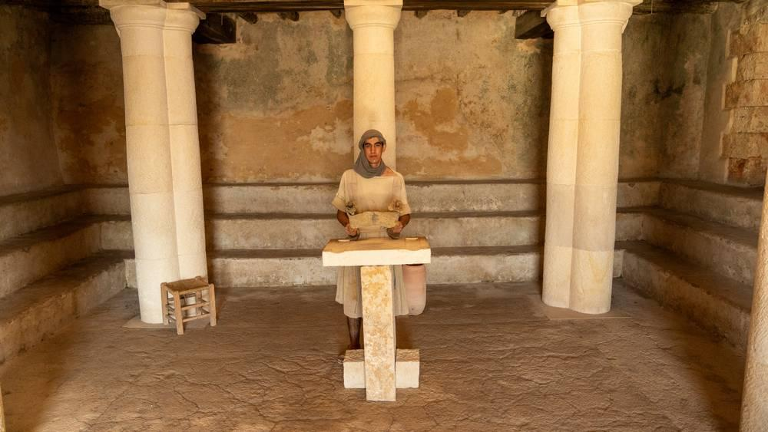
link

Sinagoga

Image Content

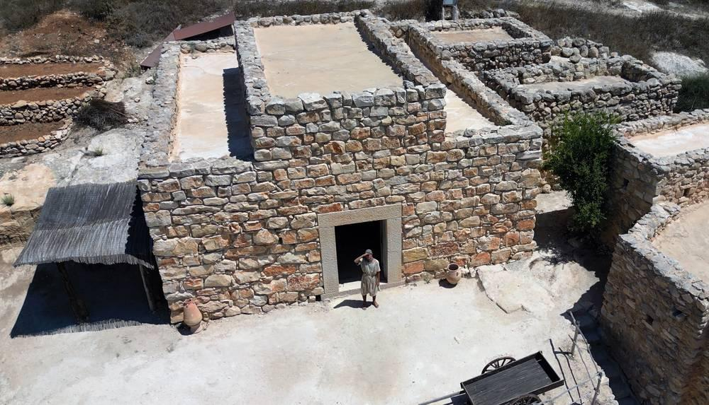
link

Suertes

Image Content

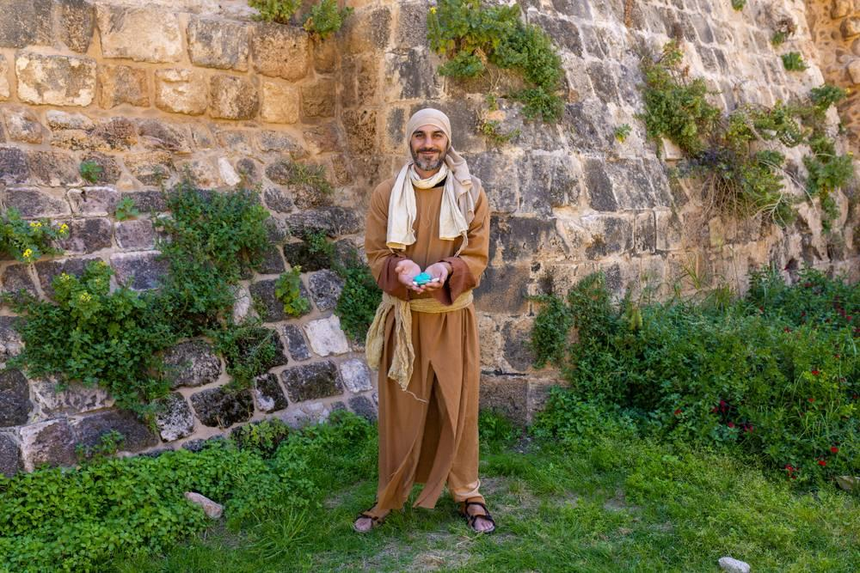
link

Suertes

Image Content

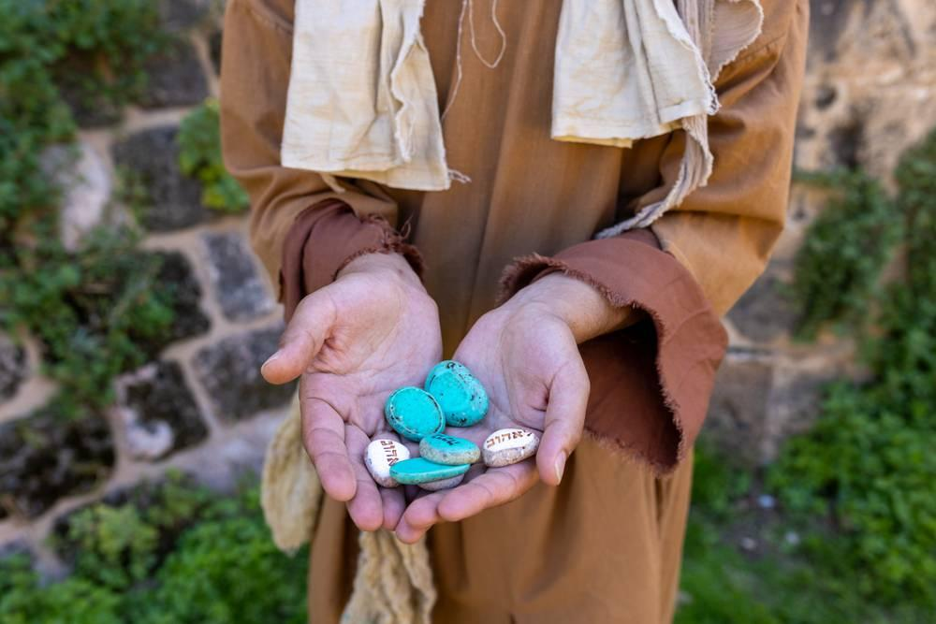
link

