Resource: Familiarization, Internalization, Articulation (Fia) Images
Familiarization, Internalization, Articulation (FIA) Images © 2023 SRV Partners Released under CC BY-SA 4.0 license. Familiarization, Internalization, Articulation (FIA) Images has been adapted in the following languages Tok Pisin, عربي, Français, हिंदी, Bahasa Indonesia, Português, Русский, Español, Kiswahili, 简体中文 from Familiarization, Internalization, Articulation (FIA) © 2023 SRV Partners. Released under CC BY-SA 4.0 license by Mission Mutual

Familiarization, Internalization, Articulation (Fia) Images

T

Templo de Herodes

Image Content

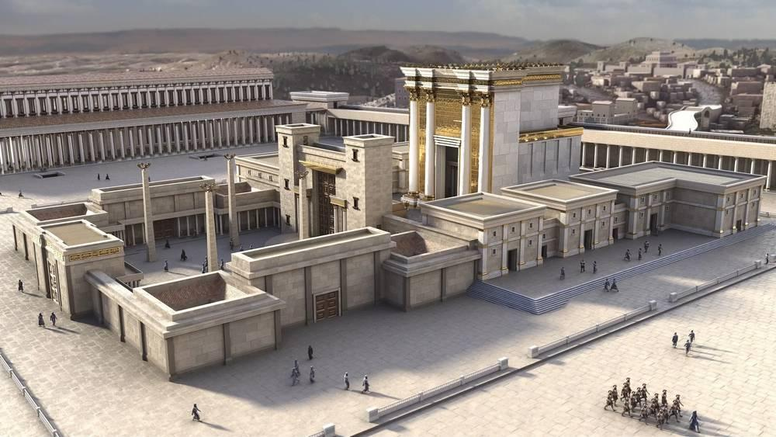
link

Templo del Monte de los Olivos

Image Content

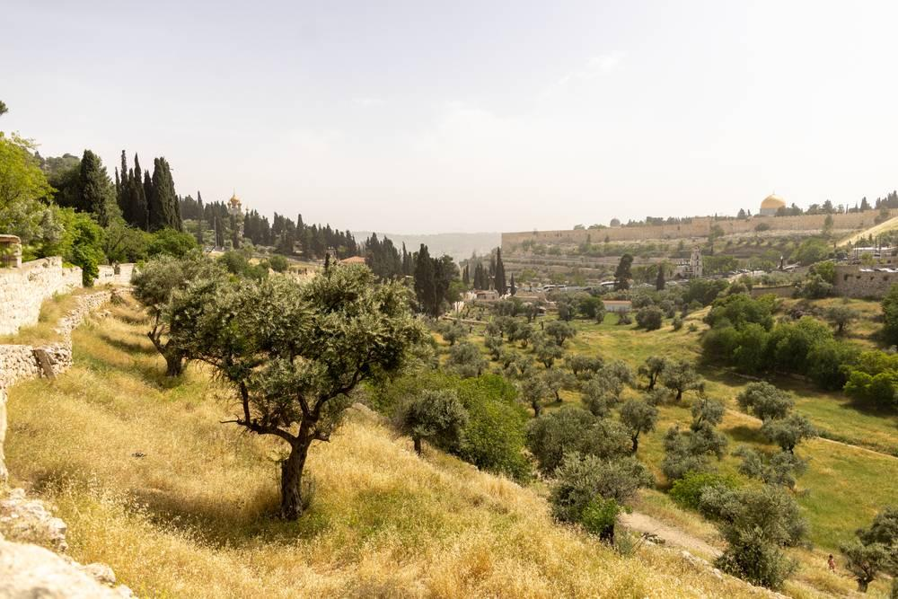
link

Templo del Monte de los Olivos

Image Content

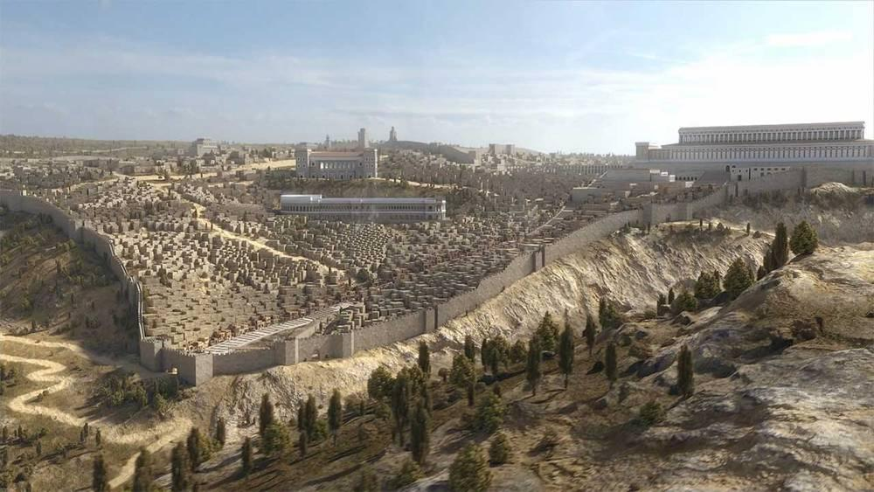
link

Tormenta en el Mar de Galilea

Image Content

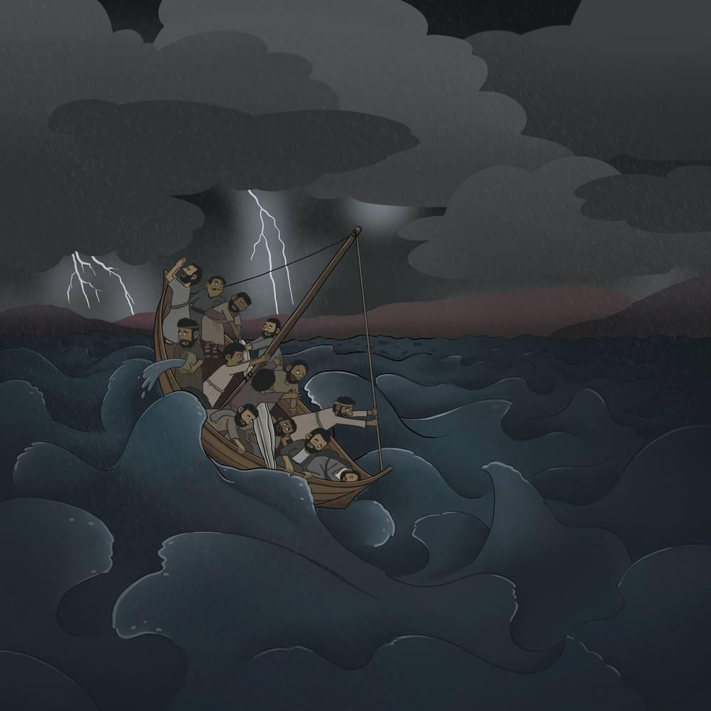
link

Torre de vigilancia para un viñedo

Image Content

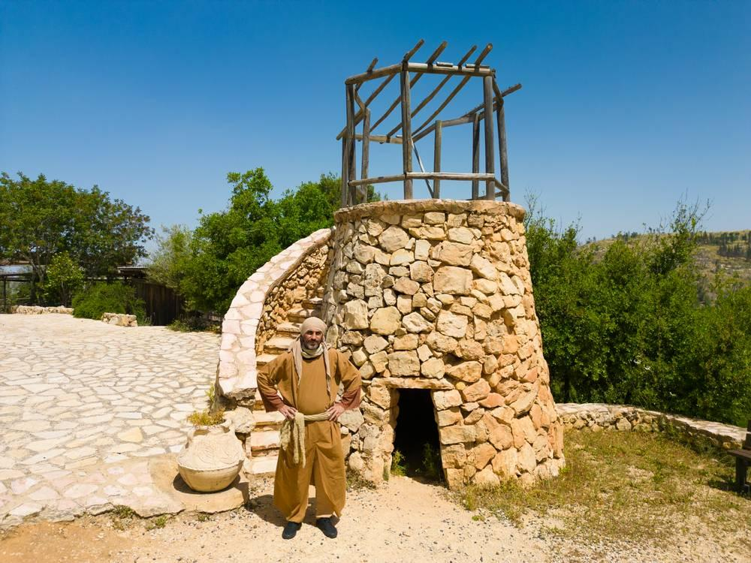
link

Torre de vigilancia para un viñedo

Image Content

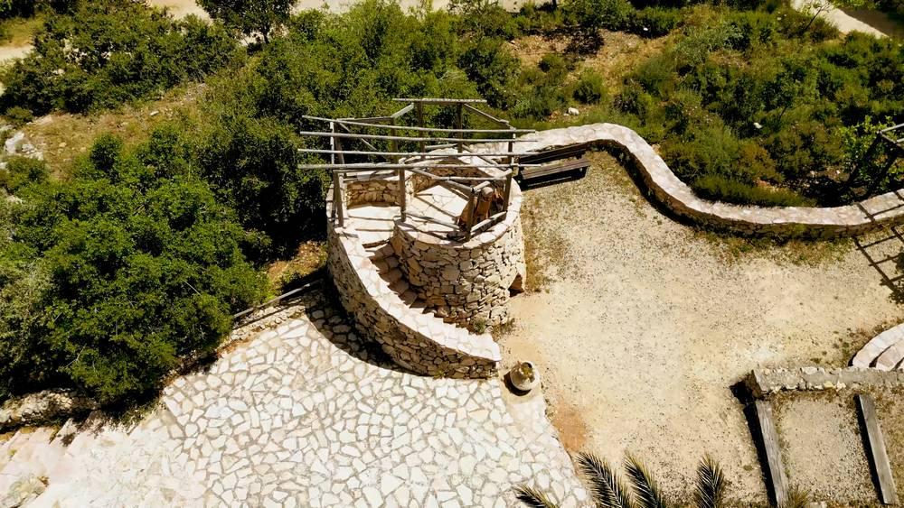
link

Trigo con espigas

Image Content

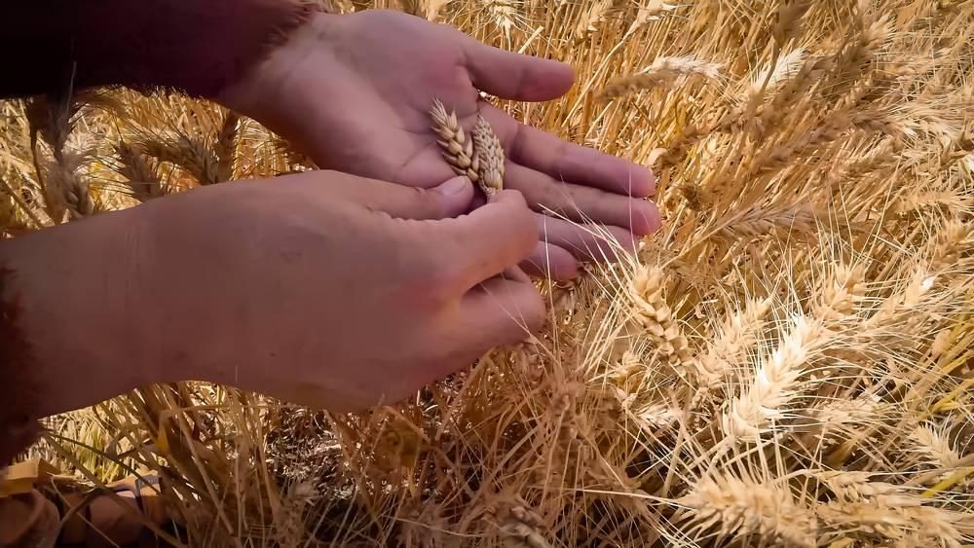
link

Trigo con espigas

Image Content

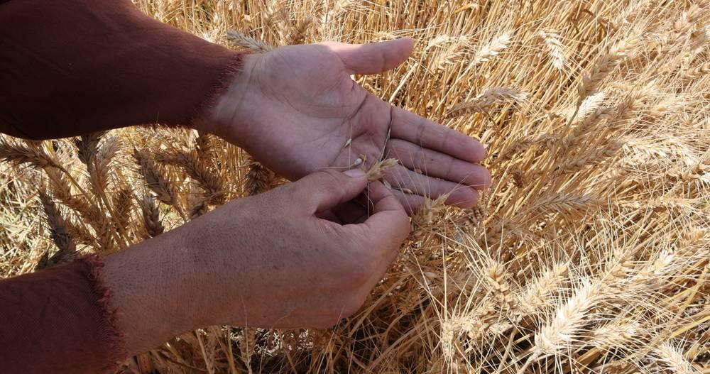
link

Trigo listo para la cosecha

Image Content

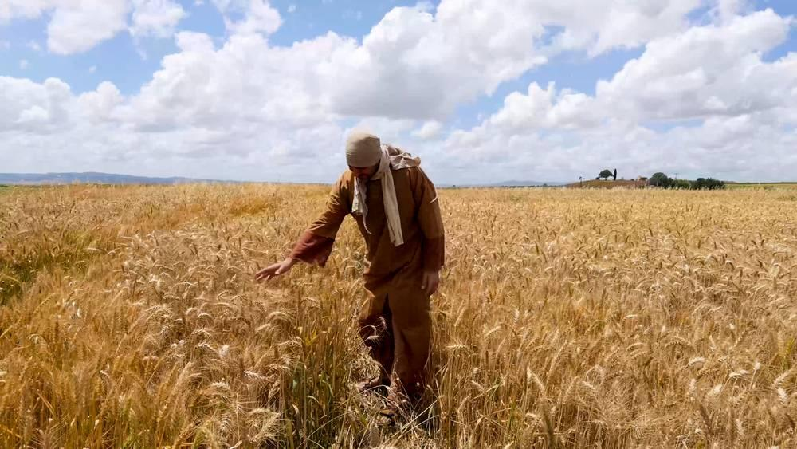
link

Tumba del jardín

Image Content

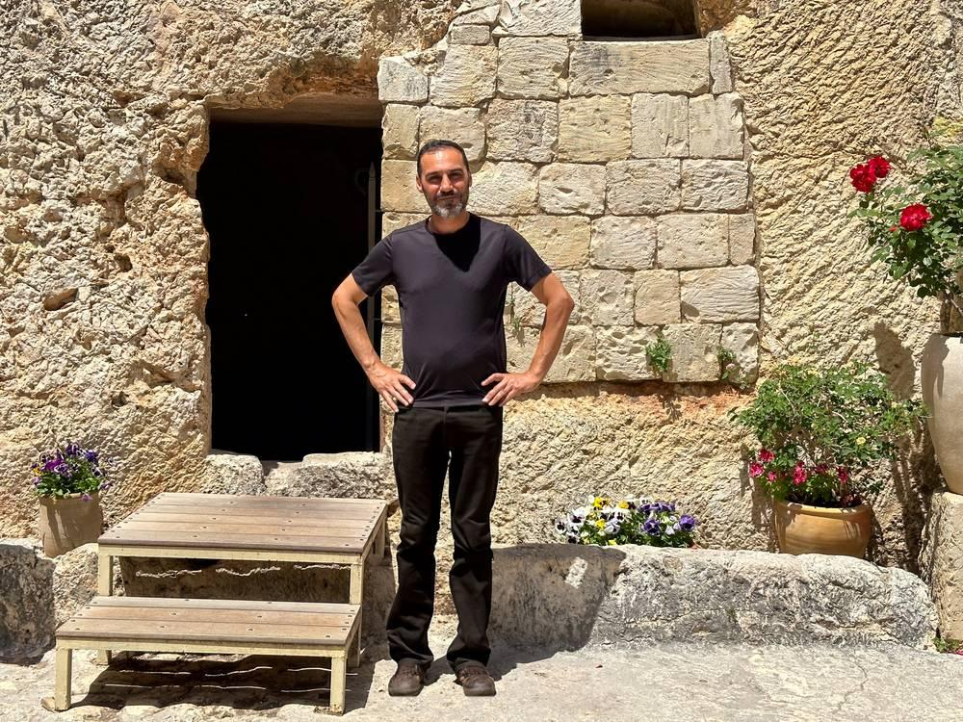
link

Tumbas

Image Content

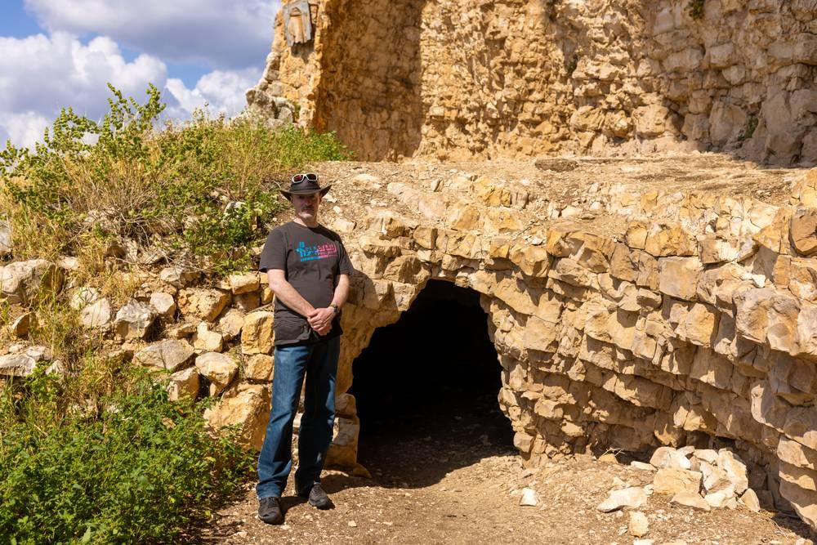
link

Tumbas

Image Content

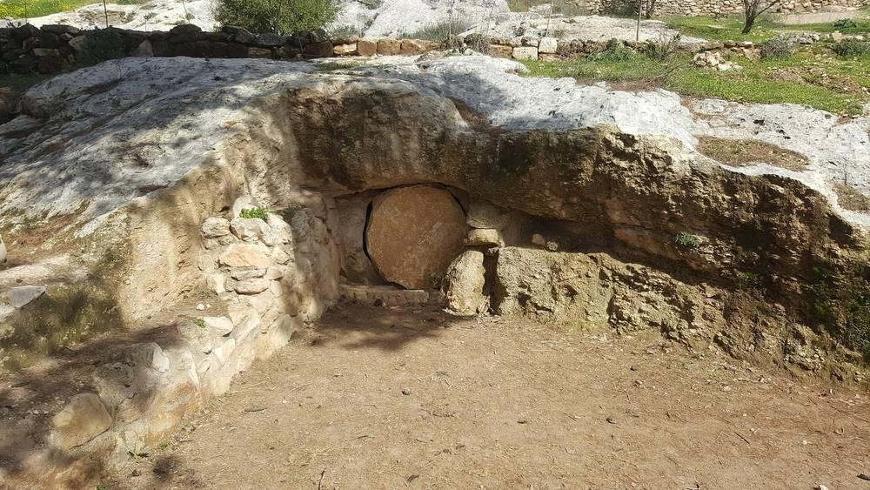
link

Túnica

Image Content

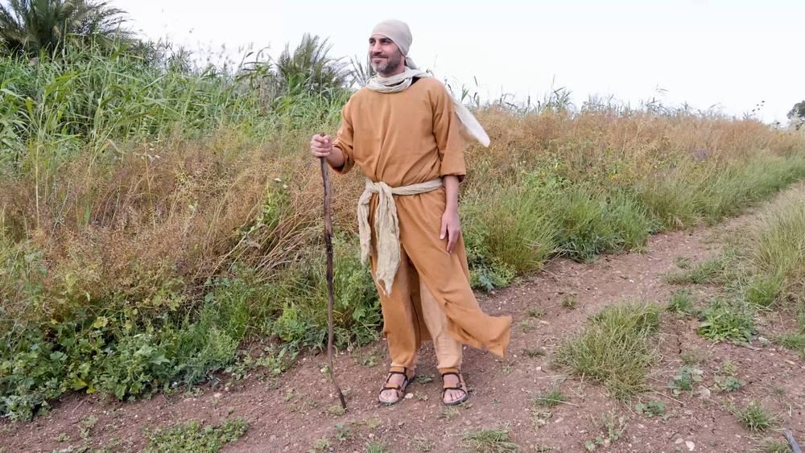
link

Túnica

Image Content

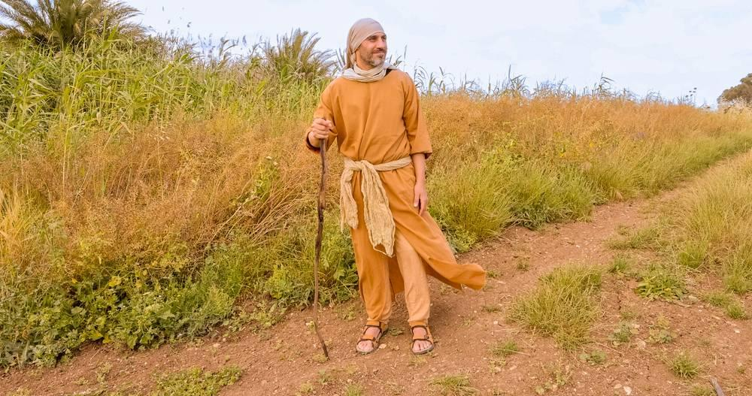
link

Túnica blanca

Image Content

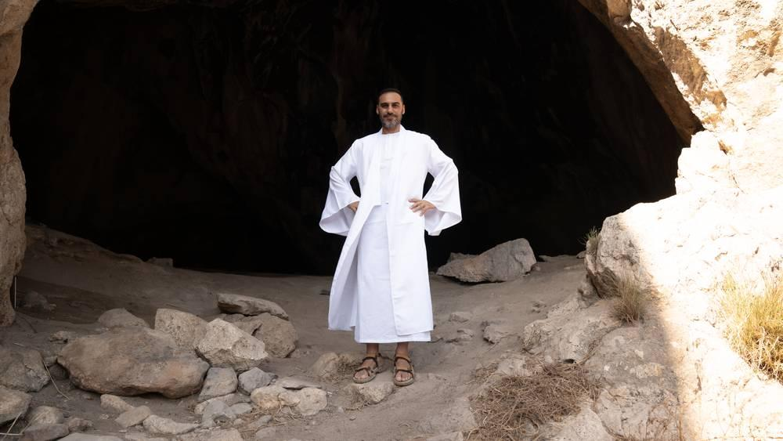
link

