Resource: Familiarization, Internalization, Articulation (Fia) Images
Familiarization, Internalization, Articulation (FIA) Images © 2023 SRV Partners Released under CC BY-SA 4.0 license. Familiarization, Internalization, Articulation (FIA) Images has been adapted in the following languages Tok Pisin, عربي, Français, हिंदी, Bahasa Indonesia, Português, Русский, Español, Kiswahili, 简体中文 from Familiarization, Internalization, Articulation (FIA) © 2023 SRV Partners. Released under CC BY-SA 4.0 license by Mission Mutual

Familiarization, Internalization, Articulation (Fia) Images

jia

加利利海

Image Content

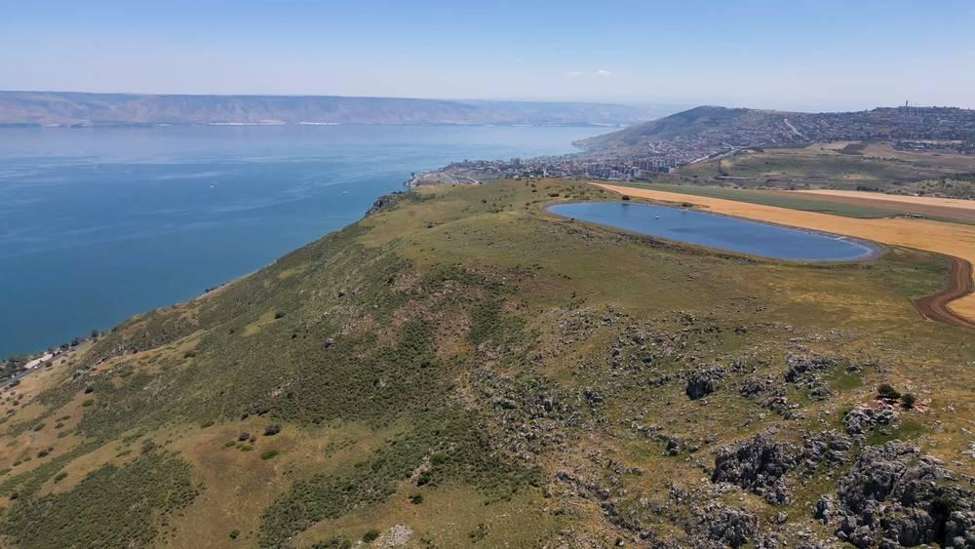
link

加利利海

Image Content

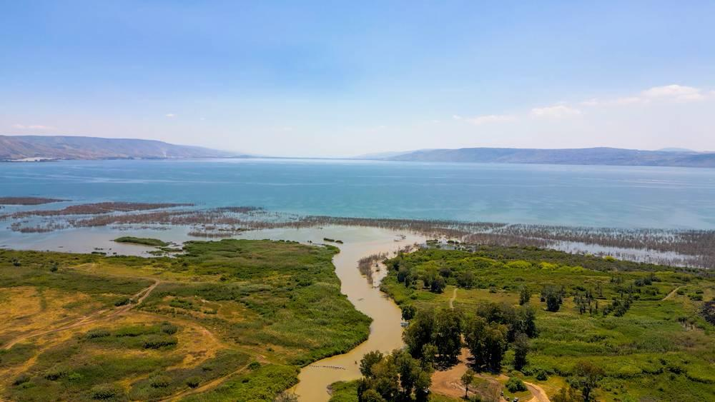
link

加利利海

Image Content

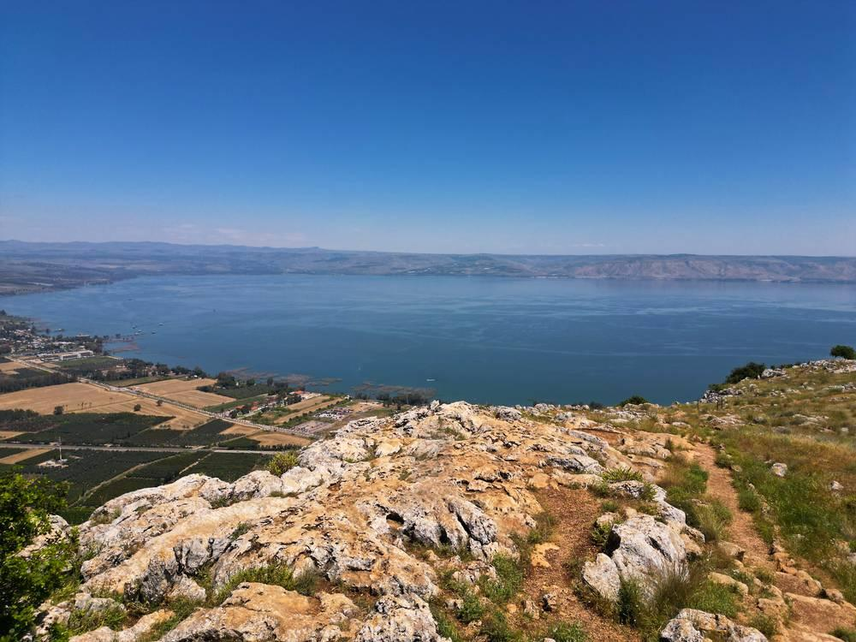
link

加利利海

Image Content

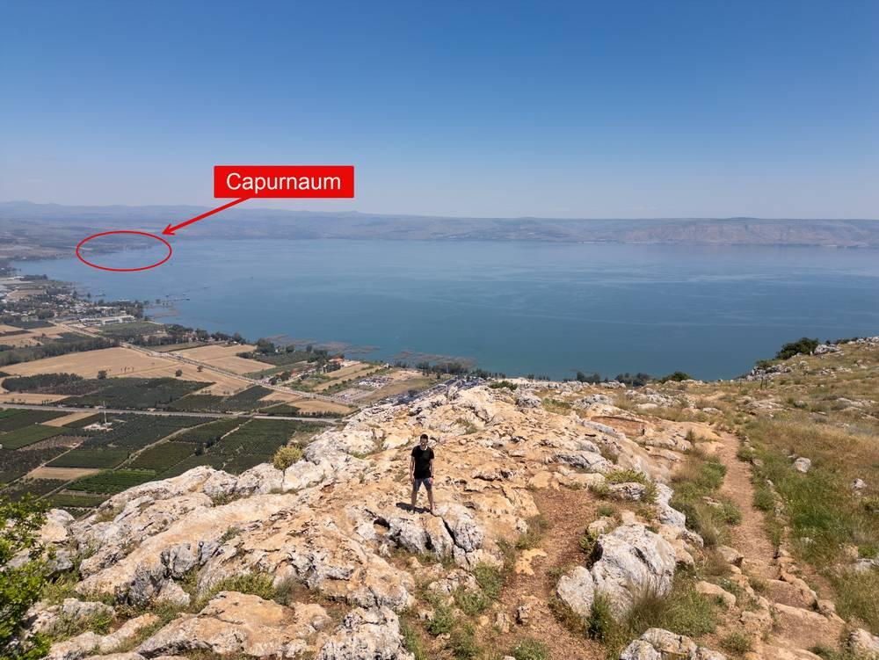
link

加利利海

Image Content

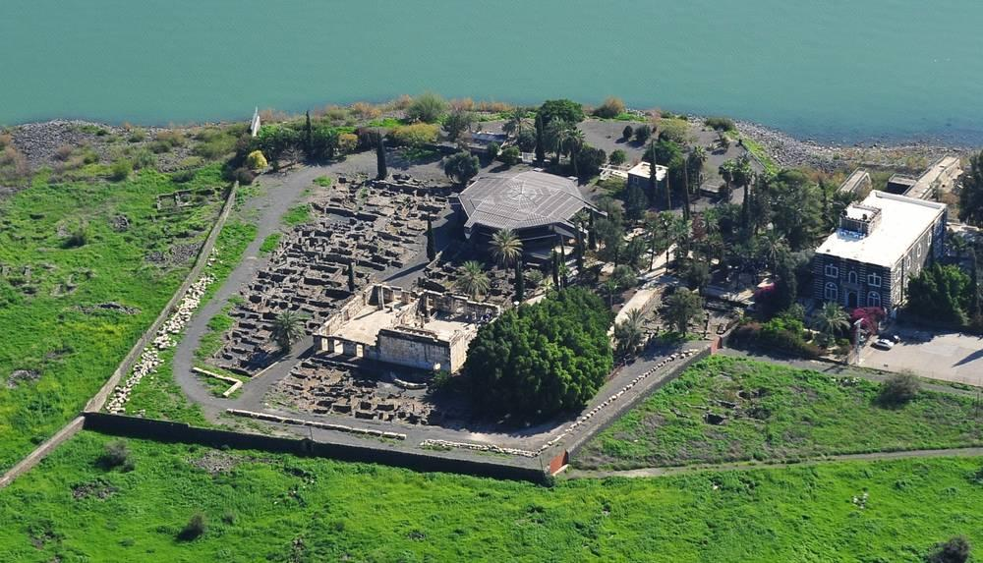
link

加利利海上的风暴

Image Content

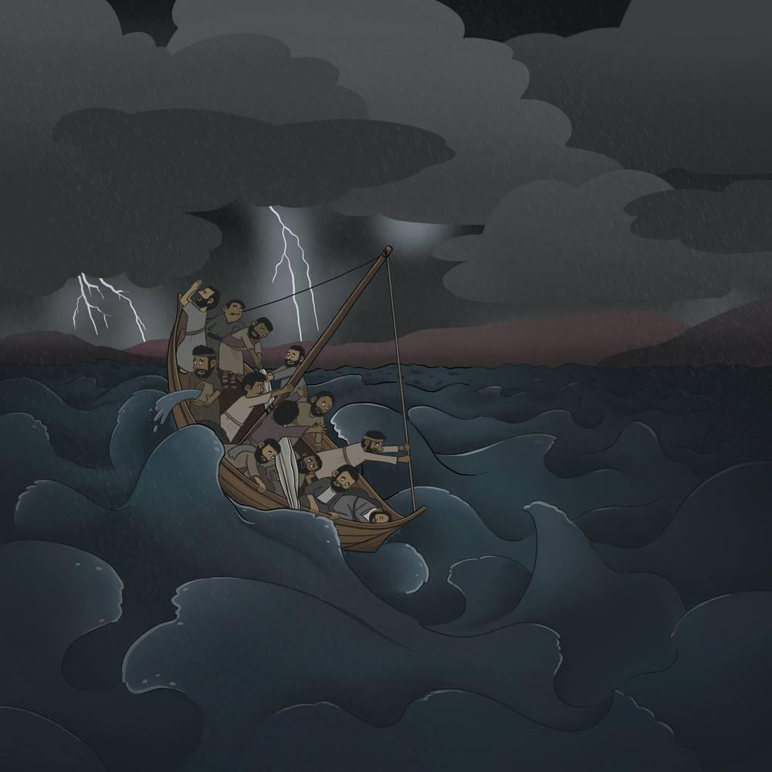
link

