Resource: Familiarization, Internalization, Articulation (Fia) Images
Familiarization, Internalization, Articulation (FIA) Images © 2023 SRV Partners Released under CC BY-SA 4.0 license. Familiarization, Internalization, Articulation (FIA) Images has been adapted in the following languages Tok Pisin, عربي, Français, हिंदी, Bahasa Indonesia, Português, Русский, Español, Kiswahili, 简体中文 from Familiarization, Internalization, Articulation (FIA) © 2023 SRV Partners. Released under CC BY-SA 4.0 license by Mission Mutual

Familiarization, Internalization, Articulation (Fia) Images

K

King's Throne during Roman Period

Image Content


link

King's Throne during Roman Period

Image Content

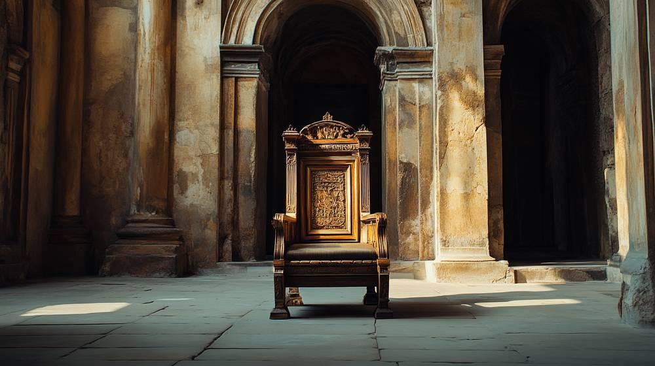
link

Kneading Bowl

Image Content

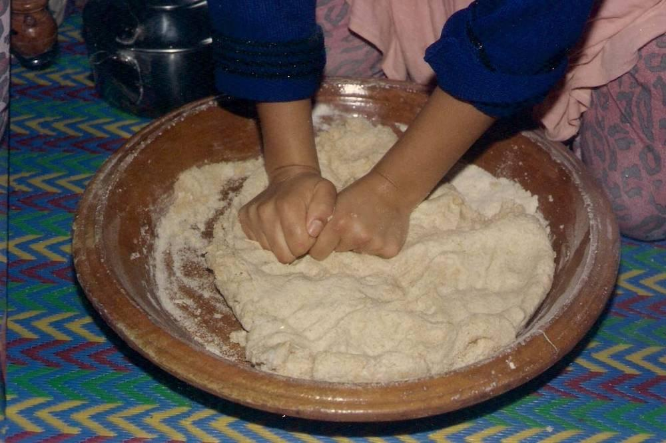
link

Kneading Yeast into Dough

Image Content

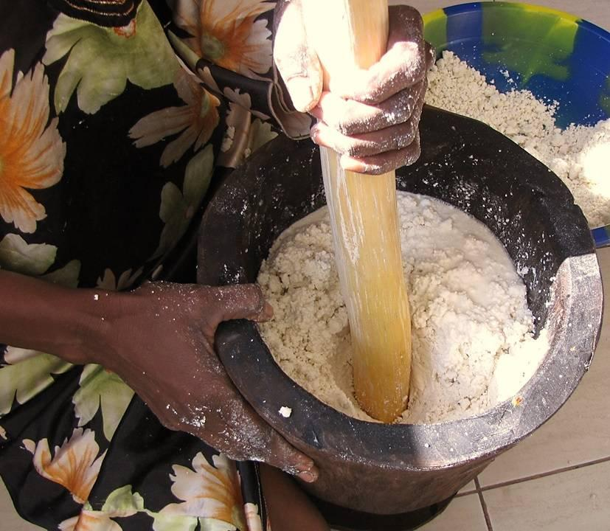
link

Kneading Yeast into Dough

Image Content

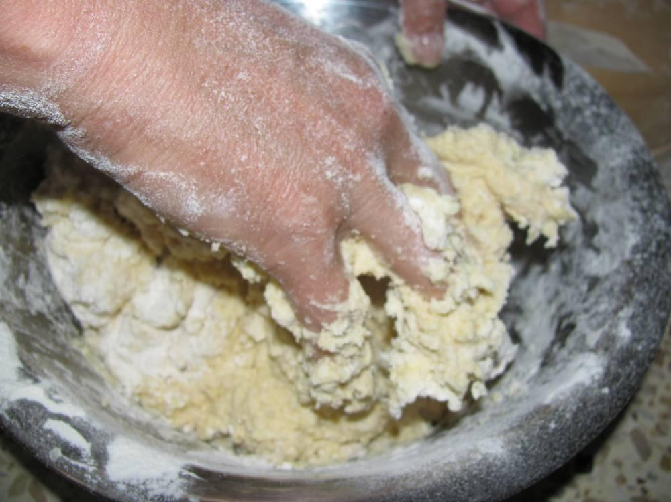
link

Kneading Yeast into Dough

Image Content

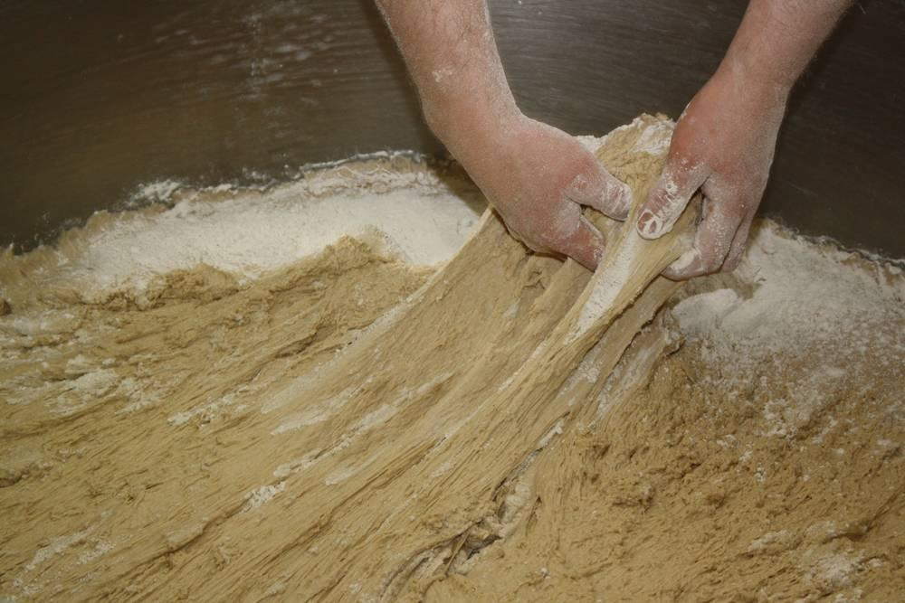
link

