Resource: Maps (FIA)
Familiarization, Internalization, Articulation (FIA) Maps © 2023 SRV Partners Released under CC BY-SA 4.0 license. Familiarization, Internalization, Articulation (FIA) Maps has been adapted in the following languages Tok Pisin, عربي, Français, हिंदी, Bahasa Indonesia, Português, Русский, Español, Kiswahili, 简体中文 from Familiarization, Internalization, Articulation (FIA) © 2023 SRV Partners. Released under CC BY-SA 4.0 license by Mission Mutual

Maps (FIA)

T

Territory of Herod Agrippa

Image Content

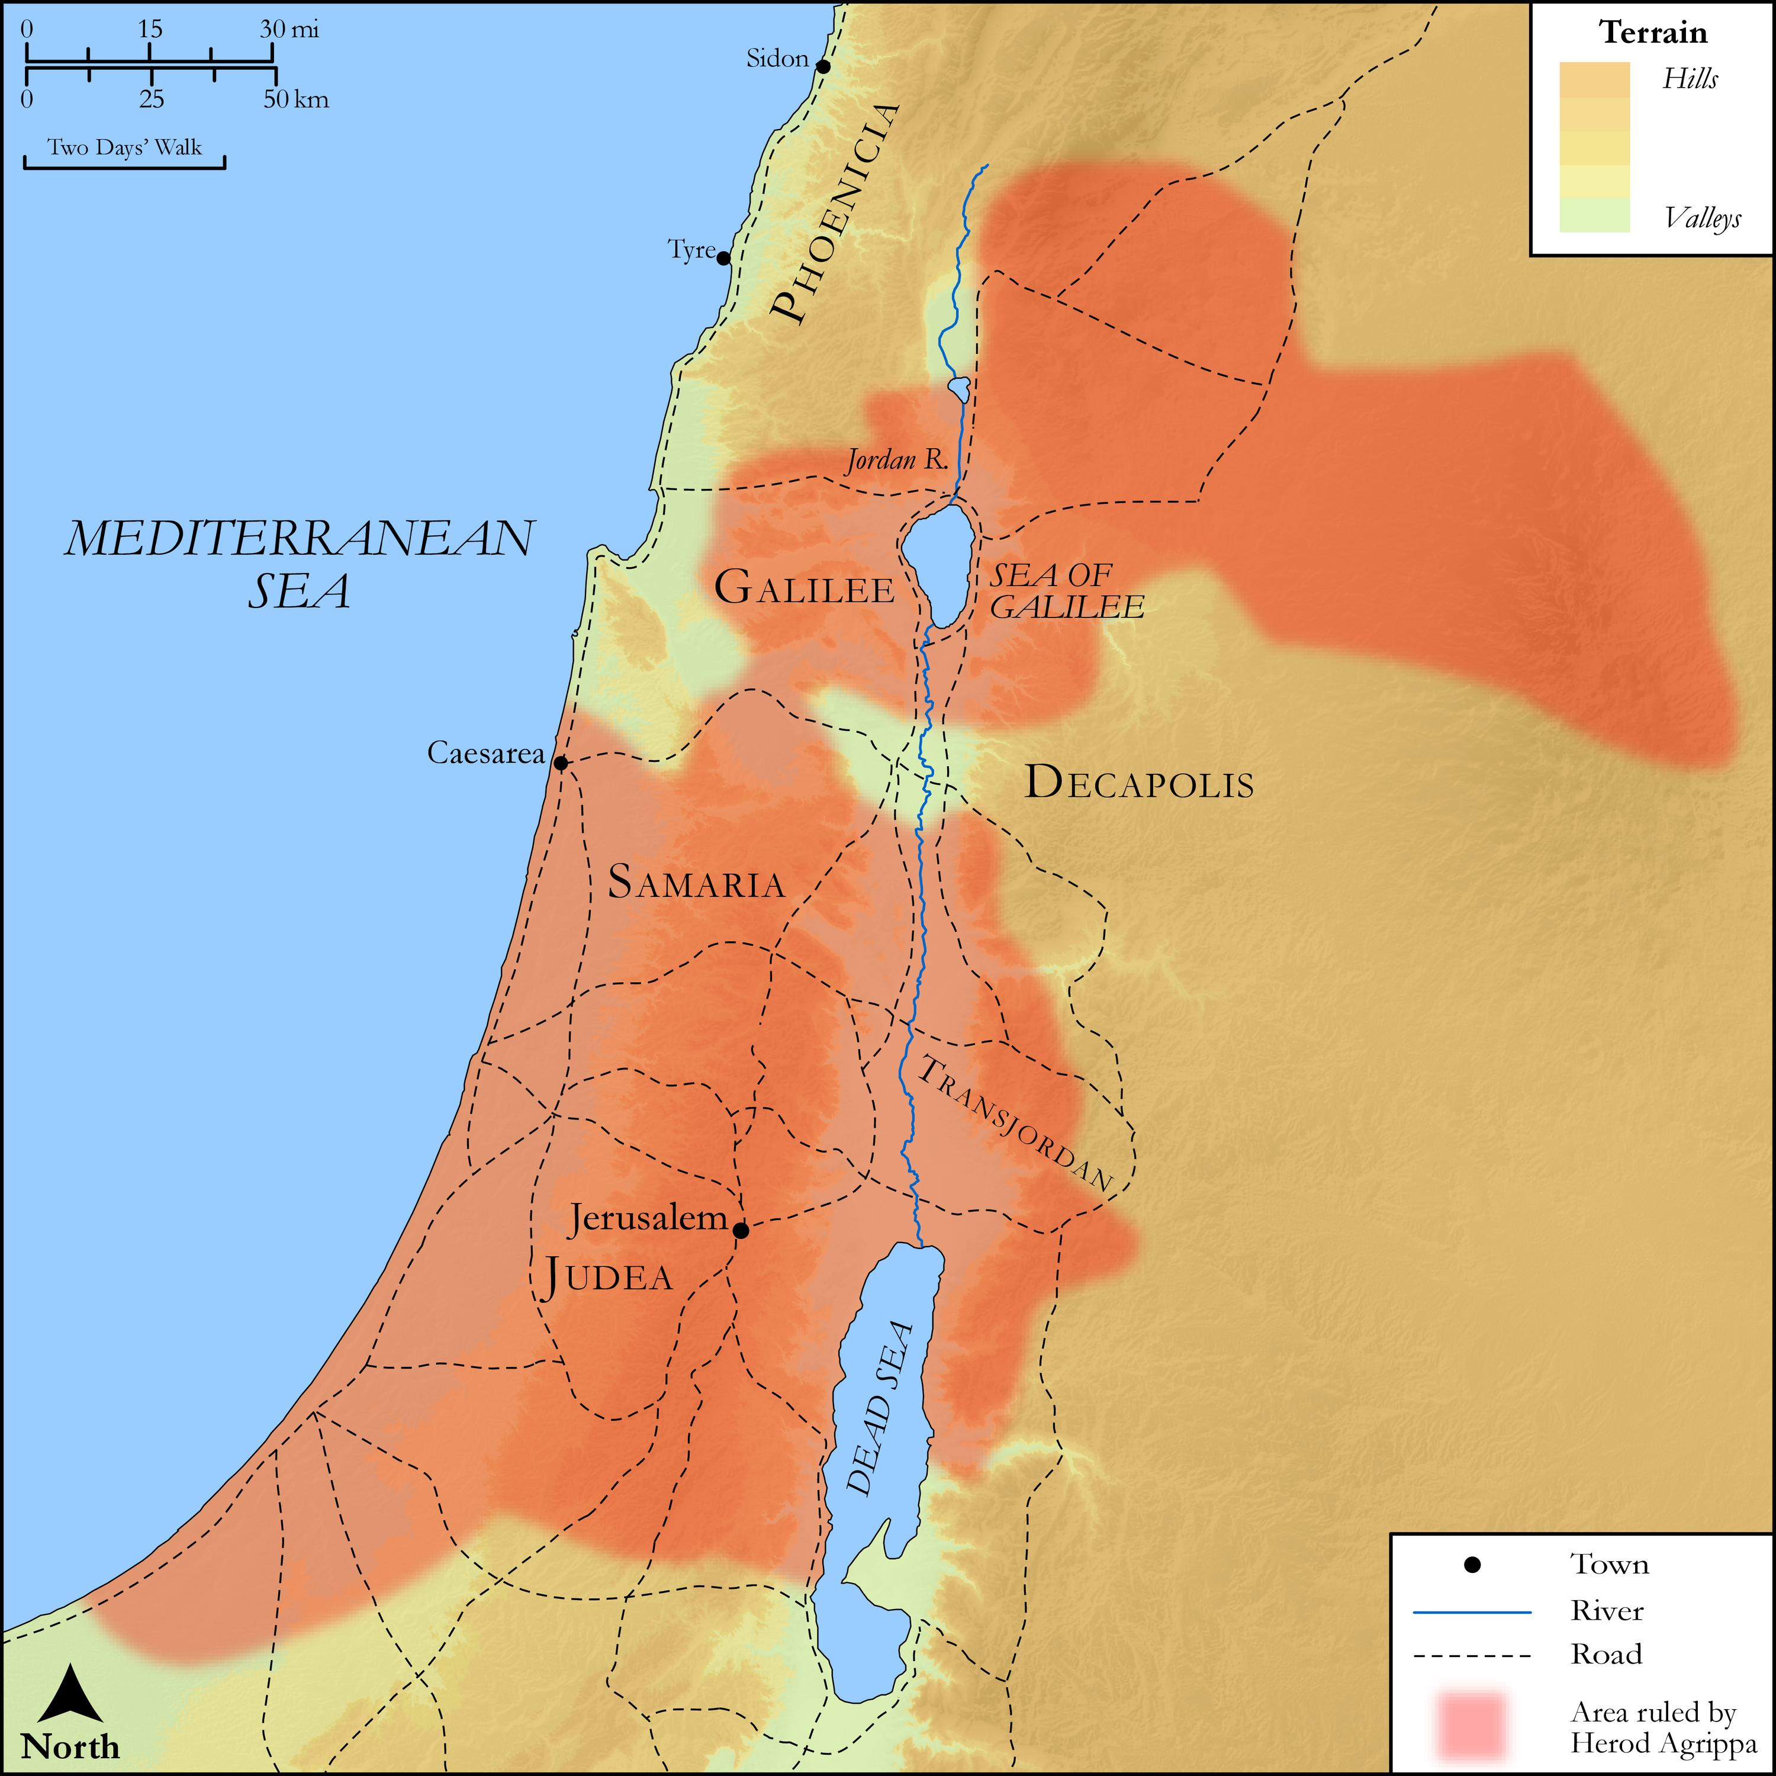
link

Territory of Herod Antipas

Image Content

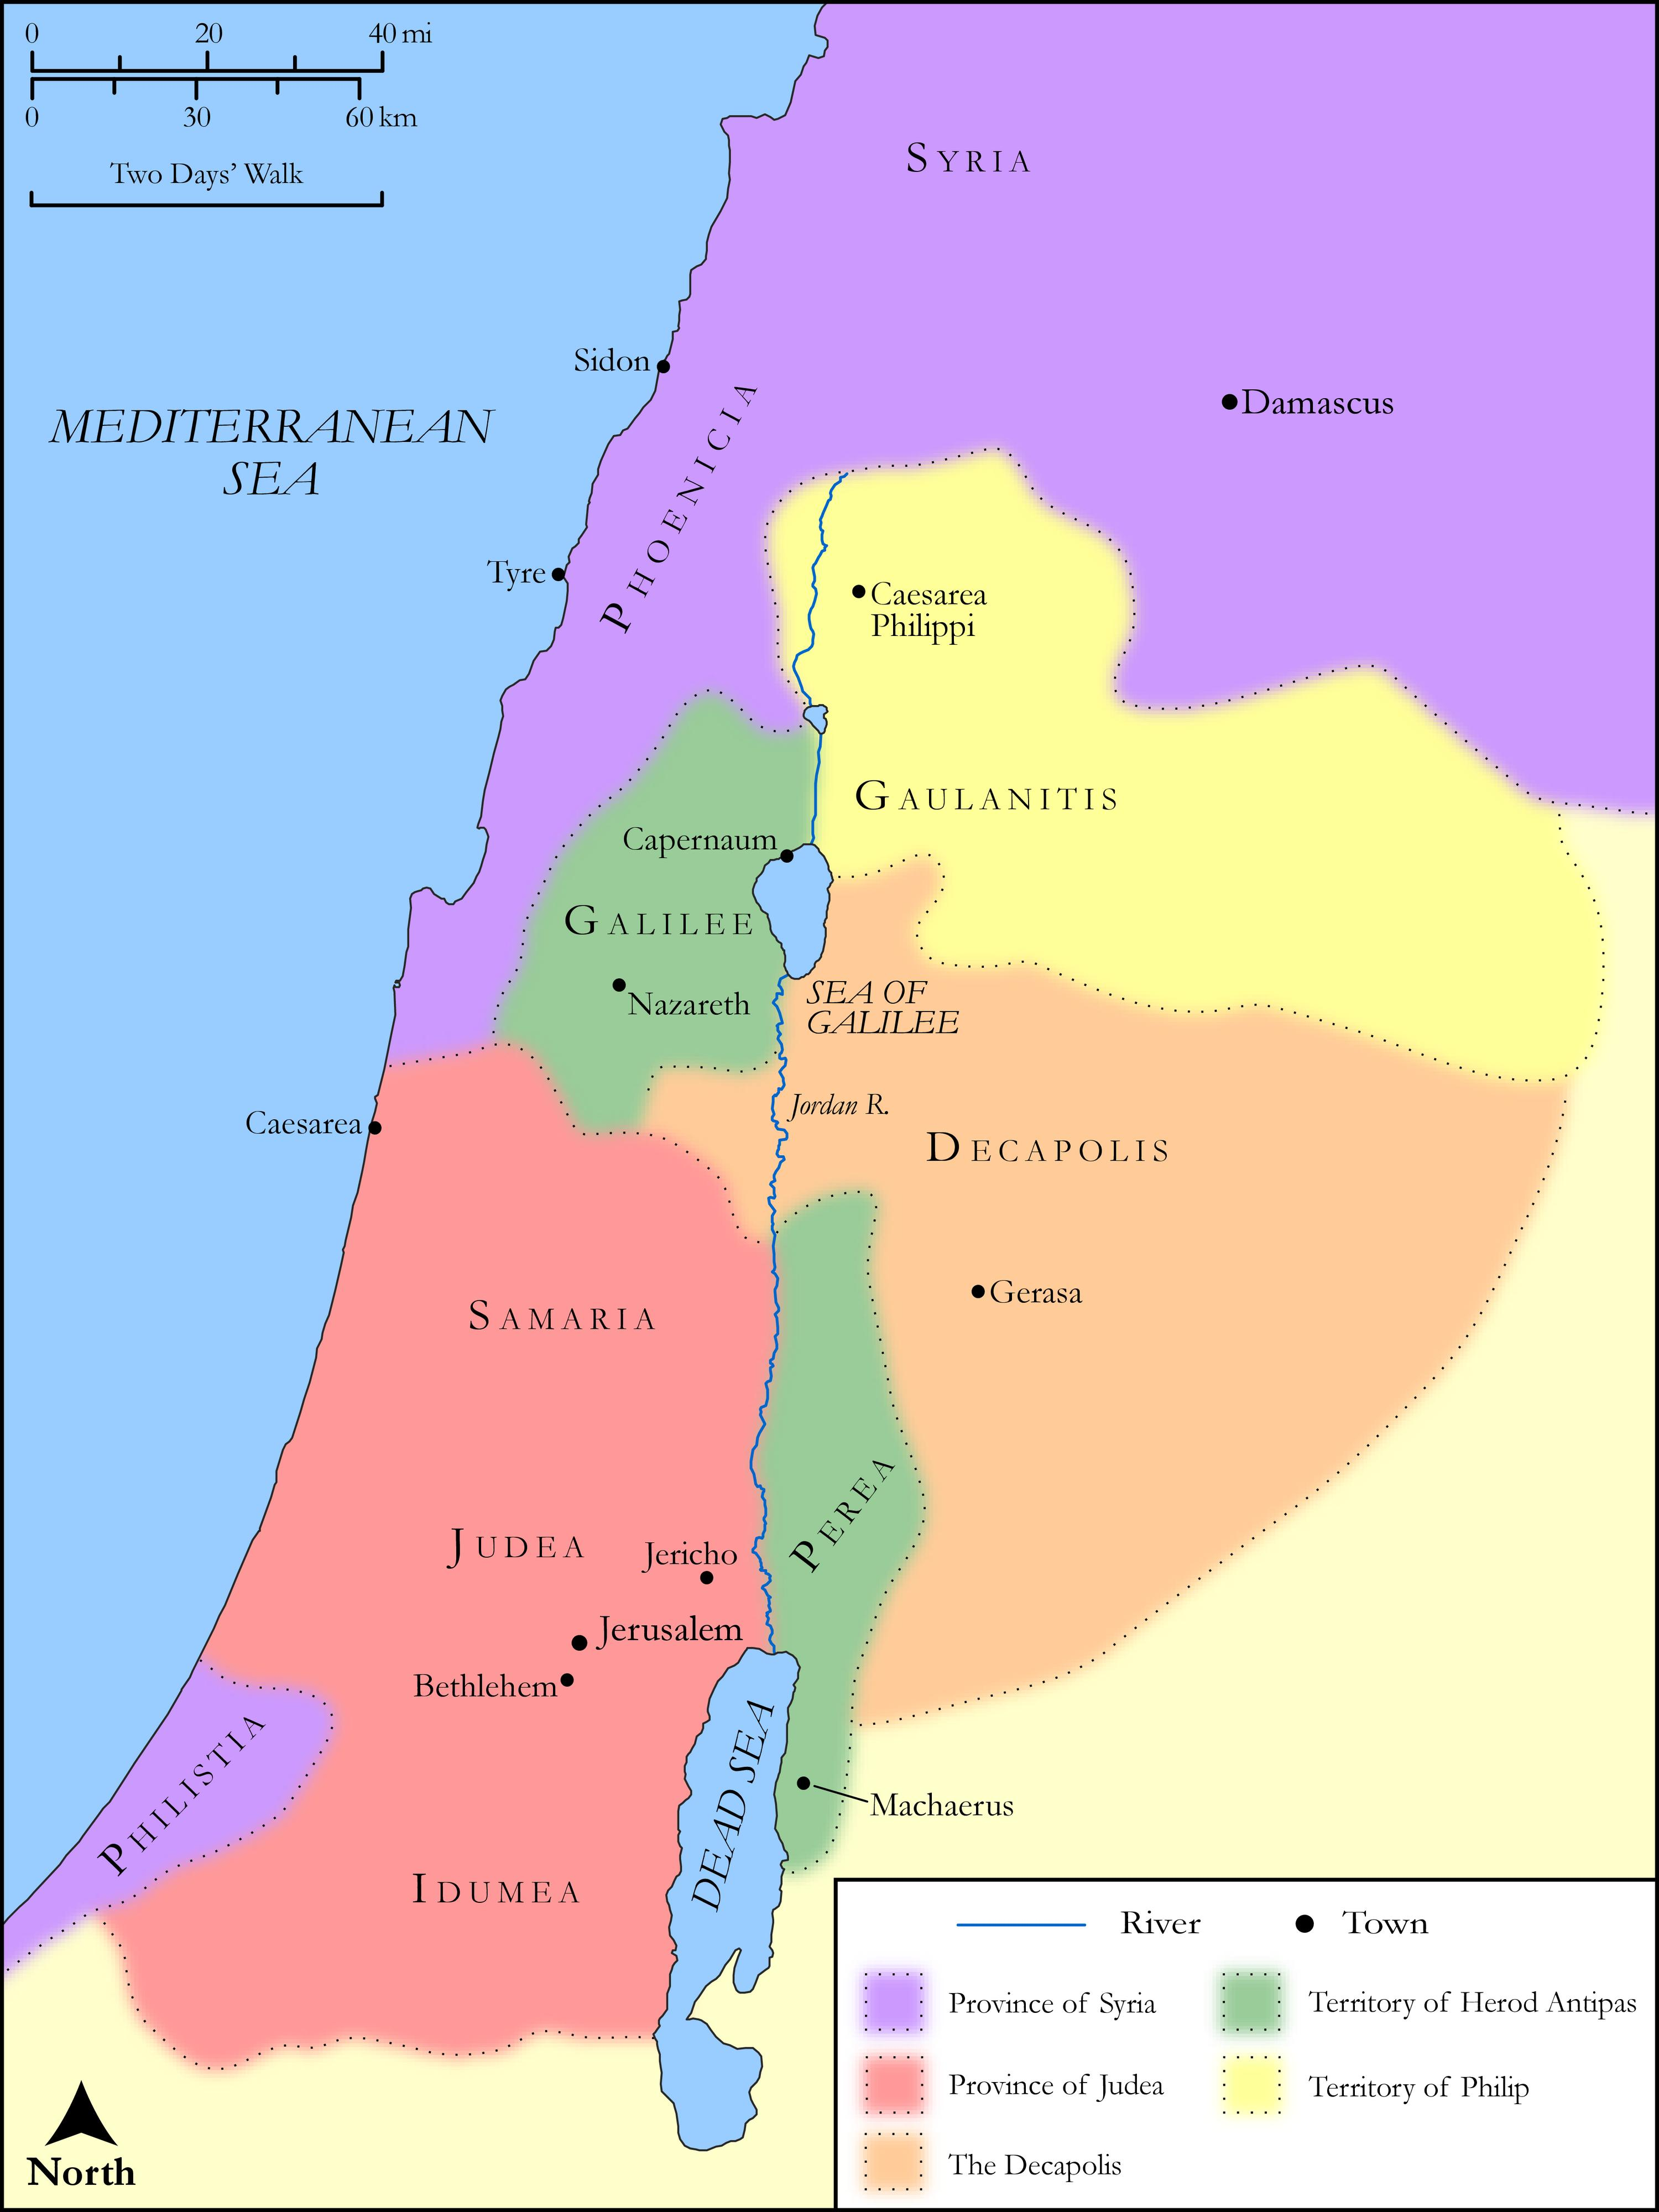
link

Territory of Pilate

Image Content

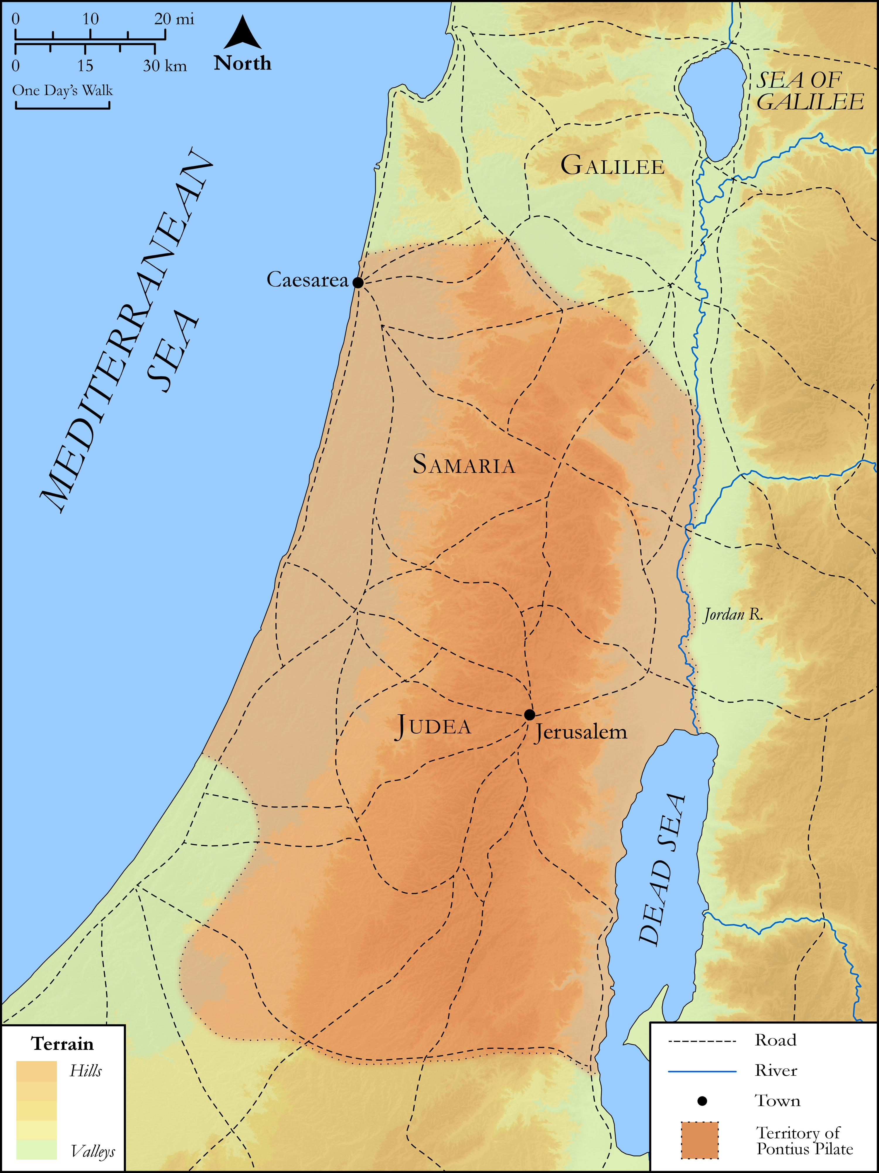
link

Thessalonica to Berea

Image Content

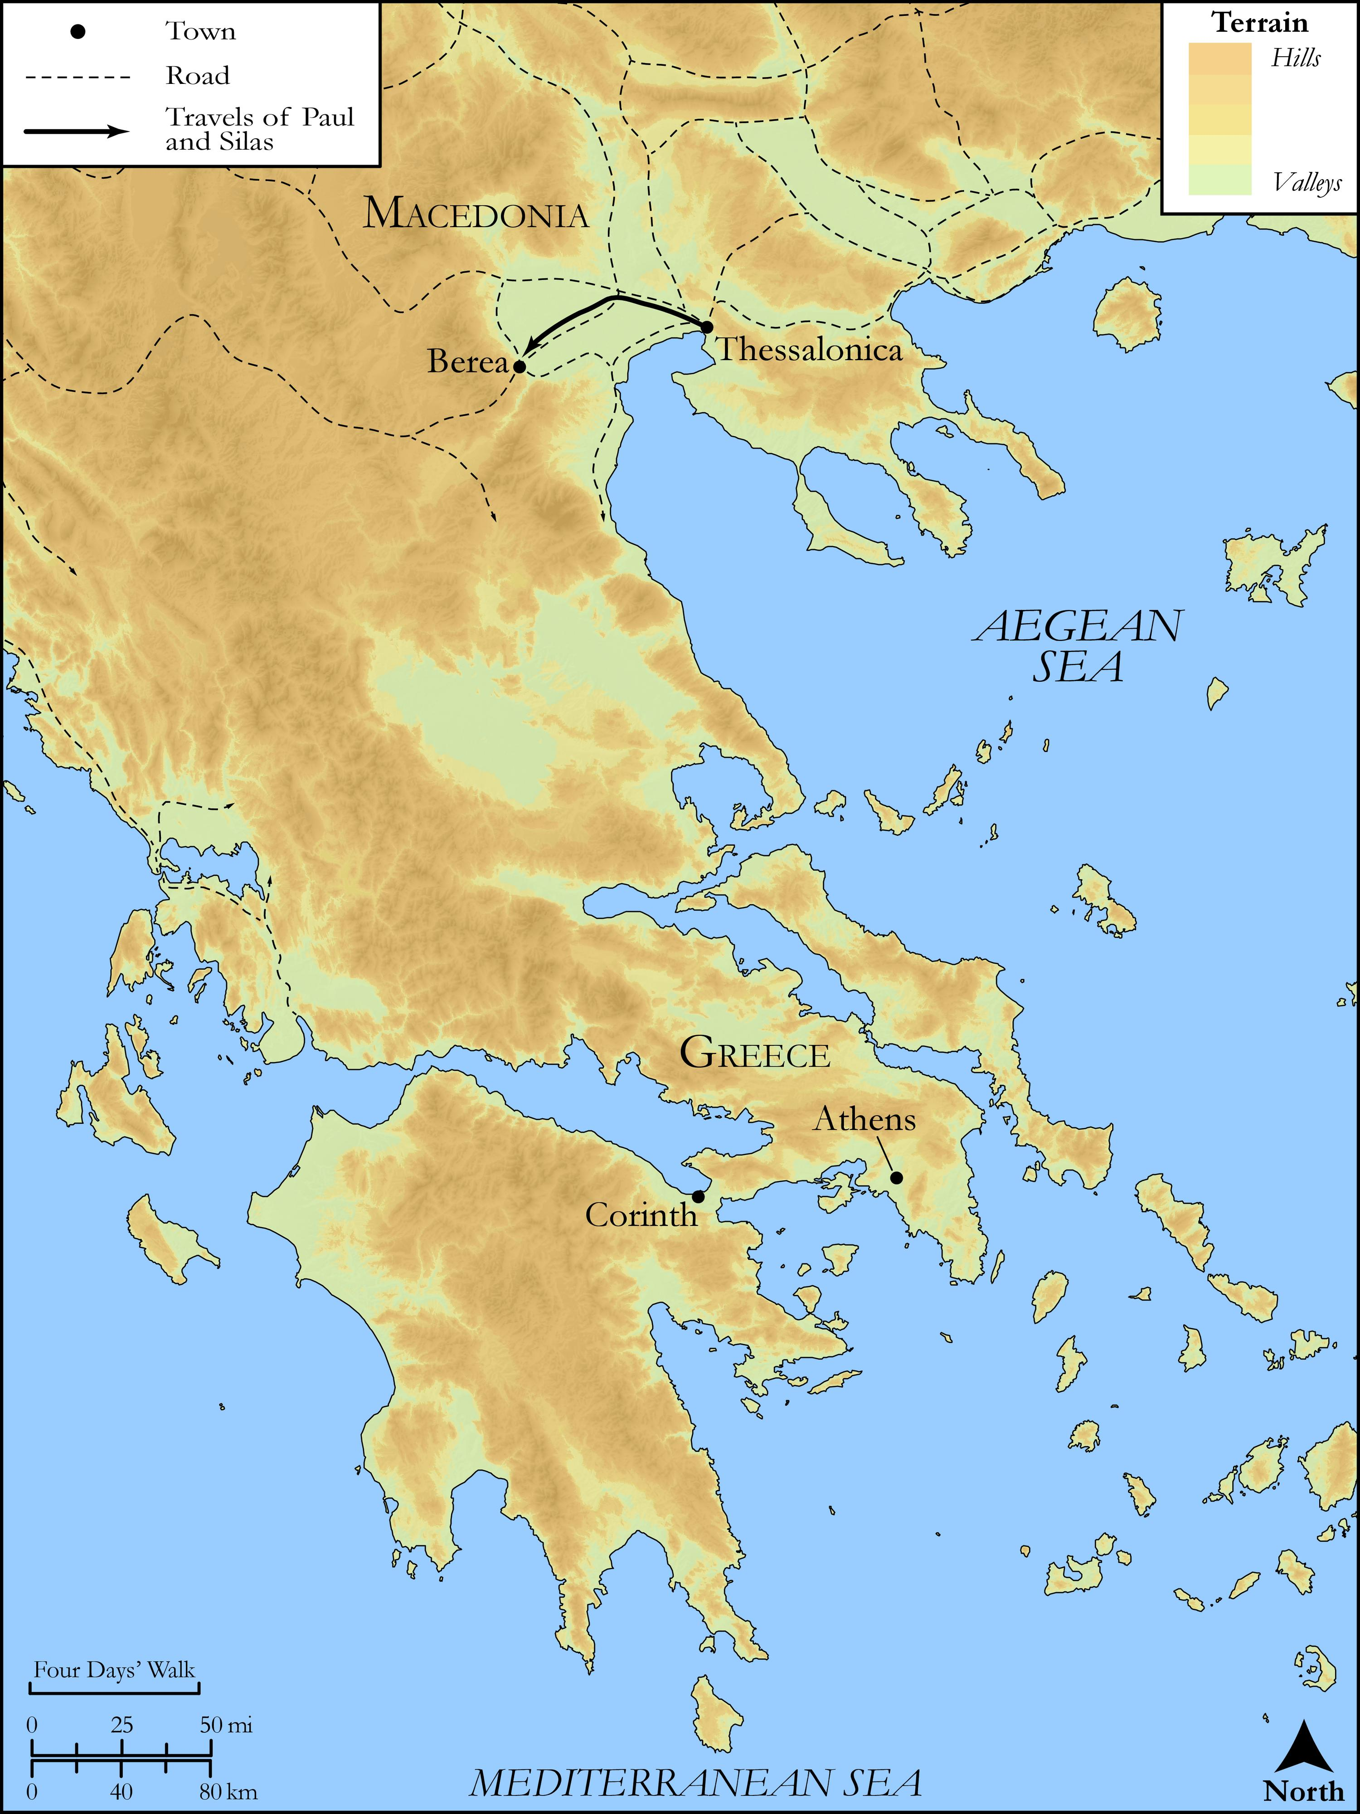
link

Troas to Assos

Image Content

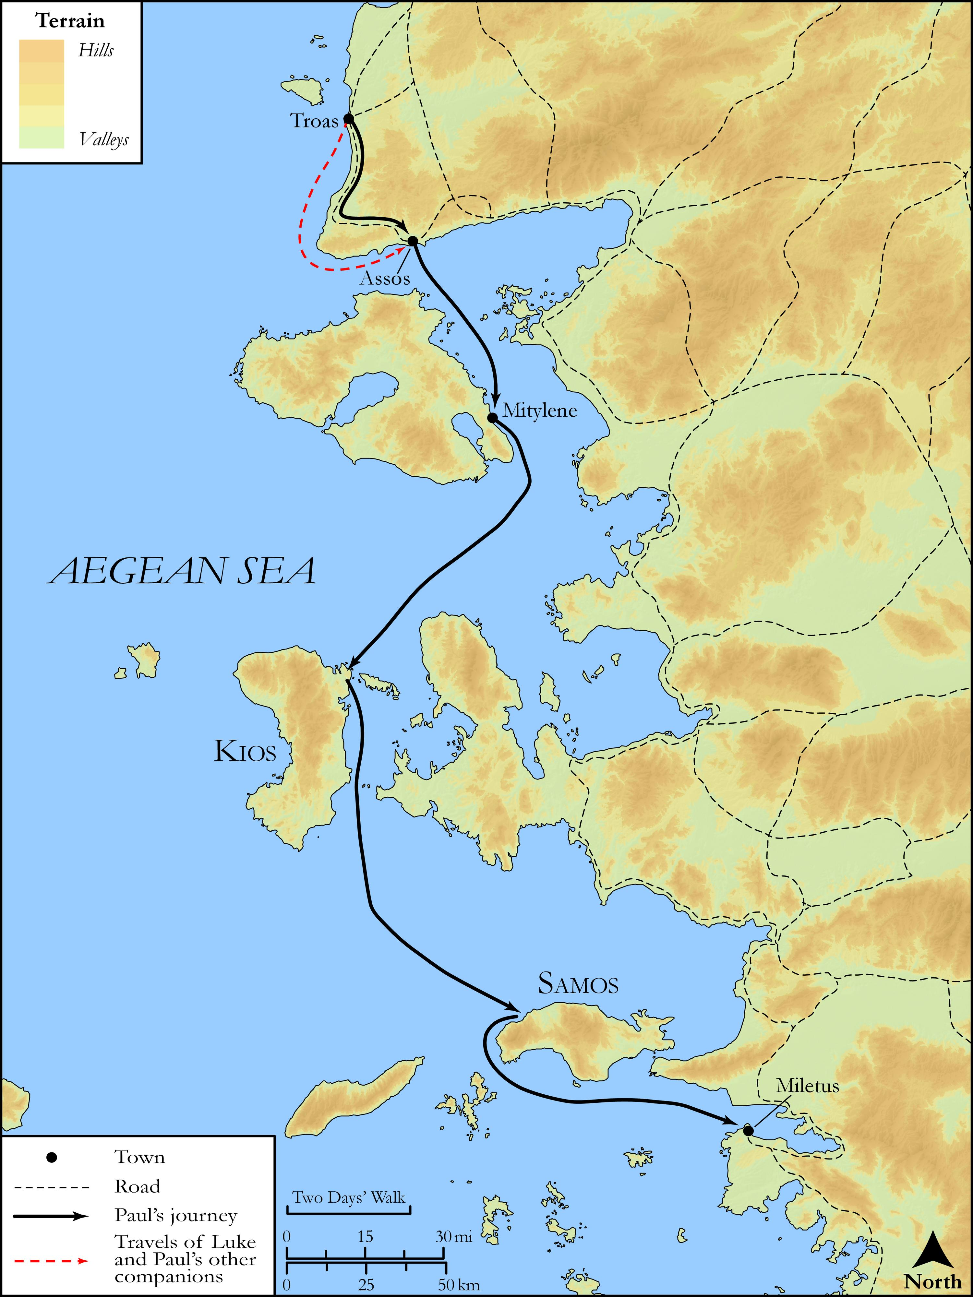
link

Troas to Miletus

Image Content


link

Tyre, Sidon and The Sea of Galilee

Image Content

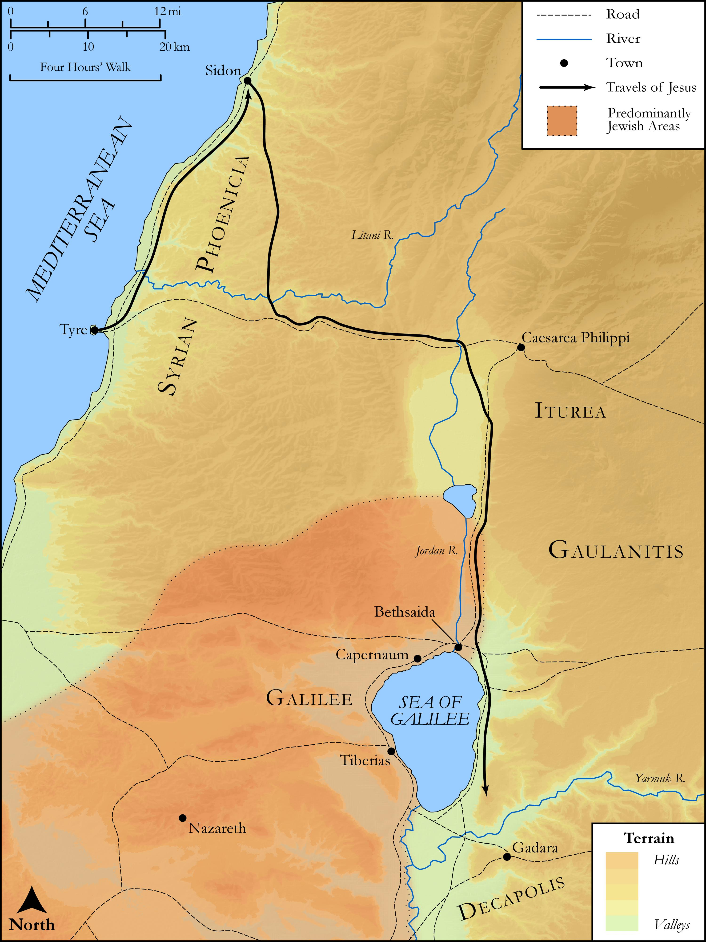
link

Tyre, Sidon and The Sea of Galilee

Image Content

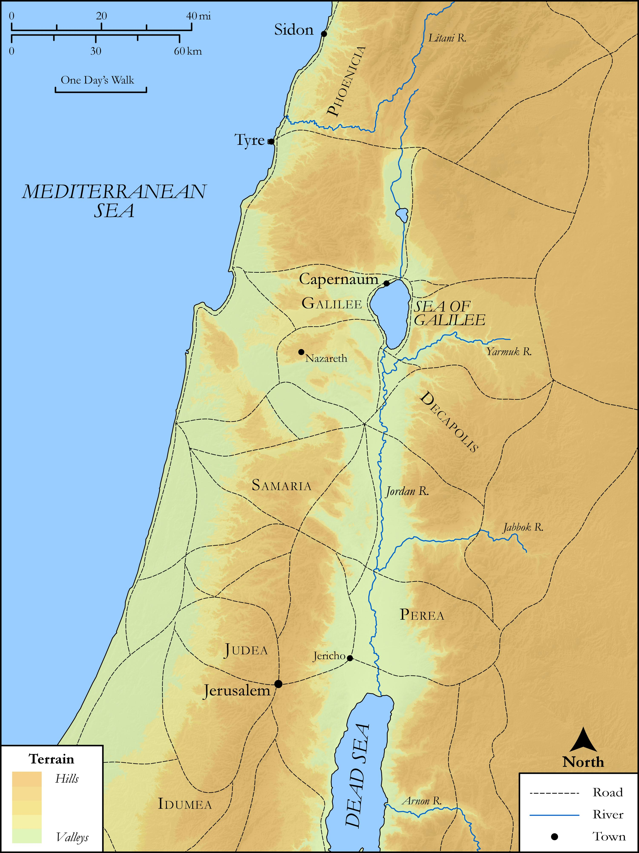
link

