Resource: Maps (FIA)
Familiarization, Internalization, Articulation (FIA) Maps © 2023 SRV Partners Released under CC BY-SA 4.0 license. Familiarization, Internalization, Articulation (FIA) Maps has been adapted in the following languages Tok Pisin, عربي, Français, हिंदी, Bahasa Indonesia, Português, Русский, Español, Kiswahili, 简体中文 from Familiarization, Internalization, Articulation (FIA) © 2023 SRV Partners. Released under CC BY-SA 4.0 license by Mission Mutual

Maps (FIA)

Z

Zoomed in View of Locations in the Book of Genesis

Image Content

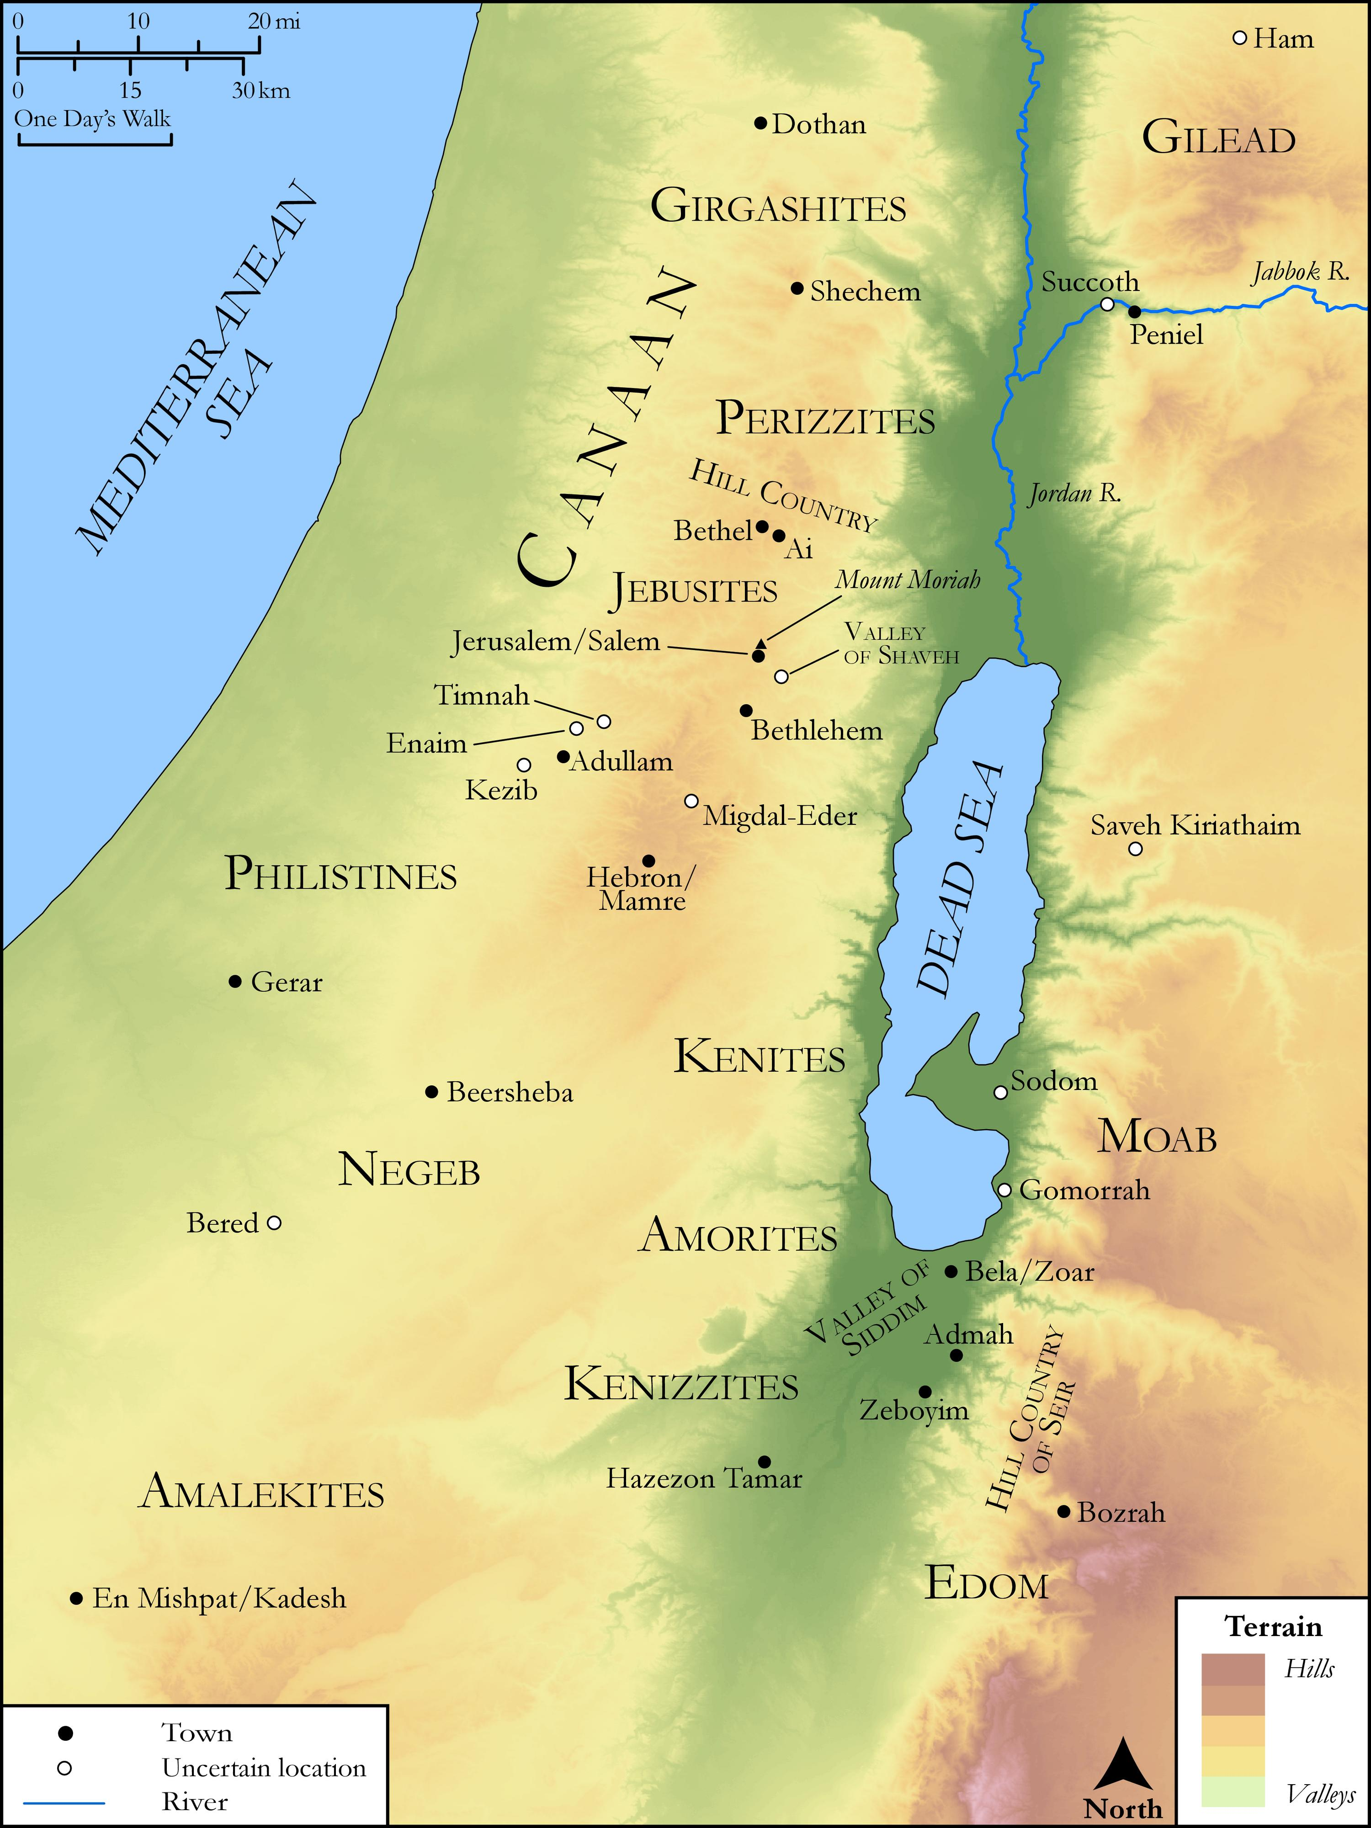
link

Zoomed Out View of the Book of Luke

Image Content

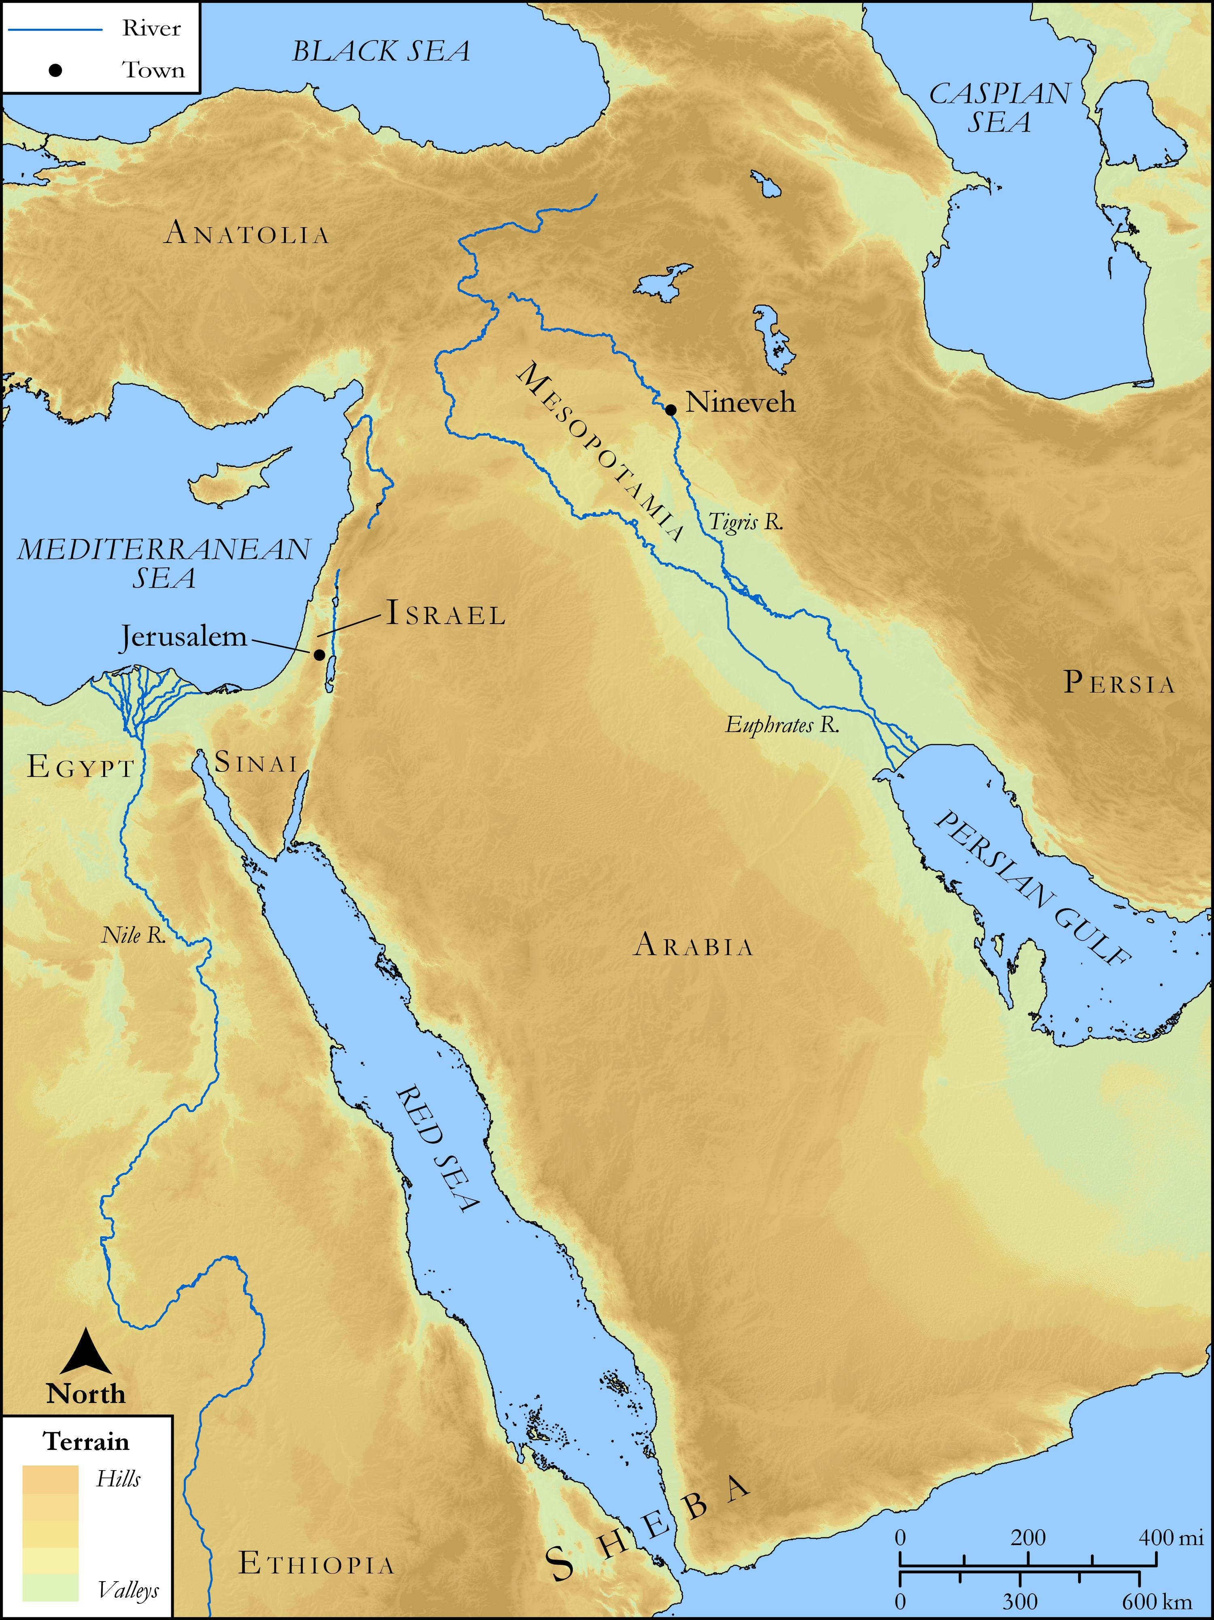
link

Zoomed Out View of the Book of Matthew

Image Content

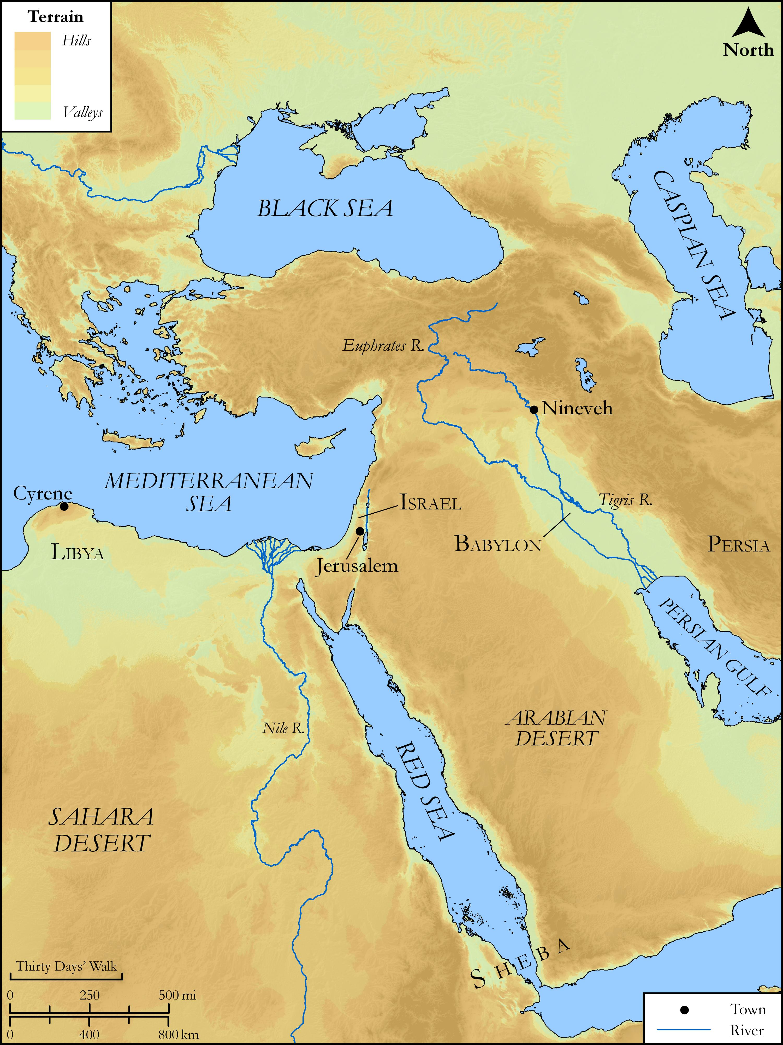
link

Zoomed-Out View of Locations in the Book of Acts

Image Content

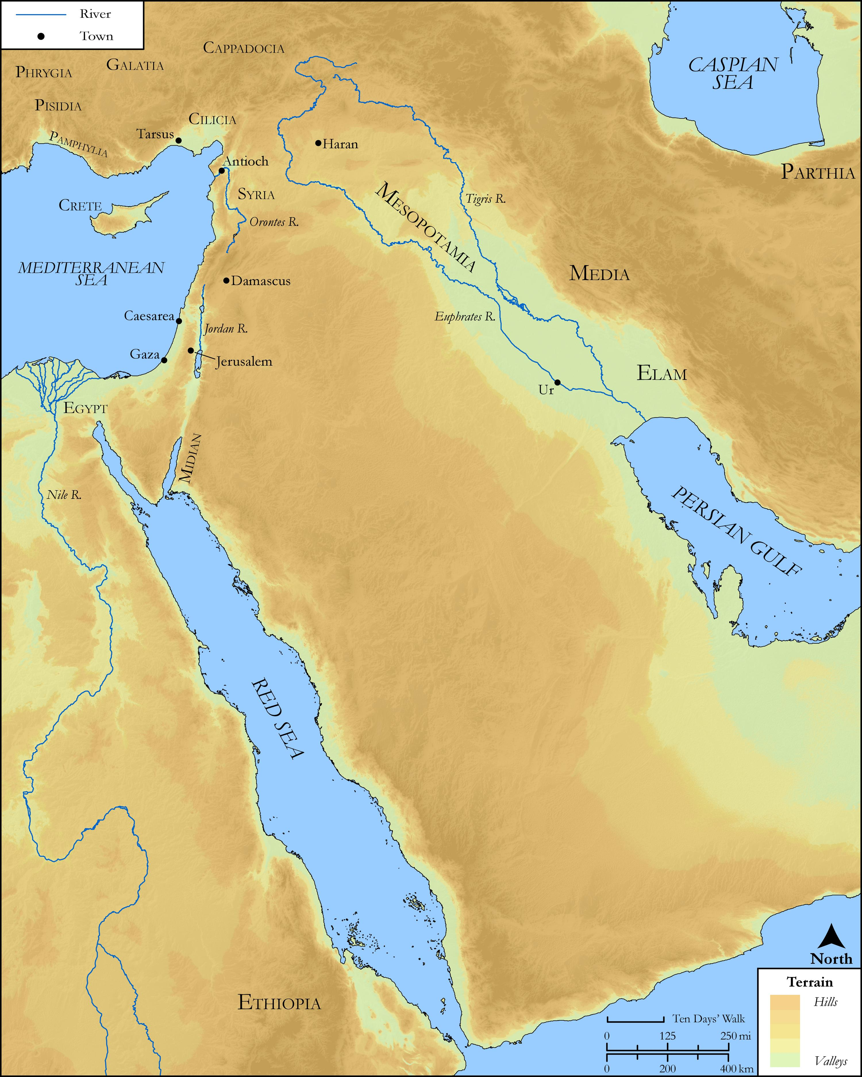
link

