Resource: Maps (SRV)
Familiarization, Internalization, Articulation (FIA) Maps © 2023 SRV Partners Released under CC BY-SA 4.0 license. Familiarization, Internalization, Articulation (FIA) Maps has been adapted in the following languages Tok Pisin, عربي, Français, हिंदी, Bahasa Indonesia, Português, Русский, Español, Kiswahili, 简体中文 from Familiarization, Internalization, Articulation (FIA) © 2023 SRV Partners. Released under CC BY-SA 4.0 license by Mission Mutual

Maps (SRV)

B
Beer Lahai Roi, Beersheba and Moriah, Beersheba, Paran and Egypt, Bethlehem to Jerusalem

Beer Lahai Roi

Image Content

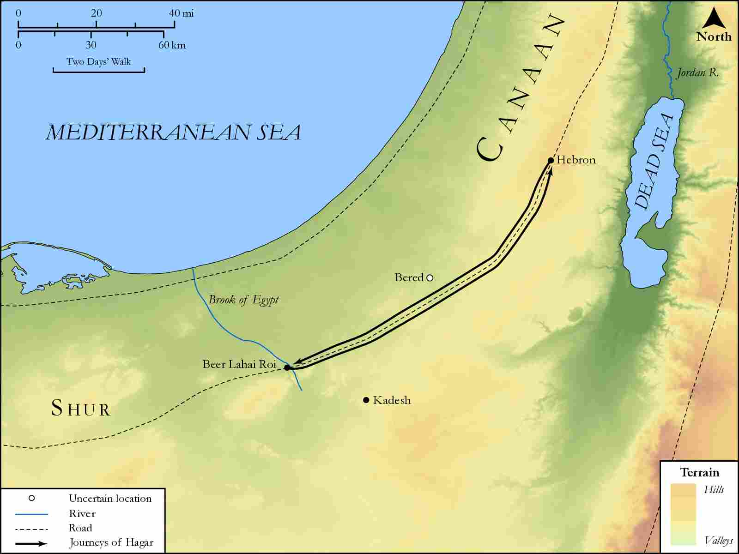
link

Beersheba and Moriah

Image Content

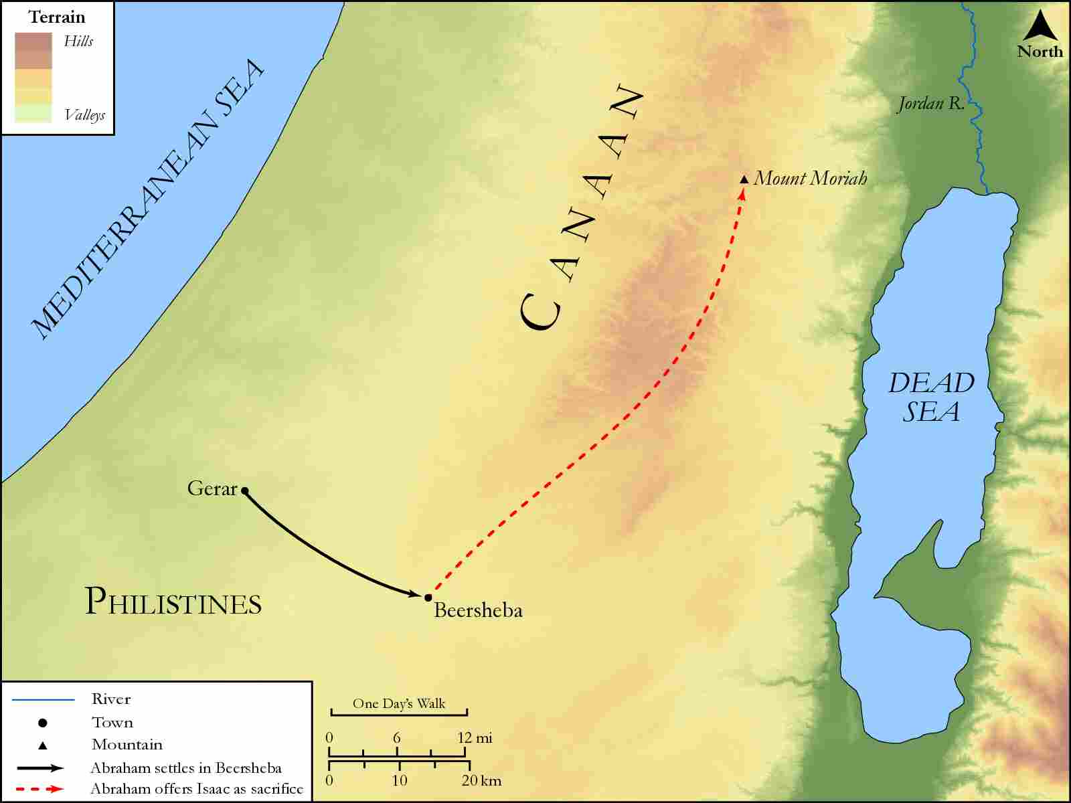
link

Beersheba, Paran and Egypt

Image Content

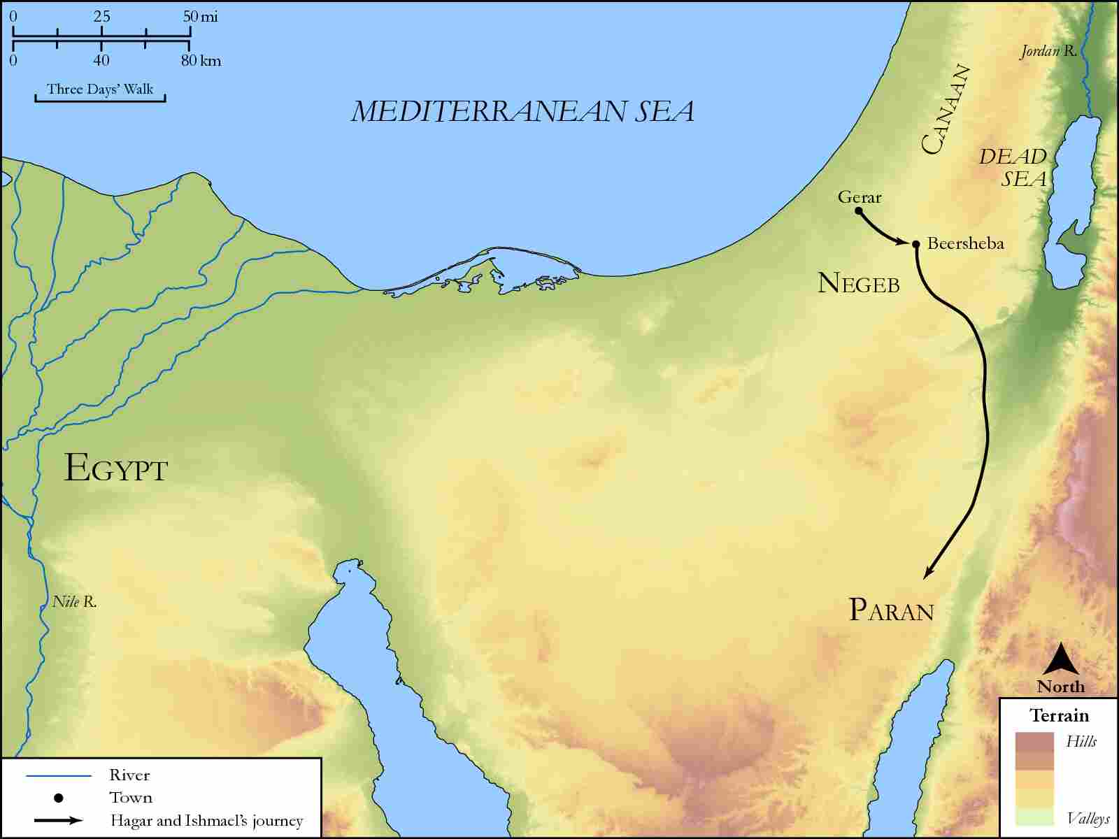
link

Bethlehem to Jerusalem

Image Content

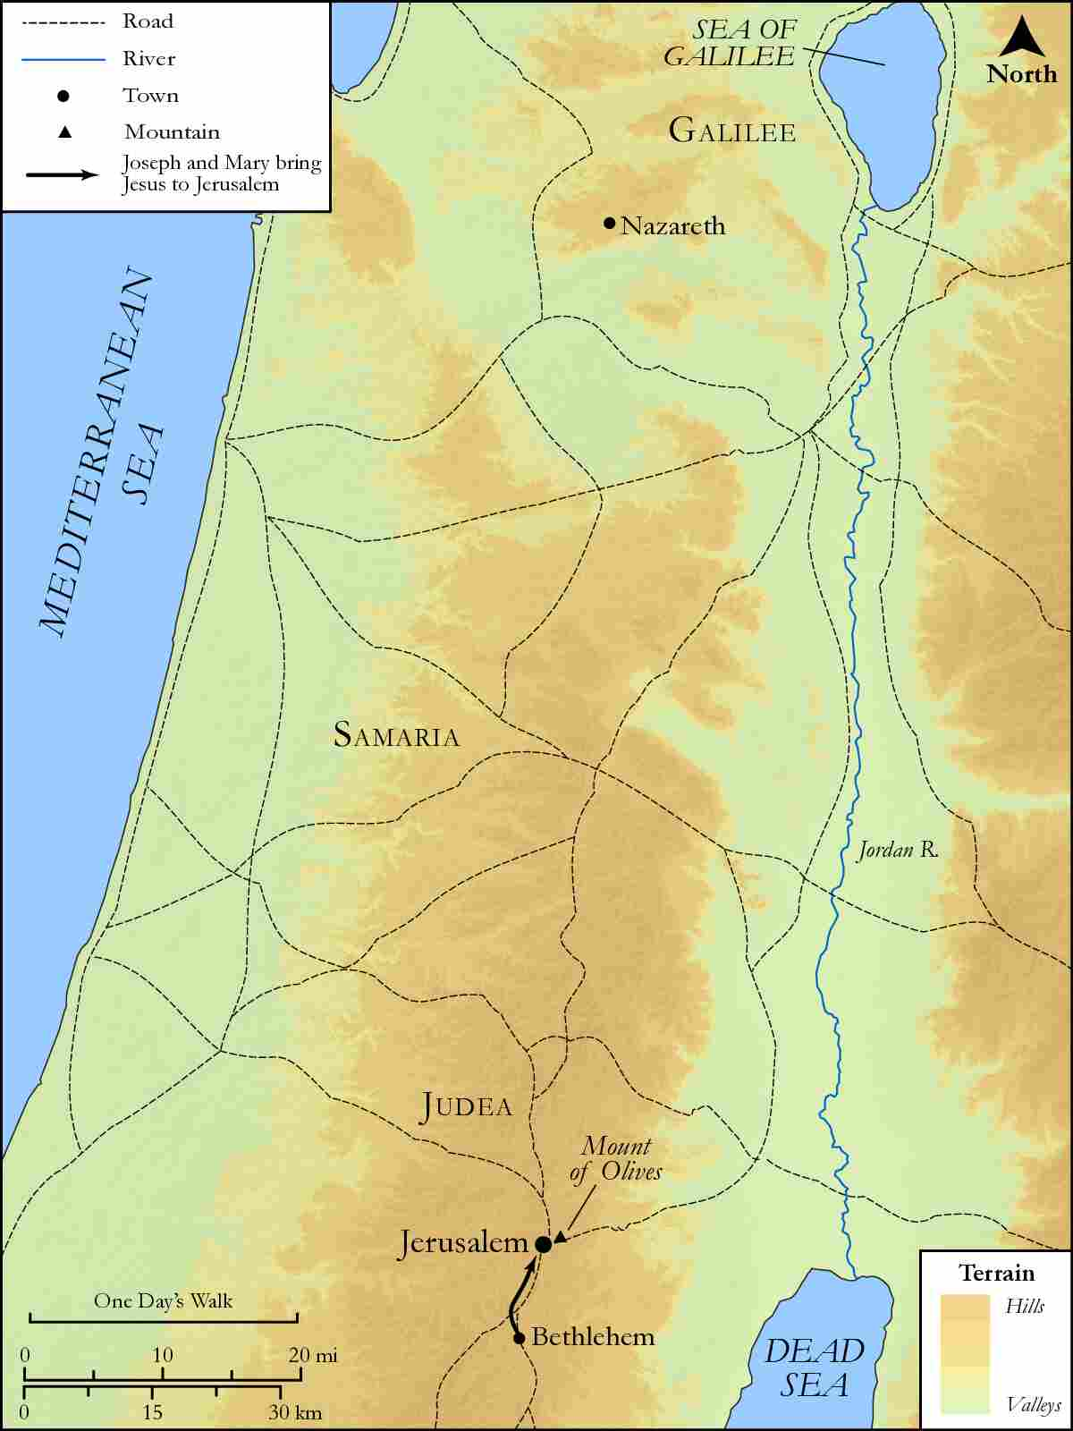
link

