Resource: Maps (SRV)
Familiarization, Internalization, Articulation (FIA) Maps © 2023 SRV Partners Released under CC BY-SA 4.0 license. Familiarization, Internalization, Articulation (FIA) Maps has been adapted in the following languages Tok Pisin, عربي, Français, हिंदी, Bahasa Indonesia, Português, Русский, Español, Kiswahili, 简体中文 from Familiarization, Internalization, Articulation (FIA) © 2023 SRV Partners. Released under CC BY-SA 4.0 license by Mission Mutual

Maps (SRV)

C
Canaan to Egypt, Capernaum on Route from Egypt to Damascus, Capernaum to Decapolis, Capernaum with Judea and Jordan River

Canaan to Egypt

Image Content

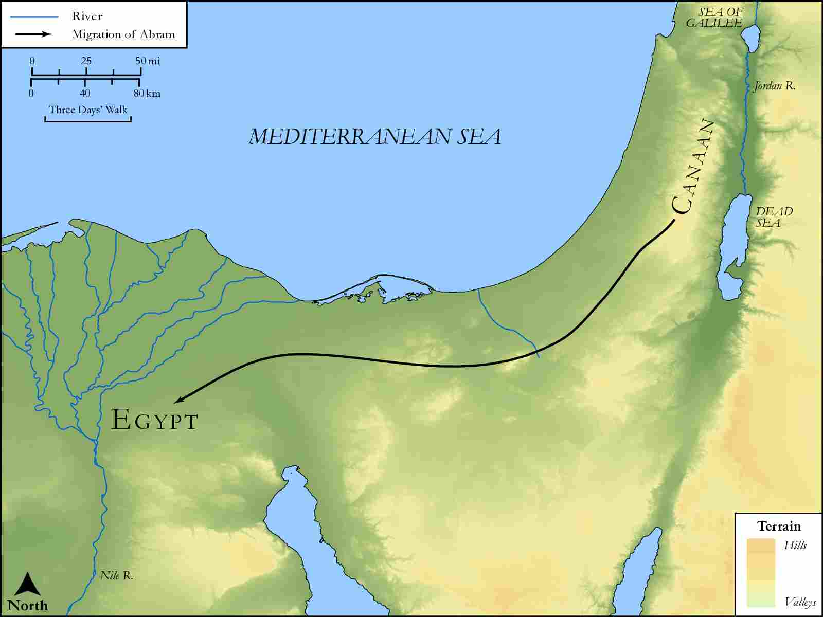
link

Capernaum on Route from Egypt to Damascus

Image Content

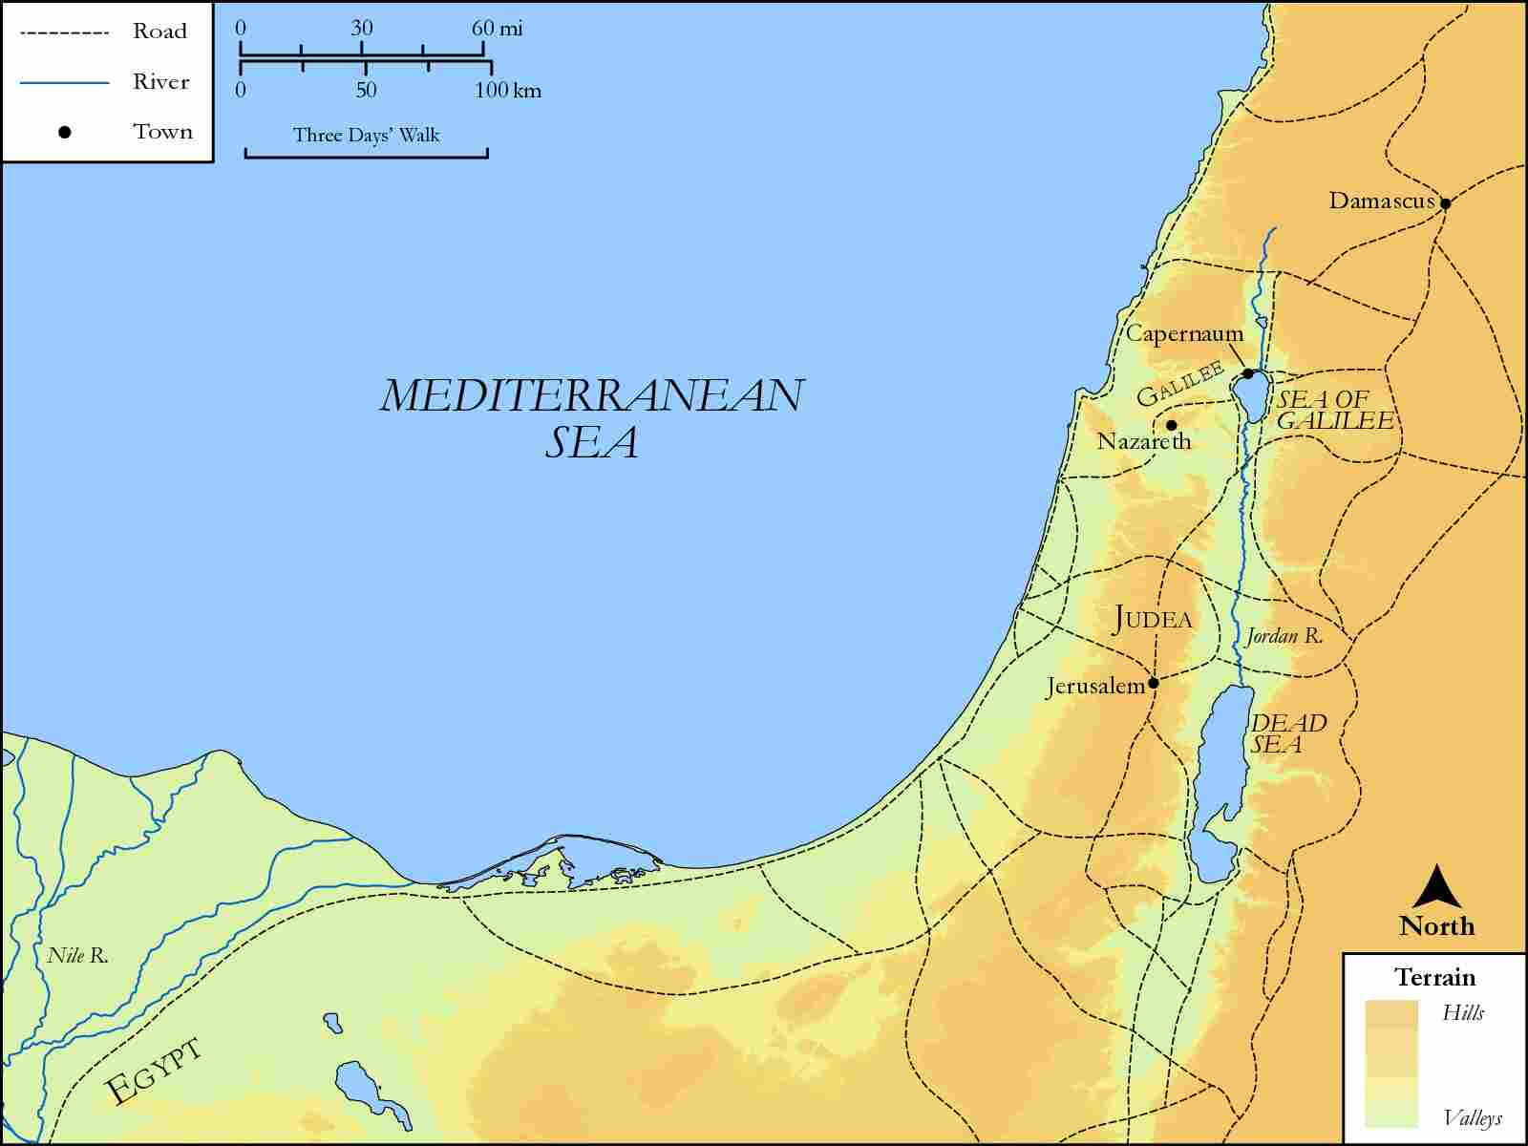
link

Capernaum to Decapolis

Image Content

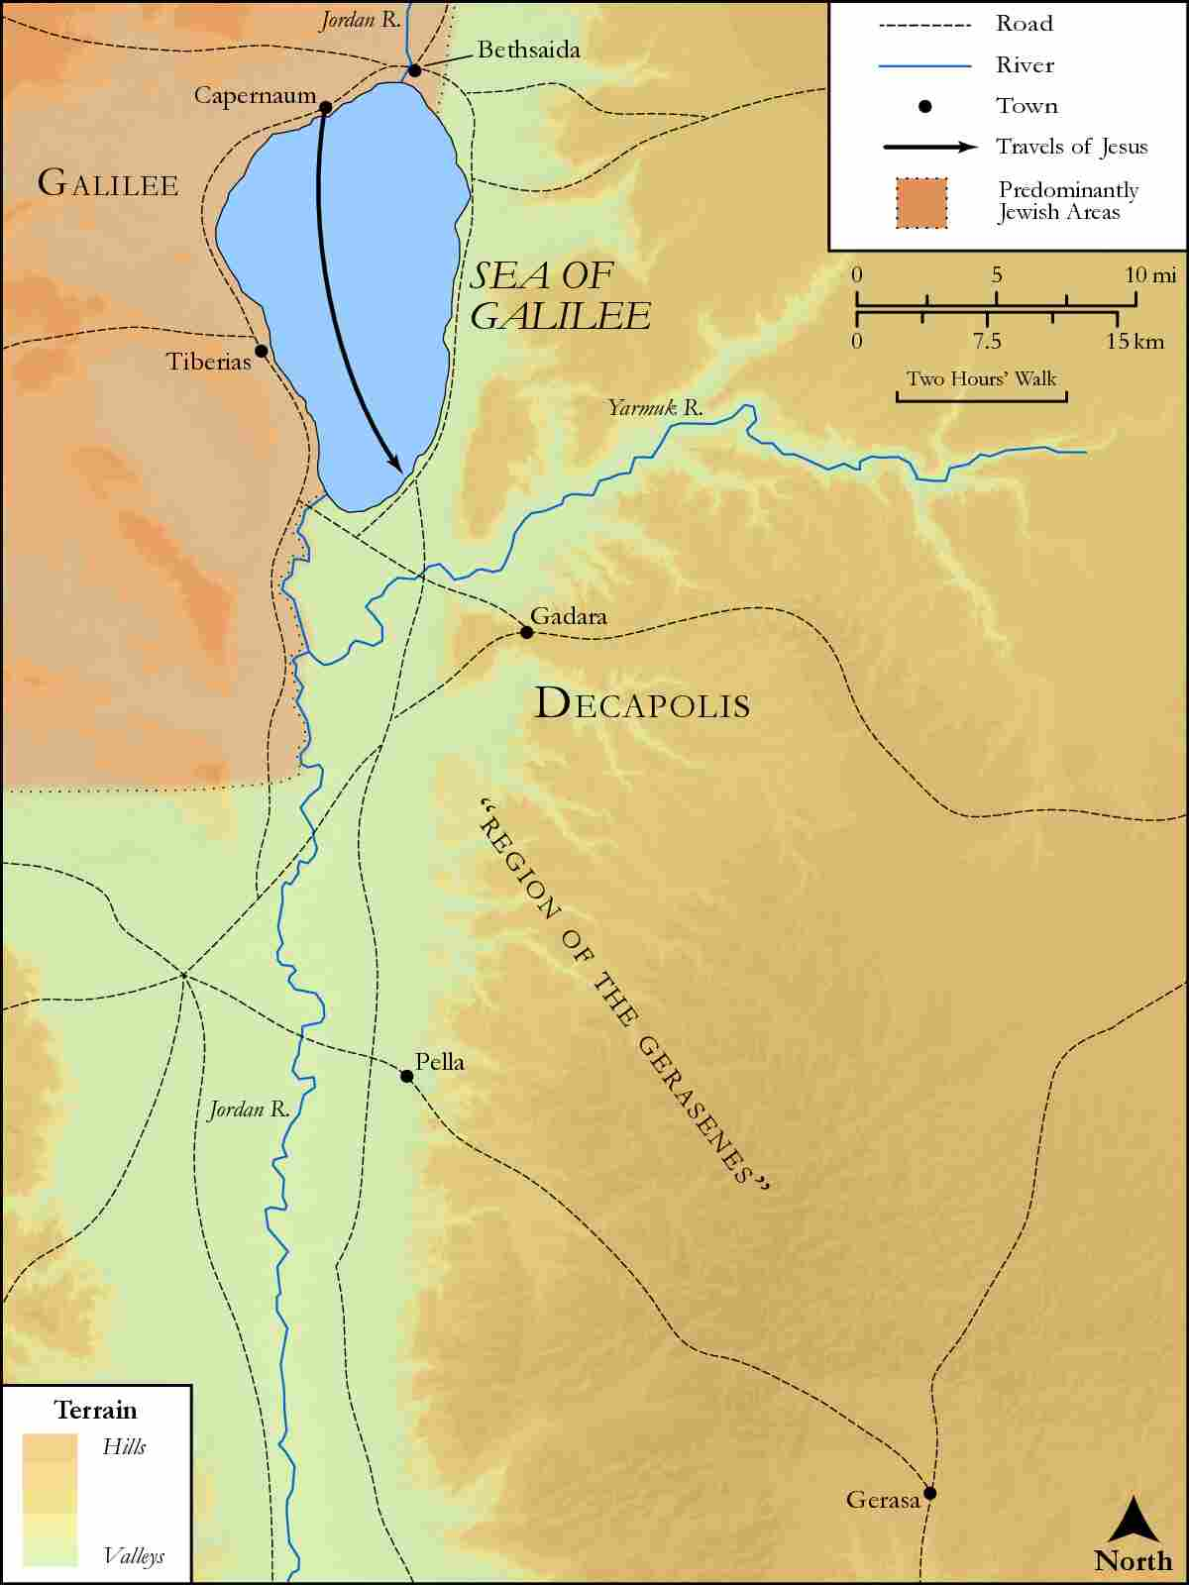
link

Capernaum with Judea and Jordan River

Image Content

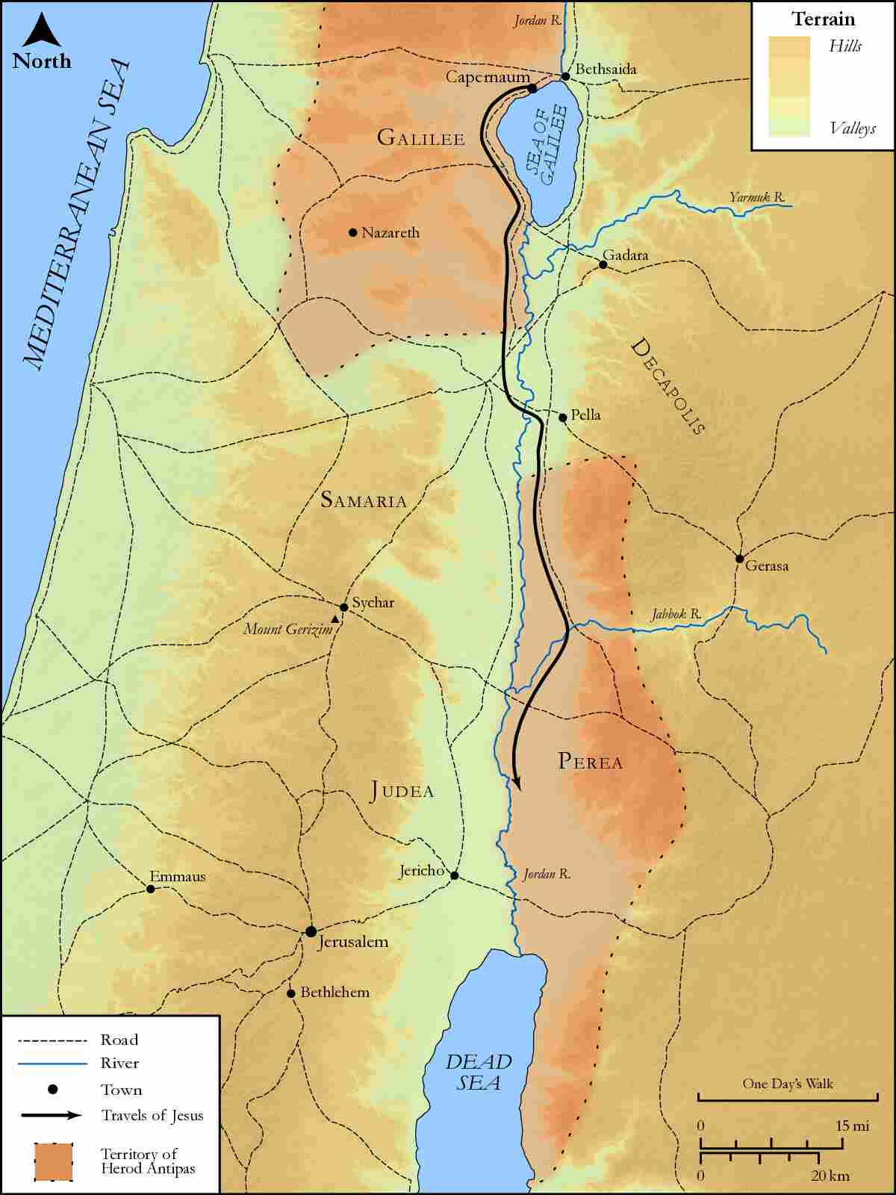
link

