Resource: Maps (SRV)
Familiarization, Internalization, Articulation (FIA) Maps © 2023 SRV Partners Released under CC BY-SA 4.0 license. Familiarization, Internalization, Articulation (FIA) Maps has been adapted in the following languages Tok Pisin, عربي, Français, हिंदी, Bahasa Indonesia, Português, Русский, Español, Kiswahili, 简体中文 from Familiarization, Internalization, Articulation (FIA) © 2023 SRV Partners. Released under CC BY-SA 4.0 license by Mission Mutual

Maps (SRV)

E
Edom and Seir, Edom, Seir, Median, Moab and Bozrah, Egypt, Emmaus

Edom and Seir

Image Content

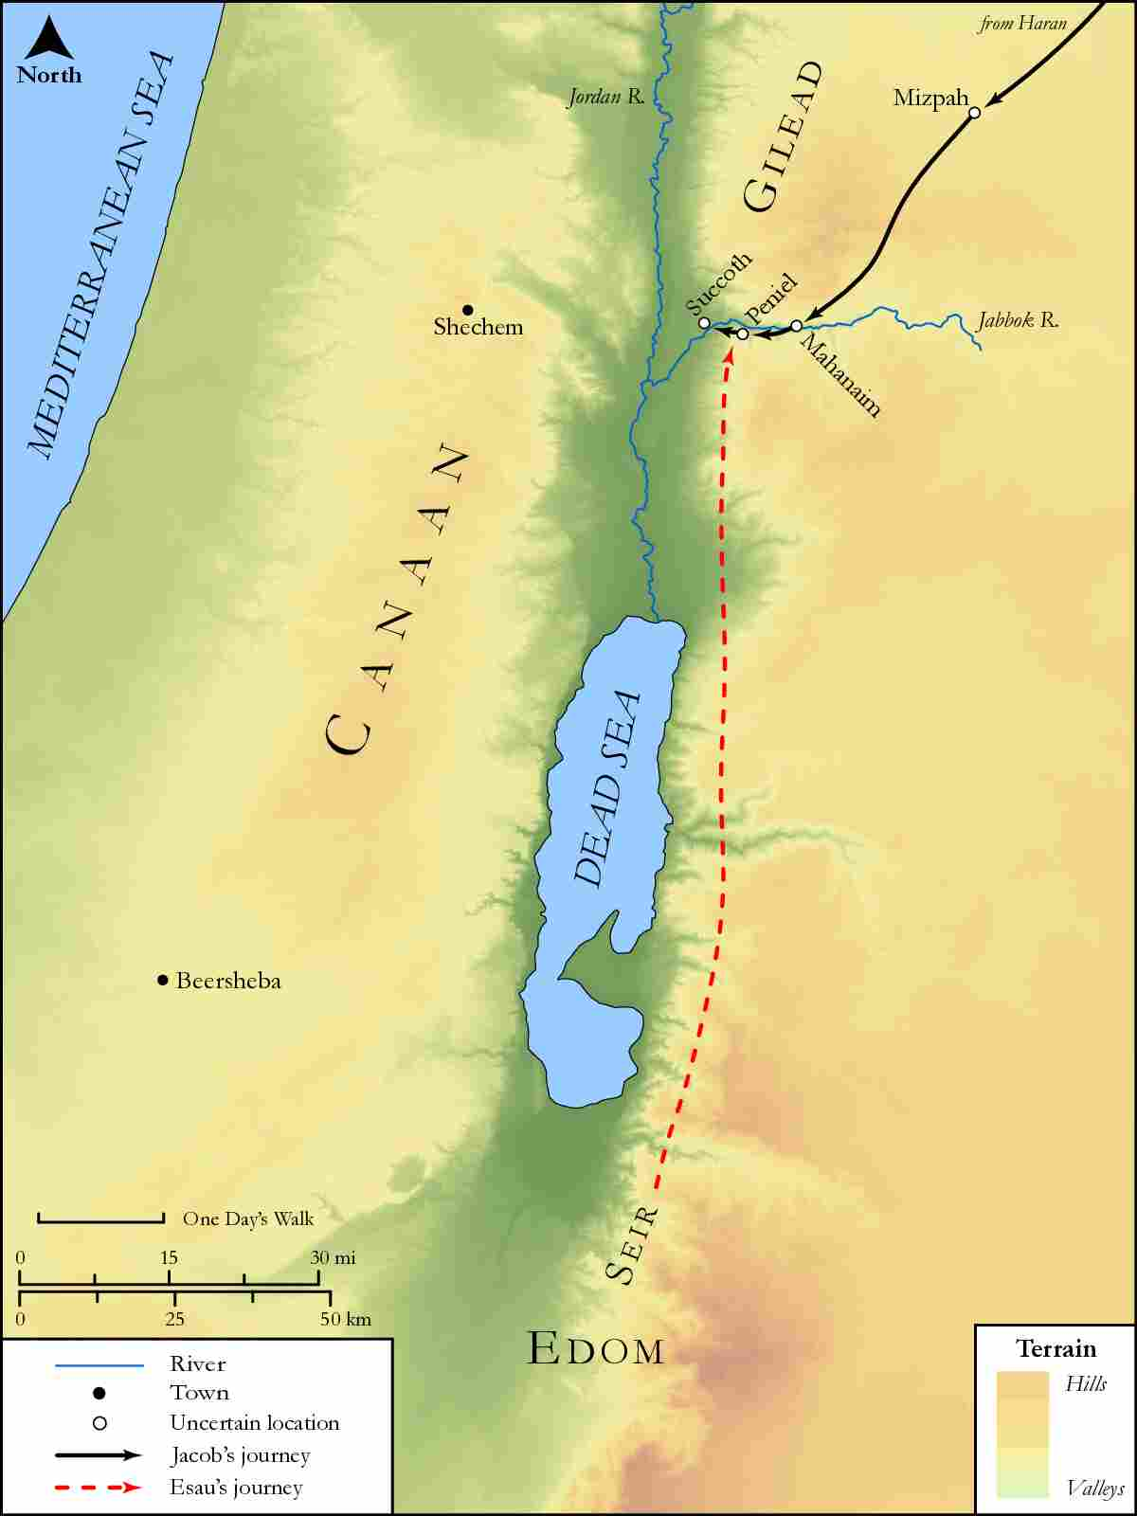
link

Edom, Seir, Median, Moab and Bozrah

Image Content

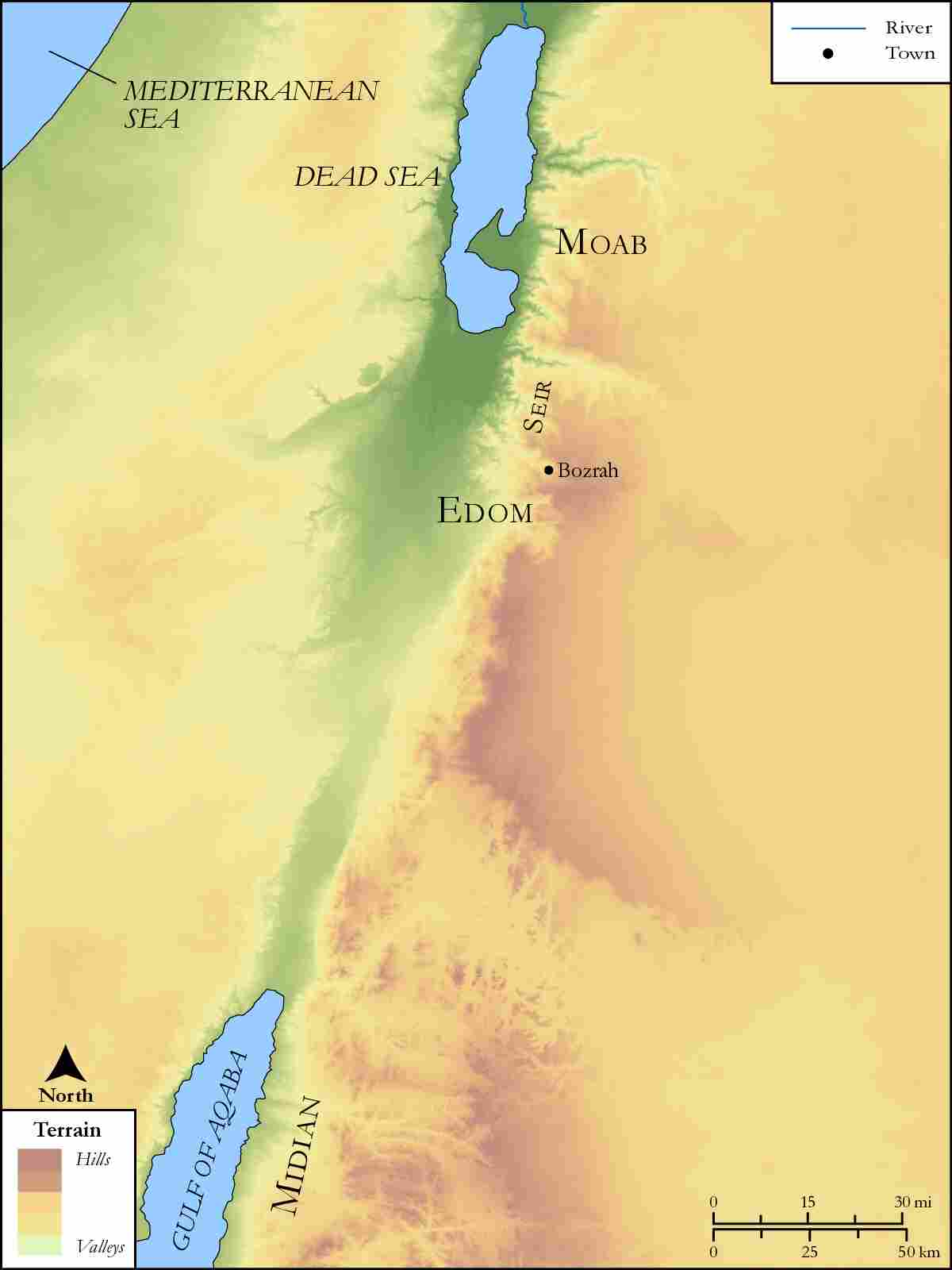
link

Egypt

Image Content

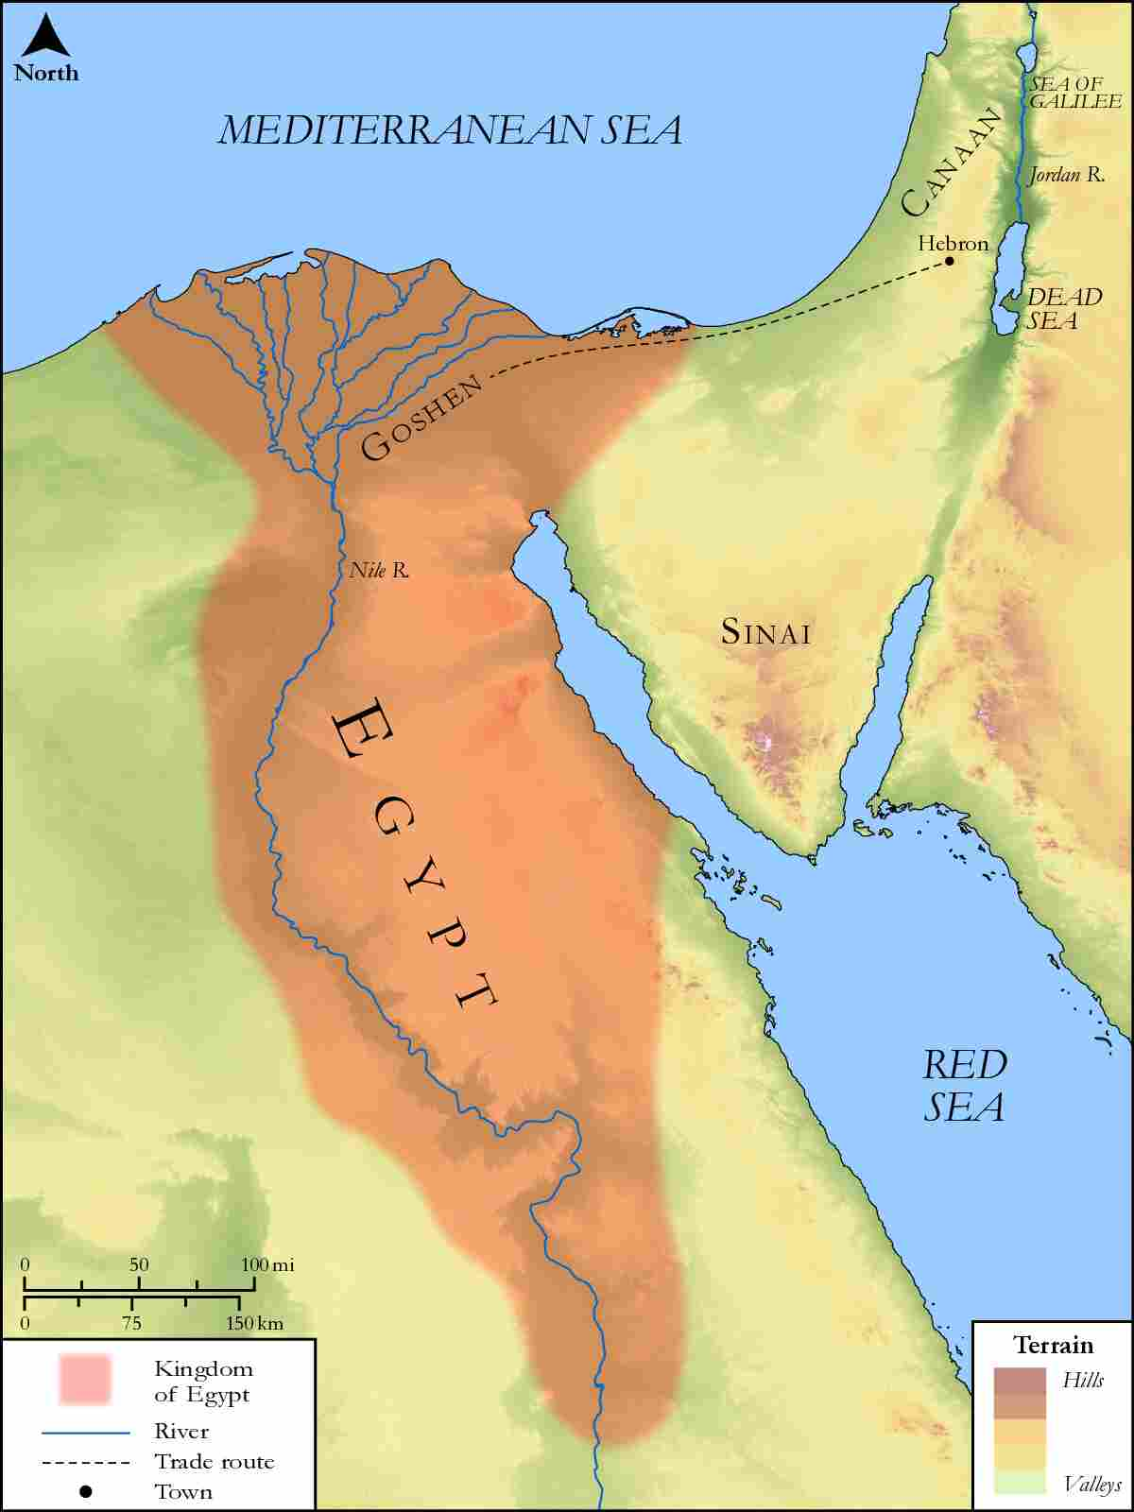
link

Emmaus

Image Content

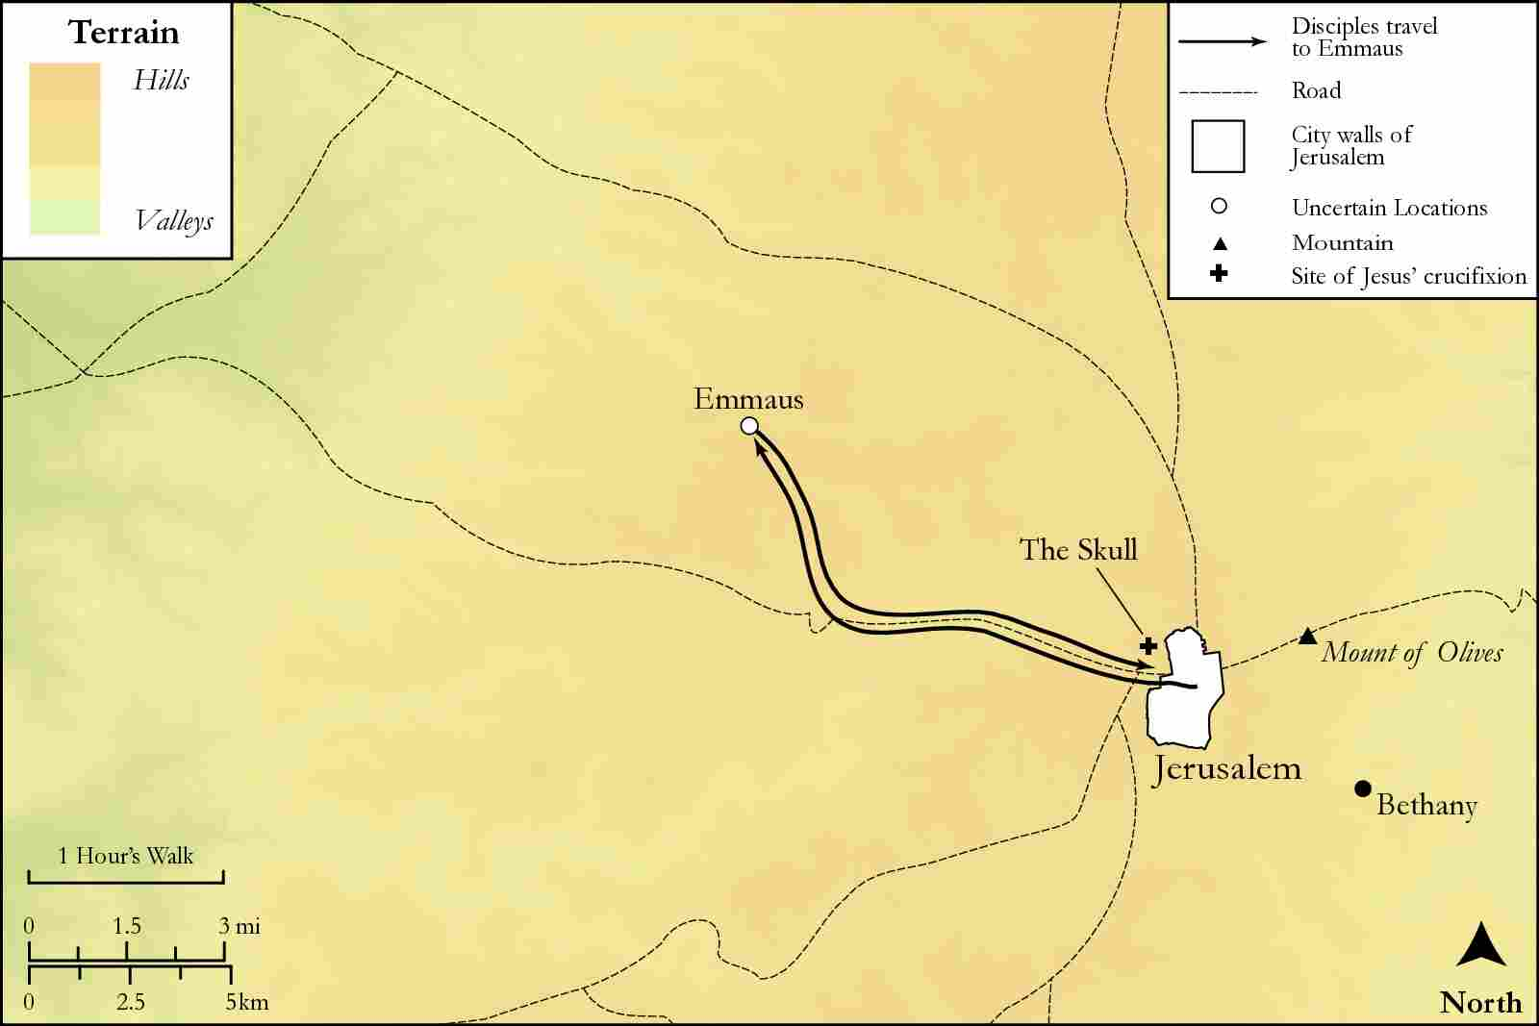
link

