Resource: Maps (SRV)
Familiarization, Internalization, Articulation (FIA) Maps © 2023 SRV Partners Released under CC BY-SA 4.0 license. Familiarization, Internalization, Articulation (FIA) Maps has been adapted in the following languages Tok Pisin, عربي, Français, हिंदी, Bahasa Indonesia, Português, Русский, Español, Kiswahili, 简体中文 from Familiarization, Internalization, Articulation (FIA) © 2023 SRV Partners. Released under CC BY-SA 4.0 license by Mission Mutual

Maps (SRV)

G
Galilee Area with Caesarea Philippi and Capernaum, Galilee Area with Capernaum, Galilee Area with Capernaum and Gerasa, Galilee to Jerusalem, Galilee with Magdala, Galilee, Judea, Samaria, and Jerusalem, Galilee, Syrian Phoenicia, Gennesaret and Tyre, Galilee,Judea and Samaria, Gennesaret and Capernaum

Galilee Area with Caesarea Philippi and Capernaum

Image Content

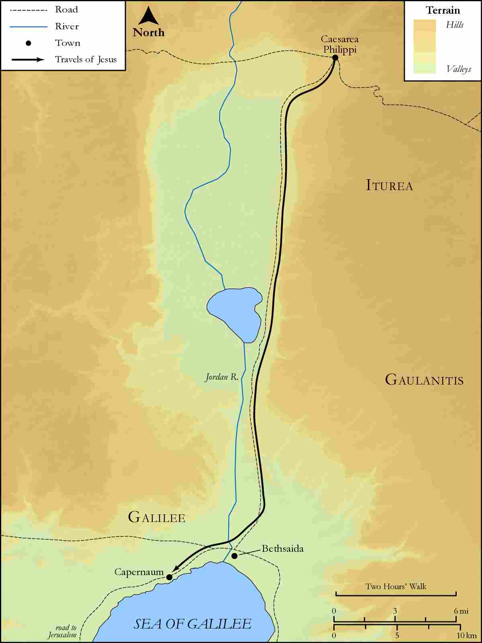
link

Galilee Area with Capernaum

Image Content

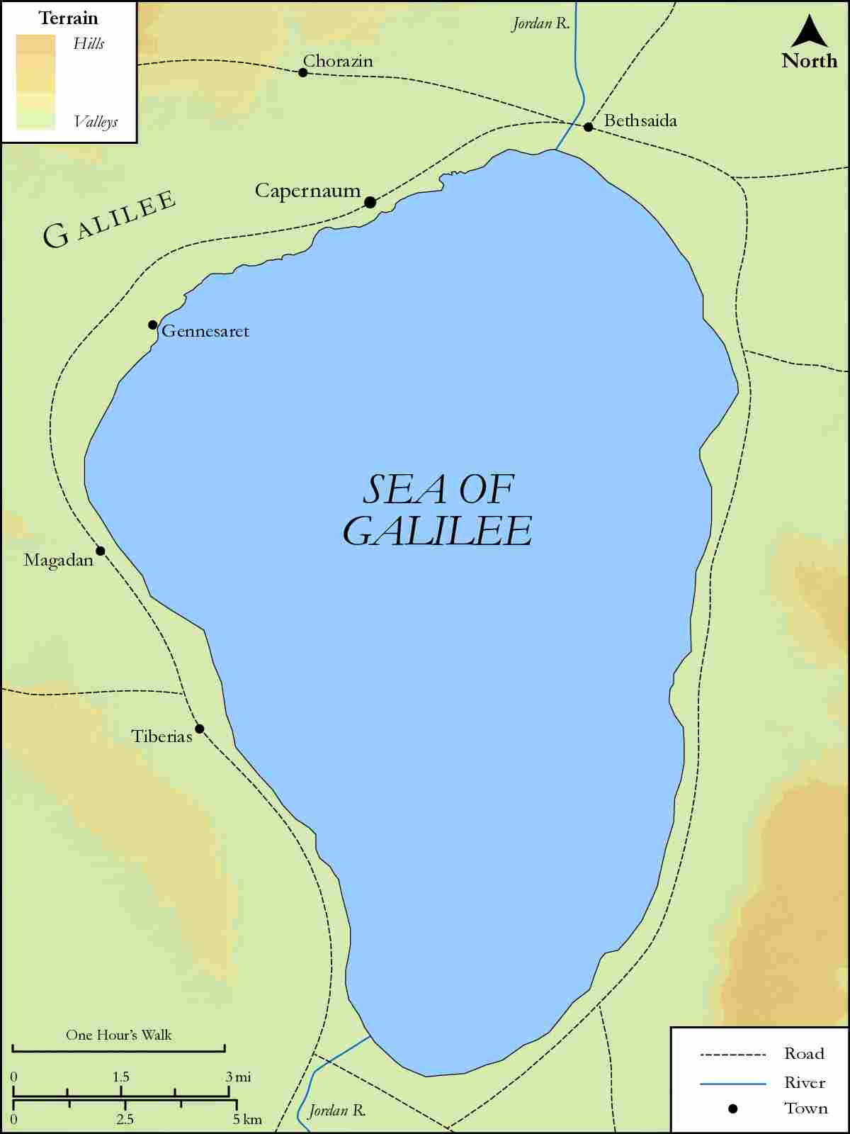
link

Galilee Area with Capernaum and Gerasa

Image Content

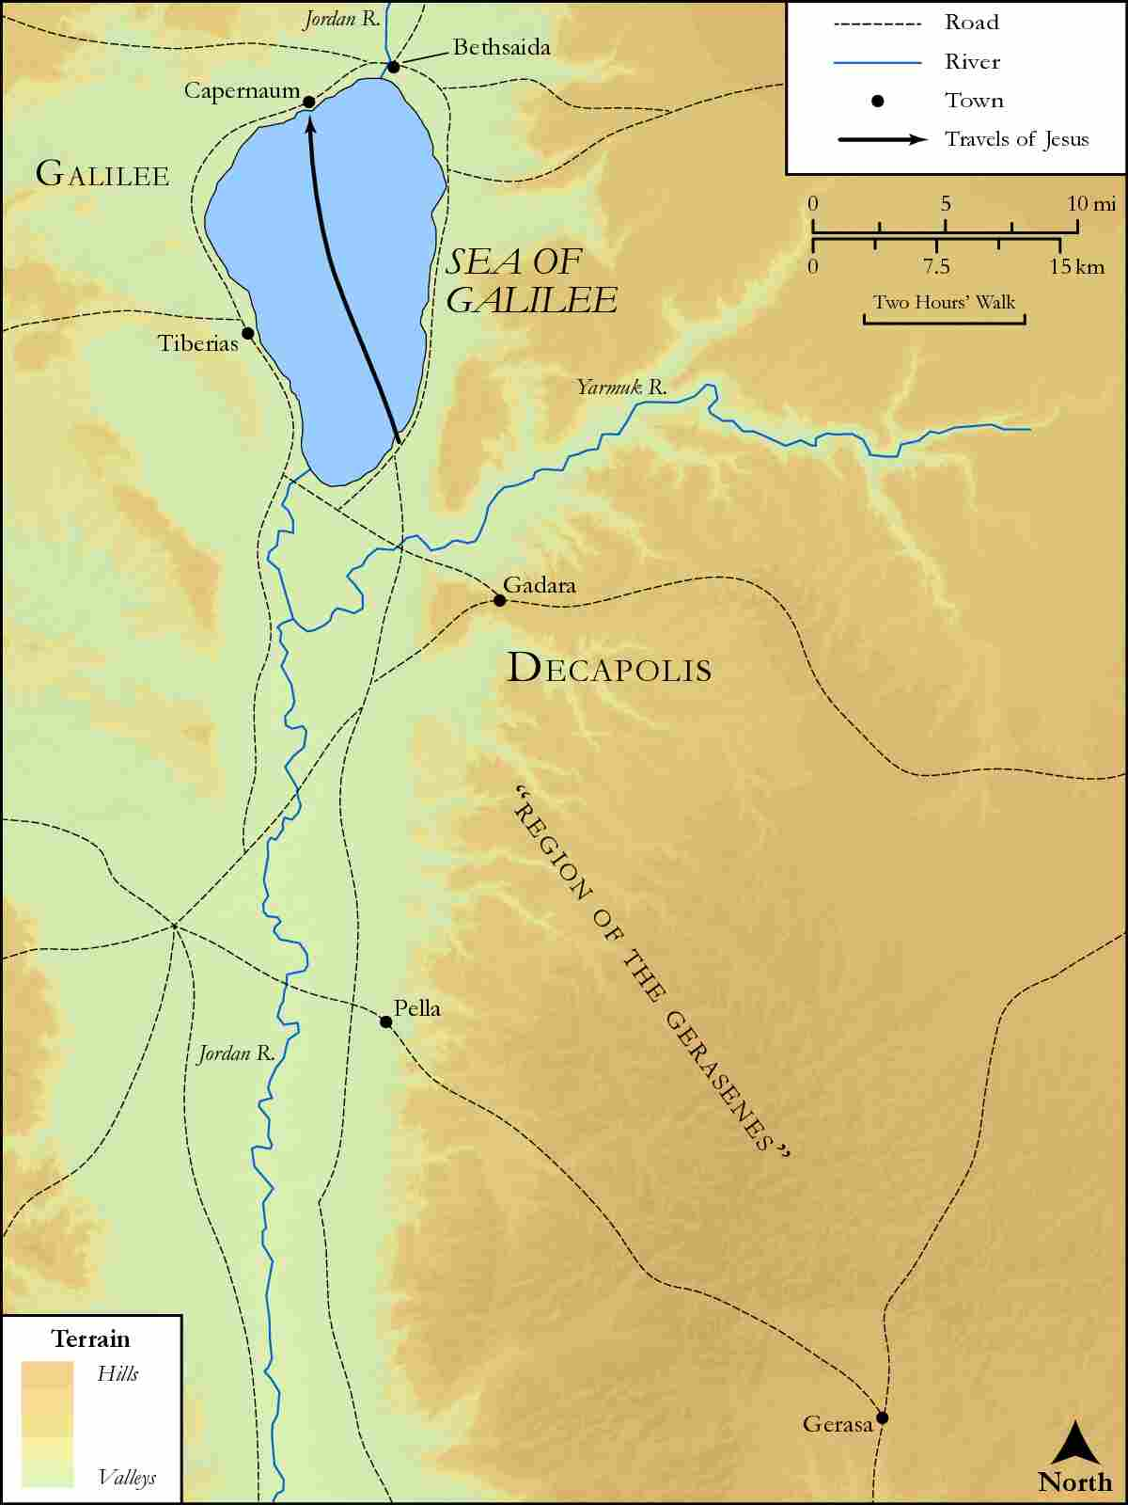
link

Galilee to Jerusalem

Image Content

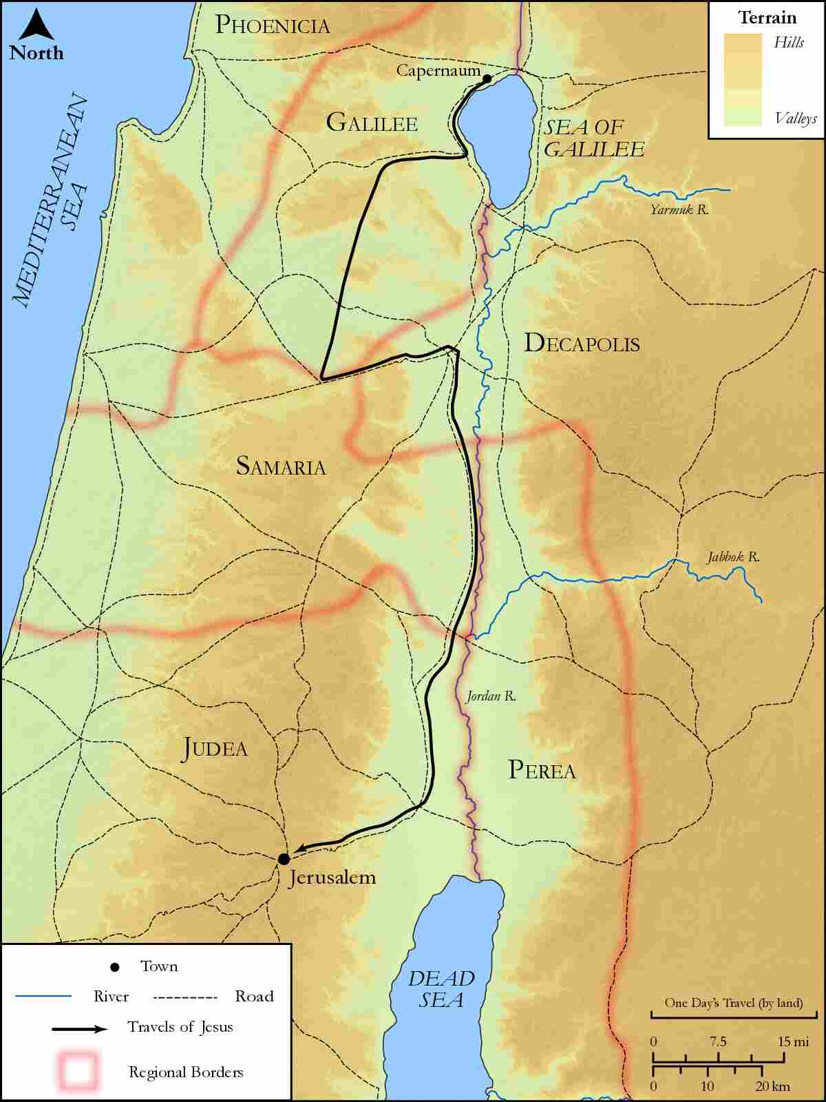
link

Galilee with Magdala

Image Content

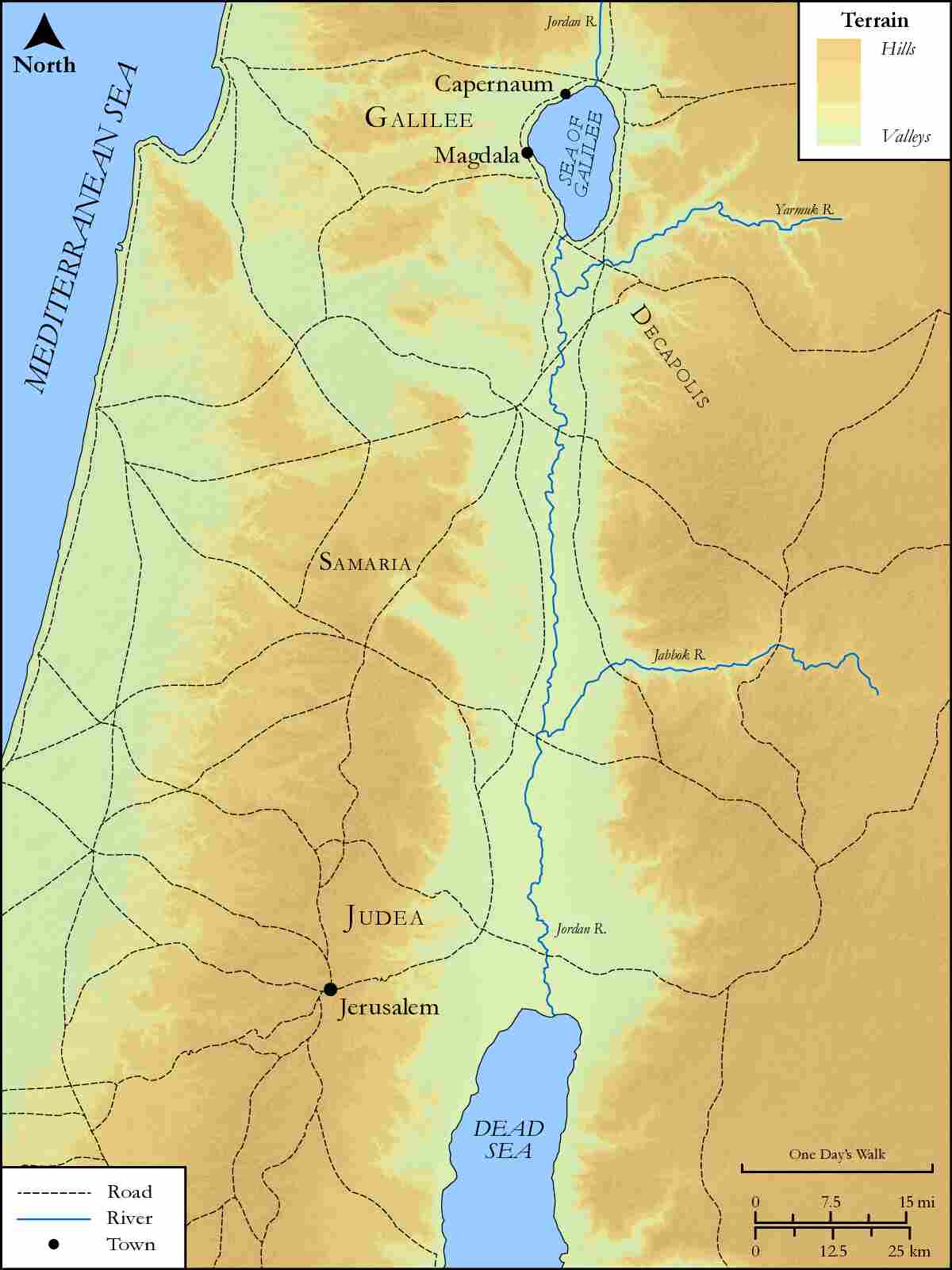
link

Galilee, Judea, Samaria, and Jerusalem

Image Content

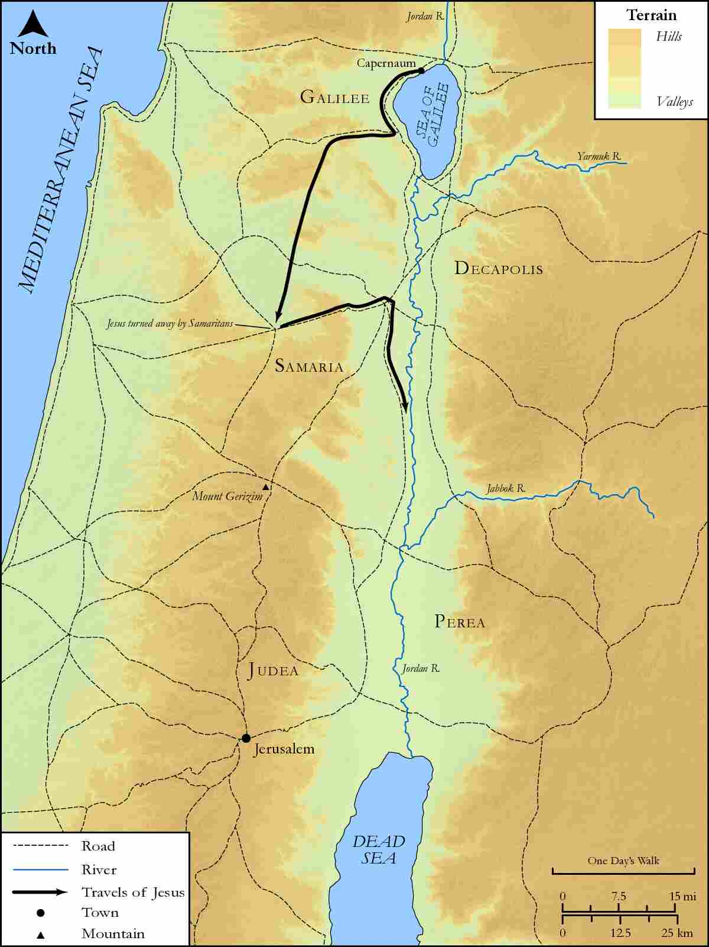
link

Galilee, Syrian Phoenicia, Gennesaret and Tyre

Image Content

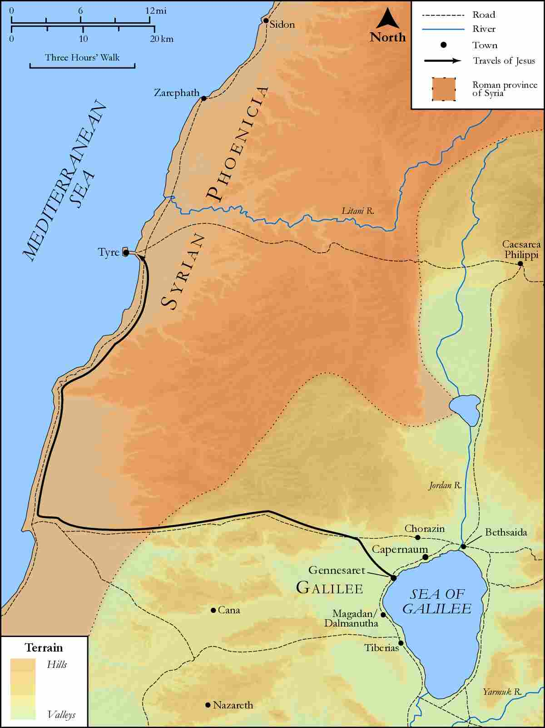
link

Galilee,Judea and Samaria

Image Content

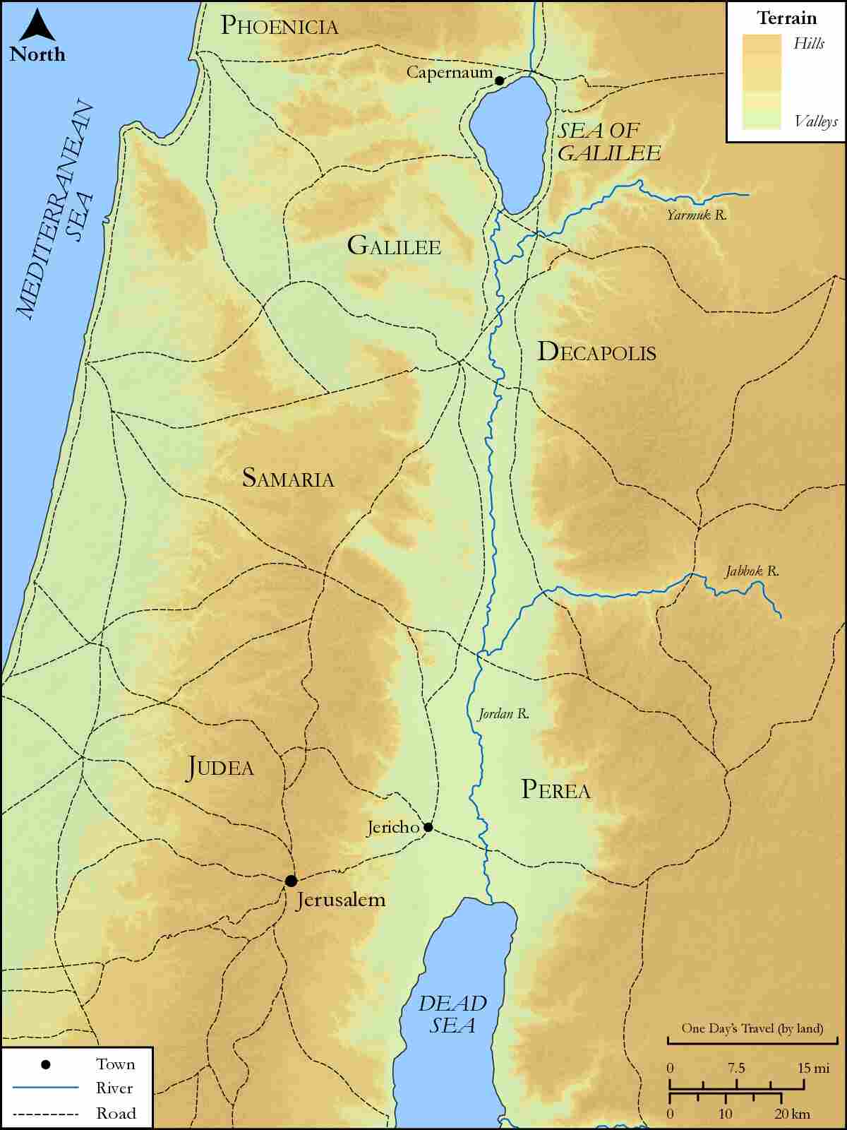
link

Gennesaret and Capernaum

Image Content

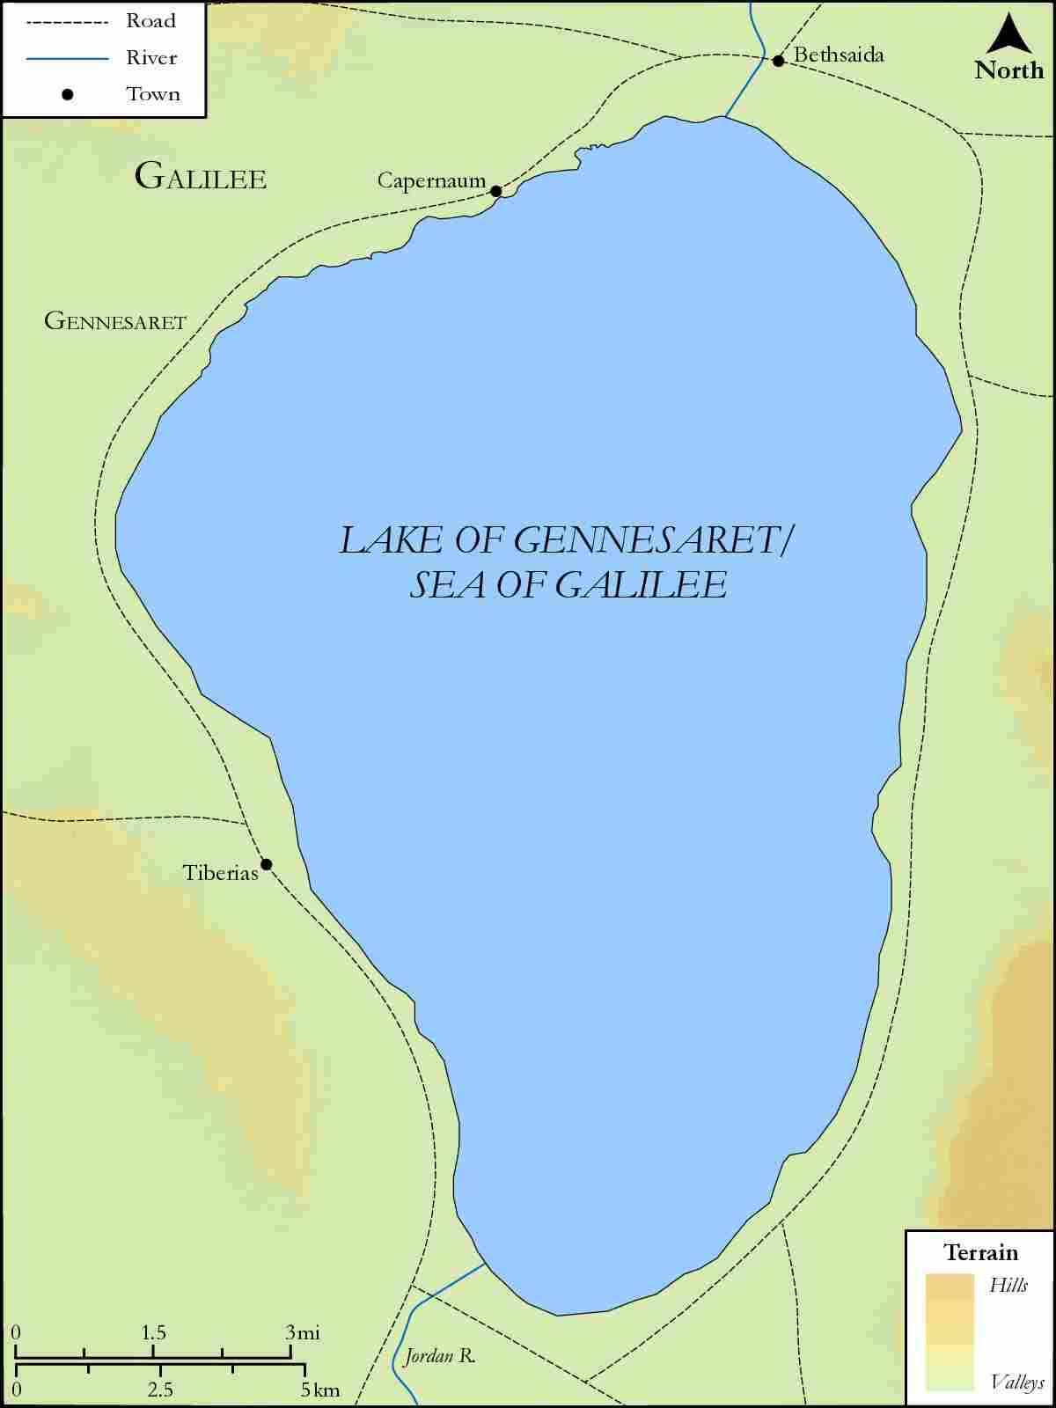
link

