Resource: Maps (SRV)
Familiarization, Internalization, Articulation (FIA) Maps © 2023 SRV Partners Released under CC BY-SA 4.0 license. Familiarization, Internalization, Articulation (FIA) Maps has been adapted in the following languages Tok Pisin, عربي, Français, हिंदी, Bahasa Indonesia, Português, Русский, Español, Kiswahili, 简体中文 from Familiarization, Internalization, Articulation (FIA) © 2023 SRV Partners. Released under CC BY-SA 4.0 license by Mission Mutual

Maps (SRV)

H
Haran and Beersheba, Haran to Canaan, Havilah, Shur, Egypt and Assyria, Hebron, Canaan, Negev and Beer Lahai Roi

Haran and Beersheba

Image Content

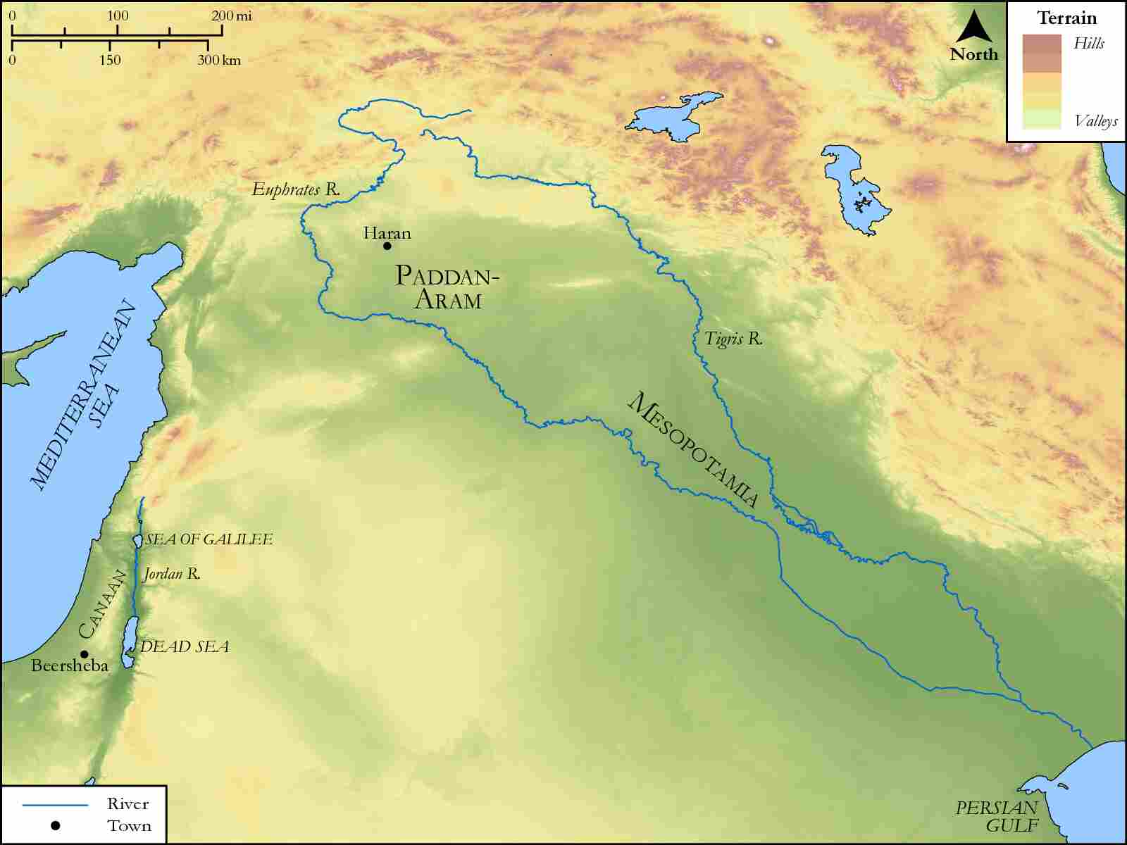
link

Haran to Canaan

Image Content

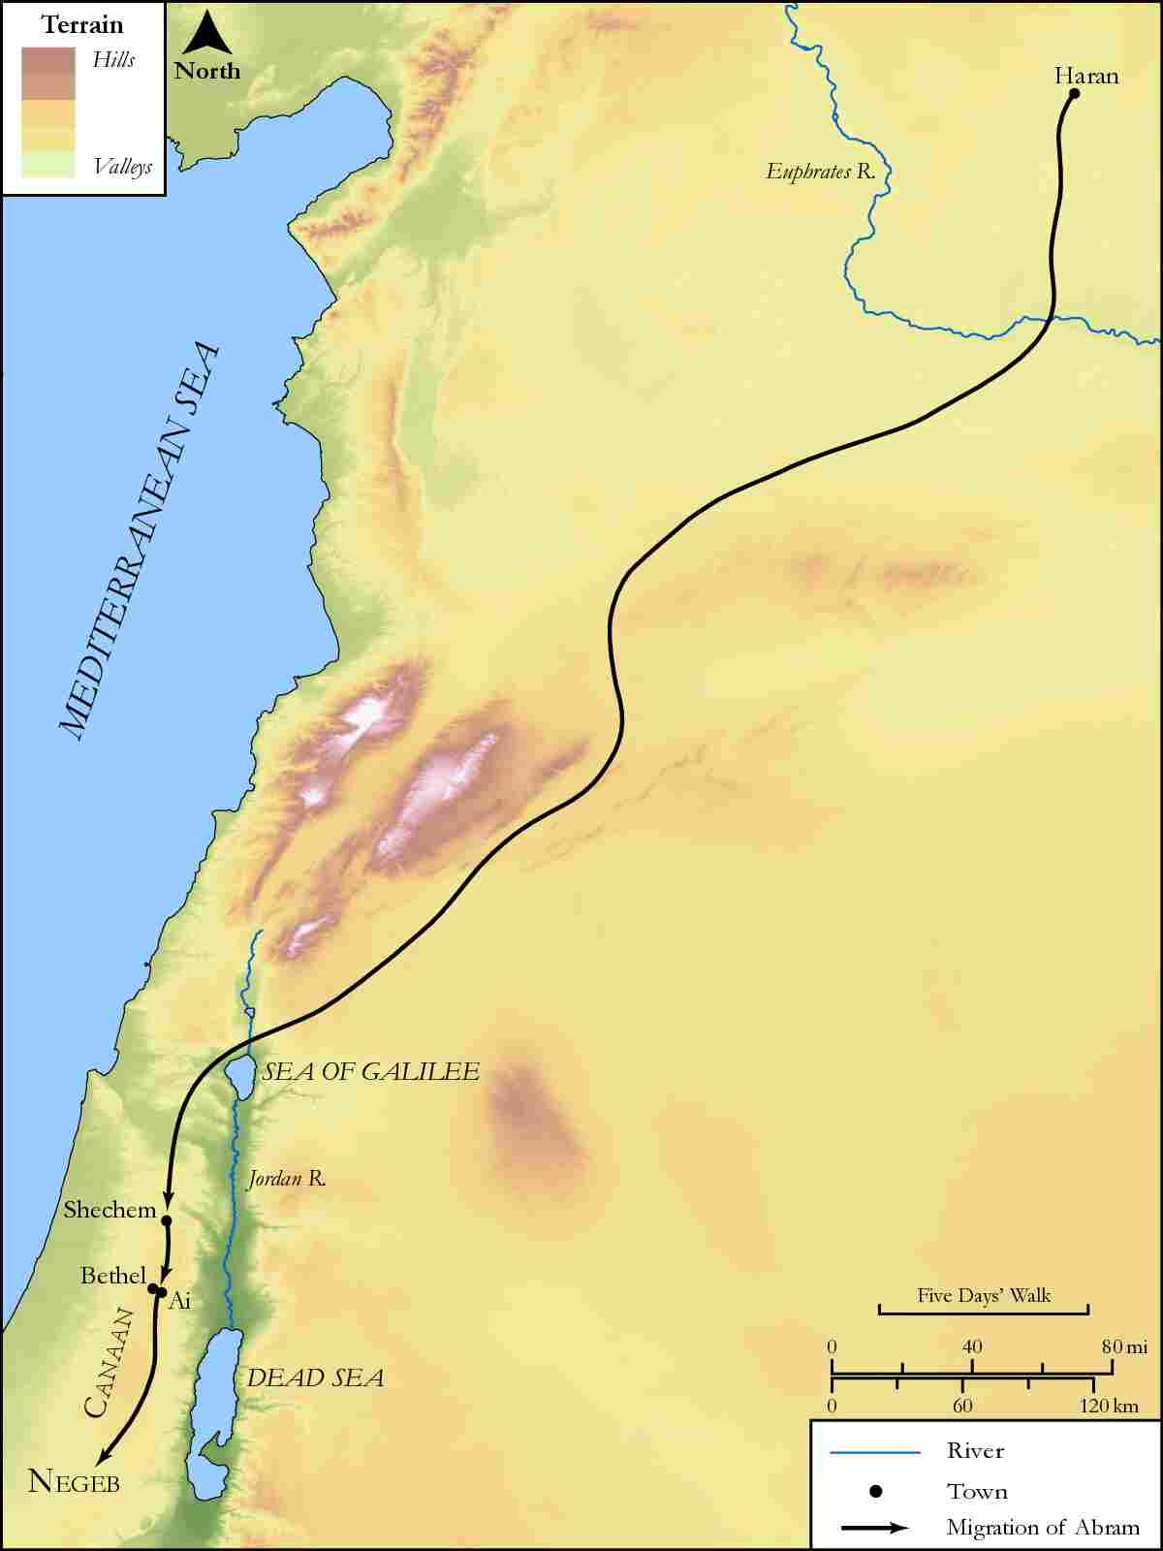
link

Havilah, Shur, Egypt and Assyria

Image Content

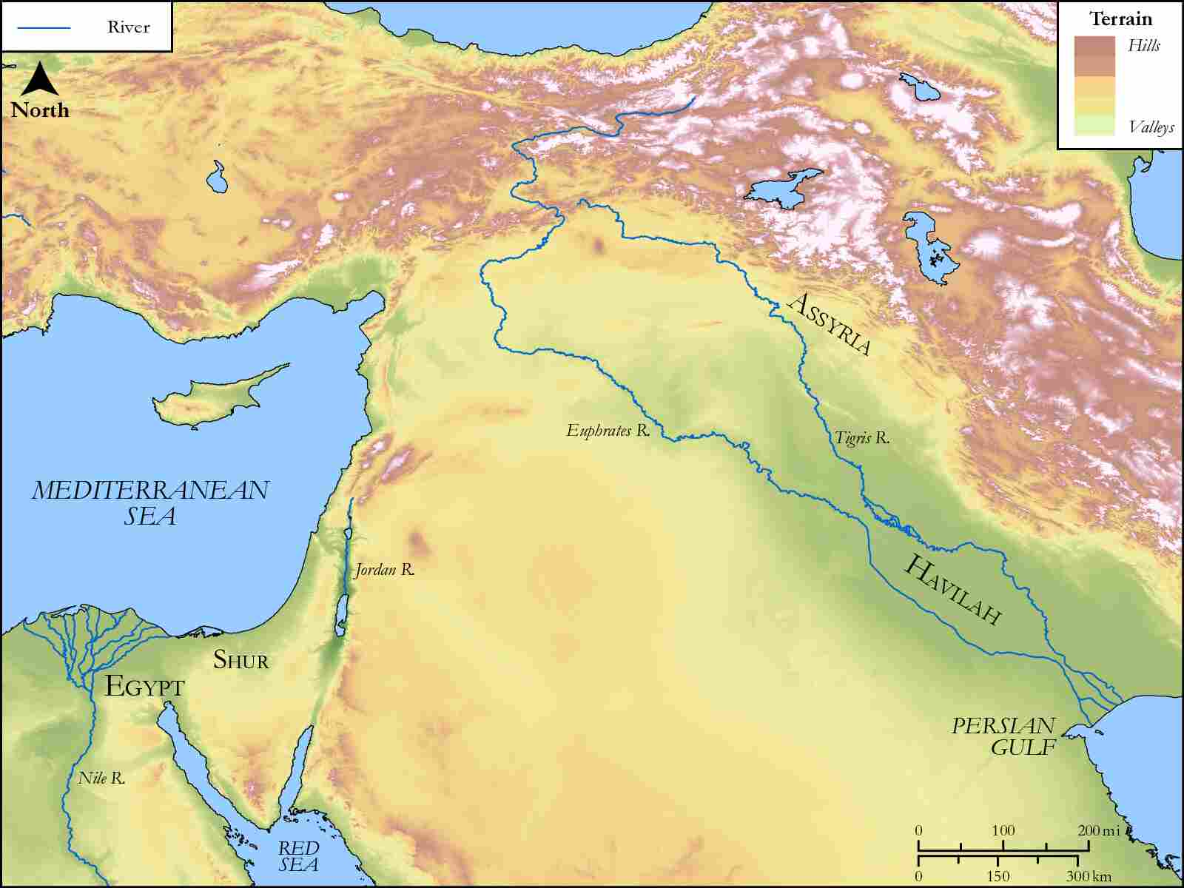
link

Hebron, Canaan, Negev and Beer Lahai Roi

Image Content

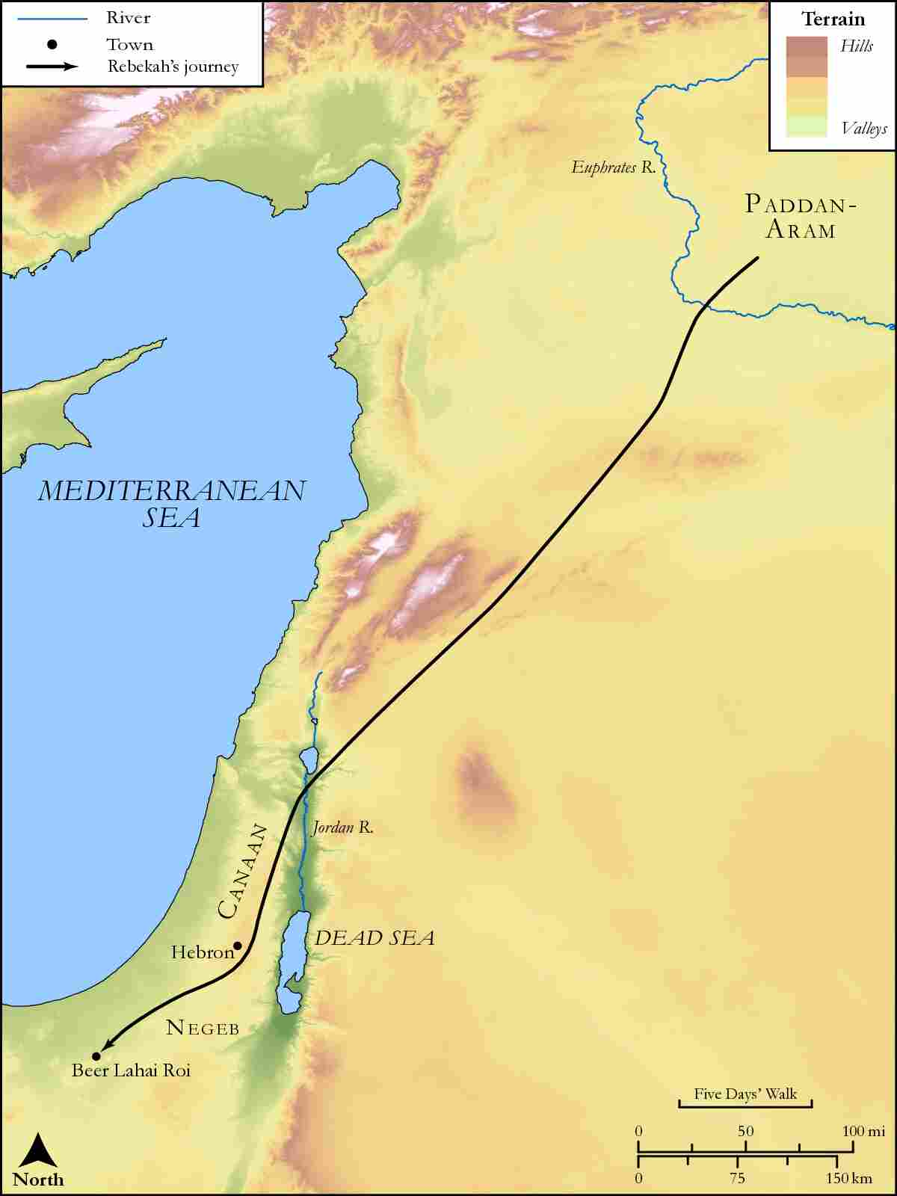
link

