Resource: Maps (SRV)
Familiarization, Internalization, Articulation (FIA) Maps © 2023 SRV Partners Released under CC BY-SA 4.0 license. Familiarization, Internalization, Articulation (FIA) Maps has been adapted in the following languages Tok Pisin, عربي, Français, हिंदी, Bahasa Indonesia, Português, Русский, Español, Kiswahili, 简体中文 from Familiarization, Internalization, Articulation (FIA) © 2023 SRV Partners. Released under CC BY-SA 4.0 license by Mission Mutual

Maps (SRV)

I
Israel, Israel with Negeb, Israel with region of Galilee, Nazareth, Jerusalem, Israel, Jordan and Egypt, Israel, Ninevah and Sheba

Israel

Image Content

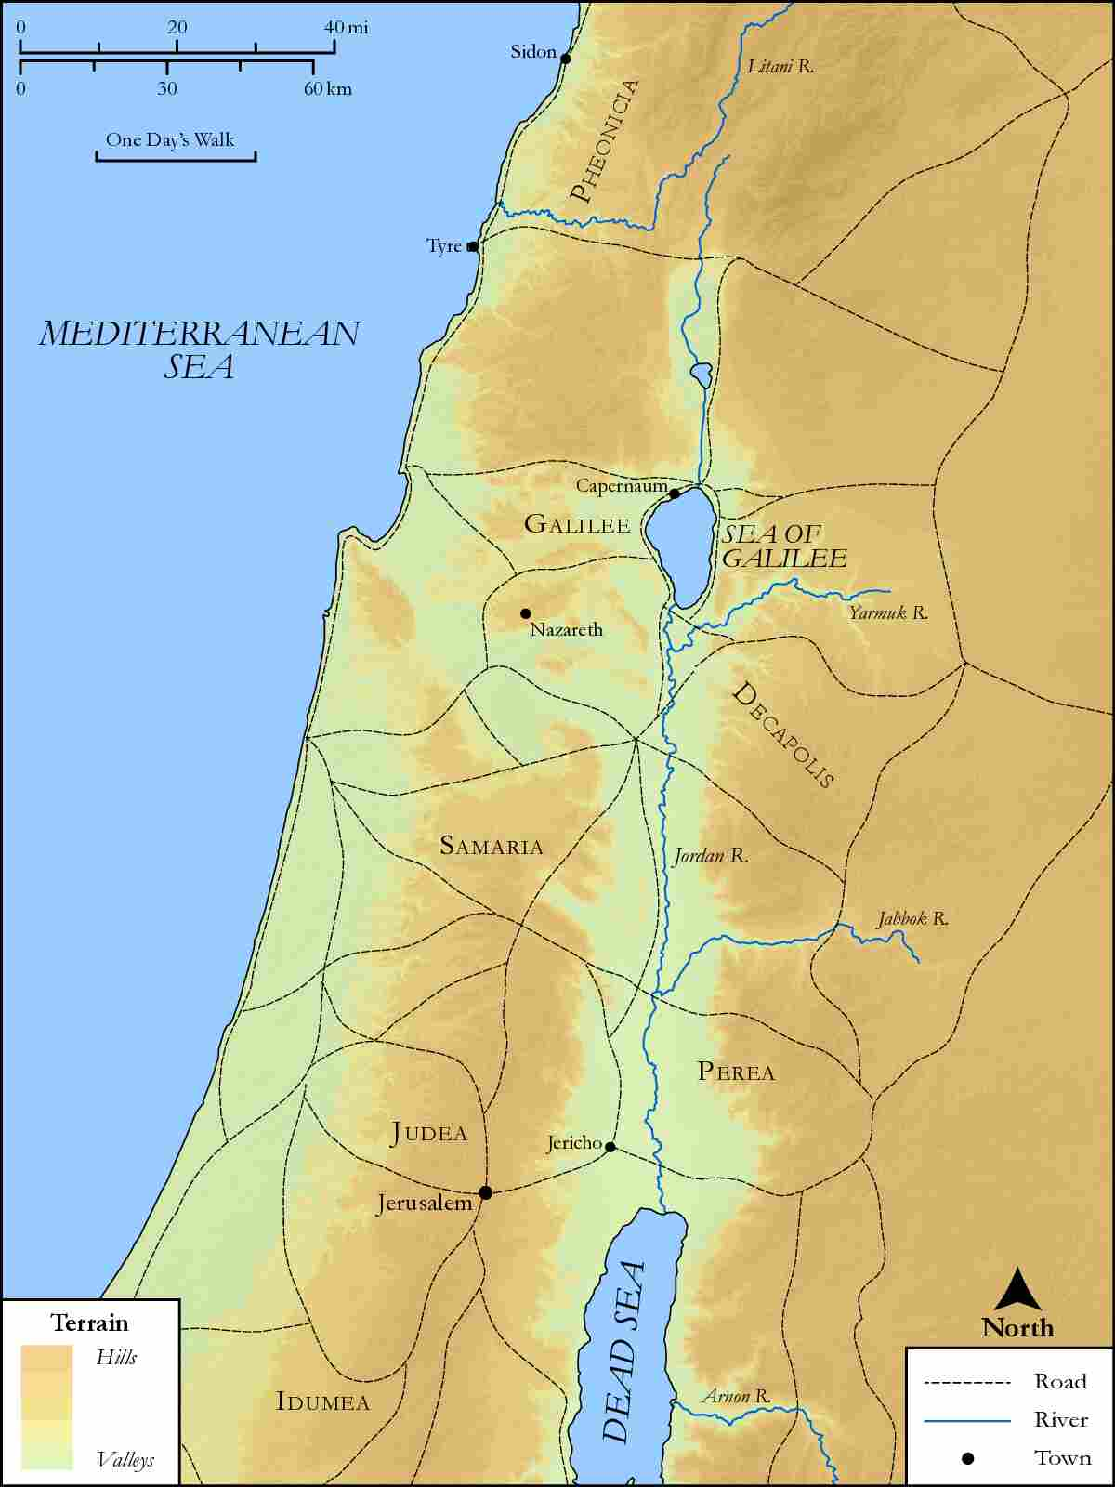
link

Israel with Negeb

Image Content

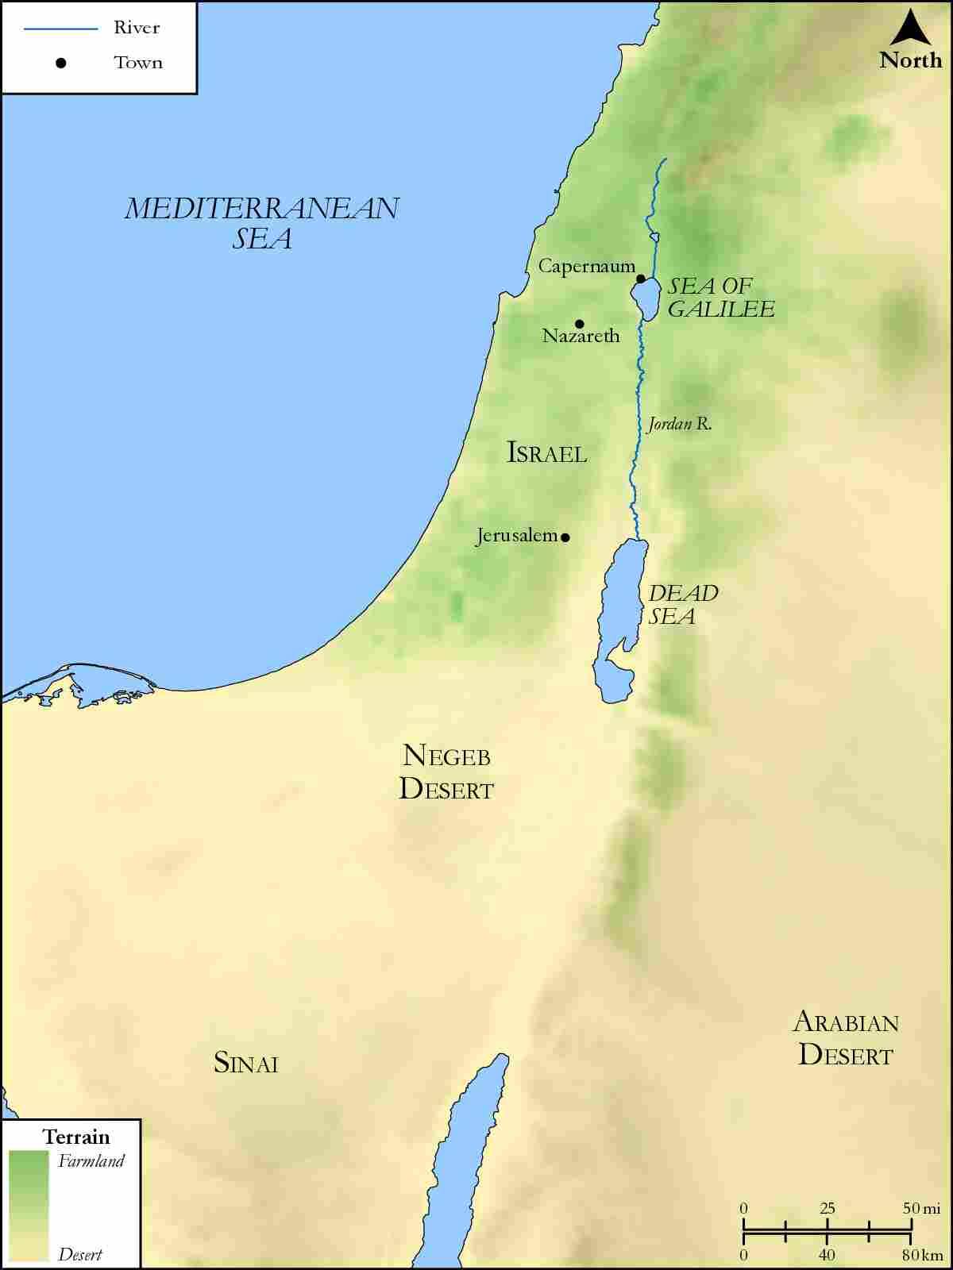
link

Israel with region of Galilee, Nazareth, Jerusalem

Image Content

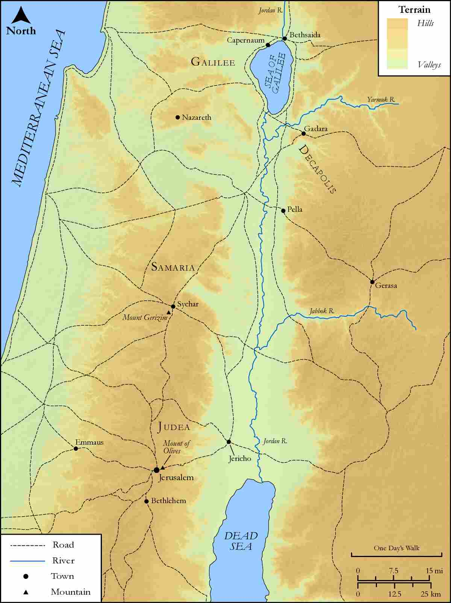
link

Israel, Jordan and Egypt

Image Content

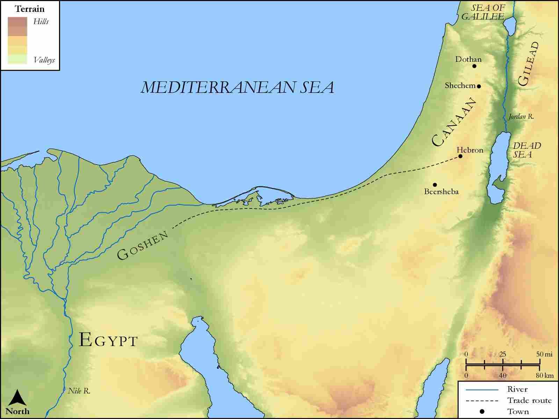
link

Israel, Ninevah and Sheba

Image Content

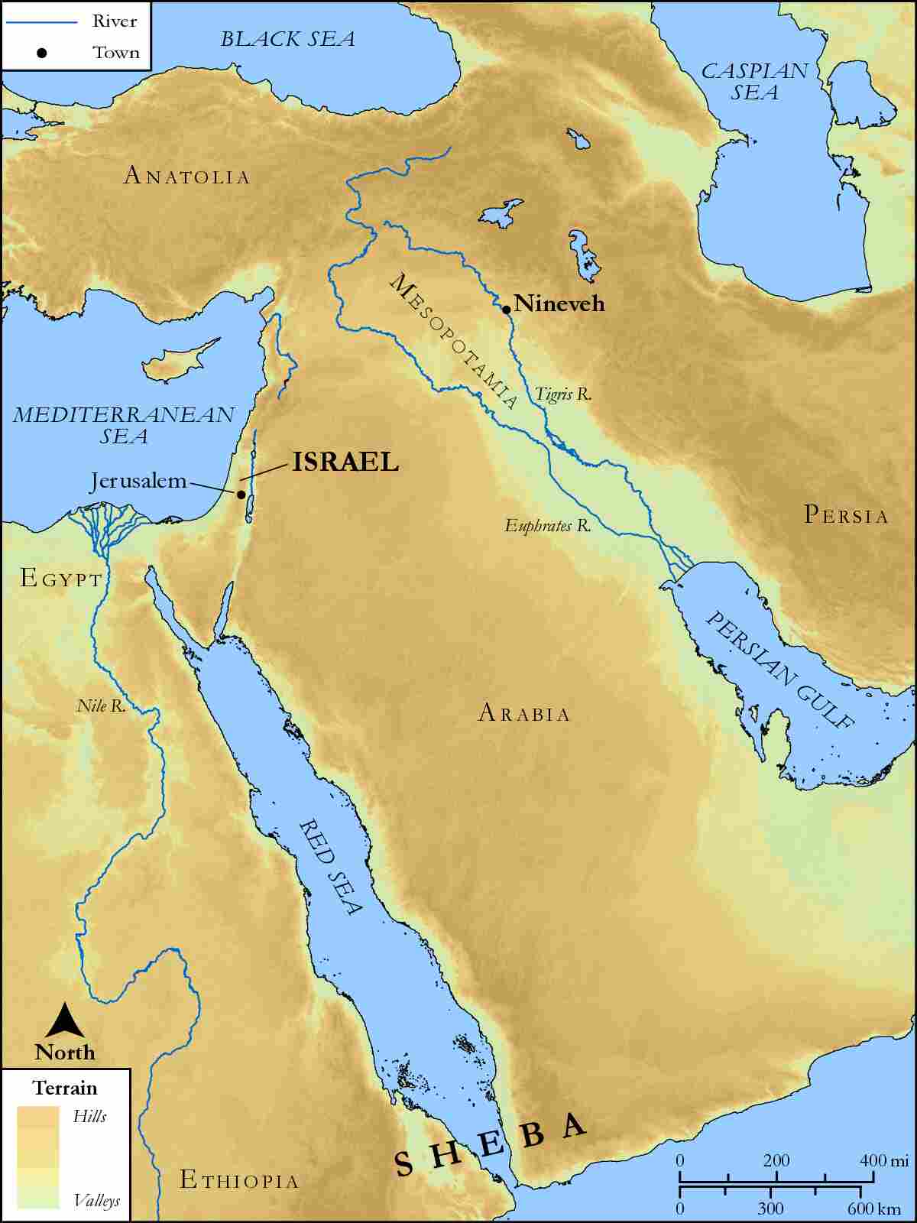
link

