Resource: Maps (SRV)
Familiarization, Internalization, Articulation (FIA) Maps © 2023 SRV Partners Released under CC BY-SA 4.0 license. Familiarization, Internalization, Articulation (FIA) Maps has been adapted in the following languages Tok Pisin, عربي, Français, हिंदी, Bahasa Indonesia, Português, Русский, Español, Kiswahili, 简体中文 from Familiarization, Internalization, Articulation (FIA) © 2023 SRV Partners. Released under CC BY-SA 4.0 license by Mission Mutual

Maps (SRV)

J
Jacob's Journey from Beersheba to Haran, Jacob's Journey from Haran to Beersheba, Jericho, Jerusalem and Galilee, Jerusalem and Galilee region, Jerusalem and Mount of Olives, Jerusalem to Jericho, Jerusalem, Bethany and the Temple, Jerusalem, Bethphage, and Bethany, Jesus' Route from Capernaum to Nain, Jesus' Travels to Jerusalem, Jordan River and Wilderness of Judah, Jordan River featuring Galilee, Judea, Iturea, Traconitis, and Abilene, Jordan Valley Region, Joseph and Mary's Route from Nazareth to Bethlehem, Joseph and Mary's Route from Nazareth to Jerusalem, Judea and Dead Sea

Jacob's Journey from Beersheba to Haran

Image Content

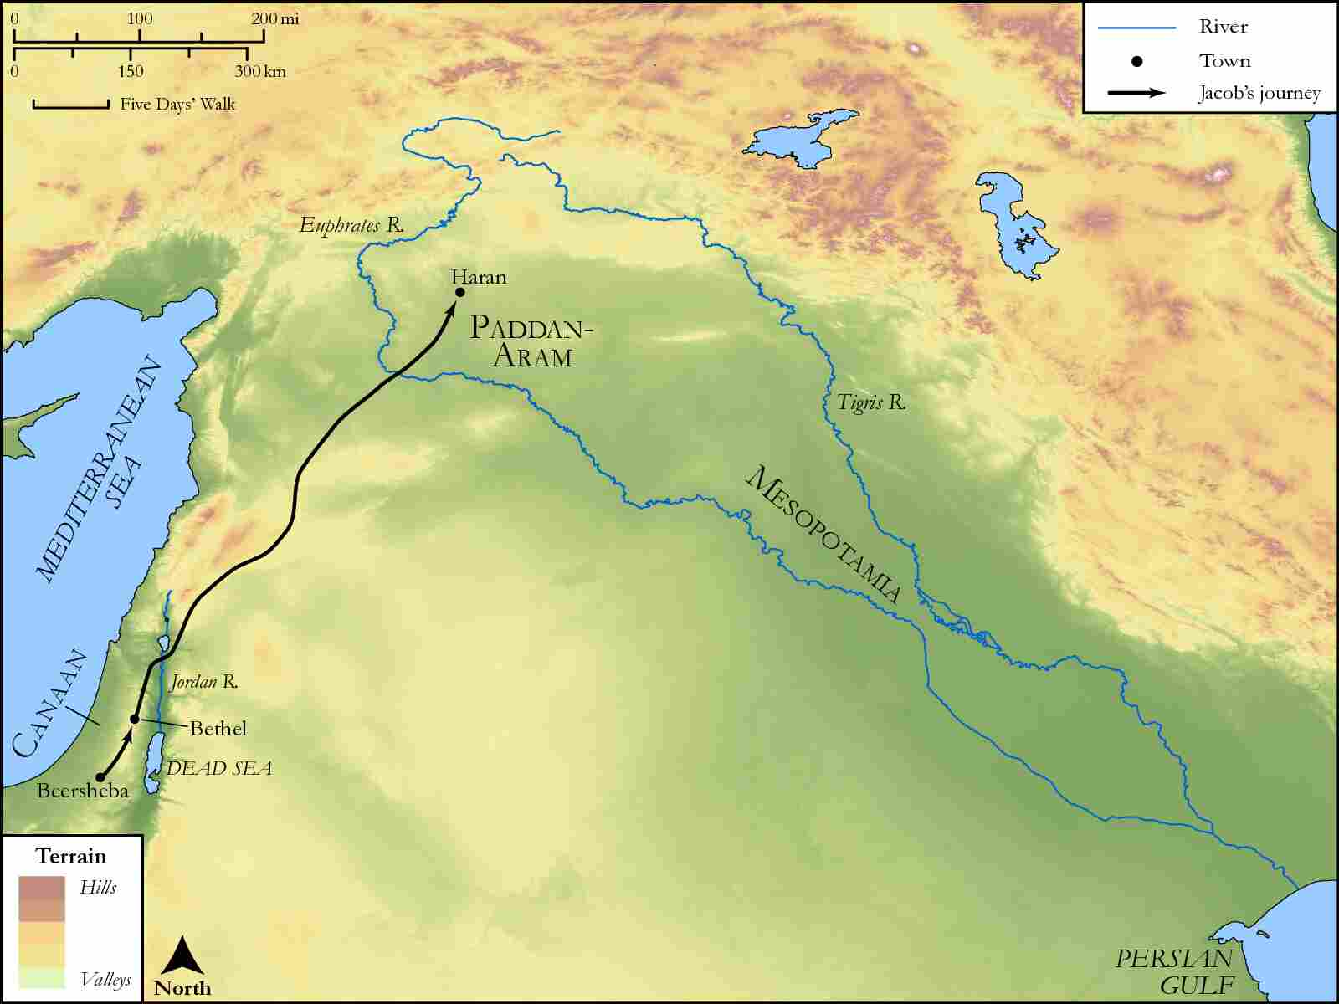
link

Jacob's Journey from Haran to Beersheba

Image Content

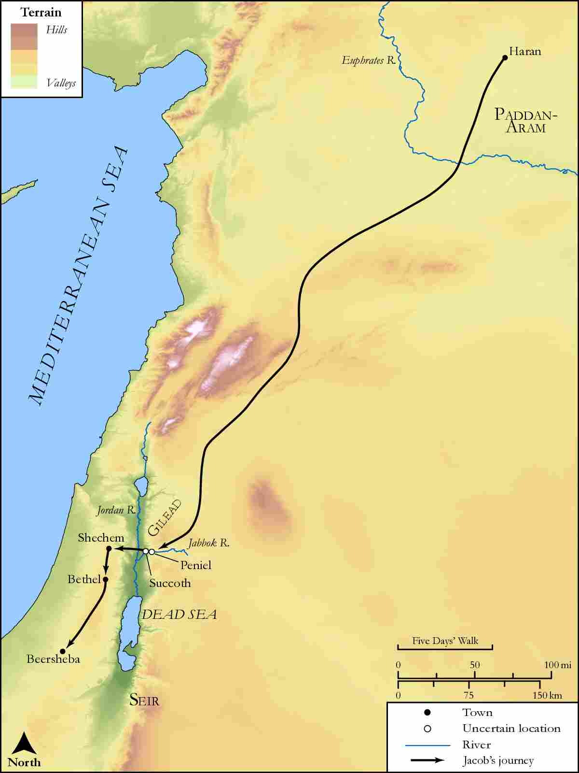
link

Jericho

Image Content

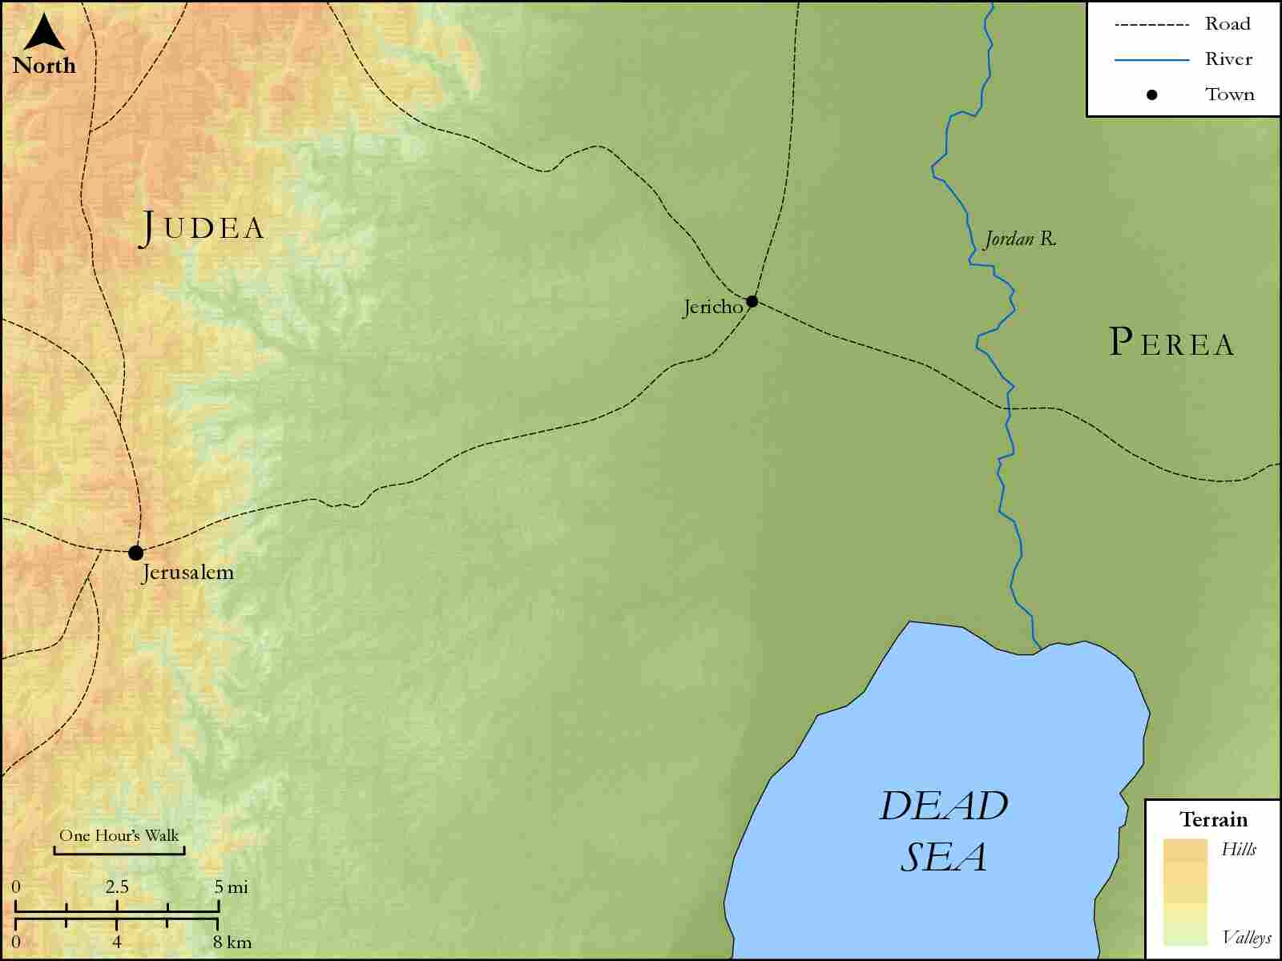
link

Jerusalem and Galilee

Image Content

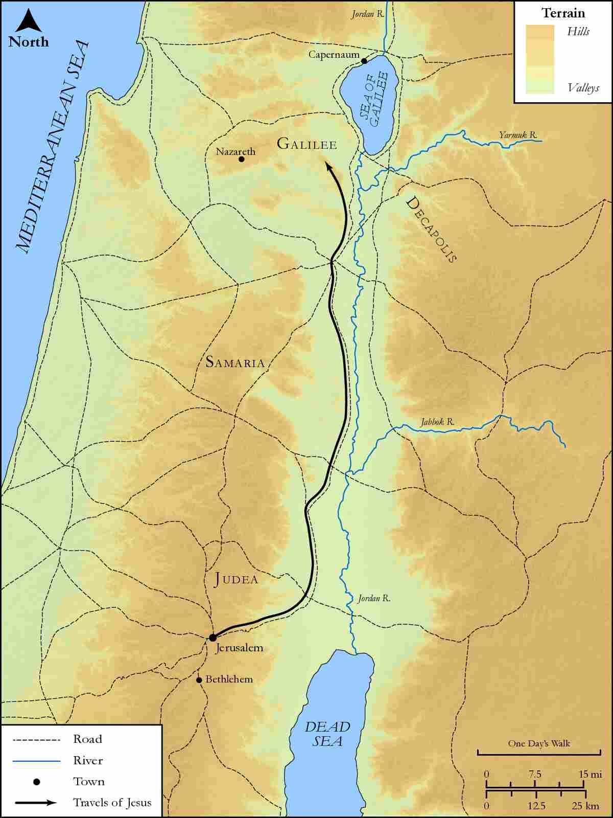
link

Jerusalem and Galilee region

Image Content

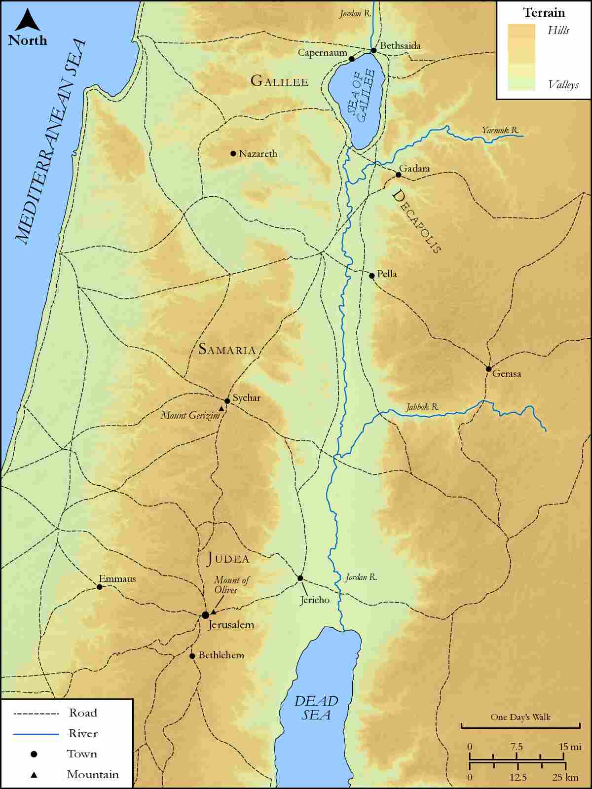
link

Jerusalem and Mount of Olives

Image Content

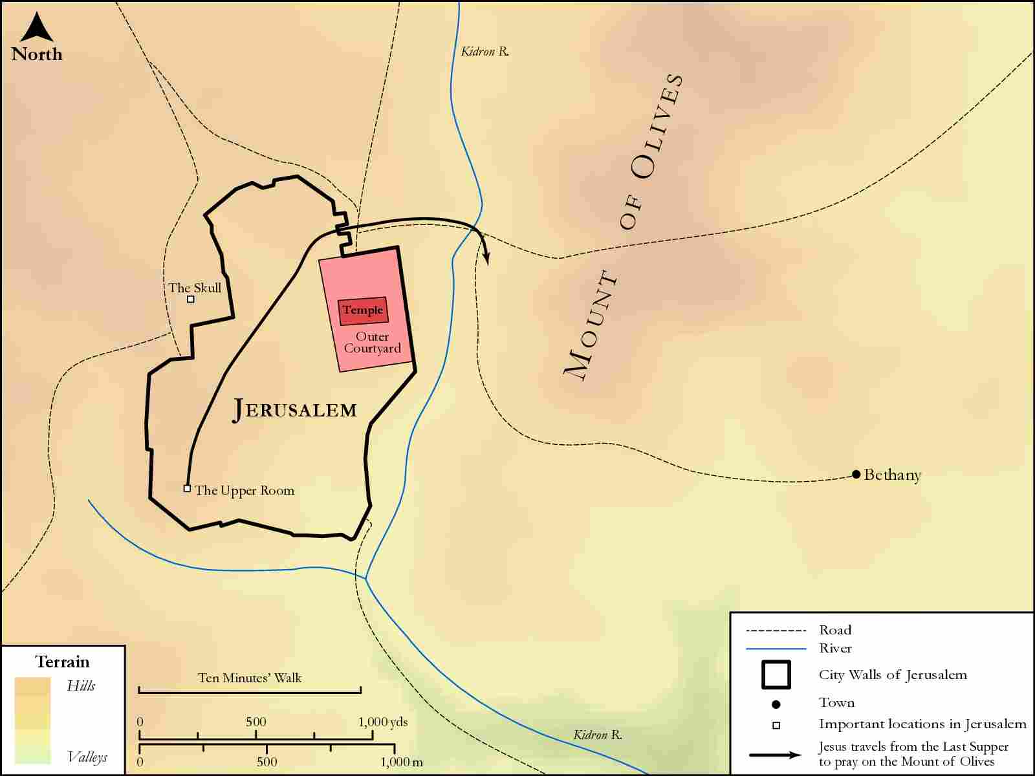
link

Jerusalem to Jericho

Image Content

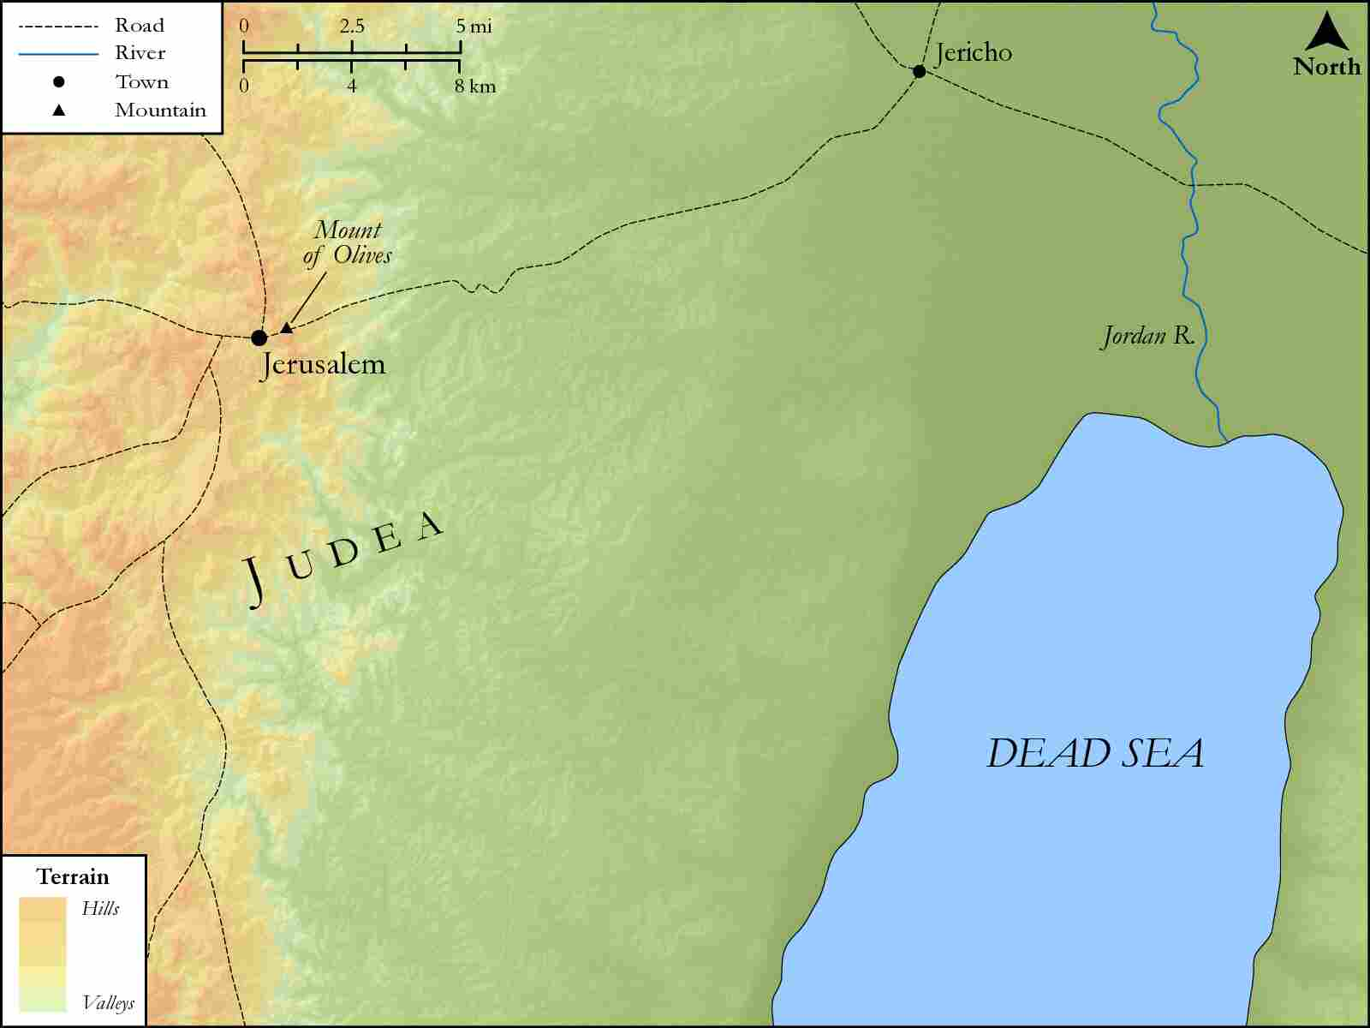
link

Jerusalem, Bethany and the Temple

Image Content

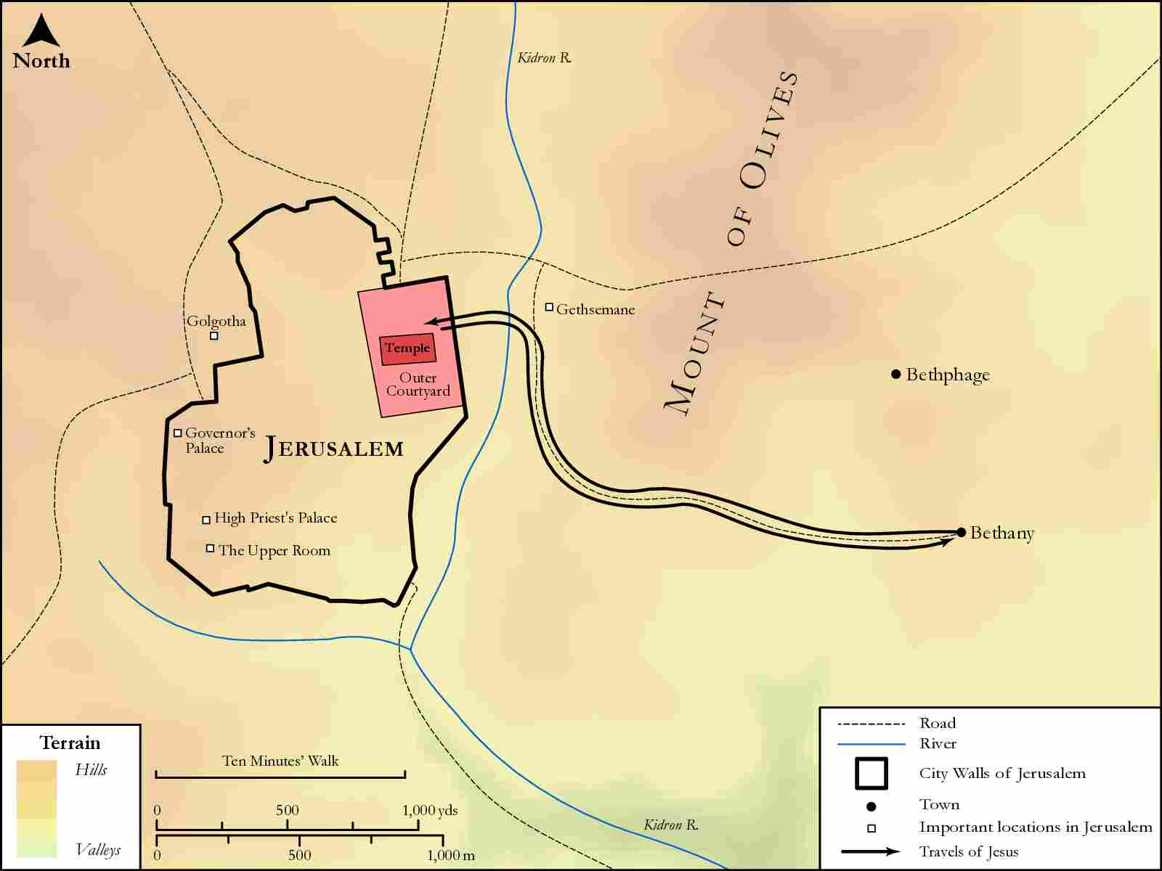
link

Jerusalem, Bethphage, and Bethany

Image Content

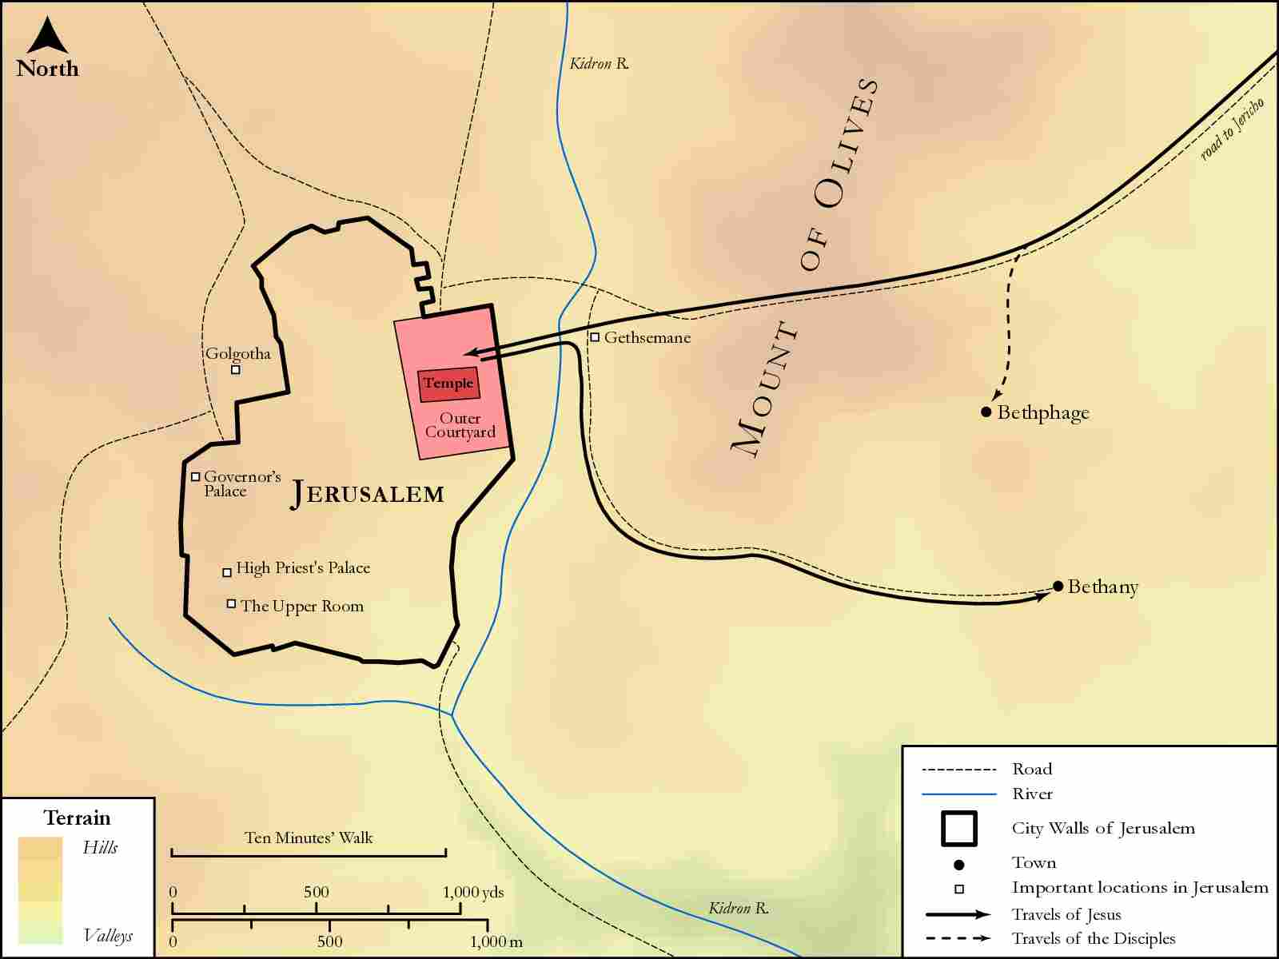
link

Jesus' Route from Capernaum to Nain

Image Content

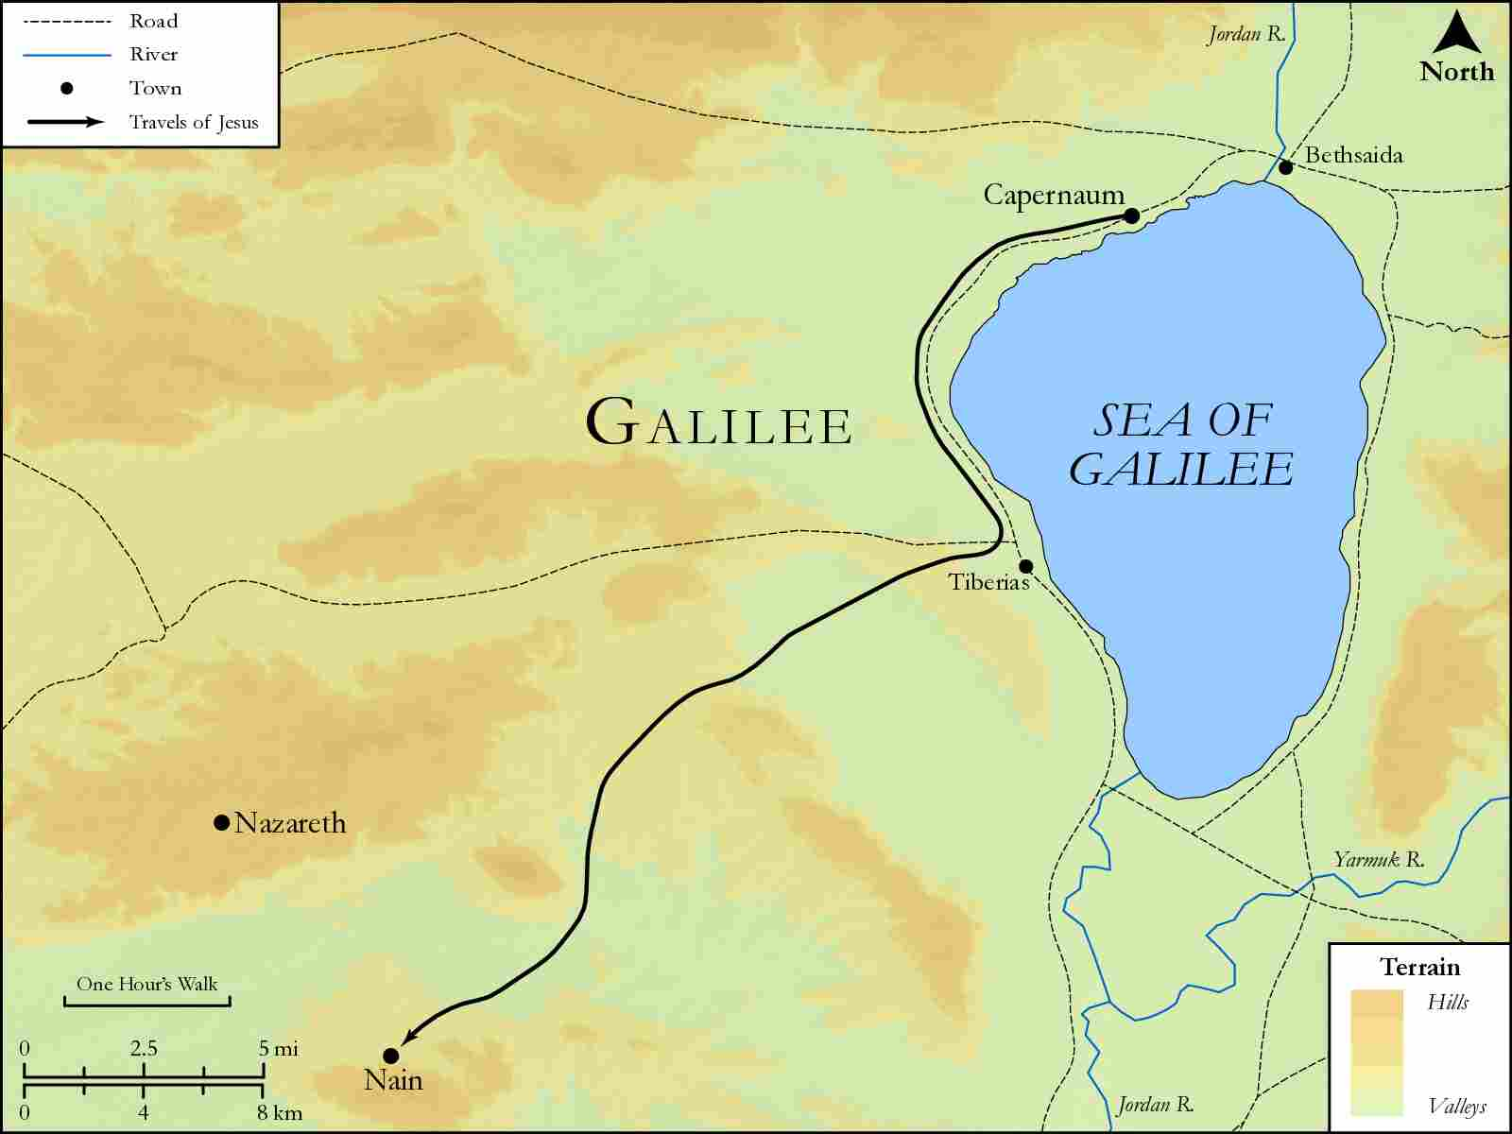
link

Jesus' Travels to Jerusalem

Image Content

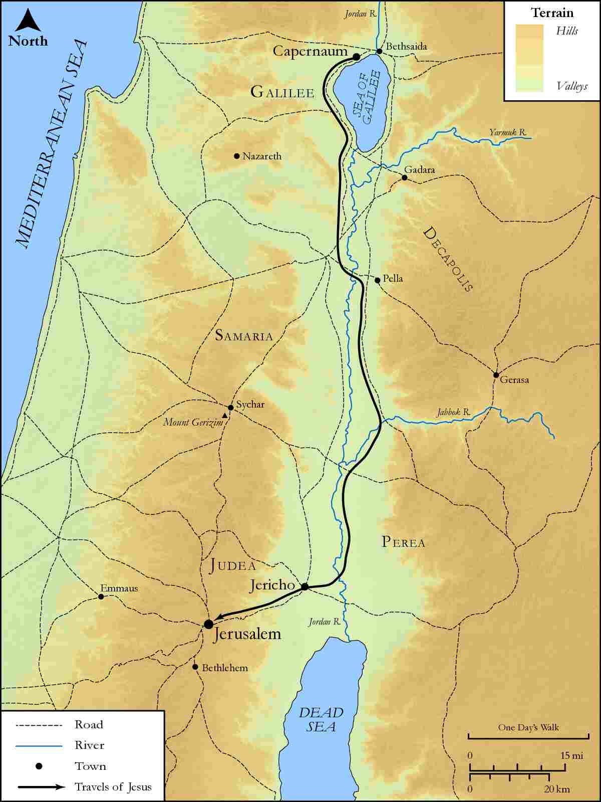
link

Jordan River and Wilderness of Judah

Image Content

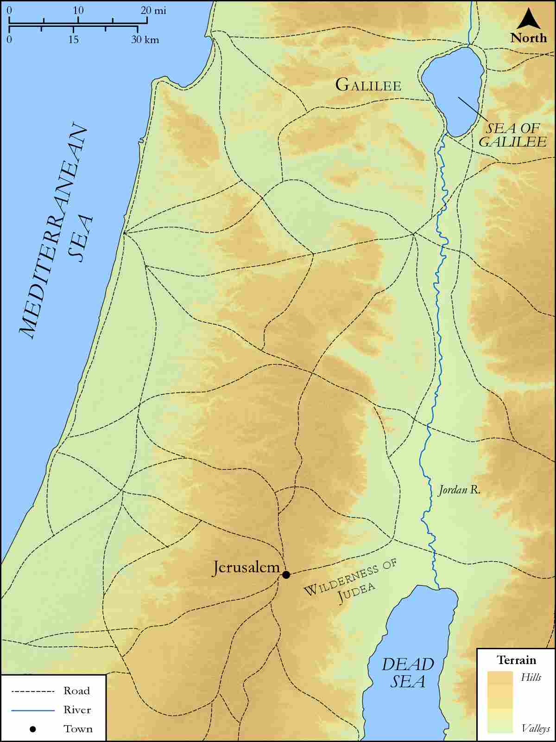
link

Jordan River featuring Galilee, Judea, Iturea, Traconitis, and Abilene

Image Content

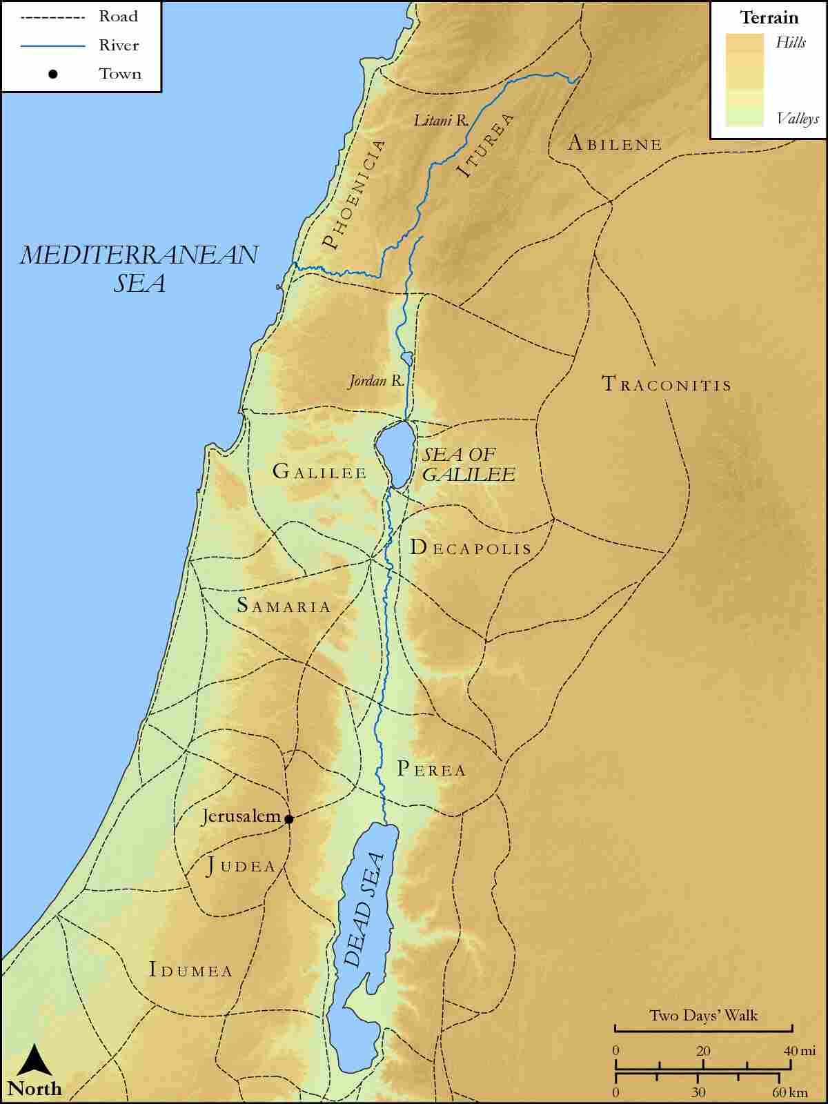
link

Jordan Valley Region

Image Content

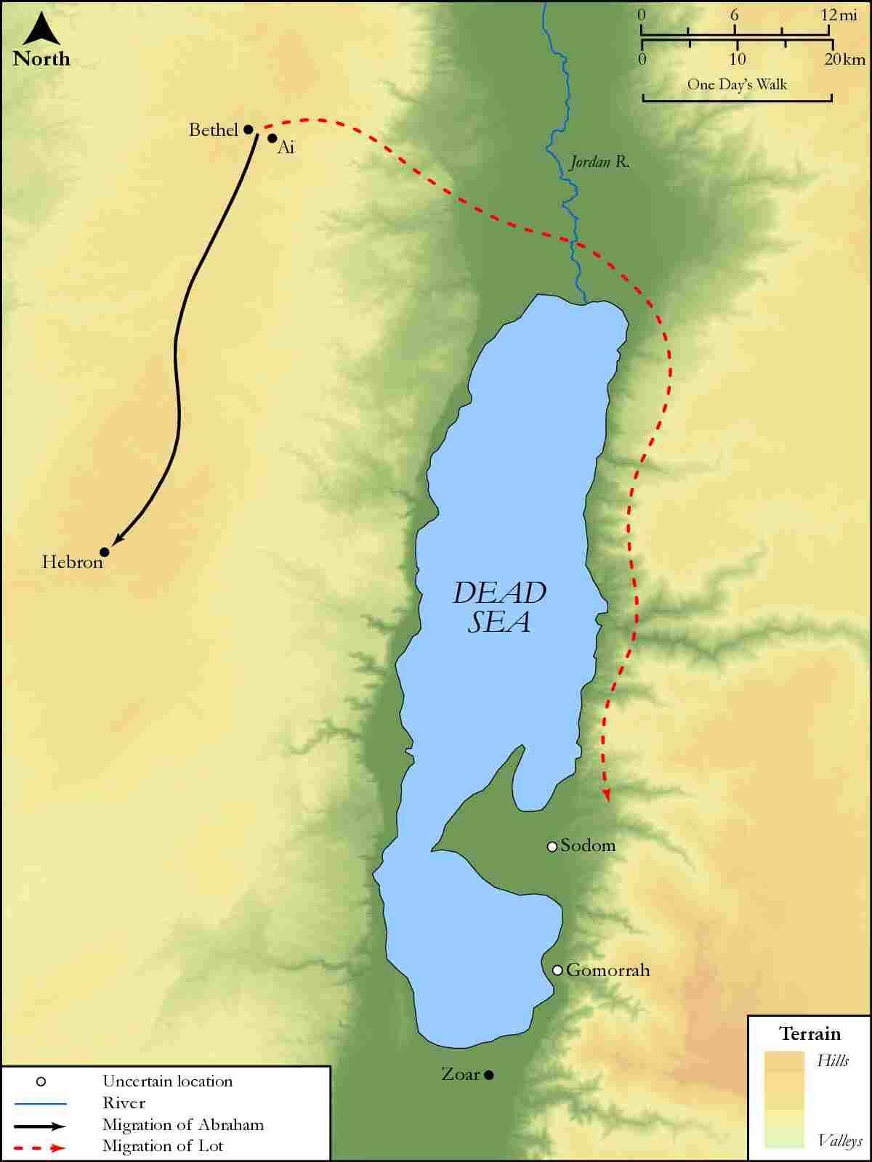
link

Joseph and Mary's Route from Nazareth to Bethlehem

Image Content

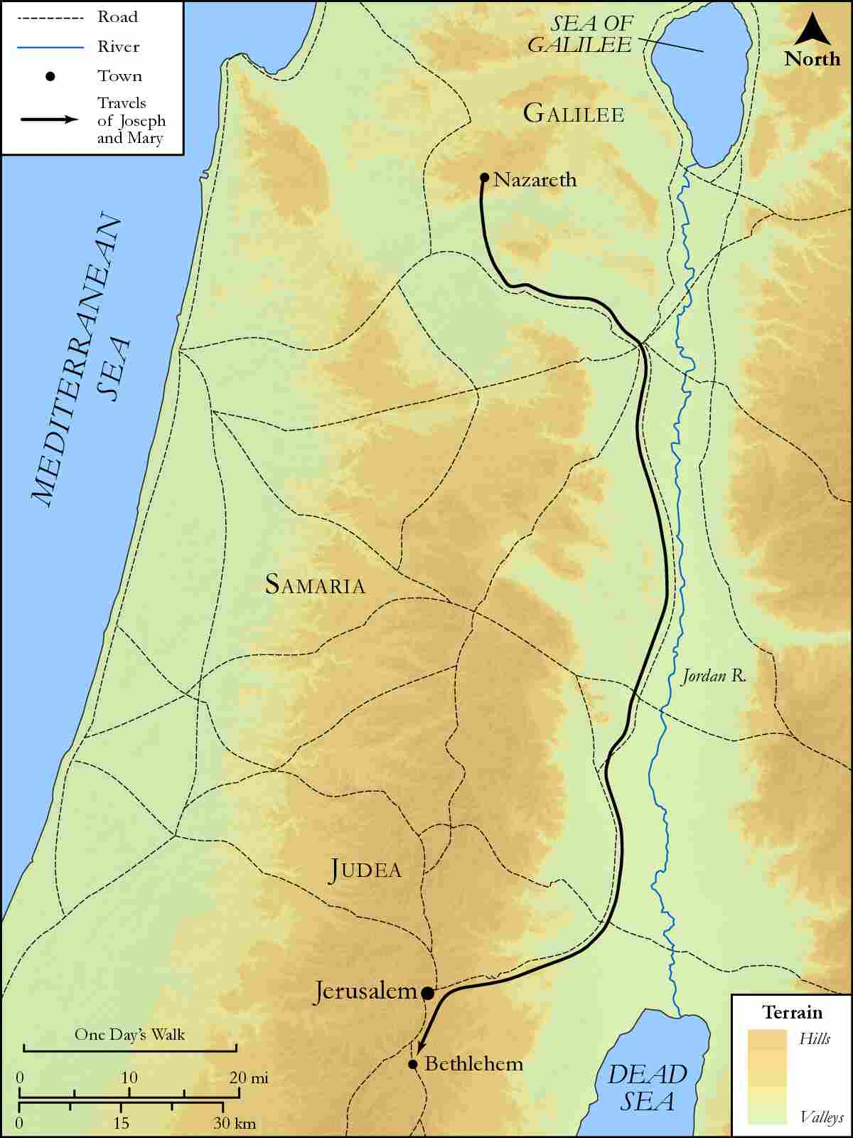
link

Joseph and Mary's Route from Nazareth to Jerusalem

Image Content

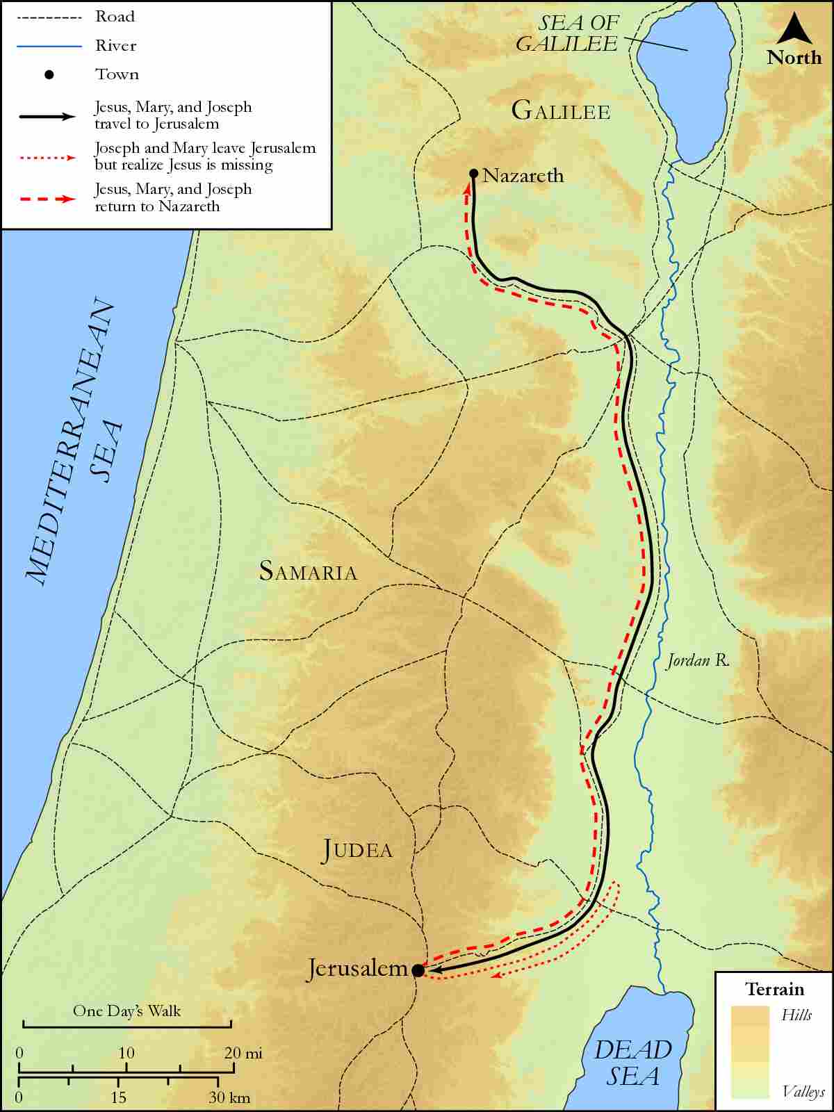
link

Judea and Dead Sea

Image Content

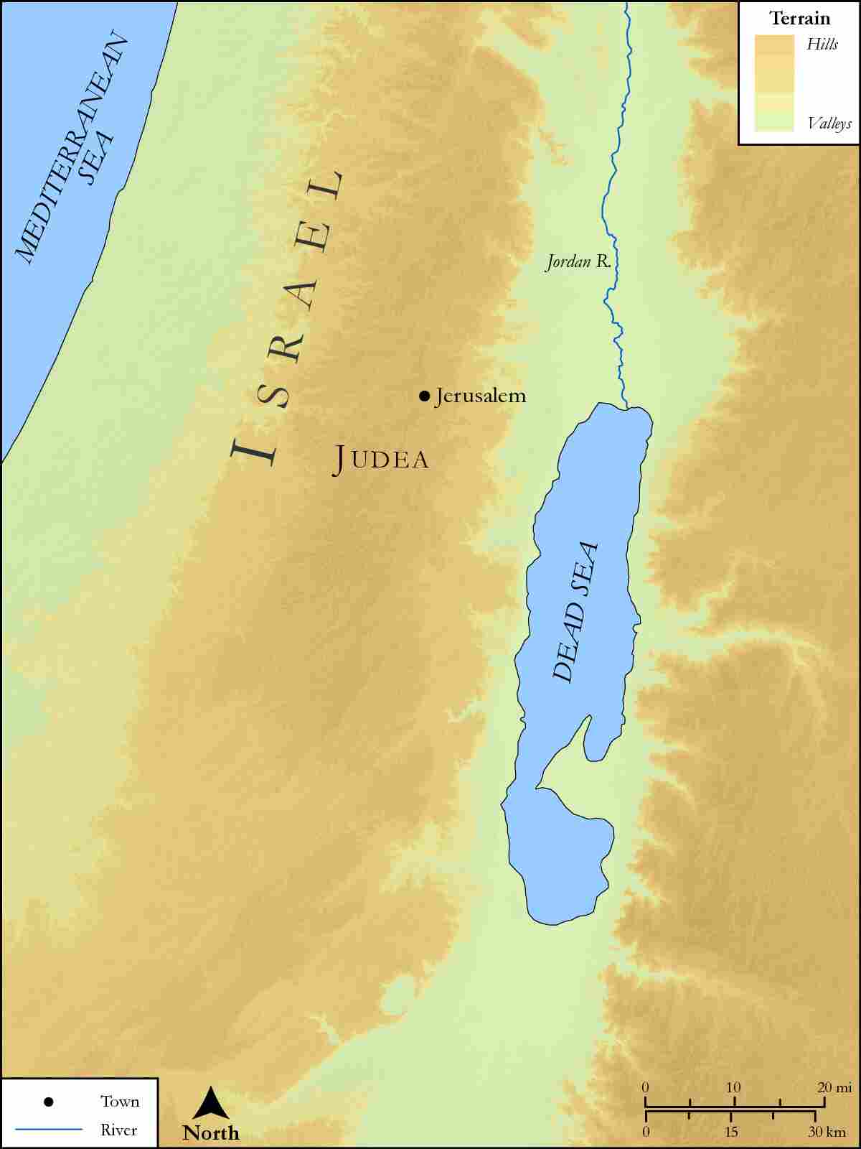
link

