Resource: Maps (SRV)
Familiarization, Internalization, Articulation (FIA) Maps © 2023 SRV Partners Released under CC BY-SA 4.0 license. Familiarization, Internalization, Articulation (FIA) Maps has been adapted in the following languages Tok Pisin, عربي, Français, हिंदी, Bahasa Indonesia, Português, Русский, Español, Kiswahili, 简体中文 from Familiarization, Internalization, Articulation (FIA) © 2023 SRV Partners. Released under CC BY-SA 4.0 license by Mission Mutual

Maps (SRV)

L
Lake with Bethsaida and Gennesaret, Lake with Capernaum and Bethsaida, Locations in the Book of Mark

Lake with Bethsaida and Gennesaret

Image Content

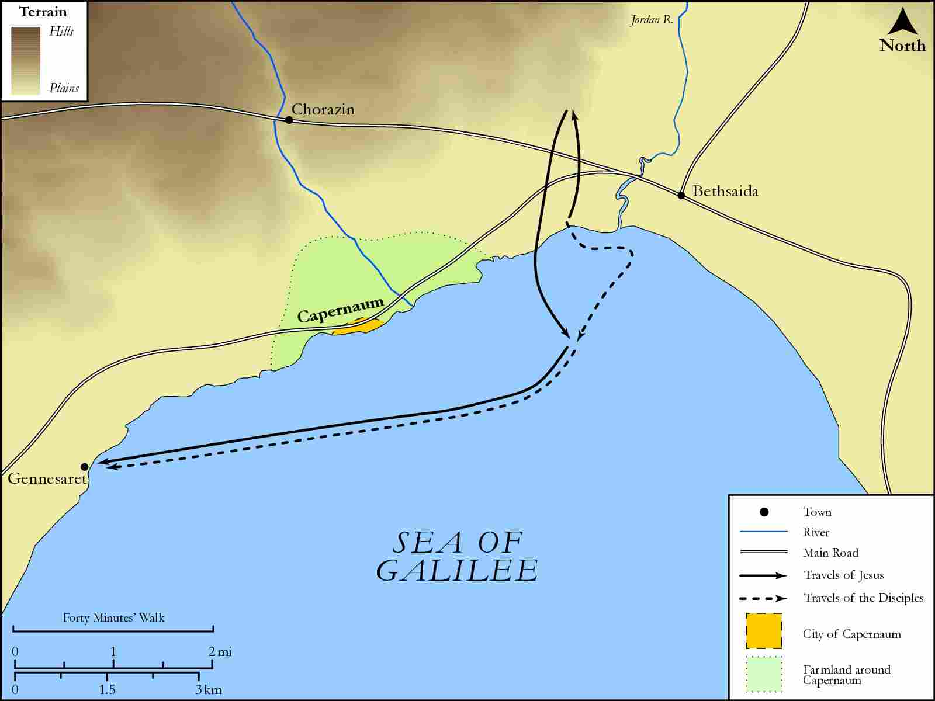
link

Lake with Capernaum and Bethsaida

Image Content

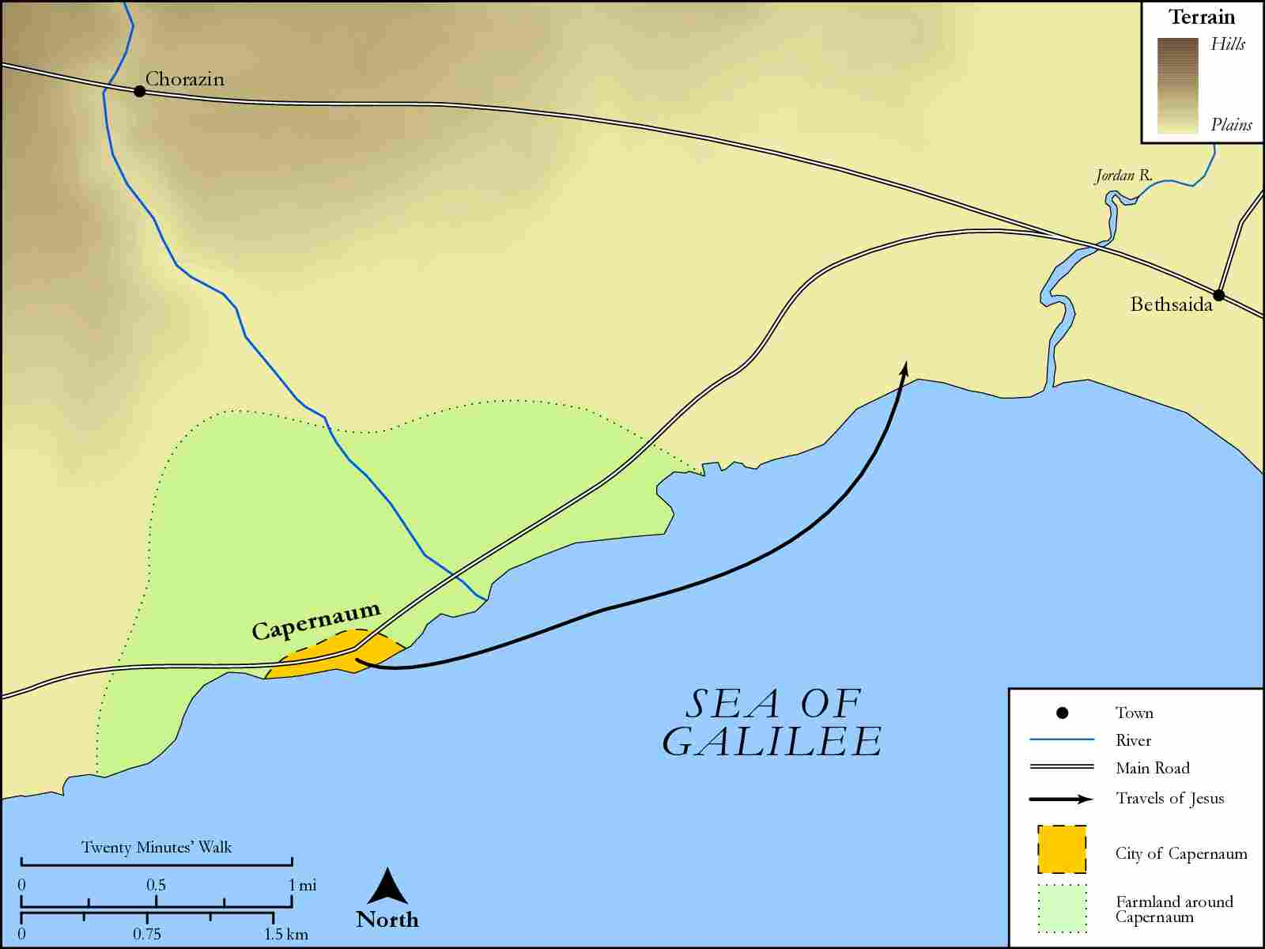
link

Locations in the Book of Mark

Image Content

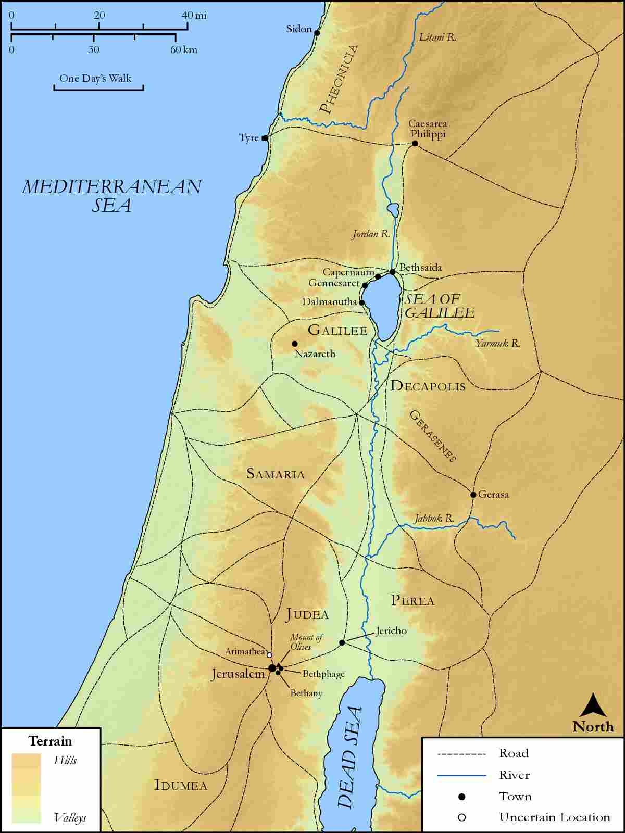
link

