Resource: Maps (SRV)
Familiarization, Internalization, Articulation (FIA) Maps © 2023 SRV Partners Released under CC BY-SA 4.0 license. Familiarization, Internalization, Articulation (FIA) Maps has been adapted in the following languages Tok Pisin, عربي, Français, हिंदी, Bahasa Indonesia, Português, Русский, Español, Kiswahili, 简体中文 from Familiarization, Internalization, Articulation (FIA) © 2023 SRV Partners. Released under CC BY-SA 4.0 license by Mission Mutual

Maps (SRV)

P
Paddan-Aram and Surrounding Areas, People Groups Between Egypt and the Euphrates, Pilate's House

Paddan-Aram and Surrounding Areas

Image Content

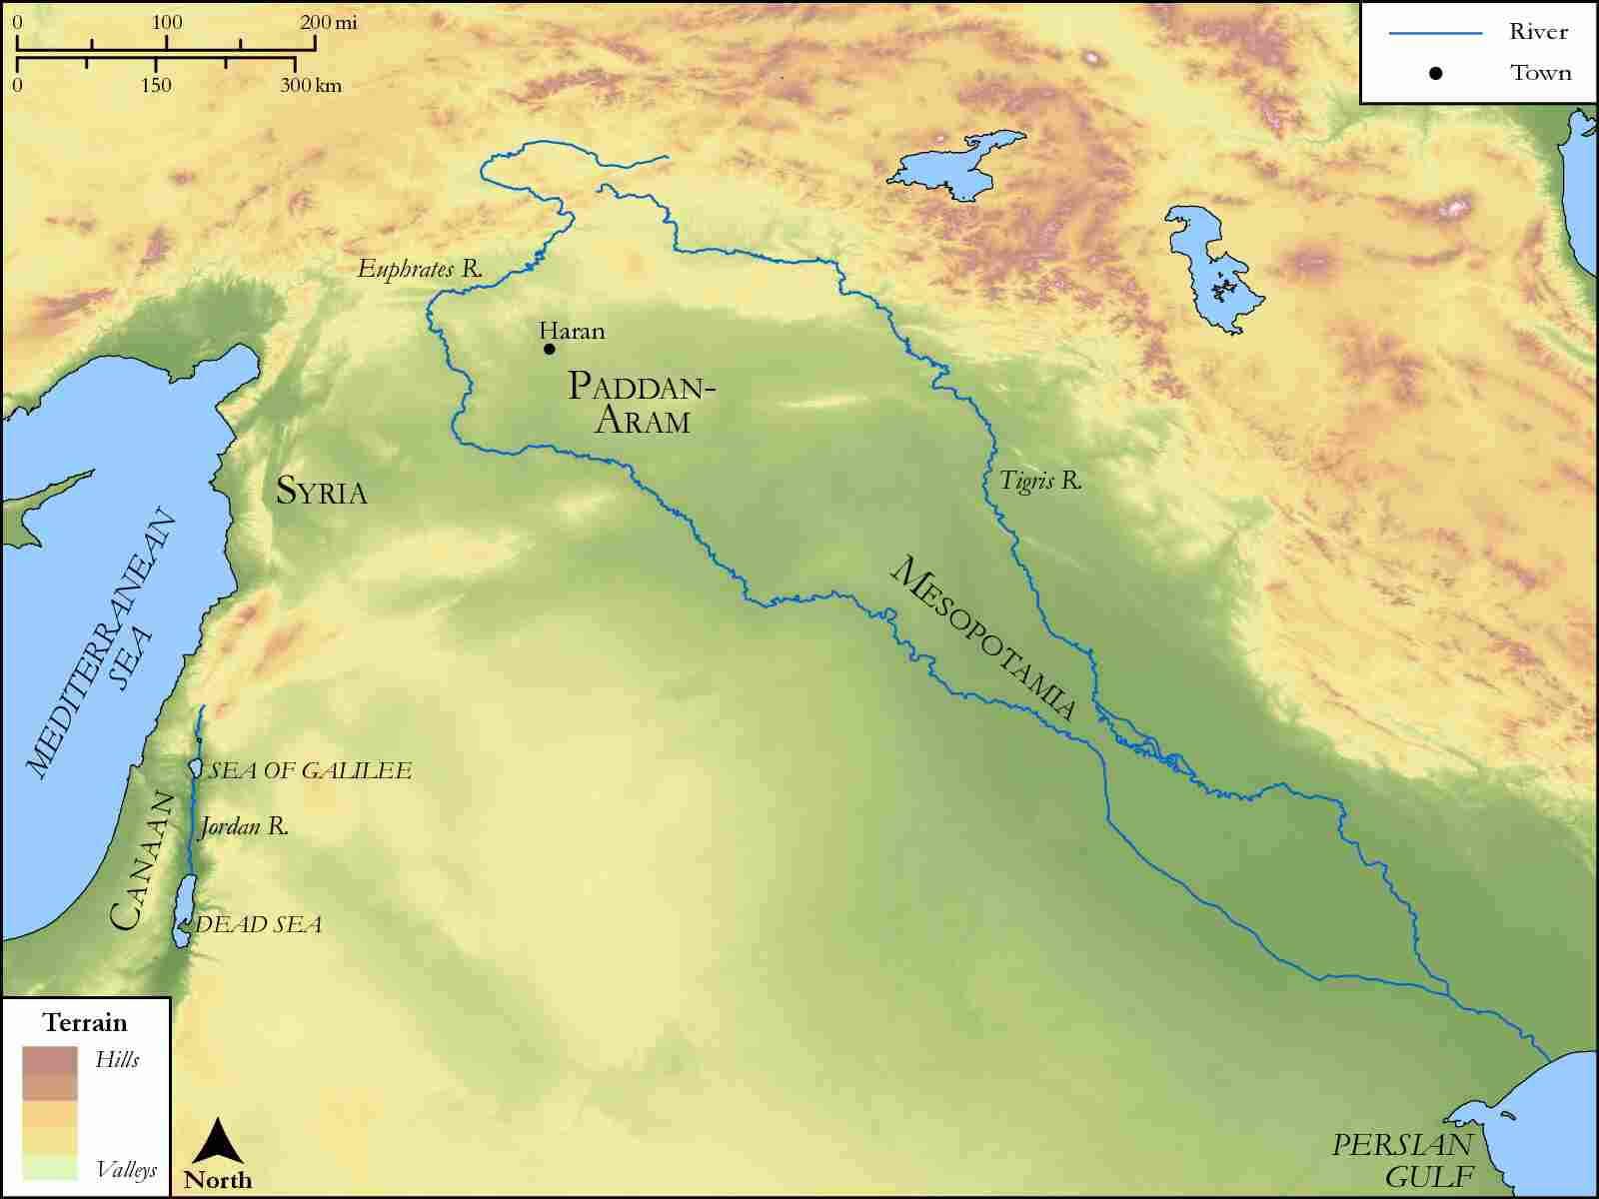
link

People Groups Between Egypt and the Euphrates

Image Content

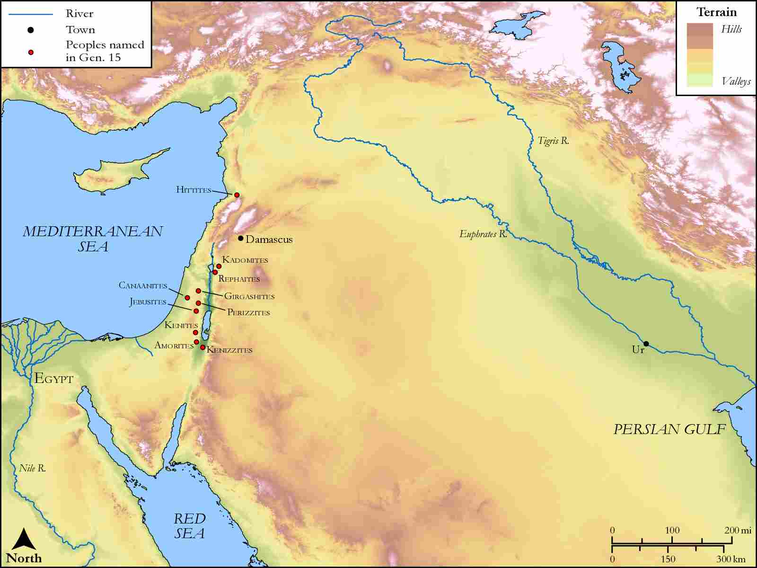
link

Pilate's House

Image Content

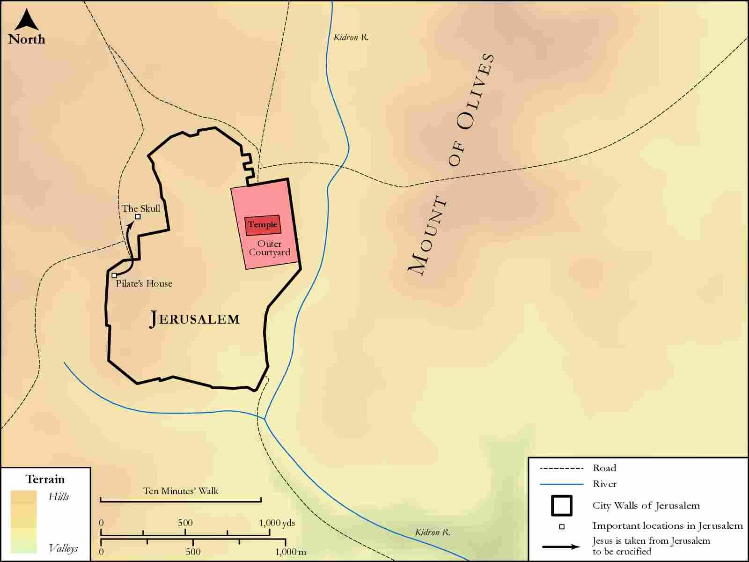
link

