Resource: Maps (SRV)
Familiarization, Internalization, Articulation (FIA) Maps © 2023 SRV Partners Released under CC BY-SA 4.0 license. Familiarization, Internalization, Articulation (FIA) Maps has been adapted in the following languages Tok Pisin, عربي, Français, हिंदी, Bahasa Indonesia, Português, Русский, Español, Kiswahili, 简体中文 from Familiarization, Internalization, Articulation (FIA) © 2023 SRV Partners. Released under CC BY-SA 4.0 license by Mission Mutual

Maps (SRV)

R
Rebel Kings in the South, Region of Seir, Region of the Gerasenes to Capernaum, Road to Shur, Route from Bethsaida to Caeserea Philippi

Rebel Kings in the South

Image Content

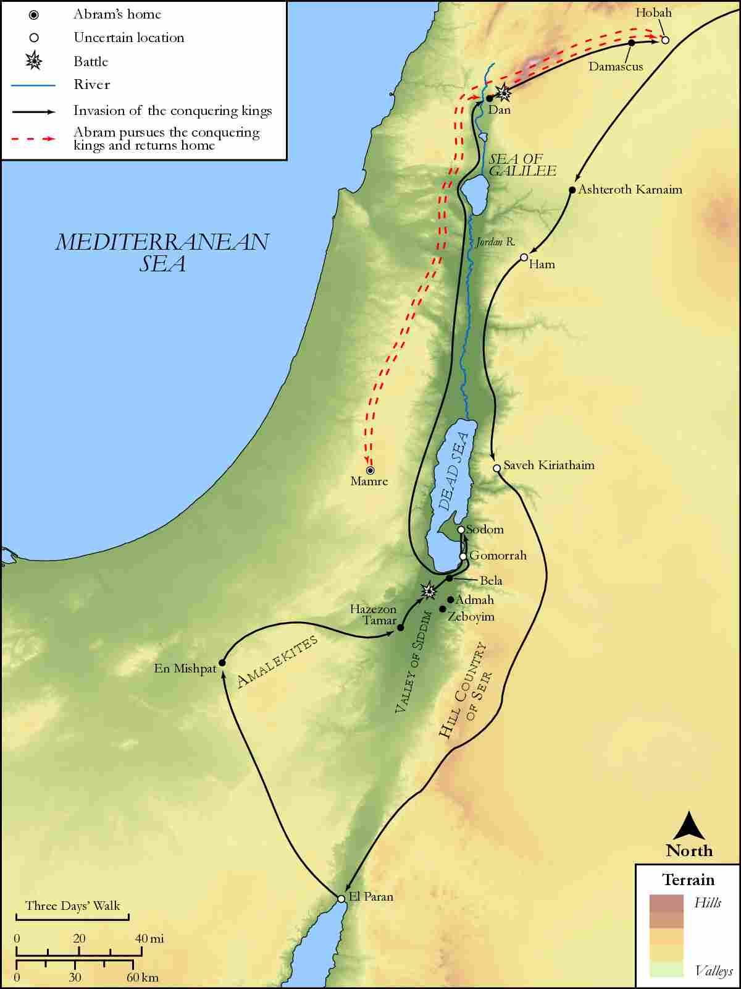
link

Region of Seir

Image Content

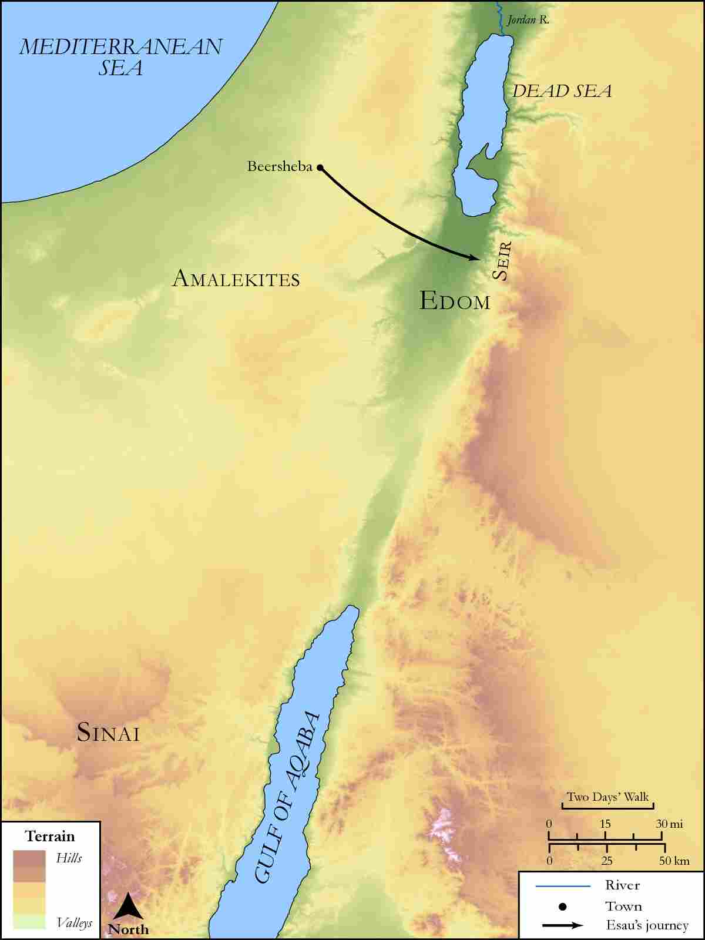
link

Region of the Gerasenes to Capernaum

Image Content

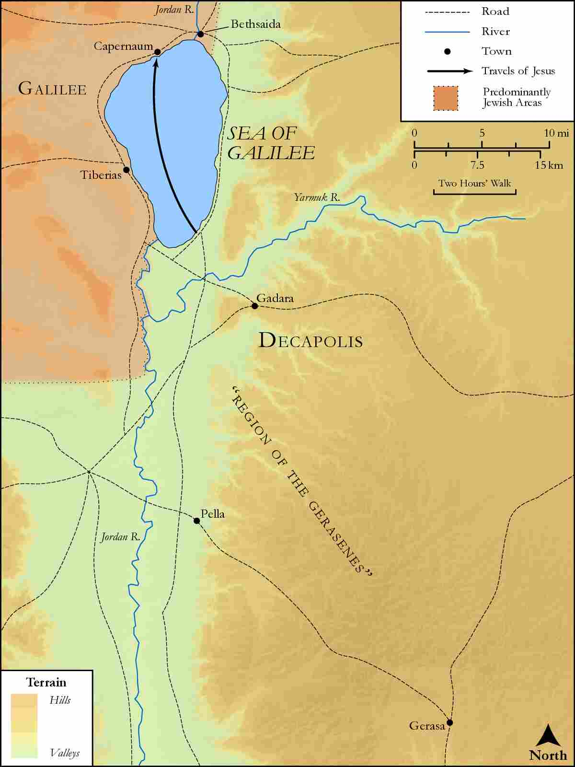
link

Road to Shur

Image Content

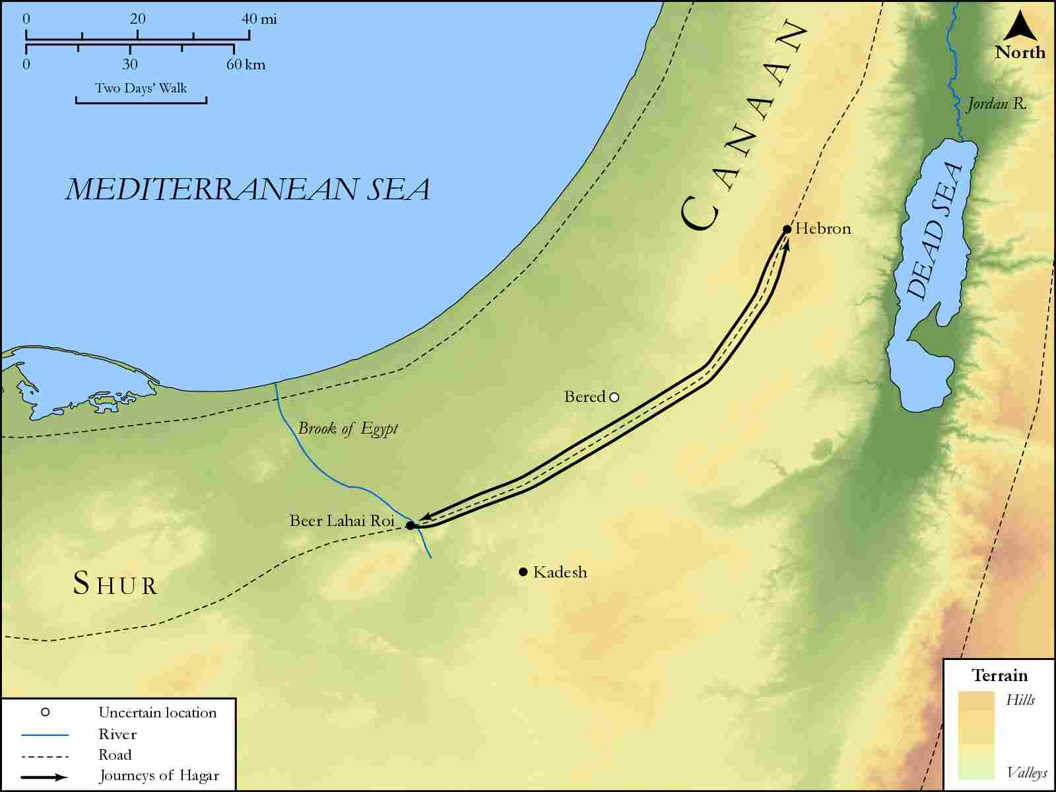
link

Route from Bethsaida to Caeserea Philippi

Image Content

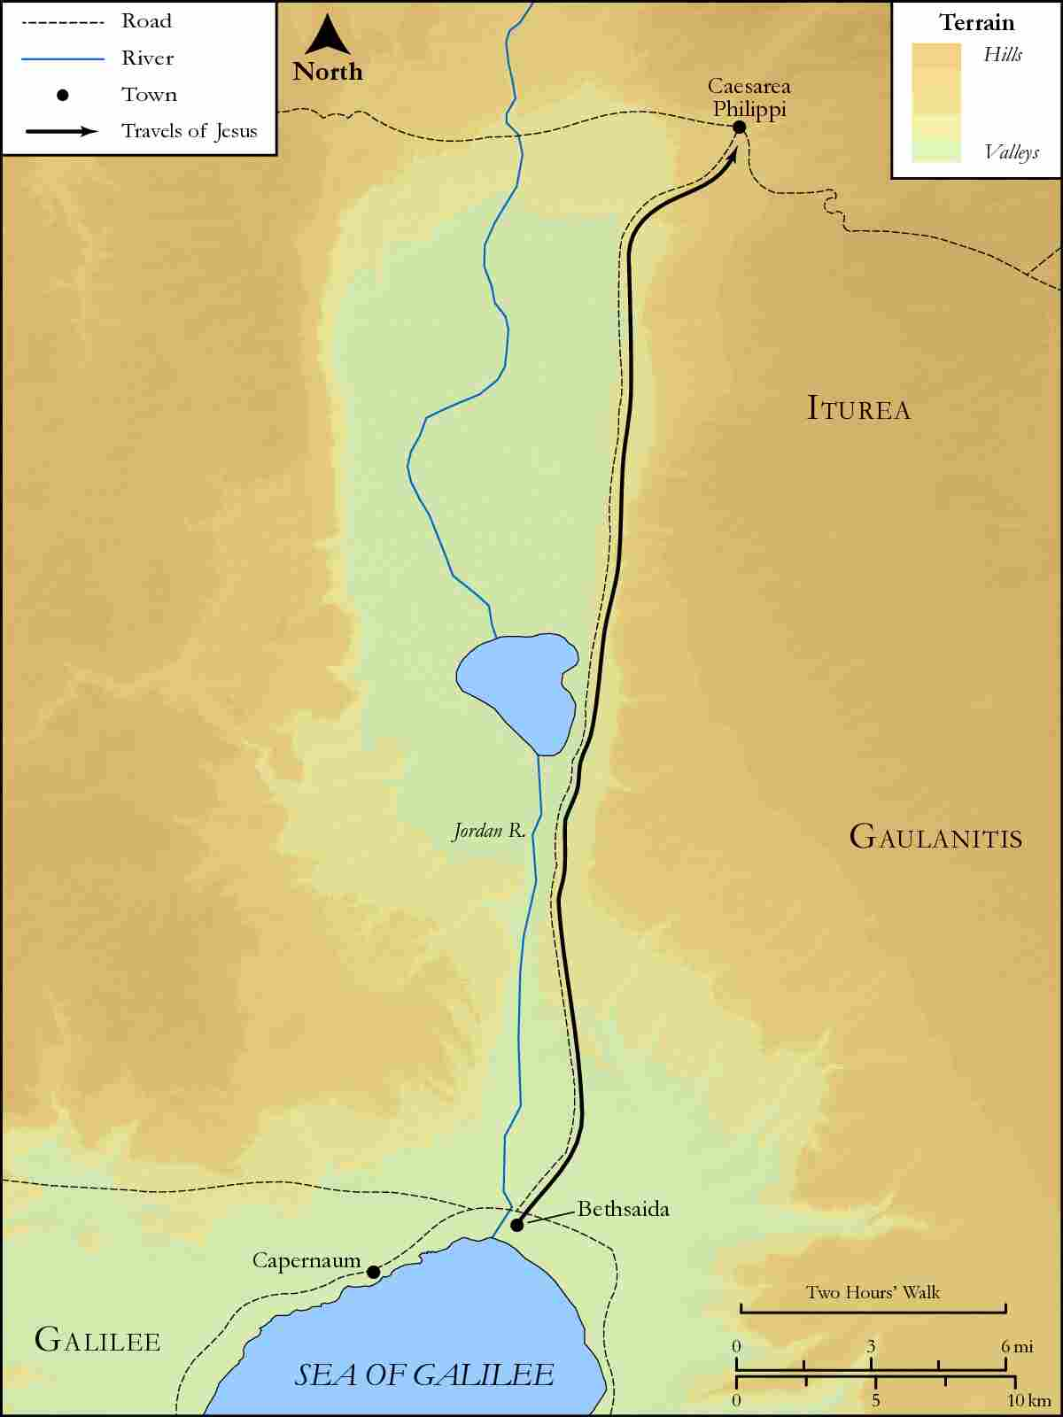
link

