Resource: Maps (SRV)
Familiarization, Internalization, Articulation (FIA) Maps © 2023 SRV Partners Released under CC BY-SA 4.0 license. Familiarization, Internalization, Articulation (FIA) Maps has been adapted in the following languages Tok Pisin, عربي, Français, हिंदी, Bahasa Indonesia, Português, Русский, Español, Kiswahili, 简体中文 from Familiarization, Internalization, Articulation (FIA) © 2023 SRV Partners. Released under CC BY-SA 4.0 license by Mission Mutual

Maps (SRV)

S
Sea of Galilee Western Side, Sea of Galilee with Bethsaida, Sea of Galilee with Capernaum and Decapolis, Sidon, Sidon and Syria, Sodom, Gomorrah and Great Oaks of Mamre

Sea of Galilee Western Side

Image Content

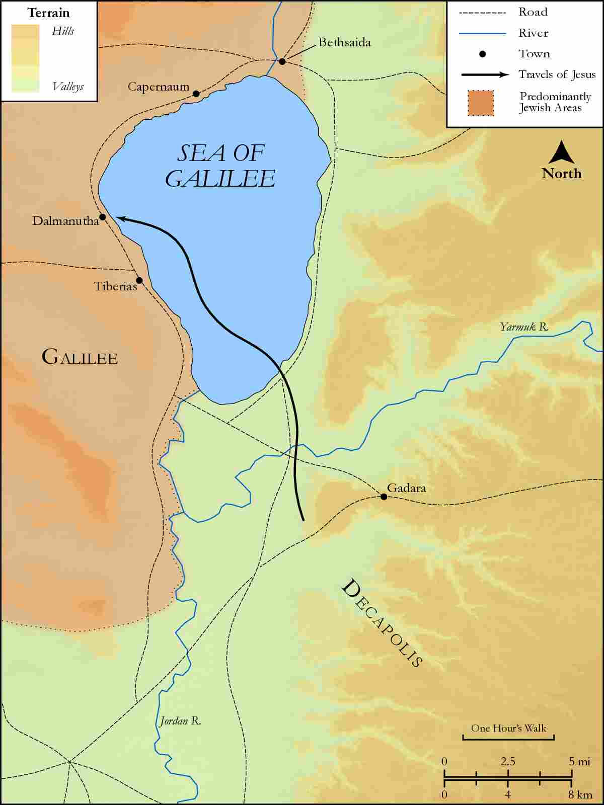
link

Sea of Galilee with Bethsaida

Image Content

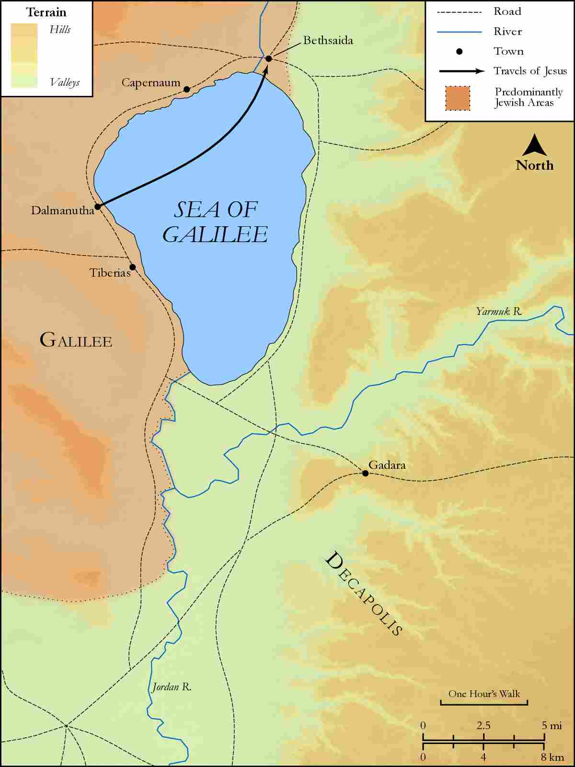
link

Sea of Galilee with Capernaum and Decapolis

Image Content

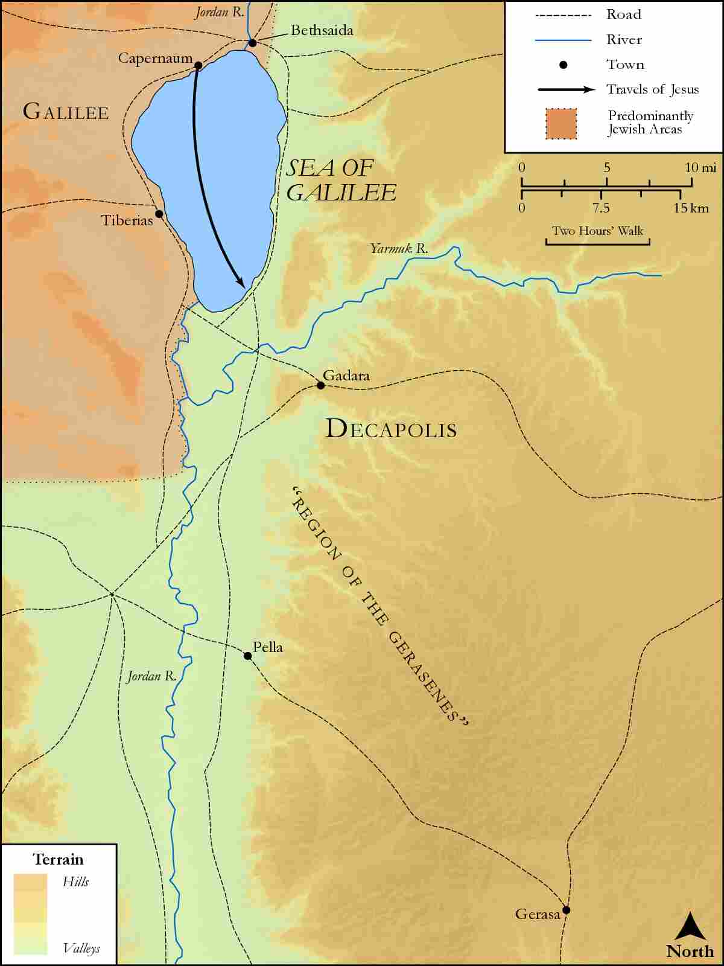
link

Sidon

Image Content

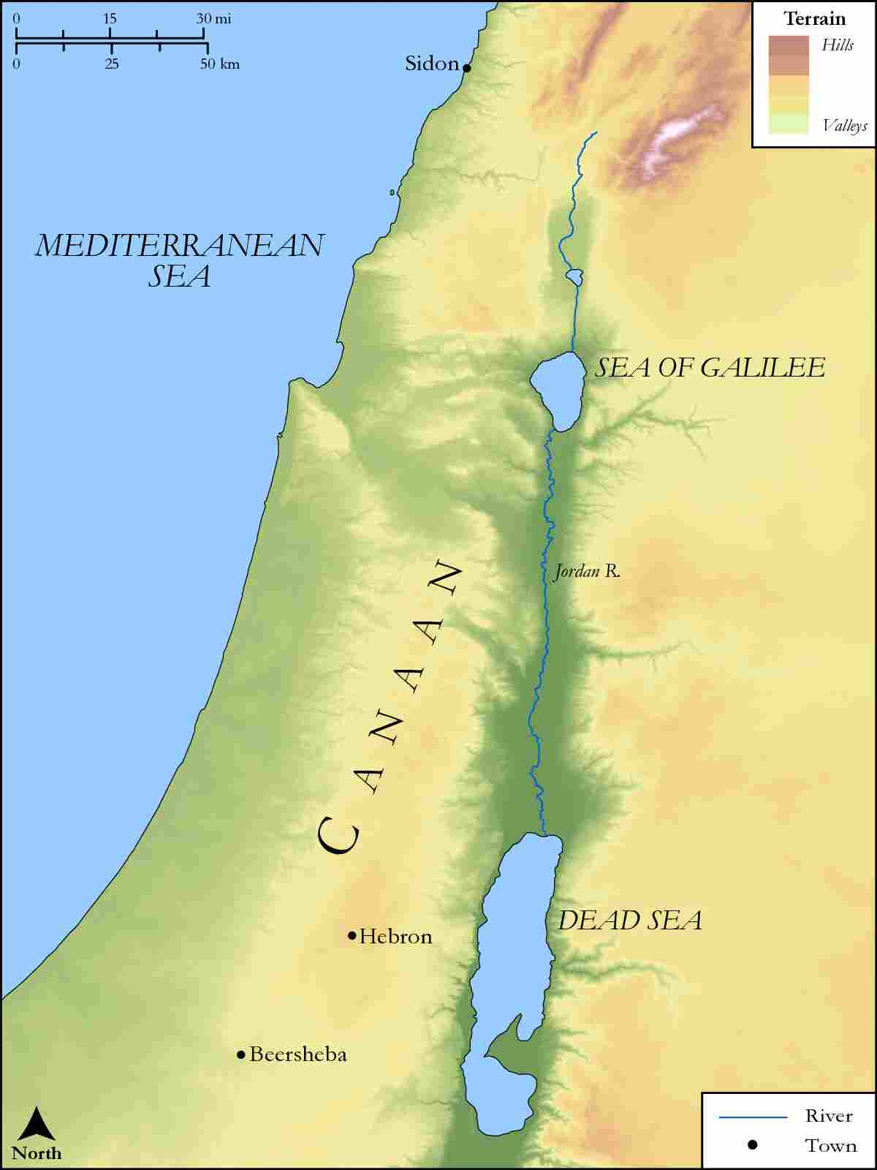
link

Sidon and Syria

Image Content

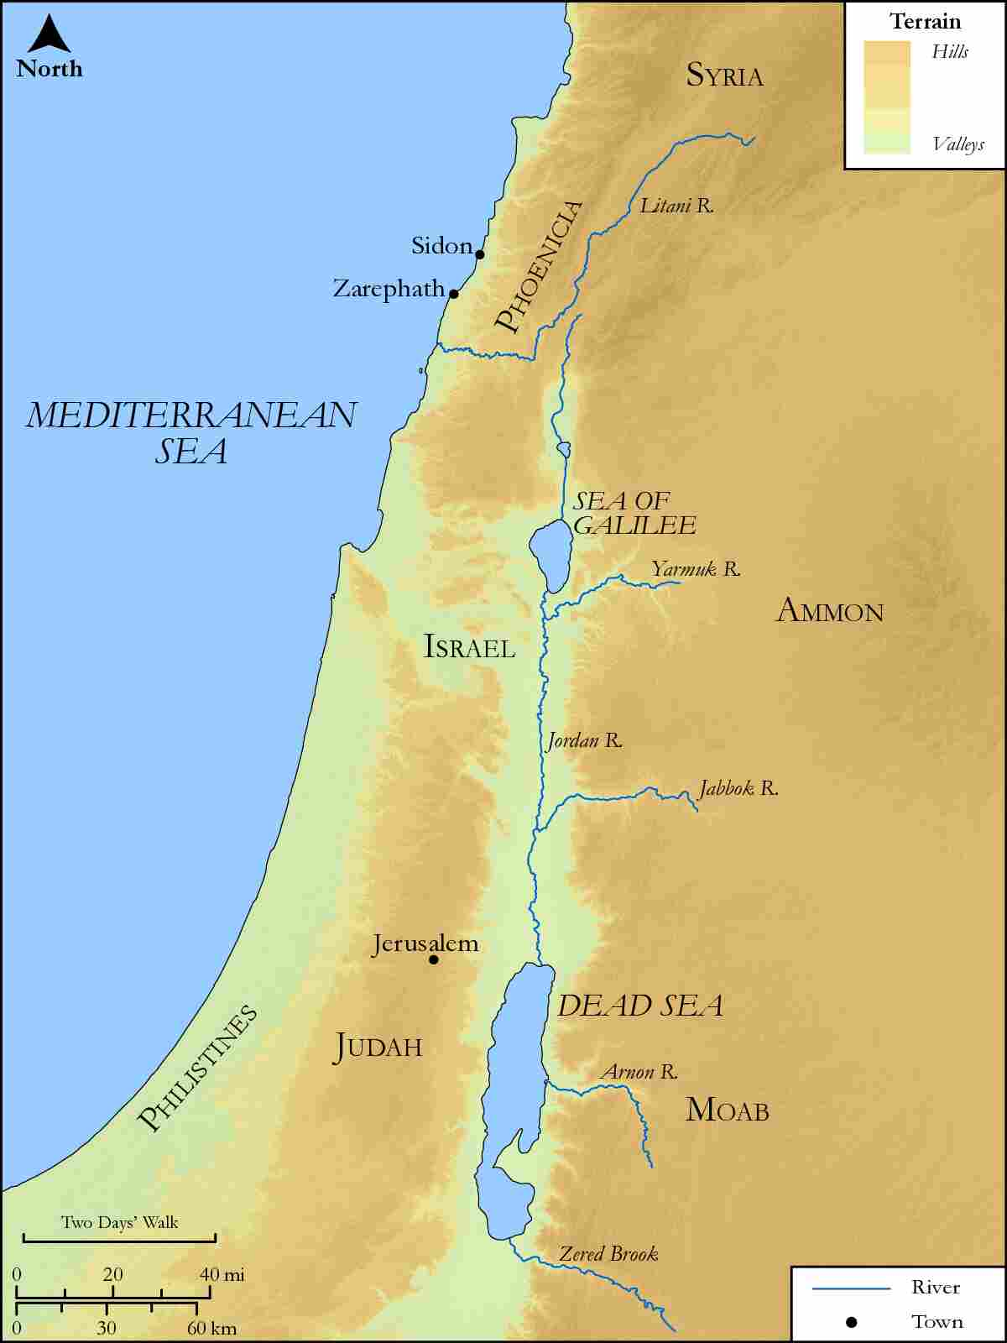
link

Sodom, Gomorrah and Great Oaks of Mamre

Image Content

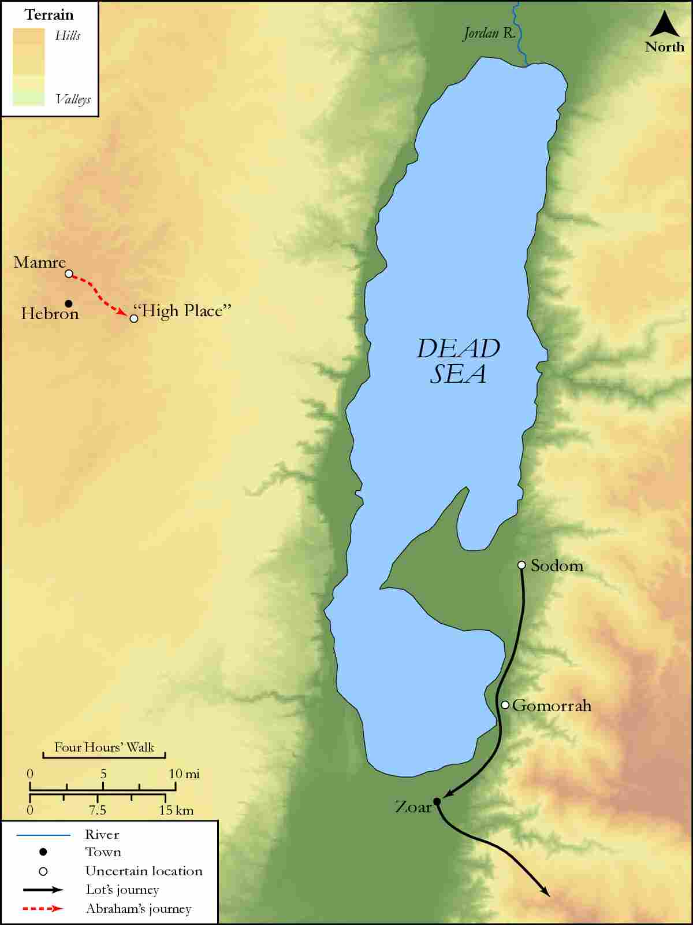
link

