License Information
Familiarization, Internalization, Articulation (FIA) Maps is based on: Familiarization, Internalization, Articulation (Fia) Maps, Biblica Inc., 2023, which is licensed under a CC BY-SA 4.0 license.
This PDF version is provided under the same license.

Familiarization, Internalization, Articulation (FIA) Maps

Abram's Journey from Ur to Canaan

Image Content

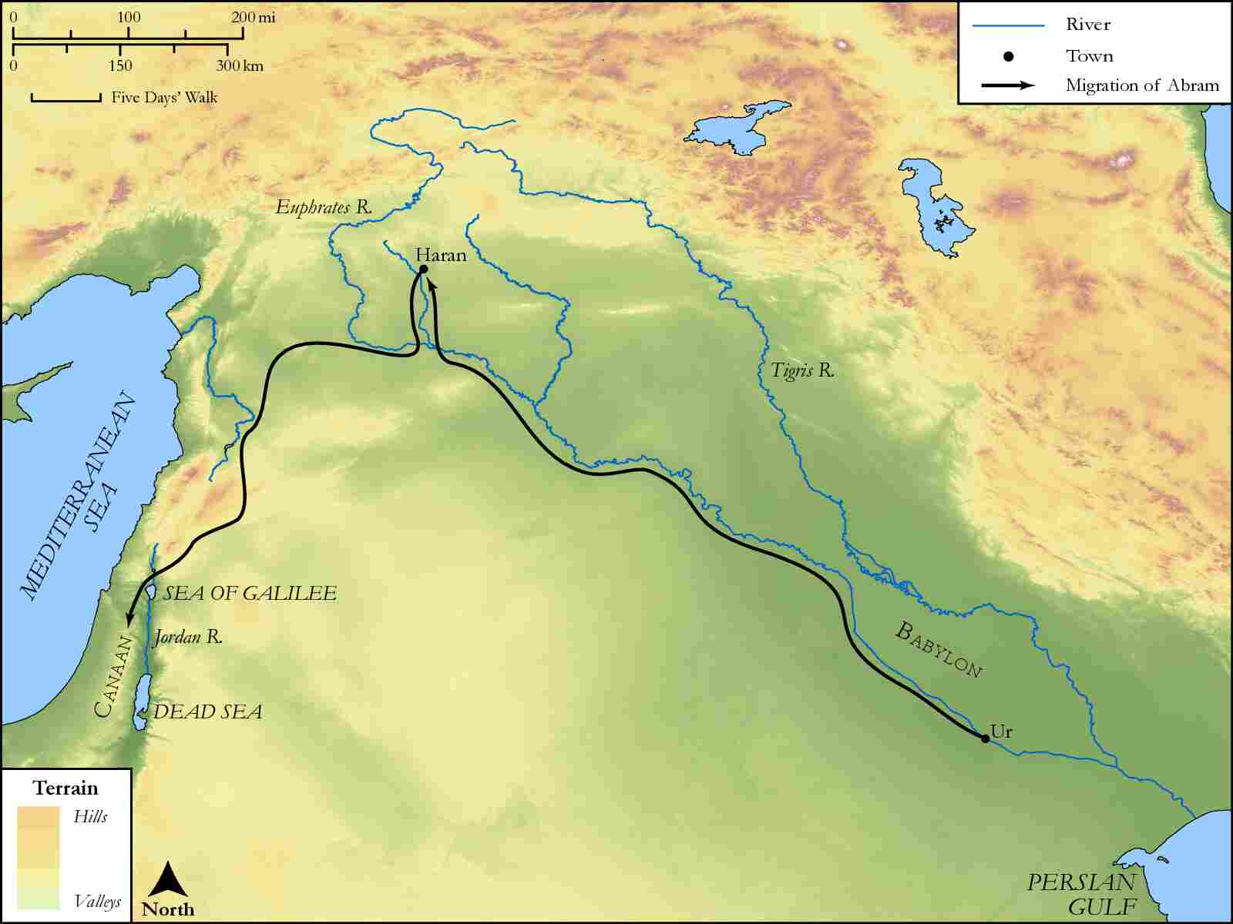
link

Beer Lahai Roi

Image Content

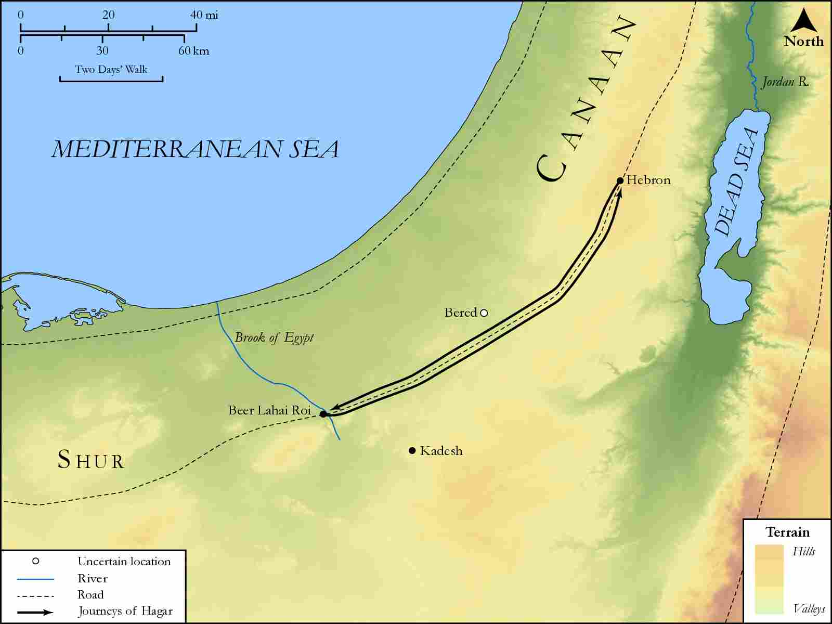
link

Beersheba and Moriah

Image Content

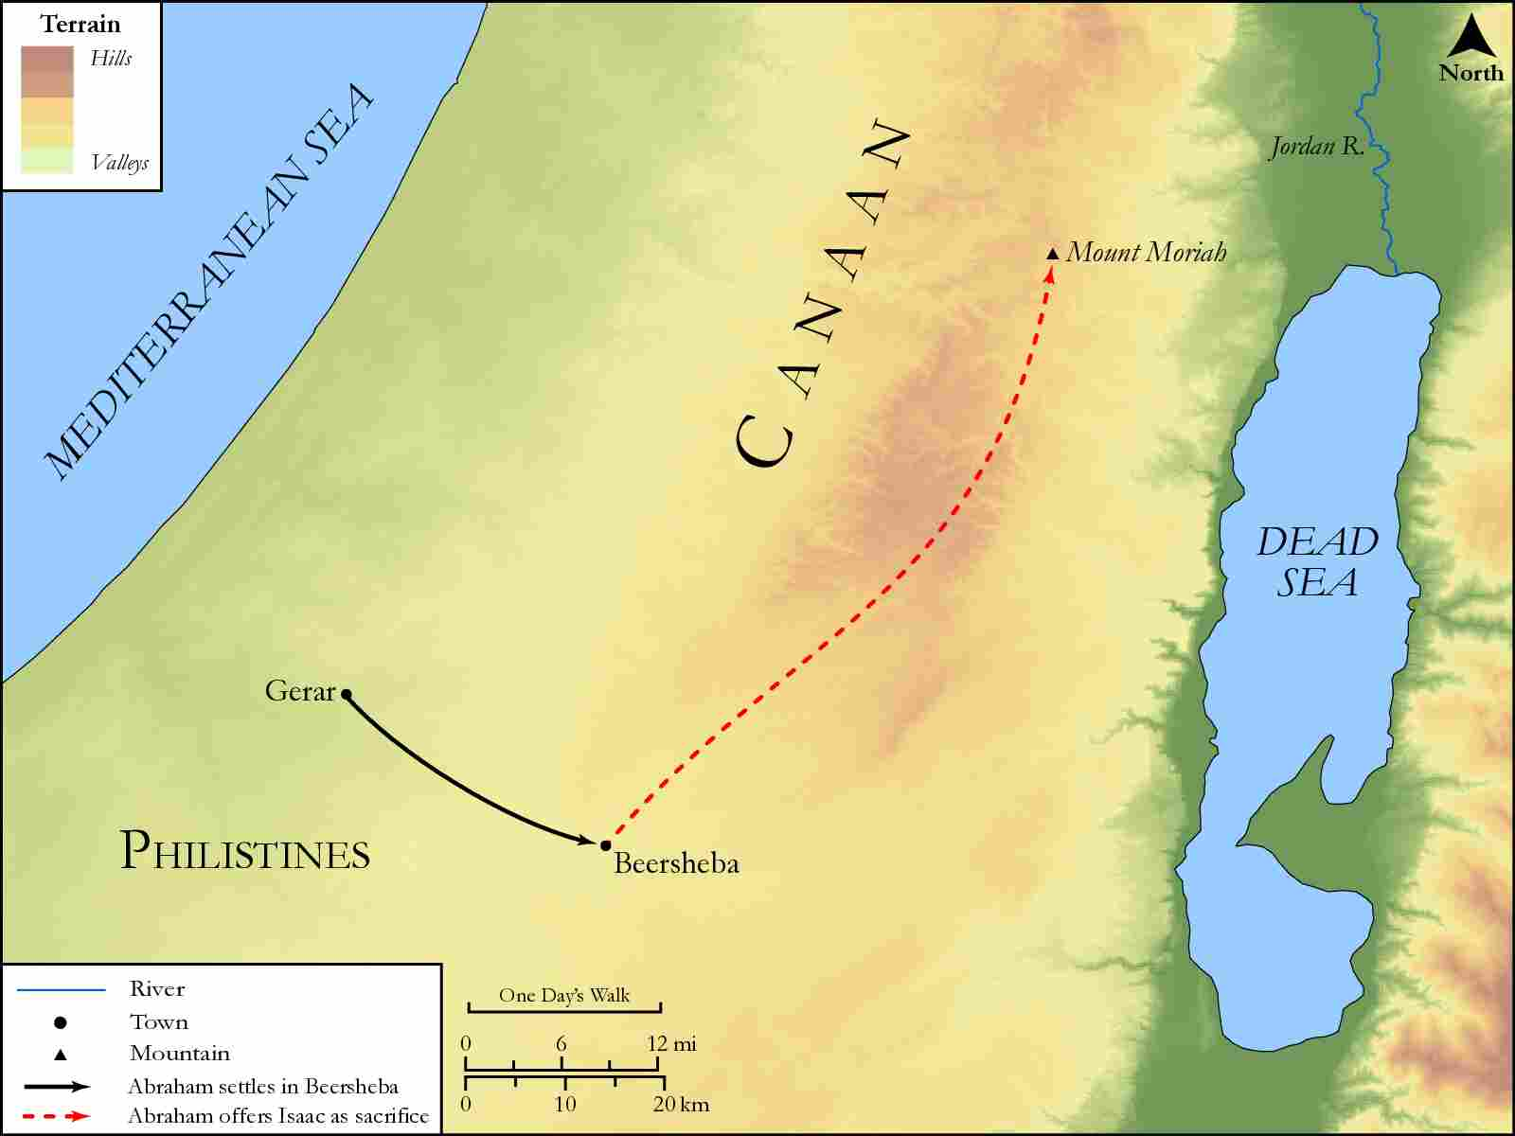
link

Beersheba, Paran and Egypt

Image Content

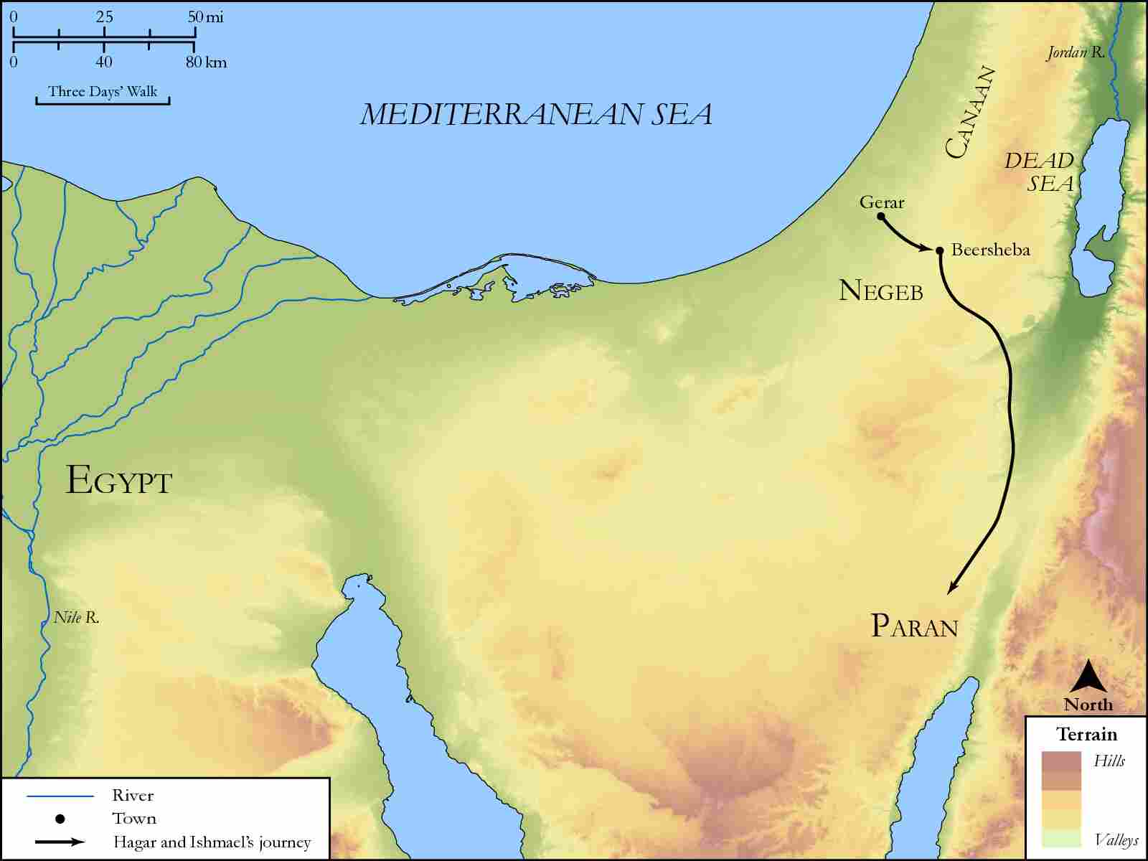
link

Bethlehem to Jerusalem

Image Content

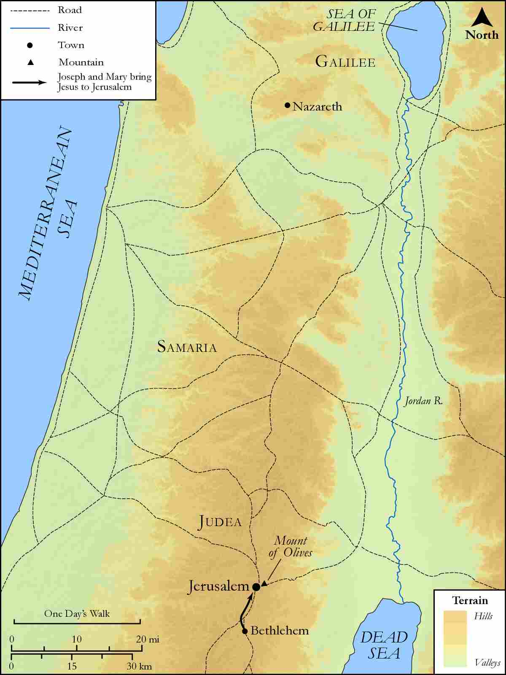
link

Canaan to Egypt

Image Content

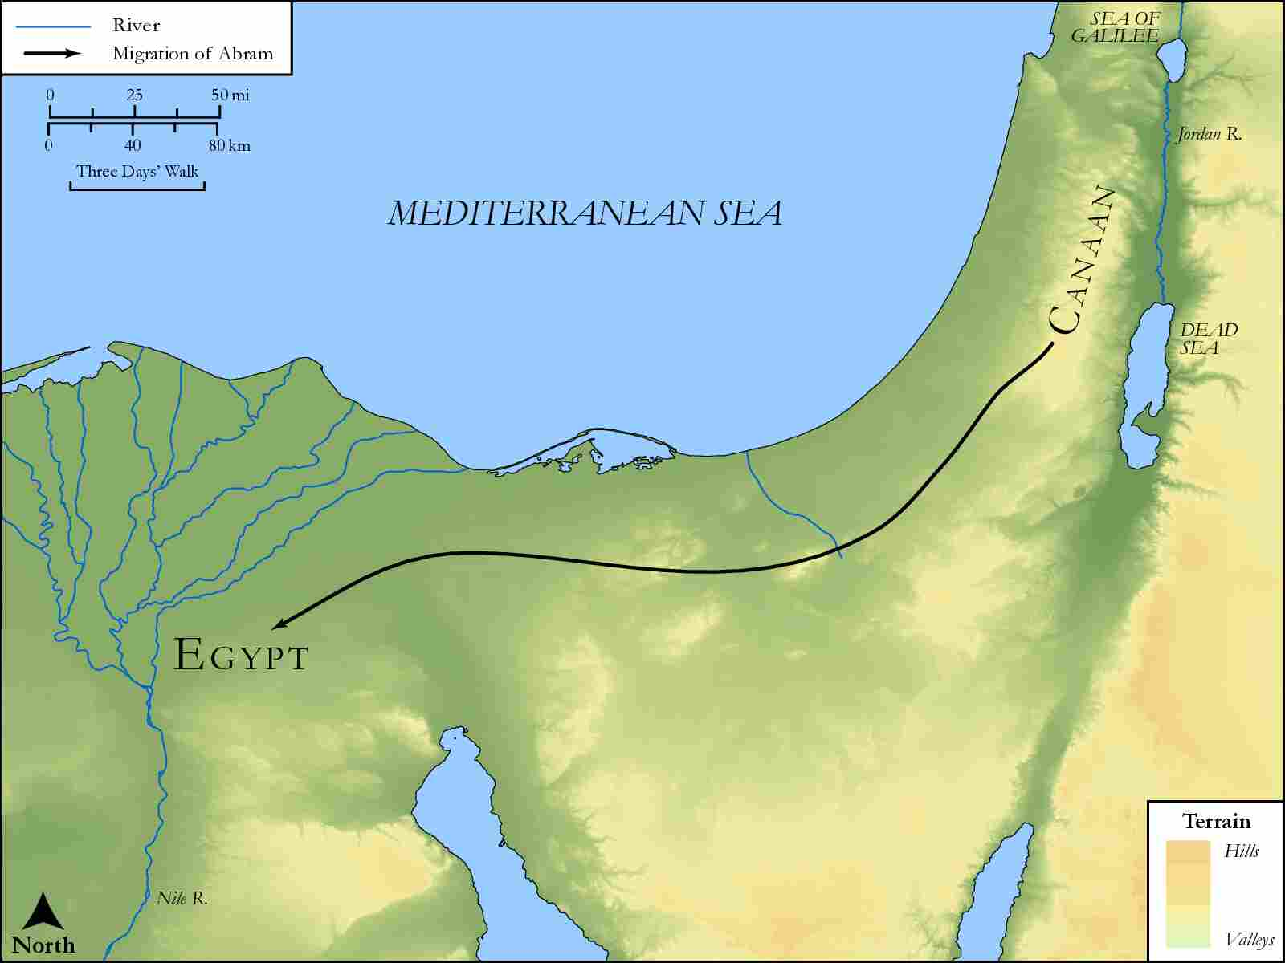
link

Capernaum on Route from Egypt to Damascus

Image Content

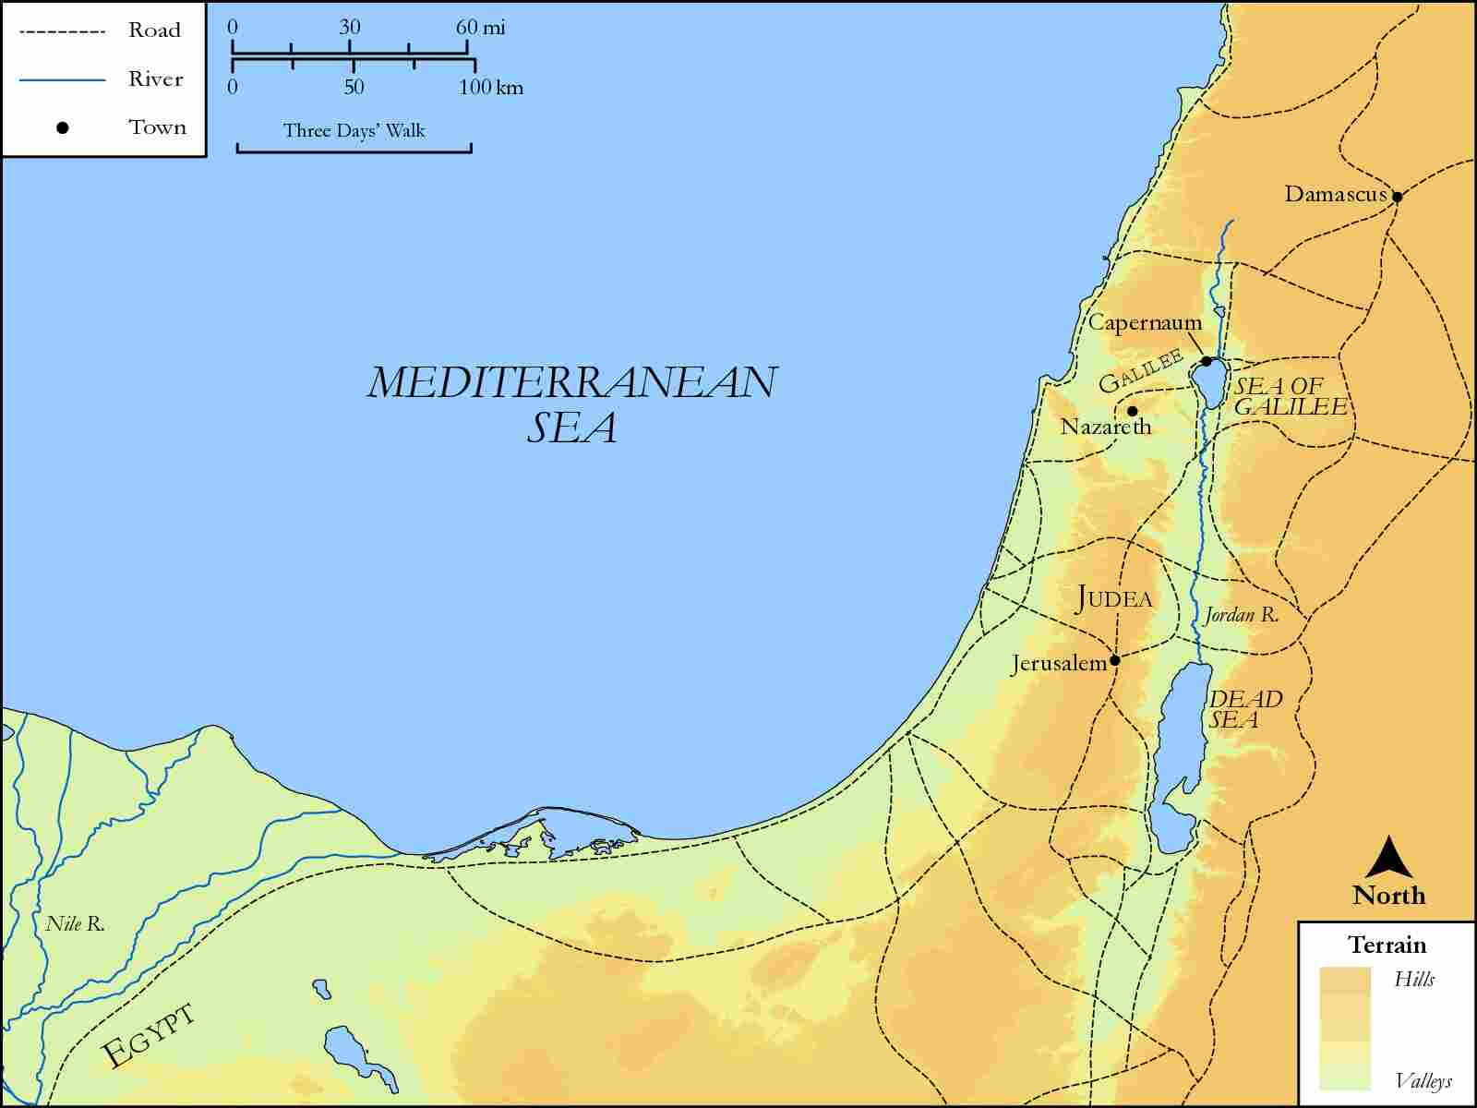
link

Capernaum to Decapolis

Image Content

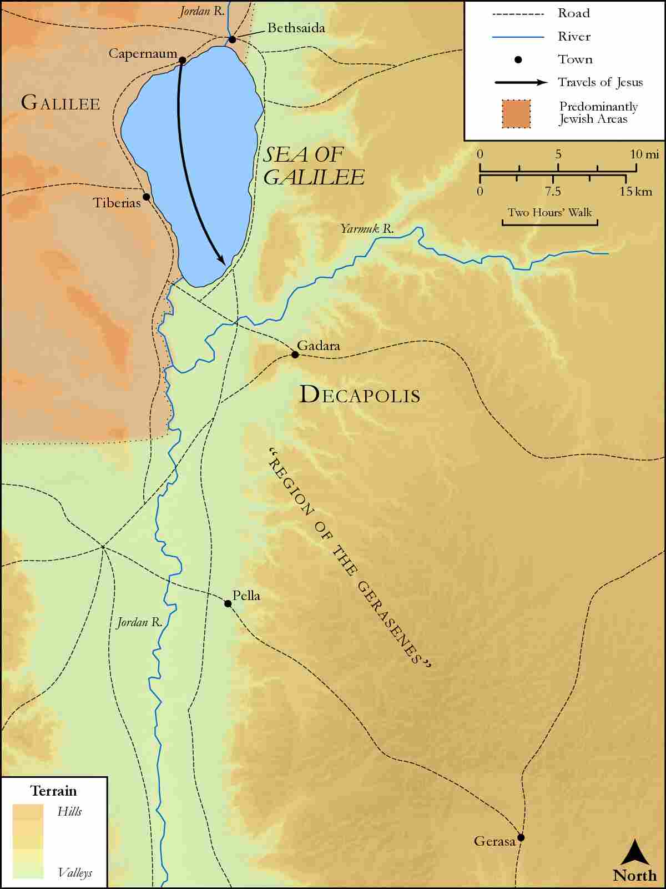
link

Capernaum with Judea and Jordan River

Image Content

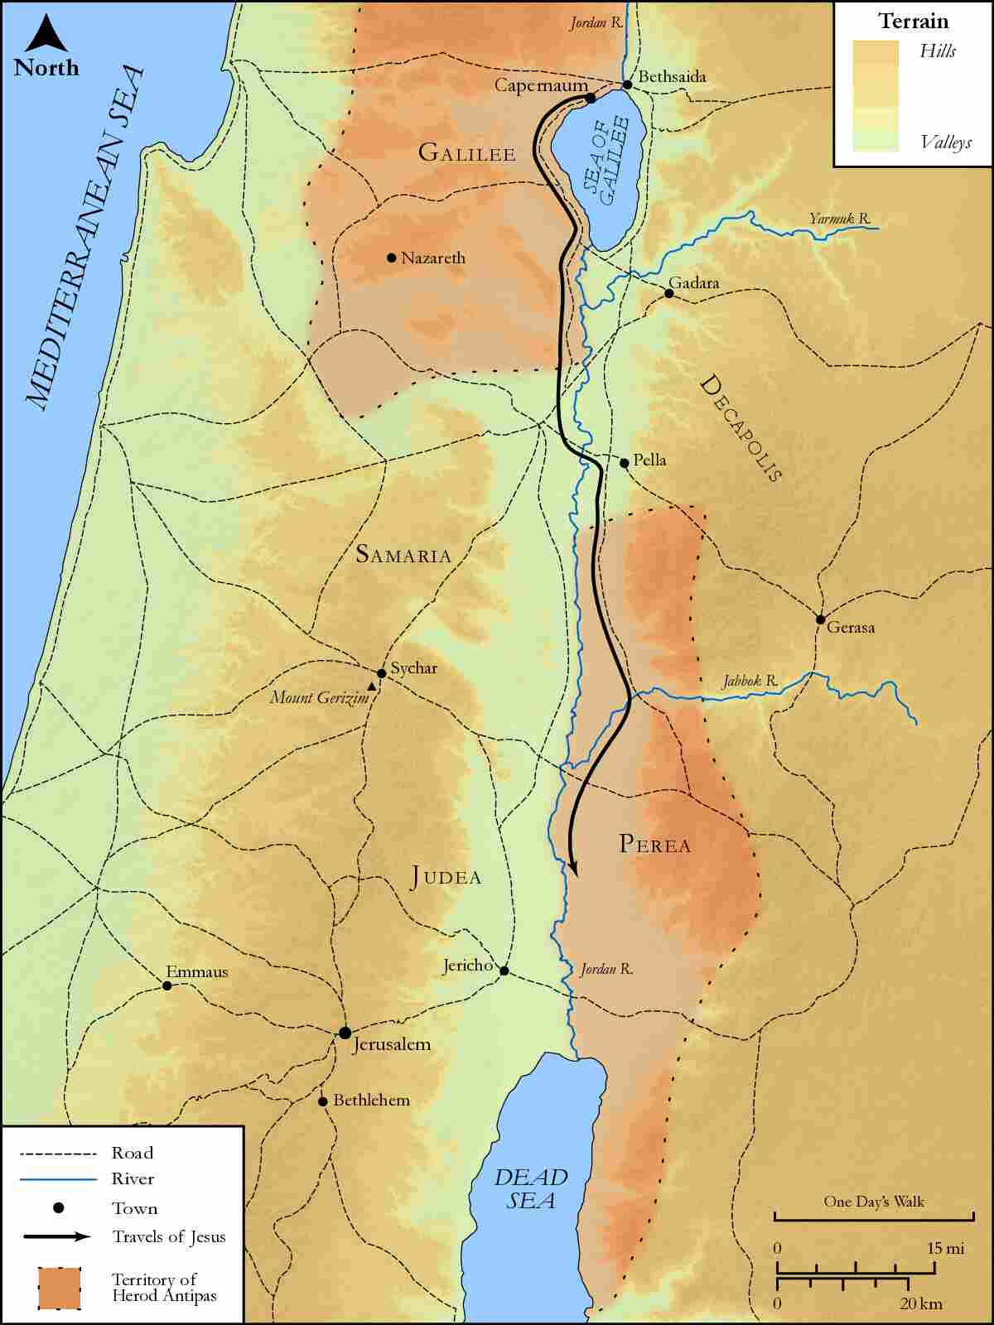
link

Edom and Seir

Image Content

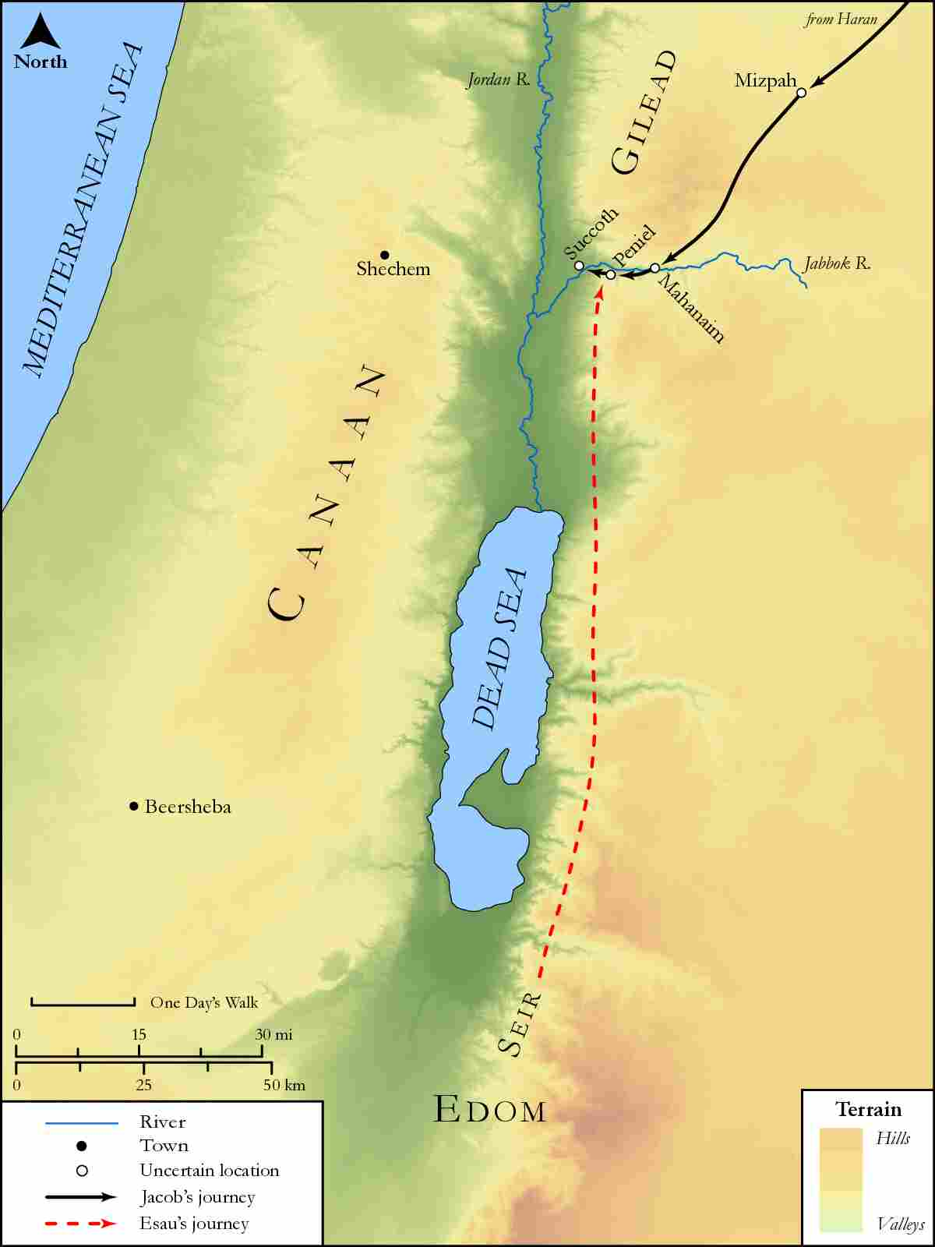
link

Edom, Seir, Median, Moab and Bozrah

Image Content

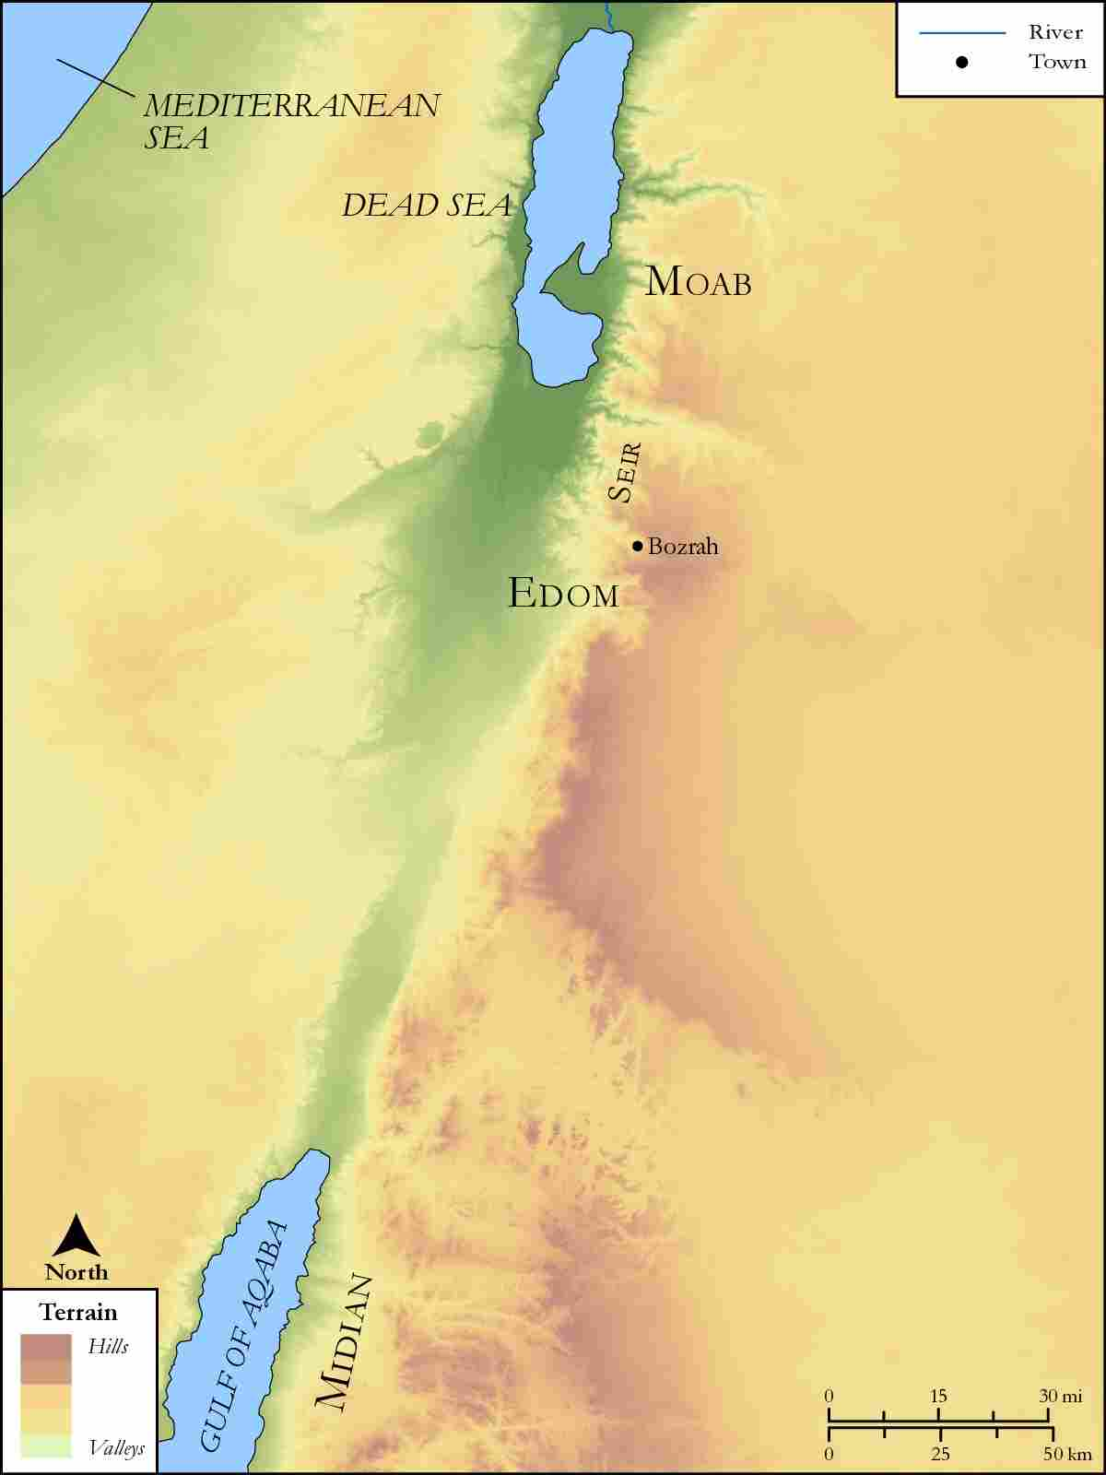
link

Egypt

Image Content

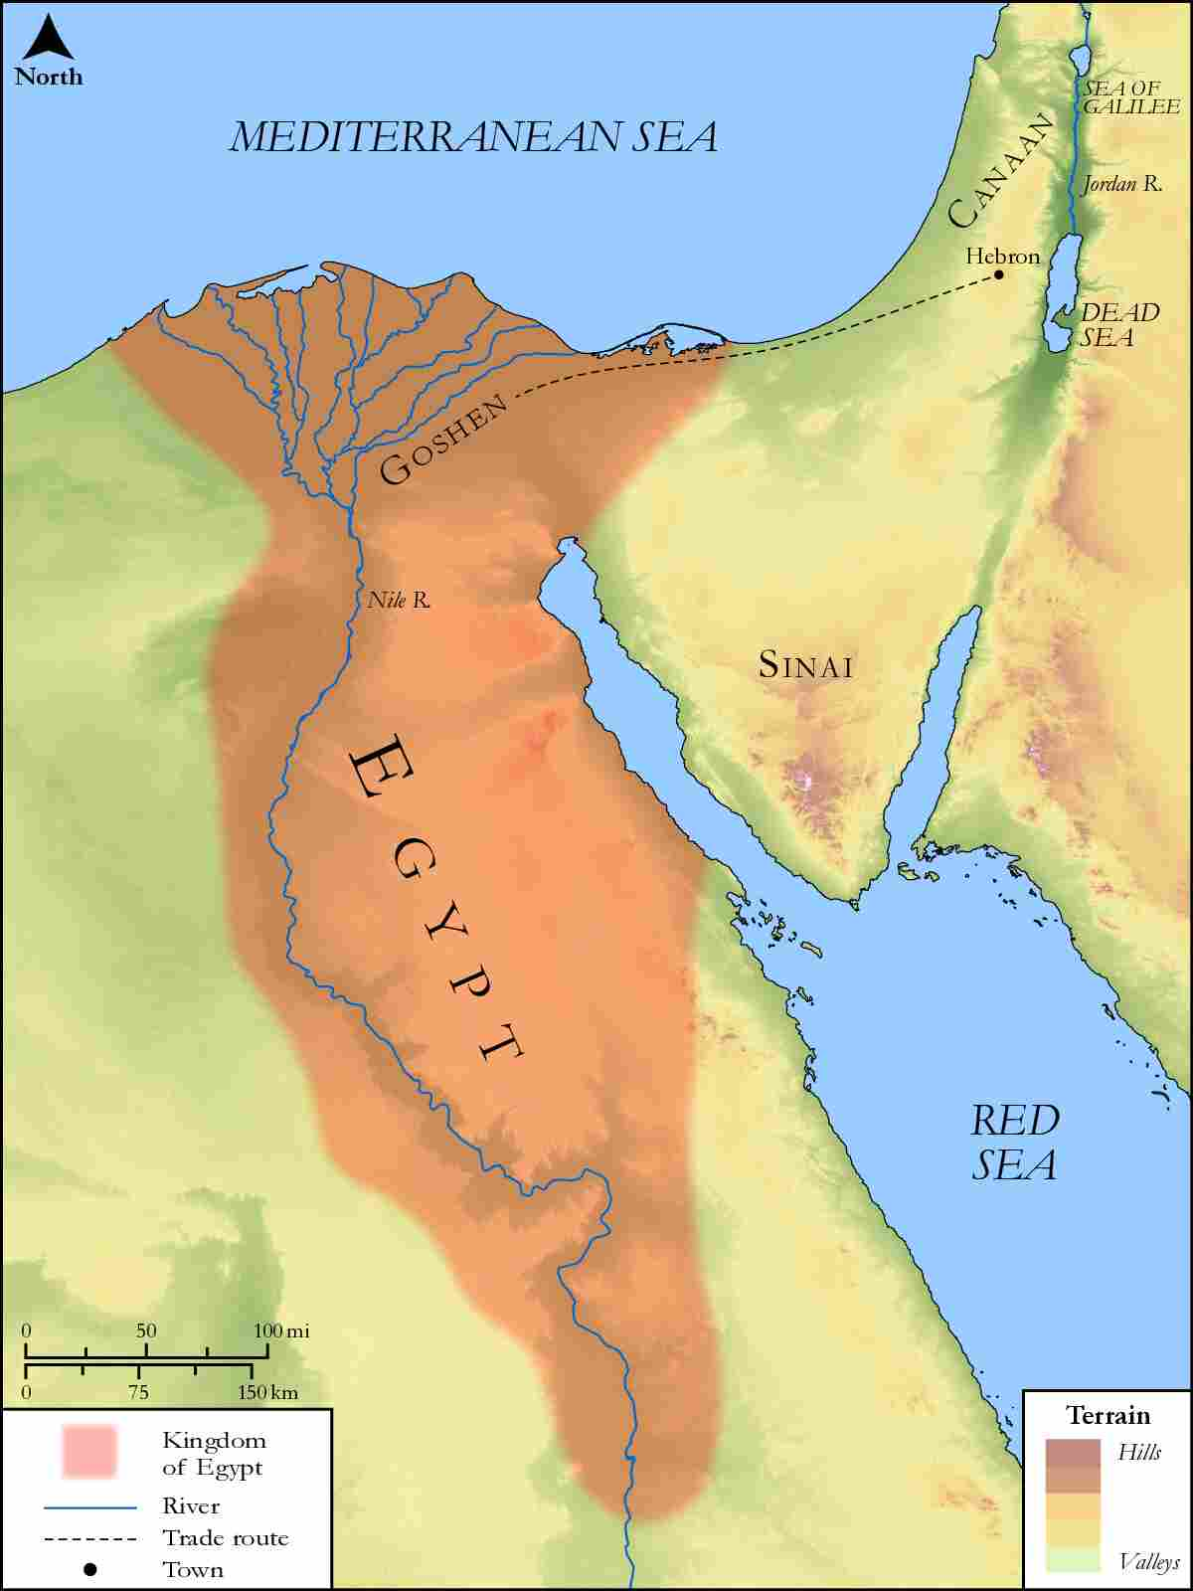
link

Emmaus

Image Content

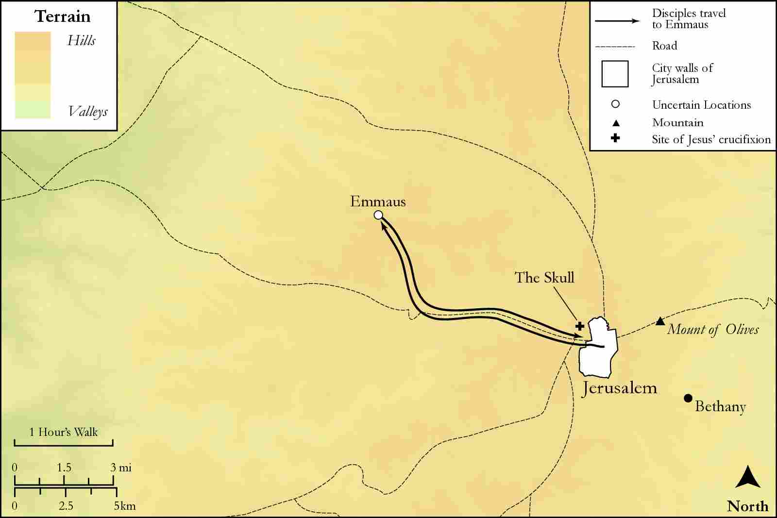
link

Four Corners of the World

Image Content

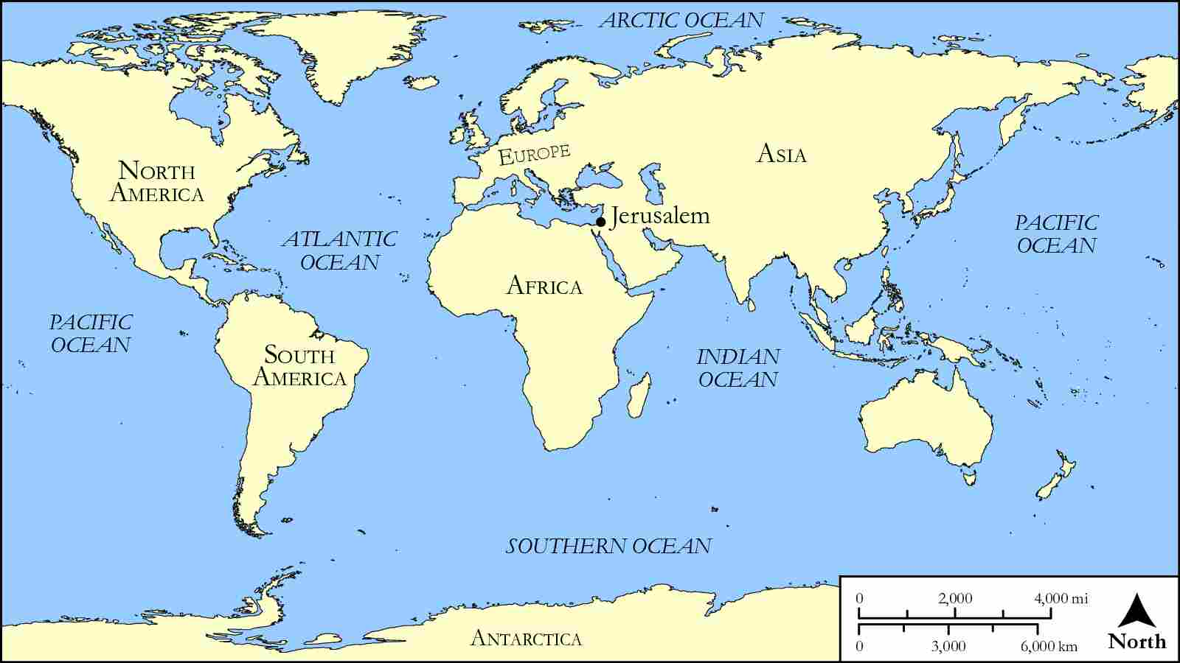
link

Galilee Area with Caesarea Philippi and Capernaum

Image Content

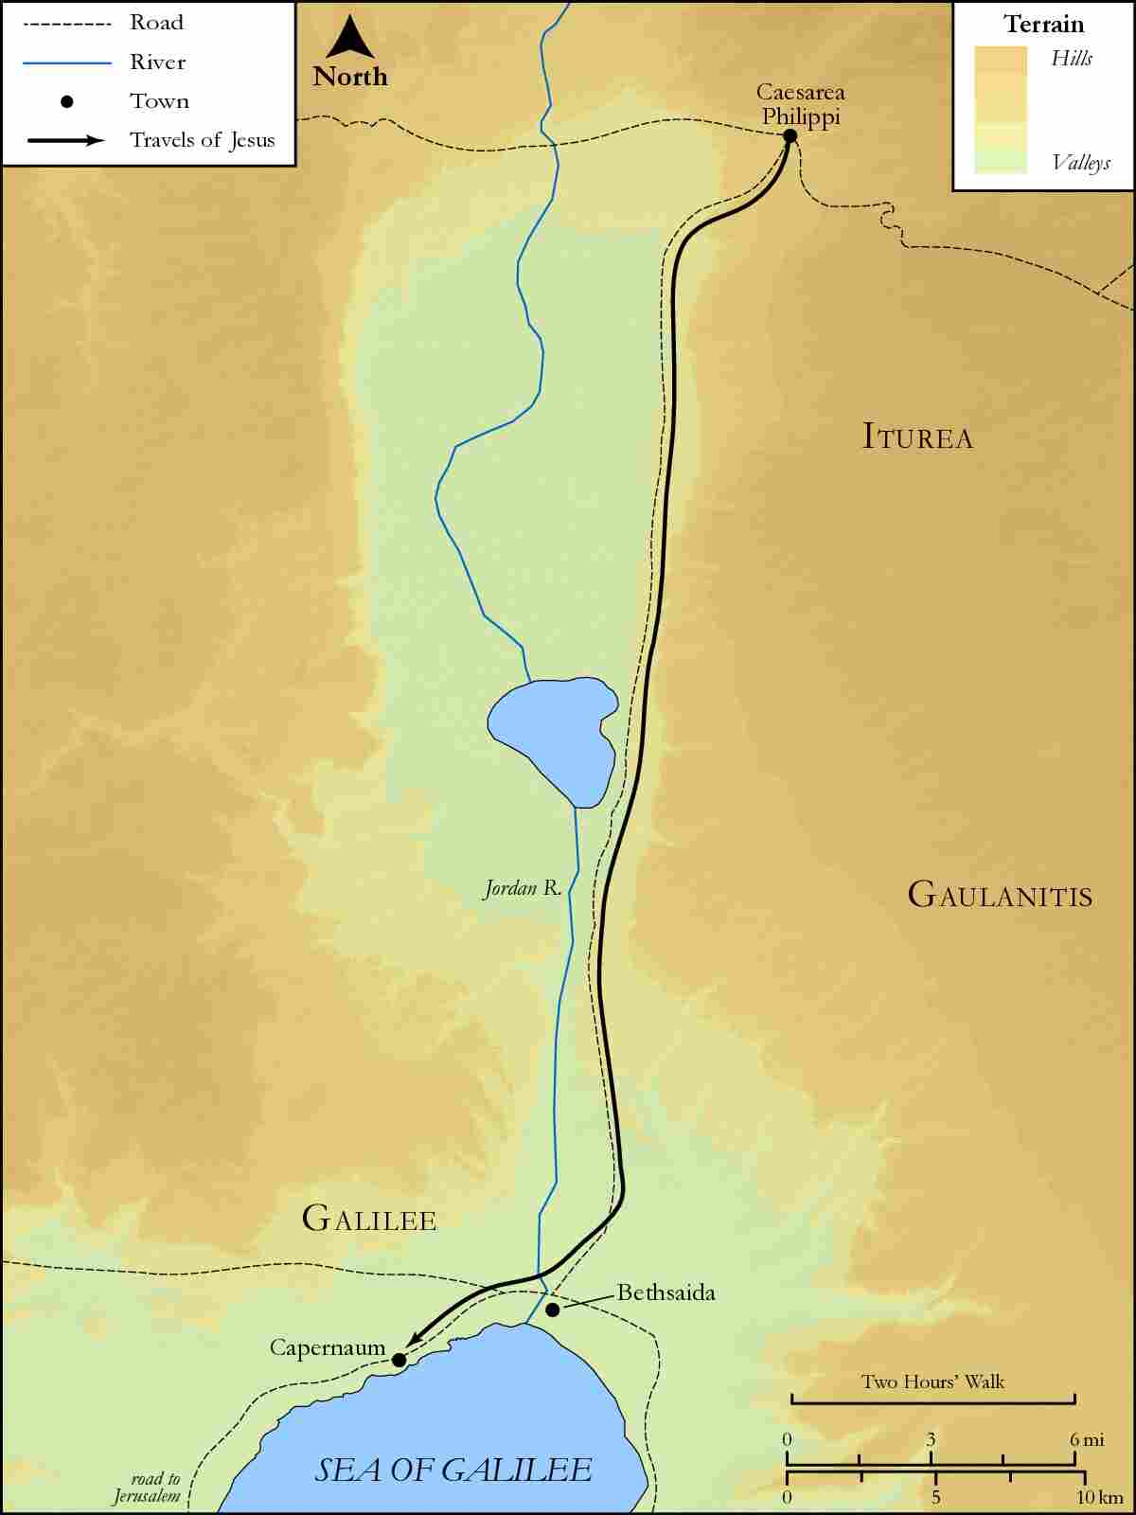
link

Galilee Area with Capernaum

Image Content

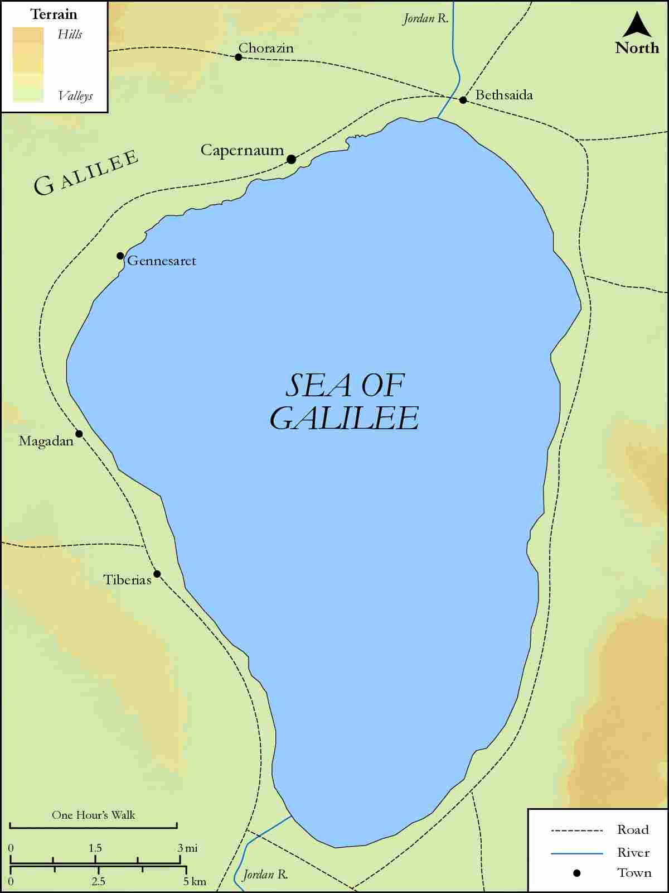
link

Galilee Area with Capernaum and Gerasa

Image Content

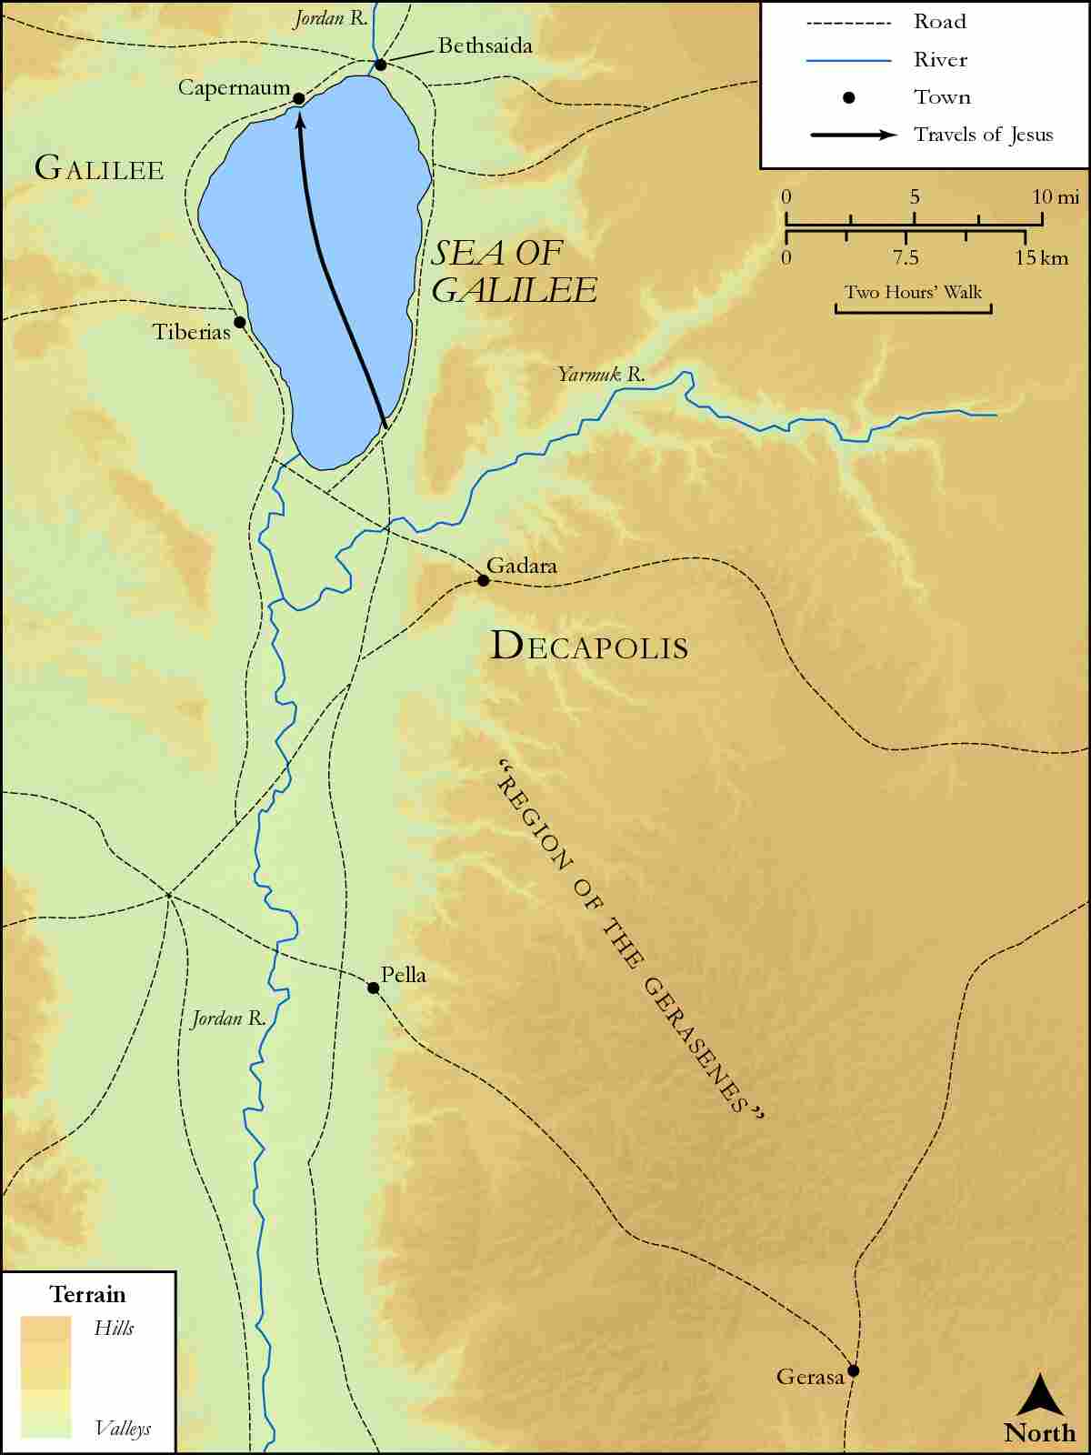
link

Galilee to Jerusalem

Image Content

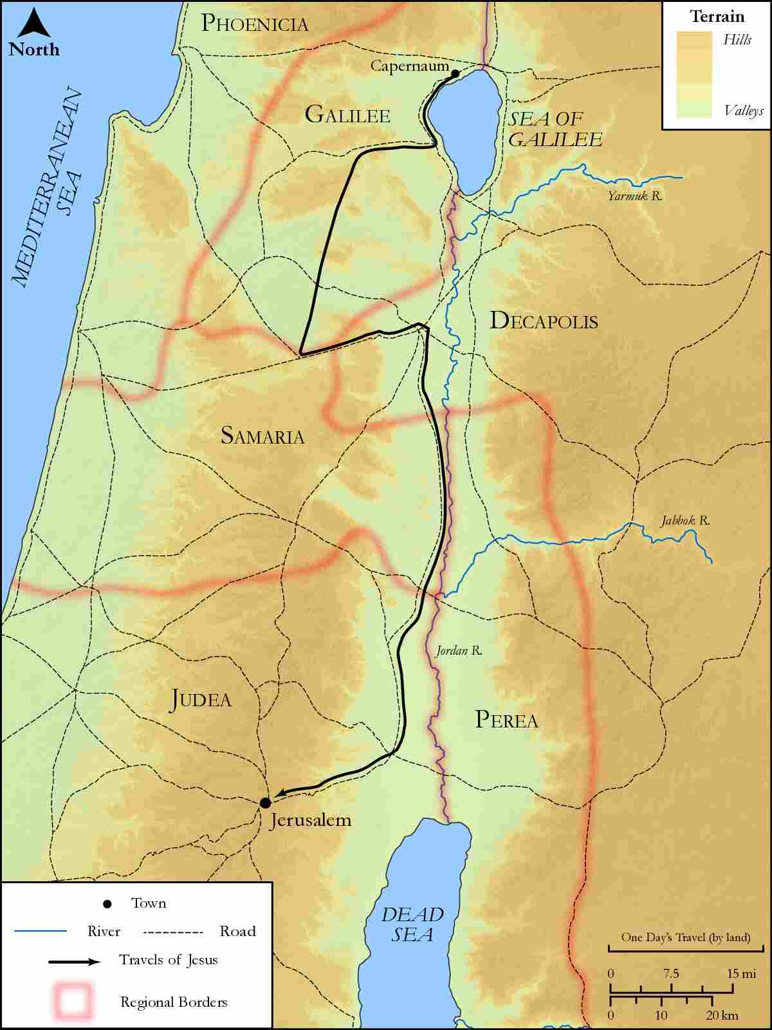
link

Galilee with Magdala

Image Content

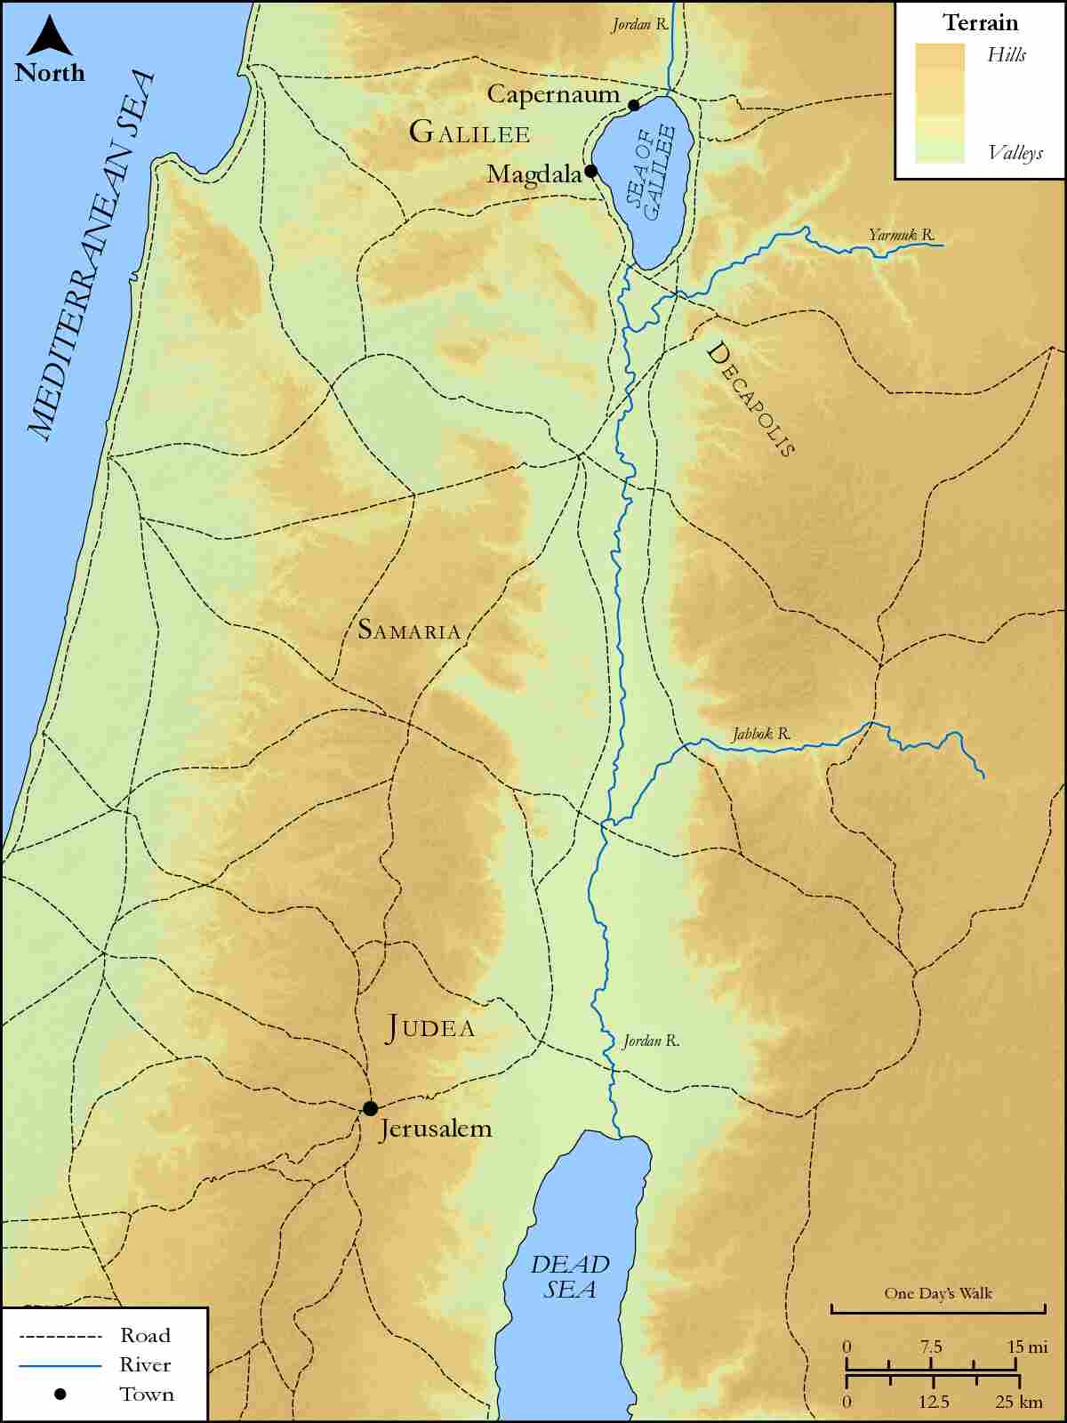
link

Galilee, Judea, Samaria, and Jerusalem

Image Content

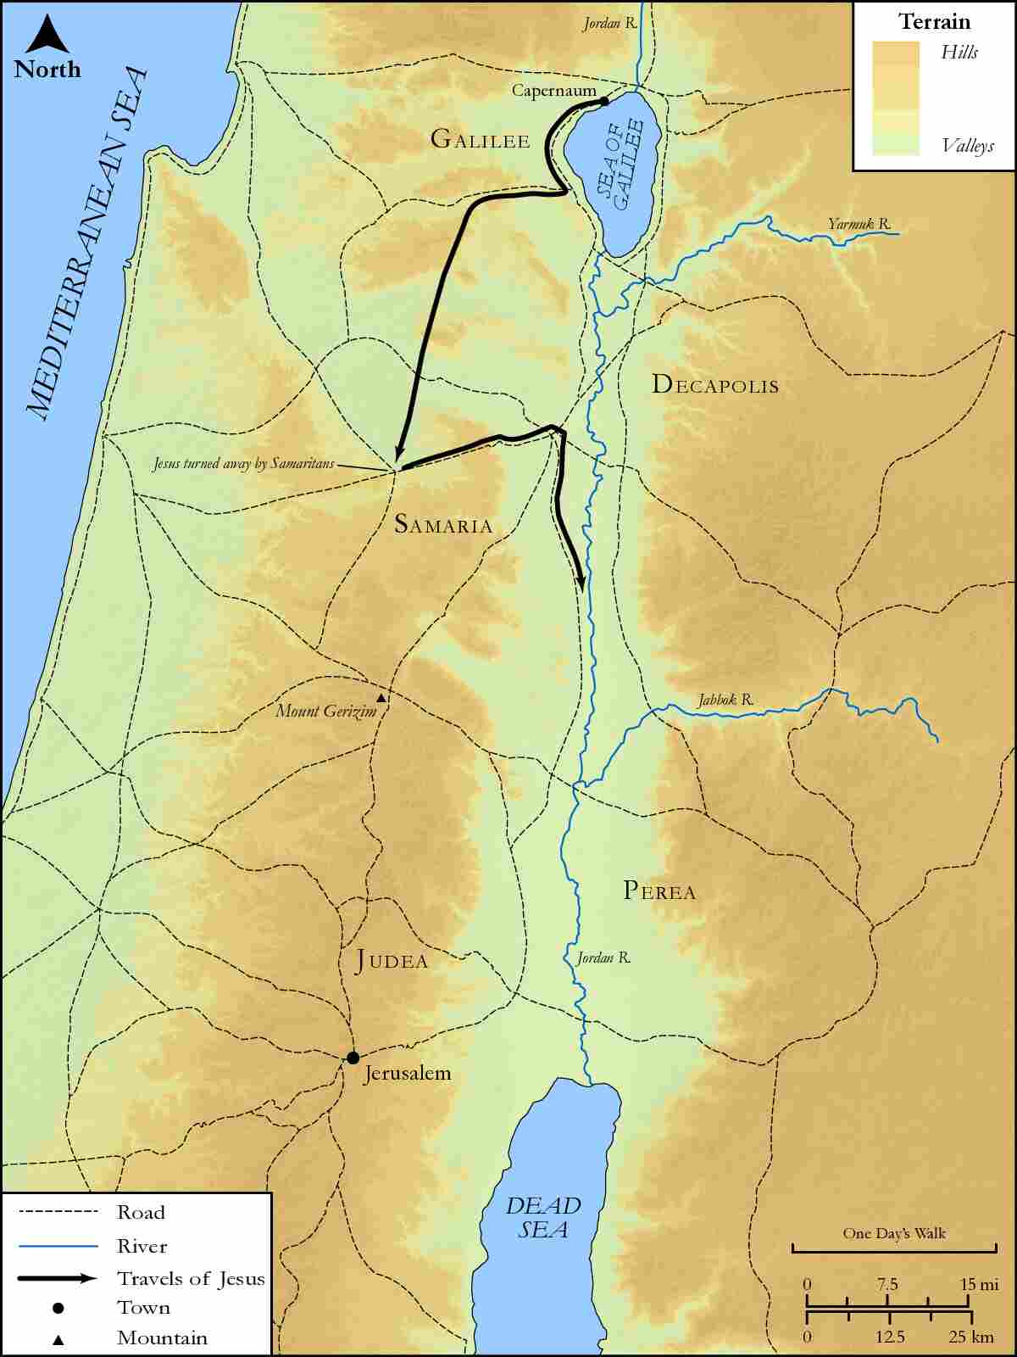
link

Galilee, Syrian Phoenicia, Gennesaret and Tyre

Image Content

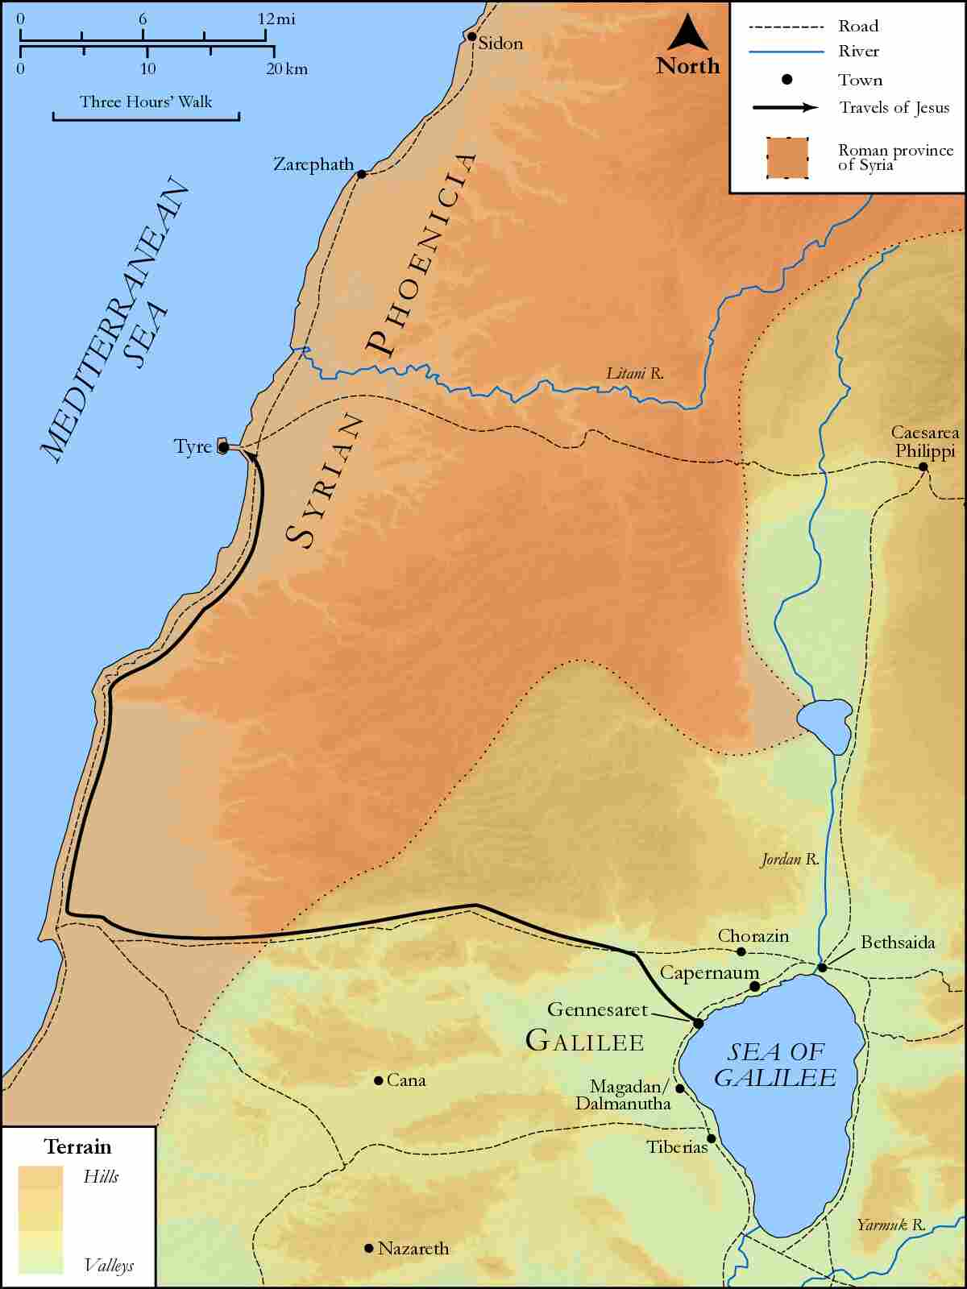
link

Galilee,Judea and Samaria

Image Content

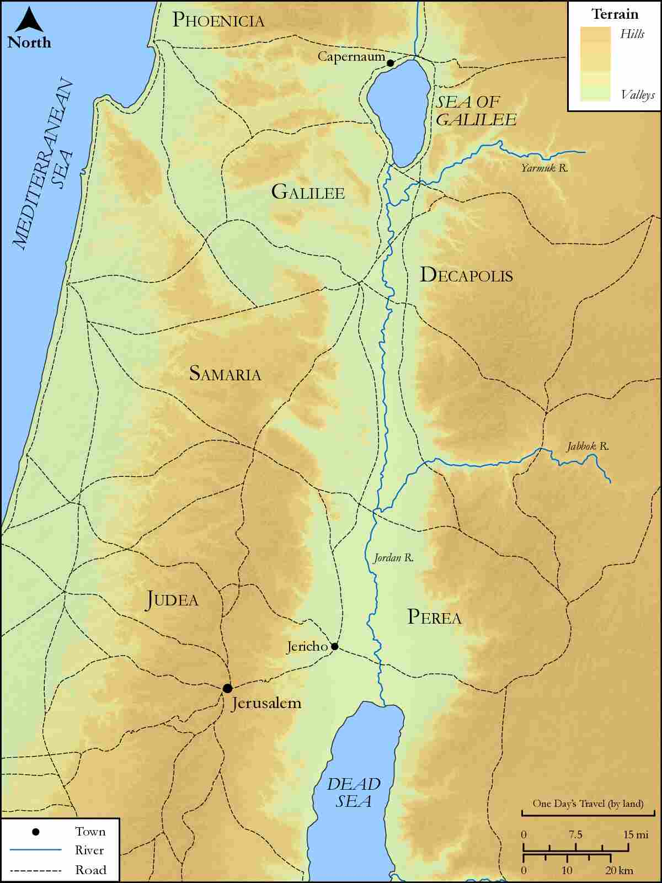
link

Gennesaret and Capernaum

Image Content

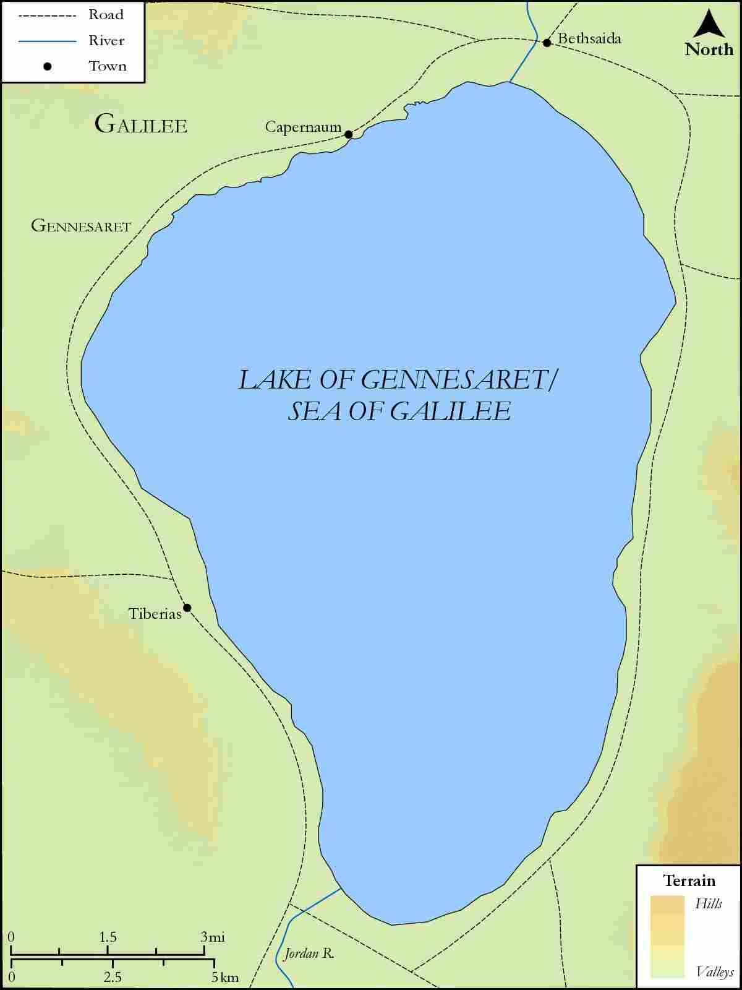
link

Haran and Beersheba

Image Content

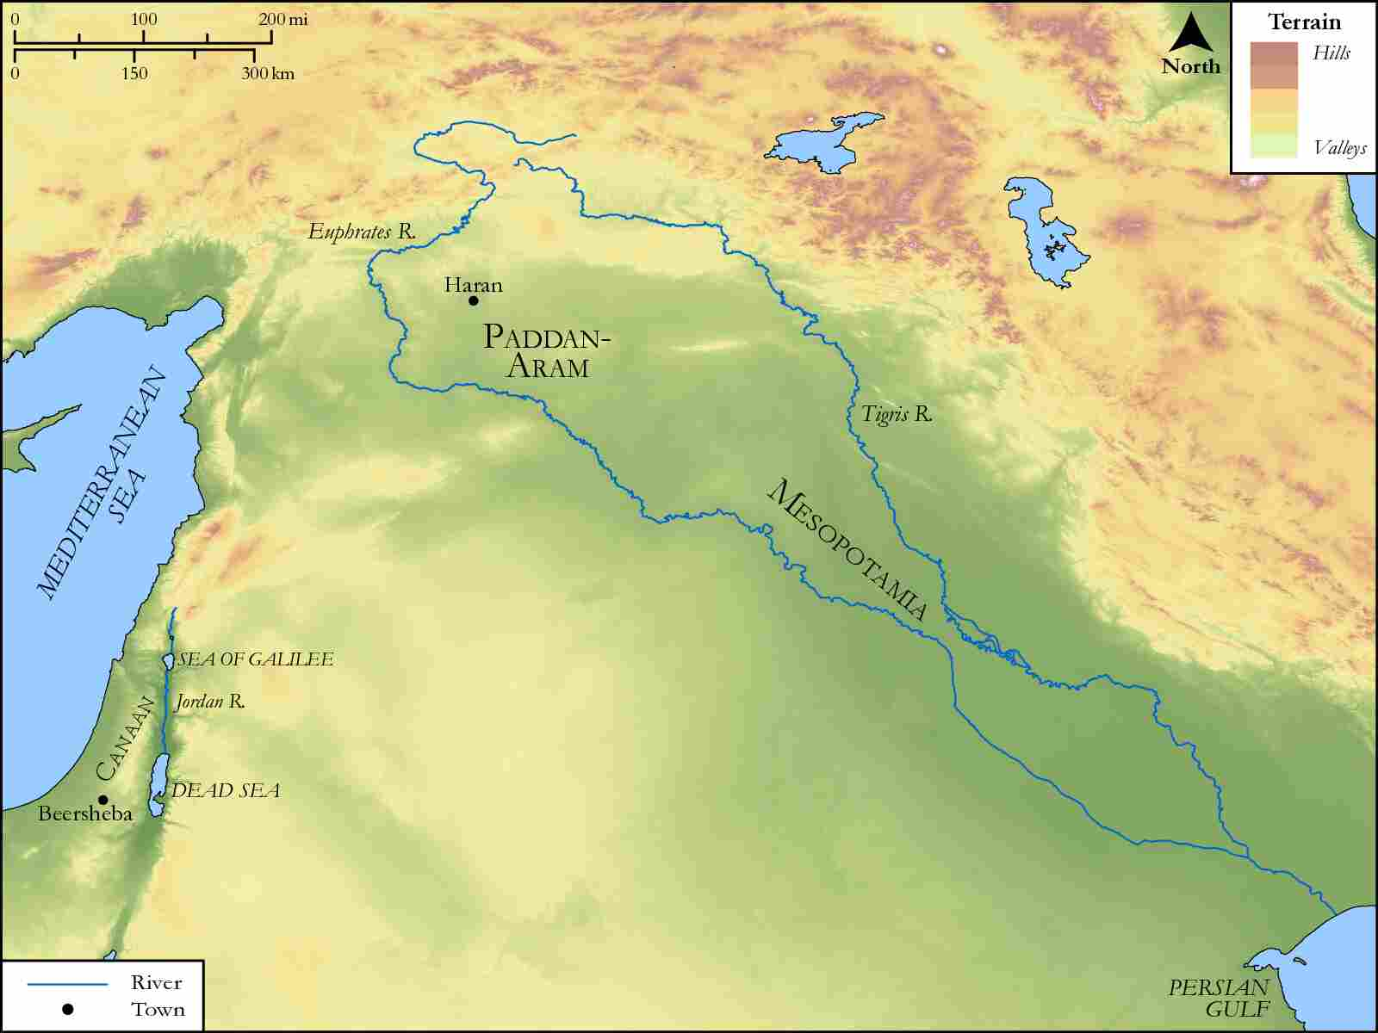
link

Haran to Canaan

Image Content

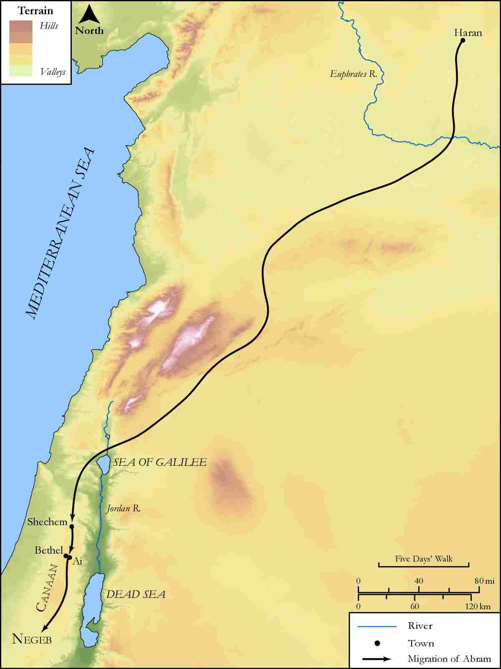
link

Havilah, Shur, Egypt and Assyria

Image Content

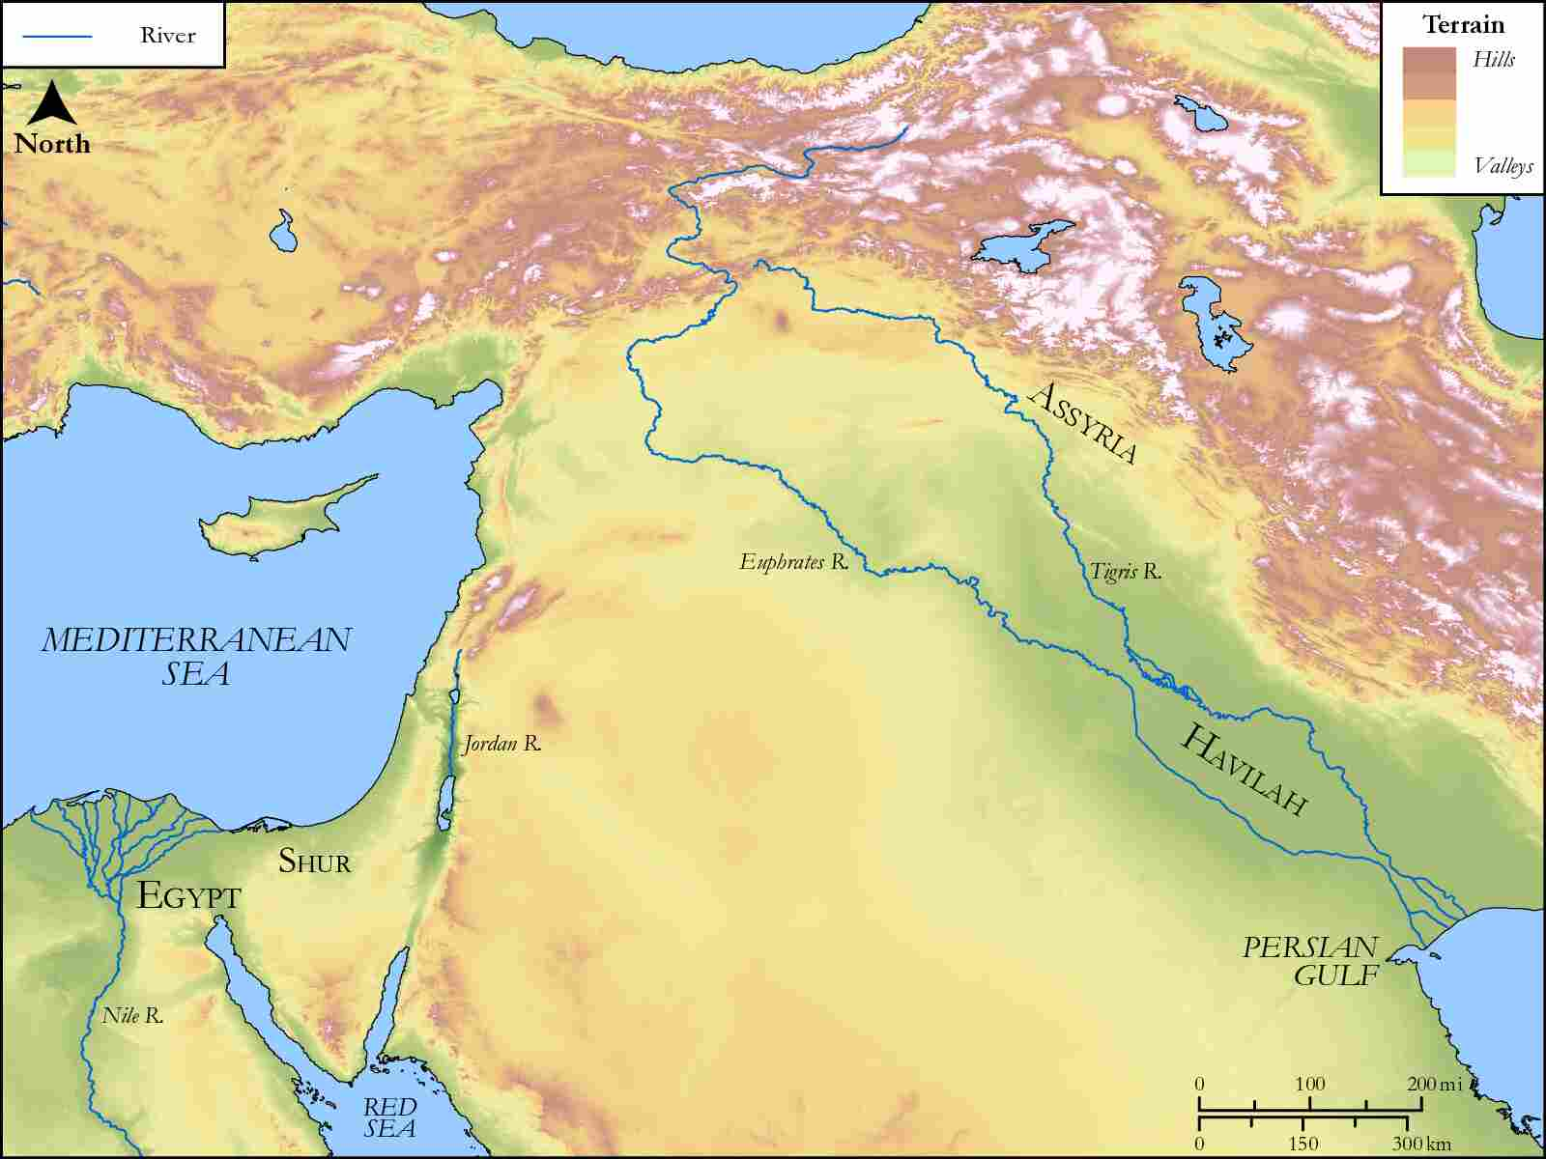
link

Hebron, Canaan, Negev and Beer Lahai Roi

Image Content

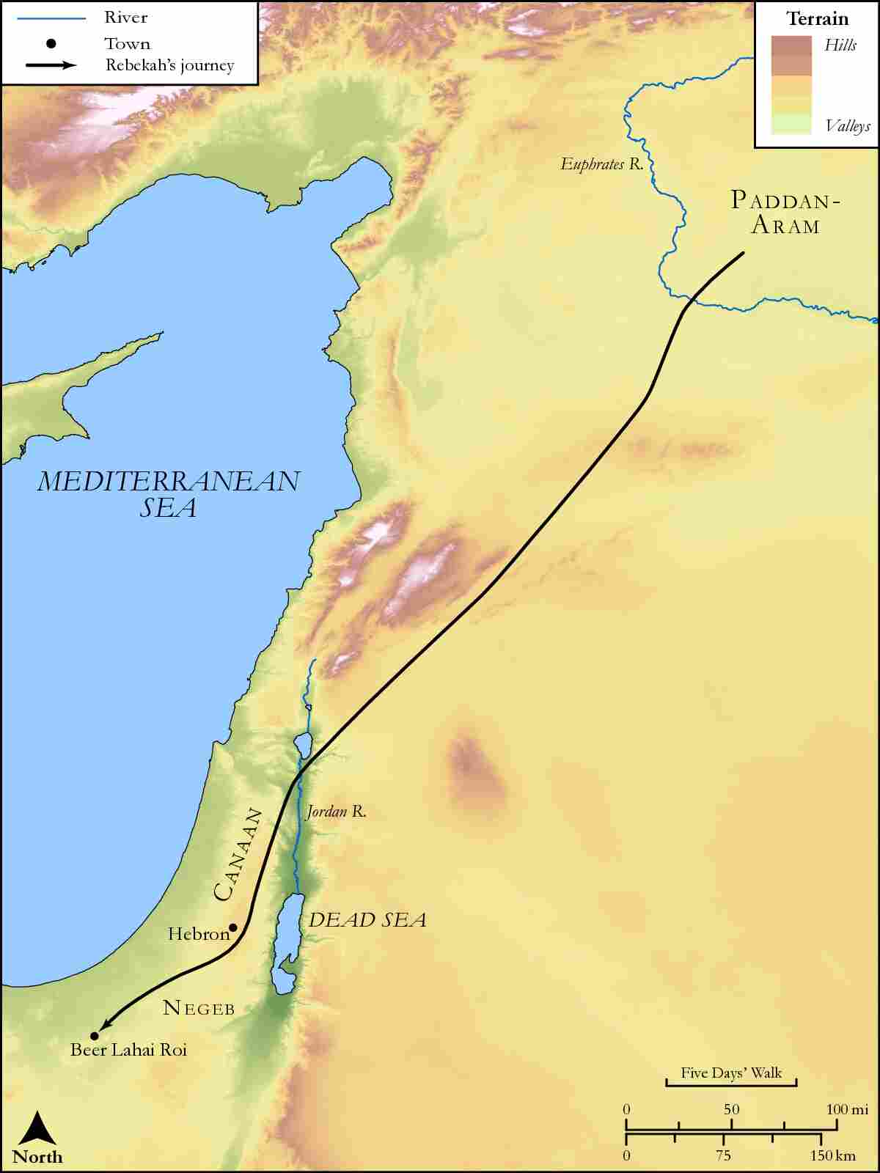
link

Israel

Image Content

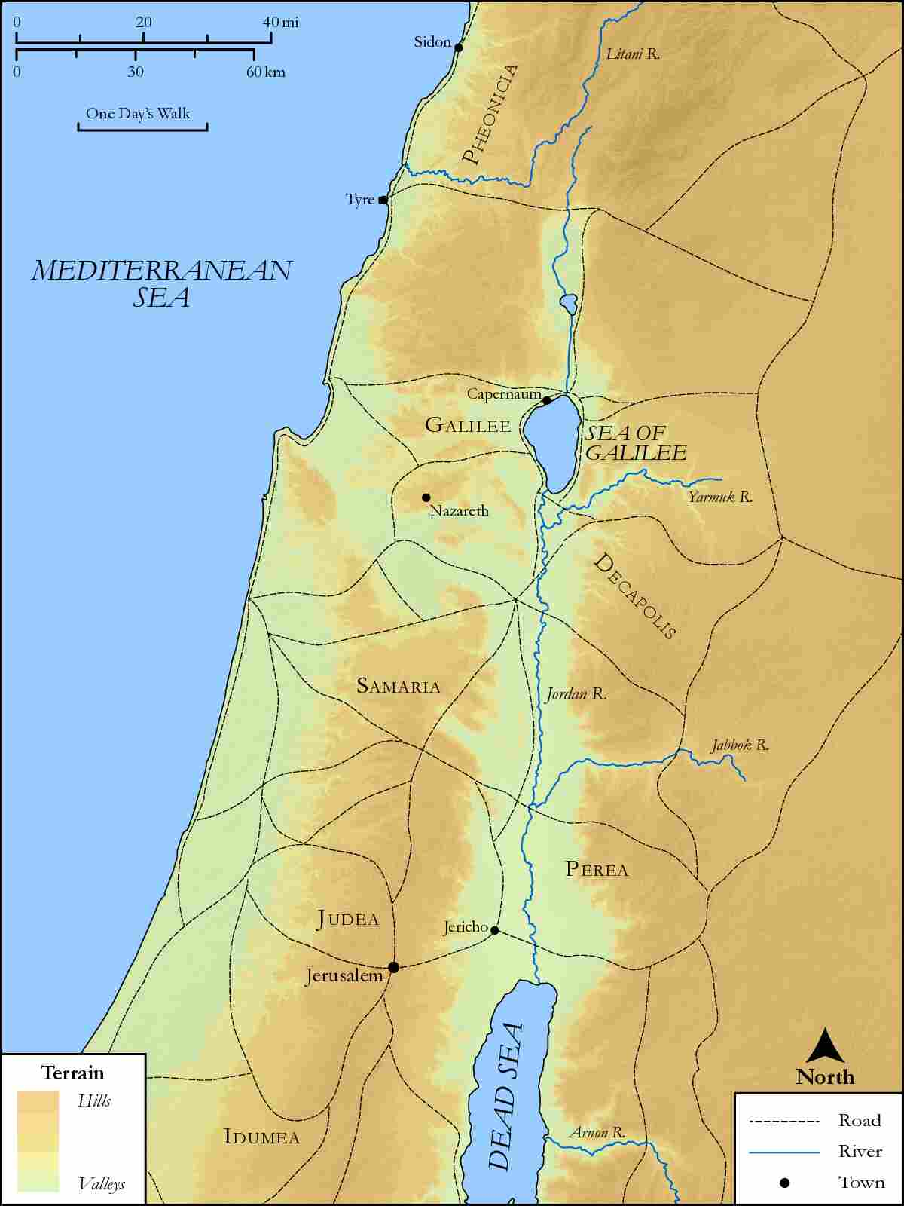
link

Israel with Negeb

Image Content

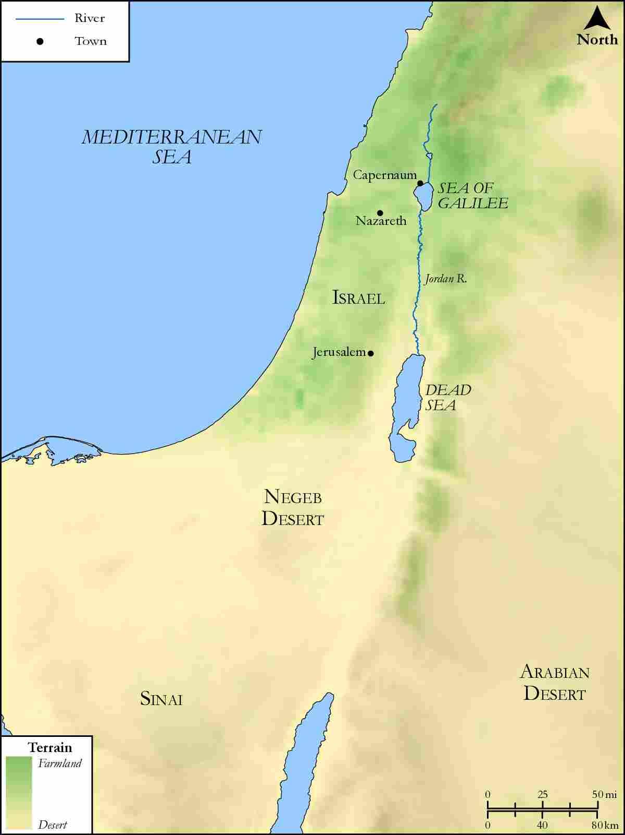
link

Israel with region of Galilee, Nazareth, Jerusalem

Image Content

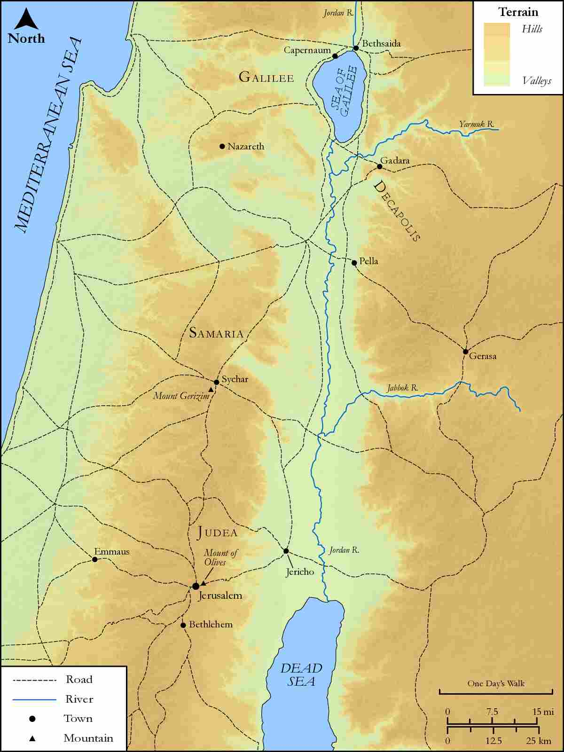
link

Israel, Jordan and Egypt

Image Content

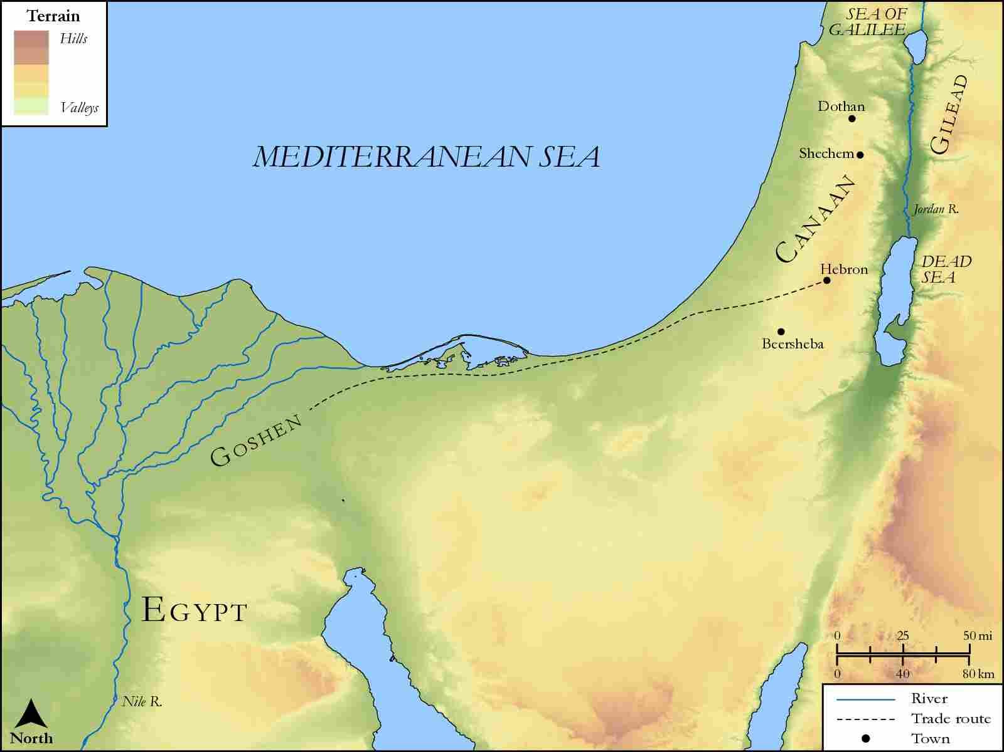
link

Israel, Ninevah and Sheba

Image Content

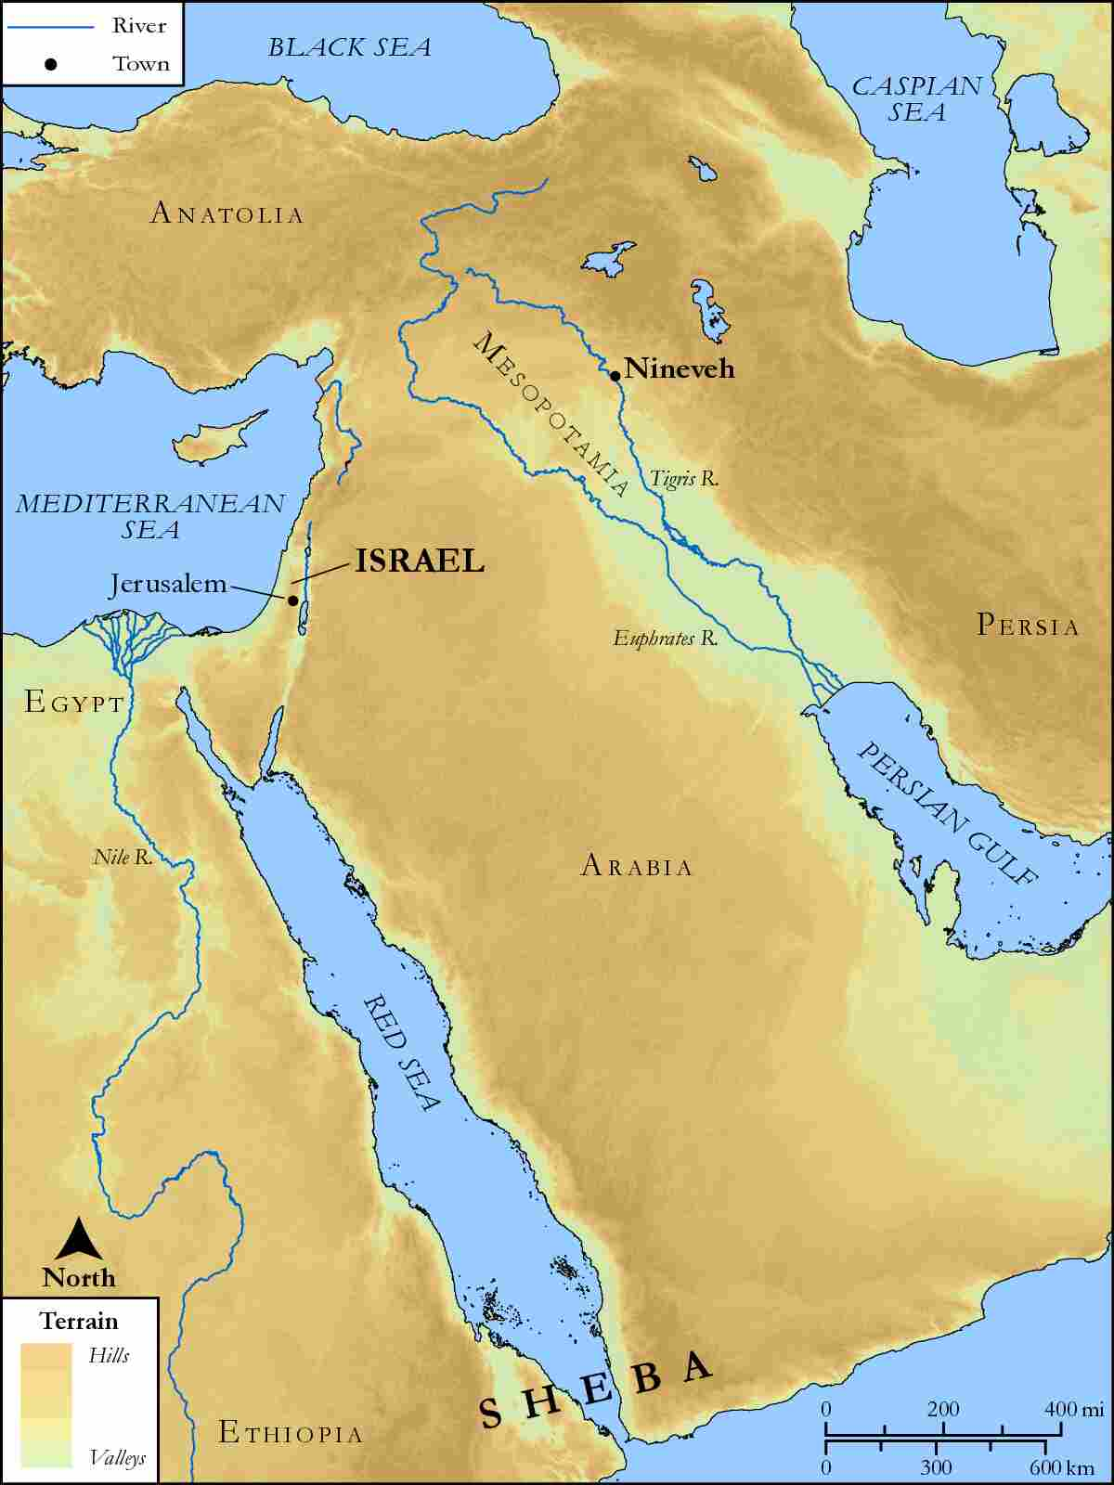
link

Jacob's Journey from Beersheba to Haran

Image Content

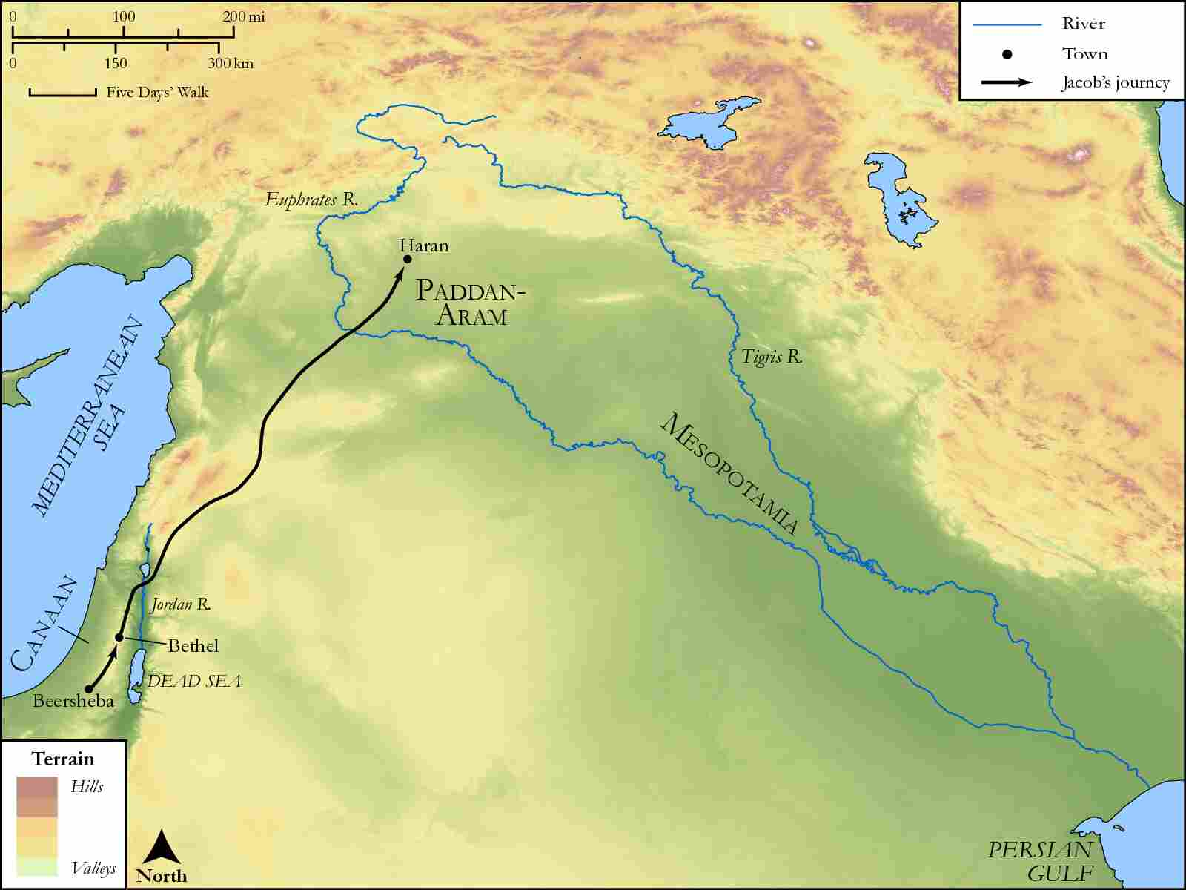
link

Jacob's Journey from Haran to Beersheba

Image Content

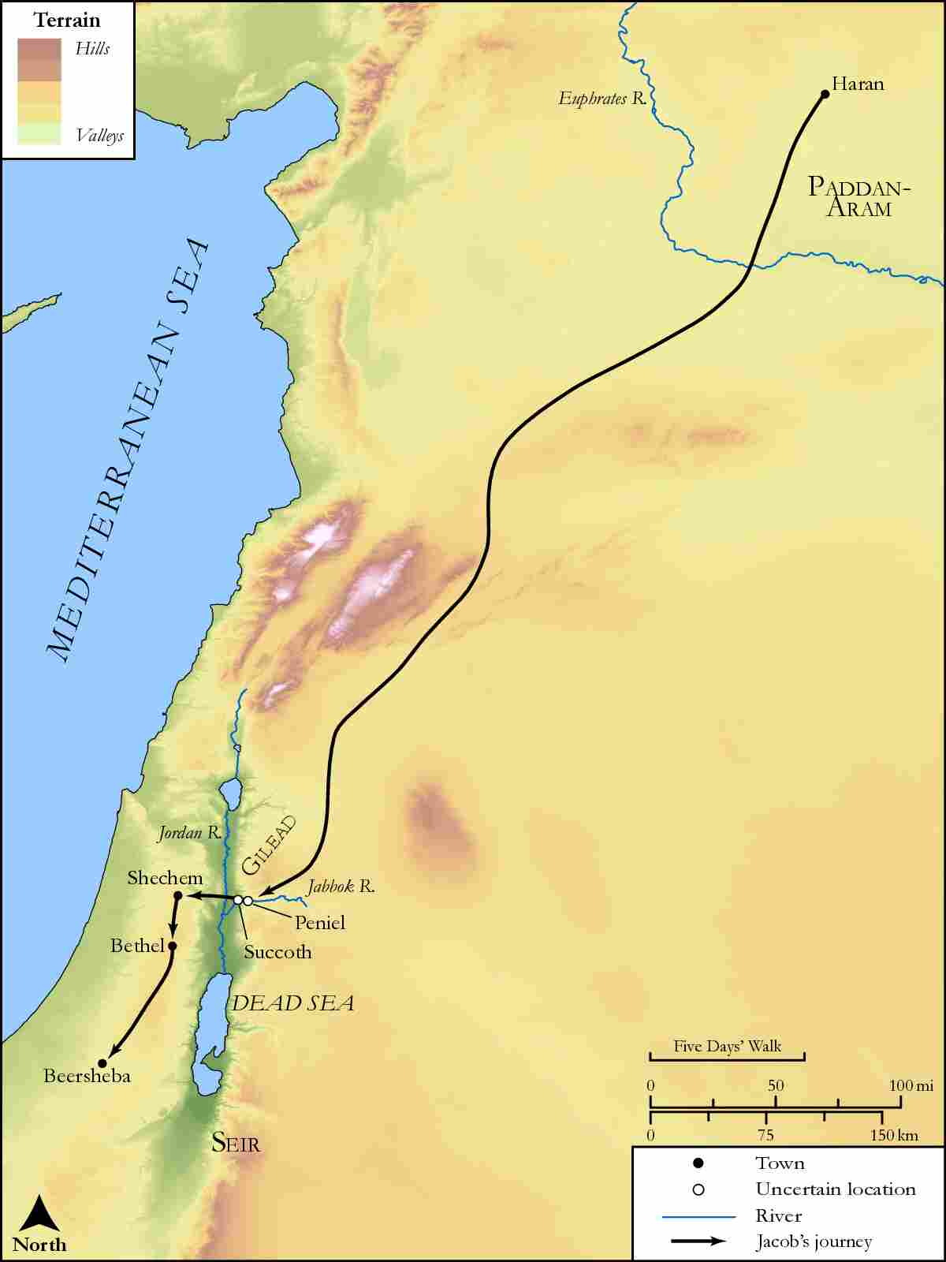
link

Jericho

Image Content

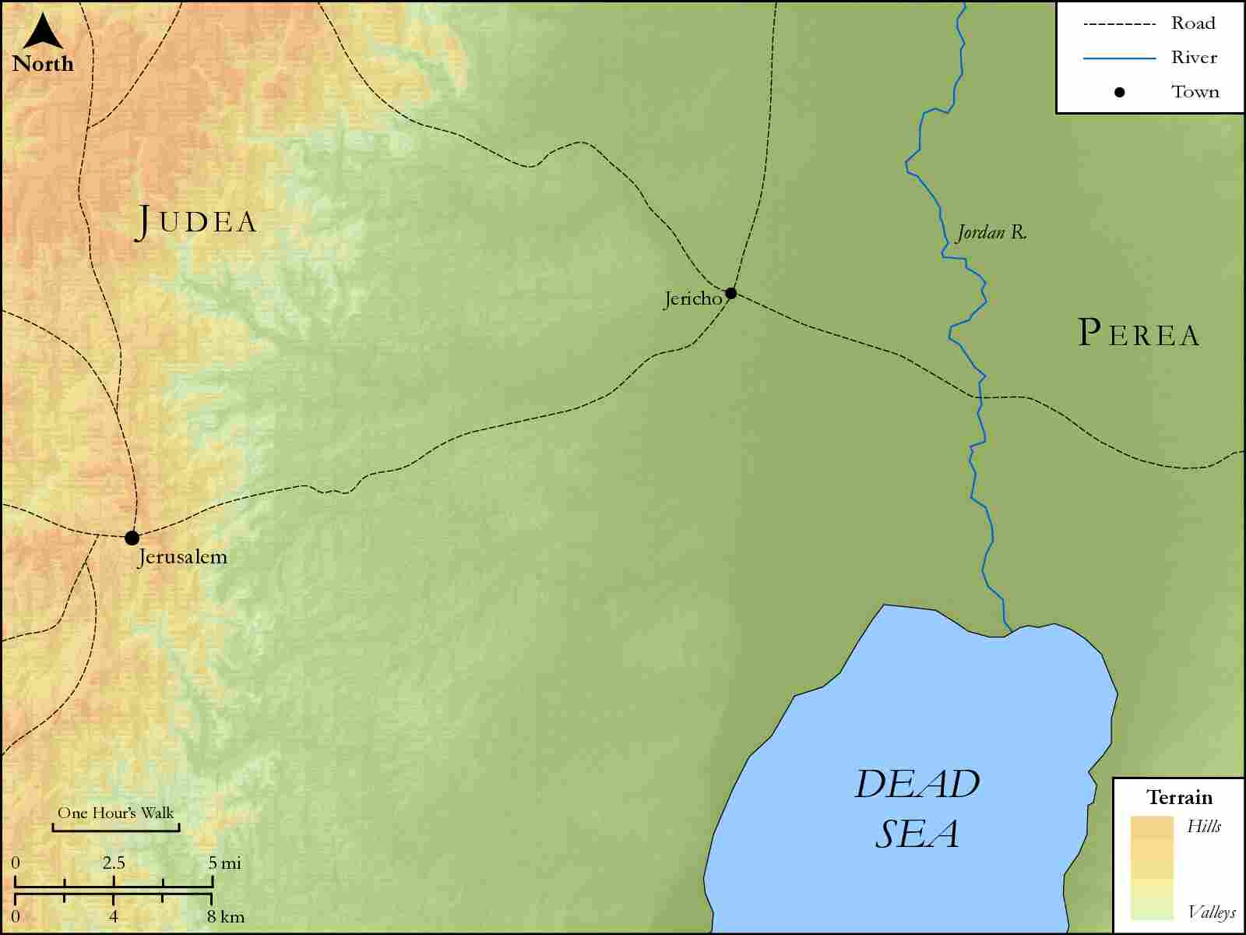
link

Jerusalem and Galilee

Image Content

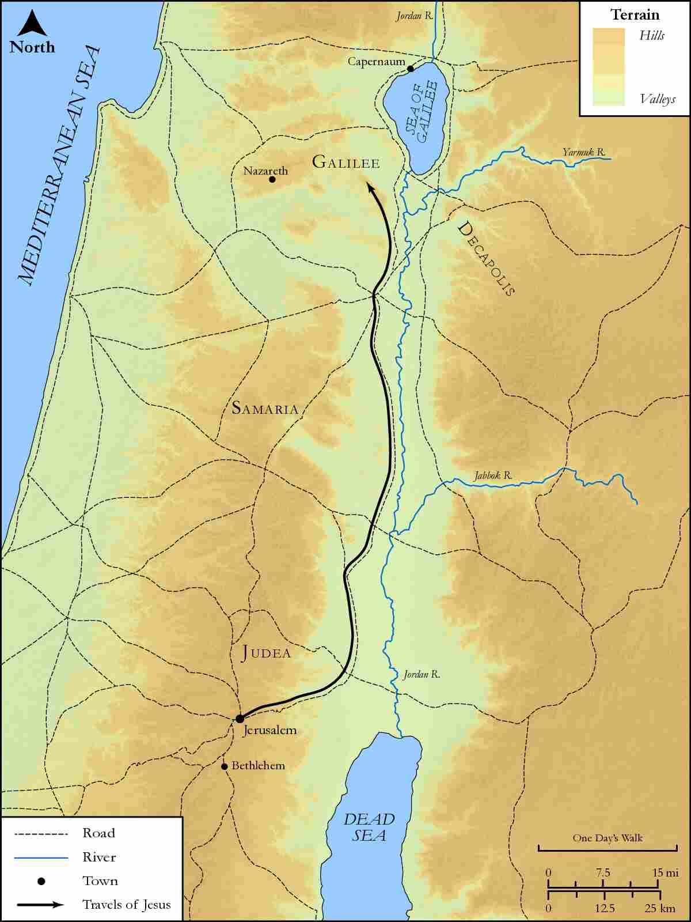
link

Jerusalem and Galilee region

Image Content

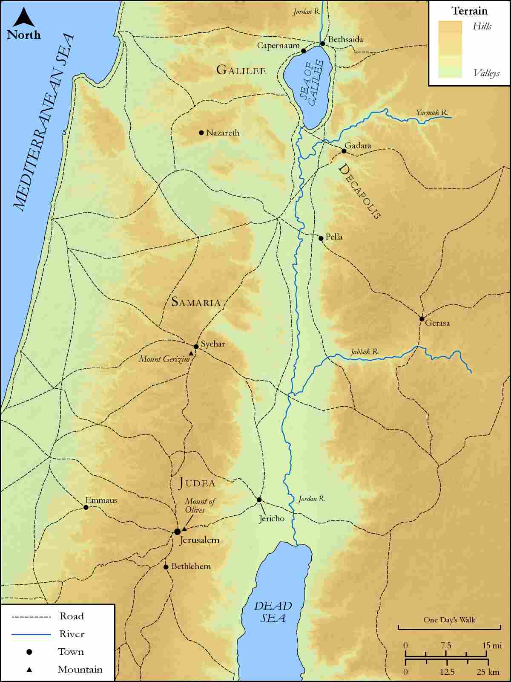
link

Jerusalem and Mount of Olives

Image Content

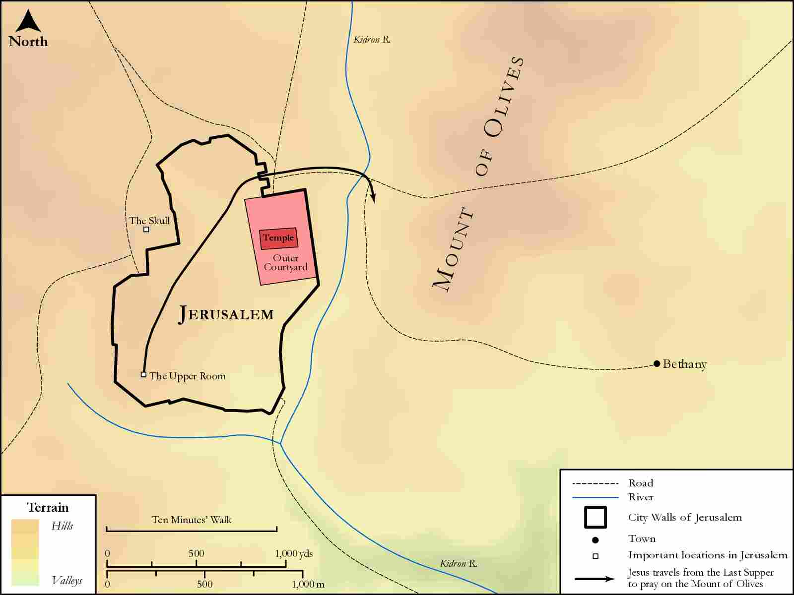
link

Jerusalem to Jericho

Image Content

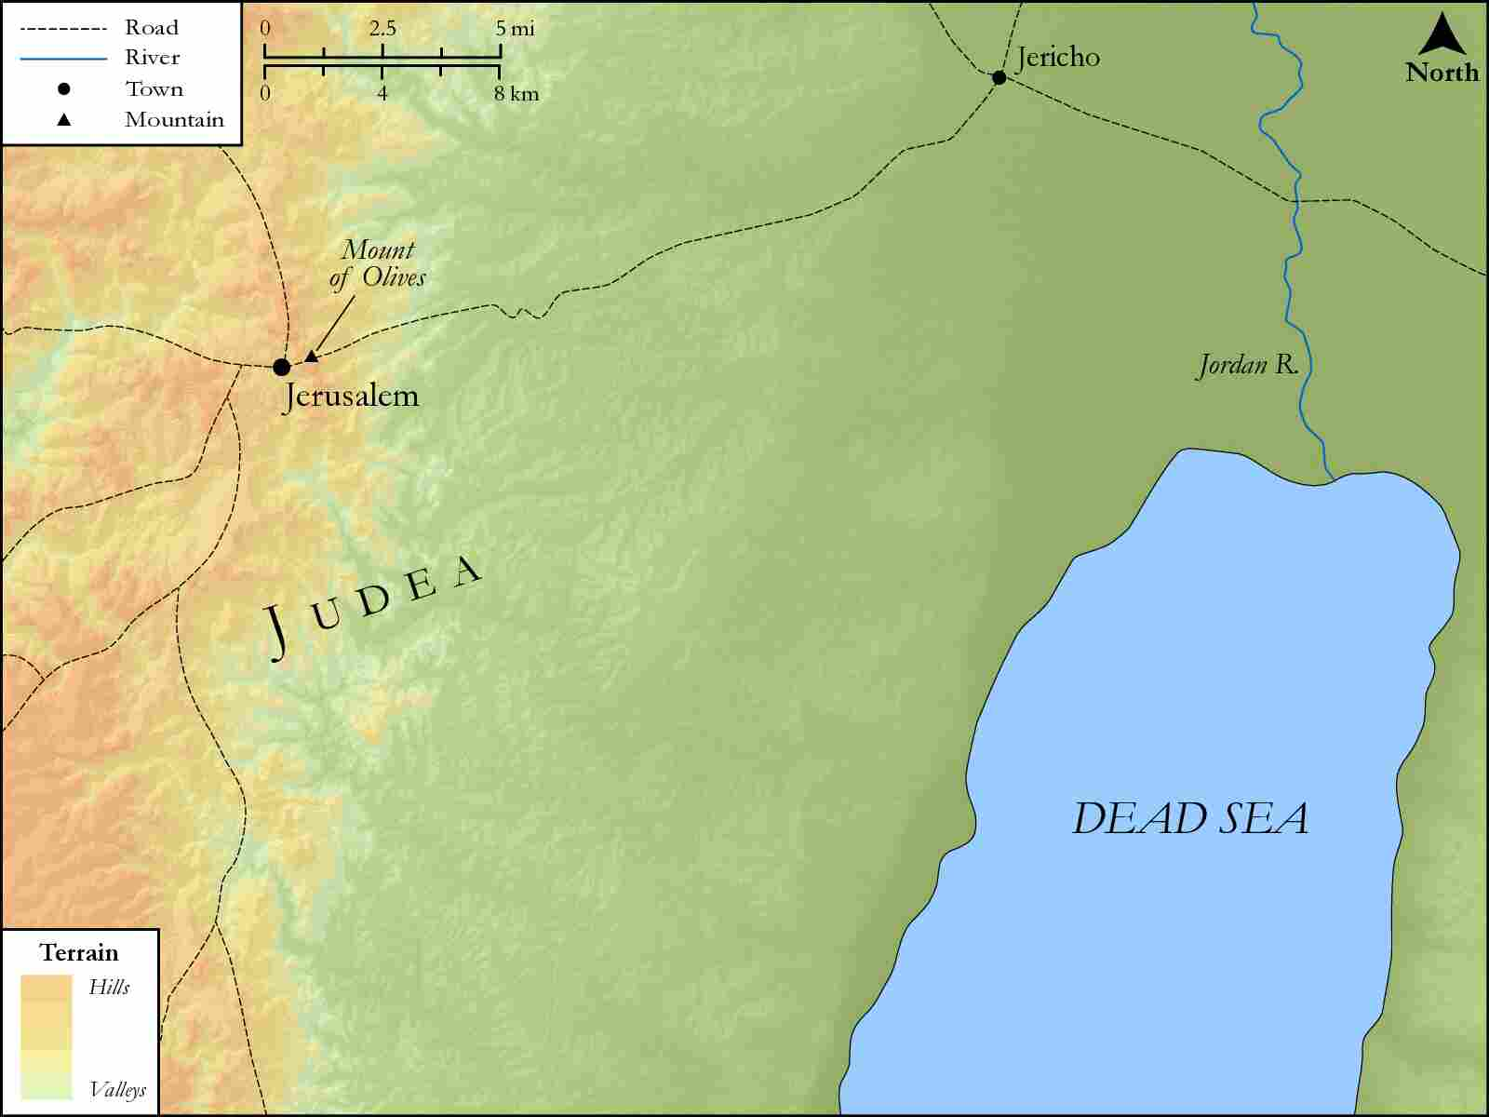
link

Jerusalem, Bethany and the Temple

Image Content

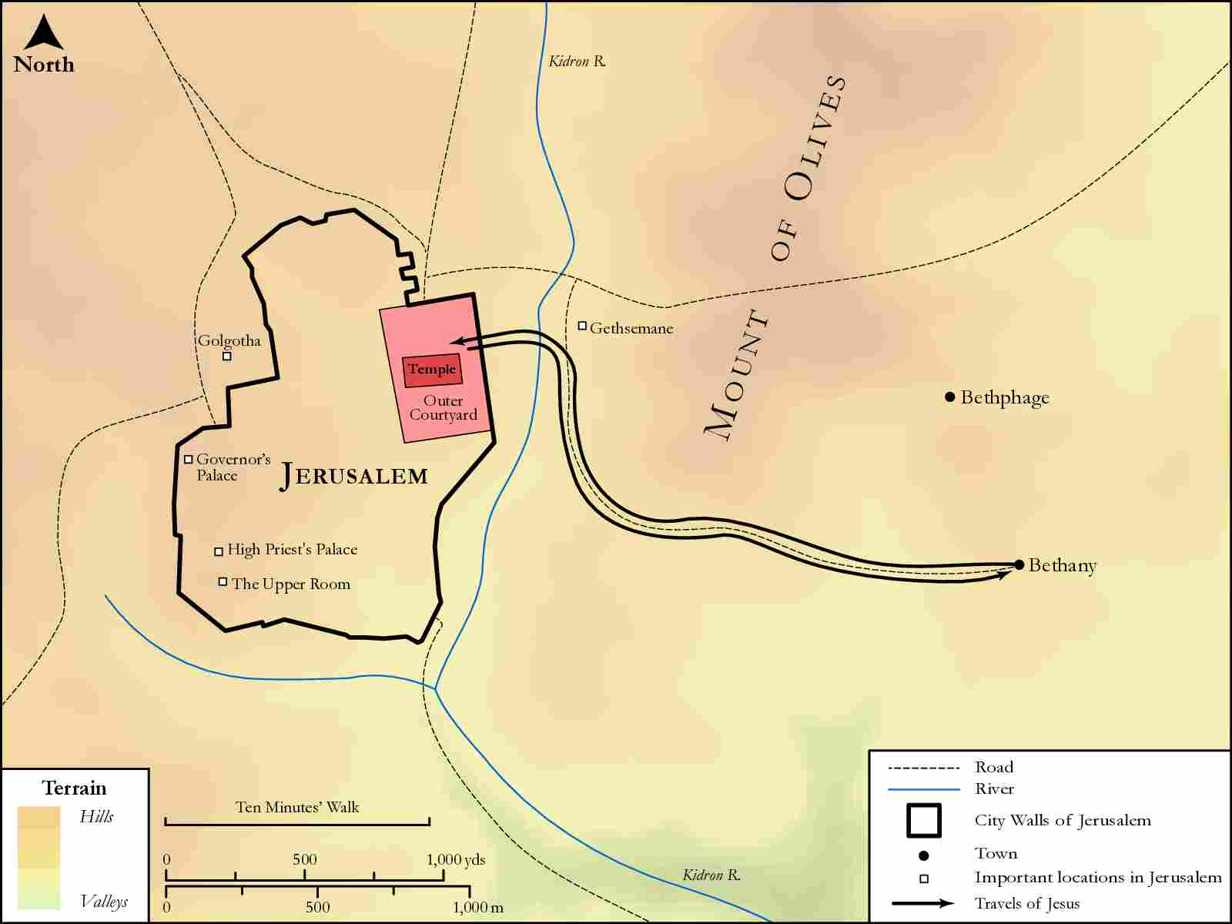
link

Jerusalem, Bethphage, and Bethany

Image Content

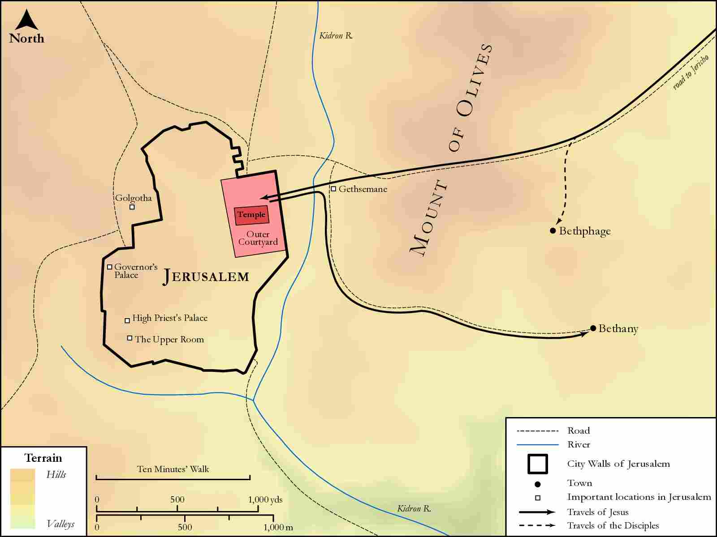
link

Jesus' Route from Capernaum to Nain

Image Content

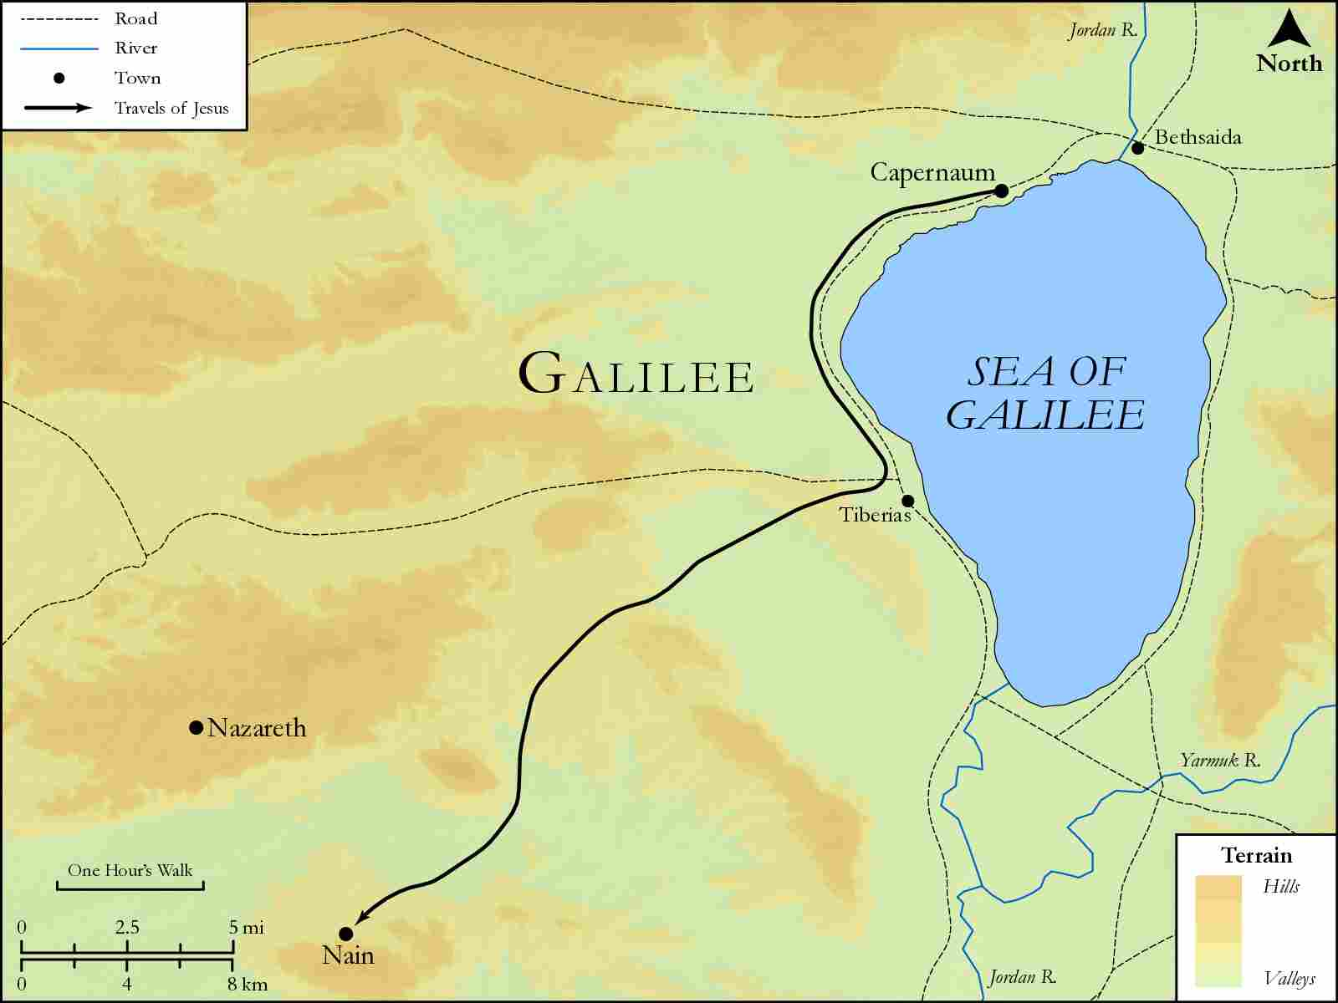
link

Jesus' Travels to Jerusalem

Image Content

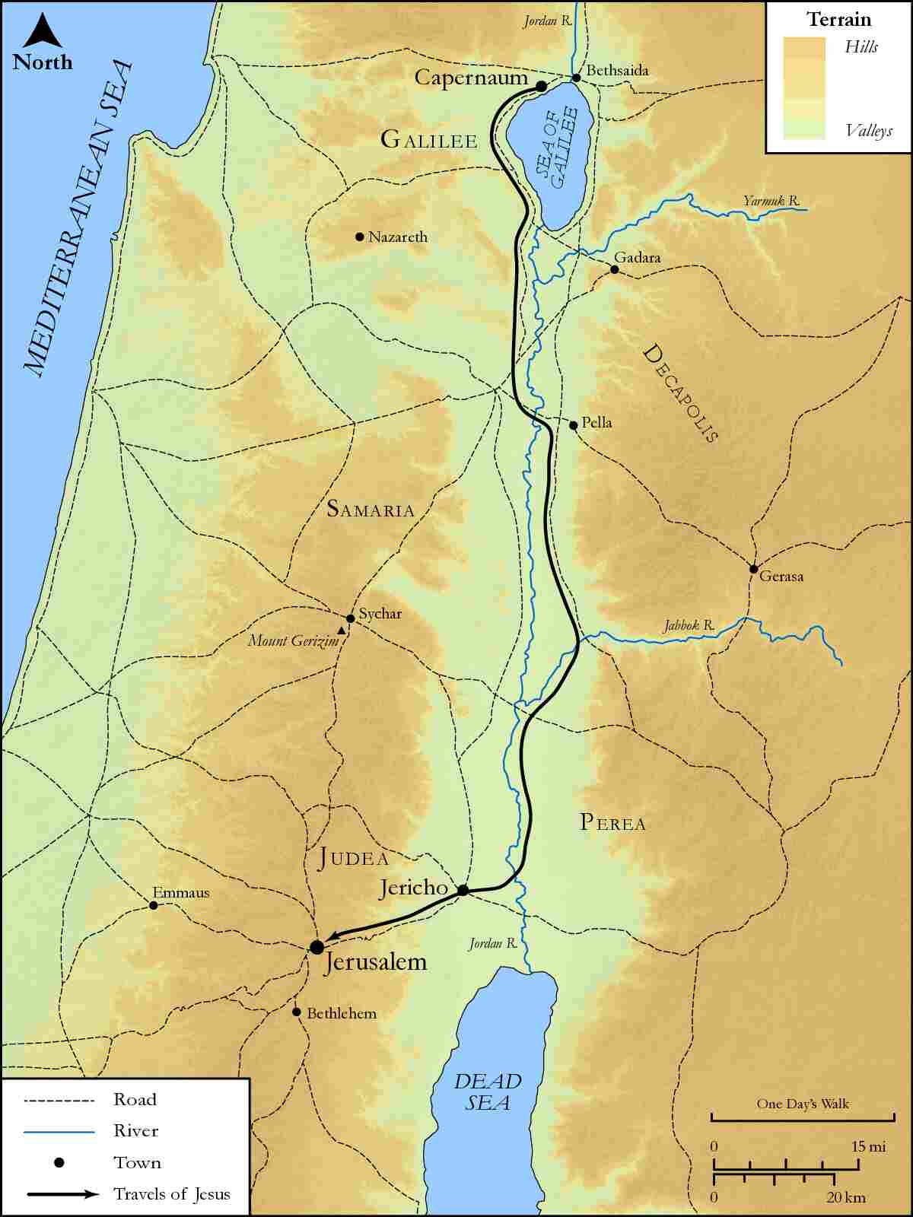
link

Jordan River and Wilderness of Judah

Image Content

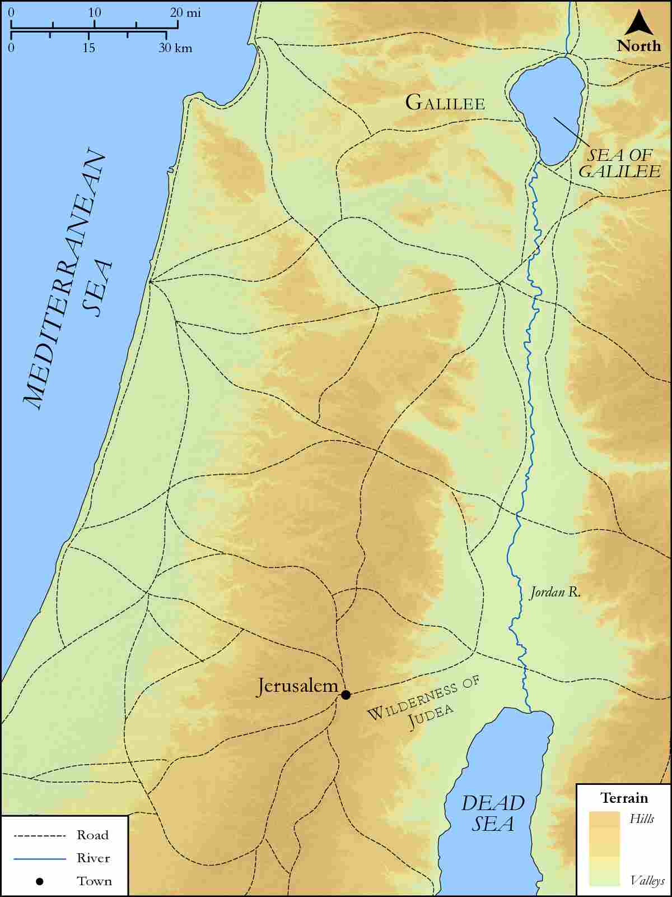
link

Jordan River featuring Galilee, Judea, Iturea, Traconitis, and Abilene

Image Content

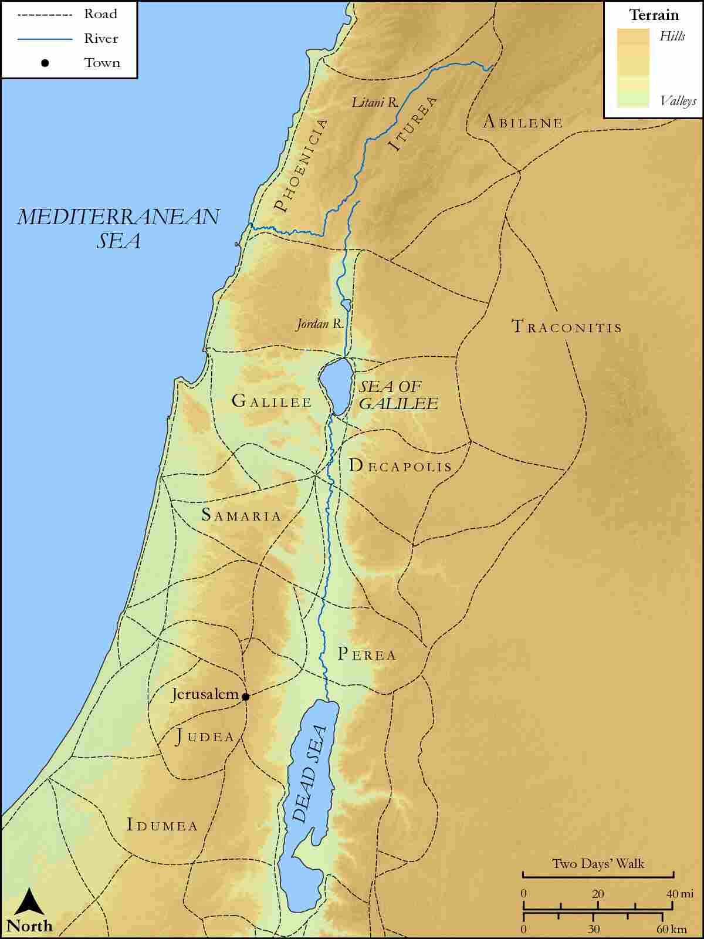
link

Jordan Valley Region

Image Content

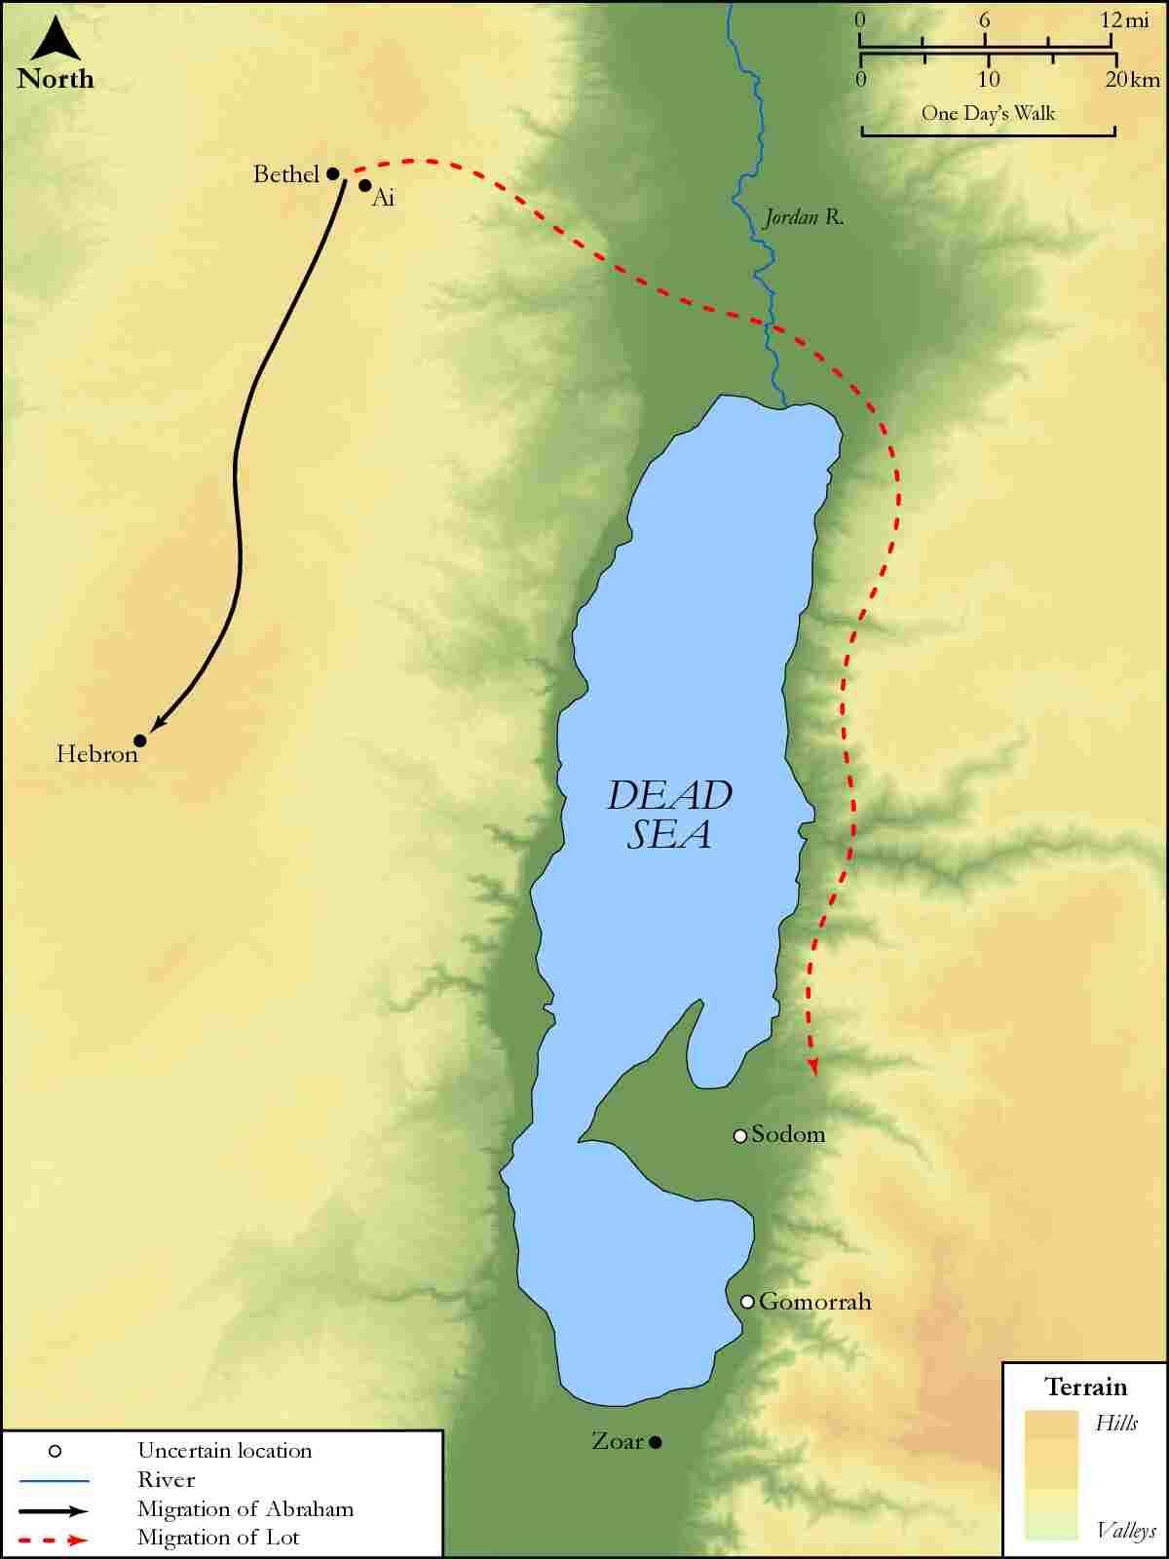
link

Joseph and Mary's Route from Nazareth to Bethlehem

Image Content

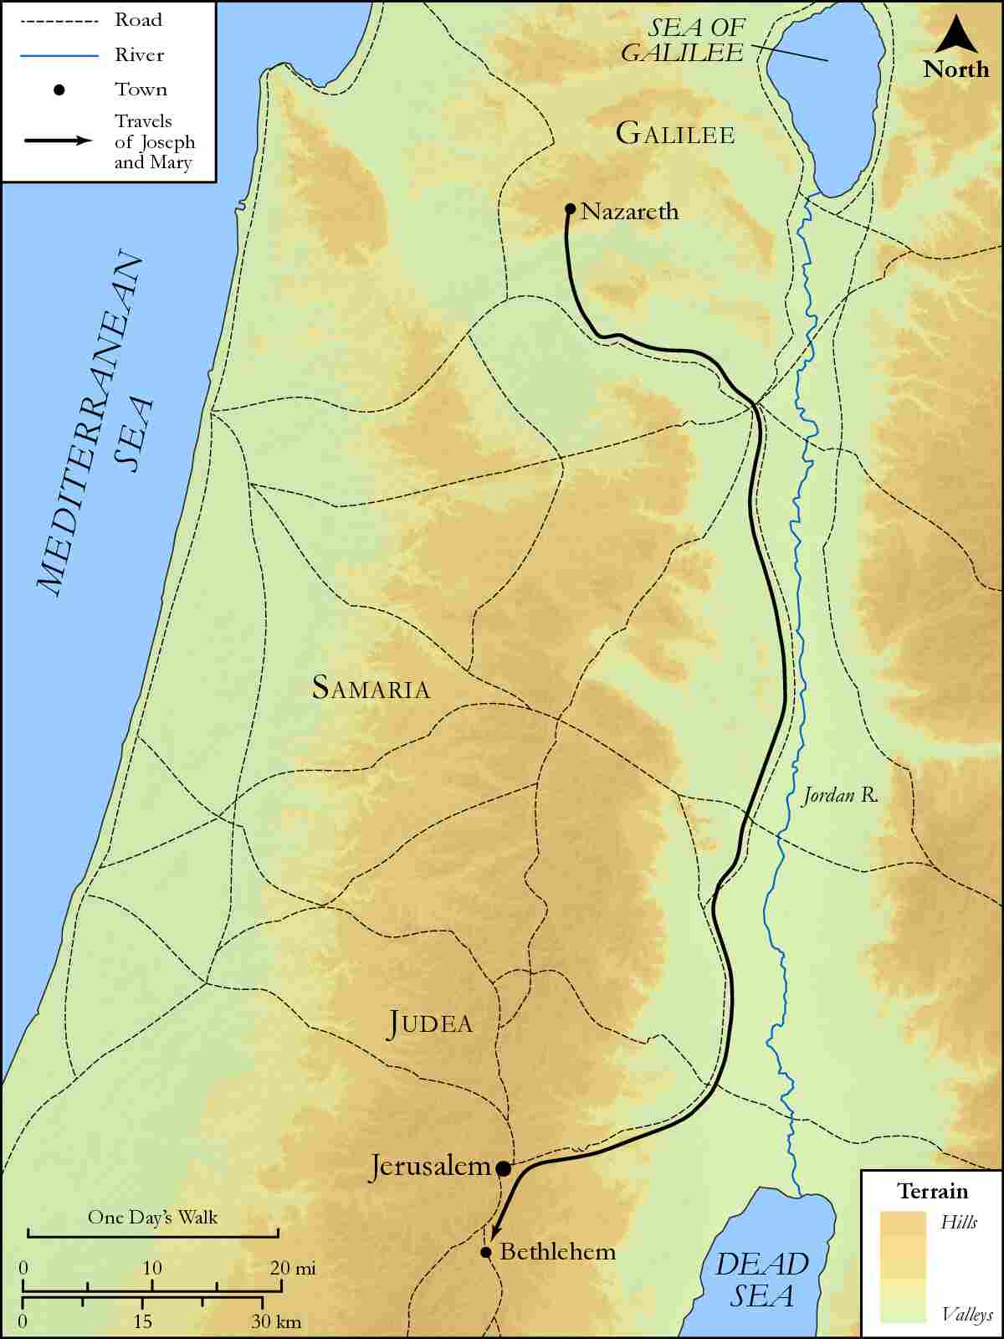
link

Joseph and Mary's Route from Nazareth to Jerusalem

Image Content

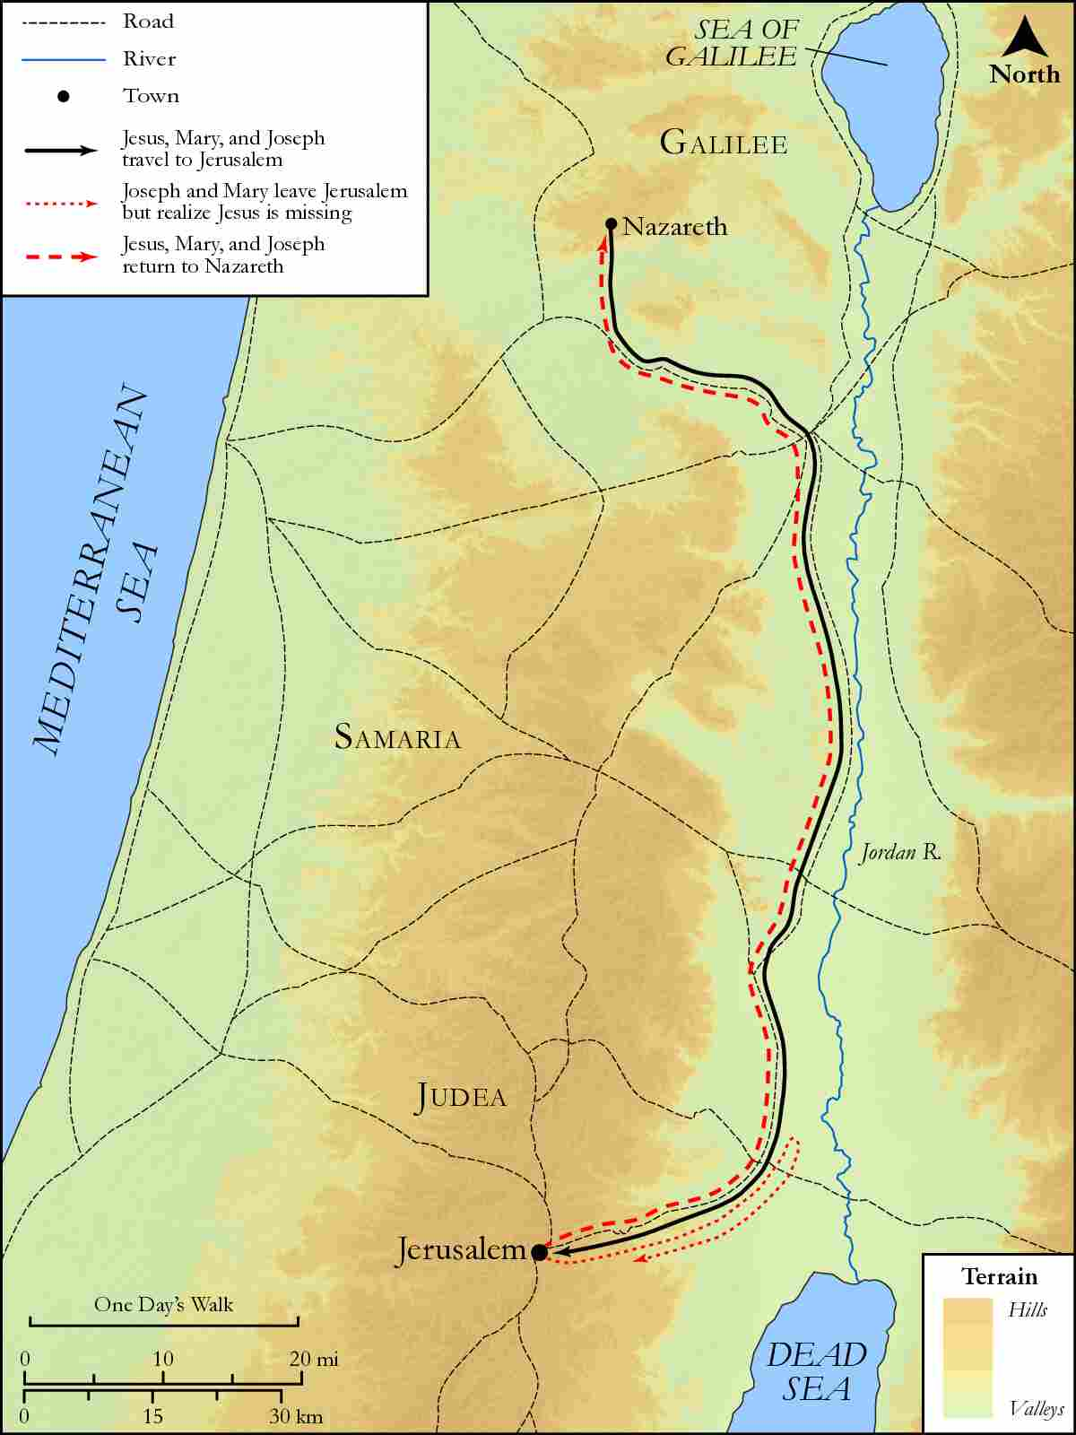
link

Judea and Dead Sea

Image Content

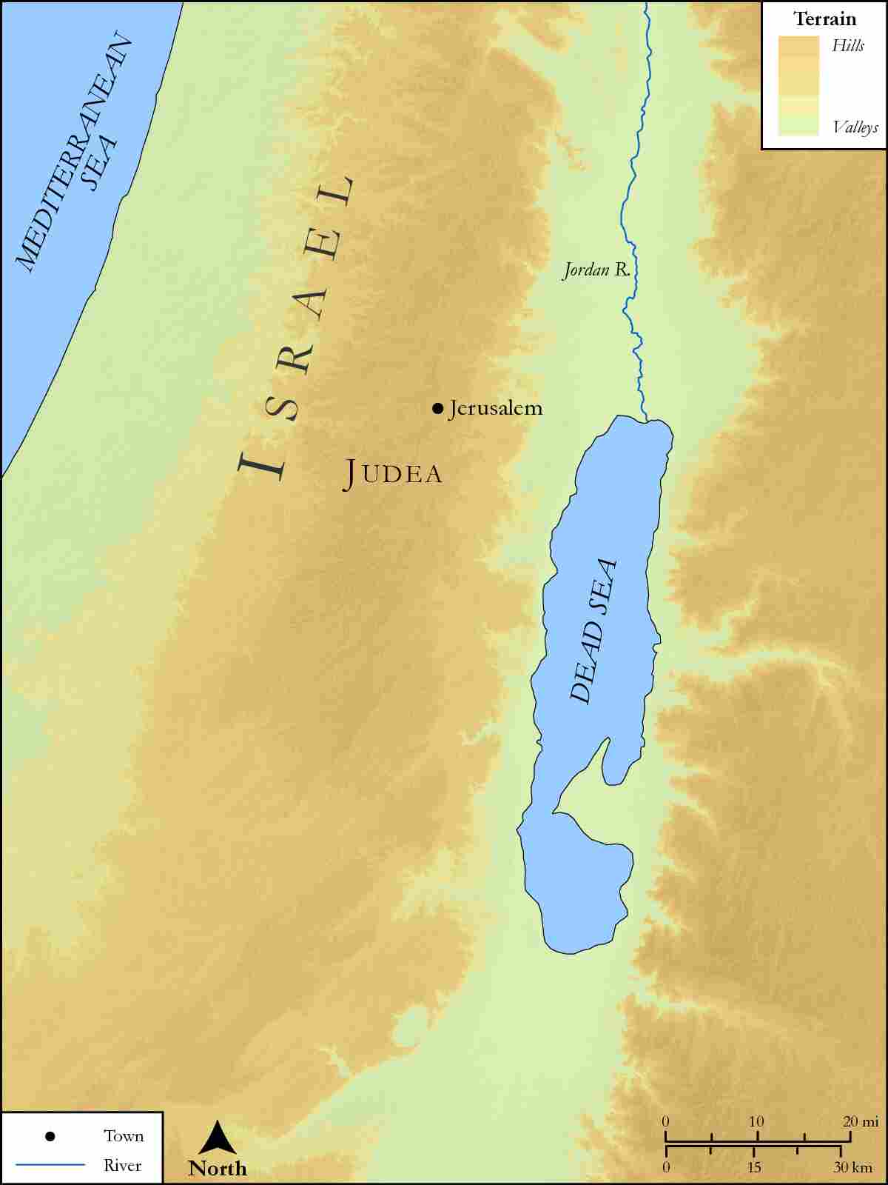
link

Lake with Bethsaida and Gennesaret

Image Content

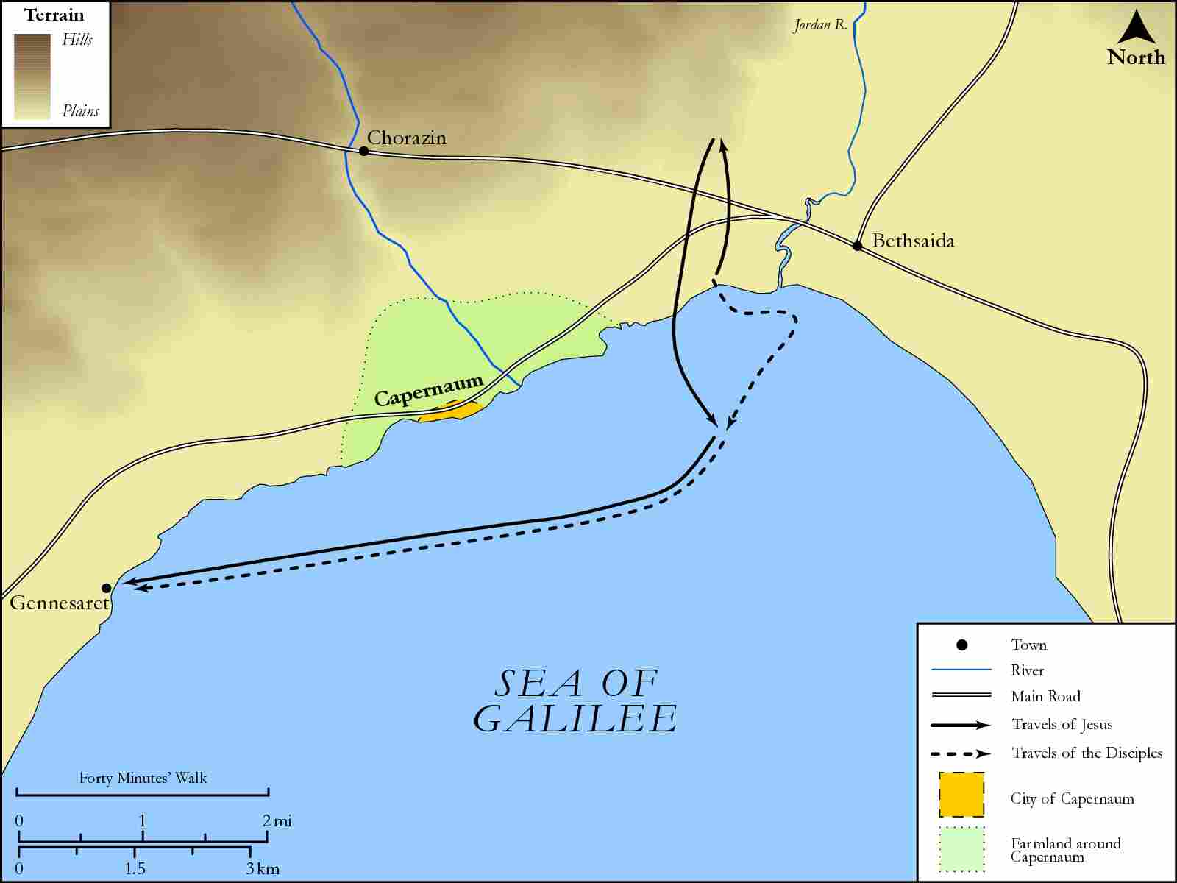
link

Lake with Capernaum and Bethsaida

Image Content

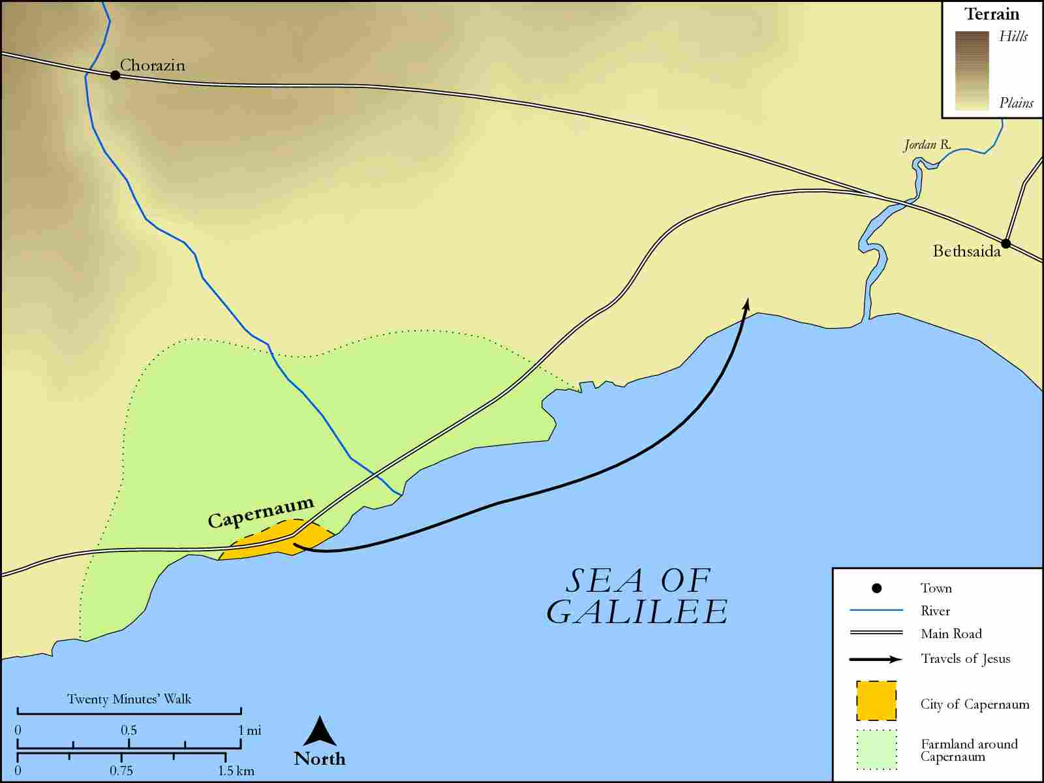
link

Locations in the Book of Mark

Image Content

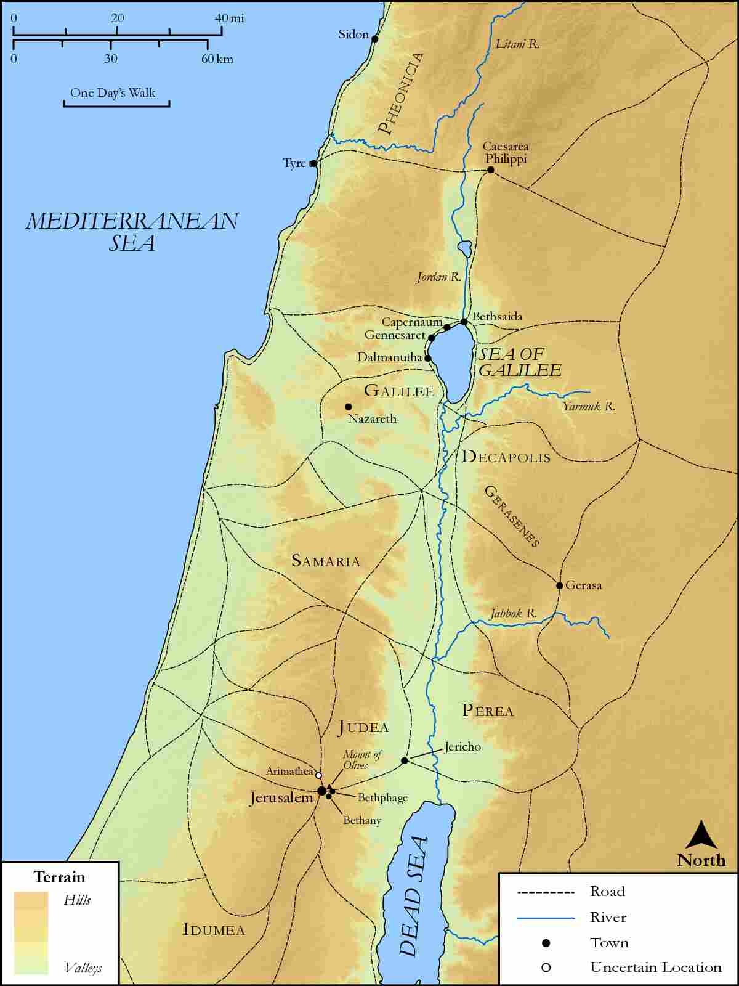
link

Mary's Route from Nazareth to Judea

Image Content

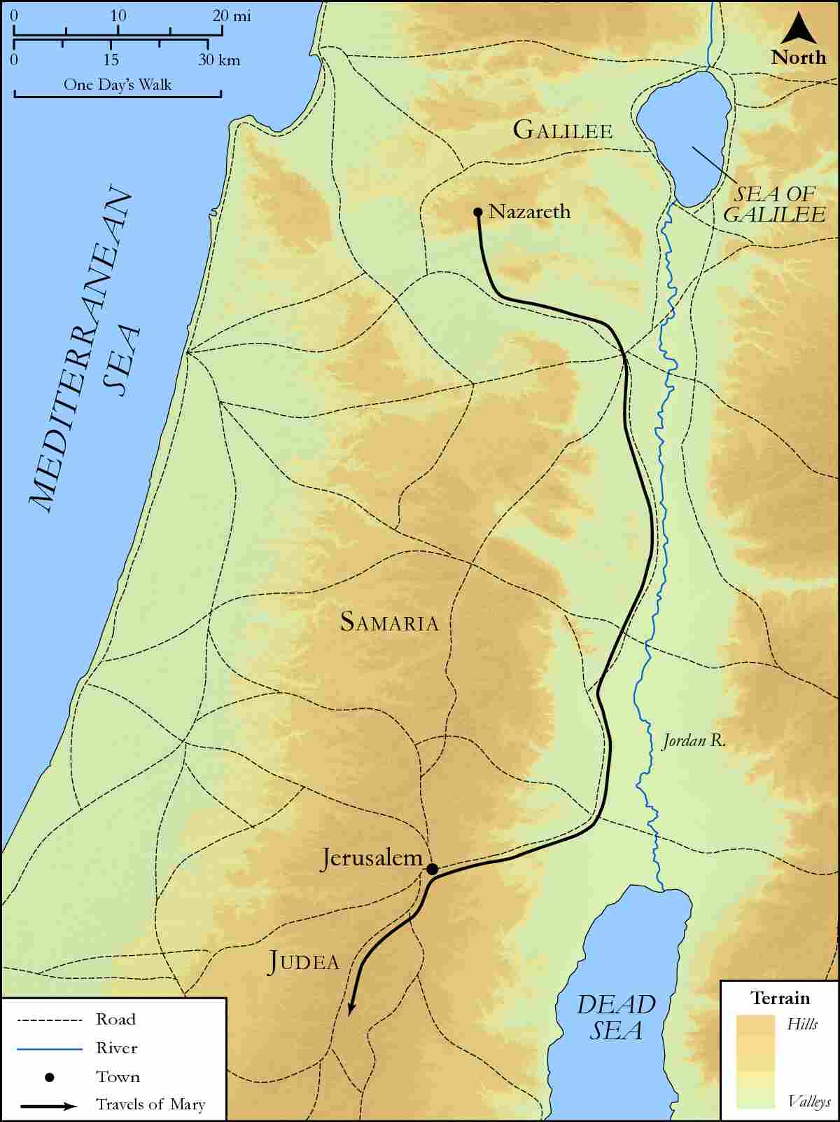
link

Mount Hermon

Image Content

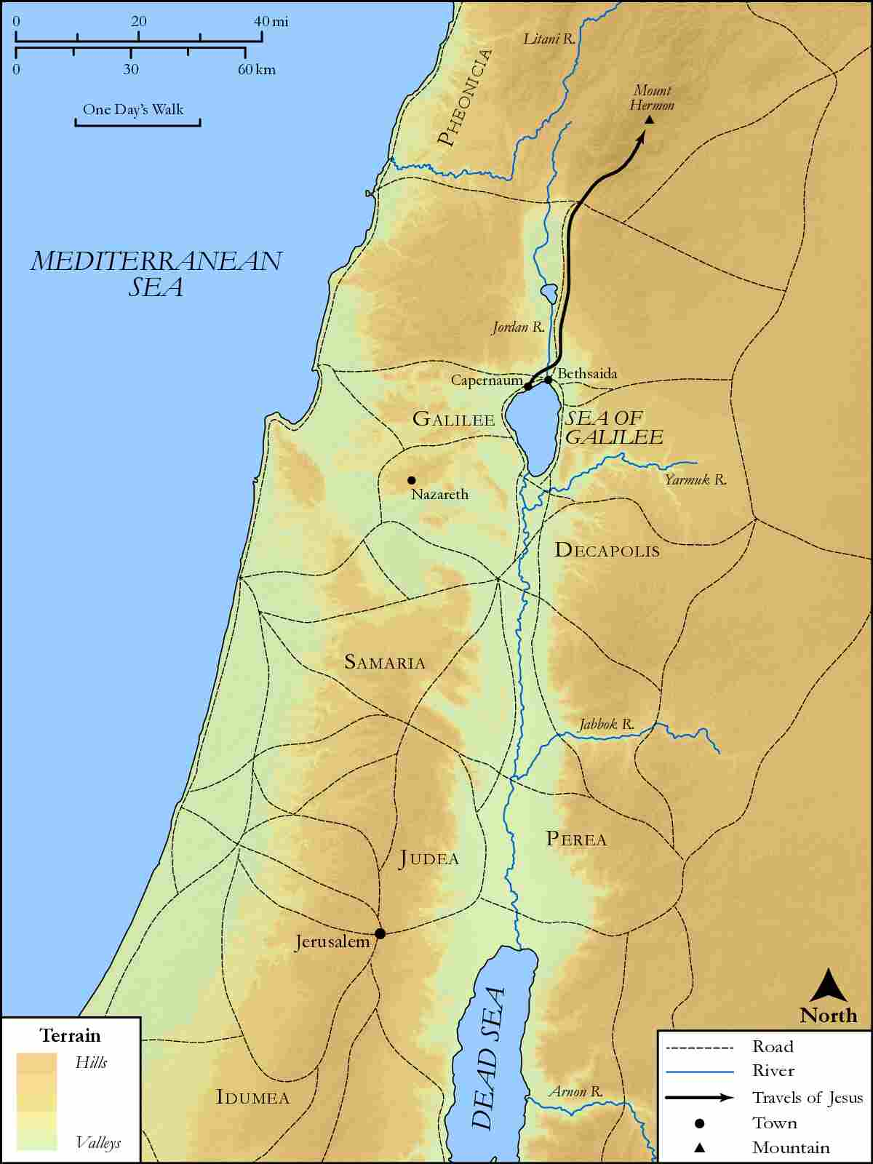
link

Mount of Olives

Image Content

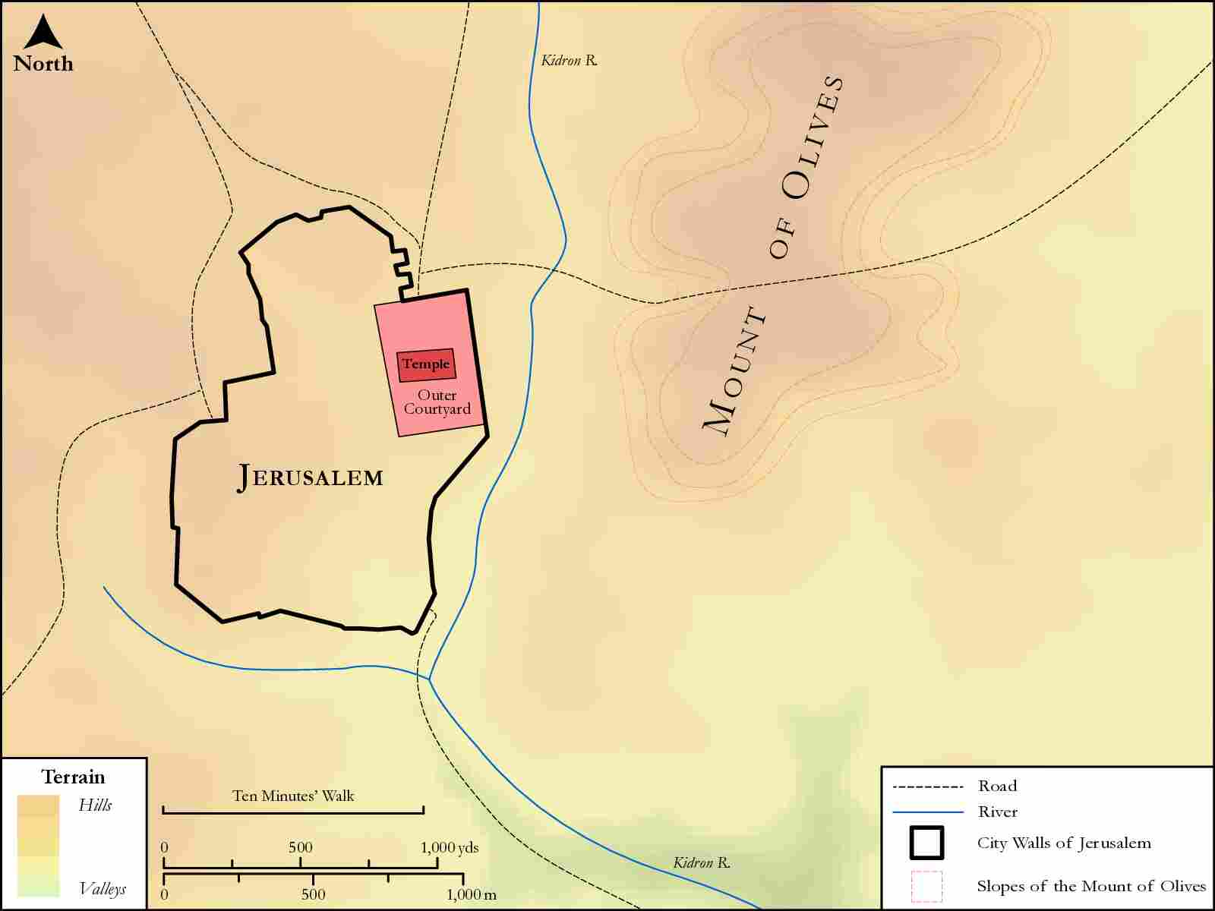
link

Nazareth

Image Content

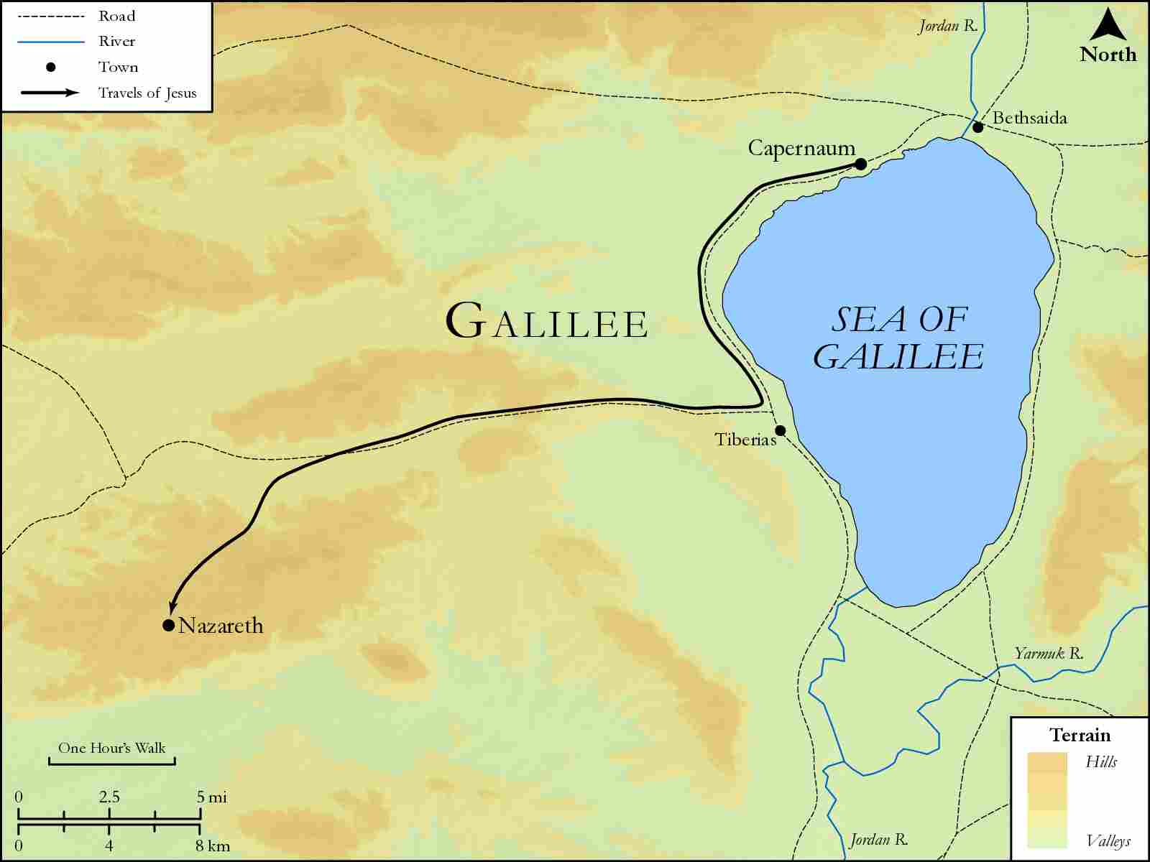
link

Nazareth and Judea

Image Content

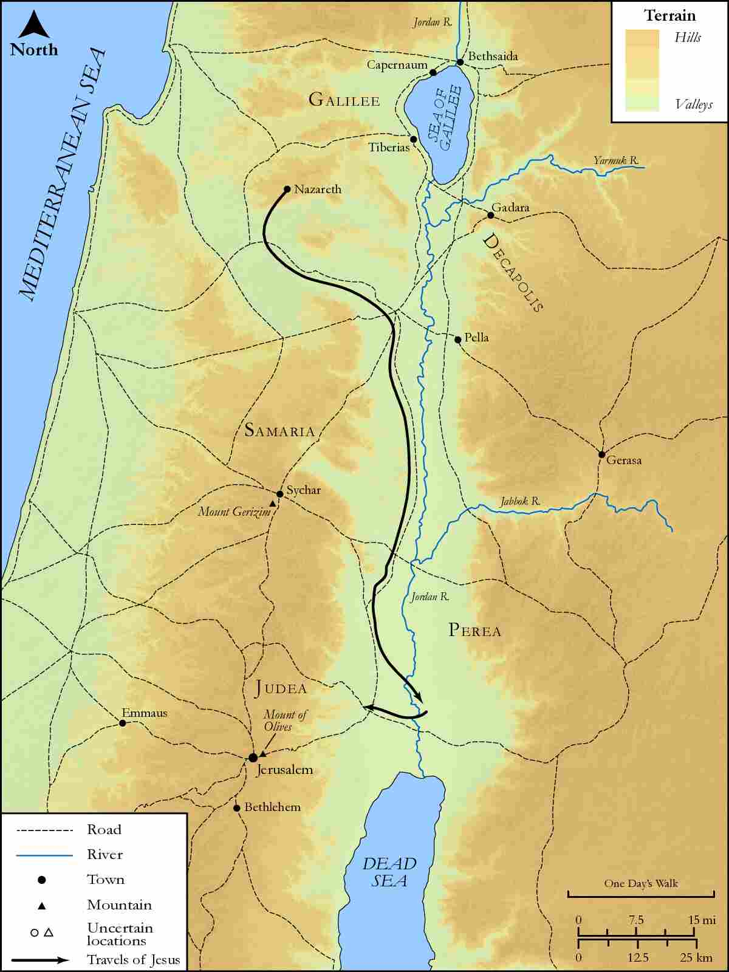
link

Nazareth to Capernaum

Image Content

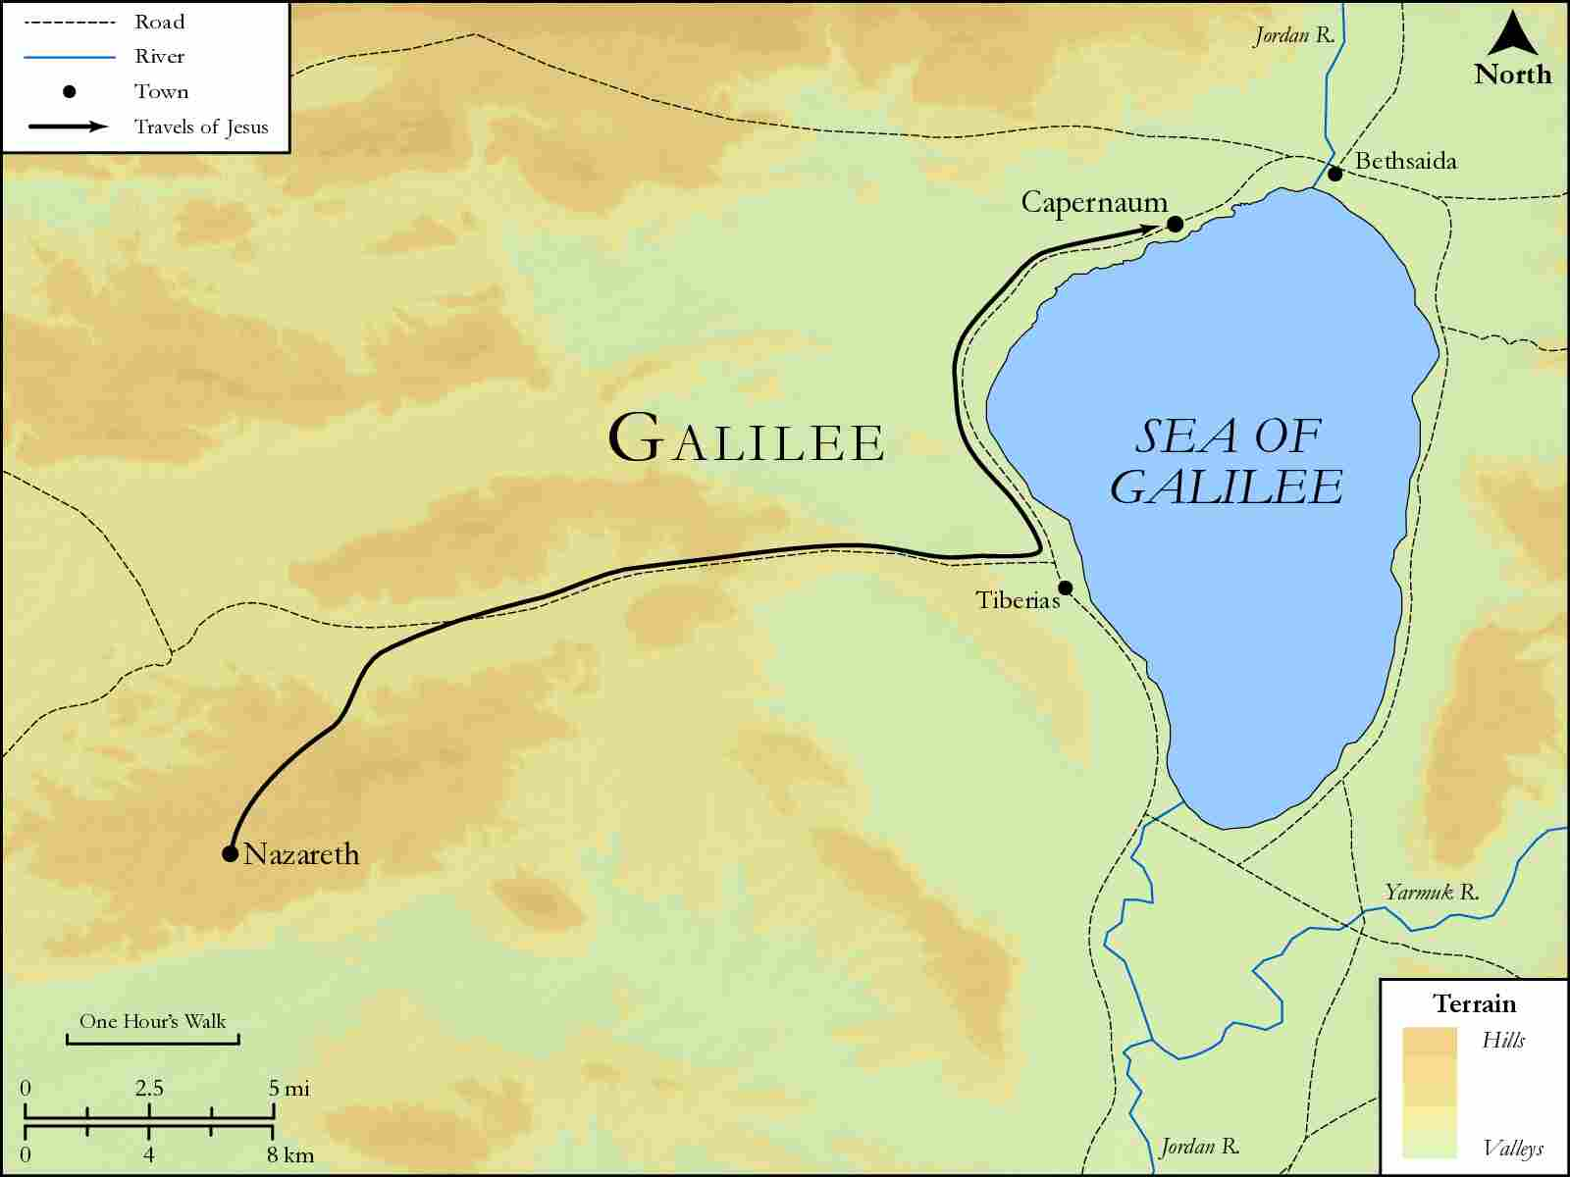
link

Negeb Area

Image Content

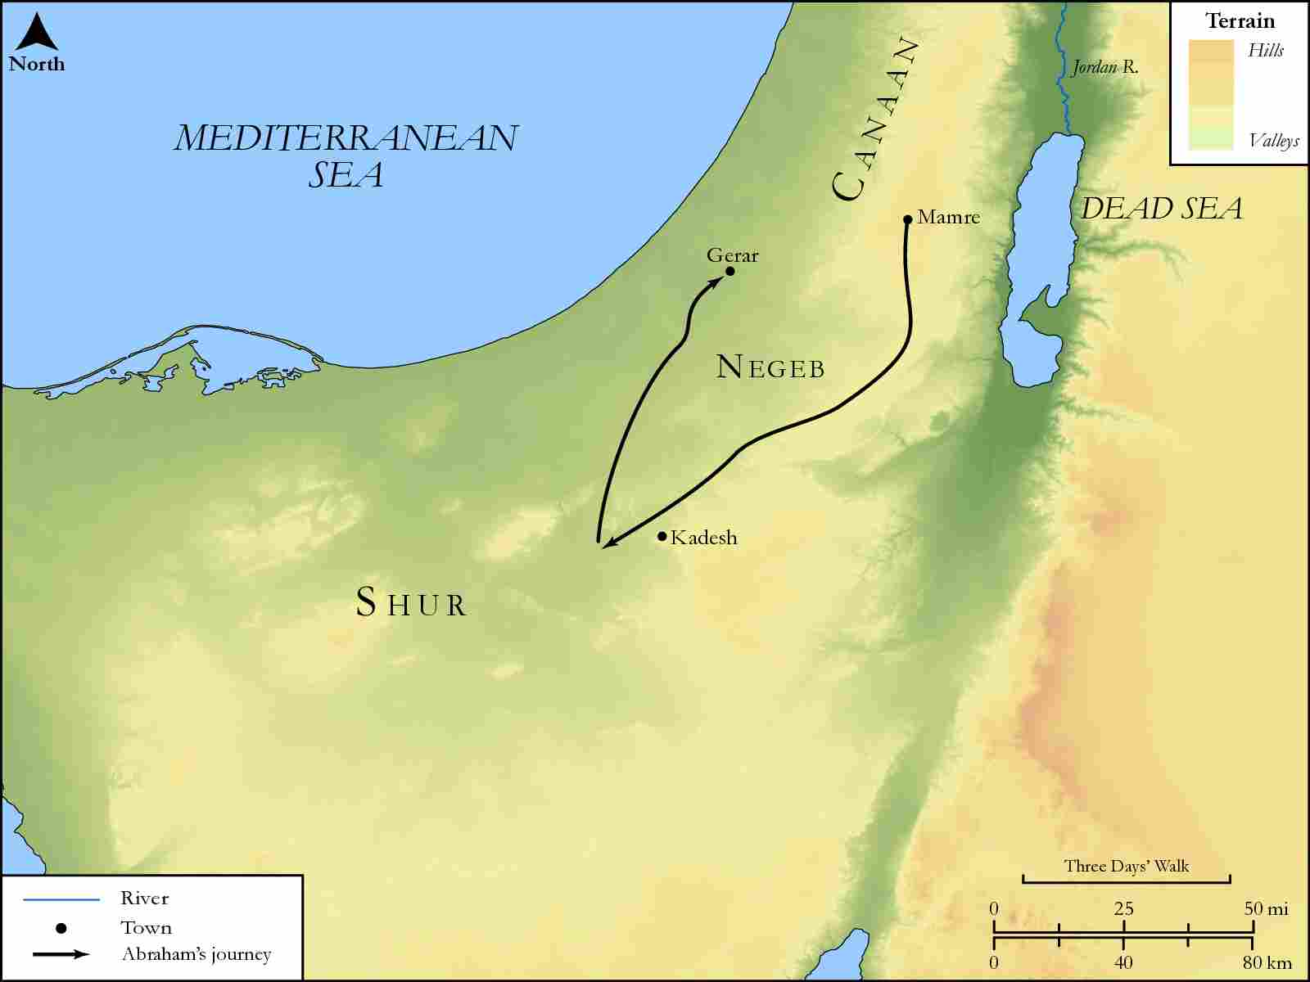
link

Oaks of Mamre

Image Content

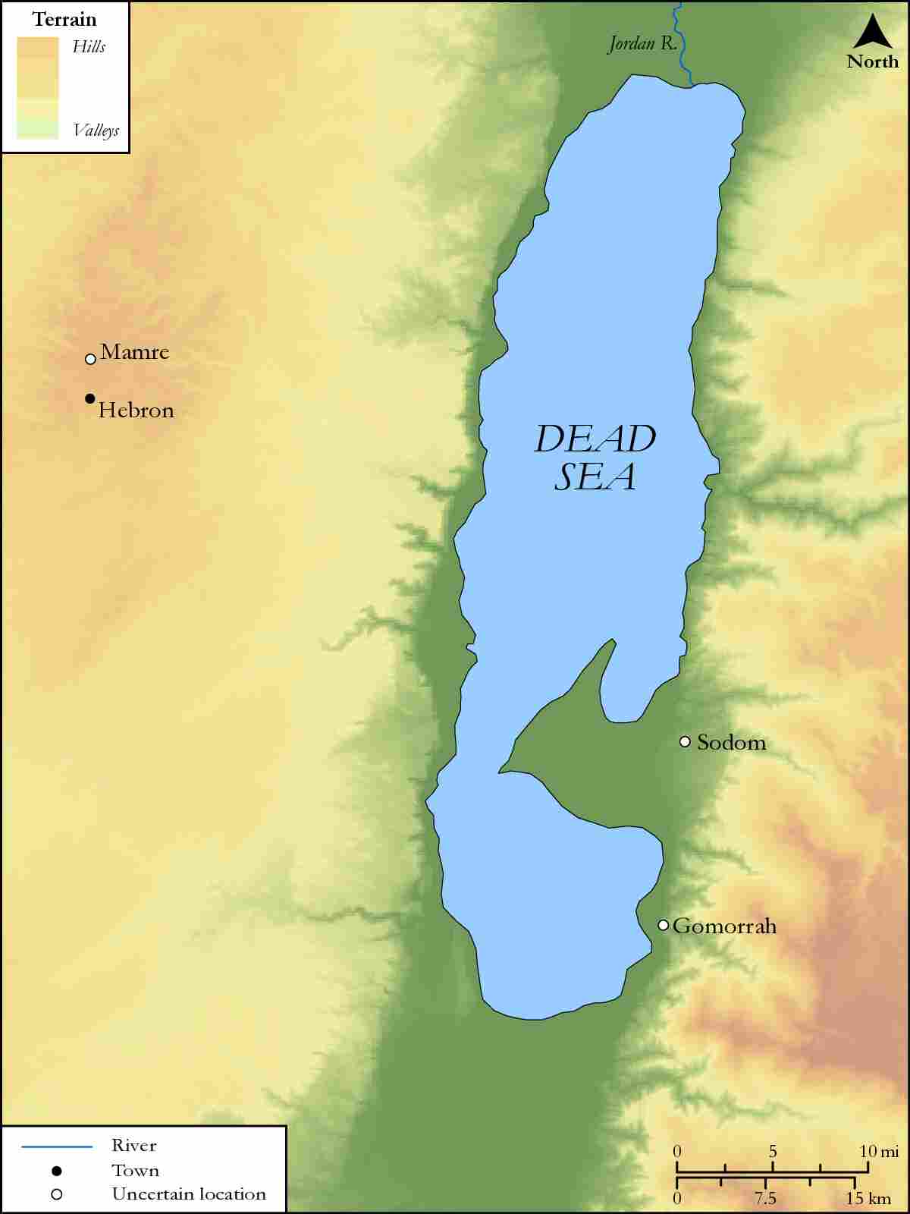
link

Paddan-Aram and Surrounding Areas

Image Content

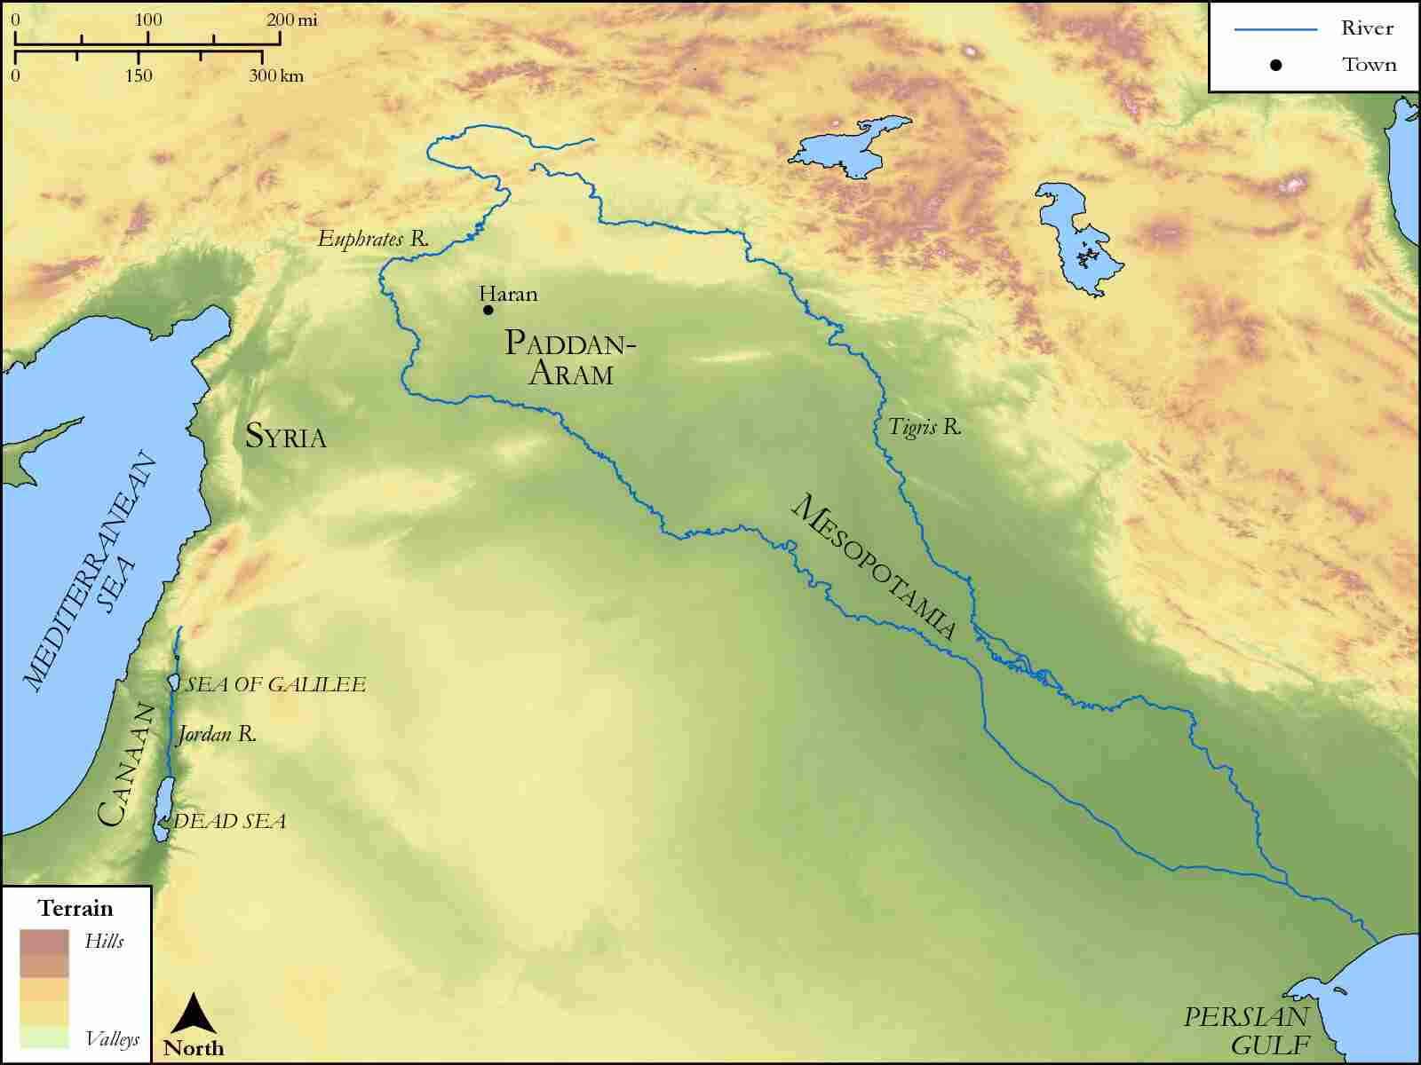
link

People Groups Between Egypt and the Euphrates

Image Content

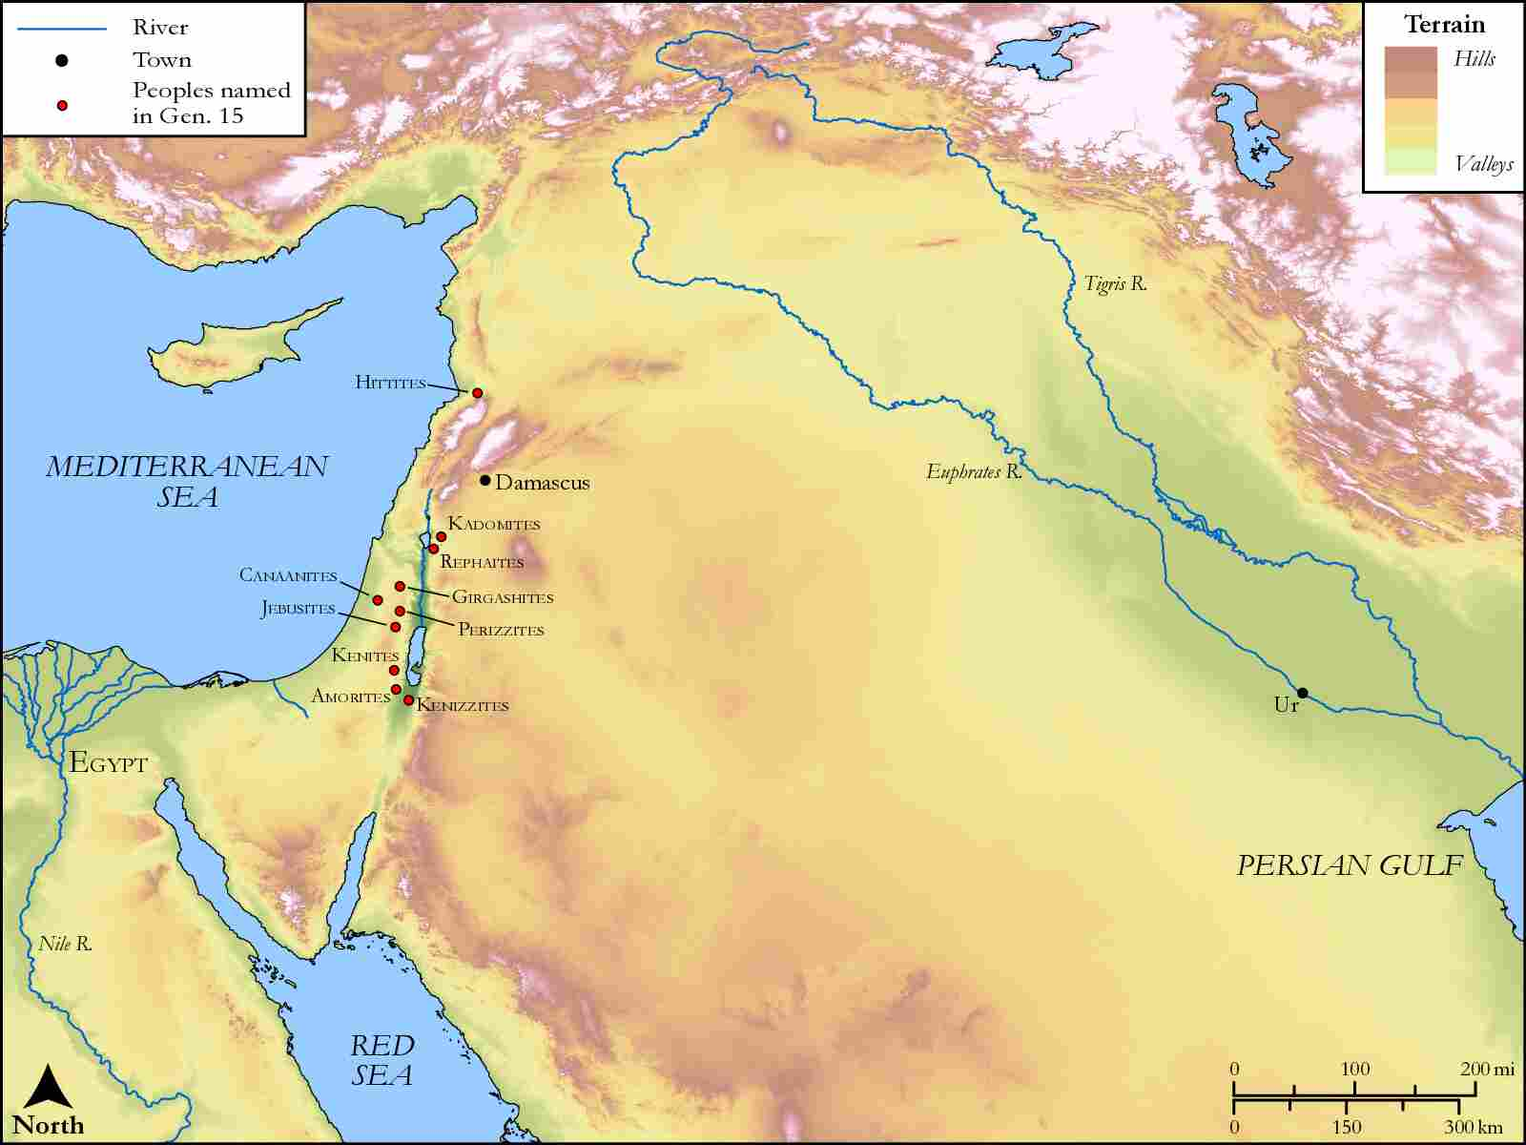
link

Pilate's House

Image Content

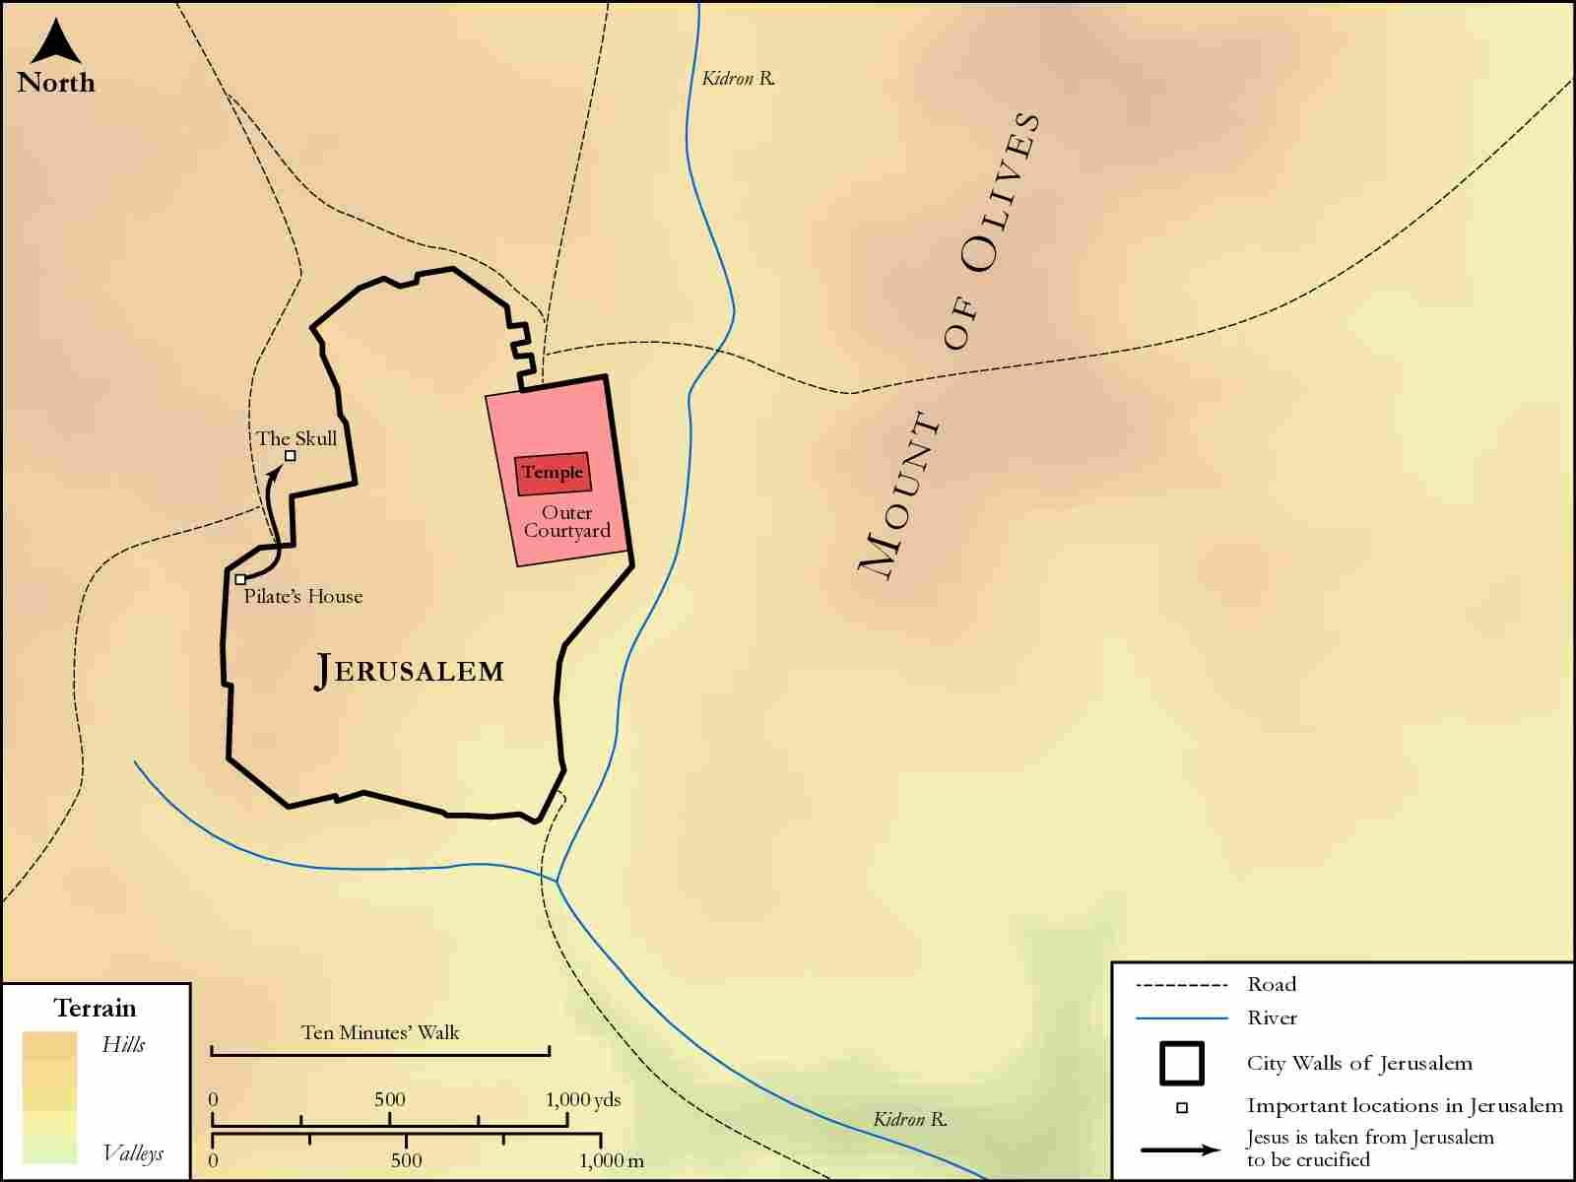
link

Rebel Kings in the South

Image Content

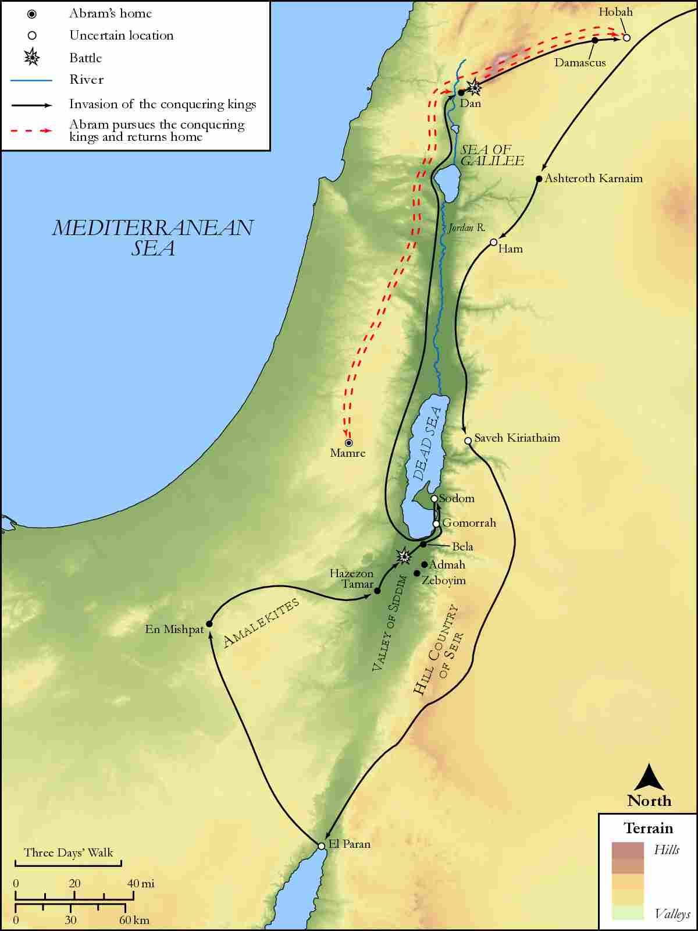
link

Region of Seir

Image Content

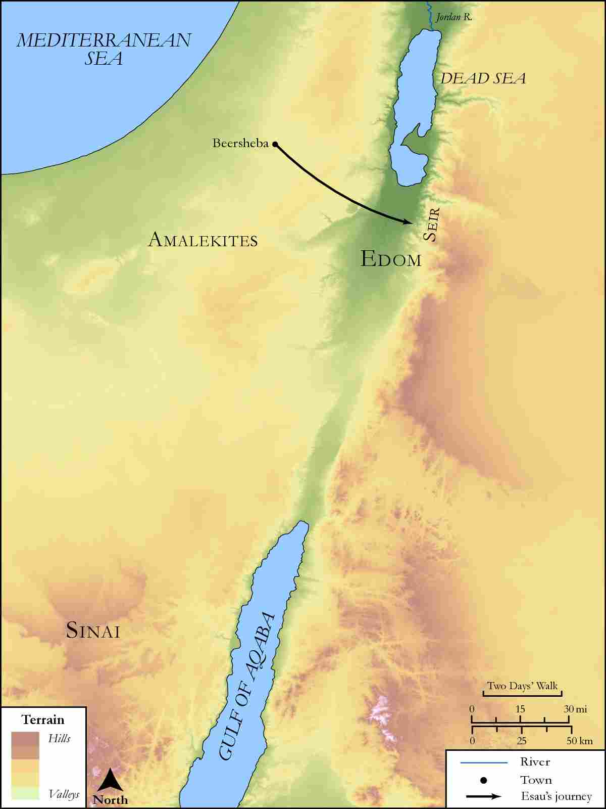
link

Region of the Gerasenes to Capernaum

Image Content

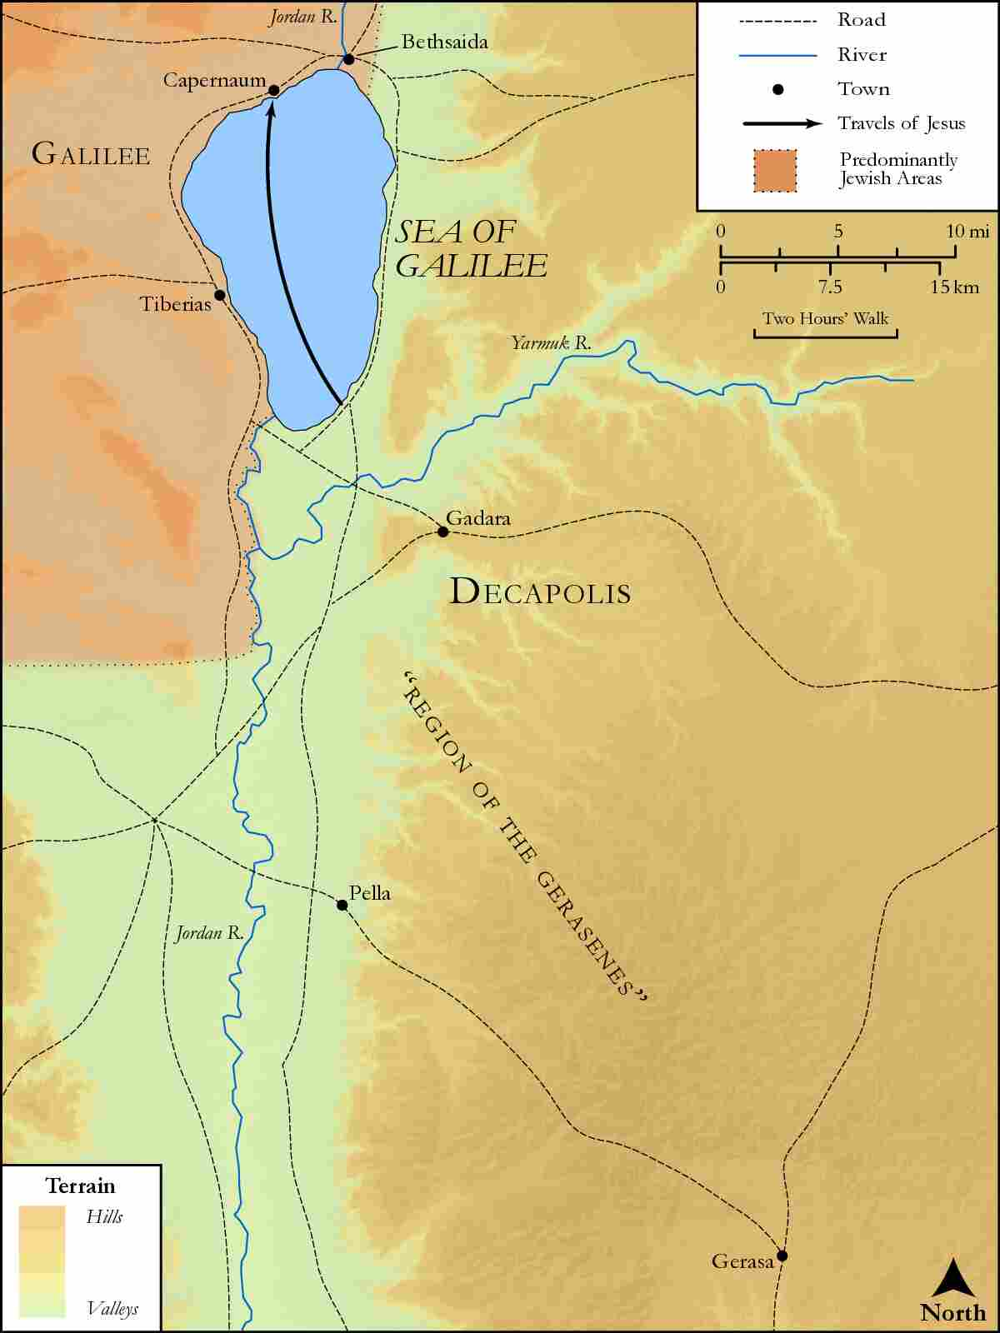
link

Road to Shur

Image Content

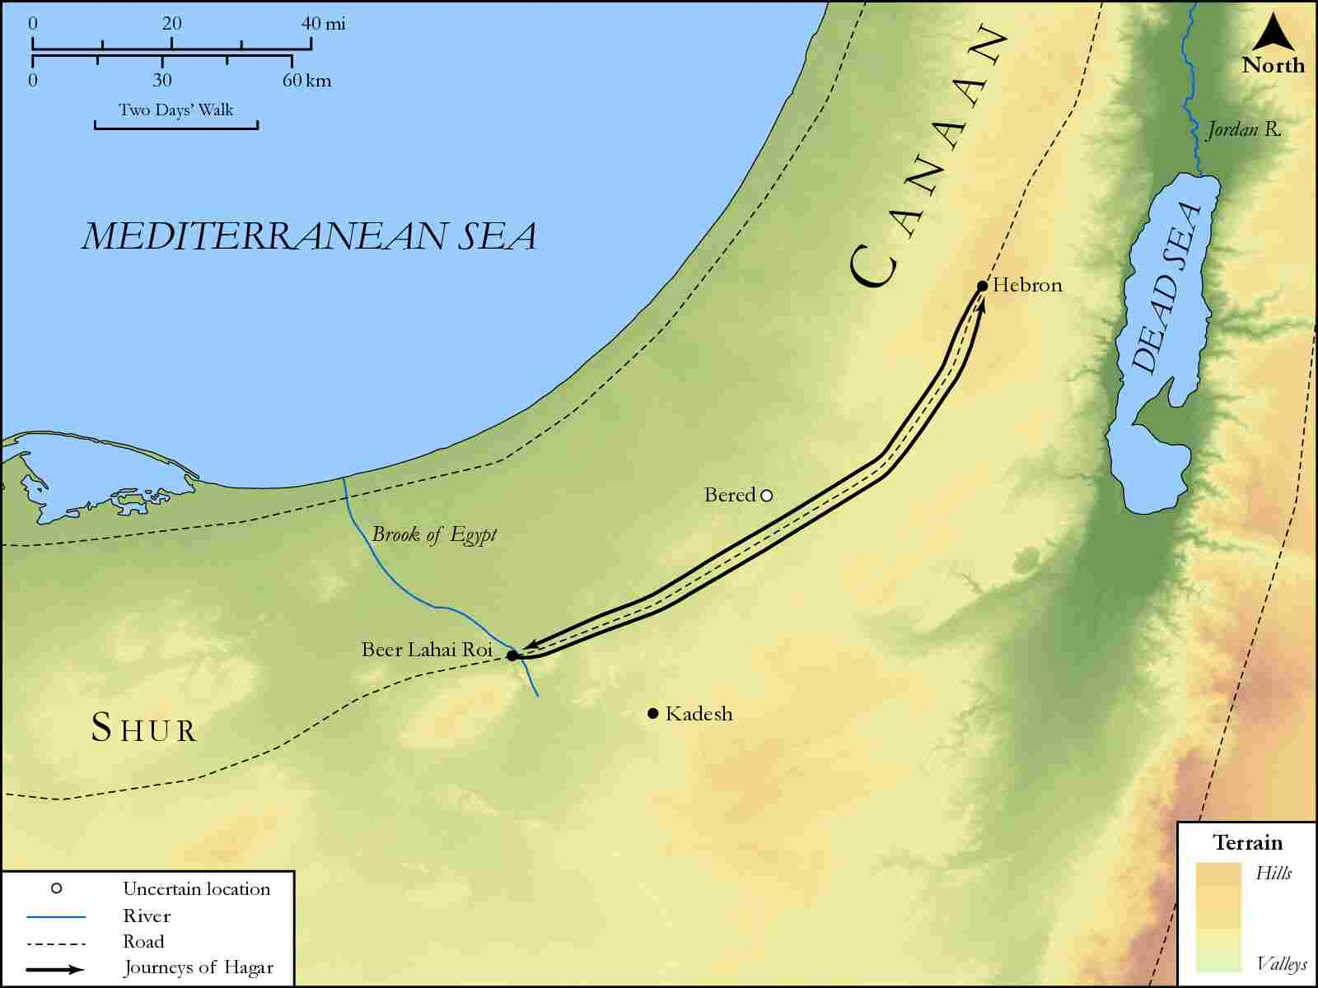
link

Route from Bethsaida to Caeserea Philippi

Image Content

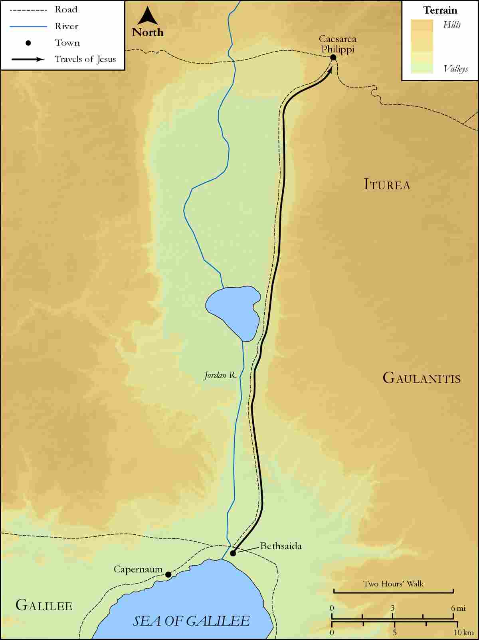
link

Sea of Galilee Western Side

Image Content

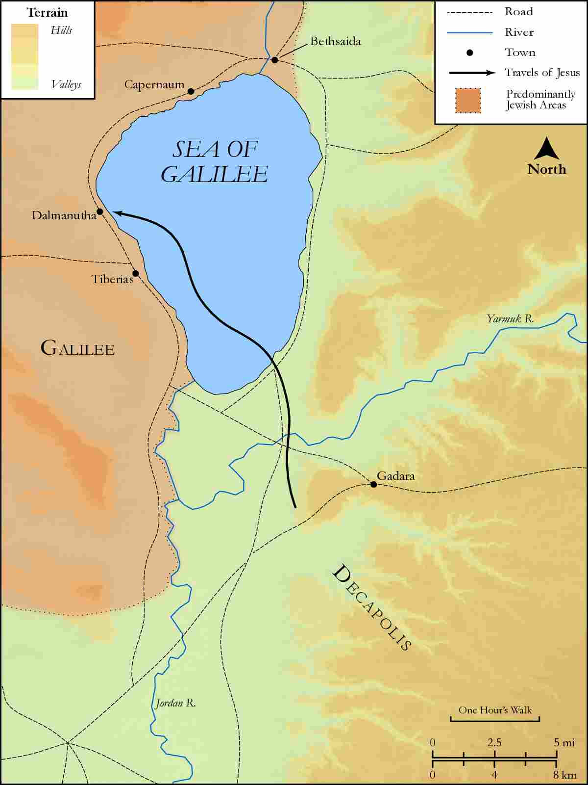
link

Sea of Galilee with Bethsaida

Image Content

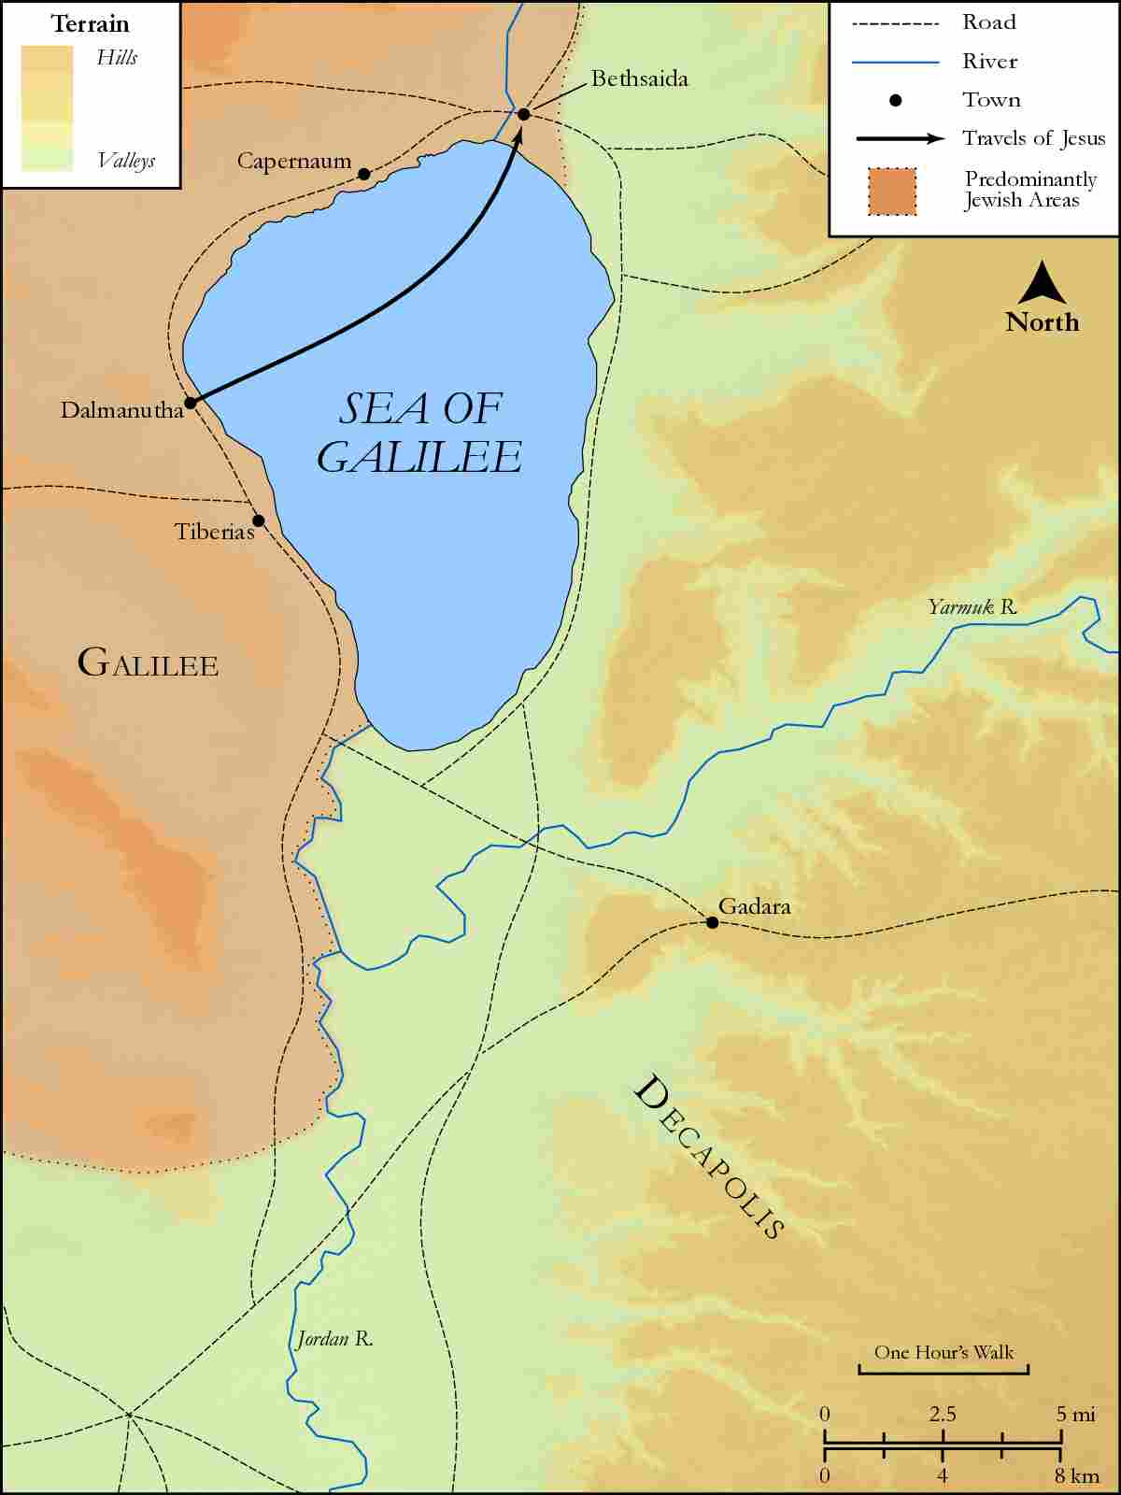
link

Sea of Galilee with Capernaum and Decapolis

Image Content

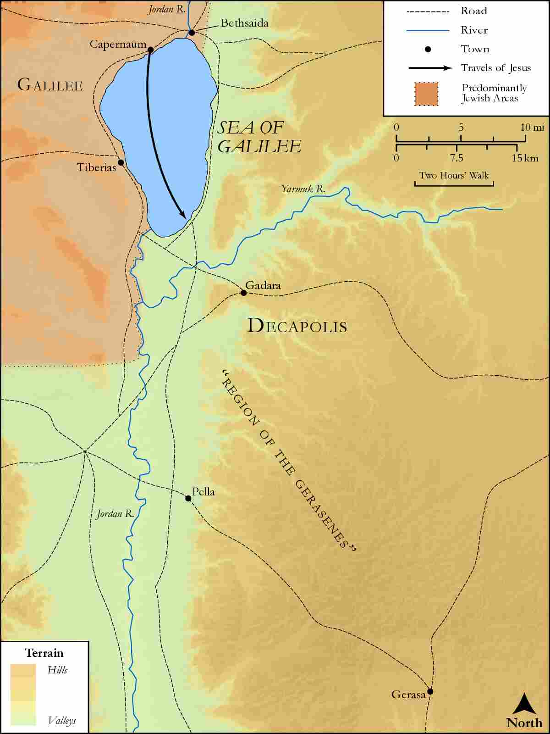
link

Sidon

Image Content

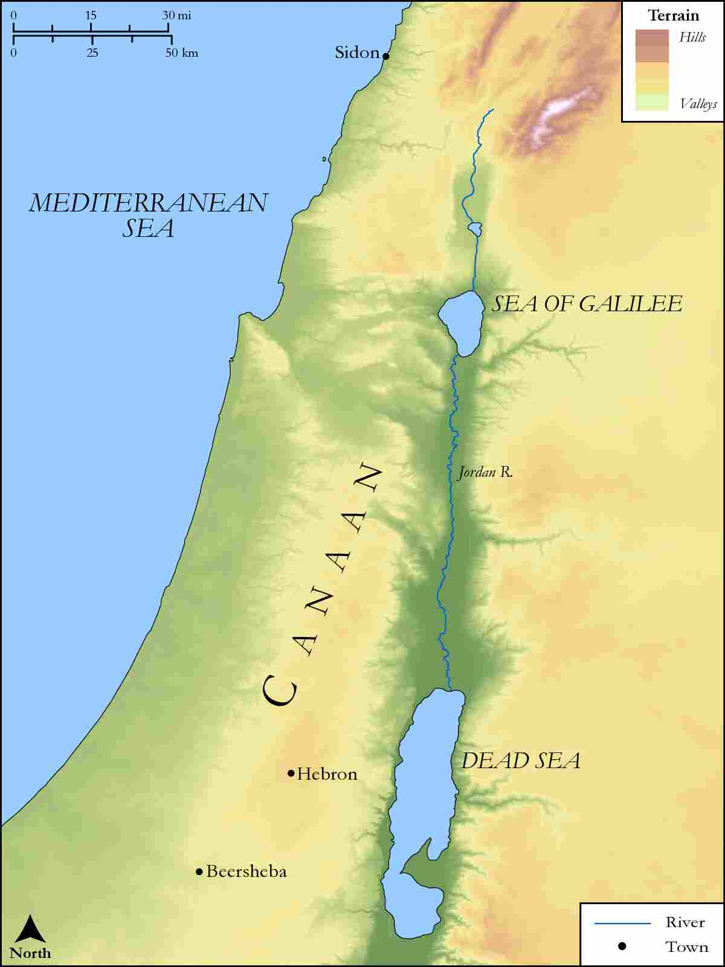
link

Sidon and Syria

Image Content

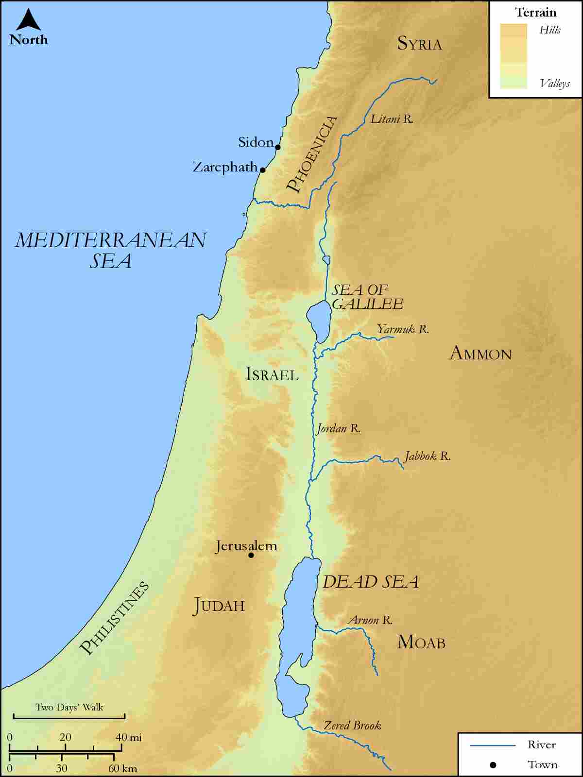
link

Sodom, Gomorrah and Great Oaks of Mamre

Image Content

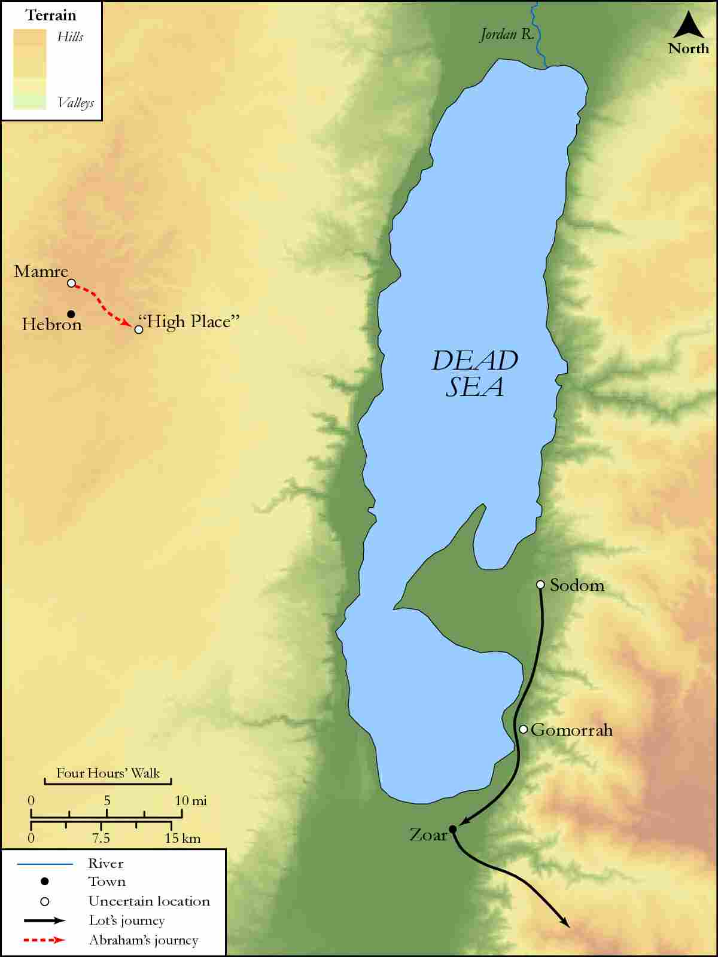
link

Territory of Herod Antipas

Image Content

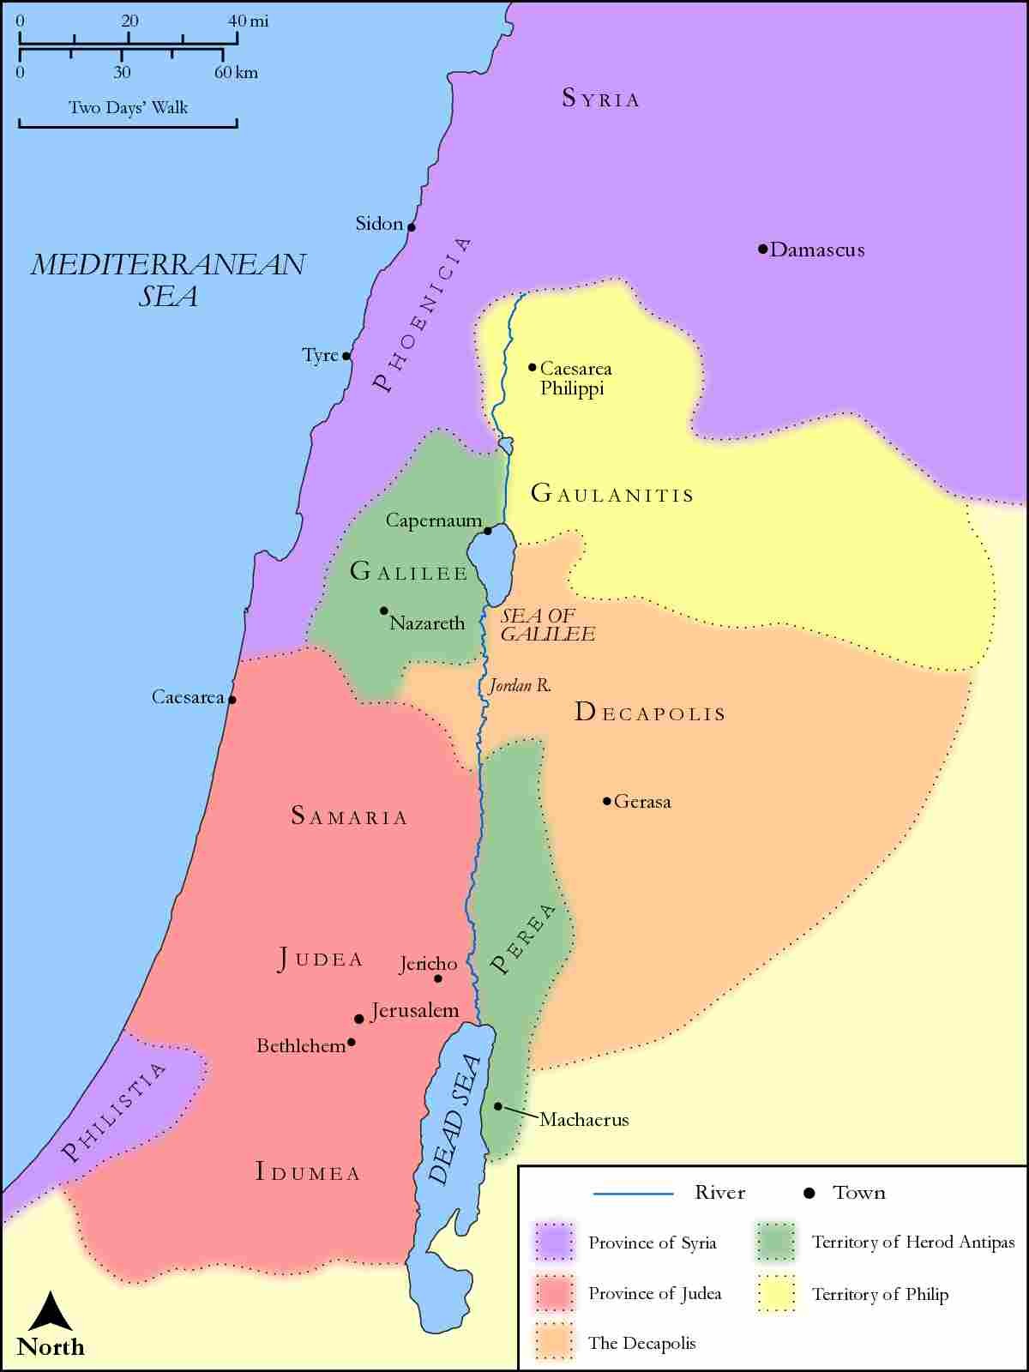
link

Tyre, Sidon and The Sea of Galilee

Image Content

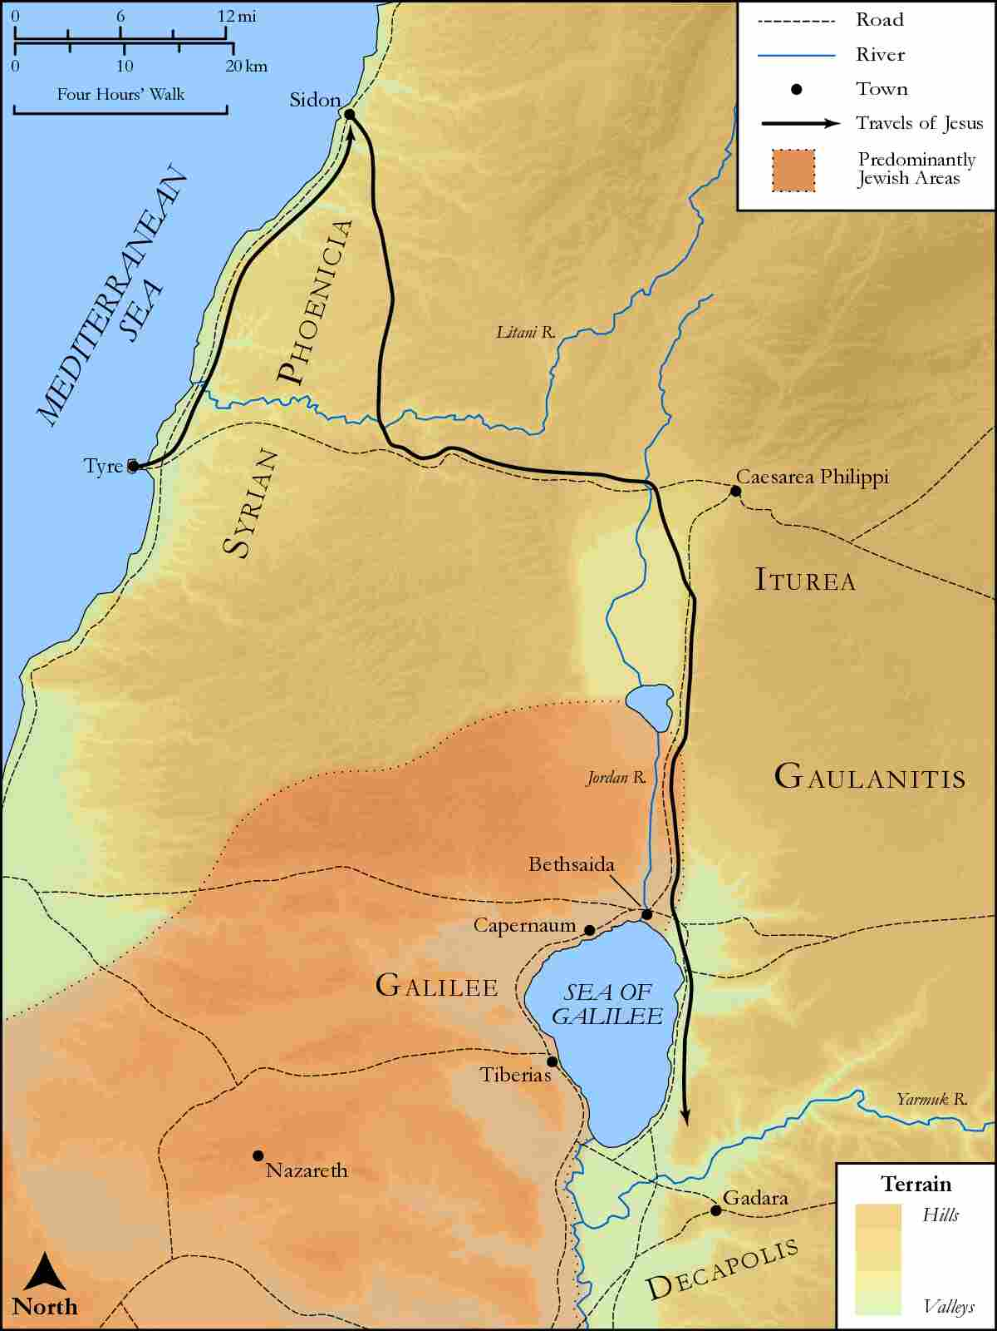
link

