Resource: Animals in the Bible
Animals in the Bible © United Bible Societies, 2025. Adapted from: All Creatures Great and Small: Living Things in the Bible, by Edward R. Hope © 2005 United Bible Societies. This work is licensed under Creative Commons Attribution-ShareAlike 4.0 International (https://creativecommons.org/licenses/by-sa/4.0/).

Animals in the Bible

Apes

2.3 Apes
- 2.3.1 Baboon
- 2.3.2 Monkey

Baboon

2.3.1 Baboon

References:Hebrew קוֹף (qof)1KI 10:22, 2CH 9:21

Discussion:
Hamadryas baboon (Public domain (Wikimedia Commons))In Africa Asia and Europe two of the primate families are the monkeys Cercopithecidae which have tails and the true apes Pongidae which have no tails. All of the evidence from ancient Egypt and the ancient Middle East indicates that monkeys and baboons were known but there is no reference at all in literature or art to apes without tails. Thus the English translation apes (which in the sixteenth and seventeenth centuries referred to any kind of non-human primate) is probably not the best term in modern English despite the fact that all English translations use this word."
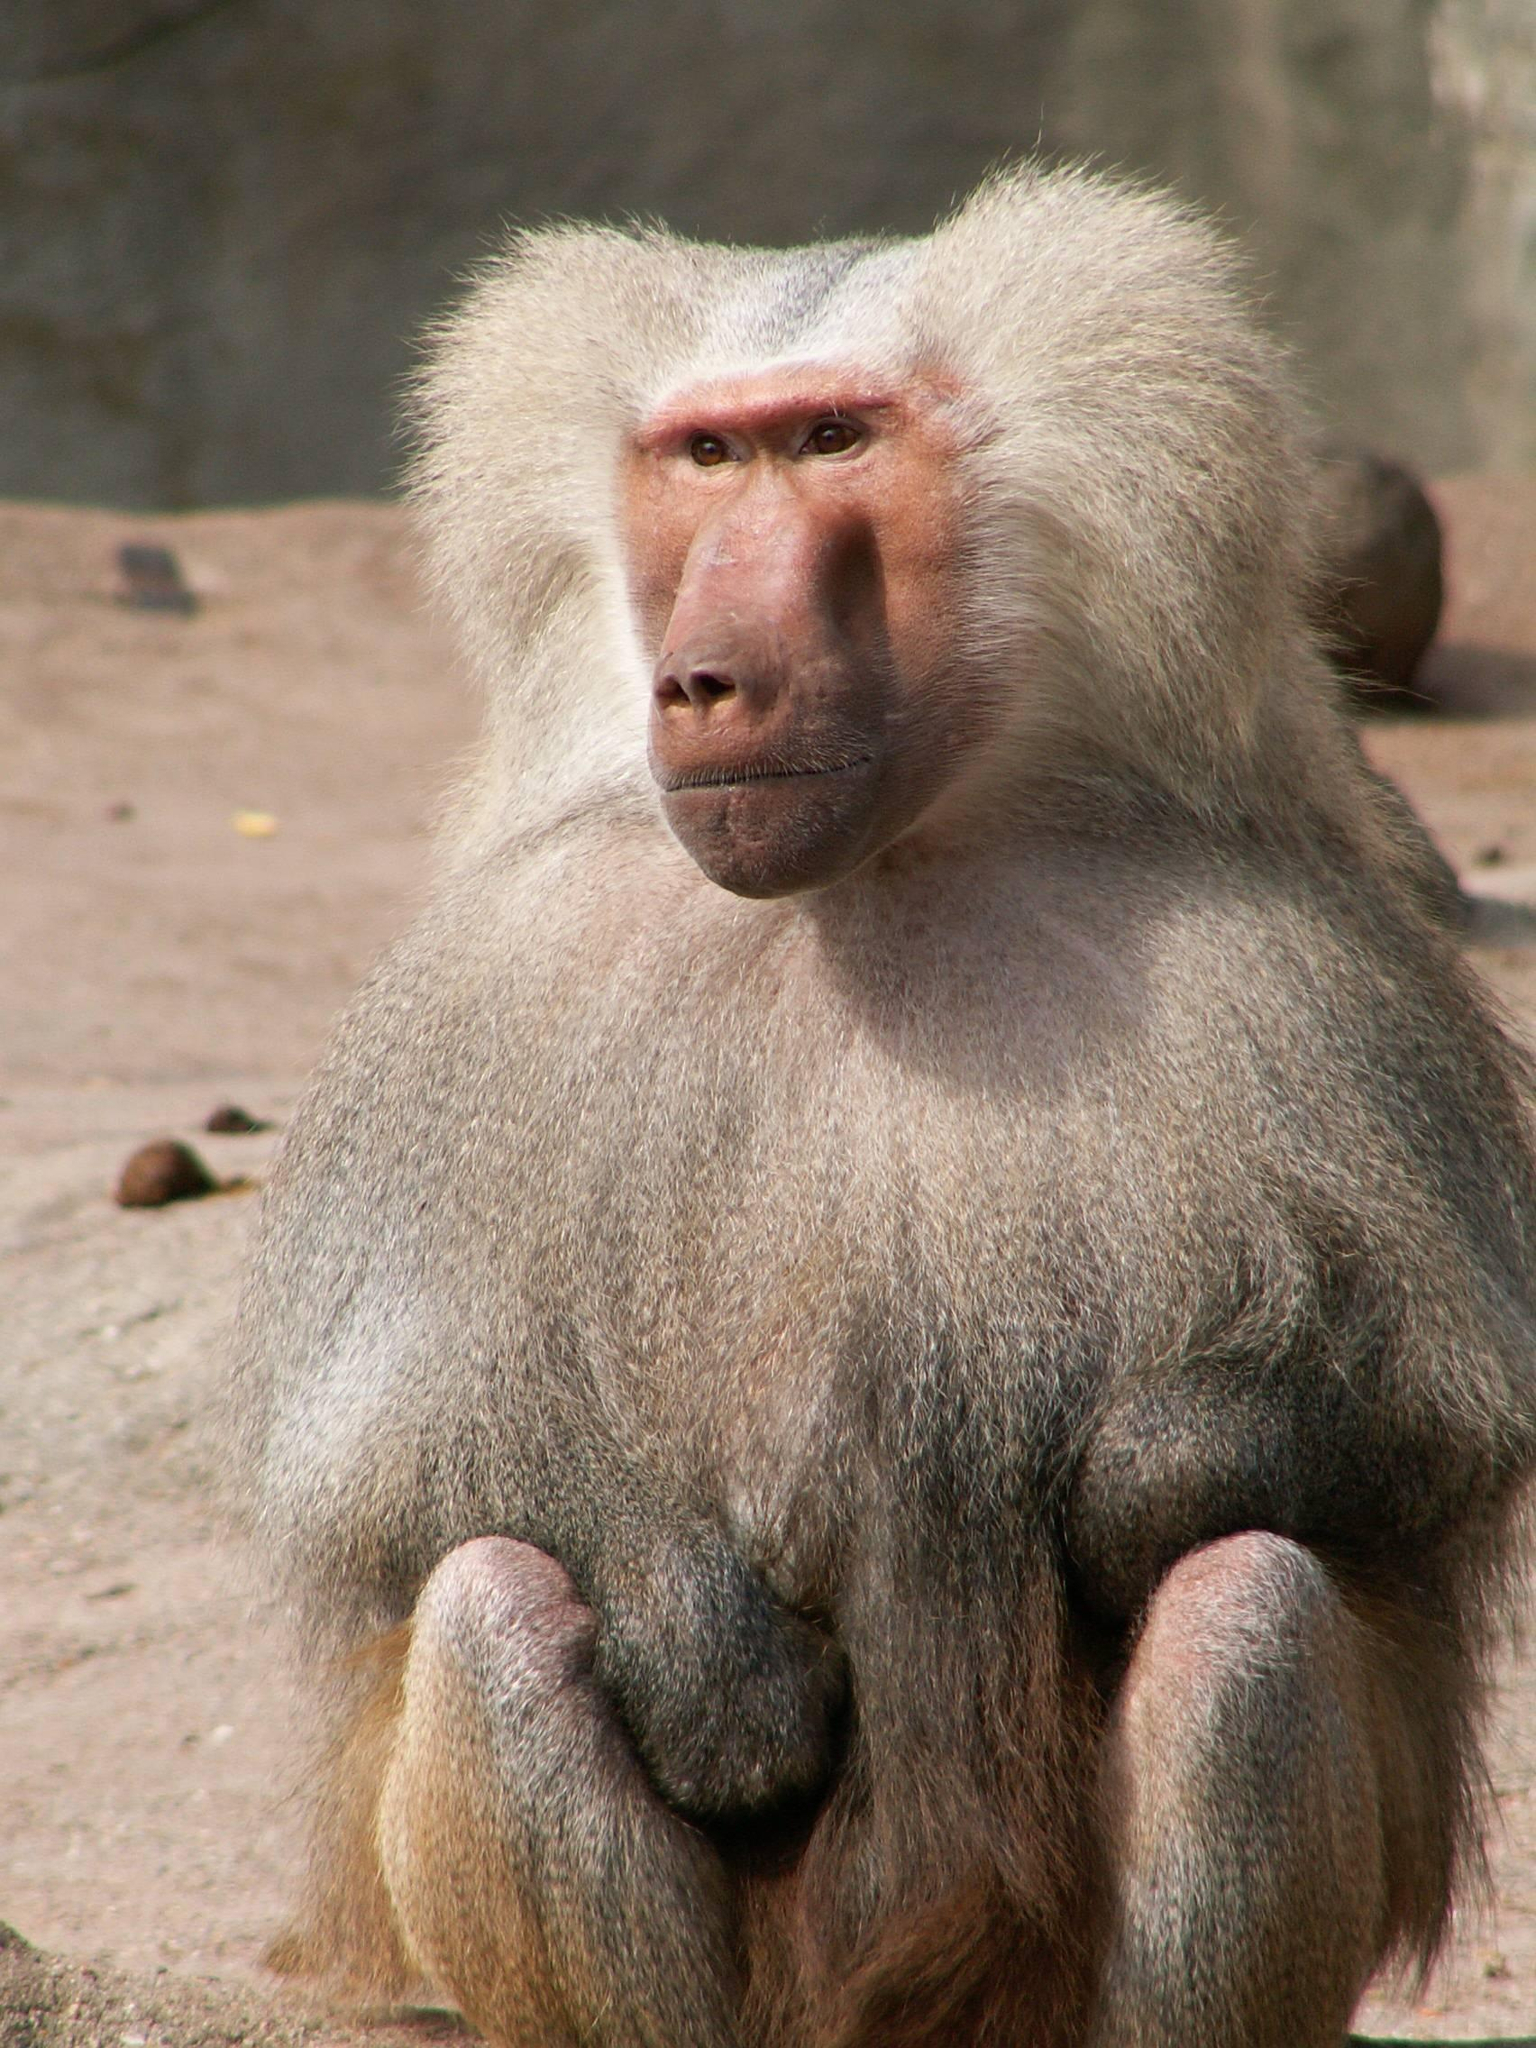
Bodenheimer identifies the Hebrew qof as a word and as a letter of the alphabet with the ancient Egyptian root g-f and the hieroglyph kafu both of which refer to the baboon. Both qof and kafu are deemed by other scholars to be onomatopoeic (that is the name sounds like the noise the animal makes) as is the case with many animal names. Since the Yellow Baboon Papio cynocephalus the Anubis Baboon Papio anubis doguerra and the Sacred Hamadryas Baboon Papio hamdryas were all well known in the ancient Middle East the above identifications seem most reasonable.

Description:
Baboons (various subspecies of the papio species) are large primates with long tails and doglike muzzles. Adults are often the size of a fairly large dog. Some large males develop a mane like a lion. They spend most of their time on the ground and eat a variety of roots, shoots, fruits, leaves, insects, and small reptiles. In some areas they hunt and eat small mammals such as mice, hares, or even juvenile gazelles. They live in troops of between thirty and eighty individuals, and the troop has a definite social structure, led by a dominant female. They are usually light brown, but older males sometimes turn gray.
Baboons or related species such as mandrills are found in rocky hill country in most parts of Africa except the Sahara and the northwest.

Translation:
In Africa the local name for baboon, mandrill, or gelada (Ethiopia) would be a good equivalent. Elsewhere, where there are large local monkeys that spend a lot of time on the ground, the local name for this species may be a good choice. In southern, eastern, and southeastern Asia, the larger varieties of macaque or rhesus monkeys are similar to baboons in many ways. In South America a generic word for the larger howler monkeys would be suitable, or where there is no generic word, a specific word for one of the howlers can be used.
In places where none of the above are known, an expression meaning big monkeys could be used, or a transliteration of the word from the original Hebrew or dominant language of the area.

Monkey

2.3.2 Monkey

References:Hebrew תֻּכִּי (tuki)1KI 10:22, 2CH 9:21

Discussion:
Vervet monkeys (Pixabay)The translation “peacocks” (KJVRSV) is almost certainly incorrect. The rest of the cargo on board Solomon’s ships is from East Africa (the ancient ivory objects discovered by archeologists in the land to date are all made from African ivory) while peacocks originate from India and Myanmar which used to be known as Burma.
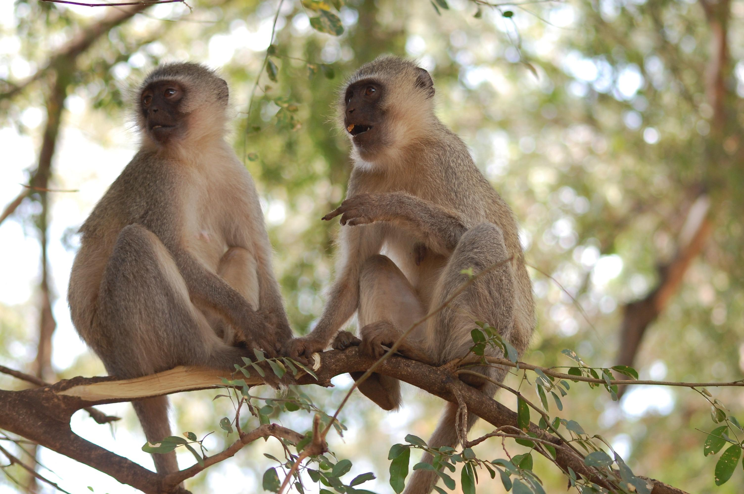
If qof refers to the baboon then it is likely that tuki refers to one of the smaller long-tailed monkeys of the guenon genus. The most common of these are the “green” and “blue” Vervet Monkeys Cercopithecus aethiops found throughout sub-Saharan Africa, Sudan, and Ethiopia. In ancient times these monkeys being easy to capture were exported as pets all over the Middle East and Europe.

Description:
Patas monkey (© Rhythmasharmad (Wikimedia Commons))Vervet monkeys are smallish, long-tailed monkeys, which have gray fur with a greenish or bluish tinge. The skin on their eyelids and the genitals of the males is also greenish or bluish. Vervets are mainly vegetarian, eating fruit and young leaves with occasional insects and spiders. They spend most of their time in trees, but they also forage for grass seeds and fallen fruit on the ground. They live in family groups of up to about twenty individuals.
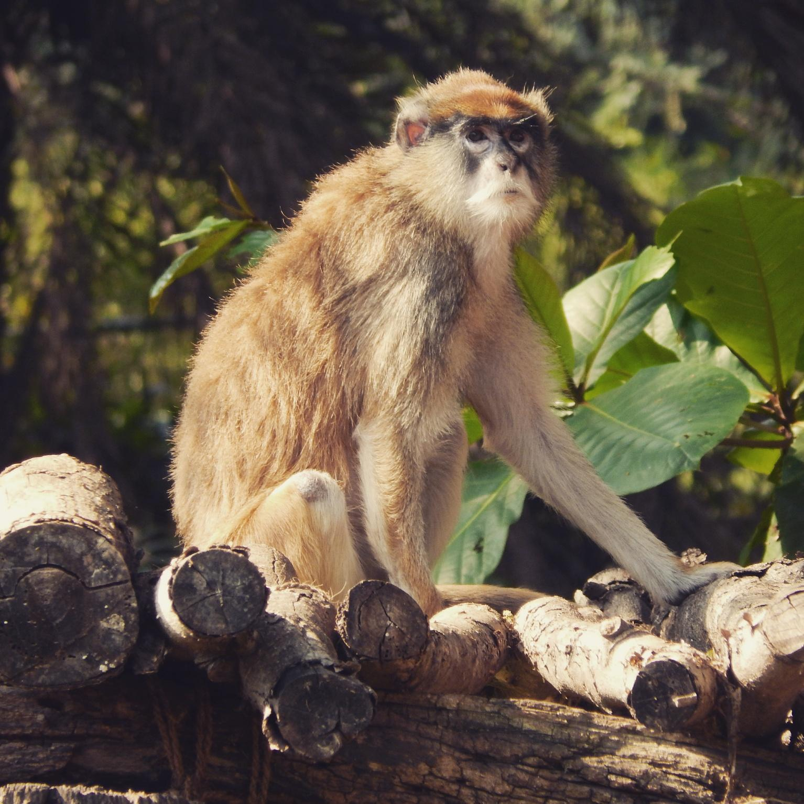

Translation:
In most parts of Africa the generic local name for the guenon type of monkey or the specific name for the vervet monkey, Cercopithecus mona or Erythrocebus patas, would be a good choice. In Asia the generic name for the long-tailed langurs or a specific name for one of the common langurs could be used, while in Latin America a generic name or a specific term for the smaller capuchin monkeys would be suitable. If there are limited choices, or only one word for monkey, then tuki can be translated “small monkey.” In places where monkeys are not known, a transliteration of tuki or the word in the dominant or trade language should be used.
The recommended interpretation of the Hebrew veqofim vetukiyim in both 1KI 10:22 and 2CH 9:21 is thus “baboons and monkeys".

