Resource: Animals in the Bible
Animals in the Bible © United Bible Societies, 2025. Adapted from: All Creatures Great and Small: Living Things in the Bible, by Edward R. Hope © 2005 United Bible Societies. This work is licensed under Creative Commons Attribution-ShareAlike 4.0 International (https://creativecommons.org/licenses/by-sa/4.0/).

Animals in the Bible

Lion

2.24 Lion

References:Hebrew אֲרִי, אַרְיֵה (’ari, ’aryeh)GEN 49:9, GEN 49:9, NUM 23:24, NUM 24:9, DEU 33:22, JDG 14:5, JDG 14:8, JDG 14:8, JDG 14:9, JDG 14:18, 1SA 17:34, 1SA 17:36, 1SA 17:37, 2SA 1:23, 2SA 17:10, 2SA 23:20, 2SA 23:20, 1KI 7:29, 1KI 7:29, 1KI 7:36, 1KI 10:19, 1KI 10:20, 1KI 13:24, 1KI 13:24, 1KI 13:25, 1KI 13:26, 1KI 13:28, 1KI 13:28, 1KI 20:36, 1KI 20:36, 2KI 17:25, 2KI 17:26, 1CH 11:22, 1CH 12:9, 2CH 9:18, 2CH 9:19, JOB 4:10, PSA 7:3, PSA 10:9, PSA 17:12, PSA 22:14, PSA 22:17, PSA 22:22, PRO 22:13, PRO 26:13, PRO 28:15, ECC 9:4, SNG 4:8, ISA 11:7, ISA 15:9, ISA 21:8, ISA 31:4, ISA 35:9, ISA 38:13, ISA 65:25, JER 2:30, JER 4:7, JER 5:6, JER 12:8, JER 49:19, JER 50:17, JER 50:44, JER 51:38, LAM 3:10, LAM 3:10, EZK 1:10, EZK 10:14, EZK 19:2, EZK 19:6, EZK 22:25, HOS 11:10, JOL 1:6, AMO 3:4, AMO 3:8, AMO 3:12, AMO 5:19, MIC 5:7, NAM 2:12, NAM 2:12, NAM 2:12, NAM 2:13, ZEP 3:3Hebrew שַׁחַץ (beney shachats)JOB 28:8Hebrew כְּפִיר (kefir)JDG 14:5, JOB 4:10, JOB 38:39, PSA 17:12, PSA 34:11, PSA 35:17, PSA 58:7, PSA 91:13, PSA 104:21, PRO 19:12, PRO 20:2, PRO 28:1, ISA 5:29, ISA 11:6, ISA 31:4, JER 2:15, JER 25:38, JER 51:38, EZK 19:2, EZK 19:3, EZK 19:5, EZK 19:6, EZK 32:2, EZK 38:13, EZK 41:19, HOS 5:14, AMO 3:4, MIC 5:7, NAM 2:12, NAM 2:14, ZEC 11:3Hebrew לָבִיא, לְבִיָּה (laviy’, leviyah)GEN 49:9, NUM 23:24, NUM 24:9, DEU 33:20, JOB 4:11, JOB 38:39, PSA 57:5, ISA 5:29, ISA 30:6, EZK 19:2, HOS 13:8, JOL 1:6, NAM 2:12, NAM 2:13Hebrew לַיִשׁ (layish)JOB 4:11, PRO 30:30, ISA 30:6Hebrew שַׁחַל (shachal)JOB 4:10, JOB 10:16, JOB 28:8, PSA 91:13, PRO 26:13, HOS 5:14, HOS 13:7Greek λέων (leōn)2TI 4:17, HEB 11:33, 1PE 5:8, REV 4:7, REV 5:5, REV 9:8, REV 9:17, REV 10:3, REV 13:2, ESG 4:17, WIS 11:17, SIR 4:30, SIR 13:19, SIR 21:2, SIR 25:16, SIR 27:10, SIR 27:28, SIR 28:23, SIR 47:3, BEL 1:31, BEL 1:34, 1MA 2:60, 1MA 3:4, 3MA 6:7, 4MA 16:3, 4MA 16:21, 4MA 18:13, 1ES 4:24, ODA 11:13Greek λεοντηδόν (leontēdon)2MA 11:11Greek σκύμνος (skumnos)1MA 3:4Latin leo2ES 11:37, 2ES 12:1, 2ES 16:6
Female and male lion (Pixabay)The word ’ari’el in 2SA 23:20 and 1CH 11:22 literally means “lion of God” or “mighty lion", but it is an idiom denoting a human hero or mighty warrior, not a lion.
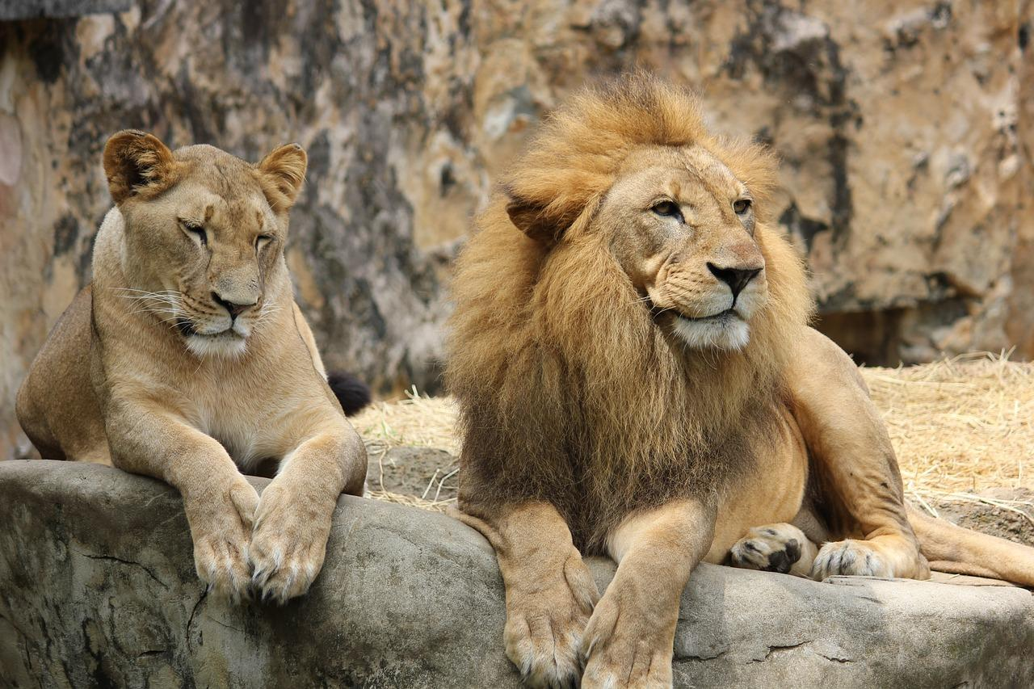
In some reference books, the Hebrew gur is also listed as a name for lion (cub). However, most scholars now believe that this word refers to the young of any carnivorous animal; it should only be taken as “lion cub” when one of the words for lion occurs as well, or when the context clearly indicates that a lion cub is meant, as for instance in cases of parallelism.

Discussion:
Among the English versions there seems to be a great deal of confusion and inconsistency in the translation of the various Hebrew words. This is due in large part to the fact that the English translators and the commentators who have guided them have had many mistaken ideas about lions and their behavior. To take AMO 3:4 as an example, Smalley and de Waard, commenting on this verse and echoing Hughell Fosbroke and many others, claim: “The lion’s roar in the first picture is the ferocious roar with which the lion attacks an animal he is going to kill and eat. When someone hears this roar, he knows that the lion has found his victim. In the second picture, however, it is the lion’s contented growl when he has dragged the food to his den."
However, lions do not roar as they attack their prey, (in fact they kill very silently as a rule), and lions do not normally live in dens. Moreover, they do not growl contentedly when eating. Instead they growl and snarl at the other lions in the pride who are trying to share the meal.
In case there are readers who react by thinking that it is unlikely that unsophisticated ancient peoples would have known these details, it should be pointed out that unsophisticated people all over Africa, who live in areas where there are lions, are very familiar with lion behavior, and it is highly likely that the Jewish writers were too. The problem would seem to lie with the mistaken presuppositions of western biblical scholars, rather than those of the Jewish writers. Later in this section evidence will be given that the biblical writers were very familiar with lion behavior.
In a similar vein, it is likely that the many Hebrew words for lions each have a slightly different meaning from one another. A closer study of lions and their behavior may help to define these meanings.
In biblical times lions were found all over the Middle East, in Mesopotamia, in Egypt, and in the area of Sudan and Ethiopia called Cush.
The Greek word leōn and the Latin leo are general words for lion, while the Greek leontēdon means something like “fierce lion".

Description:
In order to dispel many of the wrong presuppositions about lions that are current among biblical scholars, the description of this animal will be more detailed and extensive than for other animals in this book.
Lions Panthera leo are the largest of the great cats, often being about 2.8 meters (9 feet) from nose to tip of tail, standing as high as 1 meter (3 feet 3 inches) at the shoulder. However, the difference in size between lions and Bengal Tigers Panthera tigris is minimal. An adult lion is at least half a meter (20 inches) longer than a Leopard Panthera pardus and weighs twice as much, often reaching 250 kilograms (550 pounds) in weight; it is about 30 centimeters (1 foot) longer and 100 kilograms (220 pounds) heavier than a Jaguar Panthera onca or Mountain Lion (Puma) Puma concolor. Lions are a pale yellowish brown, but at birth they have spots that usually disappear gradually as they grow. Around the neck and shoulders of adult males grows a mane that is darker than the rest of their fur. Some even have black manes. Females and young males do not have manes and look very similar to each other.
Social behavior: Lions live in family groups called “prides", which are made up of a dominant male lion (often called “the pride male"), plus a group of adult and sub adult females and young males. Males may leave the pride, and occasionally one or two females may go off with a wandering male, but normally the females continue in the pride and develop very close bonds with one another that last a lifetime. The dominant male will often make ritual attacks on the younger males of the pride, who roll over in submission rather than fight.
However, adult males from within and outside the pride challenge the dominant male and one another when a female is in season and will try to mate with her. This results in serious fights. If the dominant male is defeated from within the pride, he leaves the pride to wander alone, but the remainder of the pride remains intact. If a male from outside the pride takes over from the pride male, he usually chases away the other males, which then wander singly or in small groups of three or four. These wandering males will try to take over other prides or steal females from them. Ousted pride males, since they are alone and have no help in hunting, are often hungry, thin, undernourished, and dangerous.
Lioness and cub (Pixabay)About two or three days before a pregnant female is about to give birth to cubs, she digs a temporary den under a rock or fallen log and visits it with one or two of the other females. After she gives birth in the den, one of the other females will bring her meat from a kill. This enables the mother to remain with her newborn cubs continuously for the first week or two of their lives. The mother lioness moves the newborn cubs to a new den every three or four days. When the cubs are about two weeks old, the mother carries the cubs to where the other pride members are, and the pride makes their acquaintance by licking them. Thereafter the cubs belong to the pride and suckle on any lactating lioness that happens to be near.
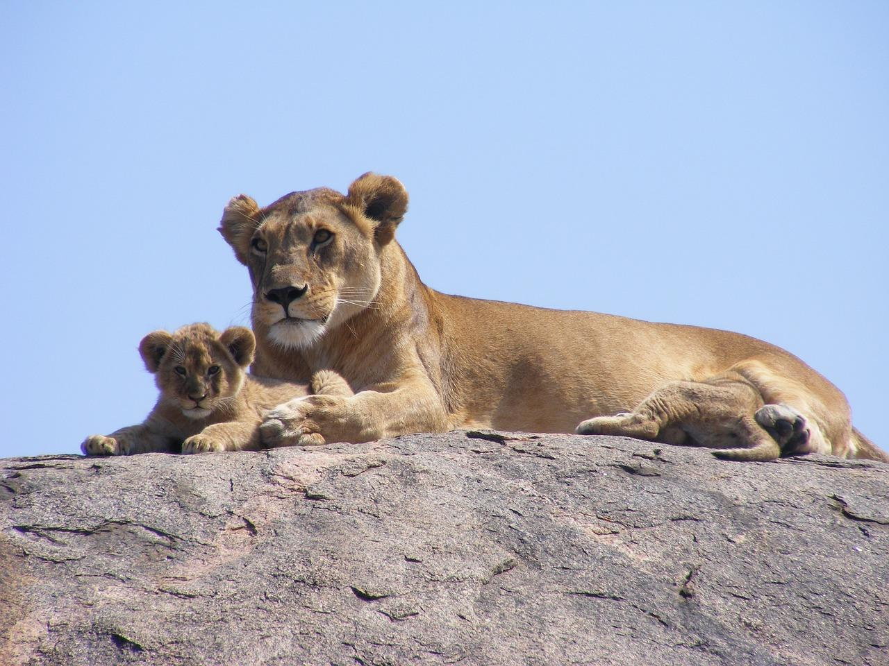
Until they are old enough to hunt, cubs hide in thickets while the pride hunters do their work. At a later stage they accompany the hunting lions, but watch the killing from the sidelines. Finally the mother will help them kill small animals, until they are able to kill efficiently. Then they join the pride hunts.
A pride lives together in the same territory. Bushes and tree trunks are marked by spraying a liquid from a gland next to the anus. This marked territory is defended against intruding lions. The pride will come together at feeding time and remain together after a feed, but will scatter across the territory prior to hunting.
Vocal behavior: Lions utter a variety of sounds, and this should be borne in mind when translating Scripture passages that refer to the noises lions make. The Hebrew words are usually not very specific, but the context will indicate the type of noise intended.
Roaring is the loudest of the lion sounds and is usually produced by the males. It is believed to be territory-marking behavior and a means of maintaining pride solidarity. It is usually done before hunting begins and also functions to help the pride locate the positions of scattered members. This is important for hunting. Roaring consists of a long, very loud moaning sound followed by shorter rhythmic panting moans, which are repeated as many as twenty times, while becoming softer and softer. No two lions roar in exactly the same way, and they can be identified from their roars. Roaring is also a means by which wandering male lions make known their availability as potential mates. Hungry lions roar more frequently than well-fed ones, and this is an indication of how hungry they are.
Growling is a warning sound. It is a very deep rumbling repeated with each breath. It is intended to chase away strange lions or other potential enemies, such as leopards, hyenas, or humans. When a lion or lioness growls, it usually advances towards its enemy. If growling does not have the desired effect, it is replaced with snarling, which is similar to growling but is more intense and is produced with exposed teeth, the body in a low crouch, and ears laid back flat. This behavior is usually the prelude to an attack. When the attack is actually made on an enemy, a deep trembling moan is uttered, and the ensuing fight takes place with a lot of loud snarling and growling.
When lions are feeding together on one carcass, there is usually a lot of growling, snarling, and snapping among the feeding lions.
Other types of sound made by lions are:
woofing sounds when pride members meet after two or three days’ absence from each other. This sound is also used to call cubs from their hiding places;
- drawn out yawning moans by females in heat and by both lions and lionesses when mating;
- grunting sounds when chasing prey toward other lions waiting in ambush;
- contented loud purring, much as cats do.
Hunting and feeding behavior: After lions have fed well, they rest and relax together for two or three days. Towards the end of this time some of the pride members will begin to move away from the others in the direction of places where prey animals are likely to be grazing. Then, before they begin to hunt, they signal their locations by roaring on and off for an hour or two. They then fall silent and begin to hunt in earnest. Hunting usually takes one of two forms. If there is good cover near the prey, two or three lionesses and young males will stalk the prey using the cover. When they get close enough, one or two will break cover and charge at the prey, while the others maneuver to cut off any escape.
Male lion (Pixabay)If the terrain is more open, the lionesses and young males will take up ambush positions downwind of the prey animals. Adult males then move fairly openly into upwind positions. They then run toward the prey uttering loud grunts with each breath. With either method, at the first charge the lions try to disable the animal by seizing a leg or by biting the spine. Once they have slowed down the prey, one lion will seize the animal by the throat and suffocate it. Thus death is usually fairly slow and drawn out. If the animal is large, the kill takes a considerable amount of energy, and the lions rest, usually standing, before they begin to feed.
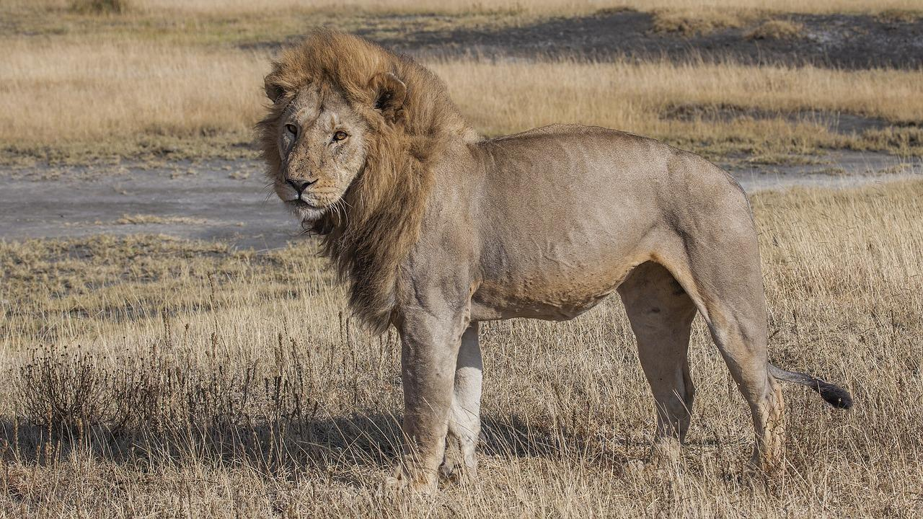
Single wandering male lions are at a great disadvantage in hunting and often go hungry. They thus roar more frequently than pride lions. They often begin to kill domestic animals and sometimes humans.
Among the lions present at the time of the kill, there is a type of seniority, with age being important. The most senior lion or lioness present will begin to feed, and this will be a signal for the others to join in. If the kill is large, they feed in relative silence, but if the prey is small, there is a lot of snarling, growling, and snapping. Whenever a dominant pride male arrives, however, the feeding lions withdraw and leave him to feed alone. A dominant male will sometimes allow an immature cub to feed with him but no mature lions. The pride members will only resume feeding when the dominant male is satisfied. Dominant males are very seldom involved in the chase or the kill. At most they make the charge that drives the prey towards lionesses and young males in ambush.

Special significance or symbolism:
In the Bible the lion is a symbol of danger and destruction, often being paired with the bear. The lion is also a symbol of great political power and regal majesty.

Translation:
Before discussing specific passages in detail, it is useful first to try and identify the various Hebrew words with likely lion types.
If we examine the verbs and adjectives with which the Hebrew nouns co-occur, we find the following:
’Ari: This, the most frequently used word for lion, is associated with a very wide range of verbs in the Bible, including crouching in ambush, leaping, growling, roaring, killing, destroying, tearing prey to pieces, breaking bones, attacking, breaking from cover, scattering sheep, trampling, and standing on prey. The adjectives used with this noun include strong, destructive, brave, and hungry.
From this evidence we can see that ’ari or its feminine form ’aryeh is the general word for lion or lioness.
’Aryeh: Although this is a feminine form, in English versions it is invariably translated as “lion", because this form usually occurs in the Hebrew phrase gur ’aryeh, which is literally “a cub of lioness", but which is more naturally translated as “lion cub” in English.
Beney shachats: This expression, which literally means “sons of pride", occurs only once, in a poetic passage (JOB 28:8) as the parallel of “lion” (shachal). Probably, besides having similar sounds, the two expressions both refer to lions. Only KJV reflects this in the translation.
Kefir: The verbs associated with this noun include kill, prowl, hunt, snarl, attack, break cover, tear prey to pieces, roar, and growl. The only adjective associated with the noun is “angry". Translators often render this as “young lion". EZK 19:1–EZK 19:9 seems to support an identification of kefir with a young male lion that is an efficient killer (see the discussion of this passage below).
Laviy’: The verbs associated with this noun are growling, devouring, lying down, crouching, and raising cubs. The only descriptive phrase that co-occurs is big teeth. The usual JB rendering of this word as “lioness” seems well founded.
Layish: This noun occurs only three times. The verb phrase that co-occurs is “ dying from lack of prey". The adjectives that co-occur are “stately in its walk", and “strong". The evidence would fit an interpretation such as “lion in its prime time” or “mighty lion". The reference would seem to be to a dominant male lion or “pride male". Versions that render this word as “old lion” in some contexts (RSV, JB, NAB), seem to be slightly misleading.
Shachal: The verbs that co-occur are roaring, hunting, and tearing prey to pieces. Some scholars, using evidence from Assyrian and classical Arabic, believe that this Hebrew word is derived from an older Semitic root meaning “to roar” or “to produce a call". All available evidence would seem to allow for the interpretation of shachal as “male lion". It may possibly be a word for a wandering male lion rather than a male that is a member of a pride.
In some English versions of Maccabees the Greek word skumnos is incorrectly translated as “cub” or “whelp". The context refers to this creature roaring, which lion cubs do not do. The word seems rather to refer to a virile young adult lion. It is better translated as lion in its prime compare TEV “like a ferocious lion."
In areas where lions are completely unknown, it is better to borrow a word from a dominant language or from Hebrew or Greek, rather than to try and find a local equivalent. This is because the biblical references to the behavior of lions are fairly specific, and if a word for a local animal is used, it will not fit the behavior mentioned in the text. This is especially so because the lion is the only great cat (apart from the cheetah) that lives and hunts in large family groups.
Some attempt should be made to maintain the slight differences in meaning of the various Hebrew words for lions, when the context requires this. This can often be done by using short, natural-sounding descriptive phrases. Often, however, in contexts where only one of the Hebrew words for lion is used, there is no need to maintain a difference, and a simple word for lion or lioness will suffice.
The most common Hebrew phrases used for the sounds lions make are sha’ag, (natan) qol, naham. When sha’ag is used in contexts of human vocal behavior, it indicates cries of pain or distress. In contexts of animal vocal behavior, however, it can signal pain and distress but can also be an aggressive sound and can be translated “bellow, roar, moan, snarl, growl” or sometimes “bark". A similar Arabic word usually refers to the lowing of cattle or the bleating of goats. For lions English translators have consistently chosen “roar", because of their mistaken preconception that a lion’s “roar” is an aggressive sound. In most contexts it is best interpreted as “growl” or “snarl".
(Natan) qol, on the other hand, is a more general expression and can mean any sort of vocalization, from calling, to groaning or singing. English translators of AMO 3:4 have chosen “growl” (TEV, REB, NIV) and “cry out” (RSV). In this text this word is the parallel of sha’ag, so the reason for these interpretations is plain. However, a neutral translation, such as “make a sound", would be equally valid. Of all the Hebrew expressions for lion sounds, this is the one most likely to mean roar, especially in contexts where the noun shachal occurs for “lion", as for example in JOB 4:10.
Naham means to moan in sorrow or pain when used of humans and is usually translated as to growl when used of animals.
Lion habitats and the meaning of ma‘on in the context of lions: Generally the word ma‘on means dwelling place, hiding place, or refuge. In one or two places it refers to a military refuge or fortress. When used of animals, it can mean “lair” (as for jackals), “hiding place", “territory", or simply “place where the animals are found". The choice in translating this Hebrew word has been either “lair” or “den” in all English translations. This choice again seems to be related to the misconceptions about the behavior of lions. Lions do not usually live in dens or lairs, and it is better to translate ma‘on as “territory” or “place where lions live". See the discussion below for AMO 3:4.
GEN 49:8; GEN 49:10: The major problems in interpreting this passage relate to the meaning of the verb ‘alah. TEV, REB, and NIV interpret ‘alah in verse 9 as “return” (TEV even has “return to his den"). However, the more usual meaning of the Hebrew verb is “to rise up", and in this context this makes perfect sense. As mentioned above, when a lion has killed its prey, the lion usually stands up, panting, and rests in this position for some minutes before crouching down again to start feeding.
JOB 4:10; JOB 4:11: In this passage there is clearly a logical link between the fact that the teeth of the efficient killers (kefirim) are broken and the fact that the dominant male (layish) is dying because no kills have been made. Most English translations translate taref as “prey", which infers that the problem is a lack of animals to hunt. It would be better to translate this word as “kills", that is, animals that have been killed.
PSA 22:13: The Hebrew of this passage indicates clearly that the growling or snarling and the tearing at prey are directed at the writer.
JER 51:38; JER 51:39: The English translations that take kefir to mean “young lions” misrepresent slightly the picture portrayed in this verse. Rather than being the immature roar of young lions, the text refers to the frightening roar of hungry hunting lions.
EZK 19:1; EZK 19:9: In this passage the picture of a lioness training her cubs to become efficient killers is clearly presented. This gives us a good indication of the meaning of kefir.
HOS 11:10: The picture here is of a lion roaring and the other members of the pride coming in response. The picture given in TEV of God roaring at his enemies is not justified.
AMO 3:4: A choice has to be made about the type of vocalizing the lion is doing, and why. If, as the existing text seems to require, the presupposition is that the lion has caught its prey, then the translation of sha’ag and natan qol will involve appropriate choices. “Snarl” and “growl” seem to be legitimate. These fit the context, match real lion behavior, and are still valid translations of the Hebrew roots.
Next, it is necessary to make a suitable choice for ma‘on. “The place where it hides” would be quite appropriate, paralleling “bush” in the first line of the couplet.
The two words for lion in this verse are ’aryeh and kefir. The first should be rendered “lioness” and the second “lion” or “killer lion".
A Translator’s Handbook on the Book of Amos can thus be rephrased: “The snarling in the first line and the growling in the second both refer to the warning sounds lions make when feeding together."
Figure 13 in the Amos Handbook gives an analysis in which the relationship of this verse to the argument is seen as being the theme “Disaster", presumably that which has befallen the prey. However, if the lion is consistently seen as the symbol of God, then one would expect AMO 3:4 to be seen as inferring that God is “roaring” (to use the Handbook’s interpretation) because a disaster has already befallen the nation of Israel, just as a “lion roars because it has caught its prey". Yet in the corresponding element of the chiasmus, AMO 3:8 a, the analysis in the Handbook identifies the disaster as being in the future, since the “roar” is interpreted as a warning. The analysis is thus not cohesive at these points.
If, however, the growling and snarling (rather than roaring) refer to the aggressive behavior of feeding lions toward each other and toward other predators and scavengers, their behavior would be more closely related to warning than to destroying. This shows better cohesion between AMO 3:4 and AMO 3:8 a. If sha’ag in AMO 3:8 a is also translated “snarl", the warning effect is greatly heightened.
The labels on the Handbook’s chiastic structure would now be:
A Harmony
B Warning signs
C Disaster
D Confusion
C' Disaster
B' Warning signs
A' Harmony
Interestingly enough this alternate translation does not change the basic arguments as identified by the Handbook, but strengthens them.
MIC 2:11; MIC 2:12: The major problems of interpretation in this verse, have been the word kefir, usually translated here as “cubs", and the words ma‘on, mir‘eh, and chor, usually translated as “den", “lair", and “cave".
In RSV, NEB, and REB, the presupposition is that lions live in dens, to which they carry their prey, and that the male lion in the passage tears up a carcass to feed to the lionesses and cubs. TEV shares this presupposition but adds the idea that lion cubs are fed in the den. But, as we have seen, lions do not live in dens, and male lions do not tear up carcasses to feed cubs. And they certainly do not feed lionesses; they usually compete with them for the meat.
A better interpretation is to take kefir in the same way as in the previous passages, that is, as killer lion. Ma‘on seems to mean “dwelling place, territory” in this context. Mir‘eh is interpreted in NIV and TEV as “feeding place", which fits the context well. This leaves chor, which functions here as a parallel expression to me‘onot “territories". Chor normally means “hole” or “cave” and can be taken to refer to the temporary dens where suckling lionesses are fed by other lionesses.

