Resource: Animals in the Bible
Animals in the Bible © United Bible Societies, 2025. Adapted from: All Creatures Great and Small: Living Things in the Bible, by Edward R. Hope © 2005 United Bible Societies. This work is licensed under Creative Commons Attribution-ShareAlike 4.0 International (https://creativecommons.org/licenses/by-sa/4.0/).

Animals in the Bible

Pig

2.30 Pig

References:Hebrew חֲזִיר (chazir)LEV 11:7, DEU 14:8, PRO 11:22, ISA 65:4, ISA 66:3, ISA 66:17Greek χοῖρος (choiros)MAT 7:6, MAT 8:30, MAT 8:31, MAT 8:32, MRK 5:11, MRK 5:12, MRK 5:13, MRK 5:16, LUK 8:32, LUK 8:33, LUK 15:15, LUK 15:16Greek ὕειος (hueios)1MA 1:47, 2MA 6:18, 2MA 7:1, 4MA 5:2, 4MA 5:6, 4MA 6:15Greek ὗς (hus)2PE 2:22

Discussion:
Pigs (Pixabay)The word chazir is used for domestic and wild pigs. The domesticated pig was known in Egypt around 2500 B.C. and was probably domesticated in Canaan about that time too. Domestication of wild pigs seems to have coincided everywhere with the development of agriculture. Wild pigs were probably penned in large enclosures and fed scraps, thus keeping them away from planted fields. Later on, when full domestication had taken place, it was more usual for pigs to be herded rather than kept in pens. Pigs eat almost anything and herding did away with the necessity to feed them. It soon was noticed that the rooting activity of the pigs rid areas of tree roots and shrubs and promoted the growth of grass for grazing. So early swineherds herded the pigs into areas where future grazing was wanted, away from planted fields. Jews who kept pigs may not have done so with the idea of eating their meat, which was unclean, but to promote grazing grass and to sell the pigs to neighboring tribes.
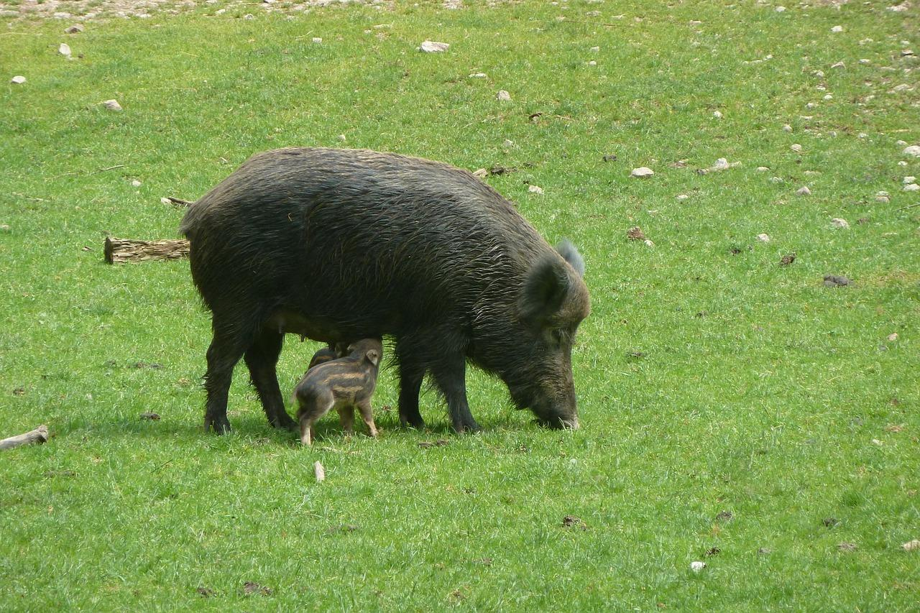
Wild pigs, in the form of the European Boar Sus scrofus, were once abundant in Israel, especially in the Jordan Valley. Even now since neither Jews nor Moslems eat the meat of wild pigs, and thus do not hunt them, they can still be found in the Jordan Valley and in many other areas where there is both water and thick undergrowth.
The Greek words choiros and hueios mean “pig” or “pig meat". The word hus means a female pig or sow.

Description:
The domesticated pigs of biblical times looked much more like wild pigs than the modern breeds of pig. They would have been brown or gray in color and fairly hairy. The young pigs probably had horizontal stripes.

Special significance or symbolism:
Of all animals the pig was considered the most unclean.

Translation:
In languages that differentiate between wild and domestic pigs, in PSA 80:13 the word for a wild pig should be used. In 2PE 2:22, although the Greek specifies a female pig, the gender of the pig is not really important in the proverb. Many translations have simply “pig".
The Hebrew expression “wild animals of the reeds” in PSA 68:30 is probably a reference to wild pigs and may be translated “wild pigs in the reeds".

