Resource: Animals in the Bible
Animals in the Bible © United Bible Societies, 2025. Adapted from: All Creatures Great and Small: Living Things in the Bible, by Edward R. Hope © 2005 United Bible Societies. This work is licensed under Creative Commons Attribution-ShareAlike 4.0 International (https://creativecommons.org/licenses/by-sa/4.0/).

Animals in the Bible

Sheep, lamb

2.31 Sheep, lamb

References:Hebrew אַיִל (’ayil)GEN 15:9, GEN 22:13, GEN 22:13, GEN 31:38, GEN 32:15, EXO 25:5, EXO 26:14, EXO 29:1, EXO 29:3, EXO 29:15, EXO 29:15, EXO 29:16, EXO 29:17, EXO 29:18, EXO 29:19, EXO 29:19, EXO 29:20, EXO 29:22, EXO 29:22, EXO 29:26, EXO 29:27, EXO 29:31, EXO 29:32, EXO 35:7, EXO 35:23, EXO 36:19, EXO 39:34, LEV 5:15, LEV 5:16, LEV 5:18, LEV 5:25, LEV 8:2, LEV 8:18, LEV 8:18, LEV 8:20, LEV 8:21, LEV 8:22, LEV 8:22, LEV 8:22, LEV 8:29, LEV 9:2, LEV 9:4, LEV 9:18, LEV 9:19, LEV 16:3, LEV 16:5, LEV 19:21, LEV 19:22, LEV 23:18, NUM 5:8, NUM 6:14, NUM 6:17, NUM 6:19, NUM 7:15, NUM 7:17, NUM 7:21, NUM 7:23, NUM 7:27, NUM 7:29, NUM 7:33, NUM 7:35, NUM 7:39, NUM 7:41, NUM 7:45, NUM 7:47, NUM 7:51, NUM 7:53, NUM 7:57, NUM 7:59, NUM 7:63, NUM 7:65, NUM 7:69, NUM 7:71, NUM 7:75, NUM 7:77, NUM 7:81, NUM 7:83, NUM 7:87, NUM 7:88, NUM 15:6, NUM 15:11, NUM 23:1, NUM 23:2, NUM 23:4, NUM 23:14, NUM 23:29, NUM 23:30, NUM 28:11, NUM 28:12, NUM 28:14, NUM 28:19, NUM 28:20, NUM 28:27, NUM 28:28, NUM 29:2, NUM 29:3, NUM 29:8, NUM 29:9, NUM 29:13, NUM 29:14, NUM 29:14, NUM 29:17, NUM 29:18, NUM 29:20, NUM 29:21, NUM 29:23, NUM 29:24, NUM 29:26, NUM 29:27, NUM 29:29, NUM 29:30, NUM 29:32, NUM 29:33, NUM 29:36, NUM 29:37, DEU 32:14, 1SA 15:22, 2KI 3:4, 1CH 15:26, 1CH 29:21, 2CH 13:9, 2CH 17:11, 2CH 29:21, 2CH 29:22, 2CH 29:32, EZR 8:35, EZR 10:19, JOB 42:8, PSA 66:15, PSA 114:4, PSA 114:6, ISA 1:11, ISA 34:6, ISA 60:7, JER 51:40, EZK 27:21, EZK 34:17, EZK 39:18, EZK 43:23, EZK 43:25, EZK 45:23, EZK 45:24, EZK 46:4, EZK 46:5, EZK 46:6, EZK 46:7, EZK 46:11, DAN 8:3, DAN 8:4, DAN 8:6, DAN 8:7, DAN 8:7, DAN 8:7, DAN 8:7, DAN 8:20, MIC 6:7Aramaic אִמַּר (’imar)EZR 6:9, EZR 6:17, EZR 7:17Aramaic דְּכַר (dekar)EZR 6:9, EZR 6:17, EZR 7:17Hebrew טָלֶה (taleh)1SA 7:9, ISA 40:11, ISA 65:25Hebrew כֶּבֶשׂ, כַבְשָׂה, כִּבְשָׂה (keves, kavsah, kivsah)GEN 21:28, GEN 21:29, GEN 21:30, EXO 12:5, EXO 29:38, EXO 29:39, EXO 29:39, EXO 29:40, EXO 29:41, LEV 4:32, LEV 9:3, LEV 12:6, LEV 14:10, LEV 14:10, LEV 14:12, LEV 14:13, LEV 14:21, LEV 14:24, LEV 14:25, LEV 23:12, LEV 23:18, LEV 23:19, LEV 23:20, NUM 6:12, NUM 6:14, NUM 6:14, NUM 7:15, NUM 7:17, NUM 7:21, NUM 7:23, NUM 7:27, NUM 7:29, NUM 7:33, NUM 7:35, NUM 7:39, NUM 7:41, NUM 7:45, NUM 7:47, NUM 7:51, NUM 7:53, NUM 7:57, NUM 7:59, NUM 7:63, NUM 7:65, NUM 7:69, NUM 7:71, NUM 7:75, NUM 7:77, NUM 7:81, NUM 7:83, NUM 7:87, NUM 7:88, NUM 15:5, NUM 15:11, NUM 28:3, NUM 28:4, NUM 28:4, NUM 28:7, NUM 28:8, NUM 28:9, NUM 28:11, NUM 28:13, NUM 28:14, NUM 28:19, NUM 28:21, NUM 28:21, NUM 28:27, NUM 28:29, NUM 28:29, NUM 29:2, NUM 29:4, NUM 29:4, NUM 29:8, NUM 29:10, NUM 29:10, NUM 29:13, NUM 29:15, NUM 29:15, NUM 29:17, NUM 29:18, NUM 29:20, NUM 29:21, NUM 29:23, NUM 29:24, NUM 29:26, NUM 29:27, NUM 29:29, NUM 29:30, NUM 29:32, NUM 29:33, NUM 29:36, NUM 29:37, 2SA 12:3, 2SA 12:4, 2SA 12:6, 1CH 29:21, 2CH 29:21, 2CH 29:22, 2CH 29:32, 2CH 35:7, EZR 8:35, JOB 31:20, PRO 27:26, ISA 1:11, ISA 5:17, ISA 11:6, JER 11:19, EZK 46:4, EZK 46:5, EZK 46:6, EZK 46:7, EZK 46:11, EZK 46:13, EZK 46:15, HOS 4:16Hebrew כֶּשֶׂב, כִּשְׂבָּה (kesev, kisvah)GEN 30:32, GEN 30:33, GEN 30:35, GEN 30:40, LEV 1:10, LEV 3:7, LEV 4:35, LEV 5:6, LEV 7:23, LEV 17:3, LEV 22:19, LEV 22:27, NUM 18:17, DEU 14:4Hebrew כַּר (kar)DEU 32:14, 1SA 15:9, 2KI 3:4, PSA 37:20, ISA 16:1, ISA 34:6, JER 51:40, EZK 27:21, EZK 39:18, AMO 6:4Hebrew רָחֵל (rachel)GEN 31:38, GEN 32:15, SNG 6:6, ISA 53:7Greek ἀμνός (amnos)JHN 1:29, JHN 1:36, ACT 8:32, 1PE 1:19, WIS 19:9, SIR 13:17, ODA 14:17Greek ἀρήν (arēn)LUK 10:3Greek ἀρνίον, ἀρνος (arnion, arnos)JHN 21:15, REV 5:6, REV 5:8, REV 5:12, REV 5:13, REV 6:1, REV 6:16, REV 7:9, REV 7:10, REV 7:14, REV 7:17, REV 12:11, REV 13:8, REV 13:11, REV 14:1, REV 14:4, REV 14:4, REV 14:10, REV 15:3, REV 17:14, REV 17:14, REV 19:7, REV 19:9, REV 21:9, REV 21:14, REV 21:22, REV 21:23, REV 21:27, REV 22:1, REV 22:3, SIR 46:16, SIR 47:3, 1ES 1:7, 1ES 6:28, 1ES 7:7, 1ES 8:14, 1ES 8:63, ODA 2:14, ODA 7:39, PSS 8:23, DAG 3:39, PSS 8:23Greek κριός (krios)TOB 7:8, 2MA 12:15, 1ES 6:28, 1ES 7:7, 1ES 8:14, 1ES 8:63, 1ES 9:20, ODA 2:14, ODA 7:39, PSS 2:1Greek μάνδρα (mandra)JDT 2:26, JDT 3:3Greek πασχα (pascha)MRK 14:12, LUK 22:7, 1CO 5:7Greek πρόβατον (probaton)MAT 7:15, MAT 9:36, MAT 10:6, MAT 10:16, MAT 12:11, MAT 12:12, MAT 15:24, MAT 18:12, MAT 25:32, MAT 25:33, MAT 26:31, MRK 6:34, MRK 14:27, LUK 15:4, LUK 15:6, JHN 2:14, JHN 2:15, JHN 10:1, JHN 10:2, JHN 10:3, JHN 10:3, JHN 10:4, JHN 10:7, JHN 10:8, JHN 10:11, JHN 10:12, JHN 10:12, JHN 10:13, JHN 10:15, JHN 10:16, JHN 10:26, JHN 10:27, JHN 21:16, JHN 21:17, ACT 8:32, ROM 8:36, HEB 13:20, 1PE 2:25, REV 18:13, TOB 7:8, JDT 2:17, JDT 8:26, JDT 11:19, SIR 47:3, BEL 1:3, 1ES 1:8, 1ES 1:9, ODA 2:14, ODA 4:17Greek πρωτότοκος (prototokos)TOB 5:14, WIS 18:13, 4MA 15:18, PSS 13:9, PSS 18:4Latin grex2ES 5:18, 2ES 15:10Latin ovis2ES 5:26, 2ES 16:33

Discussion:
Before the time of Abraham at least five breeds of sheep had already been developed in Mesopotamia. From mummified remains (that is, preserved dead bodies) and ancient art it is also known that at least two different breeds had reached Egypt by about 2000 B.C. Thus it is likely that the sheep mentioned in the Bible were of more than one breed.
The Hebrew word kar seems to be used of imported foreign sheep and may refer to a special breed but some scholars think it refers to a wether (castrated ram), since this word is never used in the context of sacrifice. This word is also used for a battering ram, that is, a heavy pole suspended on a rope, used in war for breaking down walls. ’Ayil is the word for a ram or adult male sheep, rachel is a breeding ewe or female sheep, and taleh is a very young lamb, probably still unweaned. The remaining Hebrew words refer to sheep in general.
The Greek word probaton is the general word for sheep, or flocks that may include goats. Krios is the Greek word for a ram or male sheep. Pascha is a technical name for the Passover lamb exclusively, and the remaining Greek words all mean lamb. Ovis is the Latin word for sheep.
The early Hebrews were nomadic shepherds to whom sheep were the most important domestic animal. While goats eat almost any vegetation, sheep are much more selective about the grasses and plants they eat. This meant that suitable grazing for them was not always easy to find, and shepherds had to keep moving their flocks from place to place. This led to a nomadic lifestyle, with movable tents rather than houses being the normal household shelter. It was not until the occupation of Canaan after the Exodus that the lifestyle of the Israelites changed, and they became settled village-dwelling farmers and fruit growers.
However, even then, most households owned sheep, and some family members would function as shepherds, often living away from home for fairly long periods.
Sheep in the Bible were a source of meat, milk, wool, hides, and horns, and it seems likely that various strains were bred selectively to enhance production of these commodities. Wool is mentioned in the Bible as early as the Mosaic Law, which forbade the weaving of cloth containing both wool and plant fibers. The shearing of sheep is mentioned even earlier, in GEN 31:19. Wool was in fact the most common and available fiber known to the people of Israel.
There was a very extensive wool trade in biblical times, stretching from Egypt to China. In the Middle East wool was cheaper than cotton or linen, which were the other common fibers. (Silk was known by the time of Solomon, but it was extremely expensive as it was produced in China and handled by numerous traders on its way west.) It would be a mistake to think of all wool at that time as being white, as GEN 30:0 indicates quite clearly that there were also dark colored sheep and sheep that had dark and light patches, probably varying combinations of black, white, and brown.
Sheep with lamb (© Ray Pritz (UBS))We can be fairly sure that one breed of sheep known to the Israelites was the Fat-tailed Sheep Ovis laticaudata and that its fatty tail is referred to in EXO 29:22; LEV 3:9; LEV 8:25; LEV 9:19.
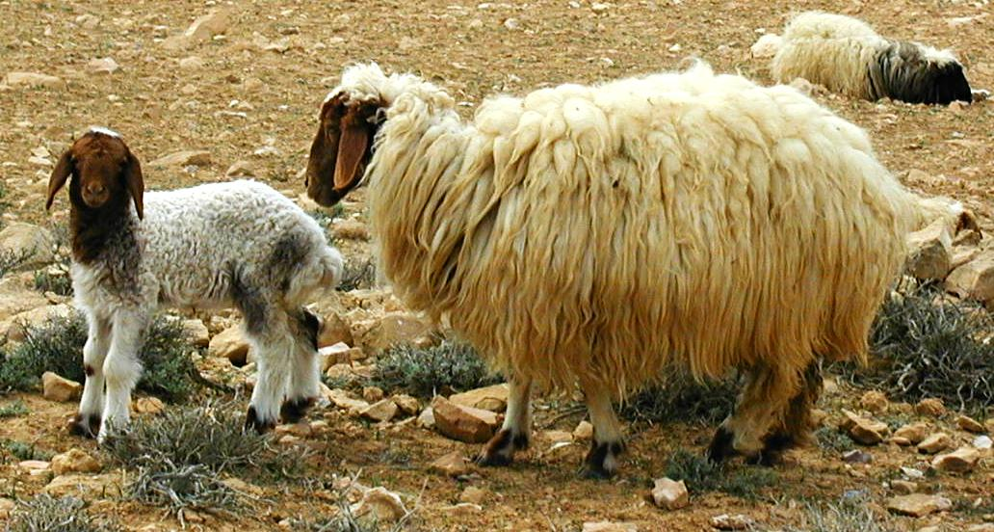
Rams’ horns had a variety of uses. Whole ram horns were used as drinking vessels, jars, and trumpets. But pieces of horn were used as handles for knives and other household implements, and for jewelry such as bracelets and beads. Needles too, and probably also arrow heads, were made from horn, as well as from bone and later from bronze and iron.
Sheep were also very important in Israelite religion. They were a very important element in the sacrificial system and in the traditional religious feasts, especially the Feast of Passover.

Description:
Sheep and goats belong to the same general family. They differ in that sheep produce wool, which is a special type of soft hair, among the ordinary hairs on their bodies. A ram’s horns too differ in shape from a goat’s horns, those of a ram curling down in a tight spiral beside its face, with those of a goat curving more gently back towards its shoulders. The sheep of biblical times produced much shorter wool than is common with wool-bearing breeds of today.
The fat-tailed or broad-tailed sheep is a smallish breed usually brown and white with a very broad tail. Like most other breeds of sheep in the Middle East it has large floppy ears.
Sheep are generally fairly timid animals, lacking the self-confidence and adaptability of goats. While goats will spread out in their search for food and then regroup without much difficulty, sheep become very insecure when they are separated from other sheep and tend to stay bunched together. They thus require a lot of shepherding. In the Middle East the method of shepherding involves training the dominant ram to follow the shepherd. The remaining sheep then follow this dominant ram, which often wears a wooden clapper or a bell. As they feed, the sheep usually keep within earshot of this sound. It is likely that this method is centuries old. (For further comparison of sheep and goats, see 2.16 Goat.)
Shepherd with sheep (Pixabay)In most modern breeds only male sheep have horns, but in most ancient breeds female sheep had short horns too. This made separating sheep from goats in a single flock more difficult than it is today. See also the illustration in 2.31.1 Flock, herd.
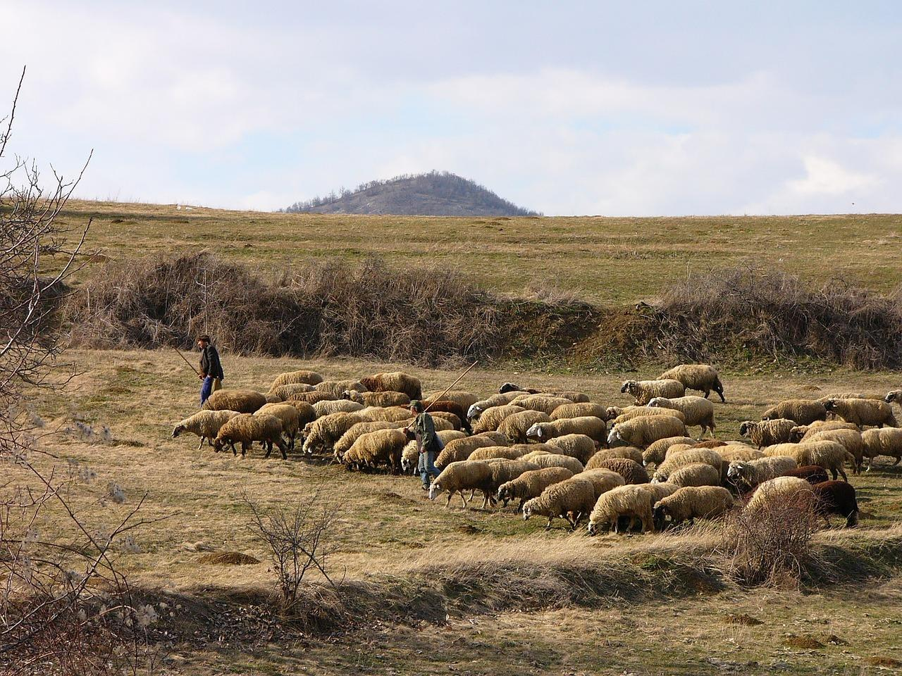

Special significance or symbolism:
Of all animals the sheep was the most important for the Israelite nation. It had great religious, social, and economic importance.
In the Bible sheep are a common metaphor for the people of Israel and perhaps for people in general. Like sheep the people are seen as easily going astray (PSA 119:176; ISA 53:6; JER 50:6; 1PE 2:25), as being in need of guidance and protection (1KI 22:17; 2CH 18:16; MAT 9:36; MRK 6:34), as being very defenseless (ISA 52:7), and as being destined to an early death (PSA 44:22; JER 12:3; ROM 8:36).
Lamb (© Ray Pritz (UBS))The metaphor of a lamb is used in the New Testament to refer to Christ, with an emphasis on his being a sacrifice for the sin of the world. This is especially the case in John’s gospel and Revelation. In the latter book the metaphor is introduced in a very striking way. In REV 5:5 as the writer is mourning the fact that no one can be found to open the scroll, he is comforted by one of the elders who tells him that “the Lion of the tribe of Judah” has triumphed and can thus open the scroll. Then the writer, expecting to see the Lion, sees instead a Lamb that looks as if it has been killed for sacrifice. The remainder of the book is then concerned with describing the triumph of this Lamb over the forces of evil.
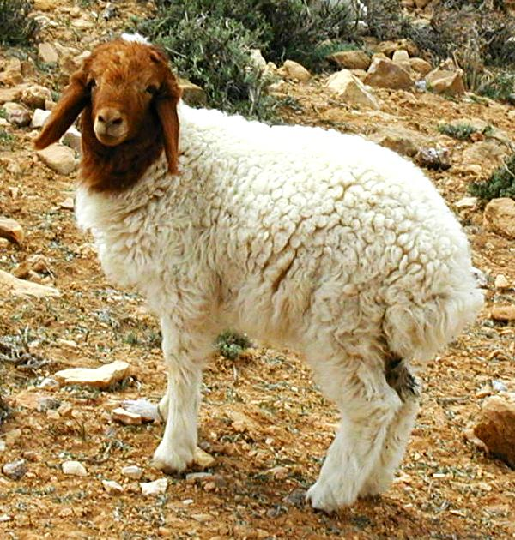
In the gospels Jesus also refers to his disciples as “sheep” and “lambs” (MAT 10:17; JHN 10:1; JHN 21:15; JHN 21:17; JHN 21:18).
The metaphor of the shepherd is extended to God himself who is the ultimate “Shepherd of Israel” (PSA 23:1; PSA 80:1). Then those who are responsible for the nurture, guidance, ruling, and protection of Israel, be it kings, prophets, or priests, are also likened to shepherds (ISA 56:11; JER 23:4; JER 49:19; EZK 34:2; ZEC 10:2).
The Messiah is also called a shepherd (ISA 40:11), and Jesus refers to himself as “the good shepherd” (JHN 10:11). In HEB 13:20 he is referred to as “the great shepherd of the sheep” and in 1PE 2:25 he is called “the Shepherd and Guardian of your lives".

Translation:
In languages that have a word for sheep, it is advisable to translate according to the meanings given under Discussion above. If possible, the feminine forms should be translated as “female lamb” or “female sheep". In languages in which sheep are not known, a word has usually been coined or borrowed by the time Bible translation begins, and this word should be used. It is not advisable to substitute another locally well-known animal in this case, since doing so negates the ritual and symbolic importance that sheep had for the biblical cultures.
In translating PSA 23:1 it is extremely important to make sure that the phrase “my shepherd” preserves the relationship intended by the writer and reflects the psalmist’s theme that Yahweh is his benefactor, protector, and guide. There are really two metaphors involved in the opening verse-the caring shepherd (God) and by clear implication, the dependent sheep (the psalmist). In many languages the literal phrase “my shepherd” depicts a wrong relationship, meaning something like “the one who looks after my sheep” or “the one I employ to watch my sheep.” In many African languages unwary translators have produced a rendering that means “The Chief is (nothing more than) my herdsman.” It is often necessary to restructure the whole verse as something like “I am a sheep, and the lord is my shepherd."

Flock, herd

2.31.1 Flock, herd

References:Hebrew מַרְעִית (mar‘it)JER 10:21Hebrew עֵדֶר (‘eder)GEN 29:2, GEN 29:3, GEN 29:8, GEN 30:40, GEN 32:17, GEN 32:20, JDG 5:16, 1SA 17:34, 2CH 32:28, JOB 24:2, PSA 78:52, PRO 27:23, SNG 1:7, SNG 4:1, SNG 4:2, SNG 6:5, SNG 6:6, ISA 17:2, ISA 32:14, ISA 40:11, JER 6:3, JER 13:17, JER 13:20, JER 31:10, JER 31:24, JER 51:23, EZK 34:12, JOL 1:18, MIC 2:12, MIC 4:8, MIC 5:7, ZEP 2:14, ZEC 10:3, MAL 1:14Hebrew צֹאן (ts’on)GEN 4:2, GEN 4:4, GEN 12:16, GEN 13:5, GEN 20:14, GEN 21:27, GEN 21:28, GEN 24:35, GEN 26:14, GEN 27:9, GEN 29:2, GEN 29:3, GEN 29:6, GEN 29:7, GEN 29:8, GEN 29:9, GEN 29:10, GEN 29:10, GEN 30:31, GEN 30:32, GEN 30:36, GEN 30:38, GEN 30:38, GEN 30:39, GEN 30:39, GEN 30:40, GEN 30:40, GEN 30:40, GEN 30:41, GEN 30:41, GEN 30:42, GEN 30:43, GEN 31:4, GEN 31:8, GEN 31:8, GEN 31:10, GEN 31:10, GEN 31:12, GEN 31:19, GEN 31:38, GEN 31:41, GEN 31:43, GEN 31:43, GEN 32:6, GEN 32:8, GEN 33:13, GEN 33:13, GEN 34:28, GEN 37:2, GEN 37:12, GEN 37:14, GEN 38:12, GEN 38:13, GEN 38:17, GEN 45:10, GEN 46:32, GEN 46:32, GEN 46:34, GEN 47:1, GEN 47:3, GEN 47:4, GEN 47:17, GEN 50:8, EXO 2:16, EXO 2:17, EXO 2:19, EXO 3:1, EXO 3:1, EXO 9:3, EXO 10:9, EXO 10:24, EXO 12:21, EXO 12:32, EXO 12:38, EXO 20:24, EXO 21:37, EXO 22:29, EXO 34:3, LEV 1:2, LEV 1:10, LEV 3:6, LEV 5:6, LEV 5:15, LEV 5:18, LEV 5:25, LEV 22:21, LEV 27:32, NUM 11:22, NUM 15:3, NUM 22:40, NUM 27:17, NUM 31:28, NUM 31:30, NUM 31:32, NUM 31:36, NUM 31:37, NUM 31:43, NUM 32:16, NUM 32:36, DEU 7:13, DEU 8:13, DEU 12:6, DEU 12:17, DEU 12:21, DEU 14:23, DEU 14:26, DEU 15:14, DEU 15:19, DEU 15:19, DEU 16:2, DEU 18:4, DEU 28:4, DEU 28:18, DEU 28:31, DEU 28:51, DEU 32:14, JOS 7:24, 1SA 8:17, 1SA 14:32, 1SA 15:9, 1SA 15:14, 1SA 15:15, 1SA 15:21, 1SA 16:11, 1SA 16:19, 1SA 17:15, 1SA 17:20, 1SA 17:28, 1SA 17:34, 1SA 24:4, 1SA 25:2, 1SA 25:2, 1SA 25:4, 1SA 25:16, 1SA 25:18, 1SA 27:9, 1SA 30:20, 2SA 7:8, 2SA 12:2, 2SA 12:4, 2SA 17:29, 2SA 24:17, 1KI 1:9, 1KI 1:19, 1KI 1:25, 1KI 5:3, 1KI 8:5, 1KI 8:63, 1KI 22:17, 2KI 5:26, 1CH 4:39, 1CH 4:41, 1CH 5:21, 1CH 12:41, 1CH 17:7, 1CH 21:17, 1CH 27:31, 2CH 5:6, 2CH 7:5, 2CH 14:14, 2CH 15:11, 2CH 17:11, 2CH 18:2, 2CH 18:16, 2CH 29:33, 2CH 30:24, 2CH 30:24, 2CH 31:6, 2CH 32:29, 2CH 35:7, EZR 10:19, NEH 3:1, NEH 3:32, NEH 5:18, NEH 10:37, NEH 12:39, JOB 1:3, JOB 1:16, JOB 21:11, JOB 30:1, JOB 42:12, PSA 44:12, PSA 44:23, PSA 49:15, PSA 65:14, PSA 74:1, PSA 77:21, PSA 78:52, PSA 78:70, PSA 79:13, PSA 80:2, PSA 95:7, PSA 100:3, PSA 107:41, PSA 114:4, PSA 114:6, PSA 144:13, PRO 27:23, ECC 2:7, SNG 1:8, ISA 7:21, ISA 13:14, ISA 22:13, ISA 53:6, ISA 60:7, ISA 61:5, ISA 63:11, ISA 65:10, JER 3:24, JER 5:17, JER 12:3, JER 13:20, JER 23:1, JER 23:2, JER 23:3, JER 25:34, JER 25:35, JER 25:36, JER 31:12, JER 33:12, JER 33:13, JER 49:20, JER 49:29, JER 50:6, JER 50:8, JER 50:45, EZK 24:5, EZK 25:5, EZK 34:2, EZK 34:3, EZK 34:6, EZK 34:6, EZK 34:8, EZK 34:8, EZK 34:8, EZK 34:8, EZK 34:10, EZK 34:10, EZK 34:10, EZK 34:11, EZK 34:12, EZK 34:12, EZK 34:15, EZK 34:17, EZK 34:19, EZK 34:22, EZK 34:31, EZK 34:31, EZK 36:37, EZK 36:38, EZK 36:38, EZK 36:38, EZK 43:23, EZK 43:25, EZK 45:15, HOS 5:6, JOL 1:18, AMO 6:4, AMO 7:15, JON 3:7, MIC 2:12, MIC 5:7, MIC 7:14, HAB 3:17, ZEP 2:6, ZEC 9:16, ZEC 10:2, ZEC 11:4, ZEC 11:7, ZEC 11:7, ZEC 11:7, ZEC 11:11, ZEC 11:17, ZEC 13:7Hebrew שֶׂה (seh)GEN 22:7, GEN 22:8, GEN 30:32, EXO 12:3, EXO 12:4, EXO 12:5, EXO 13:13, EXO 21:37, EXO 22:3, EXO 22:8, EXO 22:9, EXO 34:19, EXO 34:20, LEV 5:7, LEV 12:8, LEV 22:23, LEV 22:28, LEV 27:26, NUM 15:11, DEU 14:4, DEU 17:1, DEU 18:3, DEU 22:1, JOS 6:21, JDG 6:4, 1SA 14:34, 1SA 15:3, 1SA 17:34, 1SA 22:19, PSA 119:176, ISA 7:25, ISA 43:23, ISA 53:7, ISA 66:3, JER 50:17, EZK 34:17, EZK 34:20, EZK 34:22, EZK 45:15Greek ποίμνη (poimnē)MAT 26:31, LUK 2:8, JHN 10:16, 1CO 9:7, 1CO 9:7Greek ποίμνιον (poimnion)LUK 12:32, ACT 20:28, ACT 20:29, 1PE 5:2, 1PE 5:3, JDT 2:27, JDT 3:3, SIR 18:13, BAR 4:26, PSS 17:40

Discussion:
Flock of sheep (Wolfgang Eckert (Pixabay))To people in Bible times sheep were the basic domestic animals. A poor person may not have owned any cattle or goats but would generally have had sheep. In Nathan’s parable in 2SA 12:3–2SA 12:6 the poverty of the one person is emphasized by the fact that he had only one lamb.
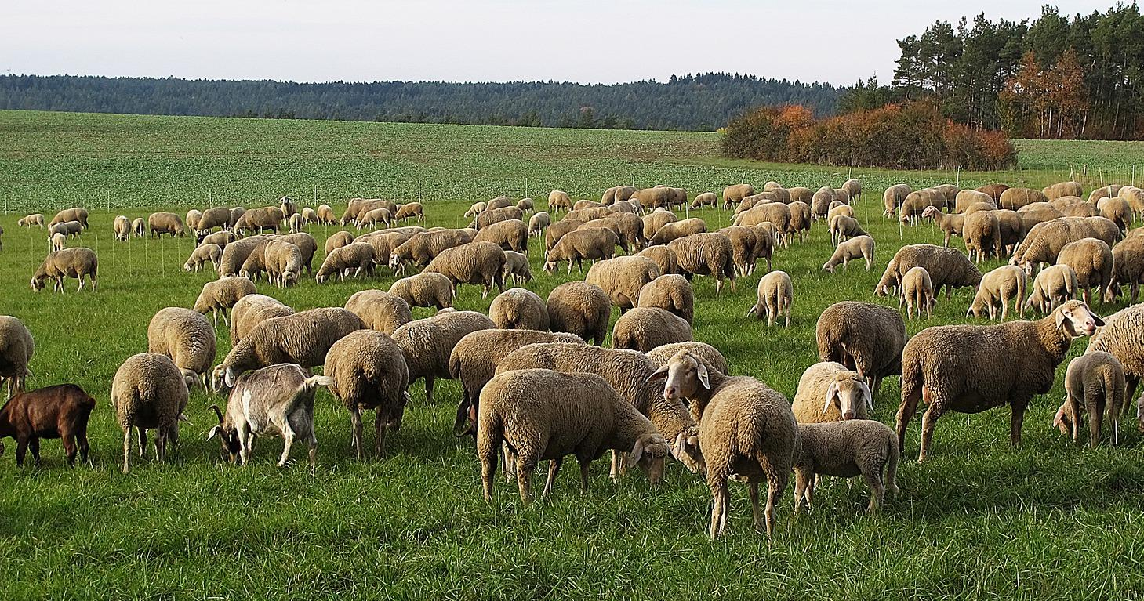
A wealthy person, on the other hand might own so many animals of different kinds that the herd would be divided up into flocks, each of which had its own herding personnel. In the search for grazing and water, the different flocks, all belonging to one person, would be scattered in different areas. In biblical Hebrew a combination of flocks of domestic animals can be referred to by the inclusive word ‘eder. This word usually includes sheep, but it can also include goats, cattle, donkeys, and possibly even camels. Within a person’s ‘eder sheep would have been the most numerous. If a writer wanted to be more specific, the groups of domestic animals within the ‘eder could be referred to with words meaning flocks, cattle, donkeys, and camels.
This “flock” within an ‘eder was called in Hebrew ts’on. This word always included sheep but could include goats too. Within the ts’on sheep would outnumber goats.
A ts’on consisted of individual animals called seh. While this word usually denotes sheep it can refer to goats too. In some contexts some English versions translate this word as “animal". For instance in EXO 12:5 the Hebrew text is best translated as “It must be an animal (seh) without defect, a one year old male; you may choose it either from your sheep or from your goats."

Translation:
The text itself will often indicate the kinds of animal being referred to. In these contexts the translation is not usually difficult. However, when ‘eder is used without indication of what animals are intended, in many languages it is best to translate this word by a phrase meaning “herds of domestic animals” or “herds of animals which people raise".
Similarly with ts’on, the context often indicates whether sheep or goats are being referred to. However, where this word occurs without further clarification, it is best translated as “flocks of sheep and goats".
The translation of seh is not quite so straightforward. In some contexts it is best rendered “one animal", in others “one sheep or goat", and in others “a sheep". In languages in which there are different noun classes or classifiers for large and small animals, the appropriate one for an animal the size of a sheep or goat should be used when translating seh as “animal".

