Resource: Animals in the Bible
Animals in the Bible © United Bible Societies, 2025. Adapted from: All Creatures Great and Small: Living Things in the Bible, by Edward R. Hope © 2005 United Bible Societies. This work is licensed under Creative Commons Attribution-ShareAlike 4.0 International (https://creativecommons.org/licenses/by-sa/4.0/).

Animals in the Bible

Hoopoe

3.12 Hoopoe

References:Hebrew דּוּכִיפַת (dukifat)LEV 11:19, DEU 14:18

Discussion:
Hoopoe (© Dr. Raju Kasambe (Wikimedia Commons))There is unanimous agreement today about the meaning of this word. KJV has “lapwing", but this is simply because the translators did not know the bird in question.
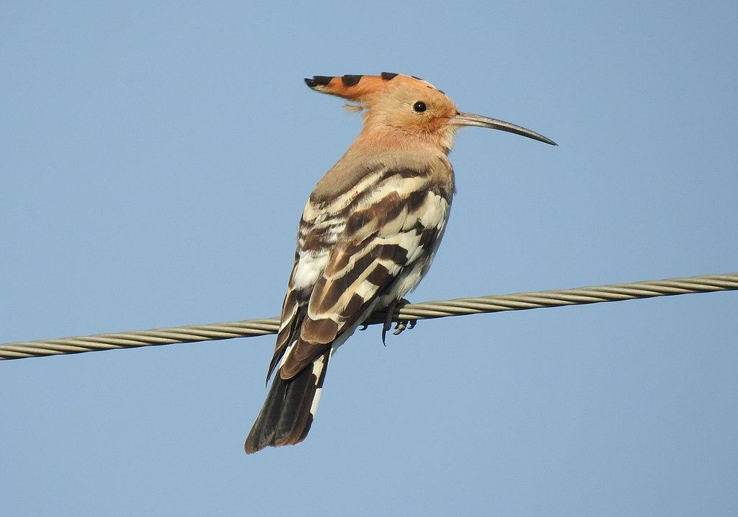

Description:
The Hoopoe Upupa epops is so named to represent its call, which has been described as hoop-hoop, poop-poop, or similar sounds. Its name is even similar in some African languages, such as Shona mupupu and Tswana pupupu. It is a bird about the size of a large dove, with a ginger colored head and body, and with wings and a tail that have black and white stripes. It has a long slender beak that curves slightly, and a long crest on its head, which it can erect into a fan shape.
The hoopoe has rather floppy wings and rises and falls as it flies. As soon as it lands, it erects its fan-shaped crest briefly. It spends a lot of time walking around on the ground looking for food. It nests in any suitable hole in a tree or in the ground and may raise two or three broods in a season. Unlike most other birds, it does not remove the nestlings’ droppings from the nest, and the nest smells badly as a result. Hoopoes eat insects and their larvae, termites, worms, small frogs, and beetles.

Special significance or symbolism:
It is listed as an unclean bird.

Translation:
The hoopoe is found all over Africa, Madagascar, the Middle East; across tropical Asia in savannah, but not rain forest areas; in Japan; and in southern Europe. In these areas a local name should not be difficult to find. Elsewhere, a name that approximates its call can usually be used, such as “hoopoo bird", “pupu bird", or something similar.

