Resource: Animals in the Bible
Animals in the Bible © United Bible Societies, 2025. Adapted from: All Creatures Great and Small: Living Things in the Bible, by Edward R. Hope © 2005 United Bible Societies. This work is licensed under Creative Commons Attribution-ShareAlike 4.0 International (https://creativecommons.org/licenses/by-sa/4.0/).

Animals in the Bible

Quail

3.19 Quail

References:Hebrew שְׂלָו (selav)EXO 16:13, NUM 11:31, NUM 11:32, PSA 105:40Greek ὀρτυγομήτρα (ortugomētra)WIS 16:2, WIS 19:12Latin coturnix2ES 1:15

Discussion:
Quail (Graham light (Pixabay))There is total agreement among versions and commentators that this is the Common Quail Coturnix coturnix. This bird existed in Egypt in enormous flocks numbering many millions for centuries, right up to the early part of the twentieth century. It was netted in enormous quantities, dried in the sun, and exported. The Egyptian bird has a rather limited migration route, going across the eastern side of Egypt to the Sinai, then southward into the Sudan. Other quails that migrate from southern Europe to Africa also cross the Sinai. It was during these migrations, when the birds fly only a few feet from the ground, that they were netted.
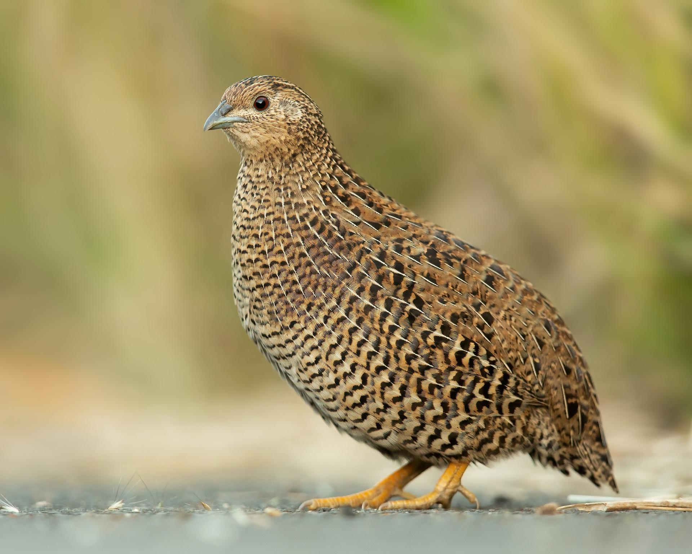

Description:
Young quails (© John Robert McPherson (Wikimedia Commons))The common quail is a small brown bird streaked with white, the smallest of the game birds. It looks like a miniature partridge, with a small white patch beneath its beak, a white stripe above its eye, and another around its neck. The males have a black chest stripe above a chestnut-colored breast patch.
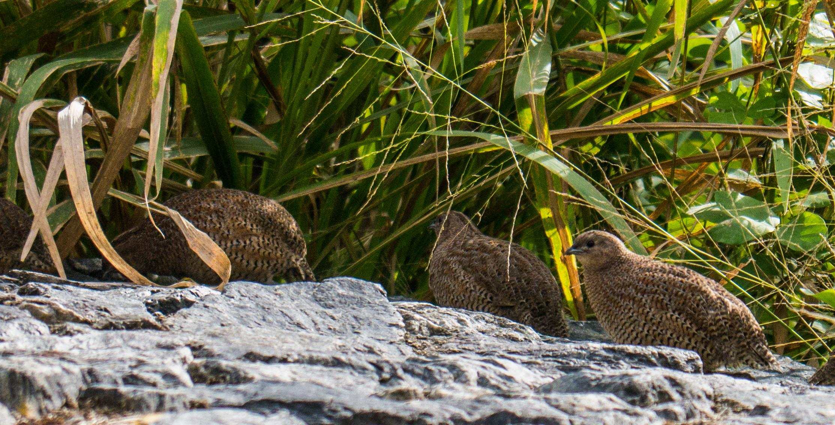

Special significance or symbolism:
The quail is associated with God’s merciful provision during the Exodus from Egypt.

Translation:
The common quail is found all over Africa, in southern and southeastern Europe, and in the Middle East. It is then found in a discontinuous band across mainland Asia to Japan. Other very similar species, the Harlequin Quail Coturnix delegorguei and the Chinese Quail Coturnix chinensis, are equally common in Africa and Asia respectively. The latter is also found in Australia, where it is called the king quail. In North America the California quail is well known. In other areas where the true quail is not known, a phrase such as small partridge can be used. The reference in NUM 11:31, literally “two cubits high above the face of the earth", should be interpreted as “they were flying about a meter 3 feet above the ground.” In the following verse, the text should be interpreted as “they spread them out on the ground,” that is, to dry in the sun.

