Resource: Animals in the Bible
Animals in the Bible © United Bible Societies, 2025. Adapted from: All Creatures Great and Small: Living Things in the Bible, by Edward R. Hope © 2005 United Bible Societies. This work is licensed under Creative Commons Attribution-ShareAlike 4.0 International (https://creativecommons.org/licenses/by-sa/4.0/).

Animals in the Bible

Sparrow

3.21 Sparrow

References:Hebrew צִפּוֹר (tsippor)GEN 7:14, GEN 15:10, LEV 14:4, LEV 14:5, LEV 14:6, LEV 14:6, LEV 14:6, LEV 14:7, LEV 14:49, LEV 14:50, LEV 14:51, LEV 14:51, LEV 14:52, LEV 14:52, LEV 14:53, DEU 14:11, DEU 22:6, JOB 40:29, PSA 11:1, PSA 84:4, PSA 102:8, PSA 104:17, PSA 124:7, PRO 6:5, PRO 7:23, PRO 26:2, PRO 27:8, ECC 9:12, ECC 12:4, ISA 31:5, LAM 3:52, HOS 11:11, AMO 3:5Greek στρουθίον (strouthion)MAT 10:29, MAT 10:31, LUK 12:6, LUK 12:7, TOB 2:10, TOB 2:10, PSS 17:16

Discussion:
Sparrow (Pixabay)While the Greek word strouthion is certainly the name for the sparrow, the Hebrew tsippor is actually an inclusive word that refers to sparrow-sized birds in general. These small birds, especially sparrows, were caught in nets and traps and were an important part of the diet of poor people.
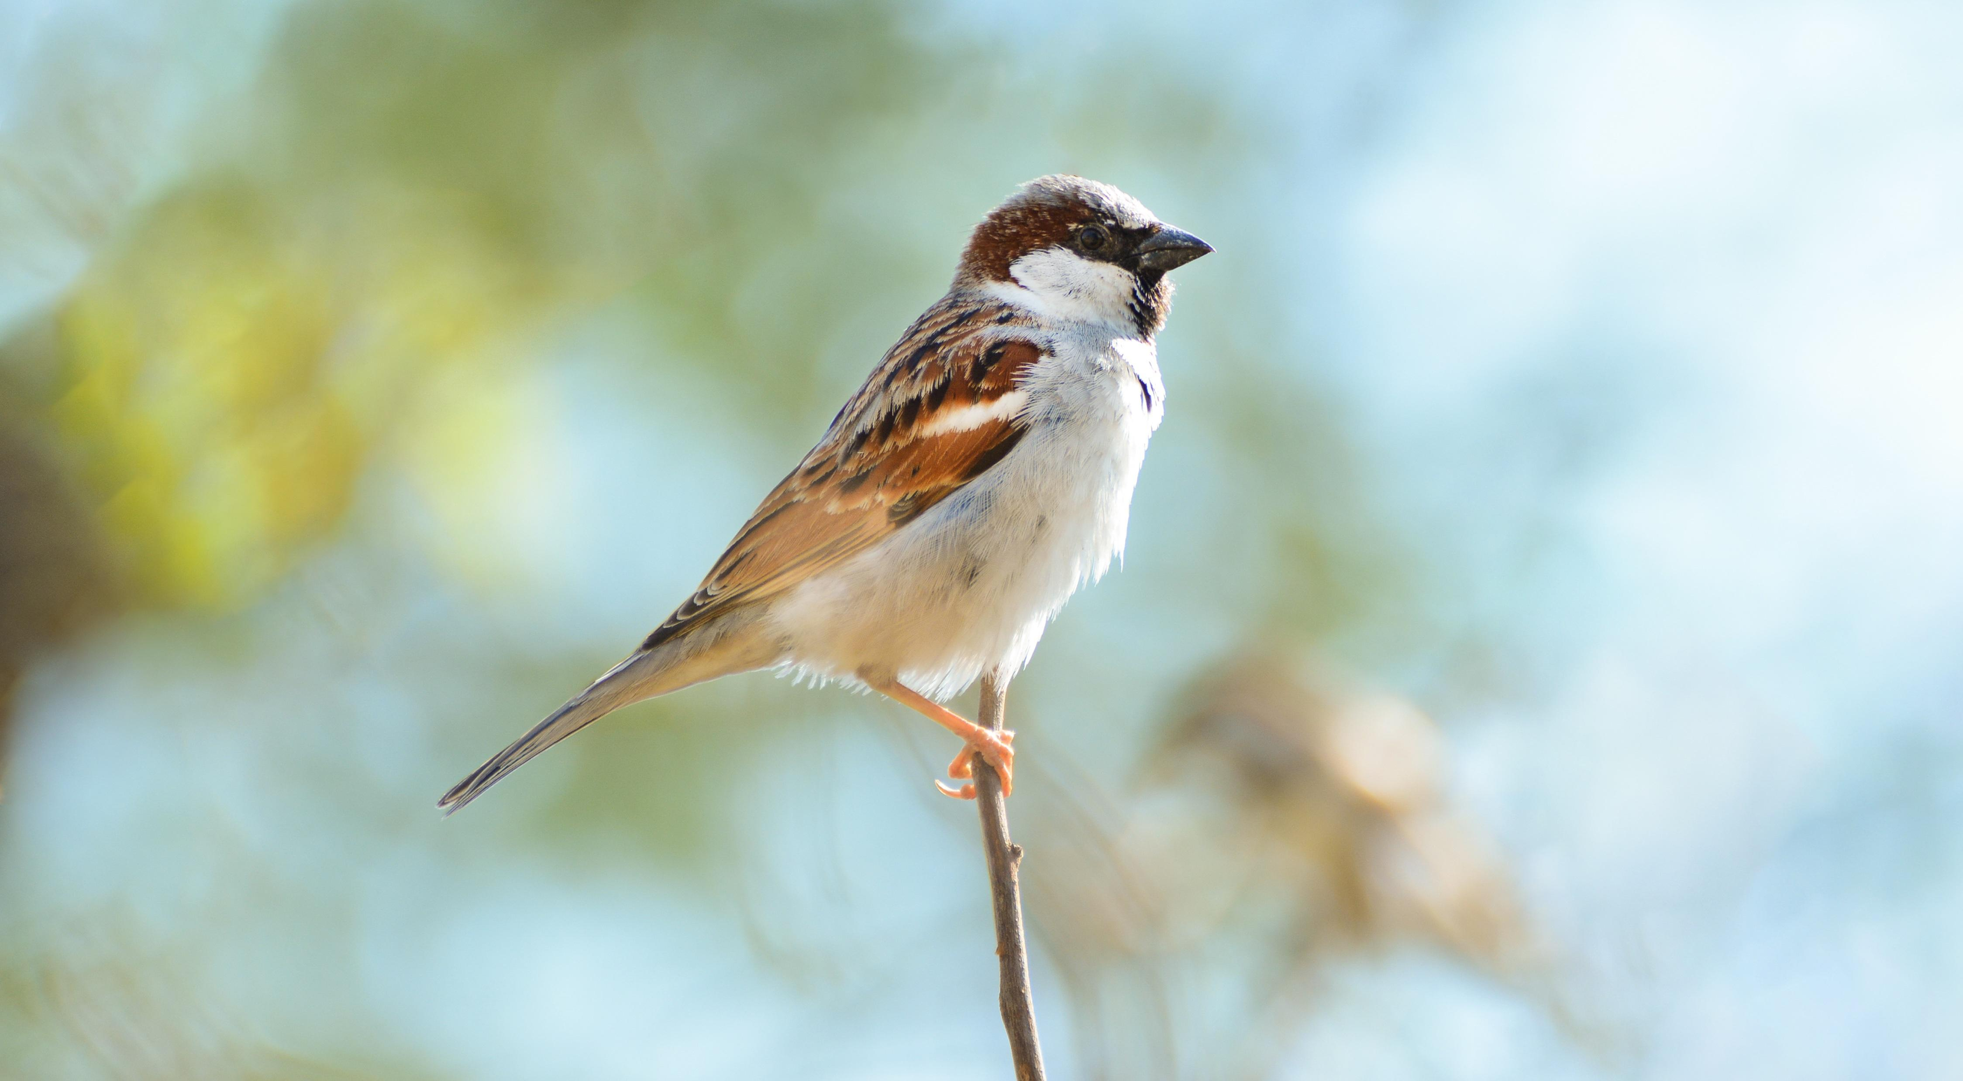

Description:
Sparrows (Pixabay)There are three types of sparrow that are common in Israel, the House Sparrow Passer domesticus, the Spanish Sparrow Passer hispaniolensis, and the Dead Sea Sparrow Passer moabiticus. All three are small speckled brown birds. Additional small birds that abound around towns and settlements are members of the bunting, finch, and tit families. Sparrows in particular are usually found in fairly large numbers roosting and nesting together. All are seed eaters and live mainly on grass seeds and grain.
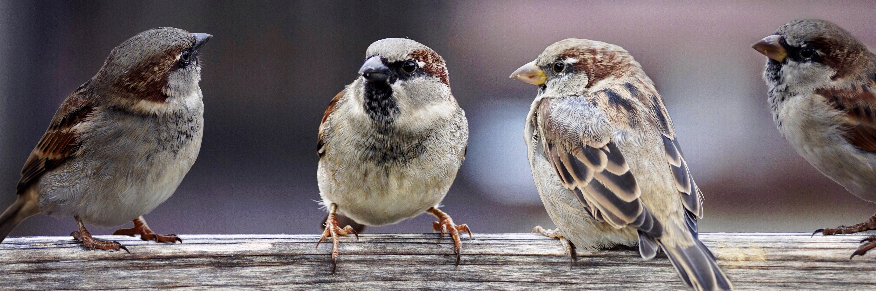

Special significance or symbolism:
Sparrows were considered clean birds and were associated with the poor.

Translation:
Sparrows or sparrow-like small birds are found all over the world. Finding a local word is not usually difficult. The reference to “a lonely bird on the housetop” in PSA 102:7 takes on additional meaning if the sparrow was intended, since it is a bird that is seldom seen alone. It would then indicate the psalmist’s sense of loneliness at being separated from those with whom he belongs.

