Resource: Animals in the Bible
Animals in the Bible © United Bible Societies, 2025. Adapted from: All Creatures Great and Small: Living Things in the Bible, by Edward R. Hope © 2005 United Bible Societies. This work is licensed under Creative Commons Attribution-ShareAlike 4.0 International (https://creativecommons.org/licenses/by-sa/4.0/).

Animals in the Bible

Fish

5.1 Fish

References:Hebrew דָּג, דָּגָה (dag, dagah)GEN 1:26, GEN 1:28, GEN 9:2, EXO 7:18, EXO 7:21, NUM 11:5, NUM 11:22, DEU 4:18, 1KI 5:13, 2CH 33:14, NEH 3:3, NEH 12:39, NEH 13:16, JOB 12:8, JOB 40:31, PSA 8:9, PSA 105:29, ECC 9:12, ISA 50:2, EZK 29:4, EZK 29:4, EZK 29:5, EZK 38:20, EZK 47:9, EZK 47:10, EZK 47:10, HOS 4:3, JON 2:1, JON 2:1, JON 2:2, JON 2:11, HAB 1:14, ZEP 1:3, ZEP 1:10Greek ἐνάλιον (enalion)JAS 3:7Greek ἔνυδρος (enudros)WIS 19:10, WIS 19:19, 4MA 1:34Greek ἰχθύς (ichthus)MAT 7:10, MAT 14:17, MAT 14:19, MAT 15:36, MAT 17:27, MRK 6:38, MRK 6:41, MRK 6:41, MRK 6:43, LUK 5:6, LUK 5:9, LUK 9:13, LUK 9:16, LUK 11:11, LUK 11:11, LUK 24:42, JHN 21:6, JHN 21:8, JHN 21:11, 1CO 15:39Greek ἰχθύδιον (ichthudion)MAT 15:34, MRK 8:7Greek κῆτος (kētos)MAT 12:40Greek νηκτός (nēktos)WIS 19:19Greek ὀψάριον (opsarion)JHN 6:9, JHN 6:11, JHN 21:9, JHN 21:10, JHN 21:13Greek προσφάγιον (prosfagion)JHN 21:5Latin piscis2ES 5:7, 2ES 6:47, 2ES 16:12

Discussion:
Fish (Pixabay)Fish that had both fins and scales were acceptable food for the people of Israel.

Fishes (Pixabay)Although fish are mentioned frequently in the Bible, there is no direct reference to fishing in the Old Testament. This is probably due to two main factors: a) the Hebrews as nomadic shepherds probably did not eat fish regularly until their sojourn in Egypt; and b) they were afraid of the sea, and thus probably did not get involved in commercial fishing until late in their history. Nevertheless, in Egypt in particular, fish would have been a regular item of the diet. The Nile River was full of good-eating fish, such as Nile perch, tilapia, and giant catfish, although this latter fish would not have been eaten by the Hebrews as it does not have obvious scales.
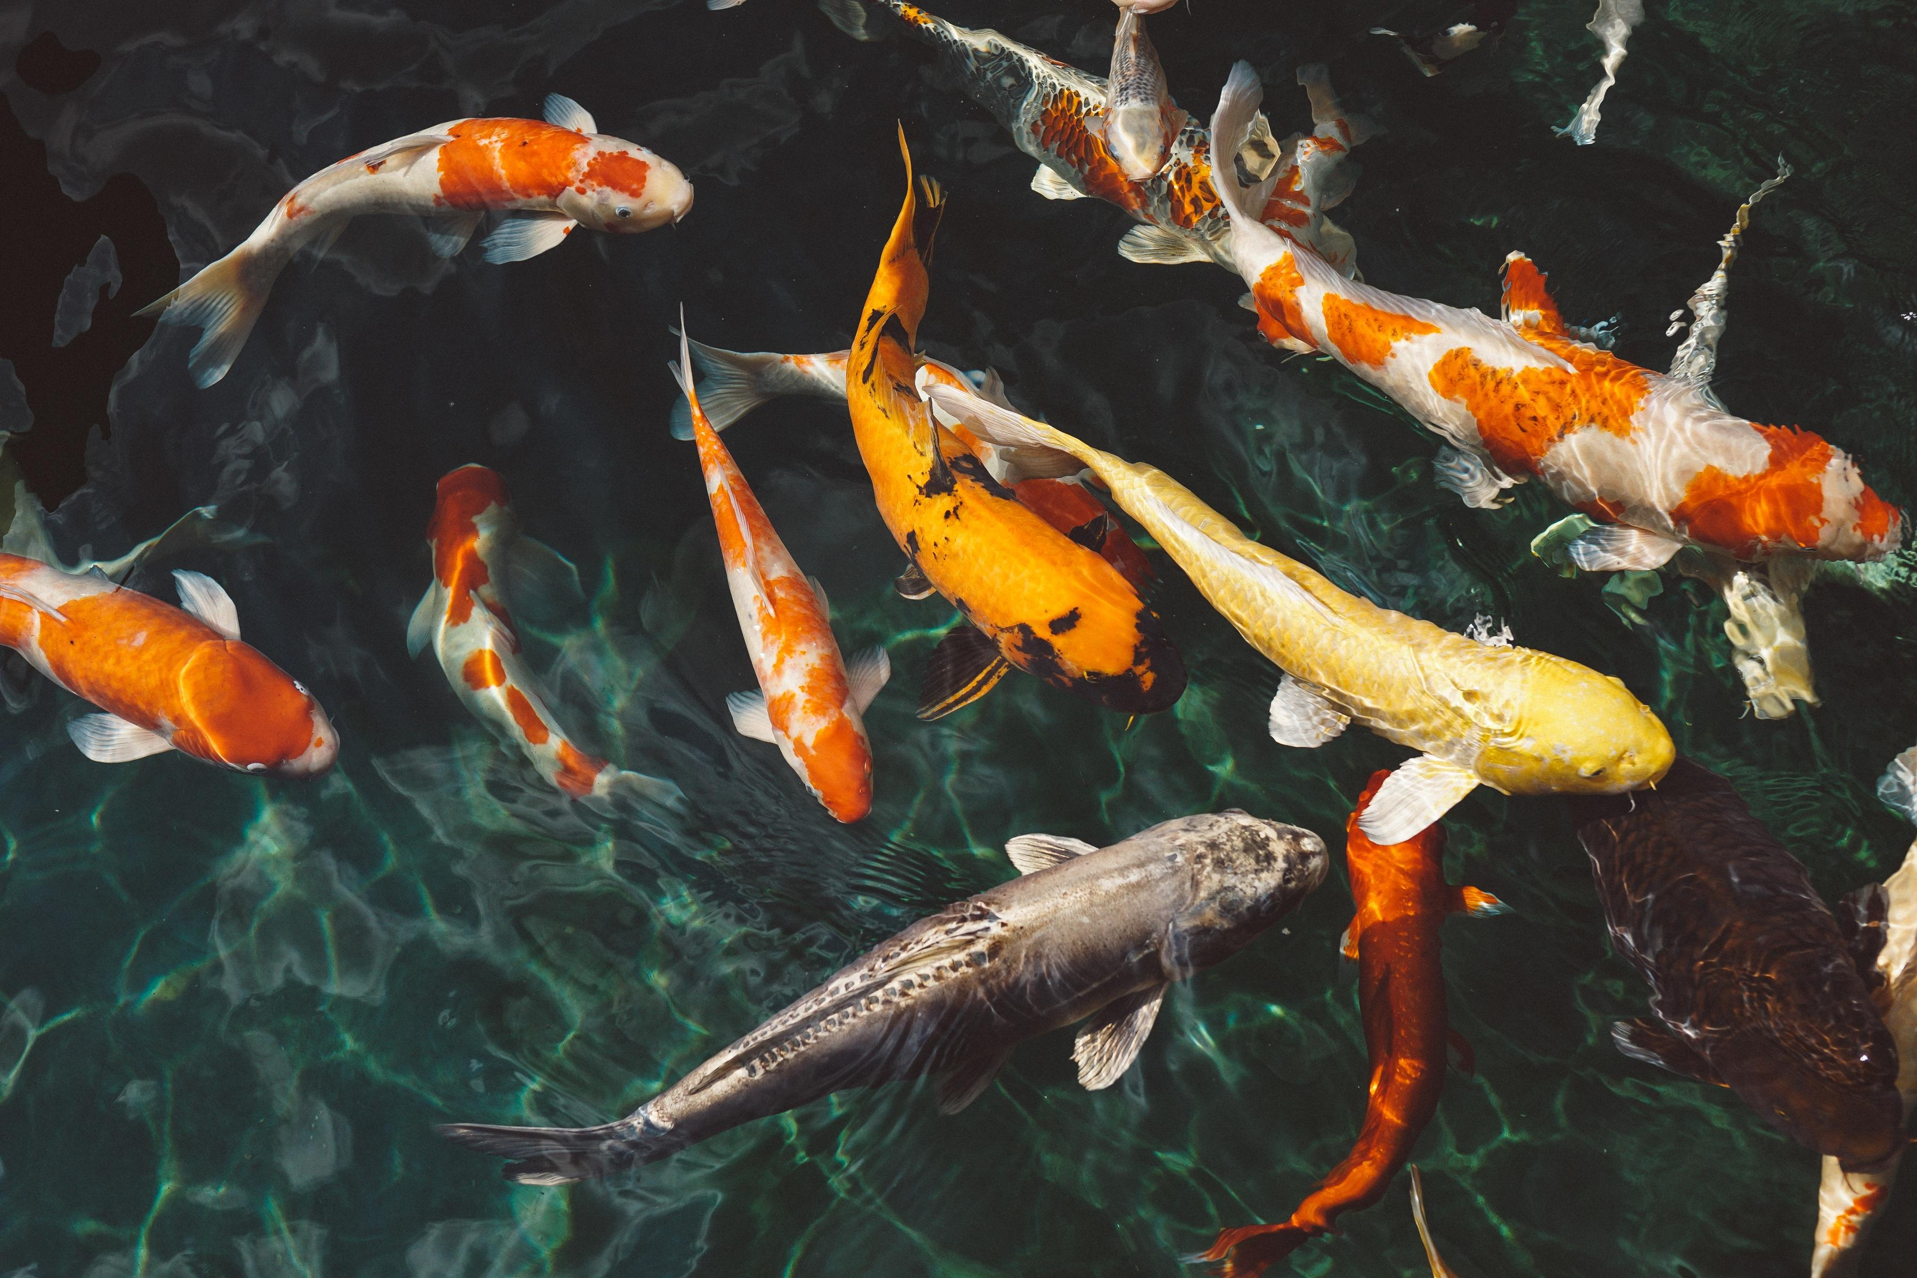
However, there is ample reference to the fact that after the Exodus from Egypt the people of Israel did eat fish, and different types of fishnets, fishing spears, and hooks are also referred to. Archeological finds indicate that the Egyptians, Babylonians, and Assyrians bred fish in ponds, and it is possible that the Israelites did the same. Most of the commercial fishing was done by the Philistines and other Phoenician peoples. One of the Philistine goddesses, Atargatis, whose cult began in Syria, was a fish-goddess.
Fishing in Lake Galilee does not seem to have been a Jewish activity until the Maccabean period. Until this period it seems that the Jews fished in rivers and streams and perhaps kept fish in ponds, but they bought dried fish from coastal peoples.
The Hebrew words dag and dagah are general terms and do not refer to any particular species. Marine fish found in the eastern Mediterranean Sea are not abundant, due to the fact that the sea in this region is poor in nutrients. The only fish likely to be caught in any numbers in nets in this region are sardines and mullet. There are tropical reef fish in those few inshore places where the reefs are shallow, and some line fishing may have been done for these species.
The Greek word ichthus and the Latin piscis are likewise general words for fish. However, ichthudion (literally “little fish") is probably a reference to the Lake or Holy Land Sardine (sometimes called Bleak) Mirogrex terrae sanctae, which is abundant in Lake Galilee and has been fished for centuries. This is a small freshwater sardine similar to the kapenta found in the great lakes of Africa. Tilapia are also abundant in Lake Galilee.
The word enalion includes fish in its meaning but refers to all sea creatures, including crustaceans and dolphins. The word opsarion refers to cooked fish or fish about to be cooked and eaten. In the context of JHN 21:5 prosfagion refers to fish for breakfast. The word nēktos literally means “swimmer” and may include other water creatures, such as frogs.

Translation:
In most contexts a general word for fish can be used. In JOB 41:7 the Hebrew text has “fish spears". These were simple sharpened reeds in contrast to metal-headed war spears.
In the case of ichthudion one may use a word for a locally known freshwater sardine or a phrase meaning “small fish". For opsarion “cooked fish” can be used. For prosfagion, which occurs in the question “Have you caught any fish?” the usual word used in such a common question should be used.
The Greek word enalion is best translated as “sea creatures” or “things that live in the sea."
Kētos is not the usual word for fish, and most commentators suggest that it means a sea monster or a monster fish. It is best translated as “monster fish", “sea monster", or “huge fish".
Note: The fish became a Christian symbol in the second century A.D. It was based on the Greek Iēsous CHristos THeou ‘Uios Sōtēr, “Jesus Christ, Son of God, Savior.” The first letters of the Greek words spell ICHTHUS, the Greek word for fish.

