Resource: Animals in the Bible
Animals in the Bible © United Bible Societies, 2025. Adapted from: All Creatures Great and Small: Living Things in the Bible, by Edward R. Hope © 2005 United Bible Societies. This work is licensed under Creative Commons Attribution-ShareAlike 4.0 International (https://creativecommons.org/licenses/by-sa/4.0/).

Animals in the Bible

Scorpion

6.11 Scorpion

References:Hebrew עַקְרָב (‘aqrav)NUM 34:4, DEU 8:15, JOS 15:3, JDG 1:36, 1KI 12:11, 1KI 12:14, 2CH 10:11, 2CH 10:14, EZK 2:6Greek σκορπίος (scorpios)LUK 10:19, LUK 11:12, REV 9:3, REV 9:5, REV 9:10, SIR 26:7, SIR 39:30, 4MA 11:10

Discussion:
Scorpion (© אבי בן זקן (https://www.flickr.com/photos/evilmacro/) (Wikimedia Commons))There is complete agreement that these words refer to the scorpion. Many scholars accept that ‘aqrav was also a nickname for a type of whip used for punishing criminals.
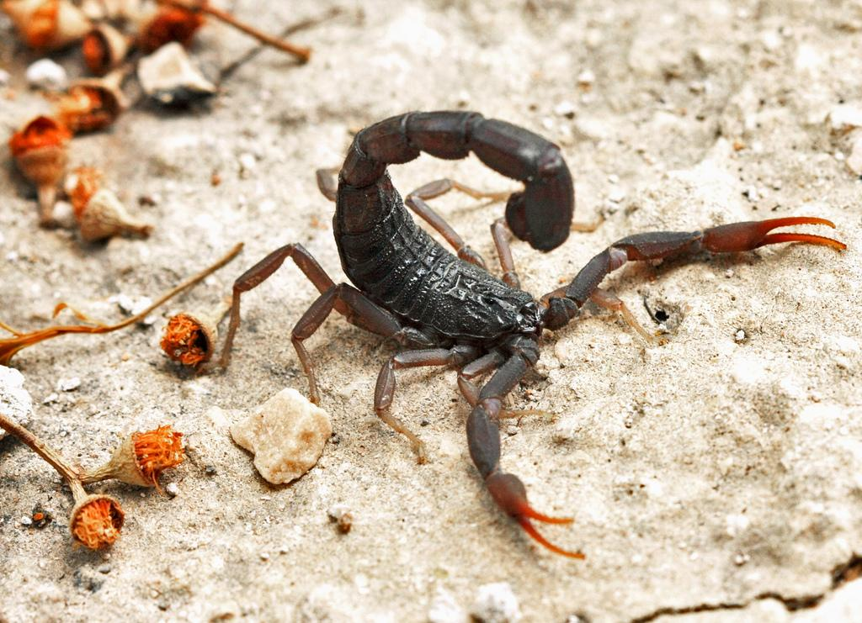

Description:
The scorpion is an eight-legged creature. In the land of Israel it grows to about 13 centimeters (5 inches) long, but in some tropical countries scorpions can be up to 18 centimeters (7 inches) long. The front pair of legs has claws similar to those on a crab, and the tail, which it can arch over its head, carries a fierce sting. It feeds on other insects and on small reptiles, such as baby lizards. It grasps its prey in its claws and stings it with its tail, either killing it or paralyzing it.

Special significance or symbolism:
In the Hebrew Bible the scorpion epitomizes harsh, inhospitable living conditions.

Translation:
The passages in 1Kings and 2Chronicles probably refer to a particularly painful type of whip, hence the NEB use of “lash", JB “loaded scourge", and TEV “bullwhips". A phrase such as “scorpion whip” is used in many non-English translations.
In NUM 34:4; JOS 15:3; JDG 1:36 reference is made to a place called ma‘aleh ‘aqrabim “Scorpion Pass", but since place names are usually not translated, the name Akrabbim Pass is usually used in translation.
Scorpions are found almost worldwide, except in the Arctic tundra and on some islands. In most places, therefore, a local word will be available.

