Resource: Animals in the Bible
Animals in the Bible © United Bible Societies, 2025. Adapted from: All Creatures Great and Small: Living Things in the Bible, by Edward R. Hope © 2005 United Bible Societies. This work is licensed under Creative Commons Attribution-ShareAlike 4.0 International (https://creativecommons.org/licenses/by-sa/4.0/).

Animals in the Bible

Leviathan

7.3 Leviathan

References:Hebrew לִוְיָתָן (livyathan)JOB 3:8, JOB 40:25, PSA 74:14, PSA 104:26, ISA 27:1, ISA 27:1Latin Leviathan2ES 6:49, 2ES 6:52

Discussion:
Nile crocodile (© Dewet (Wikimedia Commons))Scholars are divided in the details of the meaning of this word, but all are agreed that it refers to a monster that lives in water. The word seems to be related to a Hebrew root that means “to twist.” Some believe that the notion of livyathan is related to ancient Egyptian beliefs about a mythical monster crocodile that was thought to be responsible for the annual flooding of the Nile and for causing eclipses of the sun. The passages in JOB 41:1 and PSA 74:14 support this view. In PSA 74:13; PSA 74:14 livyathan occurs in parallel with another word tannin, which refers to a monster that lives in the water. In EZK 29:3 tanim is described as having powerful jaws and scales. The similarity to a crocodile has been noted by many commentators.
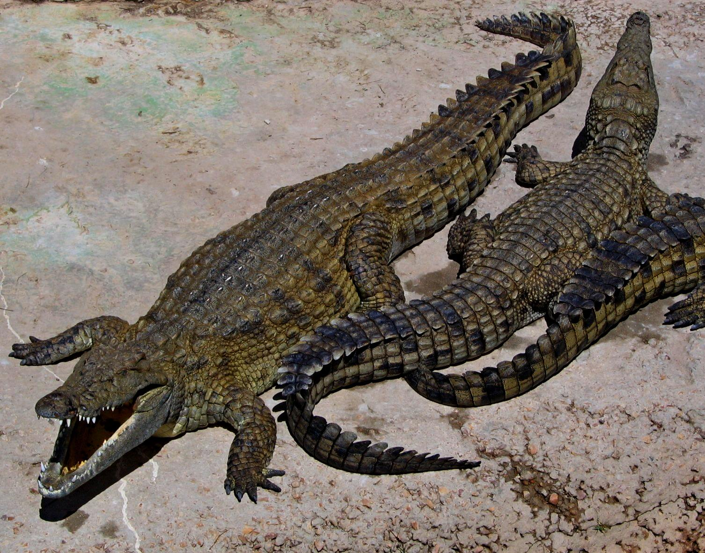
Others relate this monster to Babylonian myths about the chaos dragon Tiamat. The Ugaritic texts refer to a similar monster called lotan, which is the Ugaritic form of livyathan. It seems possible that this is the reference in ISA 27:1. The probability is that the name is used in both senses in the Bible.
The NEB and REB rendering of this word as “whale” in JOB 41:1 is very radical, especially in the light of the fact that they translate behemoth as crocodile in the previous chapter. There is very little scholarly support for either of these renderings.
There is general agreement among Jewish scholars that tannin is the more generic word for “sea monster", while behemoth and livyathan are the names of two of those monsters. This is reflected in 2ES 6:49; 2ES 6:52, where leviathan is clearly a proper name for one of these monsters.

Description:
Crocodiles are the largest of all reptiles. The species found in the Nile valley is the Nile Crocodile Crocodylus niloticus. In biblical times these crocodiles also lived in the larger rivers of the land of Israel, and another species lived in the Tigris and Euphrates rivers in Mesopotamia.
Crocodiles look like enormous lizards with large teeth, and they often reach more than 5 meters (16 feet) in length. Their skin is covered in thick fleshy scales. They live in rivers and in river estuaries and come out of the water onto land to sun themselves for long periods each day. When they are in the water they can stay submerged for ten minutes or more.
They feed on fish that they catch in the water, or lie in wait, wholly or partly submerged until some animal or person comes to drink. They then leap out of the water and seize their prey and throw or drag it into the water where they drown it. They then wedge the prey under a log or between rocks or reeds and tear large pieces from the carcass by seizing the flesh in their teeth and twisting themselves over and over until the flesh comes loose. They then swallow the meat without chewing it. In areas where these crocodiles live, people are killed every year by them.
The monster crocodile of the Egyptians, however, was not a real crocodile but a mythical one of gigantic proportions, which was associated with the annual flooding of the Nile River. It was believed to be so big that whenever it entered the Nile, it caused the river to overflow its banks.

Special significance or symbolism:
Leviathan symbolized the Egyptian nation and probably its gods; it also symbolized the two mighty nations of Assyria and Babylon. Thus it symbolized the great enemies of Israel.

Translation:
In most translations the word is transliterated from the Hebrew rather than translated, but the name by itself conveys little to the average reader. In languages where crocodiles are well known, the more meaningful expression “the giant crocodile Leviathan” can be used in the Job and Psalms passages. Then, in the Isaiah passage, where the text itself identifies Leviathan as a serpent (or reptile), the name can be used by itself. In some societies, where there are beliefs about mythical monster serpents or crocodiles associated with the flooding of rivers, the local name for the mythical monster can be used, with a footnote to indicate that in Hebrew the monster’s name is livyathan and that it represented the enemies of Israel.

