Resource: Plants and Trees in the Bible
Plants and Trees in the Bible © United Bible Societies, 2025. Adapted from: Each According to its Kind: Plants and Trees in the Bible, by Robert Koops © 2012 United Bible Societies. This work is licensed under Creative Commons Attribution-ShareAlike 4.0 International (https://creativecommons.org/licenses/by-sa/4.0/).

Plants and Trees in the Bible

Ebony

1.7 Ebony

Reference:”Hebrew הָבְנִים (hovnim)EZK 27:15

Discussion:
Ebony (Malcolm Manners (Wikimedia Commons))Ezekiel reports traders who brought hovnim to Tyre. Coupled with ivory, the Hebrew word hovnim could have referred to either Asian or African products. In 1982 Zohary stated that the identity of the hovnim in Ezekiel is unclear. He said that at best we can say that both Asian and African merchandise were shipped to Dedan, a Phoenician commercial center on the Arabian coast. Since then, however, Hepper, who believes that trading with the Far East was less than many other scholars have alleged, has said that this tree is not the Asian Ebony Diospyros ebenum we know today but a leguminous tree Dalbergia melanoxylon, which grows all across Africa along the southern edge of the Sahara Desert. Evidence for this, he says, is that the Old Egyptian cognate hbny found in hieroglyphs refers to Dalbergia melanoxylon.
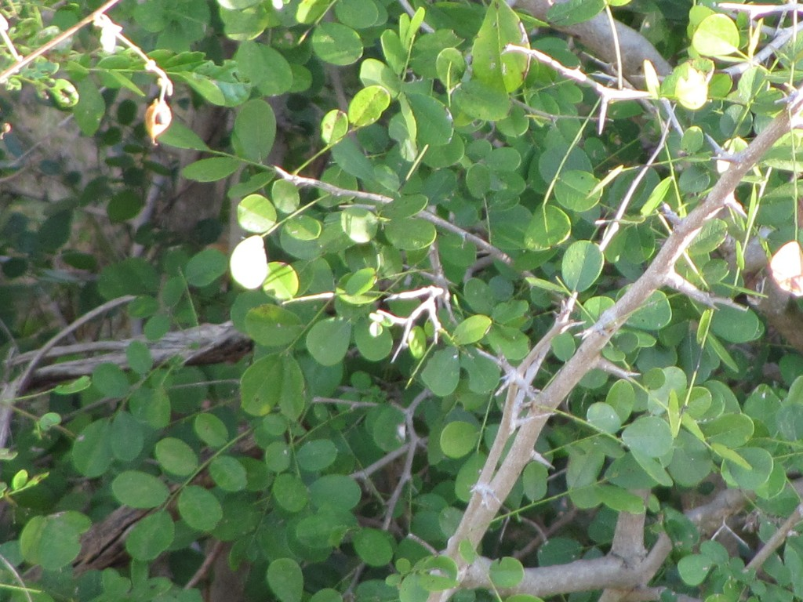

Description:
If hovnim are from Africa, they could be Dalbergia melanoxylon, as Hepper asserts, or one of the many species of the genus Diospyros found throughout the continent, such as Diospyros mespiliformis. The latter is a huge, widespread forest tree up to 35 meters (115 feet) tall. Dalbergia melanoxylon is a smaller, spiny tree reaching a height of 6–7 meters (20–23 feet). It inhabits the dry savanna areas from Ethiopia across to Senegal and as far south as southern Africa, where it is called “zebrawood.” The leaves are compound, with the leaflets nearly opposite one another on the spine. It has white flowers that hang in loose clusters, and around October they give way to flat, papery seedpods about 6 centimeters (2.5 inches) long and 1 centimeter (1/2 inch) wide. The Asian ebony, if that is what hovnim refers to, is found in India and Sri Lanka, grows to 10 meters (33 feet) tall, and has evergreen leaves. The inner part of the trunk is black, which makes it an attractive wood for carvers, who inlay the wood with ivory.

Translation:
There are hundreds of species of ebony in tropical areas of the world (eighty in the Americas, ninety-four in Africa, and two hundred in Asia). In Africa the tree that produces most of the true ebony is Diospyros mespiliformis, which is found all the way from Senegal to the Red Sea and Arabia and southward to Southwest Africa and the Transvaal (Keay, Dalziel, and Hutchinson). In Nigeria it is called kanran or kanyan (Fulani nel'bi, Kanuri bergem). Surprisingly, both the Yoruba and Igbo Bibles in Nigeria have used eboni, perhaps reflecting the urbanization and Anglicization of those societies (or at least of the translators!). The Hausa word kanya correctly refers to the ebony tree. Diospyrus ebenum, found in India and Sri Lanka, might possibly have been on the world market in Bible times. A local word for this tree could be used in translations. If Hepper is correct, then the Dalbergia melanoxylon, locally known in Africa as “ebony” and also used for carving, should be used. Other transliteration possibilities are ebene (French) and ebenuz (Spanish).
Dalbergia species are also found in Central and South America under the names of palisander, kingwood, or tulipwood. A species in India is called blackwood or rosewood. In all these places the wood is used for radio cabinets, musical instruments, buttons, knife handles, chess pieces, and decorative carvings for tourists.

