Resource: Plants and Trees in the Bible
Plants and Trees in the Bible © United Bible Societies, 2025. Adapted from: Each According to its Kind: Plants and Trees in the Bible, by Robert Koops © 2012 United Bible Societies. This work is licensed under Creative Commons Attribution-ShareAlike 4.0 International (https://creativecommons.org/licenses/by-sa/4.0/).

Plants and Trees in the Bible

Elm

1.8 Elm

Reference:”Hebrew גֶּשֶׁם (geshem)ISA 44:14

Discussion:
Elm (leaf and trunk) (Ptelea (Wikimedia Commons))In Isaiah’s description of the idol carver’s work, we find a sentence that says “he plants a cedar and the rain nourishes it” (Hebrew nata‘ ’oren wegeshem yegadel). The clause “and the rain nourishes it” has always seemed strange in the context. So Zohary emends geshem (“rain”) here to read neshem, which is the word for the Hairy Elm (Ulmus canescens) in Arabic. Given the very close similarity between the letters nun and gimel in Hebrew, and the syntax, it is tempting to conclude that another tree is being suggested. According to Zohary’s emendation, there is a possible parallelism between tirzah we’allon (“stone pine and oak”) in ISA 44:14 a and ’oren weneshem (“laurel and elm”) in ISA 44:14 b. Zohary’s hypothesis is based on the assumption that the original Hebrew word was similar to the Arabic word neshem (that is, beginning with the letter nun), and that a scribe at some point substituted the gimel for the very similar letter nun of the original text. I know of no Bible scholar who has considered this possibility. The Septuagint says “rain.”
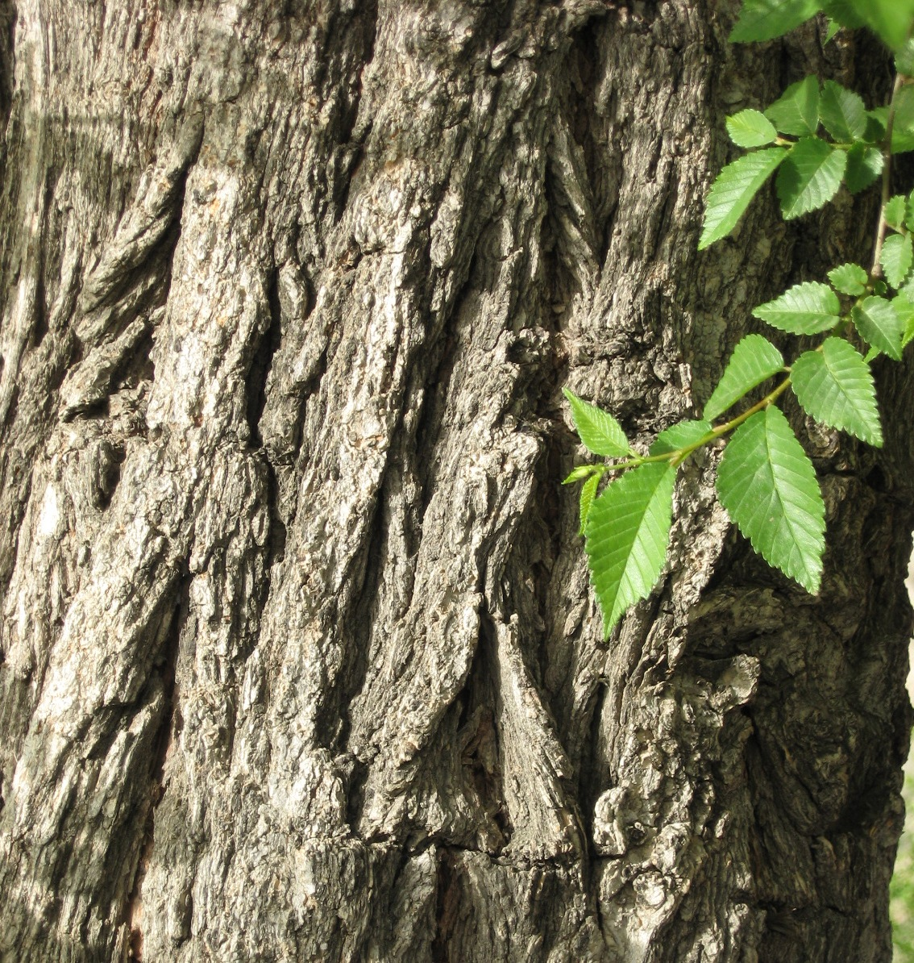
The KJV translation of ’elah as “elm” in HOS 4:13 is botanically incorrect. It should be “terebinth.”

Translation:
No translator at this date has taken up the suggestion to include the elm tree in this verse. If Zohary’s hypothesis is confirmed, however, we encourage translators to take it seriously. How it is handled in translation will depend on what the translator has done with the three other species in the verse: stone pine, oak, and laurel. If the translator takes those three rhetorically, and substitutes an equivalent species that is used for the making of idols, then the same should be done with neshem. If the others are transliterated from a major language, then neshem will also be transliterated, as, perhaps, elem /elmu (from English) or ulum /ulmu (from Latin).
Ulmus species are found in temperate climates throughout the world. They are planted along streets for shade, and the wood is used for furniture, tool handles, coffins, chair seats, wheel hubs, mallet heads, and many other things.

