Resource: Plants and Trees in the Bible
Plants and Trees in the Bible © United Bible Societies, 2025. Adapted from: Each According to its Kind: Plants and Trees in the Bible, by Robert Koops © 2012 United Bible Societies. This work is licensed under Creative Commons Attribution-ShareAlike 4.0 International (https://creativecommons.org/licenses/by-sa/4.0/).

Plants and Trees in the Bible

Juniper

1.11 Juniper

Two types of juniper grew in the Holy Land in Bible times: the Grecian juniper, referred to by the generic Hebrew word berosh, and the Phoenician juniper (or, coastal juniper), referred to as ’erez in the Pentateuch and as ‘ar‘ar in Jeremiah.

Grecian juniper (eastern savin)

1.11.1 Grecian juniper (eastern savin)

References:Hebrew בְּרוֹשׁ (berosh)ISA 14:8, ISA 37:24, ISA 41:19, ISA 55:13, ISA 60:13, EZK 27:5, EZK 31:8, HOS 14:9, ZEC 11:2

Discussion:
Greek juniper (Juniperus excelsa) (Ray Pritz (UBS))A tall evergreen, the Grecian Juniper Juniperus excelsa, also known as the Eastern Savin, grew in the mountains of Lebanon along with cedars, firs, and cypress (the Hebrew word berosh probably covered all three of these trees). The association of berosh with Mount Senir in EZK 27:5 argues for the Grecian juniper there, since Mount Senir was known to have plenty of Grecian junipers. Lebanese people up to today refer to the juniper as brotha, a likely cognate with berosh. King Solomon undoubtedly hauled these trees to Jerusalem along with cedars and firs to use in constructing his palace and the Temple of Yahweh. The Israeli botanist Hareuveni advocates translating berosh as juniper, presumably the Grecian species.
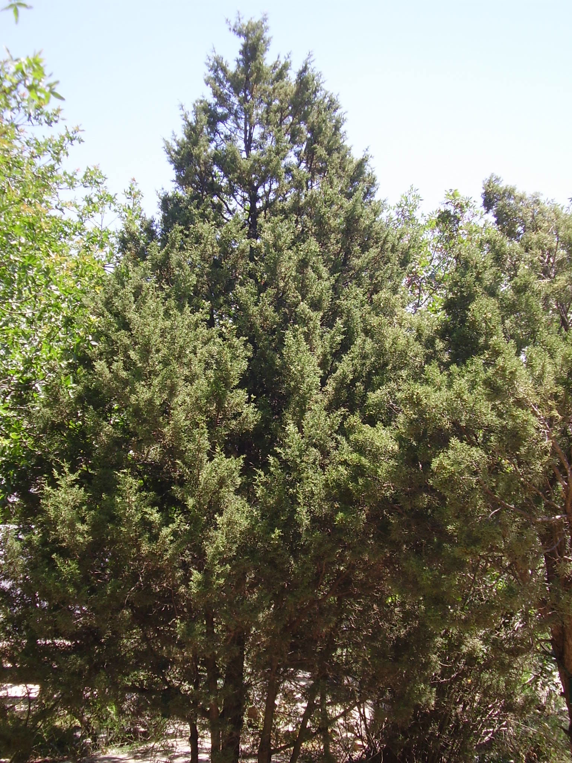

Description:
The Grecian juniper is a conical tree reaching a height of 20 meters (65 feet). Its “leaves” are round rather than flat, and the fruit is an inedible seed-bearing, fleshy cone.

Translation:
There is no single Hebrew or Greek word that refers specifically to the Grecian juniper. In our discussion of cypress and fir, we have advocated translating berosh generically or as “fir” or “juniper” in 1–2 Kings and 2 Chronicles (where it is typically associated with Lebanon or cedar). If no generic word is available in the receptor language, a descriptive phrase such as “strong, beautiful tree/wood” can be used. In poetical passages like HOS 14:9; EZK 31:8; and ZEC 11:2, local poetic equivalents could be considered.

Phoenician juniper (coastal juniper)

1.11.2 Phoenician juniper (coastal juniper)

References:Hebrew אֶרֶז (’erez)LEV 14:4, LEV 14:6, LEV 14:49, LEV 14:51, LEV 14:52, NUM 19:6, NUM 24:6Hebrew עֲרוֹעֵר (‘aro‘er)JER 48:6Hebrew עַרְעָר (‘ar‘ar)JER 17:6

Discussion:
Phoenician juniper (Juniperus phoenicea) (Ray Pritz (UBS))The Phoenician Juniper Juniperus phoenicea is a lower-altitude cousin of the Grecian juniper discussed in the previous entry. At present it is found scattered throughout the mountains of northern Sinai and southern Jordan, and Hepper notes that it occurs throughout the higher parts of Sinai and Arabia. In ancient times it may have been found throughout the Negev. DEU 2:36 refers to a town on the edge of the Wadi Arnon called Aroer, which is probably cognate with the Hebrew word ‘ar‘ar, indicating that these trees may have grown there. The identification of ‘ar‘ar /‘aro‘er as the Phoenician juniper is supported by the fact that Arabs in several countries call this juniper ‘ar‘ar. Since it is closely related to the cedars, some people also call it the “Phoenician cedar.” Note that Hebrew uses the same word ’erez to cover both the Phoenician juniper and the mighty cedar of Lebanon. For ‘ar‘ar in JER 17:6, Nogah HaReuveni (Desert and Shepherd in our Biblical Heritage, p 67–71) makes a literary case for the “apple of Sodom” (Calotropis procera). The Sodom apple, which lives in an “uninhabited salt land,” has attractive green leaves and fruit, but the fruit turns out to be hollow and toxic — a strong contrast with the fruitful tree that lives by a stream. However, other botanists have not followed this, relying more on the linguistic evidence from Arabic.
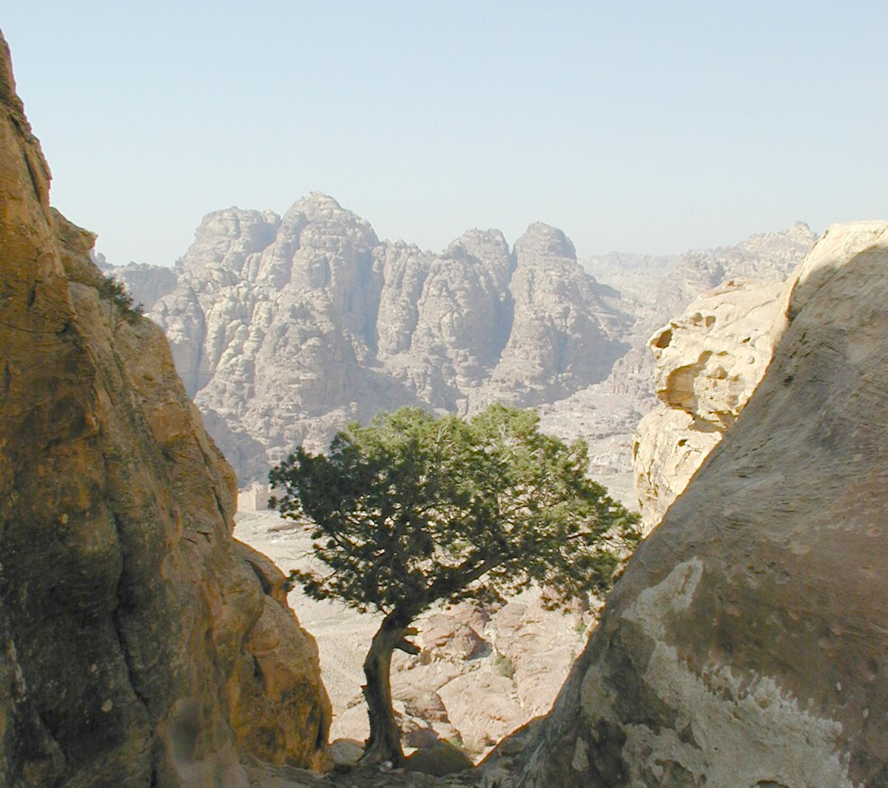

Description:
The Phoenician juniper is a short shrub or tree that may reach 5 meters (17 feet). It has tiny leathery leaflets and small berry-like cones.

Special significance:
In NUM 24:6 Balaam compares Israel’s encampments to gardens of God with fragrant aloes and verdant ’arazim. We can’t tell in this context whether the prophet envisions the modest Phoenician juniper here, or the glorious cedar of Lebanon. In JER 17:6 we read that a person who trusts only in human beings is “like a shrub (‘ar‘ar) in the desert.” The picture here is of something alone in a harsh environment, in contrast to the person who trusts in the LORD (verses 7–8).

Translation:
Following Zohary, we advocate translating ’erez as “juniper” in Leviticus and Numbers, if that species is known, or using a transliteration from a major language. The reference to ‘ar‘ar in JER 17:6 is poetic, and a cultural equivalent may be used. As the Sodom apple is common throughout Africa and Asia, the local word for "Sodom apple" may be useful. Some scholars take the Hebrew word ‘aro‘er in the last line of JER 48:6 as meaning “juniper.” There is a textual problem with the Hebrew word. There are four positions:
1. Transliterate the Hebrew and render this line as “Be like Aroer in the desert” (so NJPSV). Aroer was a desert town.
2. Amend ‘aro‘er to read ‘arod, and render this line as “Be like a wild donkey in the desert” (so RSV, GNB, CEV, NJB, NAB). The Hebrew letters for “r” and “d” are very similar.
3. Take ‘aro‘er as a reference to a juniper shrub on the basis of the Arabic use of ‘arar for juniper. NCV comes close to this by saying “Go like a bush being blown through the desert.”
4. Read ‘aro‘er as ‘ar‘ar, which means “destitute.” REB does this by saying “and become like one destitute in the desert.”

