Resource: Plants and Trees in the Bible
Plants and Trees in the Bible © United Bible Societies, 2025. Adapted from: Each According to its Kind: Plants and Trees in the Bible, by Robert Koops © 2012 United Bible Societies. This work is licensed under Creative Commons Attribution-ShareAlike 4.0 International (https://creativecommons.org/licenses/by-sa/4.0/).

Plants and Trees in the Bible

Plane

1.19 Plane

References:Hebrew עֶרְמוֹן (‘ermon)GEN 30:37, EZK 31:8Greek πλάτανος (platanos)SIR 24:14

Discussion:
Plane tree (Jean-Pol GRANDMONT (Wikimedia Commons))Zohary confidently equates the ‘ermon of EZK 31:8 with Oriental Plane Platanus orientalis, mostly on the basis of the fact that Arabs call it dilba, which is derived from the Aramaic. The name ‘ermon may come from the Hebrew word ‘erom meaning “naked,” referring to the way the bark peels off, leaving the seemingly naked trunk.
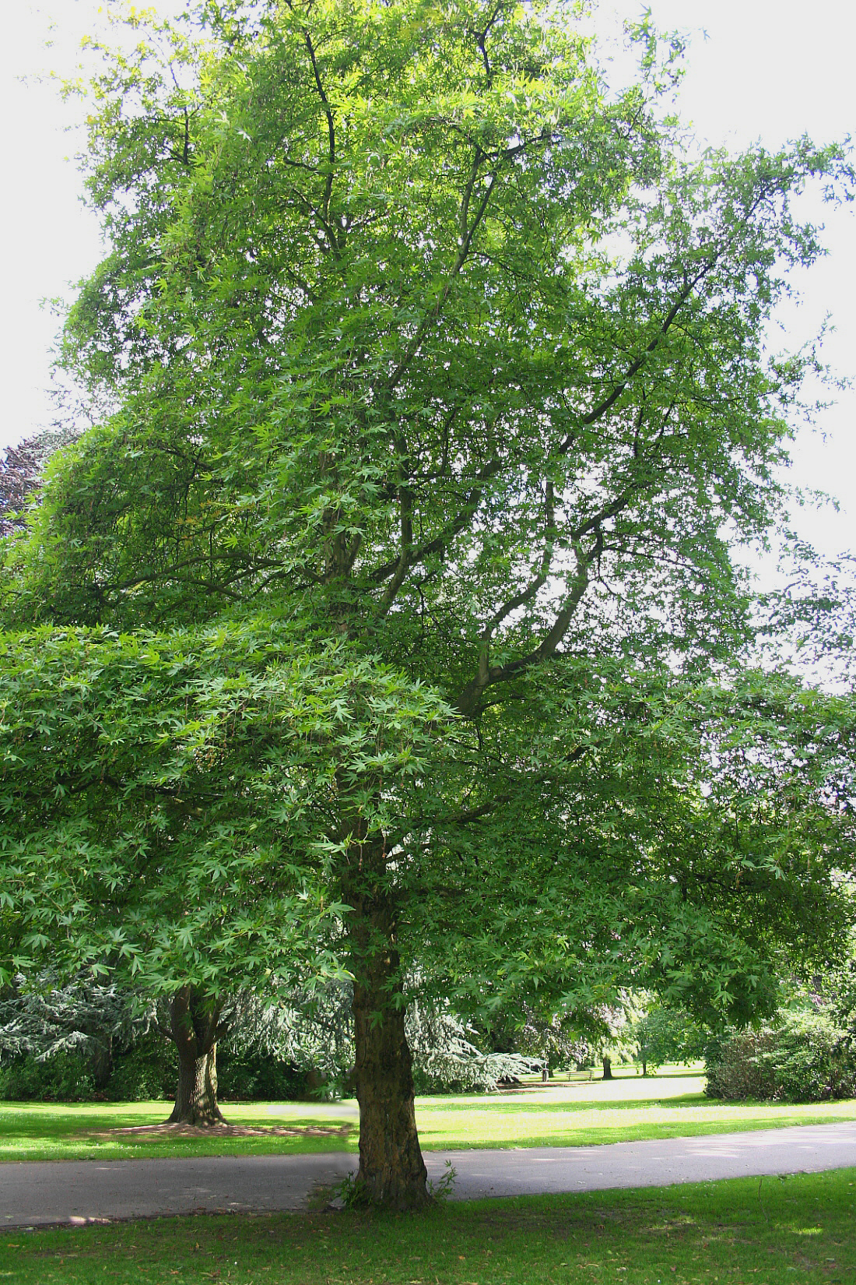
Plane trees may have been abundant in the past, if the common name “Wadi Dilb” is related to the Arabic dilba. In the present day, plane trees are fairly common in the upper Jordan Valley and its tributaries. It is widespread throughout the eastern Mediterranean region and in the hills of Iraq and Iran.

Description:
Plane tree leaves (Jean-Pol GRANDMONT (Wikimedia Commons))The plane tree is large and wide-spreading, with big branches and lobed, hairy leaves shaped like a hand. In Israel it can reach a height of 20 meters (66 feet) and the trunk 50 centimeters (2 feet) in diameter. Its flowers are small and green. The small seeds are contained in round, bristly fruits, which, when open, release the seeds with plumes that carry them great distances on the wind.
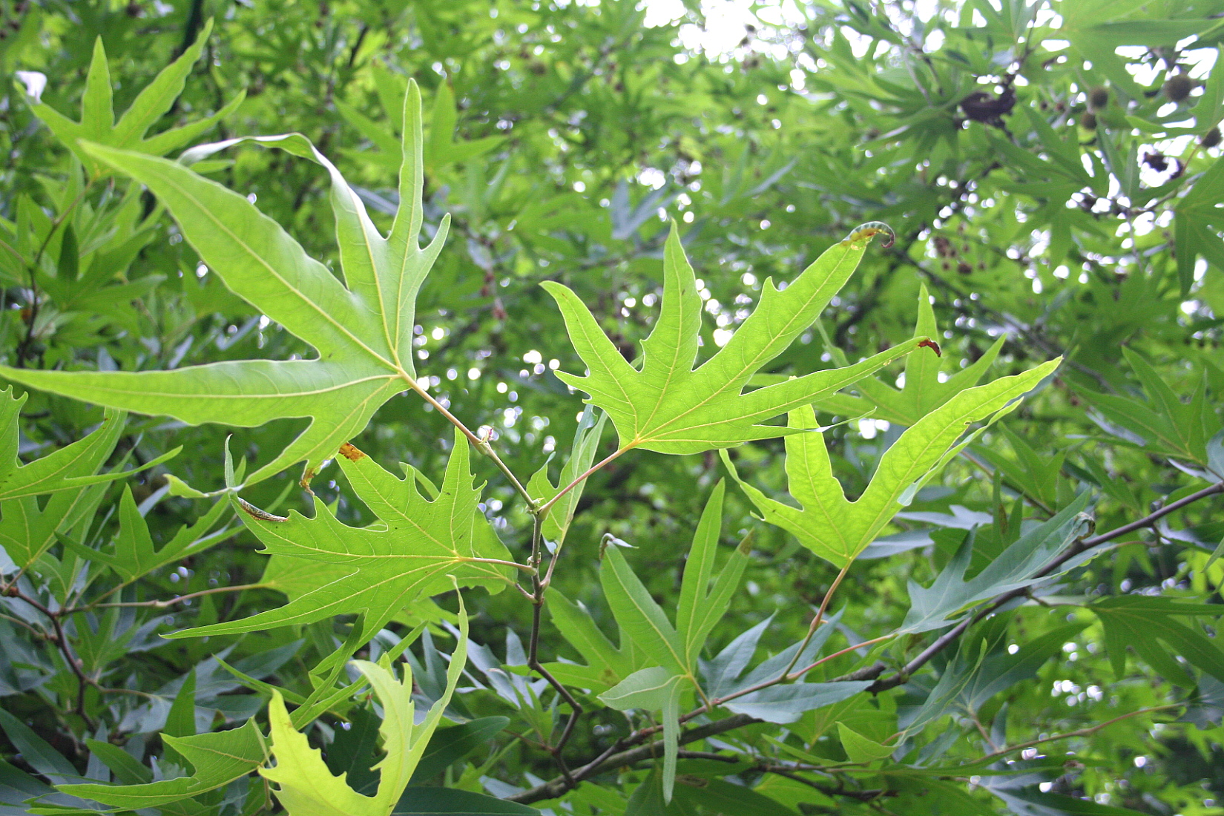

Special significance:
In GEN 30:37 Jacob presumably chose to use branches of the plane tree because its bark can easily be peeled off in strips, exposing the white or yellow inner layer. In ancient times the plane tree was praised as a shade tree by the Greeks, Romans, and Persians. EZK 31:8 associates planes, cedars, and beroshim (“cypresses” or “Grecian junipers”) with the “garden of God,” suggesting special beauty. In SIR 24:14 wisdom is compared to the plane as a beautiful, big tree.

Translation:
True plane trees are limited to Europe and North America, apart from the species that grows in the eastern Mediterranean region and Iran. (A wild maple tree in Britain is misleadingly called a “plane.”) Translators in Asia, Latin America, and Africa will have no local species available for the story of Jacob’s goat-breeding experiment in GEN 30:37 and will have to consider a transliteration in keeping with the other trees mentioned there (poplar and almond). However, the passage in EZK 31:8, where the plane is used in a metaphorical context, leaves room for local equivalents. Egypt, in this passage, is compared to a mighty cedar, against which other trees, such as the plane and the fir, do not match up. Rendering “plane” here will depend on what the translator does with the other trees.

