Resource: Plants and Trees in the Bible
Plants and Trees in the Bible © United Bible Societies, 2025. Adapted from: Each According to its Kind: Plants and Trees in the Bible, by Robert Koops © 2012 United Bible Societies. This work is licensed under Creative Commons Attribution-ShareAlike 4.0 International (https://creativecommons.org/licenses/by-sa/4.0/).

Plants and Trees in the Bible

Tamarisk

1.23 Tamarisk

References:Hebrew אֶשֶׁל (’eshel)GEN 21:33, 1SA 22:6, 1SA 31:13

Discussion:
Leafless tamarisk (Michael Baranovsky (Wikimedia Commons))There are two main species of tamarisk referred to in the Bible, the Leafless Tamarisk Tamarix aphylla and the much more common Nile Tamarisk Tamarix nilotica. Both species are found throughout the plains and in the wadis (dry stream beds) of the Aravah and the Negev, where they tap water that has soaked into the ground after flash floods. Tamarisks can grow in salty soil, earning them the name “salt cedar” in some places. A third species grows only in the Jordan Valley. None of them has proper leaves but rather fleshy twigs, which are eaten by goats and sheep. Despite a similarity in name, tamarinds (Tamarindus indica) are not related to tamarisks.
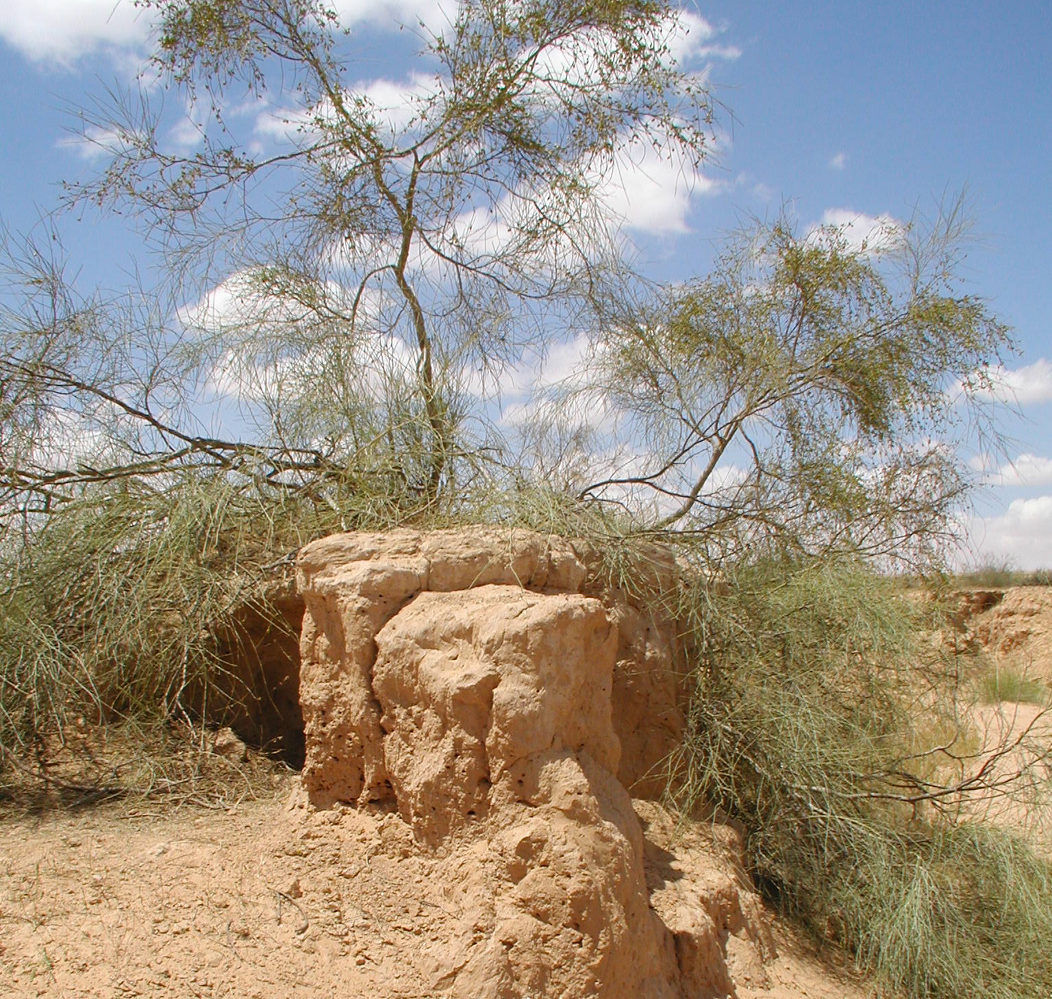
In the account of the burial of Saul we have a mismatch between 1SA 31:13, which says he was buried uner an ’eshel (“tamarisk” in RSV), and 1CH 10:12, which says he was buried under an ’elah (“oak” in RSV). So what was it? Maybe neither!
At some point in the development of Hebrew, the word ’eshel became a general term for trees. However, the words ’allon (“oak”) and ’elah (“terebinth”) also generalized in post-biblical Hebrew to ’ilan, meaning “tree,” so it is possible that at some point in the editing of 1 Chronicles, ’elah as a generic word replaced the earlier ’eshel, which itself could have already been generic at that point. That is, both words could have been regional, stylistic, or in-vogue variations of the general word for “tree.”

Description:
Tamarisk and cypress (Ray Pritz (UBS))The leafless tamarisk grows to a height of 10 meters (33 feet) and can be 1 meter (3 feet) across at the base. The more common Nile tamarisk is smaller and is really a shrub, branching right from the ground. Tamarisks grow in very dry places due to the fact that their roots extend far into the ground. A specimen in Iraq was found to have roots extending 11 meters (36 feet) below the surface (Hepper, page 53). Both species have a broad crown. The trunk is often twisted. The cedar-like branches hang down like those of the weeping willow. Bedouin shepherds have planted many of them throughout the Negev for their flocks.
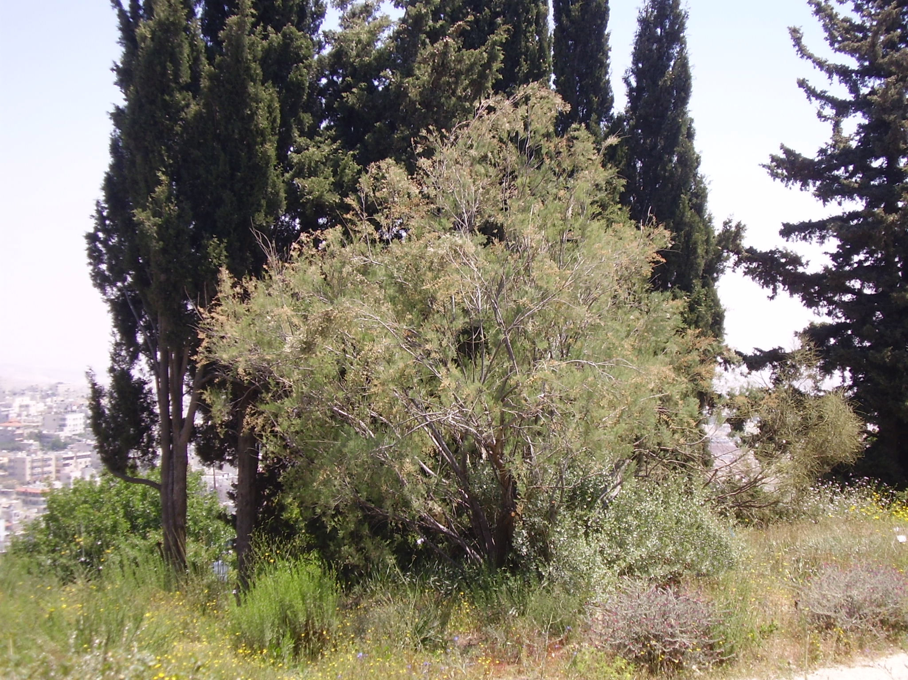

Special significance:
Tamarisk leaves (Forest and Kim Starr (Wikimedia Commons))The fact that Abraham planted a tamarisk and worshiped Yahweh there (GEN 21:33) indicates that these trees, like oaks, were associated with the spirit world. According to Zohary, the “cedar” branches mentioned in the cleansing rituals of LEV 14:4 and NUM 19:6 may possibly have been from tamarisks, although Phoenician juniper trees (very similar to cedar) were also available in some places on the journey of the wandering Israelites. Imported into the western United States, tamarisks have multiplied so fast in stream beds that they are now considered a costly nuisance. In some places they are used in making dyes and in processing leather.
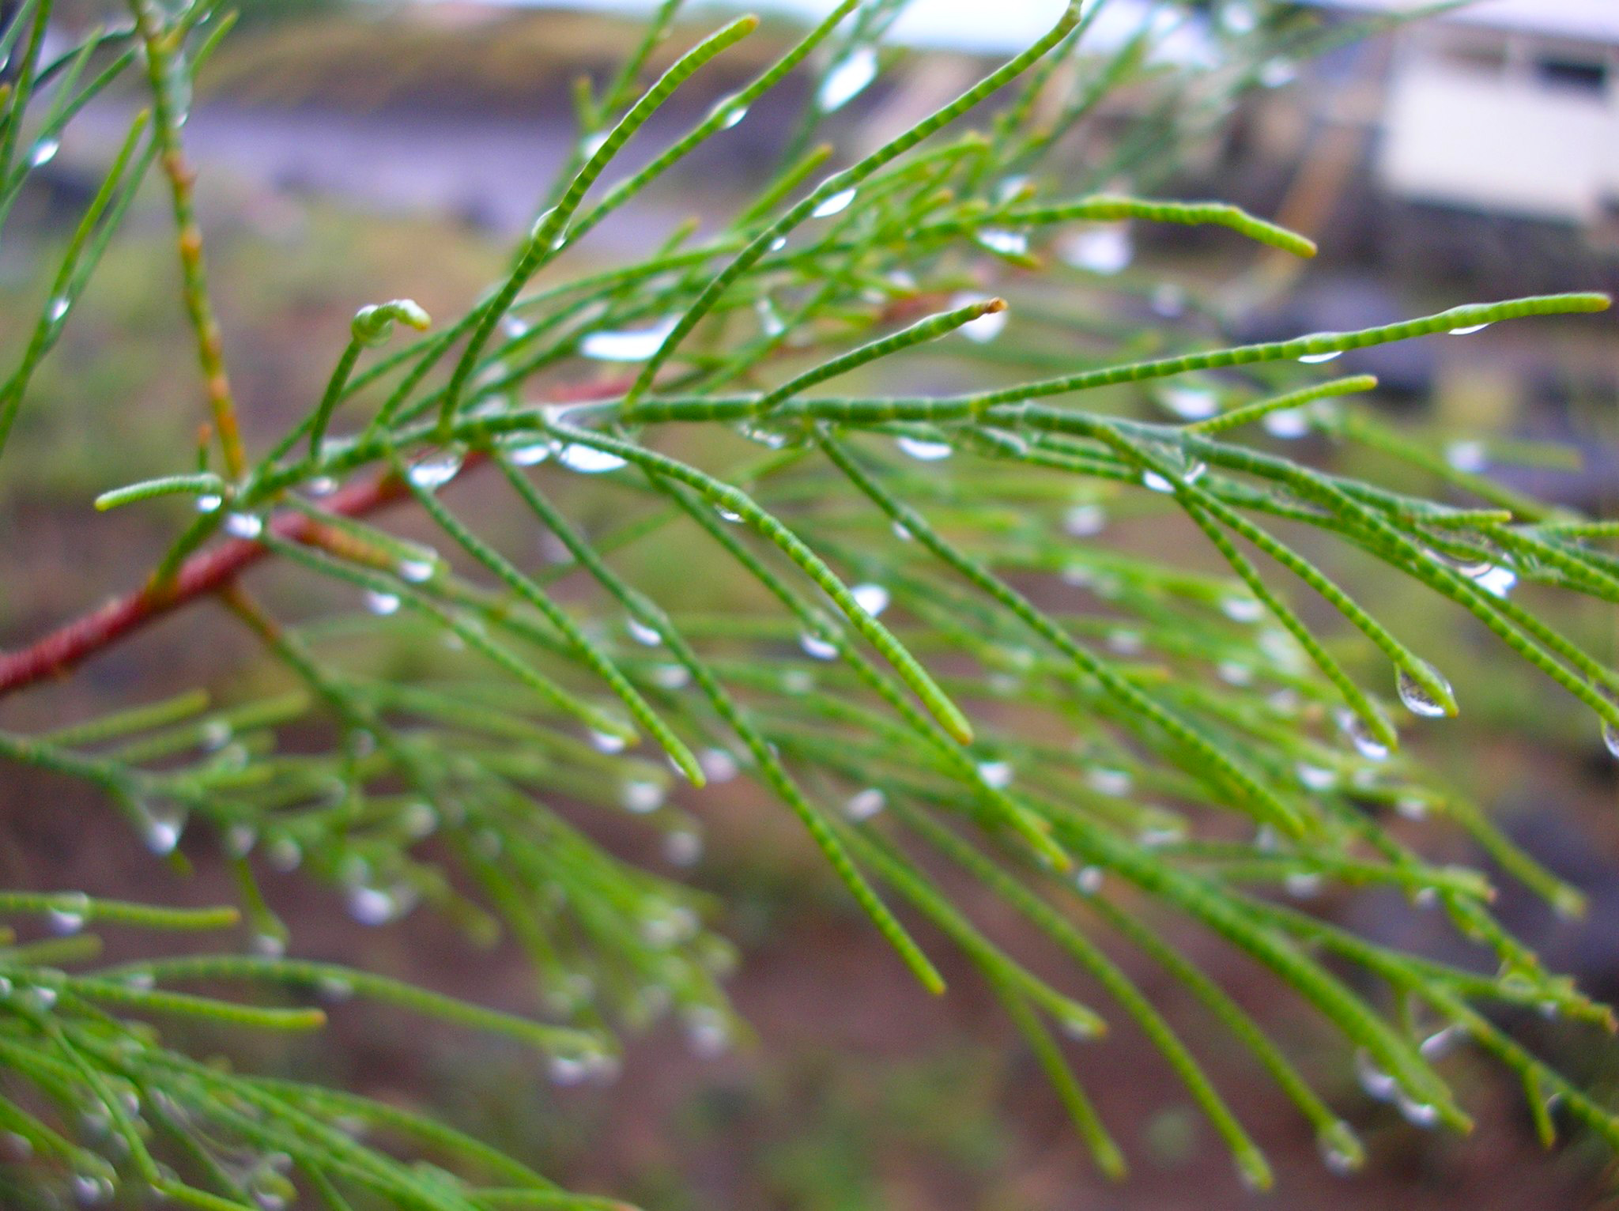

Translation:
Tamarisks are found plentifully in Asia (forty species) and Europe (fourteen species), with a few also in Africa in the Mediterranean basin. The English versions are virtually unanimous in translating ’eshel as “tamarisk.” CEV uses “tamarisk” with a footnote: “A tall shade tree that has deep roots and needs little water.” The options for translating “tamarisk” are:
1. Transliterate from a major language, for example, tamarisiki, tamaris, esheli (Hebrew), or eteli /atali (Arabic).
2. Consider the function of the tree, which in Genesis was almost certainly connected to Abraham’s worship of God, and translate as “holy tree” perhaps with a footnote giving the Hebrew and/or English, especially if you have used “holy tree” in GEN 12:6 for “oak.”
3. Simply use “tree” with a footnote stating that the Hebrew specifies ’eshel, that is, tamarisk.

