Resource: Plants and Trees in the Bible
Plants and Trees in the Bible © United Bible Societies, 2025. Adapted from: Each According to its Kind: Plants and Trees in the Bible, by Robert Koops © 2012 United Bible Societies. This work is licensed under Creative Commons Attribution-ShareAlike 4.0 International (https://creativecommons.org/licenses/by-sa/4.0/).

Plants and Trees in the Bible

Pomegranate

2.10 Pomegranate

References:Hebrew רִמּוֹן (rimmon)EXO 28:33, EXO 28:34, EXO 28:34, EXO 39:24, EXO 39:25, EXO 39:25, EXO 39:26, EXO 39:26, NUM 13:23, NUM 20:5, DEU 8:8, 1SA 14:2, 1KI 7:18, 1KI 7:20, 1KI 7:42, 1KI 7:42, 2KI 25:17, 2CH 3:16, 2CH 4:13, 2CH 4:13, SNG 4:3, SNG 4:13, SNG 6:7, SNG 6:11, SNG 7:13, SNG 8:2, JER 52:22, JER 52:22, JER 52:23, JER 52:23, JOL 1:12, HAG 2:19Greek ροΐσκος (roiskos)SIR 45:9

Discussion:
Pomegranate tree (Amnon s (Wikimedia Commons))The Pomegranate Punica granatum has been grown from ancient times across the Middle East over to Iran and into northern India. It is widely cultivated throughout India and the drier parts of Southeast Asia, Malaya, the East Indies, and tropical Africa. Pomegranates are now found throughout the warm parts of southern Europe and across North Africa and Asia all the way to Nepal. Images of pomegranate fruits have been found in Pharaoh’s temple in Karnak, Egypt, dating from around 1480 B.C. In classical Latin the species name was malum punium (apple of Puni) or malum granatum (seedy apple). This has influenced the common name for pomegranate in many languages (for example, German Granatapfel, “seeded apple”). The English word “pomegranate” itself comes from Latin pomum (fruit, apple) via Old French; (compare pomme in French). The Arabic rummân passed into some other languages, including Portuguese romã.
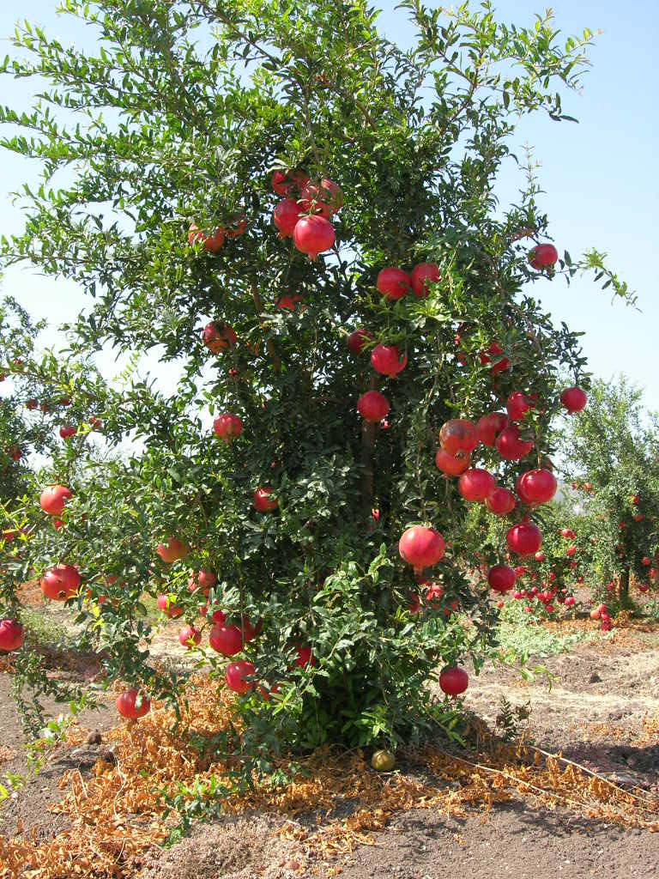

Description:

