Resource: Plants and Trees in the Bible
Plants and Trees in the Bible © United Bible Societies, 2025. Adapted from: Each According to its Kind: Plants and Trees in the Bible, by Robert Koops © 2012 United Bible Societies. This work is licensed under Creative Commons Attribution-ShareAlike 4.0 International (https://creativecommons.org/licenses/by-sa/4.0/).

Plants and Trees in the Bible

Sycomore fig

2.11 Sycomore fig

References:Hebrew שִׁקְמָה (shiqmah)1KI 10:27, 1CH 27:28, 2CH 1:15, 2CH 9:27, PSA 78:47, ISA 9:9, AMO 7:14Greek συκομορέα (sukomorea)LUK 19:4

Discussion:
Sycomore fig, on tree (Atamari (Wikimedia Coomons))Following Hepper, we favor the use of “sycomore” rather than “sycamore,” since the “o” spelling preserves the Latin (sycomorus) and Greek (suko­morea) better and is used in French. Note that the tree is spelled with an “o” in KJV and NEB. As Hepper observes (page 114), it may be useful to reserve the name “sycamore” for a kind of plane tree (Platanus) in the United States and a member of the Acer family in Britain.
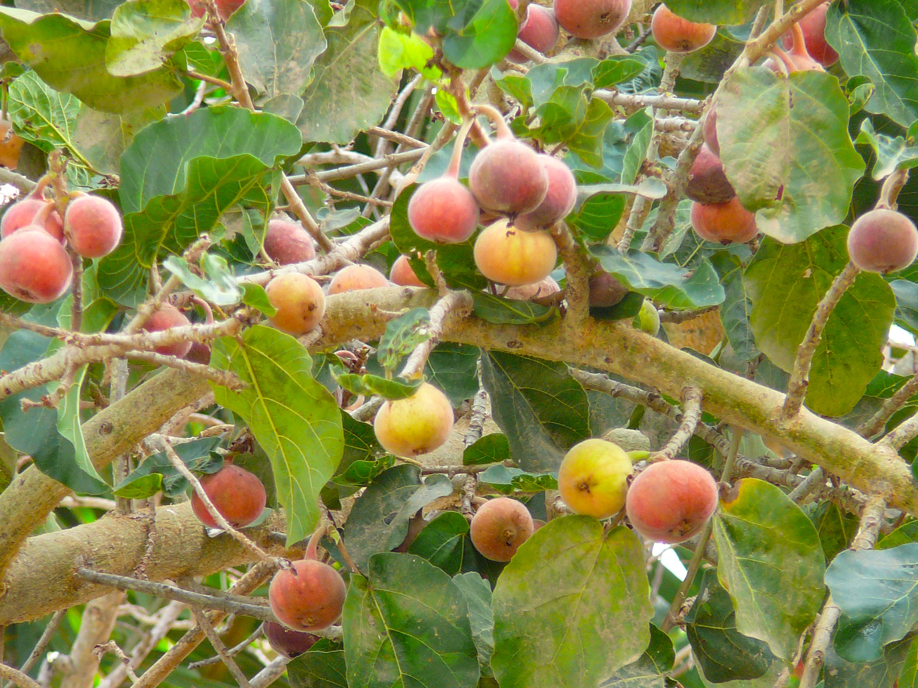
The Sycomore Fig Ficus sycomorus, also called the Mulberry Fig (compare German Maulbeerfeigen­baum), is a type of fig that is found especially in lowland areas in the Mediterranean region. It was known in Egypt as early as 3000 B.C. but also in the Indus Valley in India. Zohary surmises that the Israeli sycomores, found mostly down on the coastal plain, are survivors from an earlier time when this type of fig was more widespread.
The prophet Amos identified himself as “a dresser of sycamore trees” (AMO 7:14). It is possible that this refers to the practice of making a cut in the immature fruit, which has the effect of accelerating the growth of the fruit. Hepper (page 113) reports that this sudden growth is caused by ethylene gas released when the fruit is cut. Incidentally, today ethylene gas is used by fruit sellers to hasten the ripening of oranges and bananas.

Description:
Sycomore fig, on tree (udi Steinwell, PikiWiki Israel (Wikimedia Commons))The sycomore fig is not a tall tree (up to 10 meters [33 feet]) but has large low, spreading branches—just right for a short man to climb up in order to see over a crowd of taller people (see the story of Zacchaeus in LUK 19:4). The fruit, while edible, is not as juicy or sweet as the more common variety. The most unusual thing about the fruit is that it grows in bunches right on the trunk and branches of the tree rather than among the leaves.
<image: Z>

Special significance:
In 1KI 10:27 the sycomore is used as an image of something plentiful. The last half of this verse says “he [King Solomon] made cedar as plentiful as the sycamore of the Shephelah.” Translators should take care with the logic here. The verse does not say that Solomon would introduce cedars into the lowlands (the Shephelah), but rather that just as there are plenty of sycomores in the lowlands, there will be plenty of cedars in the land of Israel.

Translation:
Sycomore fig ripe (איתן פרמן (Wikimedia Commons))Translators need to deal with both sycomore and fig at the same time. If the translation leans toward foreignization, the translator may want to transliterate both fig and sycomore (sikomori, for example). It may be useful to use the full name sycomore fig in some cases. If a local type of fig is known, the translator could use the local name for the domestic fig (Hebrew te’enah, Greek sukē), and add the word “wild” or “lowland” when referring to the sycomore fig (Hebrew shiqmah, Greek sukomorea).
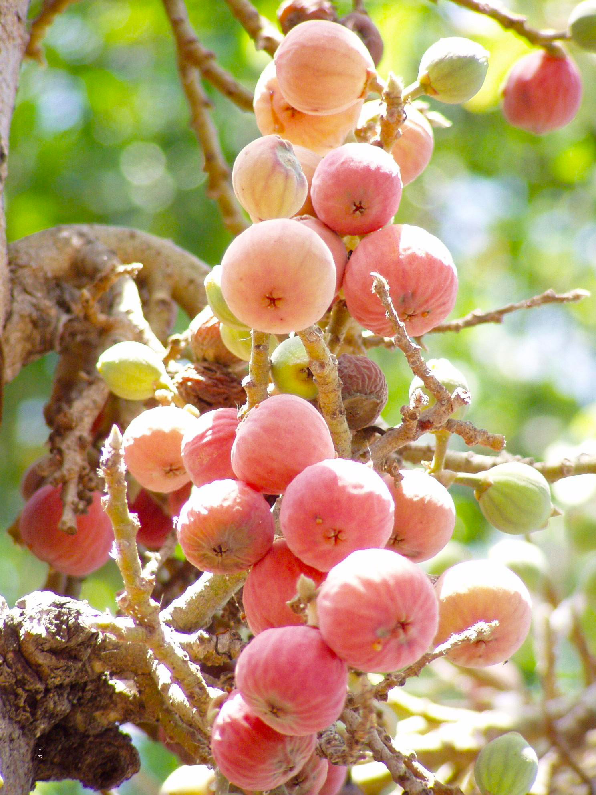
Where figs are totally unknown, transliterations can be made from an international language, for example, French (sycomore), Spanish (sicomoro), or Hebrew (shiqmah). In contrast to the regular fig, the sycomore grows in the lower elevations (Shephelah), a fact that could potentially come into use in a translation (for example, “lowland fig”). GECL uses Maulbeerfeigenbaum (“mulberry fig”).

