Resource: Plants and Trees in the Bible
Plants and Trees in the Bible © United Bible Societies, 2025. Adapted from: Each According to its Kind: Plants and Trees in the Bible, by Robert Koops © 2012 United Bible Societies. This work is licensed under Creative Commons Attribution-ShareAlike 4.0 International (https://creativecommons.org/licenses/by-sa/4.0/).

Plants and Trees in the Bible

Grain

3.1 Grain

At least four types of grain are mentioned in the Bible: barley, millet, sorghum, and wheat. In addition to these types of grain, Hebrew words for things such as “threshing floor,” “sickle,” and “winnow” attest to the prominence of grain in the life of the ancient Israelites.Hebrew דָּגָן (dagan)GEN 27:28, GEN 27:37, NUM 18:12, NUM 18:27, DEU 7:13, DEU 11:14, DEU 12:17, DEU 14:23, DEU 18:4, DEU 28:51, DEU 33:28, 2KI 18:32, 2CH 31:5, 2CH 32:28, NEH 5:2, NEH 5:3, NEH 5:10, NEH 5:11, NEH 10:40, NEH 13:5, NEH 13:12, PSA 4:8, PSA 65:10, PSA 78:24, ISA 36:17, ISA 62:8, JER 31:12, LAM 2:12, EZK 36:29, HOS 2:10, HOS 2:11, HOS 2:24, HOS 7:14, HOS 9:1, HOS 14:8, JOL 1:10, JOL 1:17, JOL 2:19, HAG 1:11, ZEC 9:17Hebrew בַּר (bar)GEN 41:35, GEN 41:49, GEN 42:3, GEN 42:25, GEN 45:23, PSA 65:14, PSA 72:16, PRO 11:26, PRO 14:4, JER 23:28, JOL 2:24, AMO 5:11, AMO 8:5, AMO 8:6Hebrew שֶׁבֶר (shever)GEN 42:1, GEN 42:2, GEN 42:19, GEN 42:26, GEN 43:2, GEN 44:2, GEN 47:14, NEH 10:32, AMO 8:5Hebrew קָמָה (qamah)EXO 22:5, DEU 16:9, DEU 23:26, DEU 23:26, JDG 15:5, JDG 15:5, 2KI 19:26, ISA 17:5, ISA 37:27, HOS 8:7Hebrew גָּדִישׁ (gadish)EXO 22:5, JDG 15:5, JOB 5:26Hebrew אָבִיב (’aviv)EXO 9:31, LEV 2:14Hebrew שִׁבֹּלֶת (shiboleth)GEN 41:5, GEN 41:6, GEN 41:7, GEN 41:7, GEN 41:22, GEN 41:23, GEN 41:24, GEN 41:24, GEN 41:26, GEN 41:27, RUT 2:2, JOB 24:24, ISA 17:5, ISA 17:5Hebrew כַּרְמֶל (karmel)LEV 2:14, LEV 23:14, 2KI 4:42Hebrew גֶּרֶשׂ (geres)LEV 2:14, LEV 2:16
KJV, REB, and some other versions, following British usage, use “corn” as a generic term to cover crops such as wheat and barley, while RSV, the New King James Version (NKJV), and many other versions, following American usage, use “grain” as the generic term. Versions such as GNB have British editions and American editions that accommodate to the different usages. Although maize as we know it now did not exist in Bible times, we may need to refer to it as a species, and we will call it “maize,” following the British tradition, and use “grain” as the generic term, following American usage.
Generic words can cause problems for a translator. In GEN 1:11; GEN 1:12 we find the Hebrew phrase ‘esev mazri‘a zera‘ (“plants yielding seed”) standing in contrast to the phrase ‘ets peri ‘oseh peri (“fruit trees bearing fruit”). Some English versions take “plants yielding seed” as referring to “grain” (GNB, CEV, NCV), whereas others use broader expressions such as “seed-bearing plants” (NIV, NJB, NJPSV) or “plants that bear seed” (REB). The writer of Genesis may be using a traditional Hebrew plant taxonomy that divides useful flora into two categories, namely seed-bearing plants and fruit-bearing plants. If so, translators should try to render “plants yielding seed” with an expression that includes more species than just the grains. After all, onions, beans, peas, melons, and other plants bear seeds, as well as grain.
The Hebrew word dagan occurs forty times in the Old Testament (for example, GEN 27:28, GEN 27:37; NUM 18:12, NUM 18:27; DEU 7:13; DEU 11:14), and it is often translated “grain.” However, in Bible times the word dagan included peas, beans, lentils, and cumin as well as what we normally call “grain” from grasses or cereals. In these forty references dagan is paired with the Hebrew word tirosh (“grape harvest”) in all but ten. The Hebrew word yitshar (“newly pressed oil”) is mentioned in twenty of them. All three words include the concept of “newly harvested.” They express the idea of “produce of the land,” as when Isaac blesses Jacob (GEN 27:28):
May God give you of the dew of heaven,
and of the fatness of the earth,
and plenty of dagan [farm produce] and tirosh [vineyard produce].
The Old Testament has many other Hebrew words and phrases that refer to grain. Since these generic terms can cause problems for translators, we will consider them one by one:
Bar: This word can refer to grain on a threshing floor (JOL 2:24) or to grain that is stored (GEN 41:35). It is used to refer to kernels of grain in contrast to chaff in JER 23:28.
Shever: In GEN 42:1; GEN 42:2 Jacob hears about shever in Egypt. In this passage the word is quite general, almost equivalent to “food.” In NEH 10:32 (31) Nehemiah forbids the sale of shever on the Sabbath. In AMO 8:5 the prophet warns about cheating on the sale of shever (parallel to bar).
Qamah: In JDG 15:5 Samson burns the qamah (“ripe, uncut grain plants”) as well as the gadish (“sheaves”) in the fields of the Philistines. English versions usually render qamah as “standing grain.” The Arabic word for wheat is al-kama, so it may have been wheat that the Philistines grew in the Sorek Valley.
Gadish refers to sheaves.
’Aviv refers to newly formed ears of grain.
Shiboleth refers to ears of grain. In RUT 2:2 Ruth gleans the stalks of ripe barley that the harvesters leave behind. In the Egyptian king’s dream (GEN 41:5; GEN 41:6; GEN 41:7; GEN 41:7) the ears of grain are presumably wheat.
Karmel refers to fresh ears of grain. In LEV 2:14 the ears of grain are probably wheat, which were roasted and brought for the firstfruits offering. The prophet Elisha received a gift of fresh ears of grain (2KI 4:42).

Geres refers to crushed grain.Hebrew קלה, קָלִי (qalah, qali)LEV 23:14, JOS 5:11, RUT 2:14, 1SA 17:17, 1SA 25:18, 2SA 17:28, 2SA 17:28Hebrew עֲבוּר (‘avur)JOS 5:11, JOS 5:12Hebrew בְּלִיל (belil)JOB 6:5, JOB 24:6, ISA 30:24Hebrew רִיפוֹת (rifoth)2SA 17:19, PRO 27:22
Qalah /qali refers to roasted, dried, or baked kernels of grain.
‘Avur: RSV renders ‘avur as “produce” in JOS 5:11; JOS 5:12, but A Handbook on The Book of Joshua translates it as “grain (barley).”
Belil: According to JOB 24:6, wild donkeys scavenge for belil (“food”) for their young.

Rifoth: In 2SA 17:19 a woman scatters rifoth (“grain”) on a mat over a well hiding two men. PRO 27:22 says “Crush a fool in a mortar with a pestle, along with crushed grain [rifoth ], yet his folly will not depart from him.”Hebrew לֶחֶם (lechem)ISA 28:28, ISA 30:23Hebrew זֶרַע (zera‘)NUM 20:5, 1SA 8:15, JOB 39:12, ISA 23:3
Lechem is normally translated “bread,” but RSV appropriately renders it “bread grain” in ISA 28:28 and “grain” in ISA 30:23.
Zera‘ is literally “sowing” or “seed,” but it means “grain” in NUM 20:5; 1SA 8:15; JOB 39:12; ISA 23:3.

The New Testament and Deuterocanon also have their share of generic Greek words for grain:Greek καρπός (karpos)MAT 13:8, MAT 13:26, MRK 4:7, MRK 4:8Greek κόκκος (kokkos)MAT 13:31, MAT 17:20, MRK 4:31, LUK 13:19, LUK 17:6, JHN 12:24, 1CO 15:37Greek σπόριμος (sporimos)MAT 12:1, MRK 2:23, LUK 6:1
Karpos is literally “fruit,” but the context of MAT 13:8, MAT 13:26 and MRK 4:7; MRK 4:8 indicates wheat or barley, and the natural equivalent is “grain” in English.
Kokkos refers to kernels or seeds of grain.

Sporimos is based on the Greek verb meaning “sow.” It clearly refers to fields of wheat or barley.Greek στάχυς (stachus)MAT 12:1, MRK 2:23, MRK 4:28, MRK 4:28, LUK 6:1

Stachus refers to the grain heads of wheat or barley.Greek ἄλφιτον (alfiton)JDT 10:5Greek σπέρμα (sperma)MAT 13:24, MAT 13:27, MAT 13:32, MAT 13:37, MAT 13:38, 1CO 15:38Greek σπορά (spora)1MA 10:30
Alfiton refers to roasted, dried, or baked kernels of grain. RSV render it “parched grain.” This is what Ruth had for lunch (Hebrew qali) when she gleaned in Boaz’s field. Alfiton is found in the Septuagint of RUT 2:14; 1SA 25:18; 2SA 17:28; JDT 10:5.
Sperma refers to a single kernal of grain, or more generically, a seed.

Spora refers to “grain harvest” (GNB).Greek σπόρος (sporos)MRK 4:26, MRK 4:27, LUK 8:5, LUK 8:11, 2CO 9:10, 2CO 9:10, SIR 40:22
Sporos in SIR 40:22 refers specifically to the sprouting of seeds, and in Sirach the reference may be to the sprouting of grain in the spring (so REB, NJB), but some translators take it more generally to mean the sprouting of flowers (so NAB).

There are also several generic Latin words for grain in 2 Esdras:
Frumentum (2ES 15:42) refers to grain harvest like the Greek word spora. RSV renders it “grain,” and REB is more generic with “crops.”
Granum in 2ES 4:30; 2ES 4:31 refers to grain in general.
Semen: In 2ES 8:43; 2ES 4:31; 2ES 4:32 semen refers to a single kernel of grain, equivalent to zera‘ in Hebrew and sperma in Greek (as in MAT 13:24).

In DEU 28:22 we read of grain being affected by “blight/blasting” (shidafon in Hebrew) and “mildew” (yeraqon). This pair of words also occurs in 1KI 8:37; 2CH 6:28; AMO 4:9; HAG 2:17, where we find a litany of disasters that come upon the people. The Hebrew verb shadaf (“to blast”) occurs by itself in GEN 41:6; GEN 41:23; GEN 41:27, where it is explicitly associated with crops being blasted by the fierce, seasonal, hot wind from the desert. The cognate in Chaldean is shadaf, which means “scorched.” The Hebrew noun shedefah (“scorching”) occurs in 2KI 19:26 (also in the emended text of ISA 37:27), which says grass on a rooftop with very little soil is scorched before it can mature. (The cognate word in Arabic means “black.”) The Hebrew word yeraqon means “paleness” in JER 30:6, where it describes people’s faces, but elsewhere it refers to a fungus that keeps grain heads from developing properly.
Threshing (Matson Collection (Wikimedia Commons))In addition to these technical words for grain, the Bible refers to grain in a number of places by the expression “out of/from … threshing floor” (for example, DEU 15:14).
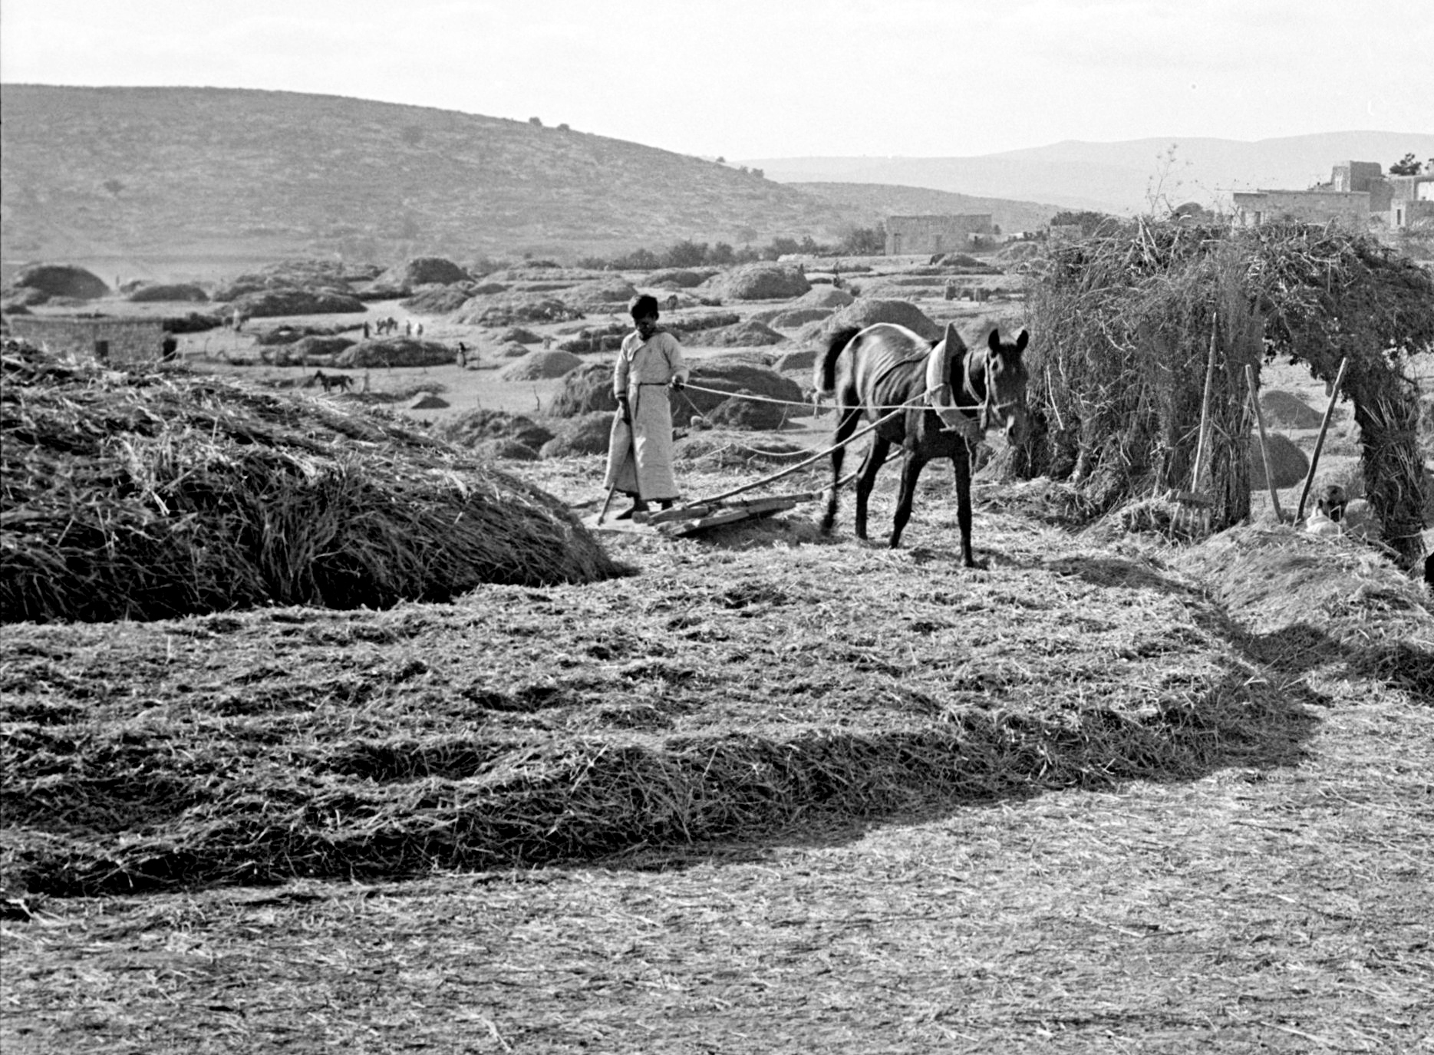
References to flour, or fine flour, for cereal offerings (also called meal or grain offerings; Hebrew minchah) would presumably refer to flour made from wheat, although barley flour was also used when wheat was scarce.

Barley

3.1.1 Barley

References:Hebrew שְׂעֹרָה (se‘orah)EXO 9:31, EXO 9:31, LEV 27:16, NUM 5:15, DEU 8:8, JDG 7:13, RUT 1:22, RUT 2:17, RUT 2:23, RUT 3:2, RUT 3:15, RUT 3:17, 2SA 14:30, 2SA 17:28, 2SA 21:9, 1KI 5:8, 2KI 4:42, 2KI 7:1, 2KI 7:16, 2KI 7:18, 1CH 11:13, 2CH 2:9, 2CH 2:14, 2CH 27:5, JOB 31:40, ISA 28:25, JER 41:8, EZK 4:9, EZK 4:12, EZK 13:19, EZK 45:13, HOS 3:2, HOS 3:2, JOL 1:11Greek κριθή (krithē)REV 6:6, JDT 8:2Greek κρίθινος (krithinos)JHN 6:9, JHN 6:13

Discussion:
Barley head (T. Voekler (Wikimedia Commons))Barley Hordeum distichum or Hordeum vulgare is a type of grass like wheat and rice. It has been cultivated in the Middle East for thousands of years and is now one of the most prominent seed crops grown in the world. Twenty species are known, of which eight are European. Barley needs less rain than wheat does, so in the Holy Land it was typically found in the drier areas above the coastal plain and near the desert. From 2KI 7:1 and REV 6:6 we know that barley was considered inferior to wheat and was often used to feed animals, as it is today. When the wheat supply ran out, people had to make their bread with barley. Barley was gathered before wheat, the harvest coming around March or April in the lower regions and in May in the mountains (see EXO 9:31; 2KI 4:42). In Egypt and in ancient Greece barley was used to make beer.
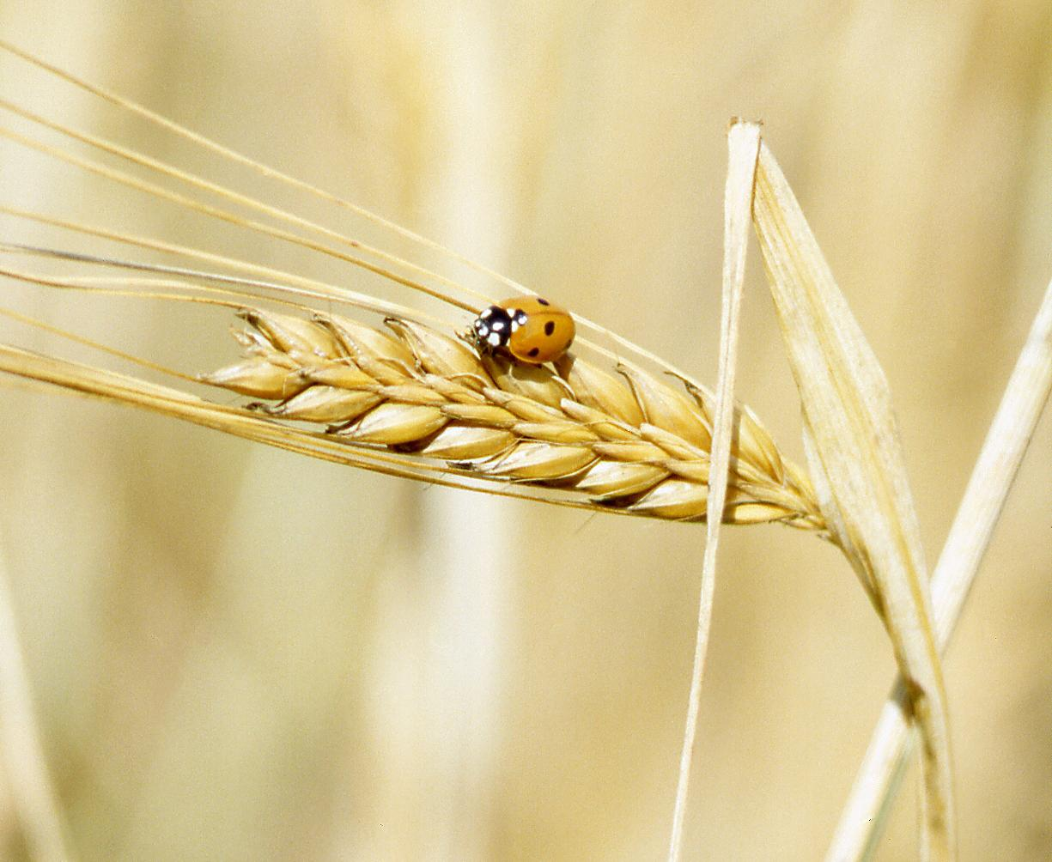

Description:
Barley seeds (Rasbak (Wikimedia Commons))Barley plants look like wheat or rice. They are less than 1 meter (3 feet) tall, and have a single head on each stalk, with six rows of kernels, although the biblical kind may have had only two rows. The head bends at a downward angle when it is ripe.
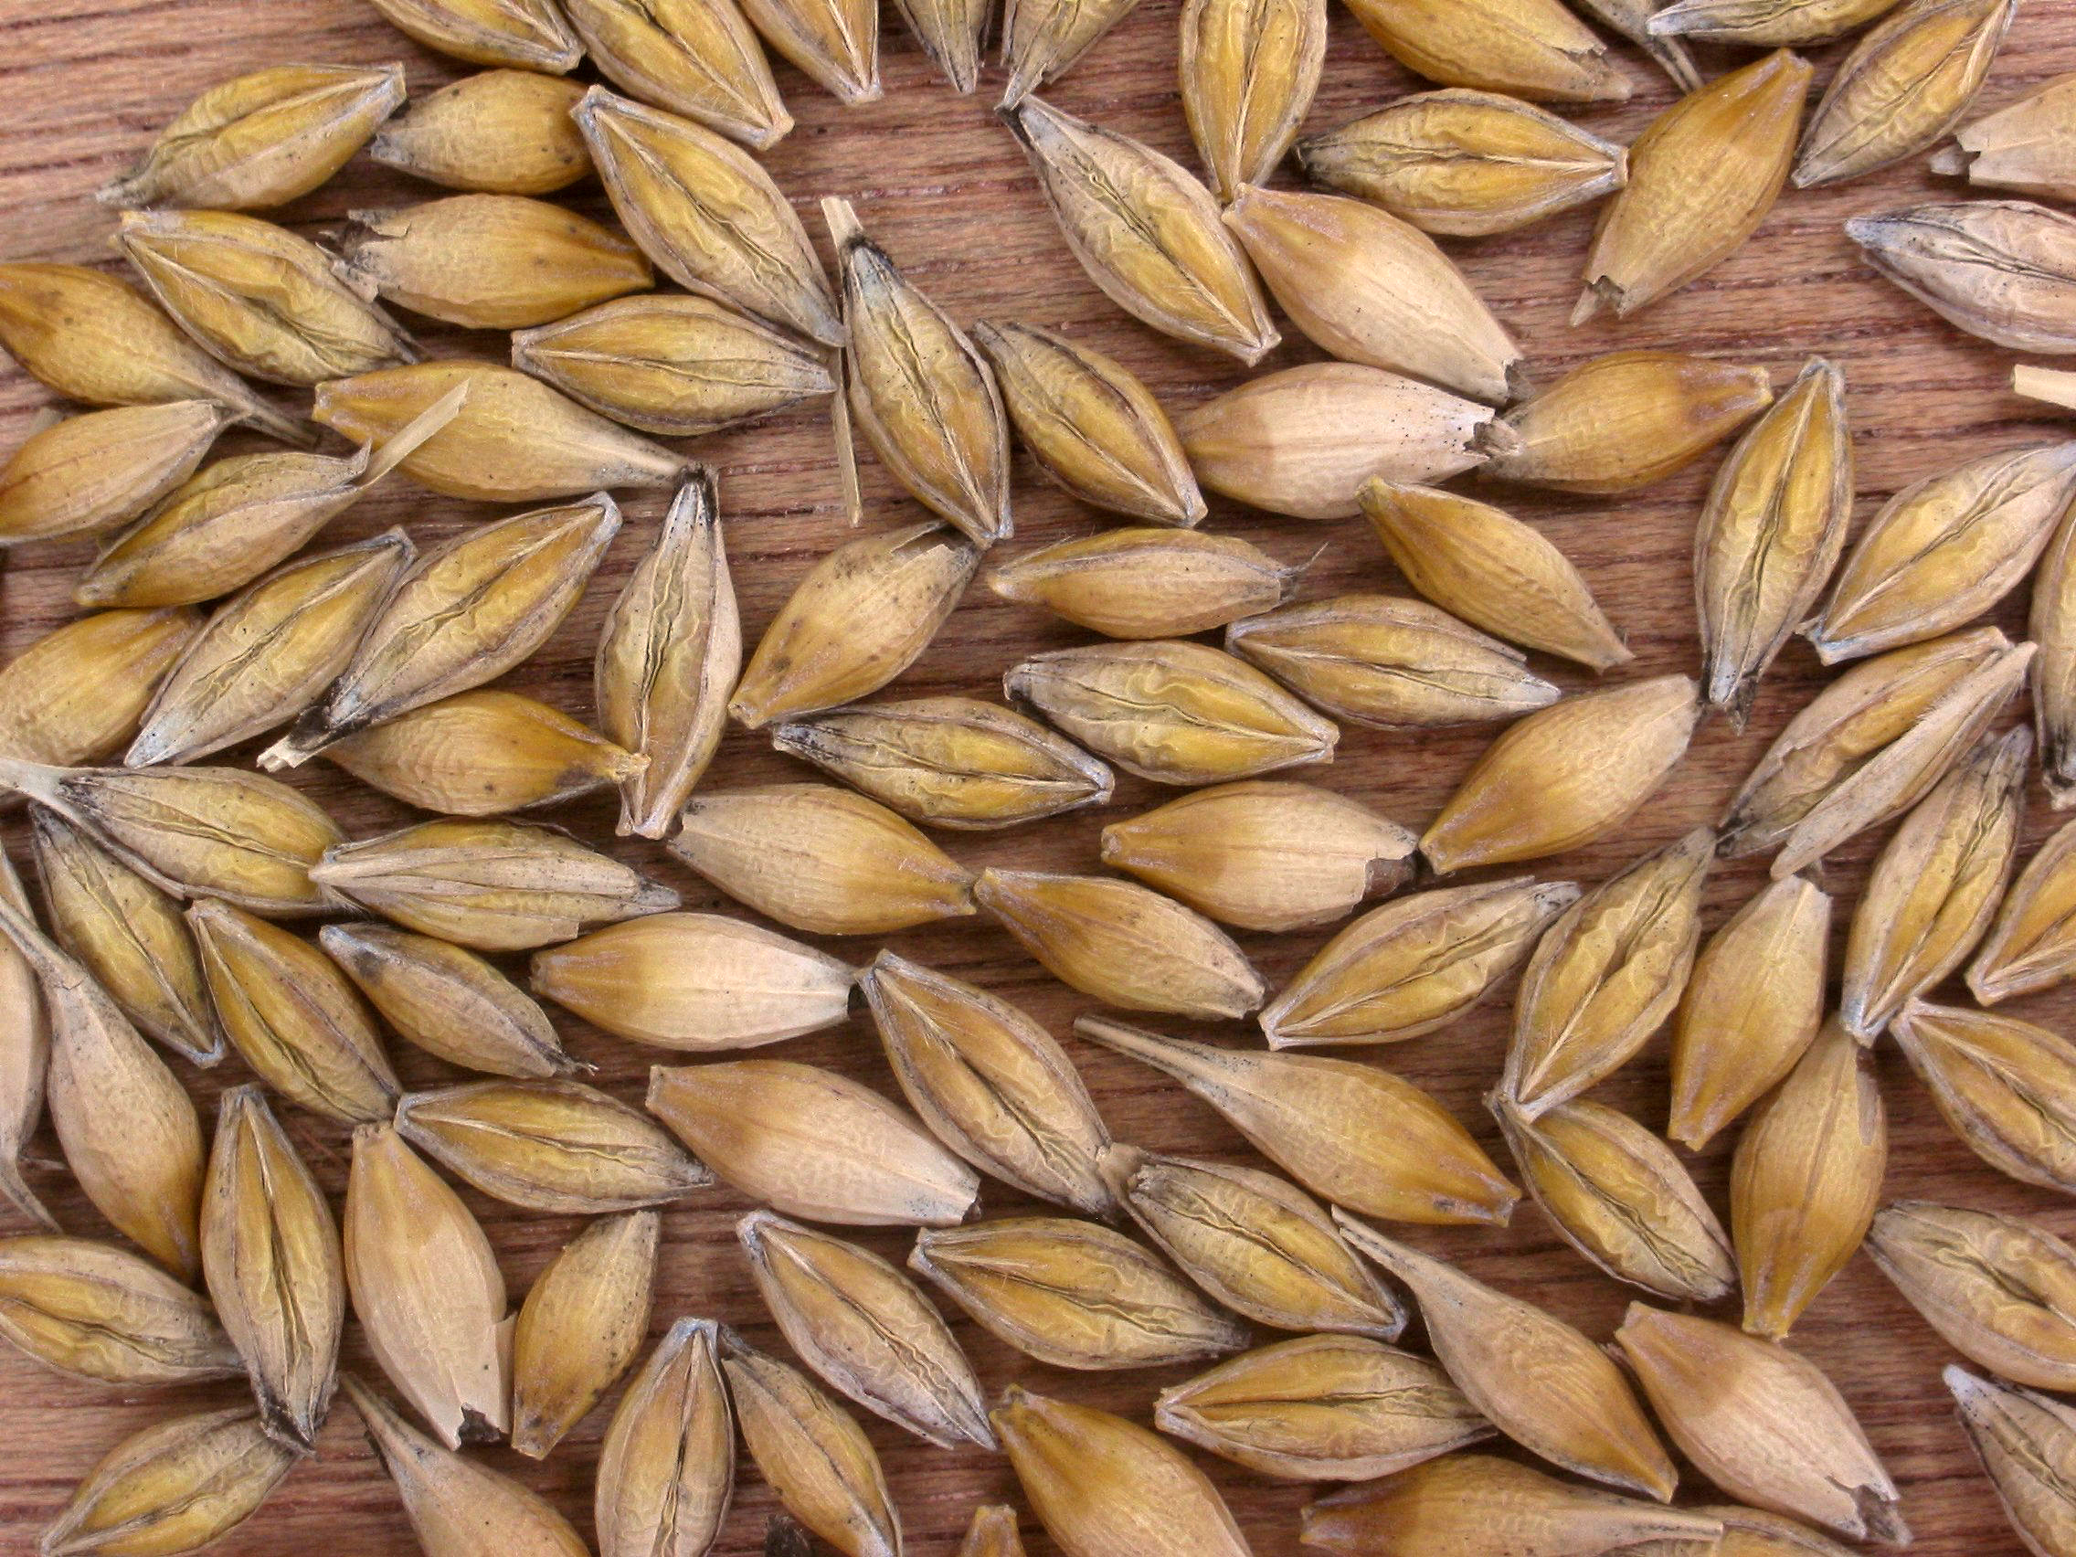

Special significance:
In the story of Gideon and the Midianites in JDG 7:13, “a cake of barley” representing the (despised) Israelite army tumbles into the Midianite camp and knocks down the tent (representing the nomadic Midianites).

Translation:
Barley is a plant of temperate zones, like Europe and the Near East; it does not grow well in the tropics. However, barley has been recently introduced along with wheat into many parts of the world for brewing beer and other malted drinks. It is also known to have grown in Korea as early as 1500 B.C. along with wheat and millet. It is becoming known in Malay as barli. Except for the reference in Judges, all references to barley in the Bible are non-rhetorical, so unrelated cultural equivalents are discouraged. Some receptor language speakers may coin a name for it as in Malay, or the translator can use a transliteration from Hebrew (se‘orah), Latin (horideyo), or from a major language (for example, Arabic sha‘ir, Spanish cebada, French orge, Portuguese cevada, Swahili shayiri), together with a classifier, if there is one (for example, “grain of shayir”). One translation used “rice of baali” but ran into a problem: Rice is now imported to parts of West Africa from Bali. Not surprisingly, it is called “rice of Bali” and was confused with “rice of baali.”
EXO 9:31 reads “The flax and the barley were ruined, for the barley was in the ear and the flax was in bud.” The plants and developmental phases referred to here can be confusing if translated literally. Two possible ways to render this verse are:
1. Use generic words plus a transliteration (for example, “grain of barli,” “plant of filas”), particularly in first half of the verse. The generic terms can be repeated optionally in the second half by saying “for the grain had already produced heads and the plants had flowers.”
2. Identify the plants generically and then put the actual name in parentheses or in footnotes; for example, the whole verse may be rendered “The crops that were ripe (barli) and those that were budding (filakis) were destroyed.” (The Hebrew chiastic structure has been rearranged in this example.)

Millet

3.1.2 Millet

References:Hebrew דֹּחַן (dochan)EZK 4:9Hebrew פַּנַּג (pannag)EZK 27:17

Discussion:
Millet (Dalgial (Wikimedia Commons))To illustrate the siege of Jerusalem, Ezekiel is instructed to make a loaf of bread out of wheat, barley, beans, lentils, millet (dochan in Hebrew), and spelt in EZK 4:9. In Arabic millet is called dukhn or dochna, suggesting that the Hebrew word dochan could indeed be millet. Some scholars believe that Millet Panicum miliaceum or Panicum callosum was first domesticated in Ethiopia, but others say in India or the East Indies. From one of those places it was carried into Mesopotamia around 3000 B.C. If that is so, it may have been known to the people of Israel during their stay in Egypt as well as after the conquest of Canaan. Zohary implies that dochan was either millet or sorghum (see 3.1.3 Sorghum (durra)). In EZK 27:17 a reference is made to pannag, which Moldenke takes as possibly referring to millet, on the basis of the fact that in Syriac pannag refers to millet. However, Hepper says that neither millet nor sorghum reached the Mediterranean area before the Christian era, making it unlikely that dochan or pannag refer to either millet or sorghum.
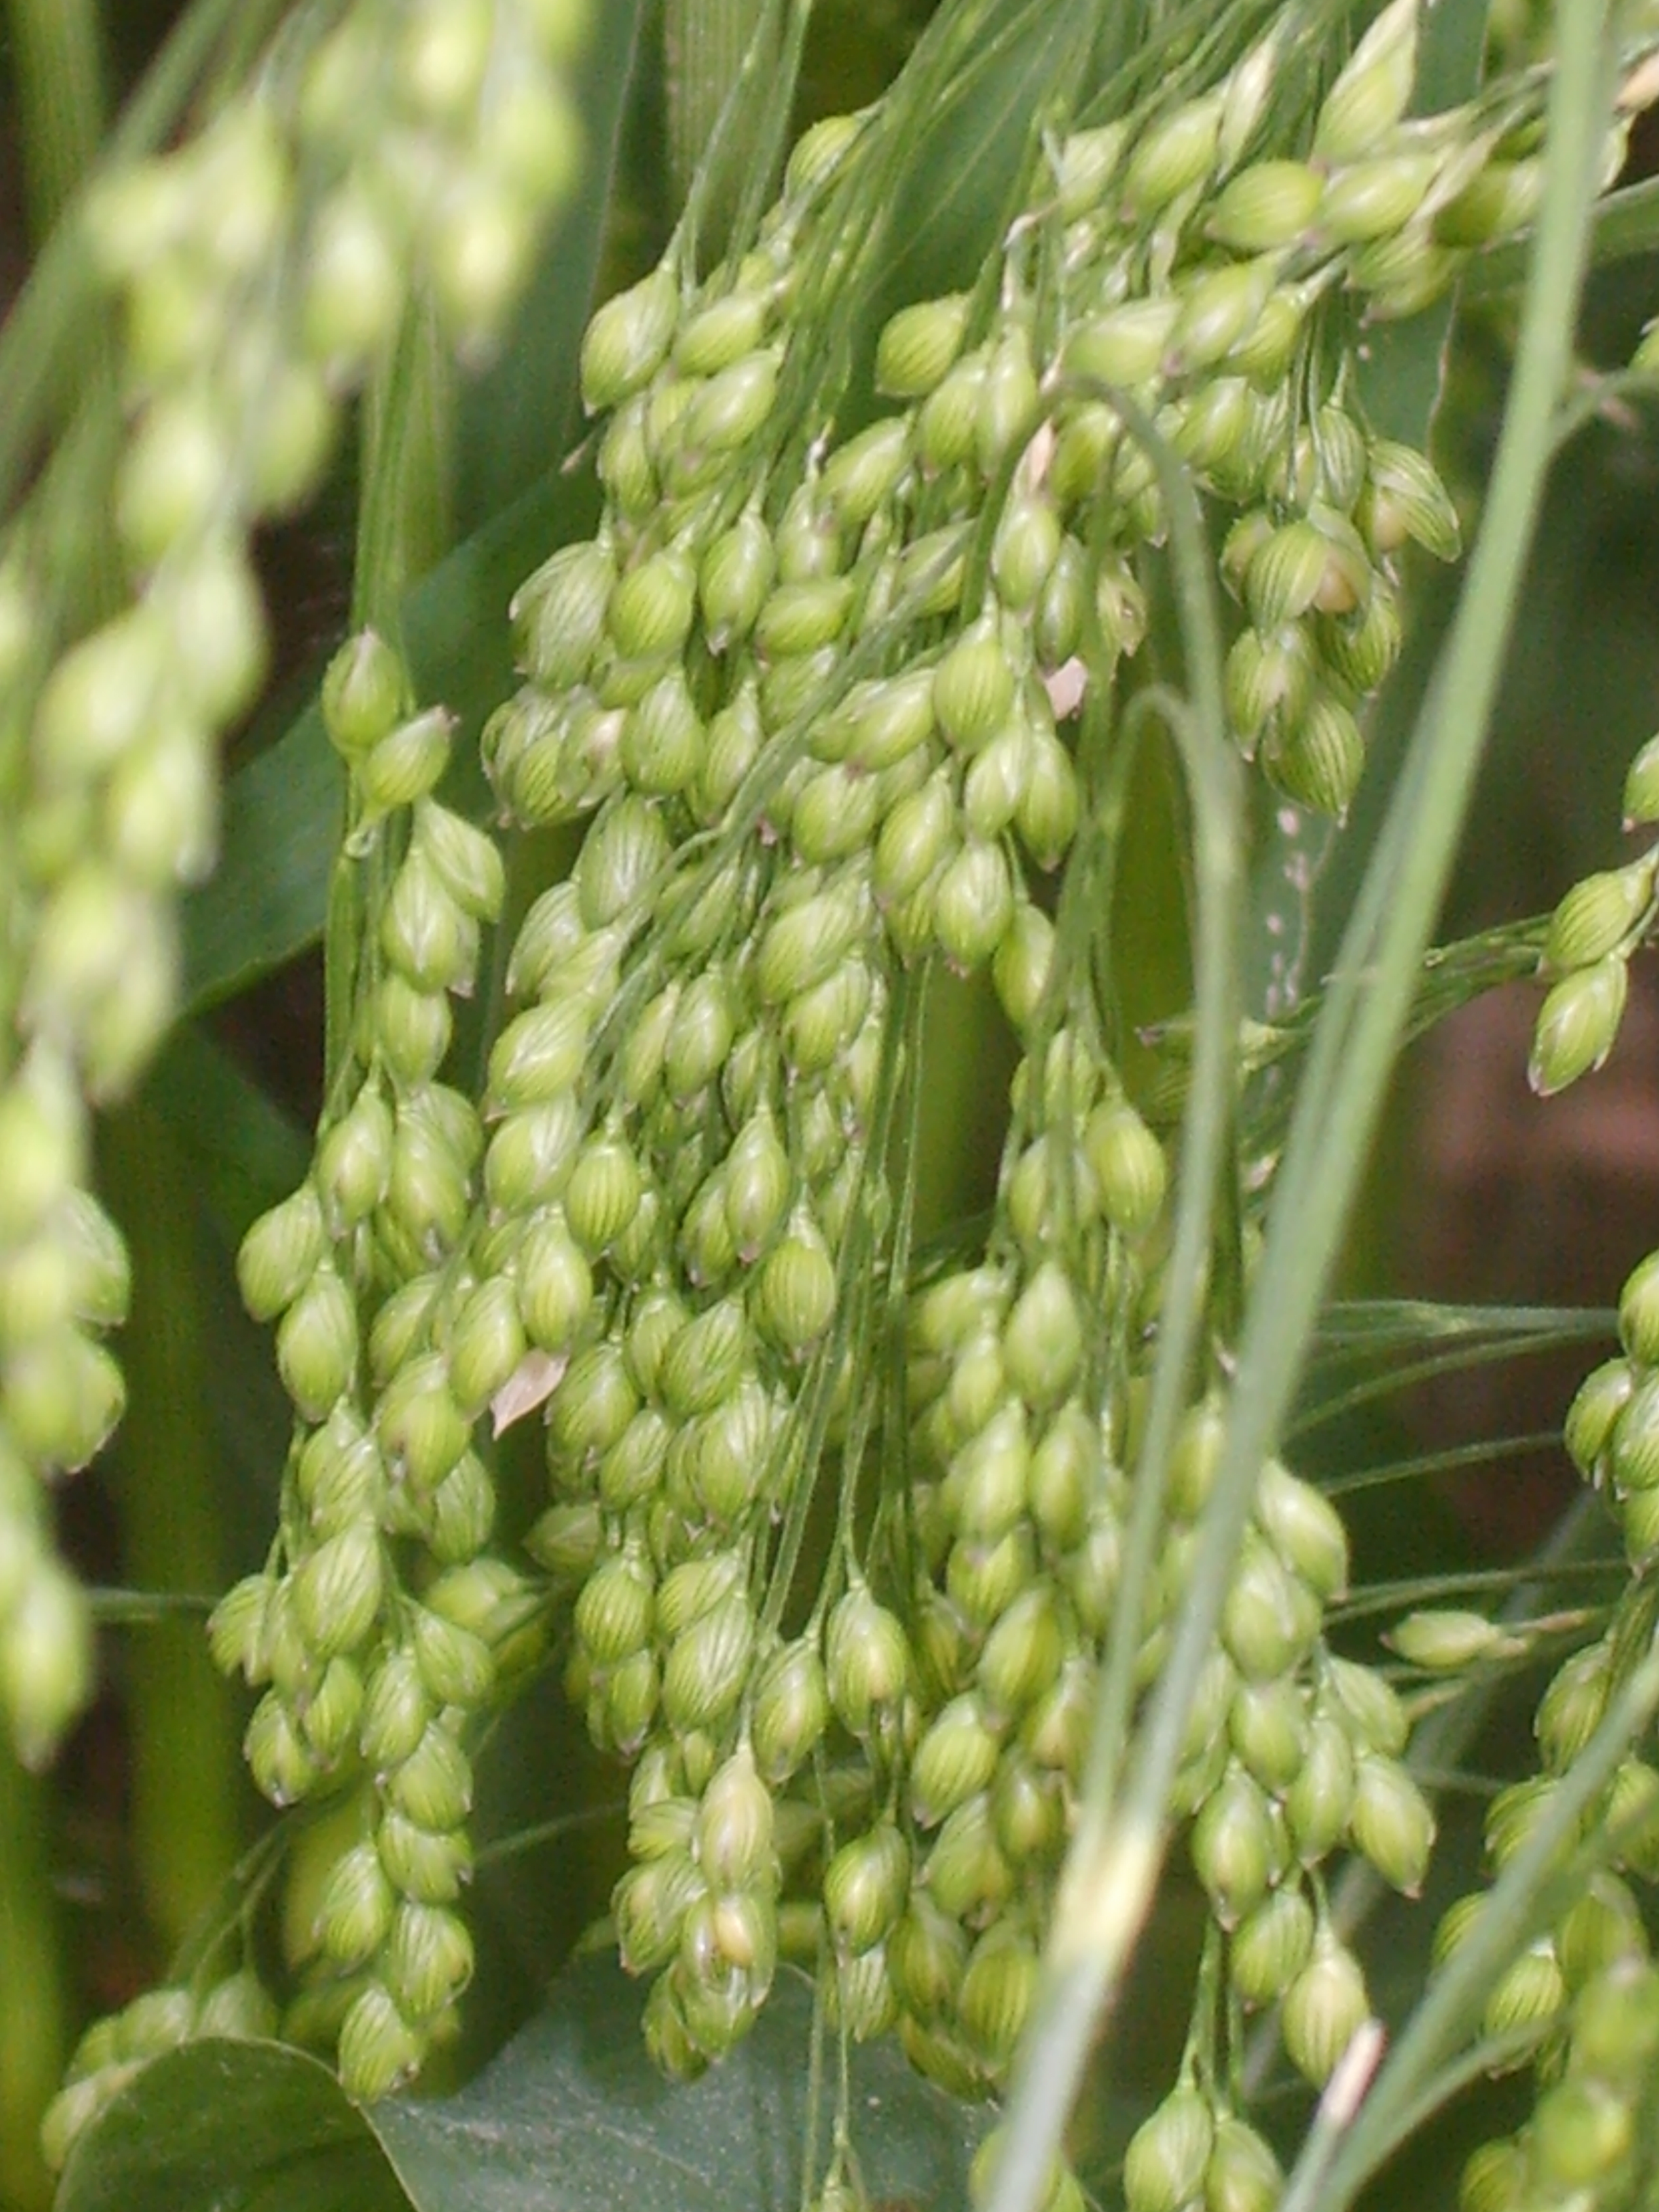
Today millet is used throughout the world for porridge, alcoholic beverages, and as animal food. It is not good for bread, which may be significant in the incident mentioned in EZK 4:9.

Description:
If indeed millet was grown at all in Old Testament times, it would have been a short variety less than 1 meter (3 feet) in height. It has a single head on a stalk, with many tiny seeds, so the Latin name is miliaceum (“million seeds”).

Translation:
There are six hundred kinds of Panicum species growing in the warm and tropical zones of the world, many of them domesticated, and two in Europe. Translators who do not have a local word for millet will need to use a transliteration from a major language, for example, French millet, Portuguese miliyo, and Spanish mijo. Since the references to millet are part of lists in non-rhetorical contexts, there is no need to look for a cultural equivalent.

Sorghum (durra)

3.1.3 Sorghum (durra)

Reference:”Hebrew דֹּחַן (dochan)EZK 4:9

Discussion:
Sorghum (durra) (1) (© Christian Fisher (Wikimedia Commons))Sorghum vulgare or Sorghum bicolor (known in West Africa as guinea corn or kint) may have originated in northeastern Africa (probably Sudan) and been carried through southwestern Asia to India as early as 2000 B.C. If so, it could have been known to the Israelites at the time of the conquest, and could be the dochan of EZK 4:9 (see 3.1.2 Millet). According to Hepper, sorghum was only introduced into the Holy Land around the time of Christ, so the word dochan cannot refer to it. It has also been suggested that dochan refers to the “reed” (see 5.1.4 Reed (common reed, giant reed)).
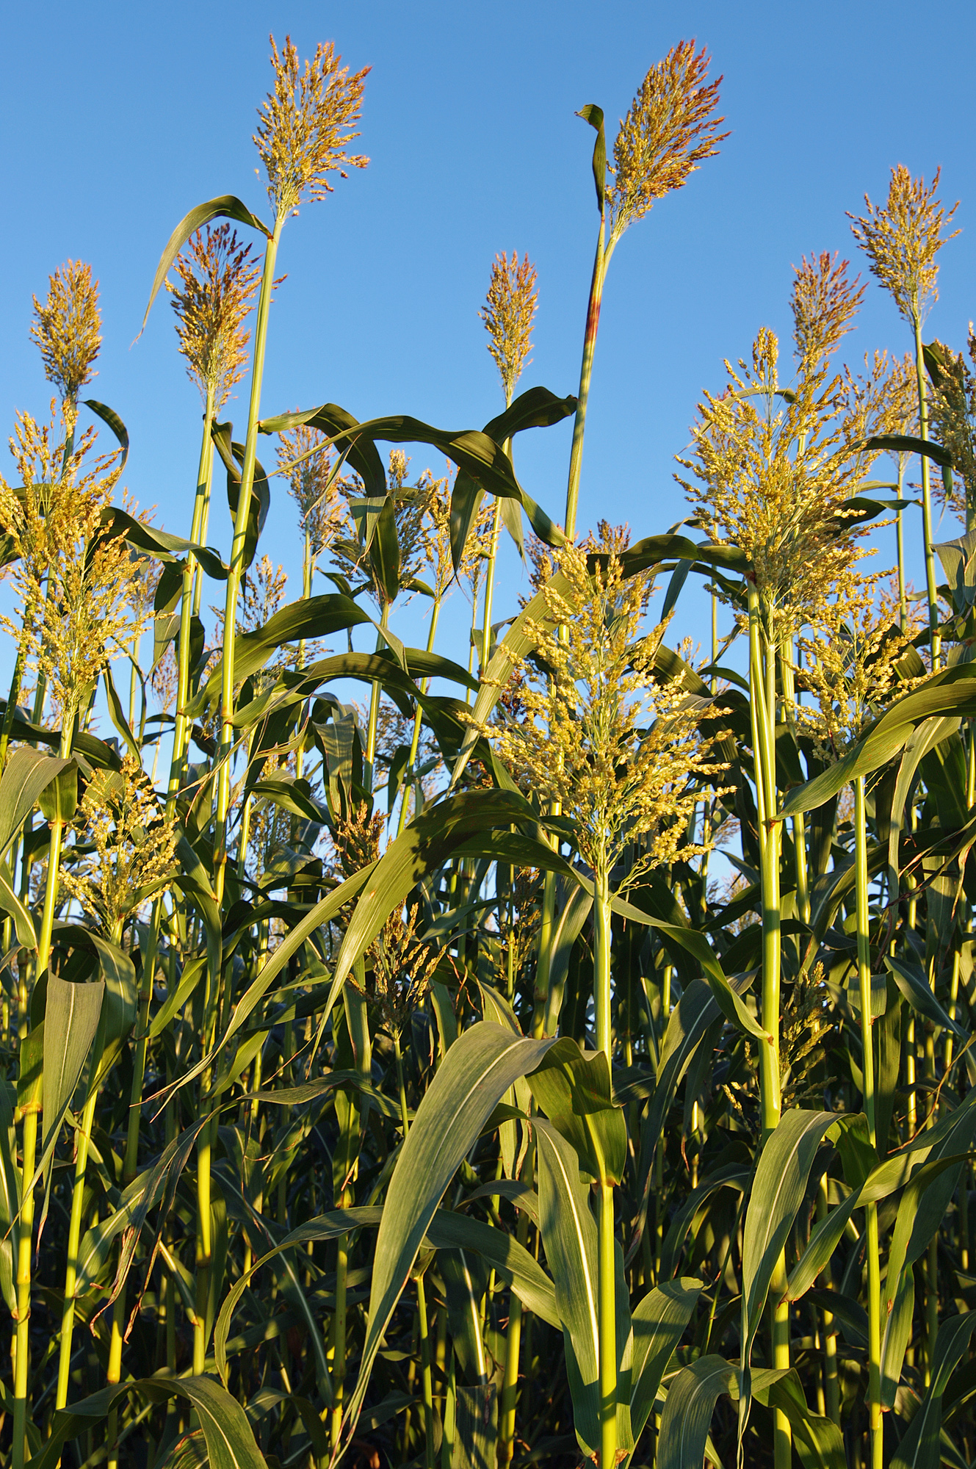
Sorghum is now the world’s fourth most important cereal after wheat, rice, and maize. It is used not only for food, but also for the sweet juice from its stalk, and for brooms and brushes.

Description:
Sorghum head (2) (Larry Rana, USDA)The early kinds of sorghum, though taller than wheat, barley or millet, would have been little more than 1–2 meters (3–7 feet) in height. Since then, kinds of sorghum have been developed that reach 5 meters (17 feet). These are especially popular in rural Africa, where the long stalks are used for roofs and fences.
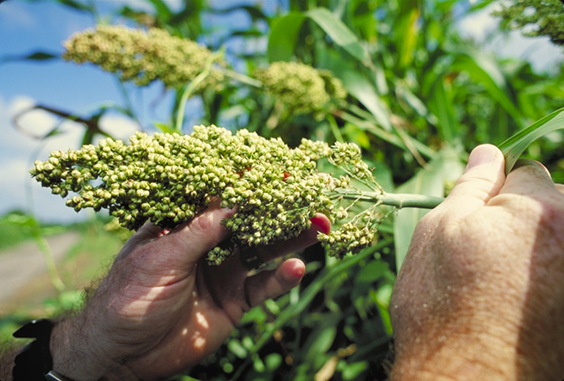

Translation:
Sorghum head (3) (Bob Nichols, USDA)Since we are unsure of the identity of the plant called dochan, it seems unwise to use a species name for it. It is better to transliterate this term. However, if sorghum is found to be accurate, translators in Africa should know that sorghum is also called guinea corn, durra, dari, and jowar (Hausa dawa, Arabic hhash, French sorgo, Mandinka kintoo, Swahili mkota). In China it is called kaolang. In the United States it is sometimes called milo or broom corn.
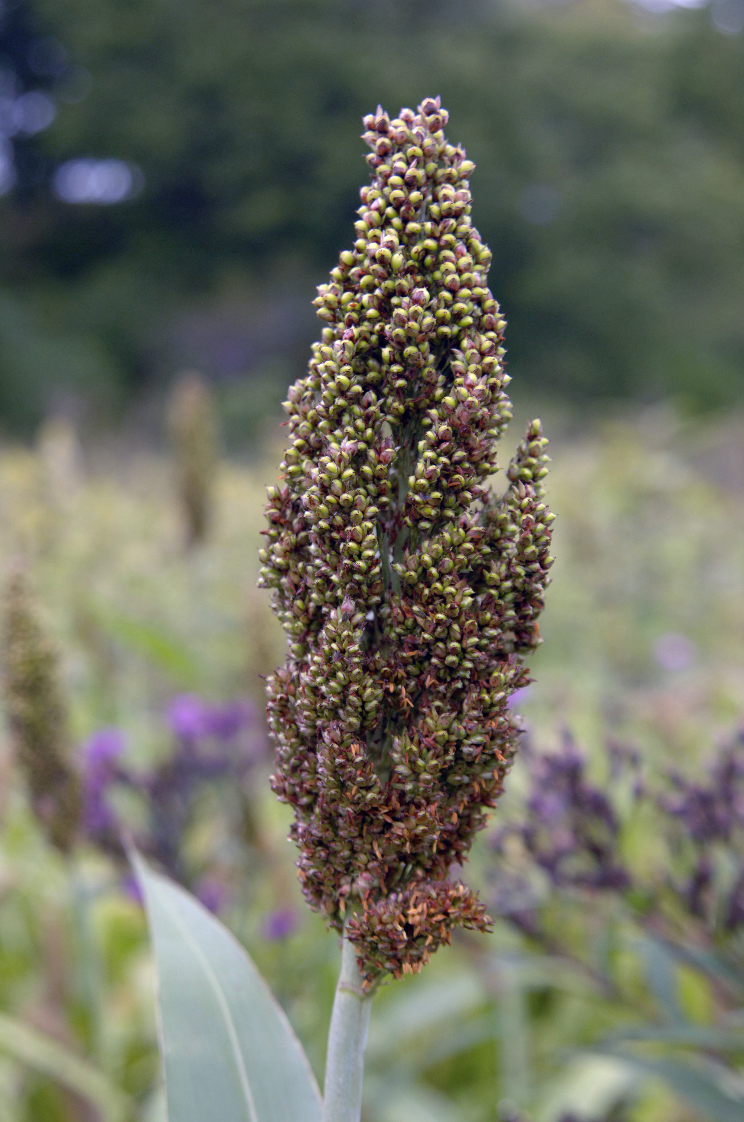

Wheat

3.1.4 Wheat

References:Hebrew חִטָּה (chittah)GEN 30:14, EXO 9:32, EXO 29:2, EXO 34:22, DEU 8:8, DEU 32:14, JDG 6:11, JDG 15:1, RUT 2:23, 1SA 6:13, 1SA 12:17, 2SA 4:6, 2SA 17:28, 1KI 5:25, 1CH 21:20, 1CH 21:23, 2CH 2:9, 2CH 2:14, 2CH 27:5, JOB 31:40, PSA 81:17, PSA 147:14, SNG 7:3, ISA 28:25, JER 12:13, JER 41:8, EZK 4:9, EZK 27:17, EZK 45:13, JOL 1:11Aramaic חִנְטִי? (chintan)EZR 6:9, EZR 7:22Hebrew כֻּסֶּמֶת (kusemeth)EXO 9:32, ISA 28:25, EZK 4:9Greek πυρός (puros)JDT 2:27, JDT 3:3, SIR 39:26, 1ES 6:29, 1ES 8:20Greek σιτίον (sition)ACT 7:12Greek σῖτος (sitos)MAT 3:12, MAT 13:25, MAT 13:29, MAT 13:30, MRK 4:28, LUK 3:17, LUK 12:18, LUK 16:7, LUK 22:31, JHN 12:24, ACT 27:38, 1CO 15:37, REV 6:6, REV 18:13, TOB 1:7, JDT 11:13, 1MA 8:26, 1MA 8:28

Discussion:
Wheat in field (Bluemoose (Wikimedia Commons))Two kinds of wild wheat have grown in the open deciduous oak woodland in the northern part of the Fertile Crescent for several thousand years: Einkorn Wheat Triticum monococcum and Emmer Wheat Triticum dicoccum. Both came into cultivation together with barley. Just before the time of the Romans, the Naked Bread Wheat or Hard Wheat Triticum durum started replacing the hulled varieties. This then became the favorite type of wheat for bread and macaroni. Spelt is a submember of the Triticum aestivum species. Unfortunately, according to one dictionary, spelt is also used as a local name for emmer wheat.
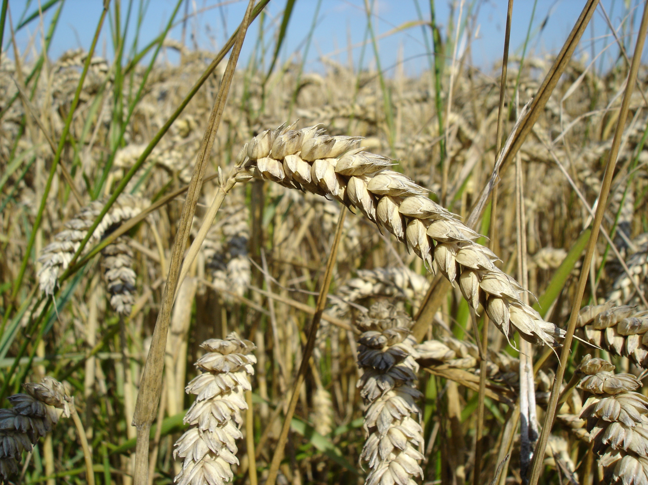
In RSV and some other versions, the generic Hebrew word bar has been rendered “wheat” in JER 23:28; AMO 5:11; AMO 8:5; AMO 8:6. This is legitimate, since the grain referred to by bar was probably wheat. However, it might be better to say “grain” in these passages.
The most important early wheat for the Israelites was emmer, probably the only wheat known in Egypt, and referred to in Hebrew as chittah. However, according to Hepper, the seven-headed wheat of the Egyptian king’s dream (GEN 41:5; GEN 41:6; GEN 41:7) suggests that there may also have been Triticum turgidum (rivet wheat) in the emmer group. The Hebrew word kusemeth probably refers to a type of emmer wheat that the Egyptians called swt. KJV renders kusemeth as “rye” in EXO 9:32 and ISA 28:25 (24), but this is not correct since rye is a European grain that was not known in Israel in Bible times.

Description:
Wheat head (Magnus Hagdorn (Wikimedia Commons))Wheat is a type of grass like rice and barley, growing to around 75 centimeters (2.5 feet) in height and having a head with many small grains in rows.
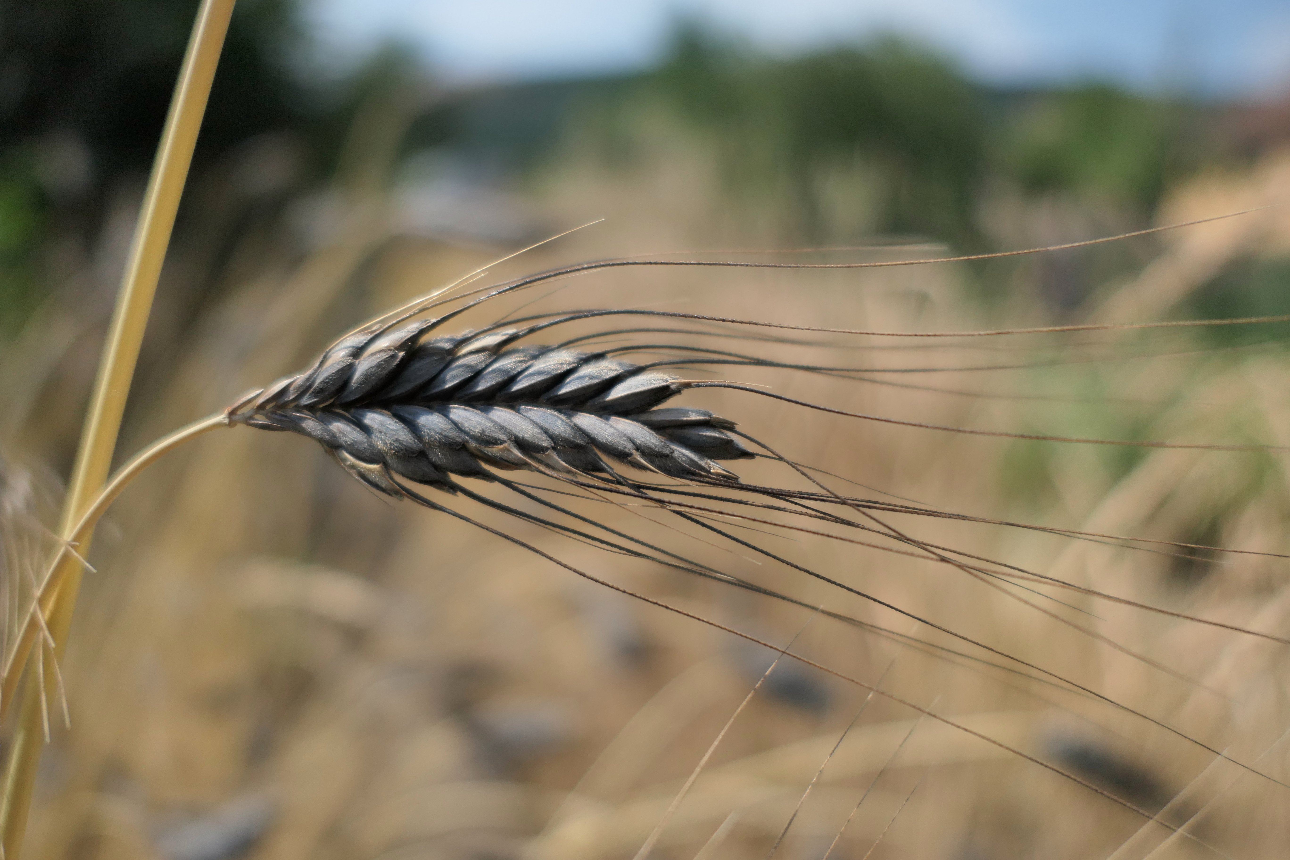

Special significance:
Bread made from wheat was the staple food for the people of ancient Israel, so God punished them by breaking “the staff of bread” (see, for example, EZK 4:16).

Translation:
If wheat is unfamiliar, translators can transliterate from a major language in non-rhetorical contexts (for example, English witi, Portuguese trigo, French ble or froment, Swahili ngano, Arabic kama /alkama). The transliteration may add a generic tag such as “grain.” The New Testament passages are mostly rhetorical, opening the possibility for a metaphorical equivalent.
EXO 9:32; EXO 9:32: “But the wheat and the spelt were not ruined, for they are late in coming up.” In this verse RSV, NIV, NLT, NJB, and NAB render the Hebrew words chittah as “wheat” and kusemeth as “spelt.” REB has “wheat” and “vetches.” Zohary and Hepper both say that rendering “spelt” as kusemeth is erroneous. Chittah and kusemeth are simply two kinds of wheat. Chittah was the more valued because it was easier to harvest. Kusemeth was still useful since it could grow in drier and less fertile areas.
In this verse GNB combines chittah and kusemeth as “wheat.” CEV is similar with “wheat crops,” and so is NCV with “wheat crops.” Following the lead of our suggestion for barley and flax in the previous verse (see 3.1.1 Barley), this verse may be rendered “but the crops that ripen later, that is, different kinds of witi, were not spoiled.” A transliteration of the Hebrew word kusemeth is also possible. This word may also be rendered “bush wheat” or “upland wheat” on the analogy of “upland rice.”
For “flour,” the food product resulting from grinding wheat, see 9.4 Bread.

