Resource: Plants and Trees in the Bible
Plants and Trees in the Bible © United Bible Societies, 2025. Adapted from: Each According to its Kind: Plants and Trees in the Bible, by Robert Koops © 2012 United Bible Societies. This work is licensed under Creative Commons Attribution-ShareAlike 4.0 International (https://creativecommons.org/licenses/by-sa/4.0/).

Plants and Trees in the Bible

Leafy vegetables

3.2 Leafy vegetables
We consider here leafy vegetables that were either grown or gathered, or both. Four types are listed in the Bible: bitter herbs, garlic, leeks, and onions. Apart from these, we know from excavations in the Near East and from Greek and Roman literature that other species of leafy vegetables, such as garden peas and fenugreek (literally “Greek hay”), were harvested and eaten for centuries and even millennia before Bible times. They were almost certainly eaten in Bible times, even though we find no reference to them in Scripture.
The Hebrew word ‘esev, which occurs thirty-three times in the Old Testament, means “herbs,” usually edible ones (see, for example GEN 9:3). According to Zohary, the Hebrew phrase ‘esev hassadeh (“grass/plants of the field”) presumably refers to edible herbs, pot herbs, and other plants that were gathered in the wild (see, for example, 2KI 19:26). However, as domestication was still going on in Bible times, it is sometimes impossible to know whether a food item was cultivated or gathered.
Another generic Hebrew expression for vegetables is ’oroth found in 2KI 4:39, where a young prophet goes out to gather ’oroth in the field. Zohary, noting that the incident took place near Gilgal in the Jordan Valley, suggests that ’oroth may well refer to the garden rocket, known in Arabic as jarjir. His case rests on the fact that the Talmud equates ’oroth with gargir. However, the context suggests a general word, so “vegetables” or “herbs” is still the best guess here. This is supported by the fact that the word is plural in form, as well as by the Aramaic translation, which uses a word that is unquestionably generic. ’Oroth comes from the Hebrew root ’arah (meaning “to gather, collect, pluck”), which also supports that it has here the general idea of “things gathered.”
Another generic Hebrew word here is chatsir (occurring twenty-two times), which Zohary says first referred to “leek” (see NUM 11:5), but later changed to mean “grazing grass” or “field herbs” (see, for example, PSA 37:2).
The Hebrew noun deshe’ (occurring fourteen times) is a general term for any plant. GEN 1:11 uses this noun and it verbal form, which are rendered “put forth vegetation.”
Another general Hebrew word for vegetables is yaraq, which occurs in DEU 11:10; 1KI 21:2; PRO 15:17. In 1KI 21:2 King Ahab covets Naboth’s vineyard to use as his gan yaraq (“vegetable garden”). This sort of expression can cause problems for translators because of the taxonomy and availability of generic terms. Many languages will have words for various types of agricultural plots depending on what is cultivated therein. Naboth’s vineyard was right next to the king’s palace, so the word for “vegetable garden” needs to be appropriate to that situation. If no specific word is available, translators may use a phrase such as “place where I can grow vegetables” or “place where I can plant things.”
The Hebrew word zeru‘a /zero‘nim (LEV 11:37; ISA 61:11; DAN 1:12; DAN 1:16) is a nominal form of the verb “to plant,” and it literally means “thing sown.” Some versions have rendered it “seed,” “plant” or “what is sown,” depending on the context. Several versions use “vegetables” in DAN 1:12; DAN 1:16.
The Greek word lachanon is a generic word for vegetables in ROM 14:2. In LUK 11:42 it includes mint and rue, so it is appropriately translated “herb.” RSV renders it “shrubs” in MAT 13:32 and MRK 4:32 since it refers to the mature plant of the mustard seed in those passages.

Bitter herbs

3.2.1 Bitter herbs

References:Hebrew מָרֹר (maror)EXO 12:8, NUM 9:11, LAM 3:15

Discussion:
Chicory (Iorsh (Wikimedia Commons))The Hebrew word merorim in EXO 12:8; NUM 9:11 is a plural form of maror, which is derived from the root marar meaning “to be bitter” (compare the name “Mara” in RUT 1:20), so it could be either a specific plant or a generic word. Zohary says merorim may refer to the Dwarf Chicory Cichorium pumilum, Reichardia Reichardia tingitana, and/or perhaps some other plant known to have bitter leaves. Moldenke suggests endive, dandelion, and sorrel. In addition to the above plants, the Mishnah names lettuce, eryngo, horseradish, and sow thistle. In other words, the rabbis considered any of these plants acceptable to fulfill the commandment to eat merorim at the Passover meal.
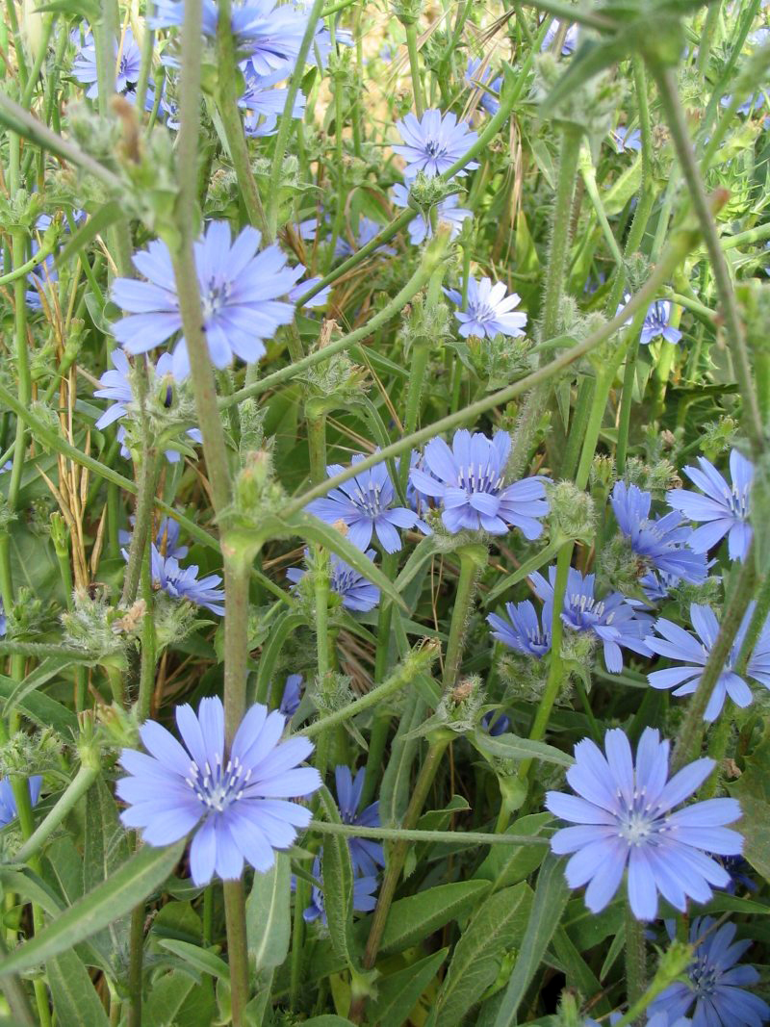

Special significance:
The point of using “unleavened bread” and “bitter herbs” in the Passover Feast is that these foods could be prepared quickly, recalling the hasty departure of the people of Israel from Egypt (see EXO 12:11). Presumably the herbs were cooked into some kind of stew or sauce that would be used in this sort of hasty situation.

Translation:
A descriptive phrase for “bitter herbs” is best, but if such a phrase is not available, specific bitter-tasting plants could be used, or some type of sauce or stew that is cooked in an emergency situation. Words for the dwarf chicory in major languages are hindiba /kasiniya (Arabic), chicoree (French), escarole (Spanish), and chicoria (Portuguese).

Garlic

3.2.2 Garlic

Reference:”Hebrew שׁוּמִים (shum)NUM 11:5

Discussion:
Garlic bulbs, sections (© Donovan Govan (Wikimedia Commons))Garlic Allium sativum is immensely popular in Egypt, West Asia and Europe, and probably was so in Bible times. Large numbers of these plants have been found in ancient tombs in Egypt and the Dead Sea area dating around 3500–3000 B.C., attesting to their popularity long before the days of the Exodus. The Greek writer Pliny knew of three types of garlic. They were used as offerings for the gods, as medicine, as food flavoring, and in preserving meat.
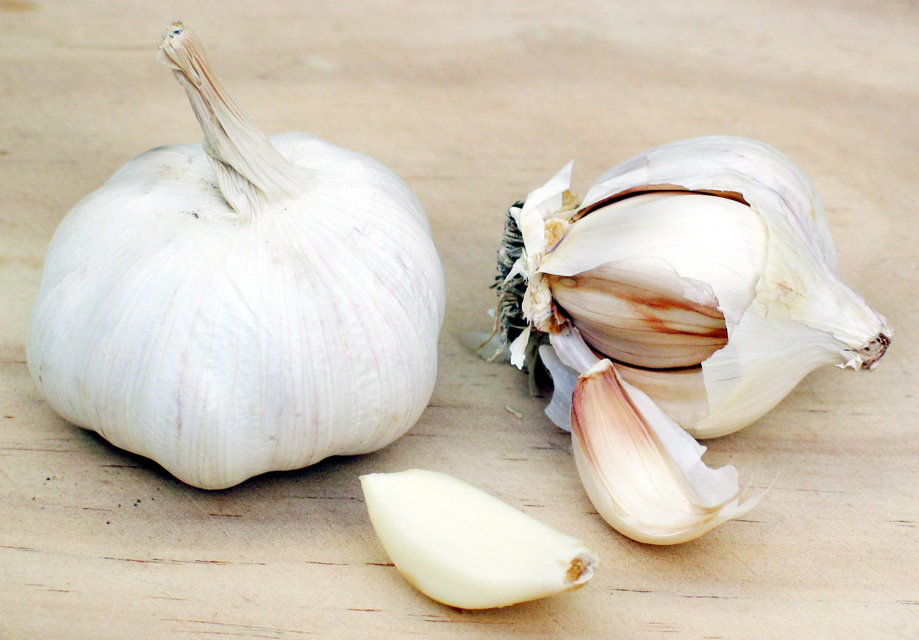

Description:
Garlic has a bulb something like that of an onion, but smaller, and it is divided into four or five parts, each of which can be planted to start a new plant, since garlic is not propagated by seeds. These sections are called “cloves” in English. Because of its distinctive taste and smell, garlic is used for seasoning food throughout the world and also as medicine.

Special significance:
In NUM 11:5 garlic is cited with onions, leeks and other tasty things that the Israelites longed for as they wandered in the Sinai Desert.

Translation:
Garlic originated in the Near East, although its wild ancestor is uncertain. Garlic is now grown throughout the world, so local words are often available. If not, since the context of NUM 11:5 is non-rhetorical, a transliteration from a major language is advisable (for example, Arabic tawm /toum, French ail, Spanish ajo /aho, Portuguese alho /alyo, Swahili kitunguusaumu, Wolof laaj, Hausa tafarnuwa).

Leek

3.2.3 Leek

Reference:”Hebrew חָצִיר (chatsir)NUM 11:5

Discussion:
Leek plant (Elisabeth Östman (Wikimedia Commons))According to Zohary, supported by Moldenke, the Hebrew word chatsir in NUM 11:5 refers to the True Leek Allium porrum, but Hepper argues that it is more likely the Salad Leek Allium kurrat (also known as Egyptian Leek), specimens of which have been found in Egyptian tombs. Moldenke and others hold that chatsir could also have been the Fenugreek Trigonella foenum-graecum, which was also known both in Egypt and in the Holy Land. The word chatsir occurs elsewhere in the Old Testament with the meaning of “grass,” “herb” or “hay,” so it could be a generic word for any edible green plant (see 5.1.2 Grass). However, in the context of “onions” and “garlics,” it is likely to refer to the leek. Zohary suggests that chatsir first referred to a specific plant and became a general word later.
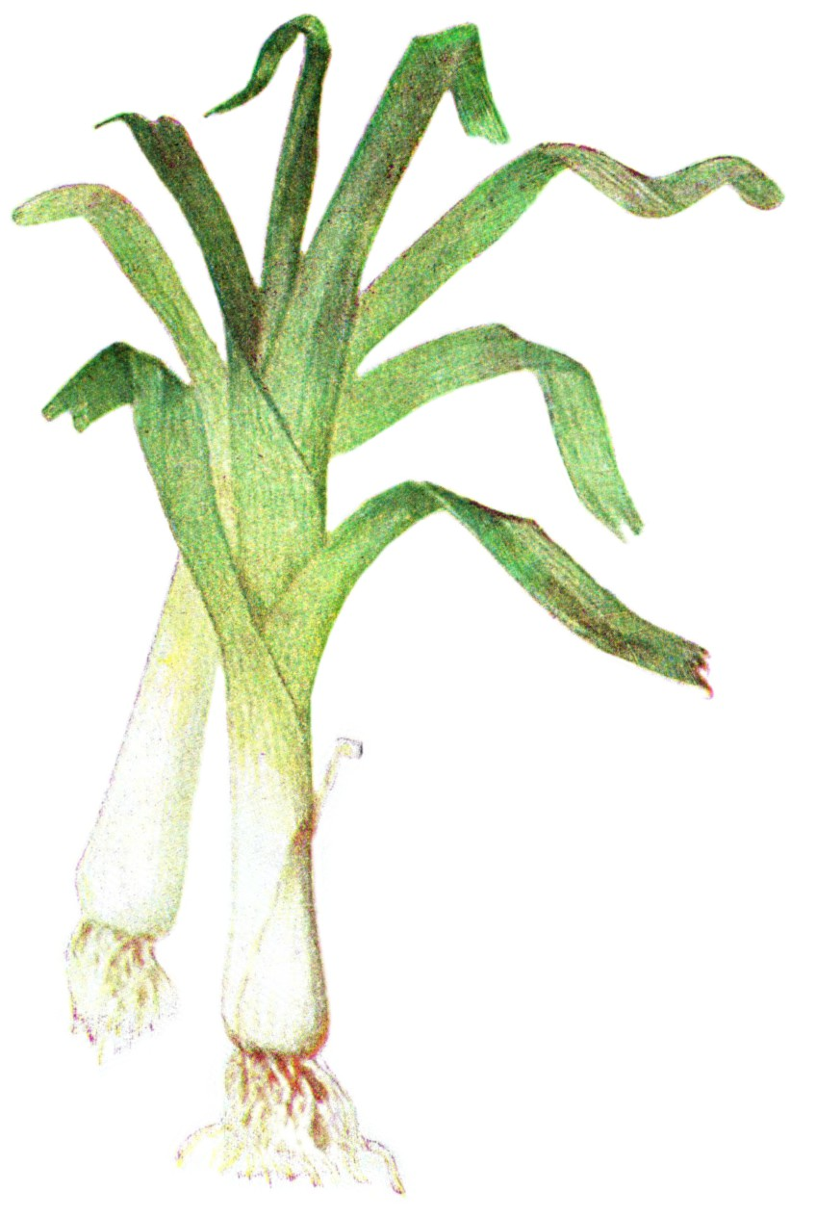

Description:
Leeks, trimmed (© Rasbak (Wikimedia Commons))Leeks have leaves like onions and taste like them, although leek leaves are flat whereas onion leaves are round and hollow. The “bulb” of the leek, if it can be called such, is long (at least 10 centimeters [4 inches]) and slender. They are used fresh in salads and cooked in stews.
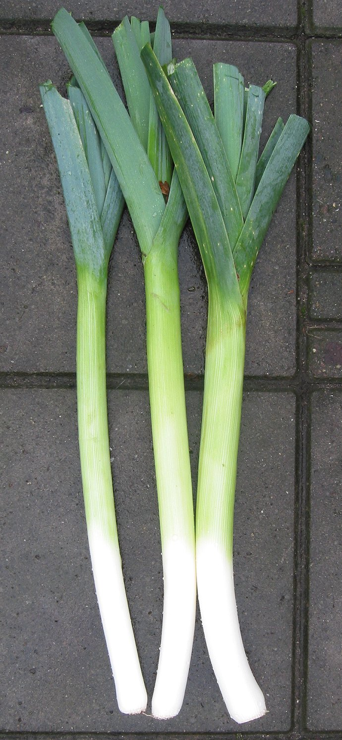

Special significance:
In the ancient world the leek was considered the food of the poor. In Numbers leeks are listed with onions and garlic as plants the Israelites longed for when they left Egypt.

Translation:
Leeks are known throughout the world. They are less common in West Africa than onions, but I have seen them for sale in the big cities of Nigeria and in The Gambia. Depending on what is done for the other items in the list in NUM 11:5 (garlic and onions), translators may find three local types of Allium or transliterate the word for garlic from a major language (for example, French poireau, Spanish puerro, Portuguese alho porro). The context is non-rhetorical.

Onion

3.2.4 Onion

Reference:”Hebrew בָּצָל (batsal)NUM 11:5

Discussion:
Onion plants (Stephen Ausmus (Wikimedia Commons))There is no doubt that the Hebrew word batsal refers to the ancestor of the Onion Allium cepa we know now. It may have been native to the Holy Land. Onions were known in Egypt as early as 3200 B.C. along with leeks and garlic. The Septuagint translates batsal as krommuon.
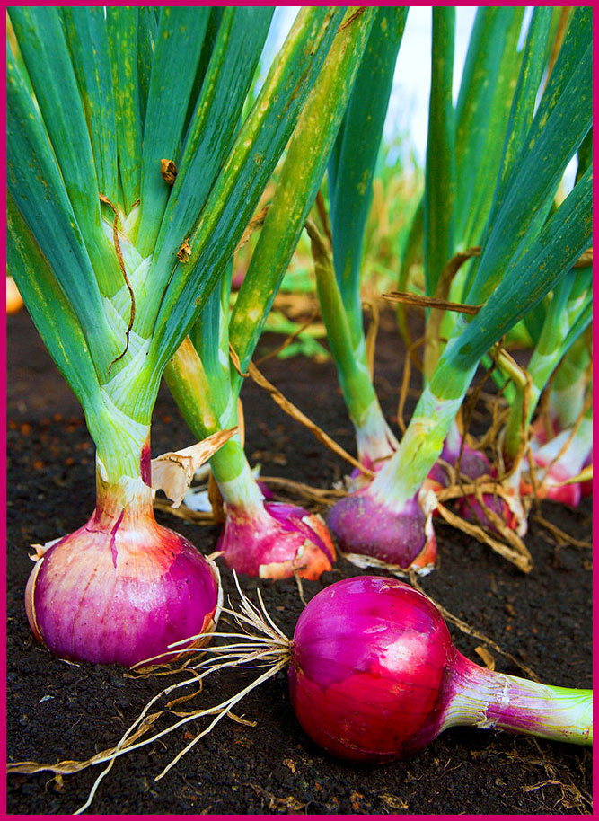

Description:
Onion bulbs (© Donovan Govan (Wikimedia Commons))The onion plant has hollow leaves and a hollow stem about 30 centimeters (1 foot) tall with a spherical head of flowers. The root is a round bulb made up of tightly packed layers of fleshy, edible tissue. It is sharp in taste, though the Egyptian variety was considered sweet.
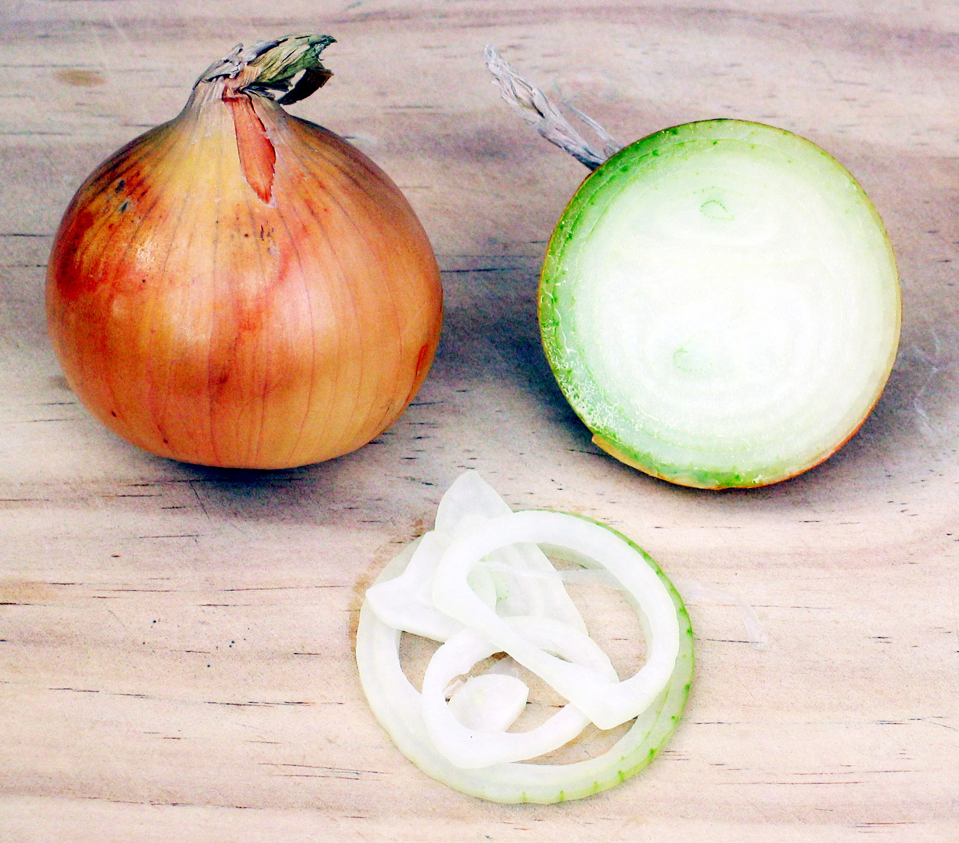

Special significance:
Onions are cited with garlic and other tasty things from the life of Egypt that the Israelites longed for as they wandered in the Sinai Desert for forty years.

Translation:
Onions, leeks, and garlic belong to the genus Allium, which comprises around six hundred species, found mainly in the temperate zones of the world. Onions are now so common in Africa that it will be a surprise to find a language that has no name for them, assuming it will be a borrowed word like Hausa albasa (from Arabic; note the similarity to the Hebrew batsal). If transliteration is needed from a major language, consider French oignon, Spanish cebolla, Portuguese cebola, Italian cipolla, and Swahili kitunguu.

