Resource: Plants and Trees in the Bible
Plants and Trees in the Bible © United Bible Societies, 2025. Adapted from: Each According to its Kind: Plants and Trees in the Bible, by Robert Koops © 2012 United Bible Societies. This work is licensed under Creative Commons Attribution-ShareAlike 4.0 International (https://creativecommons.org/licenses/by-sa/4.0/).

Plants and Trees in the Bible

Condiments

3.5 Condiments

There are eleven types of condiments in the Bible: caper, coriander, cumin, dill, dove’s dung, mallow, mint, mustard, nigella, orache, and rue.

Caper (caper bush, caper berry)

3.5.1 Caper (caper bush, caper berry)

Reference:”Hebrew אֲבִיּוֹנָה (’aviyonah)ECC 12:5

Discussion:
Caper flower, bud (Iorsh (Wikimedia Commons))In the delightful description of old age in ECC 12:0, a string of metaphors is followed by the clause “desire [’aviyonah in Hebrew] fails.” The word ’aviyonah only occurs once in the Bible, so there has been much debate over its meaning. The Septuagint translators took the first meaning of the word and rendered it “caper berry,” referring to the spicy tasting bud of a small bush (Capparis spinosa) common in the Middle East. The Syriac and the Vulgate have the same rendering, and so do NAB and GECL. GW, JB, and NJPSV are similar with “caper bush,” and so are NEB and REB with “caper-buds.” La Nouvelle Bible Segond and La Sainte Bible: Version Synodale say simply “caper,” and FRCL uses the generic term “spices.”
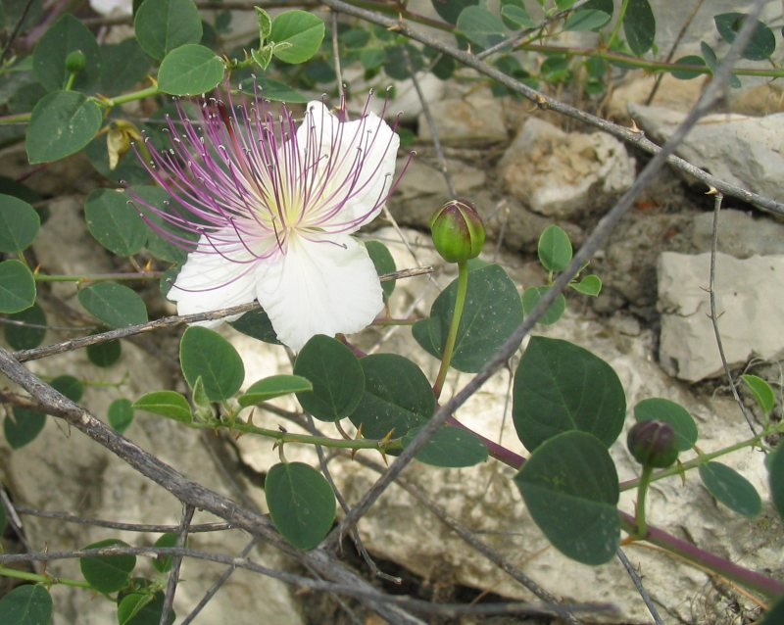
Caper buds (© Yuvalr (Wikimedia Commons))Jews and others in ancient times used the caper berry and especially the pickled bud of the bush to increase the appetite, and the words meaning “desire” found in Greek and Hebrew dictionaries seems to be based on the association of capers and desire. In the Middle Ages Europeans considered the caper berry as an aphrodisiac; Moldenke does not find evidence that it was so used in ancient times.
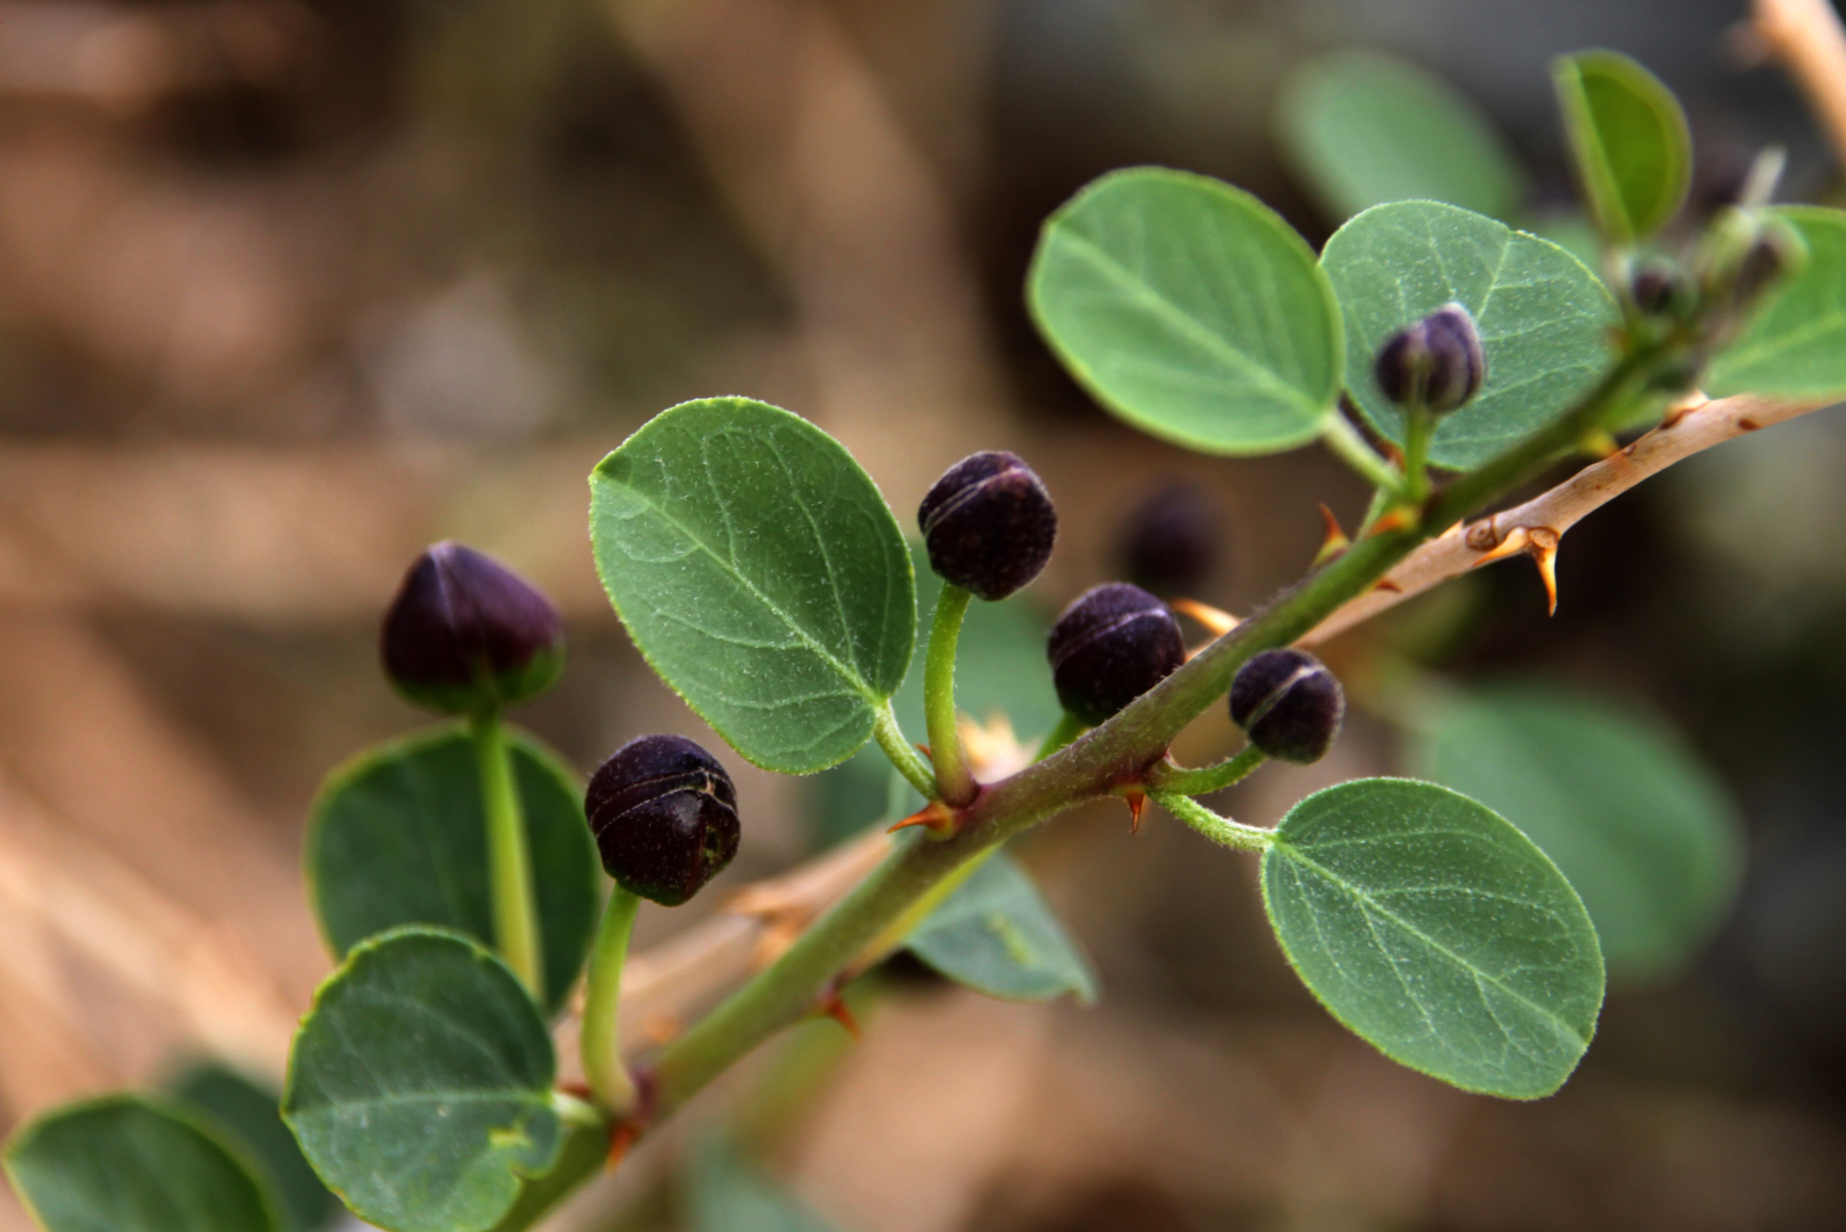
A number of prominent botanists are convinced that the Hebrew word ’ezov in the Pentateuch does not refer to the hyssop plant (so Septuagint) or even the marjoram (“Syrian hyssop”), but to the caper bush, which grows in Egypt and the Sinai Desert, where the Israelites were instructed to use it for the Passover ceremony. It also grows in the cracks of city walls, fitting the description of Solomon’s knowledge of botany as described in 1KI 5:13 (4.33). Some even say a stick from the caper bush would have been long enough to fit the reference in JHN 19:29 (hussōpos in Greek), where soldiers lifted a sponge to Jesus’ lips on a stick. However, Zohary and others, on the basis of etymology, believe the words ’ezov and hussōpos most likely refer to the marjoram plant. I agree. See also the discussion on these words under 5.2.4 Marjoram.

Description:
Caper bush (© Ray Pritz (UBS))In open areas the caper bush can grow as a bush to a meter (3 feet) in height, but more often it is found sprawling over rocks and broken-down walls, and hanging from cliffs and the cracks in outside walls. It has a beautiful flower with three purplish-white petals and many long, curved purple stamens. The leaves are round and gray-green in color. The flowers open in the evening and wilt by the following morning, eventually producing a stalk with a berry containing many seeds.
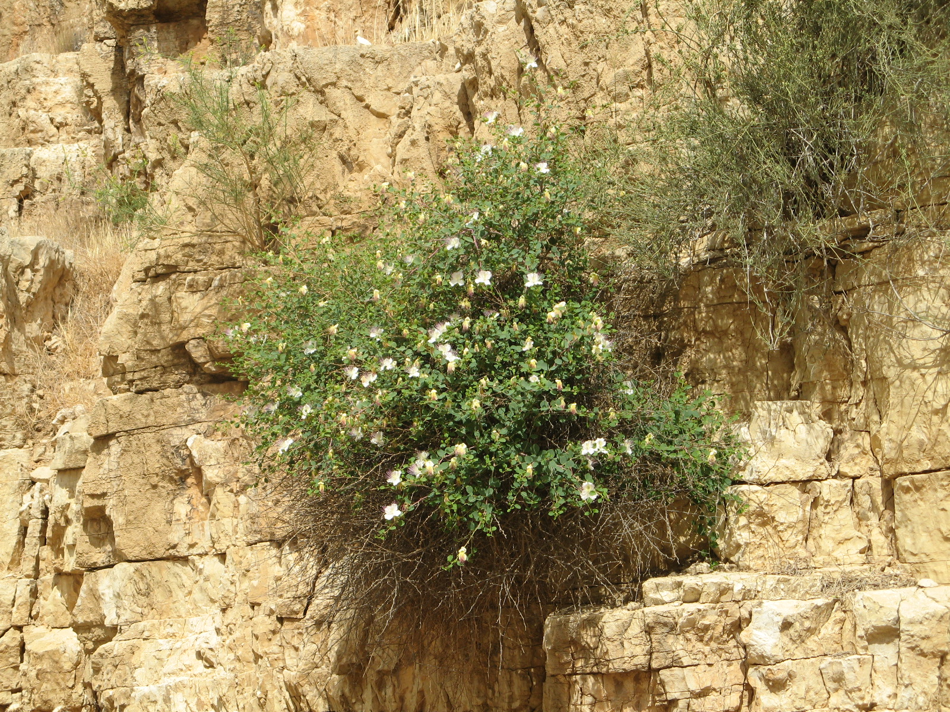

Special significance:

Caper (caper bush, caper berry)

3.5.1 Caper (caper bush, caper berry)

Reference:”Hebrew אֲבִיּוֹנָה (’aviyonah)ECC 12:5

Discussion:
Caper flower, bud (Iorsh (Wikimedia Commons))In the delightful description of old age in ECC 12:0, a string of metaphors is followed by the clause “desire [’aviyonah in Hebrew] fails.” The word ’aviyonah only occurs once in the Bible, so there has been much debate over its meaning. The Septuagint translators took the first meaning of the word and rendered it “caper berry,” referring to the spicy tasting bud of a small bush (Capparis spinosa) common in the Middle East. The Syriac and the Vulgate have the same rendering, and so do NAB and GECL. GW, JB, and NJPSV are similar with “caper bush,” and so are NEB and REB with “caper-buds.” La Nouvelle Bible Segond and La Sainte Bible: Version Synodale say simply “caper,” and FRCL uses the generic term “spices.”

Caper buds (© Yuvalr (Wikimedia Commons))Jews and others in ancient times used the caper berry and especially the pickled bud of the bush to increase the appetite, and the words meaning “desire” found in Greek and Hebrew dictionaries seems to be based on the association of capers and desire. In the Middle Ages Europeans considered the caper berry as an aphrodisiac; Moldenke does not find evidence that it was so used in ancient times.

A number of prominent botanists are convinced that the Hebrew word ’ezov in the Pentateuch does not refer to the hyssop plant (so Septuagint) or even the marjoram (“Syrian hyssop”), but to the caper bush, which grows in Egypt and the Sinai Desert, where the Israelites were instructed to use it for the Passover ceremony. It also grows in the cracks of city walls, fitting the description of Solomon’s knowledge of botany as described in 1KI 5:13 (4.33). Some even say a stick from the caper bush would have been long enough to fit the reference in JHN 19:29 (hussōpos in Greek), where soldiers lifted a sponge to Jesus’ lips on a stick. However, Zohary and others, on the basis of etymology, believe the words ’ezov and hussōpos most likely refer to the marjoram plant. I agree. See also the discussion on these words under 5.2.4 Marjoram.

Description:
Caper bush (© Ray Pritz (UBS))In open areas the caper bush can grow as a bush to a meter (3 feet) in height, but more often it is found sprawling over rocks and broken-down walls, and hanging from cliffs and the cracks in outside walls. It has a beautiful flower with three purplish-white petals and many long, curved purple stamens. The leaves are round and gray-green in color. The flowers open in the evening and wilt by the following morning, eventually producing a stalk with a berry containing many seeds.


Special significance:

Caper (caper bush, caper berry)

3.5.1 Caper (caper bush, caper berry)

Reference:”Hebrew אֲבִיּוֹנָה (’aviyonah)ECC 12:5

Discussion:
Caper flower, bud (Iorsh (Wikimedia Commons))In the delightful description of old age in ECC 12:0, a string of metaphors is followed by the clause “desire [’aviyonah in Hebrew] fails.” The word ’aviyonah only occurs once in the Bible, so there has been much debate over its meaning. The Septuagint translators took the first meaning of the word and rendered it “caper berry,” referring to the spicy tasting bud of a small bush (Capparis spinosa) common in the Middle East. The Syriac and the Vulgate have the same rendering, and so do NAB and GECL. GW, JB, and NJPSV are similar with “caper bush,” and so are NEB and REB with “caper-buds.” La Nouvelle Bible Segond and La Sainte Bible: Version Synodale say simply “caper,” and FRCL uses the generic term “spices.”

Caper buds (© Yuvalr (Wikimedia Commons))Jews and others in ancient times used the caper berry and especially the pickled bud of the bush to increase the appetite, and the words meaning “desire” found in Greek and Hebrew dictionaries seems to be based on the association of capers and desire. In the Middle Ages Europeans considered the caper berry as an aphrodisiac; Moldenke does not find evidence that it was so used in ancient times.

A number of prominent botanists are convinced that the Hebrew word ’ezov in the Pentateuch does not refer to the hyssop plant (so Septuagint) or even the marjoram (“Syrian hyssop”), but to the caper bush, which grows in Egypt and the Sinai Desert, where the Israelites were instructed to use it for the Passover ceremony. It also grows in the cracks of city walls, fitting the description of Solomon’s knowledge of botany as described in 1KI 5:13 (4.33). Some even say a stick from the caper bush would have been long enough to fit the reference in JHN 19:29 (hussōpos in Greek), where soldiers lifted a sponge to Jesus’ lips on a stick. However, Zohary and others, on the basis of etymology, believe the words ’ezov and hussōpos most likely refer to the marjoram plant. I agree. See also the discussion on these words under 5.2.4 Marjoram.

Description:
Caper bush (© Ray Pritz (UBS))In open areas the caper bush can grow as a bush to a meter (3 feet) in height, but more often it is found sprawling over rocks and broken-down walls, and hanging from cliffs and the cracks in outside walls. It has a beautiful flower with three purplish-white petals and many long, curved purple stamens. The leaves are round and gray-green in color. The flowers open in the evening and wilt by the following morning, eventually producing a stalk with a berry containing many seeds.


Special significance:

Caper (caper bush, caper berry)

3.5.1 Caper (caper bush, caper berry)

Reference:”Hebrew אֲבִיּוֹנָה (’aviyonah)ECC 12:5

Discussion:
Caper flower, bud (Iorsh (Wikimedia Commons))In the delightful description of old age in ECC 12:0, a string of metaphors is followed by the clause “desire [’aviyonah in Hebrew] fails.” The word ’aviyonah only occurs once in the Bible, so there has been much debate over its meaning. The Septuagint translators took the first meaning of the word and rendered it “caper berry,” referring to the spicy tasting bud of a small bush (Capparis spinosa) common in the Middle East. The Syriac and the Vulgate have the same rendering, and so do NAB and GECL. GW, JB, and NJPSV are similar with “caper bush,” and so are NEB and REB with “caper-buds.” La Nouvelle Bible Segond and La Sainte Bible: Version Synodale say simply “caper,” and FRCL uses the generic term “spices.”

Caper buds (© Yuvalr (Wikimedia Commons))Jews and others in ancient times used the caper berry and especially the pickled bud of the bush to increase the appetite, and the words meaning “desire” found in Greek and Hebrew dictionaries seems to be based on the association of capers and desire. In the Middle Ages Europeans considered the caper berry as an aphrodisiac; Moldenke does not find evidence that it was so used in ancient times.

A number of prominent botanists are convinced that the Hebrew word ’ezov in the Pentateuch does not refer to the hyssop plant (so Septuagint) or even the marjoram (“Syrian hyssop”), but to the caper bush, which grows in Egypt and the Sinai Desert, where the Israelites were instructed to use it for the Passover ceremony. It also grows in the cracks of city walls, fitting the description of Solomon’s knowledge of botany as described in 1KI 5:13 (4.33). Some even say a stick from the caper bush would have been long enough to fit the reference in JHN 19:29 (hussōpos in Greek), where soldiers lifted a sponge to Jesus’ lips on a stick. However, Zohary and others, on the basis of etymology, believe the words ’ezov and hussōpos most likely refer to the marjoram plant. I agree. See also the discussion on these words under 5.2.4 Marjoram.

Description:
Caper bush (© Ray Pritz (UBS))In open areas the caper bush can grow as a bush to a meter (3 feet) in height, but more often it is found sprawling over rocks and broken-down walls, and hanging from cliffs and the cracks in outside walls. It has a beautiful flower with three purplish-white petals and many long, curved purple stamens. The leaves are round and gray-green in color. The flowers open in the evening and wilt by the following morning, eventually producing a stalk with a berry containing many seeds.


Special significance:

Caper (caper bush, caper berry)

3.5.1 Caper (caper bush, caper berry)

Reference:”Hebrew אֲבִיּוֹנָה (’aviyonah)ECC 12:5

Discussion:
Caper flower, bud (Iorsh (Wikimedia Commons))In the delightful description of old age in ECC 12:0, a string of metaphors is followed by the clause “desire [’aviyonah in Hebrew] fails.” The word ’aviyonah only occurs once in the Bible, so there has been much debate over its meaning. The Septuagint translators took the first meaning of the word and rendered it “caper berry,” referring to the spicy tasting bud of a small bush (Capparis spinosa) common in the Middle East. The Syriac and the Vulgate have the same rendering, and so do NAB and GECL. GW, JB, and NJPSV are similar with “caper bush,” and so are NEB and REB with “caper-buds.” La Nouvelle Bible Segond and La Sainte Bible: Version Synodale say simply “caper,” and FRCL uses the generic term “spices.”

Caper buds (© Yuvalr (Wikimedia Commons))Jews and others in ancient times used the caper berry and especially the pickled bud of the bush to increase the appetite, and the words meaning “desire” found in Greek and Hebrew dictionaries seems to be based on the association of capers and desire. In the Middle Ages Europeans considered the caper berry as an aphrodisiac; Moldenke does not find evidence that it was so used in ancient times.

A number of prominent botanists are convinced that the Hebrew word ’ezov in the Pentateuch does not refer to the hyssop plant (so Septuagint) or even the marjoram (“Syrian hyssop”), but to the caper bush, which grows in Egypt and the Sinai Desert, where the Israelites were instructed to use it for the Passover ceremony. It also grows in the cracks of city walls, fitting the description of Solomon’s knowledge of botany as described in 1KI 5:13 (4.33). Some even say a stick from the caper bush would have been long enough to fit the reference in JHN 19:29 (hussōpos in Greek), where soldiers lifted a sponge to Jesus’ lips on a stick. However, Zohary and others, on the basis of etymology, believe the words ’ezov and hussōpos most likely refer to the marjoram plant. I agree. See also the discussion on these words under 5.2.4 Marjoram.

Description:
Caper bush (© Ray Pritz (UBS))In open areas the caper bush can grow as a bush to a meter (3 feet) in height, but more often it is found sprawling over rocks and broken-down walls, and hanging from cliffs and the cracks in outside walls. It has a beautiful flower with three purplish-white petals and many long, curved purple stamens. The leaves are round and gray-green in color. The flowers open in the evening and wilt by the following morning, eventually producing a stalk with a berry containing many seeds.


Special significance:

Caper (caper bush, caper berry)

3.5.1 Caper (caper bush, caper berry)

Reference:”Hebrew אֲבִיּוֹנָה (’aviyonah)ECC 12:5

Discussion:
Caper flower, bud (Iorsh (Wikimedia Commons))In the delightful description of old age in ECC 12:0, a string of metaphors is followed by the clause “desire [’aviyonah in Hebrew] fails.” The word ’aviyonah only occurs once in the Bible, so there has been much debate over its meaning. The Septuagint translators took the first meaning of the word and rendered it “caper berry,” referring to the spicy tasting bud of a small bush (Capparis spinosa) common in the Middle East. The Syriac and the Vulgate have the same rendering, and so do NAB and GECL. GW, JB, and NJPSV are similar with “caper bush,” and so are NEB and REB with “caper-buds.” La Nouvelle Bible Segond and La Sainte Bible: Version Synodale say simply “caper,” and FRCL uses the generic term “spices.”

Caper buds (© Yuvalr (Wikimedia Commons))Jews and others in ancient times used the caper berry and especially the pickled bud of the bush to increase the appetite, and the words meaning “desire” found in Greek and Hebrew dictionaries seems to be based on the association of capers and desire. In the Middle Ages Europeans considered the caper berry as an aphrodisiac; Moldenke does not find evidence that it was so used in ancient times.

A number of prominent botanists are convinced that the Hebrew word ’ezov in the Pentateuch does not refer to the hyssop plant (so Septuagint) or even the marjoram (“Syrian hyssop”), but to the caper bush, which grows in Egypt and the Sinai Desert, where the Israelites were instructed to use it for the Passover ceremony. It also grows in the cracks of city walls, fitting the description of Solomon’s knowledge of botany as described in 1KI 5:13 (4.33). Some even say a stick from the caper bush would have been long enough to fit the reference in JHN 19:29 (hussōpos in Greek), where soldiers lifted a sponge to Jesus’ lips on a stick. However, Zohary and others, on the basis of etymology, believe the words ’ezov and hussōpos most likely refer to the marjoram plant. I agree. See also the discussion on these words under 5.2.4 Marjoram.

Description:
Caper bush (© Ray Pritz (UBS))In open areas the caper bush can grow as a bush to a meter (3 feet) in height, but more often it is found sprawling over rocks and broken-down walls, and hanging from cliffs and the cracks in outside walls. It has a beautiful flower with three purplish-white petals and many long, curved purple stamens. The leaves are round and gray-green in color. The flowers open in the evening and wilt by the following morning, eventually producing a stalk with a berry containing many seeds.


Special significance:

Caper (caper bush, caper berry)

3.5.1 Caper (caper bush, caper berry)

Reference:”Hebrew אֲבִיּוֹנָה (’aviyonah)ECC 12:5

Discussion:
Caper flower, bud (Iorsh (Wikimedia Commons))In the delightful description of old age in ECC 12:0, a string of metaphors is followed by the clause “desire [’aviyonah in Hebrew] fails.” The word ’aviyonah only occurs once in the Bible, so there has been much debate over its meaning. The Septuagint translators took the first meaning of the word and rendered it “caper berry,” referring to the spicy tasting bud of a small bush (Capparis spinosa) common in the Middle East. The Syriac and the Vulgate have the same rendering, and so do NAB and GECL. GW, JB, and NJPSV are similar with “caper bush,” and so are NEB and REB with “caper-buds.” La Nouvelle Bible Segond and La Sainte Bible: Version Synodale say simply “caper,” and FRCL uses the generic term “spices.”

Caper buds (© Yuvalr (Wikimedia Commons))Jews and others in ancient times used the caper berry and especially the pickled bud of the bush to increase the appetite, and the words meaning “desire” found in Greek and Hebrew dictionaries seems to be based on the association of capers and desire. In the Middle Ages Europeans considered the caper berry as an aphrodisiac; Moldenke does not find evidence that it was so used in ancient times.

A number of prominent botanists are convinced that the Hebrew word ’ezov in the Pentateuch does not refer to the hyssop plant (so Septuagint) or even the marjoram (“Syrian hyssop”), but to the caper bush, which grows in Egypt and the Sinai Desert, where the Israelites were instructed to use it for the Passover ceremony. It also grows in the cracks of city walls, fitting the description of Solomon’s knowledge of botany as described in 1KI 5:13 (4.33). Some even say a stick from the caper bush would have been long enough to fit the reference in JHN 19:29 (hussōpos in Greek), where soldiers lifted a sponge to Jesus’ lips on a stick. However, Zohary and others, on the basis of etymology, believe the words ’ezov and hussōpos most likely refer to the marjoram plant. I agree. See also the discussion on these words under 5.2.4 Marjoram.

Description:
Caper bush (© Ray Pritz (UBS))In open areas the caper bush can grow as a bush to a meter (3 feet) in height, but more often it is found sprawling over rocks and broken-down walls, and hanging from cliffs and the cracks in outside walls. It has a beautiful flower with three purplish-white petals and many long, curved purple stamens. The leaves are round and gray-green in color. The flowers open in the evening and wilt by the following morning, eventually producing a stalk with a berry containing many seeds.


Special significance:

Caper (caper bush, caper berry)

3.5.1 Caper (caper bush, caper berry)

Reference:”Hebrew אֲבִיּוֹנָה (’aviyonah)ECC 12:5

Discussion:
Caper flower, bud (Iorsh (Wikimedia Commons))In the delightful description of old age in ECC 12:0, a string of metaphors is followed by the clause “desire [’aviyonah in Hebrew] fails.” The word ’aviyonah only occurs once in the Bible, so there has been much debate over its meaning. The Septuagint translators took the first meaning of the word and rendered it “caper berry,” referring to the spicy tasting bud of a small bush (Capparis spinosa) common in the Middle East. The Syriac and the Vulgate have the same rendering, and so do NAB and GECL. GW, JB, and NJPSV are similar with “caper bush,” and so are NEB and REB with “caper-buds.” La Nouvelle Bible Segond and La Sainte Bible: Version Synodale say simply “caper,” and FRCL uses the generic term “spices.”

Caper buds (© Yuvalr (Wikimedia Commons))Jews and others in ancient times used the caper berry and especially the pickled bud of the bush to increase the appetite, and the words meaning “desire” found in Greek and Hebrew dictionaries seems to be based on the association of capers and desire. In the Middle Ages Europeans considered the caper berry as an aphrodisiac; Moldenke does not find evidence that it was so used in ancient times.

A number of prominent botanists are convinced that the Hebrew word ’ezov in the Pentateuch does not refer to the hyssop plant (so Septuagint) or even the marjoram (“Syrian hyssop”), but to the caper bush, which grows in Egypt and the Sinai Desert, where the Israelites were instructed to use it for the Passover ceremony. It also grows in the cracks of city walls, fitting the description of Solomon’s knowledge of botany as described in 1KI 5:13 (4.33). Some even say a stick from the caper bush would have been long enough to fit the reference in JHN 19:29 (hussōpos in Greek), where soldiers lifted a sponge to Jesus’ lips on a stick. However, Zohary and others, on the basis of etymology, believe the words ’ezov and hussōpos most likely refer to the marjoram plant. I agree. See also the discussion on these words under 5.2.4 Marjoram.

Description:
Caper bush (© Ray Pritz (UBS))In open areas the caper bush can grow as a bush to a meter (3 feet) in height, but more often it is found sprawling over rocks and broken-down walls, and hanging from cliffs and the cracks in outside walls. It has a beautiful flower with three purplish-white petals and many long, curved purple stamens. The leaves are round and gray-green in color. The flowers open in the evening and wilt by the following morning, eventually producing a stalk with a berry containing many seeds.


Special significance:

Caper (caper bush, caper berry)

3.5.1 Caper (caper bush, caper berry)

Reference:”Hebrew אֲבִיּוֹנָה (’aviyonah)ECC 12:5

Discussion:
Caper flower, bud (Iorsh (Wikimedia Commons))In the delightful description of old age in ECC 12:0, a string of metaphors is followed by the clause “desire [’aviyonah in Hebrew] fails.” The word ’aviyonah only occurs once in the Bible, so there has been much debate over its meaning. The Septuagint translators took the first meaning of the word and rendered it “caper berry,” referring to the spicy tasting bud of a small bush (Capparis spinosa) common in the Middle East. The Syriac and the Vulgate have the same rendering, and so do NAB and GECL. GW, JB, and NJPSV are similar with “caper bush,” and so are NEB and REB with “caper-buds.” La Nouvelle Bible Segond and La Sainte Bible: Version Synodale say simply “caper,” and FRCL uses the generic term “spices.”

Caper buds (© Yuvalr (Wikimedia Commons))Jews and others in ancient times used the caper berry and especially the pickled bud of the bush to increase the appetite, and the words meaning “desire” found in Greek and Hebrew dictionaries seems to be based on the association of capers and desire. In the Middle Ages Europeans considered the caper berry as an aphrodisiac; Moldenke does not find evidence that it was so used in ancient times.

A number of prominent botanists are convinced that the Hebrew word ’ezov in the Pentateuch does not refer to the hyssop plant (so Septuagint) or even the marjoram (“Syrian hyssop”), but to the caper bush, which grows in Egypt and the Sinai Desert, where the Israelites were instructed to use it for the Passover ceremony. It also grows in the cracks of city walls, fitting the description of Solomon’s knowledge of botany as described in 1KI 5:13 (4.33). Some even say a stick from the caper bush would have been long enough to fit the reference in JHN 19:29 (hussōpos in Greek), where soldiers lifted a sponge to Jesus’ lips on a stick. However, Zohary and others, on the basis of etymology, believe the words ’ezov and hussōpos most likely refer to the marjoram plant. I agree. See also the discussion on these words under 5.2.4 Marjoram.

Description:
Caper bush (© Ray Pritz (UBS))In open areas the caper bush can grow as a bush to a meter (3 feet) in height, but more often it is found sprawling over rocks and broken-down walls, and hanging from cliffs and the cracks in outside walls. It has a beautiful flower with three purplish-white petals and many long, curved purple stamens. The leaves are round and gray-green in color. The flowers open in the evening and wilt by the following morning, eventually producing a stalk with a berry containing many seeds.


Special significance:

Caper (caper bush, caper berry)

3.5.1 Caper (caper bush, caper berry)

Reference:”Hebrew אֲבִיּוֹנָה (’aviyonah)ECC 12:5

Discussion:
Caper flower, bud (Iorsh (Wikimedia Commons))In the delightful description of old age in ECC 12:0, a string of metaphors is followed by the clause “desire [’aviyonah in Hebrew] fails.” The word ’aviyonah only occurs once in the Bible, so there has been much debate over its meaning. The Septuagint translators took the first meaning of the word and rendered it “caper berry,” referring to the spicy tasting bud of a small bush (Capparis spinosa) common in the Middle East. The Syriac and the Vulgate have the same rendering, and so do NAB and GECL. GW, JB, and NJPSV are similar with “caper bush,” and so are NEB and REB with “caper-buds.” La Nouvelle Bible Segond and La Sainte Bible: Version Synodale say simply “caper,” and FRCL uses the generic term “spices.”

Caper buds (© Yuvalr (Wikimedia Commons))Jews and others in ancient times used the caper berry and especially the pickled bud of the bush to increase the appetite, and the words meaning “desire” found in Greek and Hebrew dictionaries seems to be based on the association of capers and desire. In the Middle Ages Europeans considered the caper berry as an aphrodisiac; Moldenke does not find evidence that it was so used in ancient times.

A number of prominent botanists are convinced that the Hebrew word ’ezov in the Pentateuch does not refer to the hyssop plant (so Septuagint) or even the marjoram (“Syrian hyssop”), but to the caper bush, which grows in Egypt and the Sinai Desert, where the Israelites were instructed to use it for the Passover ceremony. It also grows in the cracks of city walls, fitting the description of Solomon’s knowledge of botany as described in 1KI 5:13 (4.33). Some even say a stick from the caper bush would have been long enough to fit the reference in JHN 19:29 (hussōpos in Greek), where soldiers lifted a sponge to Jesus’ lips on a stick. However, Zohary and others, on the basis of etymology, believe the words ’ezov and hussōpos most likely refer to the marjoram plant. I agree. See also the discussion on these words under 5.2.4 Marjoram.

Description:
Caper bush (© Ray Pritz (UBS))In open areas the caper bush can grow as a bush to a meter (3 feet) in height, but more often it is found sprawling over rocks and broken-down walls, and hanging from cliffs and the cracks in outside walls. It has a beautiful flower with three purplish-white petals and many long, curved purple stamens. The leaves are round and gray-green in color. The flowers open in the evening and wilt by the following morning, eventually producing a stalk with a berry containing many seeds.


Special significance:

Caper (caper bush, caper berry)

3.5.1 Caper (caper bush, caper berry)

Reference:”Hebrew אֲבִיּוֹנָה (’aviyonah)ECC 12:5

Discussion:
Caper flower, bud (Iorsh (Wikimedia Commons))In the delightful description of old age in ECC 12:0, a string of metaphors is followed by the clause “desire [’aviyonah in Hebrew] fails.” The word ’aviyonah only occurs once in the Bible, so there has been much debate over its meaning. The Septuagint translators took the first meaning of the word and rendered it “caper berry,” referring to the spicy tasting bud of a small bush (Capparis spinosa) common in the Middle East. The Syriac and the Vulgate have the same rendering, and so do NAB and GECL. GW, JB, and NJPSV are similar with “caper bush,” and so are NEB and REB with “caper-buds.” La Nouvelle Bible Segond and La Sainte Bible: Version Synodale say simply “caper,” and FRCL uses the generic term “spices.”

Caper buds (© Yuvalr (Wikimedia Commons))Jews and others in ancient times used the caper berry and especially the pickled bud of the bush to increase the appetite, and the words meaning “desire” found in Greek and Hebrew dictionaries seems to be based on the association of capers and desire. In the Middle Ages Europeans considered the caper berry as an aphrodisiac; Moldenke does not find evidence that it was so used in ancient times.

A number of prominent botanists are convinced that the Hebrew word ’ezov in the Pentateuch does not refer to the hyssop plant (so Septuagint) or even the marjoram (“Syrian hyssop”), but to the caper bush, which grows in Egypt and the Sinai Desert, where the Israelites were instructed to use it for the Passover ceremony. It also grows in the cracks of city walls, fitting the description of Solomon’s knowledge of botany as described in 1KI 5:13 (4.33). Some even say a stick from the caper bush would have been long enough to fit the reference in JHN 19:29 (hussōpos in Greek), where soldiers lifted a sponge to Jesus’ lips on a stick. However, Zohary and others, on the basis of etymology, believe the words ’ezov and hussōpos most likely refer to the marjoram plant. I agree. See also the discussion on these words under 5.2.4 Marjoram.

Description:
Caper bush (© Ray Pritz (UBS))In open areas the caper bush can grow as a bush to a meter (3 feet) in height, but more often it is found sprawling over rocks and broken-down walls, and hanging from cliffs and the cracks in outside walls. It has a beautiful flower with three purplish-white petals and many long, curved purple stamens. The leaves are round and gray-green in color. The flowers open in the evening and wilt by the following morning, eventually producing a stalk with a berry containing many seeds.


Special significance:

