Resource: Human-made Things in the Bible
Human-made Things in the Bible © United Bible Societies, 2025. Adapted from: The Works of Their Hands: Man-made Things in the Bible, by Ray Pritz © 2009 United Bible Societies. This work is licensed under Creative Commons Attribution-ShareAlike 4.0 International (https://creativecommons.org/licenses/by-sa/4.0/).

Human-made Things in the Bible

Animal husbandry

1.2 Animal husbandry

Sheep pen, sheepfold

1.2.1 Sheep pen, sheepfold

References:Hebrew בָּצְרָה (botsrah)MIC 2:12Hebrew גְּדֵרָה (gidroth, gidroth ts’on)NUM 32:16, NUM 32:24, NUM 32:36, 1SA 24:4, JER 49:3, ZEP 2:6Hebrew מִכְלָא (mikla’, mikl’oth, mikl’oth ts’on)PSA 50:9, PSA 78:70, HAB 3:17Hebrew מִשְׁפְּתַיִם, שְׁפַתַּיִם (mishpthayim, shfatayim)GEN 49:14, JDG 5:16, PSA 68:14Greek αὐλή (aulē)JHN 10:1, JHN 10:16Greek μάνδρα (mandra)JDT 2:26, JDT 3:3

Description and usage:
A stone fence protected sheep at night (© Free Bible Images © David Padfield)The sheep pen was an area enclosed by a stone wall or hedge made of branches and thorns. It had a narrow opening through which the sheep could pass and which could be closed with brush or by the shepherd’s body. Sheep were put in the pen at night to protect them from thieves or wild animals.
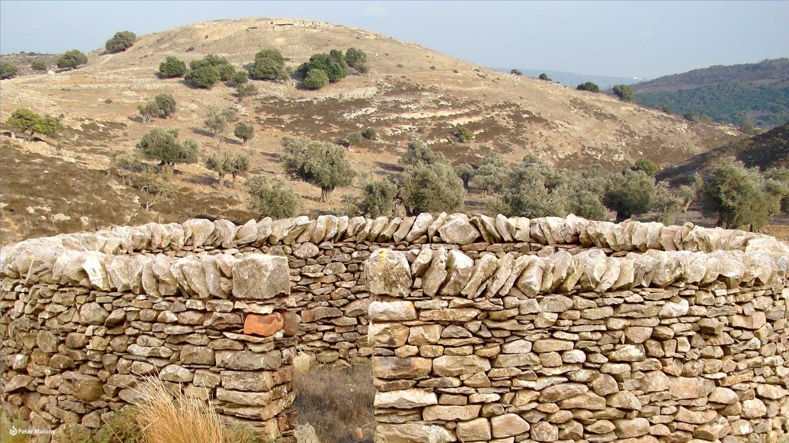

Translation:
“Sheep pen” must often be rendered “place for the protection of sheep,” “place for sheep with a wall built around it,” or “enclosure for sheep.” In contrast to the next entry (1.2.2 Animal pen, stall<REALIA:1.2.2>), this enclosure was built out in the areas where the sheep were grazing, and not near the house. It could often be a temporary structure.
In JER 49:3 the Hebrew word gderoth is rendered “sheep-pens” by NJB and “sheepfolds” by NJPSV. Others have “walls” (NIV, NASB, New Century Version [NCV]) or “hedges” (RSV, New Living Translation [NLT]). Others, however, prefer a small change in the Hebrew, so that it would mean “covered with gashes” as an expression of mourning. Translations that take this approach render the last half of the fourth line in this verse as “lament, and slash yourselves with whips” (NRSV) or “and score your bodies with gashes” (Revised English Bible [REB]).
The Hebrew words mishpthayim and shfatayim are translated in different ways. In GEN 49:14RSV and NJPSV have “sheepfolds,” while REB says “cattle pens.” These versions believe these words refer to an enclosure for domestic animals. GNT and NIV have “saddlebags,” which is preferred by A Handbook on Genesis, page 1090.

Animal pen, stall

1.2.2 Animal pen, stall

References:Hebrew אֻרְוָה (’awerah, ’urwah, ’uryah)1KI 5:6, 2CH 9:25, 2CH 32:28Hebrew בַּיִת (bayith)1SA 6:7, 1SA 6:10Hebrew מַרְבֵּק (marbeq)1SA 28:24, JER 46:21, AMO 6:4, MAL 3:20Hebrew רֶפֶת (refeth)HAB 3:17Greek φάτνη (fatnē)LUK 13:15

Description and usage:
This structure was a stall, part of a barn where animals were fed, or it was simply a customary place where animals were fed outside, often in a semi-circular enclosure. Since people normally possessed few cattle, the stalls were often near, or even inside, the house where the family lived.

Translation:
In contrast to 1.2.1 Sheep pen, sheepfold<REALIA:1.2.1>, this enclosure was permanent and built near the dwelling of the owner of the sheep.
In 1SA 28:24; JER 46:21; and AMO 6:4, the Hebrew phrase ‘egel marbeq is literally “calf of the stall,” indicating a calf that has been kept in a stall and fed until it is fat. While marbeq may usually be left untranslated, it is also possible to follow CEV ’s translation of the equivalent phrase in LUK 15:23, where it has “best calf” (compare GNT “prize calf”).

Manger, feed trough, feedbox

1.2.3 Manger, feed trough, feedbox

References:Hebrew אֵבוּס (’evus)JOB 39:9, PRO 14:4, ISA 1:3Greek φάτνη (fatnē)LUK 2:7, LUK 2:12, LUK 2:16

Description and usage:
Feed and water troughs in the stables at Megiddo (© Immanuel Giel, CC BY-SA 4.0, via Wikimedia Commons)The manger was a trough, made of stone or wood, where animals fed, possibly even an open feeding place under the sky.
<image: Z>

Translation:
It may be important in some languages to distinguish between various alternatives. A “feed trough” or “manger” normally refers to a relatively large box or rack containing hay, where an animal stands when it feeds; a “feedbox” is a much smaller container, usually for grain. There is no way of knowing precisely where the baby Jesus was placed in LUK 2:7, but it would have been appropriate for the baby to be placed in the feedbox or in the manger.

Rod, club, shepherd’s staff

1.2.4 Rod, club, shepherd’s staff

References:Hebrew מַטֶּה (mateh)GEN 38:18, GEN 38:25, EXO 4:2, EXO 4:4, EXO 4:17, EXO 4:20, EXO 7:9, EXO 7:10, EXO 7:12, EXO 7:12, EXO 7:12, EXO 7:15, EXO 7:17, EXO 7:19, EXO 7:20, EXO 8:1, EXO 8:12, EXO 8:13, EXO 9:23, EXO 10:13, EXO 14:16, EXO 17:5, EXO 17:9, NUM 17:17, NUM 17:17, NUM 17:17, NUM 17:17, NUM 17:18, NUM 17:18, NUM 17:20, NUM 17:21, NUM 17:21, NUM 17:21, NUM 17:21, NUM 17:21, NUM 17:22, NUM 17:23, NUM 17:24, NUM 17:24, NUM 17:25, NUM 20:8, NUM 20:9, NUM 20:11, 1SA 14:27, 1SA 14:43, ISA 9:3, ISA 10:5, ISA 10:15, ISA 10:24, ISA 10:26, ISA 14:5, ISA 28:27, ISA 30:32, EZK 7:10, EZK 7:11, EZK 19:11, EZK 19:12, EZK 19:14, EZK 19:14, HAB 3:14Hebrew מַקֵּל (maqel)GEN 32:11, EXO 12:11, NUM 22:27, 1SA 17:40, 1SA 17:43, HOS 4:12, ZEC 11:7, ZEC 11:10, ZEC 11:14Hebrew מִשְׁעֶנֶת (mash‘enah, mish‘eneth)EXO 21:19, NUM 21:18, JDG 6:21, 2KI 4:29, 2KI 4:29, 2KI 4:31, 2KI 18:21, PSA 23:4, ISA 36:6, EZK 29:6, ZEC 8:4Hebrew שֵׁבֶט (shevet)EXO 21:20, LEV 27:32, 2SA 7:14, 2SA 23:21, 1CH 11:23, JOB 9:34, JOB 21:9, JOB 37:13, PSA 2:9, PSA 23:4, PSA 89:33, PRO 10:13, PRO 13:24, PRO 22:8, PRO 22:15, PRO 23:13, PRO 23:14, PRO 26:3, PRO 29:15, ISA 9:3, ISA 10:5, ISA 10:15, ISA 10:24, ISA 11:4, ISA 14:29, ISA 28:27, ISA 30:31, LAM 3:1, EZK 20:37, EZK 21:15, EZK 21:18, MIC 4:14, MIC 7:14Greek ῥάβδος (rhabdos)MAT 10:10, MRK 6:8, LUK 9:3, 1CO 4:21, HEB 9:4, HEB 11:21, REV 2:27, REV 11:1, REV 12:5, REV 19:15, TOB 5:18, SIR 33:25, BEL 1:25

Description:
Shepherd holding a staff (Image generated by ChatGPT using OpenAI technology)The rod was a straight stick about 1–2 meters (3–6 feet) in length. Its diameter allowed it to fit comfortably in a person’s hand.
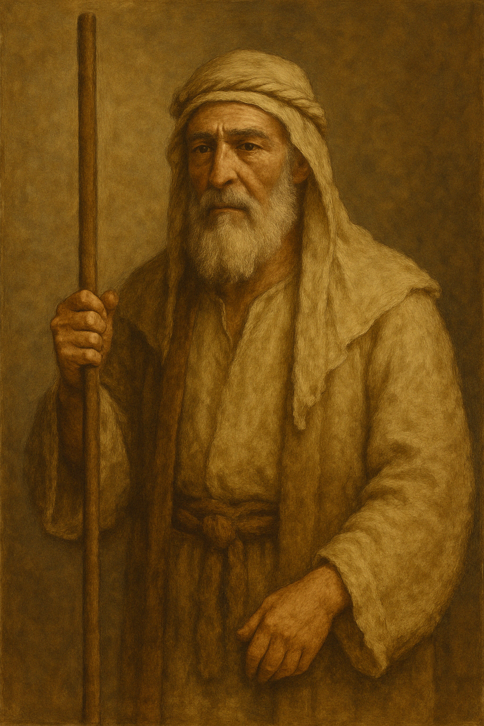

Usage:
The rod was, first of all, just a walking stick, and in some of the references above that is its primary purpose. However, it could serve many other purposes, including herding animals, fighting off wild animals, beating people, or even for divining (HOS 4:12). In the hands of a shepherd, the rod extended the shepherd’s reach, enabling him to direct stray sheep back to the flock.

Translation:
Translators must pay special attention to the context when rendering the Hebrew and Greek words listed above. The rod in the hand of the shepherd or traveler could serve multiple purposes. Sometimes it simply helped to maintain balance while walking over rough ground. It could also be wielded as an offensive or defensive weapon. On offense, it is probably best rendered “club” (see also 2.7 Club, war club, mace, shattering weapon<REALIA:2.7>). The Hebrew words are similar in meaning, and in several places they are used in poetic parallelism (mateh and shevet in LEV 27:32; ISA 10:5, ISA 10:15, ISA 10:24; ISA 28:27; ISA 30:31; ISA 30:32).
Some cultures will have a special word for a staff carried by a shepherd or someone who herds other animals. In other contexts the best rendering will be something like “walking stick” (CEV in HEB 11:21). However, in most passages translators should avoid using a word that gives the impression that the user of the stick was somehow feeble or crippled or injured. Such a staff was carried by men of all ages and states of health.
LEV 27:32: The phrase “every tenth animal of all that pass under the herdsman’s staff” (RSV) is probably an allusion to the way in which animals were selected for the tithe. The animals were counted as they passed single file under the staff of the herdsman. Every tenth animal was marked with a red colored stick to show that it had been chosen for the tithe. If this image can be retained in the receptor-language translation while at the same time clearly conveying the idea of counting, then this will probably be better. But the details of the actual procedure are less important than the fact that one of every ten animals was to be designated as belonging to the LORD. One possible model for the whole verse is “When you count your animals, cattle, sheep or goats, every tenth animal must be marked as belonging to the LORD.”
PSA 23:4: The Hebrew words shevet and mish‘eneth are used together in this verse as if they are distinguishable objects. We may quote from A Handbook on Psalms: “The \+u rod\+u* was a club used to drive away wild animals; the \+u staff\+u* was a long stick used for support in walking. Kirkpatrick takes the two words to be a poetic description of the shepherd’s crook, using two names for the one instrument. So FRCL ‘your shepherd’s rod, that is what reassures me.’ Most translations, however, have two different words. TEV [that is, GNT] has used the traditional ‘rod and staff ’; but since there will be many readers who will not know what these are, TEV qualifies them with ‘Your shepherd’s rod and staff ’ ” (page 234).
1CO 4:21: This is the only place where Paul uses the Greek word rhabdos, and its meaning must be determined from the context. It is very unlikely that Paul thinks of a literal stick with which he is threatening to beat his converts. It is also very unlikely that he thinks of himself as a ruler. His authority is “in Christ” (verses 15, 17), and he describes it as the authority of a father (verse 15) or a teacher. Both fathers and teachers had the acknowledged right to correct their children or pupils, if necessary, by using force. This idea is difficult to convey in the setting of many modern societies. Paul’s language also seems to have irony in it. Translators have found different ways of explaining or bringing out the meaning of the word rhabdos. Some maintain the image of the instrument of punishment (REB and DUCL “a rod in my hand”; Moffatt [Mft] and Barclay [Brc] “rod of discipline”). Others focus on the element of punishment; for example, CEV begins the second question of this verse with “Do you want me to be hard on you,” and NCV has “that I come to you with punishment.” GNT has replaced the rod with a whip by saying “Shall I come to you with a whip.” This has been done presumably because a whip or strap is more familiar in English as an instrument of punishment. Some translators will want to follow this model and substitute an instrument better known in their society.
HEB 11:21: In GEN 47:31 the Hebrew word m-t-h can mean either “staff” or “bed,” depending on what vowels are given to the word (see the discussion at 5.5 Bed, sleeping mat<REALIA:5.5>). Most translations render it “bed.” NIV is an exception with “staff,” and it gives “bed” in the margin. The writer of Hebrews has followed the Septuagint, which has “staff.” The translator of Hebrews must not try to harmonize these verses but should translate the Greek of this verse, which can only mean “staff.”
REV 2:27; REV 12:5; REV 19:15: The literal phrase “to rule … with a rod of iron” appears in these three verses (compare PSA 2:9). This means to rule completely, ruthlessly, crushing all opposition. The “iron rod” was probably a heavy wooden club capped with iron, not a club made of iron. When translating this expression, some cultural adjustment may have to be made. If there is no local equivalent to “a rod of iron,” the translation may say “to rule with complete authority.”
The “staff” is often used in Scripture in a figurative sense, and the figures may not correspond to something known in the receptor language. In such cases it will be preferable to translate the sense.
In TOB 5:18 Tobit’s parents speak of him as “the staff of our hand” (NRSV), meaning that they are dependent on his help. GNT has found a good English idiom to convey the meaning: “He’s our only means of support.”

Shepherd’s bag/pouch

1.2.5 Shepherd’s bag/pouch

References:Hebrew יַלְקוּט (yalqut)1SA 17:40Hebrew כְּלִי, הָרֹעִים (kli (haro‘im))1SA 17:40, 1SA 17:49

Description:
A shepherd carries a bag for food and other provisions (Image generated by ChatGPT using OpenAI technology)The shepherd’s bag was a pouch hung from the shoulder by a strap or attached to the belt or sash around the waist. It could be made of leather or cloth.
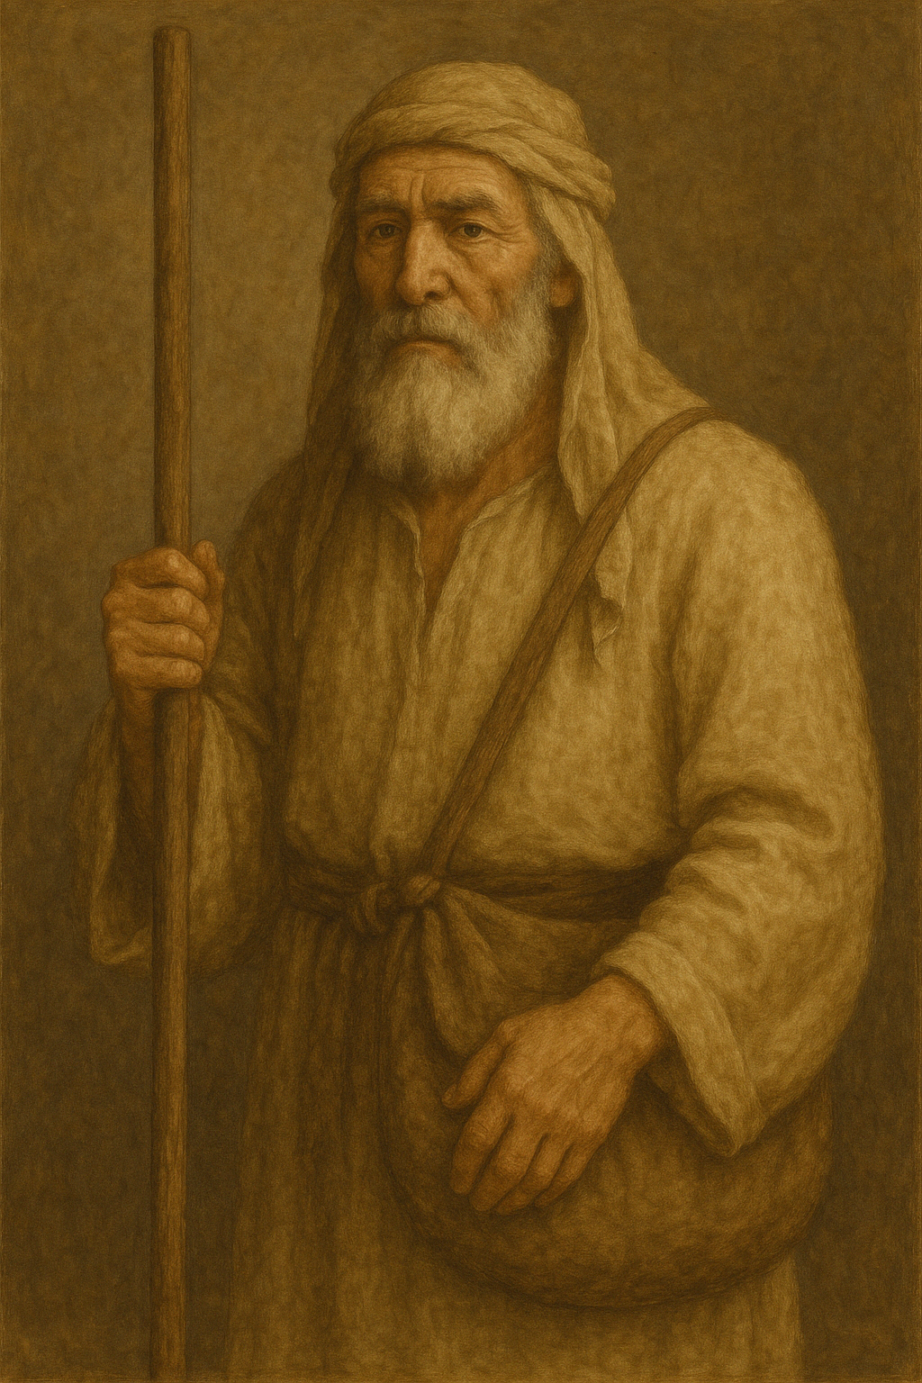

Usage:
The shepherd used the bag to carry food and small personal items.

Translation:
1SA 17:40: This verse uses two words to describe the place where David put the five stones he selected for his upcoming battle with Goliath. Some translations understand the one item to be part of the other: “in the pouch of his shepherd’s bag” (NIV; similarly NRSV, ITCL). Others treat the two terms as referring to one object: “in a shepherd’s bag, which served as his pouch” (REB; similarly NASB). Most common-language translations that were consulted use only one word to translate the two Hebrew words; for example, GNT has “in his bag,” while several others have “in his shepherd’s bag” (PV). SPCL can serve as a good model: “in the bag which he carried with him.”
For the Hebrew word kli, see 5.18 Containers, vessels<REALIA:5.18>.

Bit and bridle

1.2.6 Bit and bridle

References:Hebrew מֶתֶג (metheg)2KI 19:28, PSA 32:9, PRO 26:3, ISA 37:29Hebrew רֶסֶן (resen)JOB 41:5, PSA 32:9, ISA 30:28Greek χαλινός (chalinos)JAS 3:3, REV 14:20Greek χρυσοχάλινος (chrusochalinos)2MA 10:29, 1ES 3:6Greek κόσμος (kosmos)2MA 5:3Greek σαγή (sagē)2MA 3:25

Description:
Ancient bronze horse bit (© Deutsche Bibelgesellschaft, Stuttgart by United Bible Societies)The bit was a short bar, usually made of metal, placed in the mouth of a horse. Its ends, which projected from the mouth of the animal, were attached to ropes or leather straps that fitted over the head as the bridle.
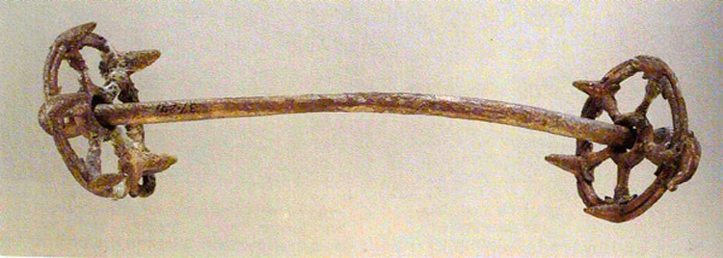

Usage:
Harness with bridle and bit fitted on the horse's head (© Gary Todd - Wikimedia Commons)By pulling on the bridle straps to the right or left, the rider or driver of the wagon could control the actions of the horse.
<image: 2Q==>

Translation:
Horse and rider showing use of reins (© Wikimedia Commons)The Hebrew words metheg and resen respectively refer to the “bit” and “bridle” (although RSV has once rendered metheg as “bridle” in PRO 26:3). The Greek words chalinos and chrusochalinos refer to both the bit and bridle. Where a bit or bridle as a piece of harness is unknown, translators can use a descriptive phrase, such as “something to guide a horse with” or “something to put in the mouth of a horse to guide it.”
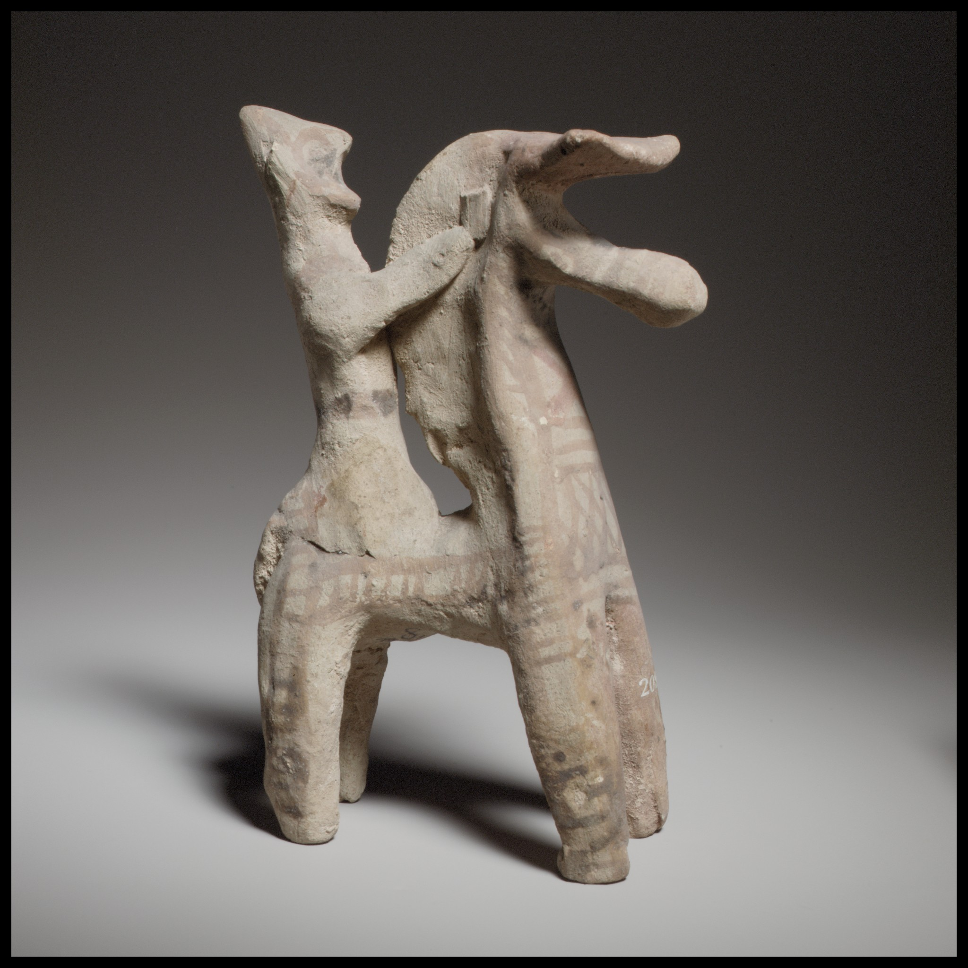
The Hebrew word mtsilah in ZEC 14:20 probably refers to some sort of noise-making decoration on the harness of a horse. The word occurs only here in the Bible.
In REV 14:20 the reference to “a horse’s bridle” (RSV) is merely an indication of measurement. It refers to the height of the bridle from the ground, so we may render this measurement as “about a meter and a half” (FRCL) or “about five feet” (GNT).
The Greek word used in 2MA 10:29 and 1ES 3:6 indicates that the metal parts of the bridle were made of gold.

