Resource: Human-made Things in the Bible
Human-made Things in the Bible © United Bible Societies, 2025. Adapted from: The Works of Their Hands: Man-made Things in the Bible, by Ray Pritz © 2009 United Bible Societies. This work is licensed under Creative Commons Attribution-ShareAlike 4.0 International (https://creativecommons.org/licenses/by-sa/4.0/).

Human-made Things in the Bible

Blacksmith

1.11 Blacksmith

Smelting furnace, kiln

1.11.1 Smelting furnace, kiln

References:Aramaic אַתּוּן (’atun)DAN 3:6, DAN 3:11, DAN 3:15, DAN 3:17, DAN 3:19, DAN 3:20, DAN 3:21, DAN 3:22, DAN 3:23, DAN 3:26Hebrew כִּבְשָׁן (kivshan)GEN 19:28, EXO 9:8, EXO 9:10, EXO 19:18Hebrew כּוּר (kur)DEU 4:20, 1KI 8:51, PRO 17:3, PRO 27:21, ISA 48:10, JER 11:4, EZK 22:18, EZK 22:20, EZK 22:22Hebrew מַצְרֵף (matsref)PRO 17:3, PRO 27:21Hebrew עֲלִיל (‘alil)PSA 12:7Greek κάμινος (kaminos)MAT 13:42, MAT 13:50, REV 1:15, REV 9:2, SIR 2:5, SIR 22:24, SIR 27:5, SIR 31:26, SIR 38:28, SIR 38:30, SIR 43:4, 3MA 6:6, 4MA 13:9, 4MA 16:3, 4MA 16:21, DAG 3:6, DAG 3:11, DAG 3:15, DAG 3:17, DAG 3:19, DAG 3:20, DAG 3:21, DAG 3:22, DAG 3:23, DAG 3:46, DAG 3:47, DAG 3:48, DAG 3:49, DAG 3:49, DAG 3:50, DAG 3:51, DAG 3:88, DAG 3:93Greek χωνευτήριον (chōneutērion)WIS 3:6Latin fornax2ES 4:48Latin clibanus2ES 7:36

Description:
Cross section of a pottery kiln (Encyclopaedia Biblica, 1903, Public domain, via Wikimedia Commons)The kiln was a furnace used for the smelting of ore or the firing of ceramic ware. Such furnaces were made of hardened clay or of brick. They could vary considerably in size and shape. See also 5.11 Oven<REALIA:5.11>.
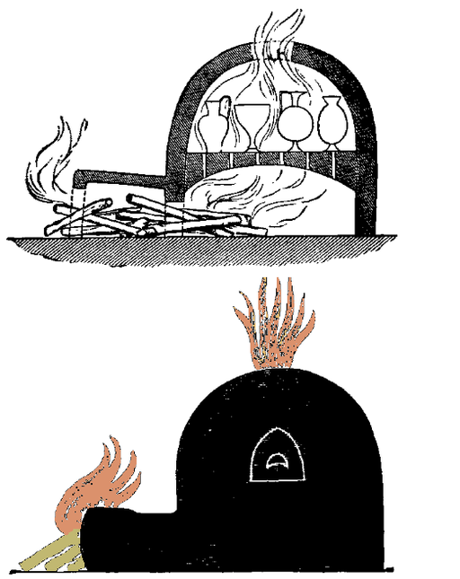

Usage:
Reconstructed kiln in Revadim, Israel (© Heritage Conservation Outside the City, Pikiwiki Israel, CC BY 2.5, via Wikimedia Commons)Almost all metals exist in nature in combination with other minerals. To remove the other minerals requires chemical treatment combined with heating the ore to very high temperatures in kilns. Such heating chambers served also for firing bricks or pottery and for other purposes.
<image: 9k=>

Translation:
When translating the word “furnace,” the emphasis should be upon the extreme heat, rather than upon the particular type of construction. However, if a particular word for “furnace” is chosen, it should be remembered that this furnace or oven was not made of metal but of brick or hardened clay.
The Hebrew word kur is always used in metaphorical or symbolic language describing human sufferings. It will often be possible to portray the meaning of the metaphor without reference to the physical object; for example, CEV renders DEU 4:20 as “But you are the LORD’s people, because he led you through fiery trials and rescued you from Egypt.”
PSA 12:7: The Hebrew word ‘alil occurs only here in the Old Testament, and its meaning is uncertain. It seems best to translate the obscure clause at the end of this verse in a general sense; for example, GNT has “they are as genuine as silver refined seven times in the furnace,” and NIV says “like silver refined in a furnace of clay, purified seven times.” “Seven times” means “many times,” that is, as many times as needed to get rid of all the impurities.
PRO 17:3; PRO 27:21: Two instruments for heating and refining metals are mentioned in these verses: the matsref and the kur. If separate words exist in a language for these two instruments (for example, “crucible” and “furnace”), these may be used. Many translations combine the two words; for example, in PRO 17:3 a GNT says “Gold and silver are tested by fire,” and NCV has “A hot furnace tests silver and gold.”
DAN 3:0: The furnace described here probably had an opening at the top and another at ground level. It was clearly large enough for men to stand and even walk around in. The word for “furnace” here should also be used in DAG 3:23–DAG 3:28 and DAG 3:66.
In MAT 13:42; MAT 13:50 the Greek word kaminos is used figuratively of hell. Alternative renderings for the literal phrase “the furnace of fire” are “the fires of hell” and “hell, which is like a great fire.” Another possibility is simply “the great fire.” Similarly, the Latin word clibanus is used metaphorically in 2ES 7:36 for the heat of hell.
The difference between this entry and 5.11 Oven<REALIA:5.11> is primarily one of size rather than of basic design. Ovens, of course, could be put to many uses. Where a language does not have a variety of words, such as “oven,” “furnace” and “kiln” in English, a single word will normally suffice. In that case, it will sometimes be necessary to indicate the relative size of the oven according to the context. An oven in which bread was baked may be rendered “small oven,” while the one into which several people were thrown will be a “very large oven.”
The fuel burned in ancient ovens was wood, the leftover flesh of pressed olives, or dried animal dung. Translators should avoid a word for “oven” that indicates a device that runs on electricity or uses a refined fuel like oil or kerosene.

Bellows

1.11.1.1 Bellows

References:Hebrew מַפּוּחַ (mapuach)JER 6:29Greek ζώπυρον, πῦρ (zōpuron tou puros)4MA 8:13

Description:
Bellows operated by workers (© Le plombier du désert, CC BY-SA 4.0, via Wikimedia Commons)Where extremely high temperatures were needed, such as when smelting ore, it was common to blow air into the bottom of the fire with a bellows. One type of bellows consisted of two vertical cylinders covered with thick leather. The operator stood on these, pulling the leather up with an attached strap and then pressing it down with his foot to create the rush of air, which was channeled into the furnace.
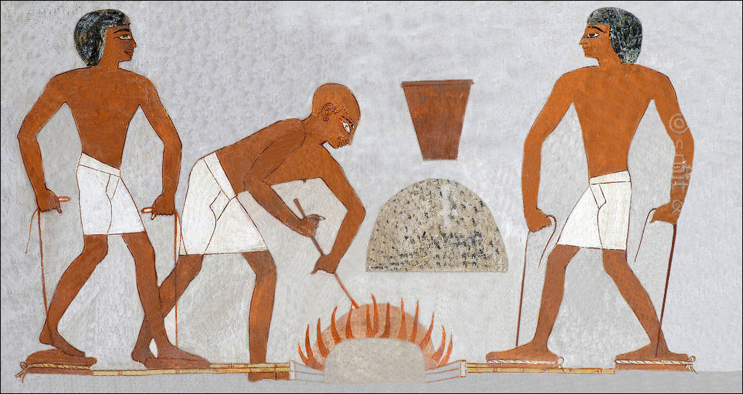

Translation:
Not all present-day English speakers are familiar with the structure or operation of a bellows, so several common-language English translations have avoided using the word in JER 6:29 by rendering the first line of this verse as “The fire is fanned to make it hotter” (NCV), “The furnace burns fiercely” (GNT), or “in a fiery furnace” (CEV).

Anvil

1.11.2 Anvil

References:Hebrew פַּעַם (pa‘am)ISA 41:7Greek ἄκμων (akmōn)SIR 38:28

Description and usage:
Modern anvil (© MikiNikoloski, CC BY-SA 3.0, via Wikimedia Commons)The anvil was a heavy piece of metal that served as a base for hammering and shaping other pieces of metal.
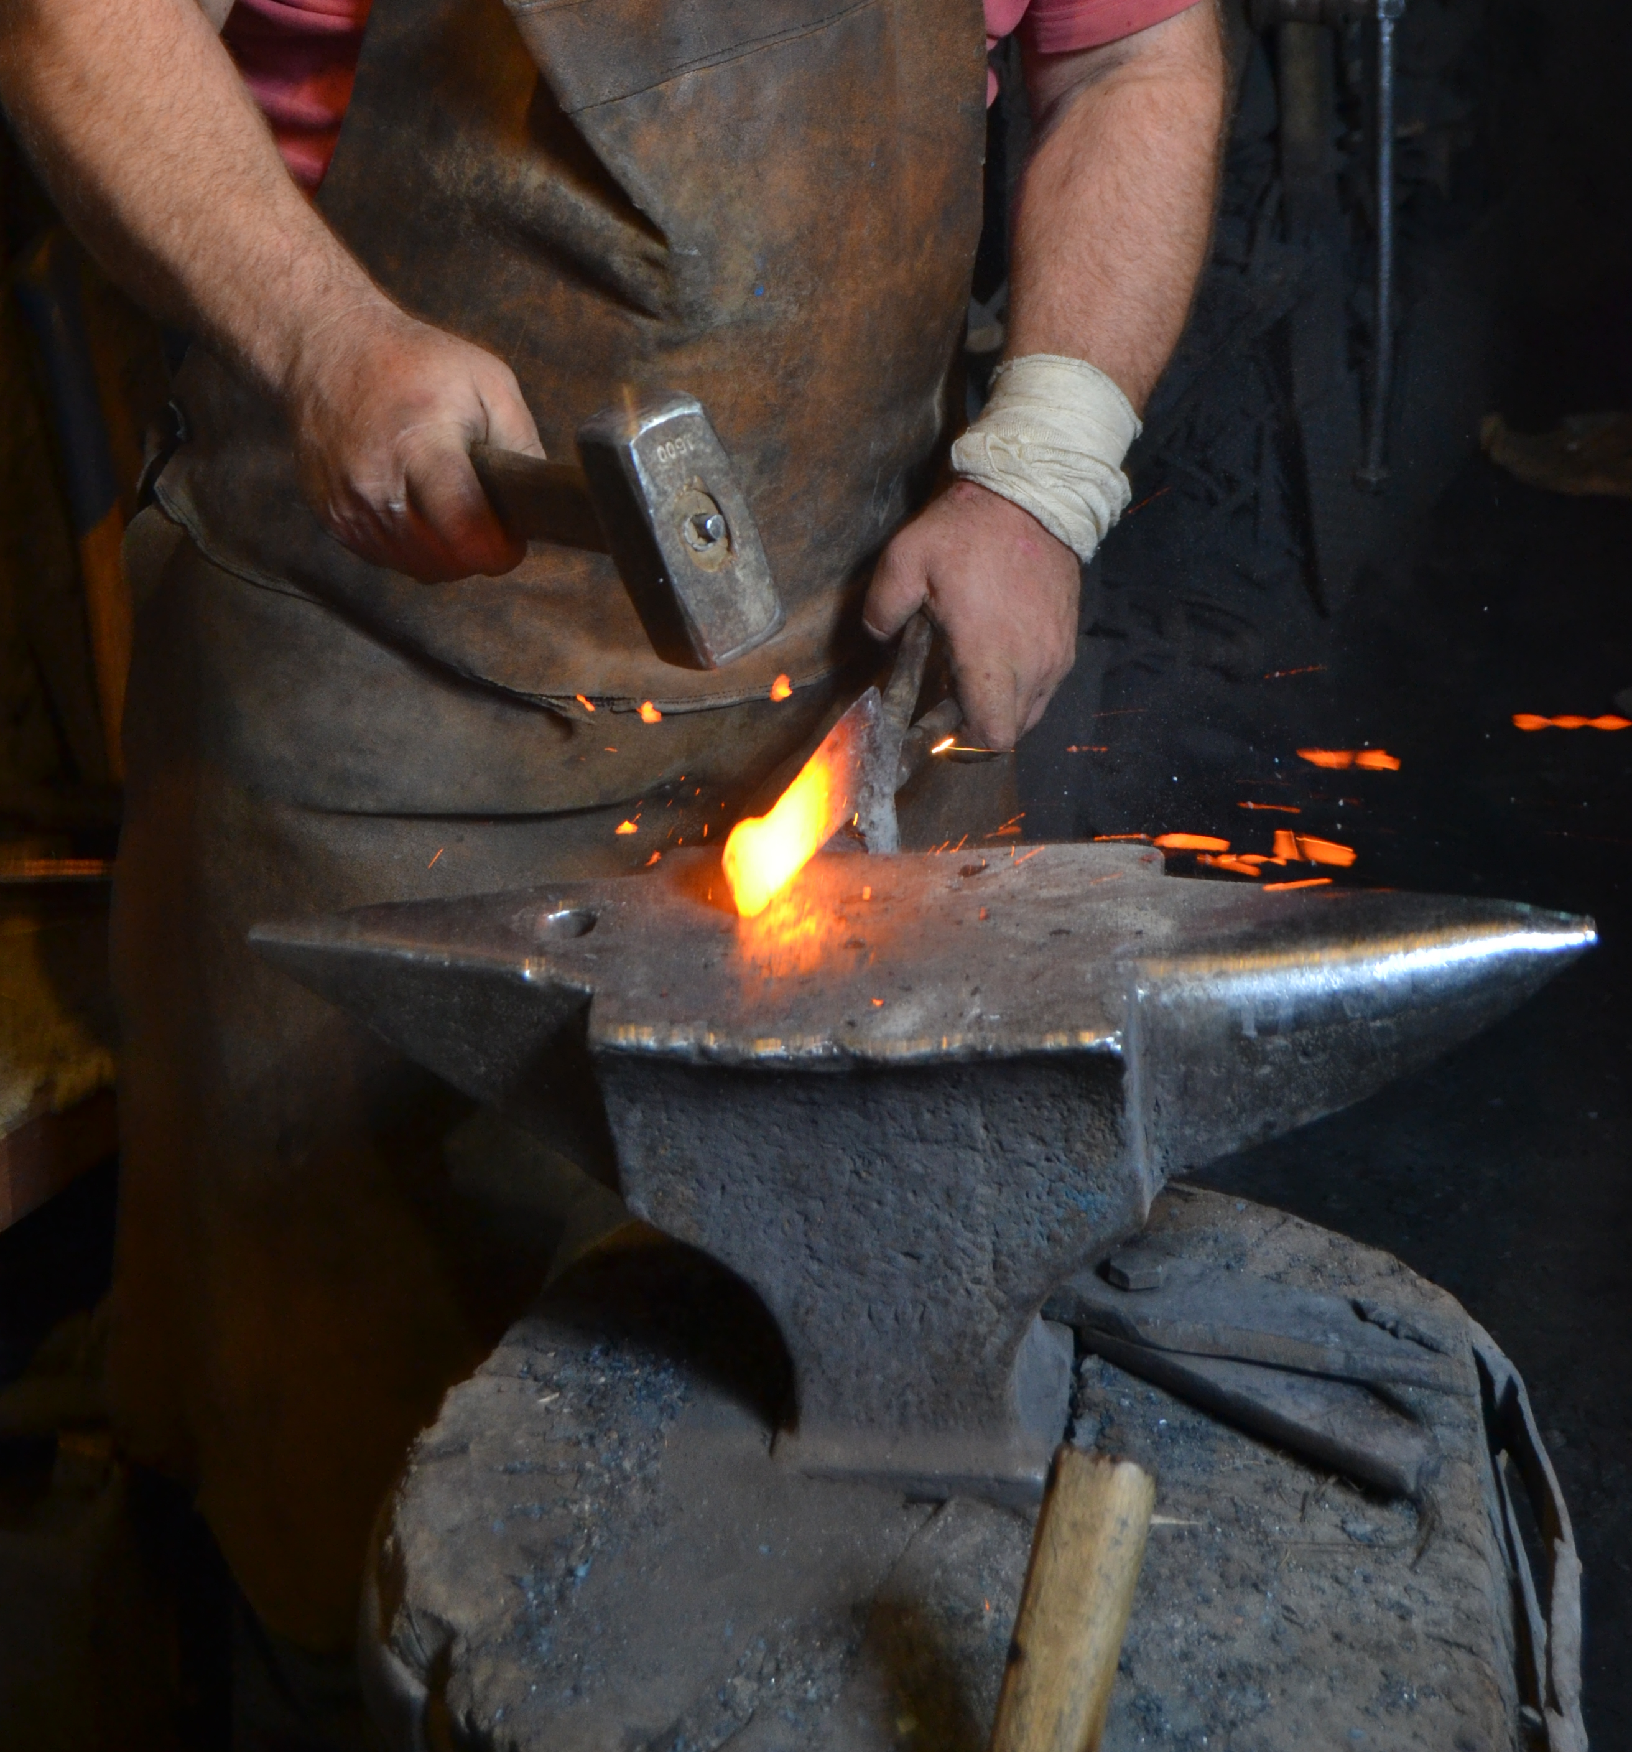

Translation:
The meaning of the Hebrew phrase holem pa‘am in ISA 41:7 is uncertain, so translations vary. The basic meaning seems to be connected to striking blows with a hammer. This has given rise to several interpretations: GNT “the one who nails it together,” NCV “the one who shapes the metal,” and NRSV “the one who strikes the anvil” (similarly NIV). CEV has “other workers” and adds a footnote explaining that the text is difficult.
Where there is no equivalent for “anvil,” in SIR 38:28 translators may say “It is the same with the iron worker at his work.”
Tongs: See 4.4.3 Tongs<REALIA:4.4.3>.

