Resource: Human-made Things in the Bible
Human-made Things in the Bible © United Bible Societies, 2025. Adapted from: The Works of Their Hands: Man-made Things in the Bible, by Ray Pritz © 2009 United Bible Societies. This work is licensed under Creative Commons Attribution-ShareAlike 4.0 International (https://creativecommons.org/licenses/by-sa/4.0/).

Human-made Things in the Bible

Cistern

3.9 Cistern

References:Hebrew בֹּאר (bo’r)2SA 23:20, JER 2:13, JER 2:13Hebrew בּוֹר (bor)GEN 37:20, GEN 37:22, GEN 37:24, GEN 37:24, GEN 37:28, GEN 37:29, GEN 37:29, GEN 40:15, GEN 41:14, EXO 12:29, EXO 21:33, EXO 21:33, EXO 21:34, LEV 11:36, DEU 6:11, 1SA 13:6, 1SA 19:22, 2SA 23:15, 2SA 23:16, 2SA 23:20, 2KI 10:14, 2KI 18:31, 1CH 11:17, 1CH 11:18, 1CH 11:22, 2CH 26:10, NEH 9:25, PSA 7:16, PSA 28:1, PSA 30:4, PSA 40:3, PSA 88:5, PSA 88:7, PSA 143:7, PRO 1:12, PRO 5:15, PRO 28:17, ECC 12:6, ISA 14:15, ISA 14:19, ISA 24:22, ISA 36:16, ISA 38:18, ISA 51:1, JER 2:13, JER 2:13, JER 6:7, JER 37:16, JER 38:6, JER 38:6, JER 38:7, JER 38:9, JER 38:10, JER 38:11, JER 38:13, JER 41:7, JER 41:9, LAM 3:53, LAM 3:55, EZK 26:20, EZK 26:20, EZK 31:14, EZK 31:16, EZK 32:18, EZK 32:23, EZK 32:24, EZK 32:25, EZK 32:29, EZK 32:30, ZEC 9:11Hebrew גֵּב (gev)JER 14:3Greek ἀποδοχεῖον (apodocheion)SIR 50:3Greek λάκκος (lakkos)JDT 7:21, JDT 8:31, SIR 50:3, 2MA 10:37Greek φρέαρ (frear)1MA 7:19, 2MA 1:19

Description:
Water cistern with plaster walls (© צילום:ד"ר אבישי טייכר, CC BY 2.5, via Wikimedia Commons)The cistern was a pit hollowed out of solid rock for the purpose of storing water. Cisterns could be 6 meters (20 feet) across and 6 meters (20 feet) deep or even larger. In earliest times they were hewn out of rock that did not allow water to seep through it. With the discovery how to make plaster, cisterns could be dug in many kinds of rock and then lined with plaster, which sealed any holes or cracks.
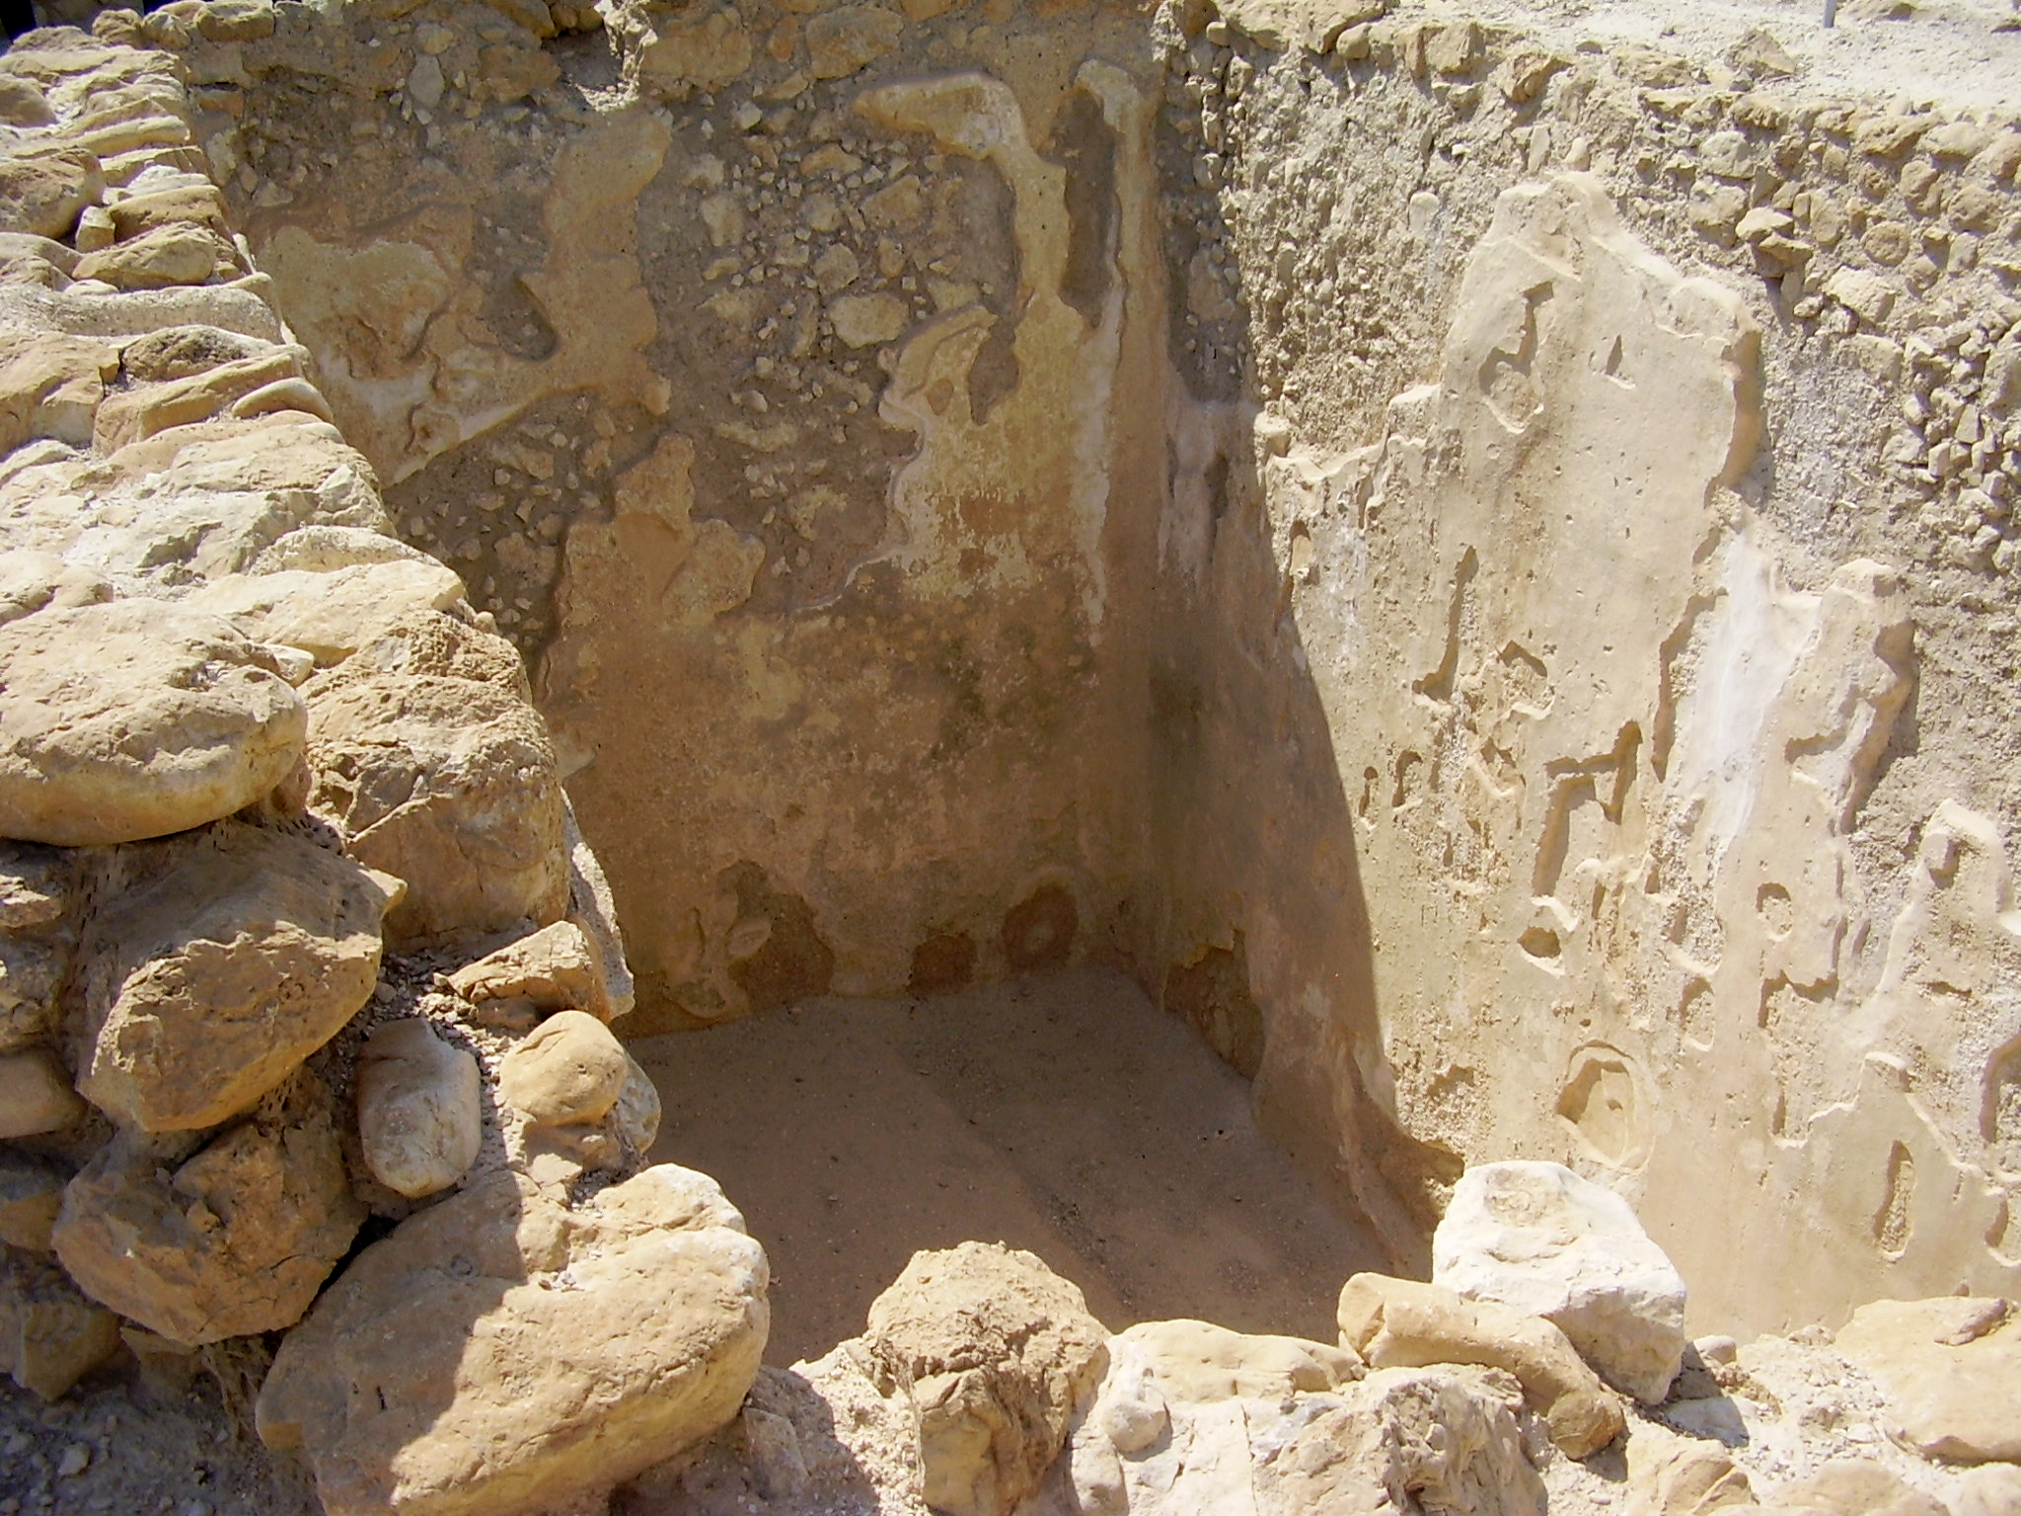

Usage:
In the land of Israel, almost all of the annual rain falls between the months of November and March. Cisterns served to store excess rainwater or water from springs that dried up in the summer. The stored water could be used during the dry months of the year.

Translation:
A cistern differed from a well in that a cistern received water that flowed to it from a source removed from it at some distance, while the water in a well accumulated from its immediate vicinity. It is not always clear from the context whether a well or a cistern is intended in the passages listed above; for example, in NEH 9:25NIV, TOB and NCV have “wells,” while RSV, GNT and CEV have “cisterns.” Similar uncertainty exists for most of the above references to the Hebrew word bor. In some cases bor can refer to a “pit” that occurs naturally. This may be true of the bor into which Joseph was thrown by his brothers in GEN 37:0. Some translations have “cistern” (NIV, FRCL, GECL), some say “well” (GNT, CEV), while others are noncommittal with “pit” (RSV, NASB).
It is possible to render “cistern” with a descriptive phrase such as “hollowed place in a rock for storing water.” In 2CH 26:10CEV provides a helpful model for the clause “he dug cisterns” by expanding it as follows: “he had cisterns dug there to catch the rainwater.” In JER 2:13CEV says “you’ve tried to collect water in cracked and leaking pits dug in the ground.”
PRO 5:15: See the comments on this verse at 3.8 Well<REALIA:3.8>.
ECC 12:6: For the last clause in this verse, RSV has “the wheel broken at the cistern.” This rendering is uncertain and translations differ. At the end of this verse the Hebrew text has two parallel clauses, which are literally “the jar will be shattered at the spring, and the wheel will be broken at the cistern.” Most translators and commentators understand the Hebrew word galgal (“wheel”) to refer to a kind of pulley that aided in lifting the water container at a well; for example, for the last clause CEV has “the pulley at the well is shattered” (similarly NJB, NAB, ITCL). Scott points out that the parallelism demands that galgal correspond to kad, which is a clay pitcher or jar. However, in his own translation he has “the water wheel broken at the cistern” (page 254). GNT seems to reverse the last two clauses in order to follow the order of events: “the rope at the well will break, and the water jar will be shattered.” It is probably best to treat the “wheel” as a pulley. Where a pulley wheel is unknown, translators may follow the GNT model. However, even if you follow GNT, a note may be necessary to explain that the rope was used to pull up a water container attached to it.

