Resource: Human-made Things in the Bible
Human-made Things in the Bible © United Bible Societies, 2025. Adapted from: The Works of Their Hands: Man-made Things in the Bible, by Ray Pritz © 2009 United Bible Societies. This work is licensed under Creative Commons Attribution-ShareAlike 4.0 International (https://creativecommons.org/licenses/by-sa/4.0/).

Human-made Things in the Bible

Booth, tabernacle

3.16 Booth, tabernacle

References:Hebrew סֹךְ, סֻכָּה (sok, sukah)GEN 33:17, LEV 23:34, LEV 23:42, LEV 23:42, LEV 23:43, DEU 16:13, DEU 16:16, DEU 31:10, 2SA 11:11, 2SA 22:12, 1KI 20:12, 1KI 20:16, 2CH 8:13, EZR 3:4, NEH 8:14, NEH 8:15, NEH 8:16, NEH 8:17, NEH 8:17, JOB 27:18, JOB 36:29, JOB 38:40, PSA 10:9, PSA 18:12, PSA 27:5, PSA 31:21, PSA 76:3, ISA 1:8, ISA 4:6, JER 25:38, AMO 9:11, JON 4:5, ZEC 14:16, ZEC 14:18, ZEC 14:19Greek σκηνή (skēnē)MAT 17:4, MRK 9:5, LUK 9:33, ACT 15:16, 2MA 10:6Greek σκήνωμα (skēnōma)2MA 10:6Greek σκηνοπηγία (skēnopēgia)JHN 7:2, 1MA 10:21, 2MA 1:9, 2MA 1:18, 1ES 5:50

Description and usage:
Temporary dwelling (sukkah) (© Ori229, CC BY-SA 3.0, via Wikimedia Commons)The booth was a small, temporary dwelling usually made of natural materials such as leafy branches, reeds, or grass. While it had no fixed size or shape, it was probably only large enough for a family to sleep in.
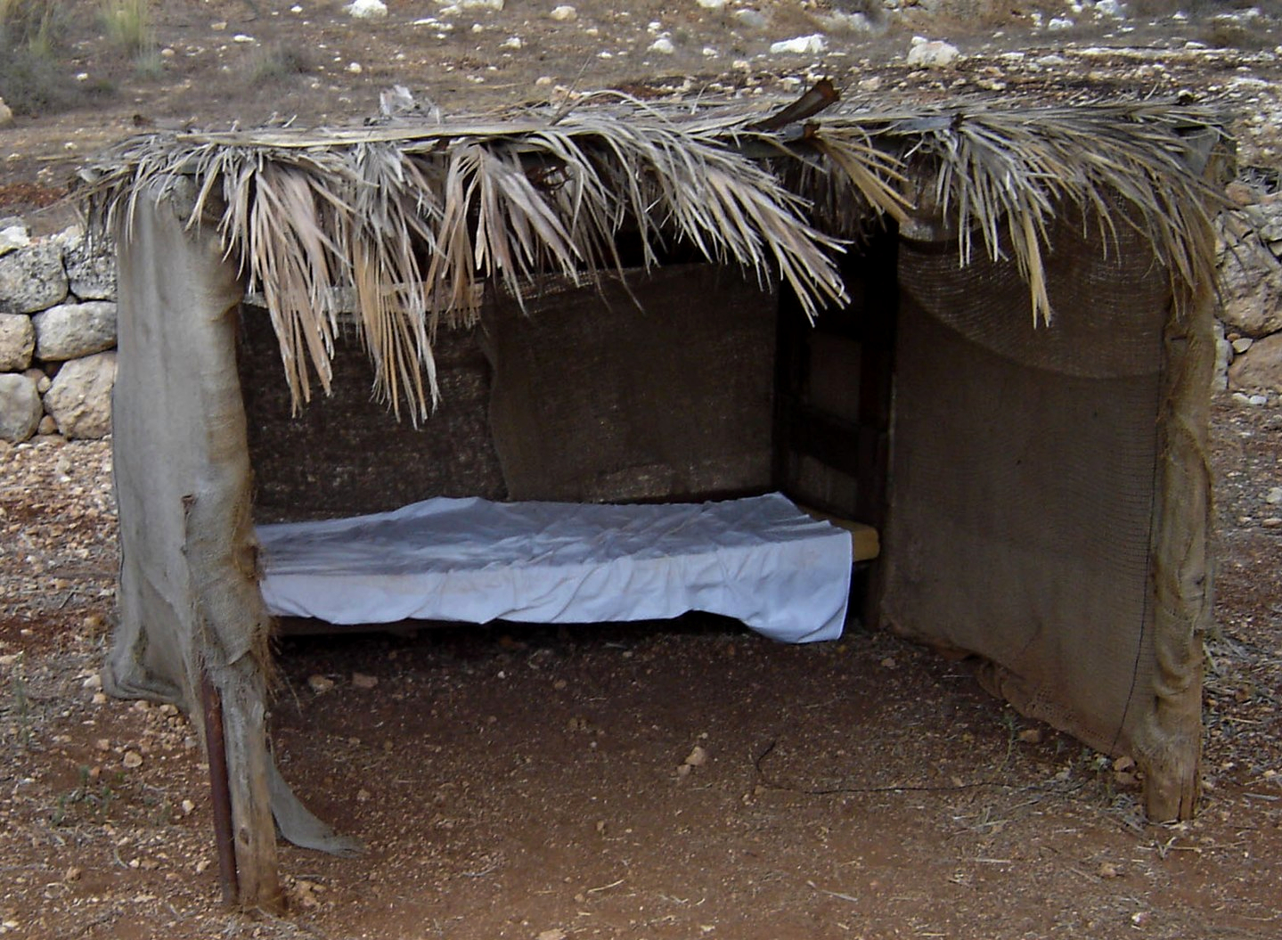

Translation:
Many languages will have no common word for such a temporary dwelling. In English the words “tabernacle” and “booth,” used by older translations, are likely to be misunderstood today. Common-language translations have “shelter,” which adequately preserves the sense of the word.
Watchman's shelter (© Deutsche Bibelgesellschaft, Stuttgart by United Bible Societies)On the other hand, many languages will have a word for a structure that is almost identical to the structure referred to by the Hebrew word sukah, even though such a structure is the normal dwelling and not considered temporary or portable. Translators should seek for a word that indicates a temporary and portable dwelling. If at all possible, however, a word meaning “tent” should be avoided, since the tent, while portable, was the permanent dwelling of many Bible characters (see 3.2 Tent<REALIA:3.2>). Often such temporary dwellings may be used by farmers during the day for shade, or even overnight if they have to stay in the fields to protect their crop from monkeys and other pests. Or they may be used by herders when traveling with their cattle.
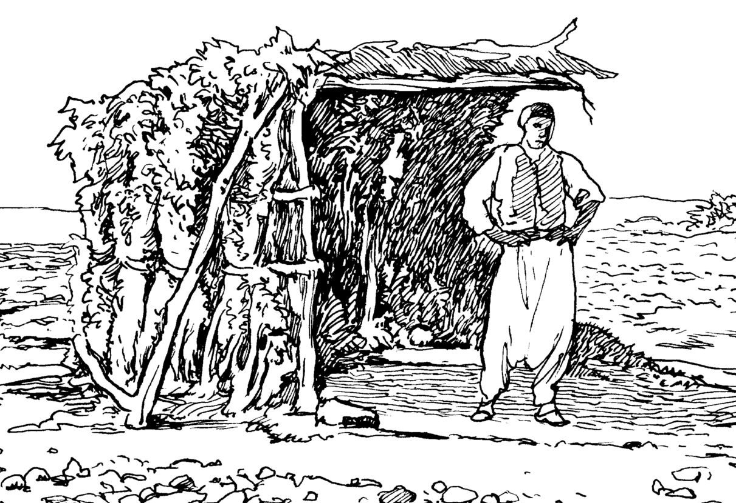
Where no single appropriate word exists, it is possible to use a descriptive expression, such as “temporary hut” or “temporary dwelling.”
In 2SA 22:12; JOB 36:29; PSA 18:12; PSA 27:5; and PSA 31:21 the Hebrew word sukah symbolizes the dwelling place of God.
AMO 9:11: The Hebrew word sukah is used here as a picture to which the kingdom of David is probably being compared. The point of similarity is almost certainly to be found in the word “fallen” (RSV). David’s kingdom is now destroyed, broken down, like an old broken down building. “The kingdom of David” (GNT) refers to the people of Israel at the highest point of their political and military power. In English it is more natural to translate sukah here as “house”; for example, NEB says “On that day I will restore David’s fallen house ….” GNT has made the comparison clear in every way, which is what most translations need to do: “The LORD says, ‘A day is coming when I will restore the kingdom of David, which is like a house fallen into ruins. I will repair its walls and restore it. I will rebuild it and make it as it was long ago.’ ”
The Greek word skēnopēgia, which appears in JHN 7:2, is the name of the festival, often known as the “Feast of Tabernacles” (NIV) or the “Festival of Booths.” During this festival the people of Israel were commanded to live in huts. The name of this festival should be rendered the same as in LEV 23:34.

