Resource: Human-made Things in the Bible
Human-made Things in the Bible © United Bible Societies, 2025. Adapted from: The Works of Their Hands: Man-made Things in the Bible, by Ray Pritz © 2009 United Bible Societies. This work is licensed under Creative Commons Attribution-ShareAlike 4.0 International (https://creativecommons.org/licenses/by-sa/4.0/).

Human-made Things in the Bible

Covenant Box, Ark of the Covenant

4.1 Covenant Box, Ark of the Covenant

References:Hebrew אֲרוֹן (’aron)GEN 50:26, EXO 25:10, EXO 25:14, EXO 25:14, EXO 25:15, EXO 25:16, EXO 25:21, EXO 25:21, EXO 25:22, EXO 26:33, EXO 26:34, EXO 30:6, EXO 30:26, EXO 31:7, EXO 35:12, EXO 37:1, EXO 37:5, EXO 37:5, EXO 39:35, EXO 40:3, EXO 40:3, EXO 40:5, EXO 40:20, EXO 40:20, EXO 40:20, EXO 40:21, EXO 40:21, LEV 16:2, NUM 3:31, NUM 4:5, NUM 7:89, NUM 10:33, NUM 10:35, NUM 14:44, DEU 10:1, DEU 10:2, DEU 10:3, DEU 10:5, DEU 10:8, DEU 31:9, DEU 31:25, DEU 31:26, JOS 3:3, JOS 3:6, JOS 3:6, JOS 3:8, JOS 3:11, JOS 3:13, JOS 3:14, JOS 3:15, JOS 3:15, JOS 3:17, JOS 4:5, JOS 4:7, JOS 4:9, JOS 4:10, JOS 4:11, JOS 4:16, JOS 4:18, JOS 6:4, JOS 6:6, JOS 6:6, JOS 6:7, JOS 6:8, JOS 6:9, JOS 6:11, JOS 6:12, JOS 6:13, JOS 6:13, JOS 7:6, JOS 8:33, JOS 8:33, JDG 20:27, 1SA 3:3, 1SA 4:3, 1SA 4:4, 1SA 4:4, 1SA 4:5, 1SA 4:6, 1SA 4:11, 1SA 4:13, 1SA 4:17, 1SA 4:18, 1SA 4:19, 1SA 4:21, 1SA 4:22, 1SA 5:1, 1SA 5:2, 1SA 5:3, 1SA 5:4, 1SA 5:7, 1SA 5:8, 1SA 5:8, 1SA 5:8, 1SA 5:10, 1SA 5:10, 1SA 5:10, 1SA 5:11, 1SA 6:1, 1SA 6:2, 1SA 6:3, 1SA 6:8, 1SA 6:11, 1SA 6:13, 1SA 6:15, 1SA 6:18, 1SA 6:19, 1SA 6:21, 1SA 7:1, 1SA 7:1, 1SA 7:2, 1SA 14:18, 1SA 14:18, 2SA 6:2, 2SA 6:3, 2SA 6:4, 2SA 6:4, 2SA 6:6, 2SA 6:7, 2SA 6:9, 2SA 6:10, 2SA 6:11, 2SA 6:12, 2SA 6:12, 2SA 6:13, 2SA 6:15, 2SA 6:16, 2SA 6:17, 2SA 7:2, 2SA 11:11, 2SA 15:24, 2SA 15:24, 2SA 15:25, 2SA 15:29, 1KI 2:26, 1KI 3:15, 1KI 6:19, 1KI 8:1, 1KI 8:3, 1KI 8:4, 1KI 8:5, 1KI 8:6, 1KI 8:7, 1KI 8:7, 1KI 8:9, 1KI 8:21, 2KI 12:10, 2KI 12:11, 1CH 6:16, 1CH 13:3, 1CH 13:5, 1CH 13:6, 1CH 13:7, 1CH 13:9, 1CH 13:10, 1CH 13:12, 1CH 13:13, 1CH 13:14, 1CH 15:1, 1CH 15:2, 1CH 15:2, 1CH 15:3, 1CH 15:12, 1CH 15:14, 1CH 15:15, 1CH 15:23, 1CH 15:24, 1CH 15:24, 1CH 15:25, 1CH 15:26, 1CH 15:27, 1CH 15:28, 1CH 15:29, 1CH 16:1, 1CH 16:4, 1CH 16:6, 1CH 16:37, 1CH 16:37, 1CH 17:1, 1CH 22:19, 1CH 28:2, 1CH 28:18, 2CH 1:4, 2CH 5:2, 2CH 5:4, 2CH 5:5, 2CH 5:6, 2CH 5:7, 2CH 5:8, 2CH 5:8, 2CH 5:9, 2CH 5:10, 2CH 6:11, 2CH 6:41, 2CH 8:11, 2CH 24:8, 2CH 24:10, 2CH 24:11, 2CH 24:11, 2CH 35:3, PSA 132:8, JER 3:16Greek κιβωτός (kibōtos)HEB 9:4, REV 11:19, 2MA 2:4, 2MA 2:5, 1ES 3:6Latin arca2ES 10:22

References:

Leg:Hebrew פַּעַם (pa‘am)EXO 25:12, EXO 37:3

References:

Side:Hebrew צֵלָע (tsela‘)EXO 25:12, EXO 25:12, EXO 25:14, EXO 37:3, EXO 37:3, EXO 37:5

References:

Ring:Hebrew טַבַּעַת (taba‘ath)EXO 25:12, EXO 25:12, EXO 25:12, EXO 25:14, EXO 25:15, EXO 37:3, EXO 37:3, EXO 37:3, EXO 37:5

References:

Pole:Hebrew בַּד (bad)EXO 25:13, EXO 25:14, EXO 25:15, EXO 35:12, EXO 37:4, EXO 37:5, EXO 39:35, EXO 40:20, NUM 4:6, 1KI 8:7, 1KI 8:8, 1KI 8:8, 2CH 5:8, 2CH 5:9, 2CH 5:9Hebrew מוֹט, מוֹטָה (mot, motah)NUM 4:10, NUM 4:12, 1CH 15:15

References:

Rim, molding:Hebrew זֵר (zer)EXO 25:11, EXO 37:2

Description:
The instructions for making the Covenant Box are found in EXO 25:11, and its construction is described in EXO 37:0. It was a rectangular box, about 125 centimeters (49 inches) long, 75 centimeters (30 inches) wide, and 75 centimeters (30 inches) high. It was made of acacia wood and was overlaid with gold. It had a raised gold rim or molding around it for decoration. Evidently it stood on four legs on its corners. A gold ring was attached to each of the four feet. Through these rings were inserted two poles for carrying the Box. (In the illustration below, the rings and poles should be at the bottom, nearer to the foot of the Box; see the illustration above.) The poles were also of acacia wood overlaid with gold. Their length or circumference is not given. Inserting the poles through the rings made it possible to lift and move the Box without actually touching it. The Box had a special lid or cover (see 4.1.1 Mercy seat, atonement cover, atonement lid<REALIA:4.1.1>).
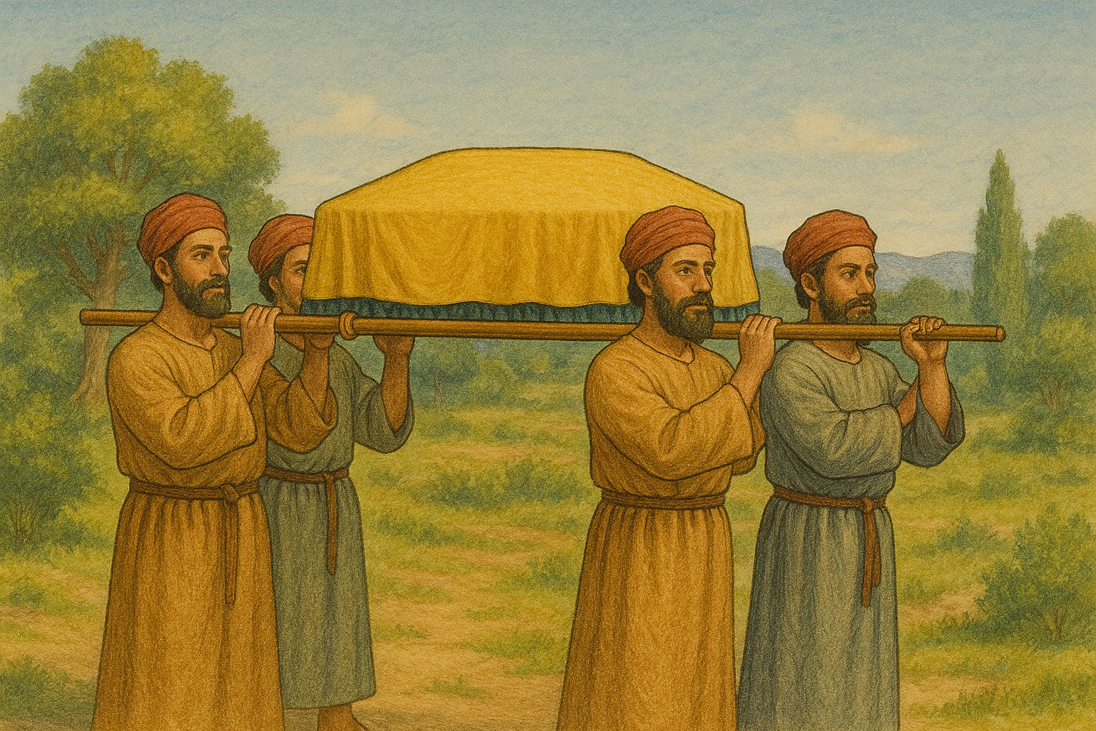

Translation:
In English some people object to speaking of the so-called “Ark of the Covenant” as “the Covenant Box,” since they assume that the English word “ark” has some special meaning equivalent to the corresponding Hebrew or Greek terms. However, the term “ark” in Old English and Middle English is simply a transliteration of the Latin word arca, which means “box, chest, coffer.” Indeed, the Hebrew word for “ark” (’aron) is used also to refer to other types of boxes (GEN 50:26; 2KI 12:10; 2KI 12:11; 2CH 24:8; 2CH 24:9; 2CH 24:10; 2CH 24:11; see, for example, 4.8.4 Bier, coffin<REALIA:4.8.4>).
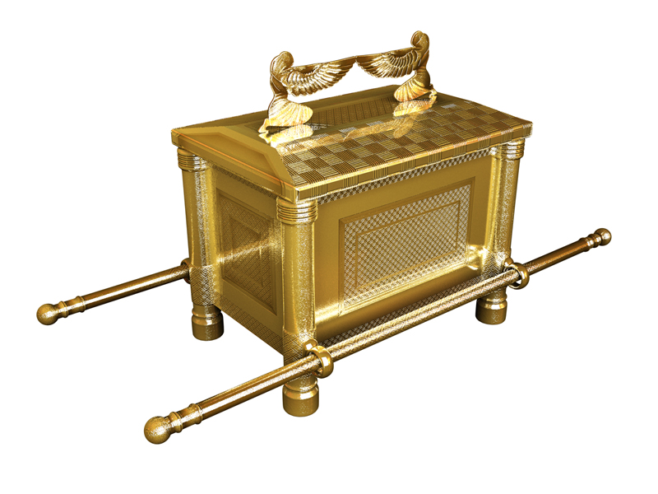
In present-day English the term “ark” is known primarily from the context of “Noah’s ark.” Translators should be aware that it is only by historical accident that the same word was used in older translations in English, French, and some other European languages both for Noah’s ship (see 8.1.3 Ark, ship<REALIA:8.1.3>) and for the Covenant Box. Hebrew uses a different word for Noah’s vessel. No attempt should be made to render them identically in the receptor language.

Molding: The gold “border” or “band” around the Covenant Box seems to have been for decoration. In 2CH 24:11 the Hebrew word rendered “round about” by RSV means “all around it,” as GNT renders it, since the word has the basic meaning of encircling. NAB has “around the top of it,” but the molding may have been placed somewhat lower than at the top edge of the Box. For the last half of this verse CEV has “put a gold edging around the lid”, but this seems to miss the point since the edging was around the Box itself.

Poles and rings: Several pieces of the Tabernacle furniture were carried by means of long poles inserted into rings attached to the objects. The translator should employ the same terminology uniformly for these poles and rings. It is explicitly stated in EXO 25:15 that the poles of the Box were not to be removed. In NUM 4:10; NUM 4:12 the Hebrew word mot is rendered “carrying frame” by RSV, GNT, and NIV. REB understands it to be a “pole” from which a bundle was hung.

Mercy seat, atonement cover, atonement lid

4.1.1 Mercy seat, atonement cover, atonement lid

References:Hebrew כַּפֹּרֶת (kaporeth)EXO 25:17, EXO 25:18, EXO 25:19, EXO 25:20, EXO 25:20, EXO 25:21, EXO 25:22, EXO 26:34, EXO 30:6, EXO 31:7, EXO 35:12, EXO 37:6, EXO 37:7, EXO 37:8, EXO 37:9, EXO 37:9, EXO 39:35, EXO 40:20, LEV 16:2, LEV 16:2, LEV 16:13, LEV 16:14, LEV 16:14, LEV 16:15, LEV 16:15, NUM 7:89, 1CH 28:11Greek ἱλαστήριον (hilastērion)HEB 9:5

Description:
The “mercy seat” was a lid that covered the Covenant Box (see 4.1 Covenant Box, Ark of the Covenant<REALIA:4.1>). It was rectangular with the same dimensions as the top of the Covenant Box. It was made of beaten gold. Standing on its top were two golden figures with wings, called literally “cherubim” (see 4.1.2 Winged creatures, cherubim<REALIA:4.1.2>).

Usage:
Besides serving as a top for the Covenant Box, the atonement lid (or, cover) was the focal point for an annual act of atonement by the High Priest of the Jewish people. Once a year, on the Day of Atonement (see LEV 16:14; LEV 16:15), the priest sprinkled blood from sacrificial animals on and in front of the atonement lid.

Translation:
The Hebrew word kaporeth comes from a root meaning “to cover,” but this may be understood in two different ways in the context of the Covenant Box. It may refer to the “covering” or forgiving of sin (that is, “atonement”), or it may simply mean a “covering” or lid on top of the Covenant Box. Possibly the Hebrew word contained both of these elements of meaning in this context. JB renders it “throne of mercy” (although NJB reverts to “mercy-seat”). NIV has “atonement cover.” Many other versions have simply “cover” (NJPSV, FRCL, Mft, NEB). Most French versions have propitiatoire (TOB; compare AT “propitiatory”), which places the emphasis on the “atonement” or “forgiveness” domain of meaning in the word kaporeth. All things considered, it is probably better to translate “lid” or “cover.”

Winged creatures, cherubim

4.1.2 Winged creatures, cherubim

References:Hebrew כְּרוּב (kruv)GEN 3:24, EXO 25:18, EXO 25:19, EXO 25:19, EXO 25:19, EXO 25:20, EXO 25:20, EXO 25:22, EXO 26:1, EXO 26:31, EXO 36:8, EXO 36:35, EXO 37:7, EXO 37:8, EXO 37:8, EXO 37:8, EXO 37:9, EXO 37:9, NUM 7:89, 1SA 4:4, 2SA 6:2, 2SA 22:11, 1KI 6:23, 1KI 6:24, 1KI 6:24, 1KI 6:25, 1KI 6:25, 1KI 6:26, 1KI 6:26, 1KI 6:27, 1KI 6:27, 1KI 6:27, 1KI 6:28, 1KI 6:29, 1KI 6:32, 1KI 6:32, 1KI 6:35, 1KI 7:29, 1KI 7:36, 1KI 8:6, 1KI 8:7, 1KI 8:7, 2KI 19:15, 1CH 13:6, 1CH 28:18, 2CH 3:7, 2CH 3:10, 2CH 3:11, 2CH 3:11, 2CH 3:12, 2CH 3:12, 2CH 3:13, 2CH 3:14, 2CH 5:7, 2CH 5:8, 2CH 5:8, PSA 18:11, PSA 80:2, PSA 99:1, ISA 37:16, EZK 9:3, EZK 10:1, EZK 10:2, EZK 10:2, EZK 10:3, EZK 10:4, EZK 10:5, EZK 10:6, EZK 10:7, EZK 10:7, EZK 10:7, EZK 10:8, EZK 10:9, EZK 10:9, EZK 10:9, EZK 10:14, EZK 10:15, EZK 10:16, EZK 10:16, EZK 10:18, EZK 10:19, EZK 10:20, EZK 11:22, EZK 28:14, EZK 28:16, EZK 41:18, EZK 41:18, EZK 41:18, EZK 41:18, EZK 41:20, EZK 41:25Greek Χερούβ (cheroub)HEB 9:5, SIR 49:8, ODA 8:54, DAG 3:55

Description:
Nimrud ivory plaque with ram-headed sphinx (Assyrian, Syro-Phoenician, 8th-7th c. BCE) (© I, Sailko, CC BY-SA 3.0, via Wikimedia Commons)The cherub is mentioned over ninety times in Scripture and seems to be a composite being. (Some of the references are to the creatures themselves, but the places listed above refer to physical representations of those creatures.) The only consistent information given to describe cherubim (the Hebrew plural of kruv) is that they had wings. In some places they have one face, in others four faces. Sometimes they are said to have two legs, at other times four legs. Three-dimensional statues of them were part of the atonement lid that covered the Covenant Box (see 4.1.1 Mercy seat, atonement cover, atonement lid<REALIA:4.1.1> and the illustration at 4.1 Covenant Box, Ark of the Covenant<REALIA:4.1>). These figures faced each other from either end of the lid, and their wings arched up to meet over the middle of the lid, providing a kind of protecting cover over the Box.
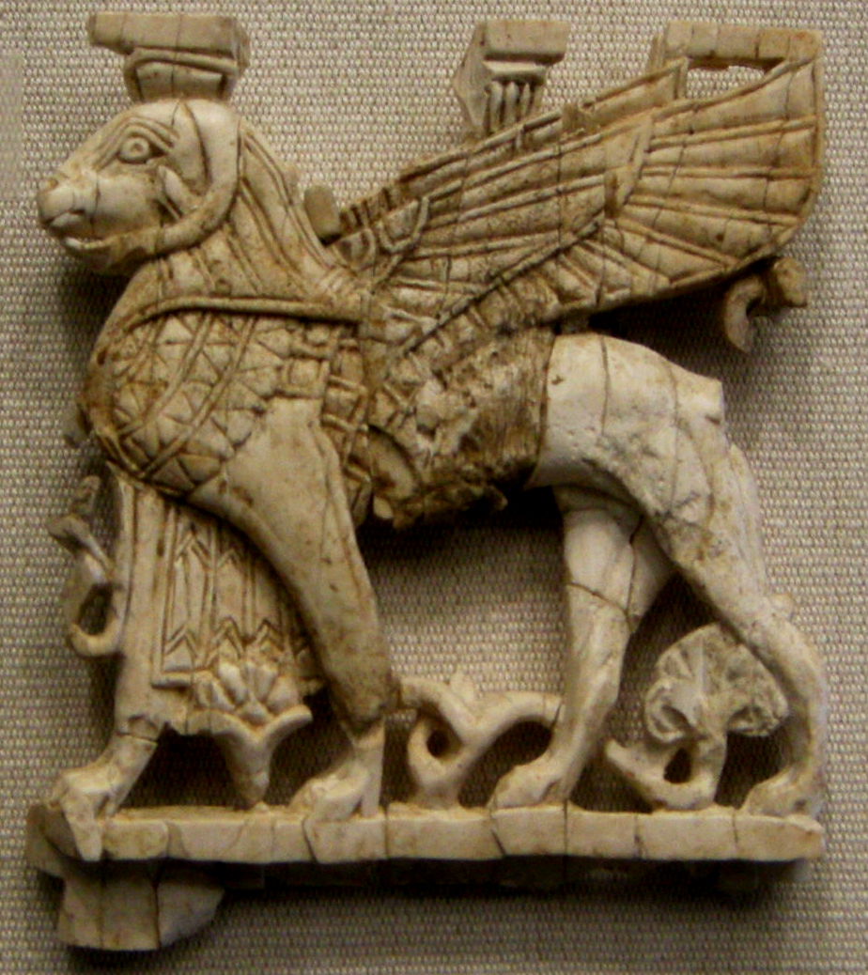
Much larger three-dimensional cherubim were placed by Solomon in the Most Holy Place of the Temple. These were carved of olivewood and were overlaid with gold. Unlike the cherubim on the atonement lid, these stood side by side facing the same direction. Their wings were extended, with one wing of each meeting a wing of the other in the center of the room.
Representations of cherubim were also embroidered on different cloth items in the Tabernacle. In the Temple, where walls replaced the curtains, similar figures were carved in relief on the walls.
The cherubim serve in Scripture as symbols of God’s majesty and presence. They have also been understood as guardians of the approach to the presence of God (compare GEN 3:24).

Translation:
Since the term “cherub” is largely unknown or misunderstood, translators should normally avoid transliterating this word unless it is accompanied by a descriptive phrase, and even then the transliterated form may not be helpful. In most translations a descriptive note will be helpful. Some attempts at rendering this word by means of a descriptive phrase may result in confusing the reader, due to the very large number of winged creatures he already knows. If the descriptive phrase is confusing for the reader, it may be better to borrow the term from a major language in the area. Translators must not give the impression that the cherub is a variant of some locally known large bird. Even though the cherub’s distinguishing characteristic was the fact of having wings, “winged animal” does not do justice to the composite nature of this ancient symbol. A phrase like “flying being” may be meaningless, and “flying thing” may be equated with anything from an insect to an airplane. It may be appropriate to say “winged image” or “winged figure.” In general, it may be best to employ a phrase such as “image of a winged heavenly creature” or “statue of a winged heavenly animal.”

