Resource: Human-made Things in the Bible
Human-made Things in the Bible © United Bible Societies, 2025. Adapted from: The Works of Their Hands: Man-made Things in the Bible, by Ray Pritz © 2009 United Bible Societies. This work is licensed under Creative Commons Attribution-ShareAlike 4.0 International (https://creativecommons.org/licenses/by-sa/4.0/).

Human-made Things in the Bible

Eating utensils

5.20 Eating utensils

People in biblical times ate food from plates and bowls, as is familiar in most cultures today, but it seems that they did not use implements to lift the food from the plate to their mouth. This was done with the right hand.

Bowl

5.20.1 Bowl

References:Hebrew אַגָּן (’agan)SNG 7:3, ISA 22:24Hebrew גֻּלָּה (gulah)ECC 12:6, ZEC 4:2, ZEC 4:3Hebrew מִזְרָק (mizraq)AMO 6:6Hebrew מִשְׁאֶרֶת (mish’ereth)EXO 7:28, EXO 12:34, DEU 28:5, DEU 28:17Hebrew צְלֹחִית (tslochith)2KI 2:20Greek ἀργύρωμα (argurōma)JDT 12:1, JDT 15:11, 1MA 15:32Greek ὁλκεῖον (holkeion)JDT 15:11Greek σκάφη (skafē)BEL 1:33Greek τρύβλιον (trublion)MAT 26:23, MRK 14:20, SIR 31:14Greek φιάλη (fialē)REV 5:8, REV 15:7, REV 16:1, REV 16:2, REV 16:3, REV 16:4, REV 16:8, REV 16:10, REV 16:12, REV 16:17, REV 17:1, REV 21:9, 1MA 1:22, 1ES 2:10Greek χρύσωμα (chrusōma)1MA 15:32

Description and usage:
The bowl was a concave dish used for holding or cooking food or liquids. Bowls varied widely in diameter and depth. Such bowls would normally have been made of fired clay, but the reference in REV 5:8 specifically states that the bowls there were of gold. Because of the variety in size and depth, and because cups frequently had no handles, there was essentially no physical difference between cups and smaller bowls. The first illustration under 5.20.3 “Cup” also pictures bowls.

Translation:
In ZEC 4:2 the purpose of the bowl (gulah in Hebrew) may not be immediately clear to the reader. It is recommended that the translator follow the example of GNT by saying “At the top is a bowl for the oil.”
The bowls mentioned in AMO 6:6 are specifically said to be for drinking (see 5.20.3 Cup<REALIA:5.20.3>). Some kind of cultural adaptation may be necessary. In some cultures, for example, it is possible to use a word for a particular kind of large calabash, or a general word for calabash which is qualified as “big” and “filled.”
The Hebrew word mish’ereth refers to a large bowl in which bread dough was kneaded and allowed to rise before baking. Most translations have “kneading bowls” (RSV, NJPSV) or “kneading troughs” (NIV, REB). “Baking pans” in GNT is misleading. Where a special word for such a bowl does not exist or is not well known, translators may follow the example of CEV with “bowls of bread dough.”
In MAT 26:23 and MRK 14:20 the Greek word trublion can be understood as part of an idiom, which is literally “to dip one’s hands into a bowl with someone.” Most translations render the idiom more or less literally, which can give the reader the wrong impression that a person is putting his fingers in the bowl rather than dipping food that he holds in his hand. If the translator chooses to translate the idiom somewhat literally, it is important to render it “to dip food into a bowl together with someone” or “to dip food jointly into a sauce.” It is probably preferable to interpret the idiom as “sharing a meal with someone” or “eating together with someone.” For the last half of MRK 14:20CEV has “one ... who is eating from this dish with me,” and NLT says “one who is eating with me now.”
1MA 15:32: The Greek word chrusōma is literally “golden object.” However, here it is used to refer to gold or gold-plated eating utensils. GNT and NRSV say “gold[en] bowls.”

Plate, platter

5.20.2 Plate, platter

References:Hebrew צַלַּחַת (tsalachath)2KI 21:13, PRO 19:24, PRO 26:15Greek παροψίς (paropsis)MAT 23:25Greek πίναξ (pinax)MAT 14:8, MAT 14:11, MRK 6:25, MRK 6:28, LUK 11:39

Description and usage:
Platter (Gary Todd, Israel Museum, CC0, via Wikimedia Commons)The plate was a flat dish on which food was eaten or served. It was normally made of baked clay, but the dishes of royalty and rich people could be made of precious metals.
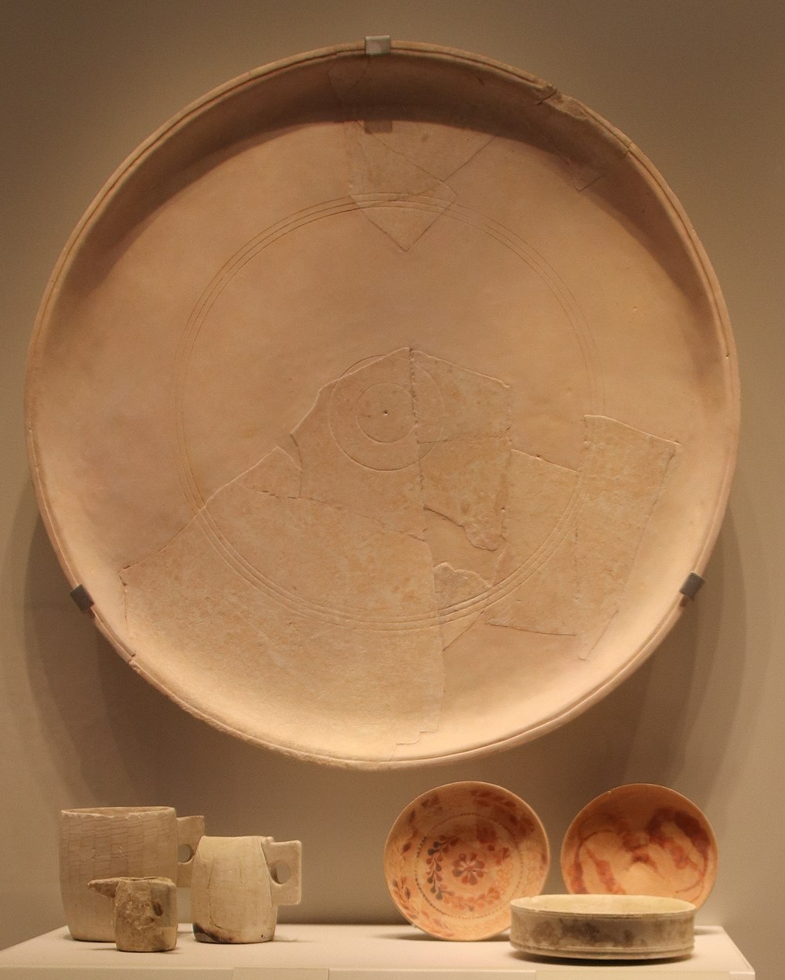

Translation:
PRO 19:24; PRO 26:15: In these passages the lazy person is described as someone who puts his hand in the dish and will not lift it to his mouth. In many cultures this could be misunderstood to mean that he is too lazy even to pick up a fork but just puts his hand in his food. This, however, is not the point of the proverb. It was normal to eat food with one’s hand. The person is lazy because he will not even lift his hand to his mouth. A translator should try to focus on the real reason for the person’s laziness. Two good models for PRO 19:24 are GNT “Some people are too lazy to put food in their own mouths” and CEV “Some people are too lazy to lift a hand to feed themselves.”
MAT 14:8: The Greek noun pinax may refer to any kind of flat dish; the word originally meant “board” or “plank.” In cultures where plates are not normally used, translators will use “bowl” or whatever is the normal object on which someone would carry food.

Cup

5.20.3 Cup

References:Hebrew גָּבִיעַ (gavi‘a)GEN 44:2, GEN 44:2, GEN 44:12, GEN 44:16, GEN 44:17, EXO 25:31, EXO 25:33, EXO 25:33, EXO 25:34, EXO 37:17, EXO 37:19, EXO 37:19, EXO 37:20, JER 35:5Hebrew כּוֹס (kos)GEN 40:11, GEN 40:11, GEN 40:11, GEN 40:13, GEN 40:21, 2SA 12:3, 1KI 7:26, 2CH 4:5, PSA 11:6, PSA 16:5, PSA 23:5, PSA 75:9, PSA 116:13, PRO 23:31, ISA 51:17, ISA 51:17, ISA 51:22, ISA 51:22, JER 16:7, JER 25:15, JER 25:17, JER 25:28, JER 35:5, JER 49:12, JER 51:7, LAM 4:21, EZK 23:31, EZK 23:32, EZK 23:33, EZK 23:33, HAB 2:16Hebrew סַף (saf)ZEC 12:2Hebrew סֵפֶל (sefel)JDG 5:25, JDG 6:38Greek ποτήριον (potērion)GEN 40:11, GEN 40:11, GEN 40:11, GEN 40:13, GEN 40:21, 2SA 12:3, 1KI 7:12, 2CH 4:5, PSA 10:6, PSA 15:5, PSA 22:5, PSA 74:9, PSA 115:4, PRO 23:31, ISA 51:17, ISA 51:17, ISA 51:22, JER 16:7, JER 28:7, JER 30:6, JER 32:15, JER 32:17, JER 32:28, JER 42:5, LAM 2:13, LAM 4:21, EZK 23:31, EZK 23:32, EZK 23:33, EZK 23:33, HAB 2:16, MAT 10:42, MAT 20:22, MAT 20:23, MAT 23:25, MAT 23:26, MAT 26:27, MAT 26:39, MRK 7:4, MRK 9:41, MRK 10:38, MRK 10:39, MRK 14:23, MRK 14:36, LUK 11:39, LUK 22:17, LUK 22:20, LUK 22:20, LUK 22:42, JHN 18:11, 1CO 10:16, 1CO 10:21, 1CO 10:21, 1CO 11:25, 1CO 11:25, 1CO 11:26, 1CO 11:27, 1CO 11:28, REV 14:10, REV 16:19, REV 17:4, REV 18:6, ESG 1:7, PSS 8:14Greek σπονδεῖον (spondeion)SIR 50:15, 1MA 1:22, 1ES 2:9, 1ES 2:9Greek χρύσωμα (chrusōma)1MA 11:58, 1MA 11:58, 1ES 3:6Latin calix2ES 14:39

Description and usage:
The cup was an implement used for drinking. Common cups were made of earthenware, sometimes fired and glazed. By New Testament times, cups made of glass were common. Richer people often used cups made of bronze, silver, or gold. A cup could be cylindrical, similar to a modern cup, or it could be more the half-globe shape of a bowl. In either of these forms, it might have one or two handles or no handles at all.
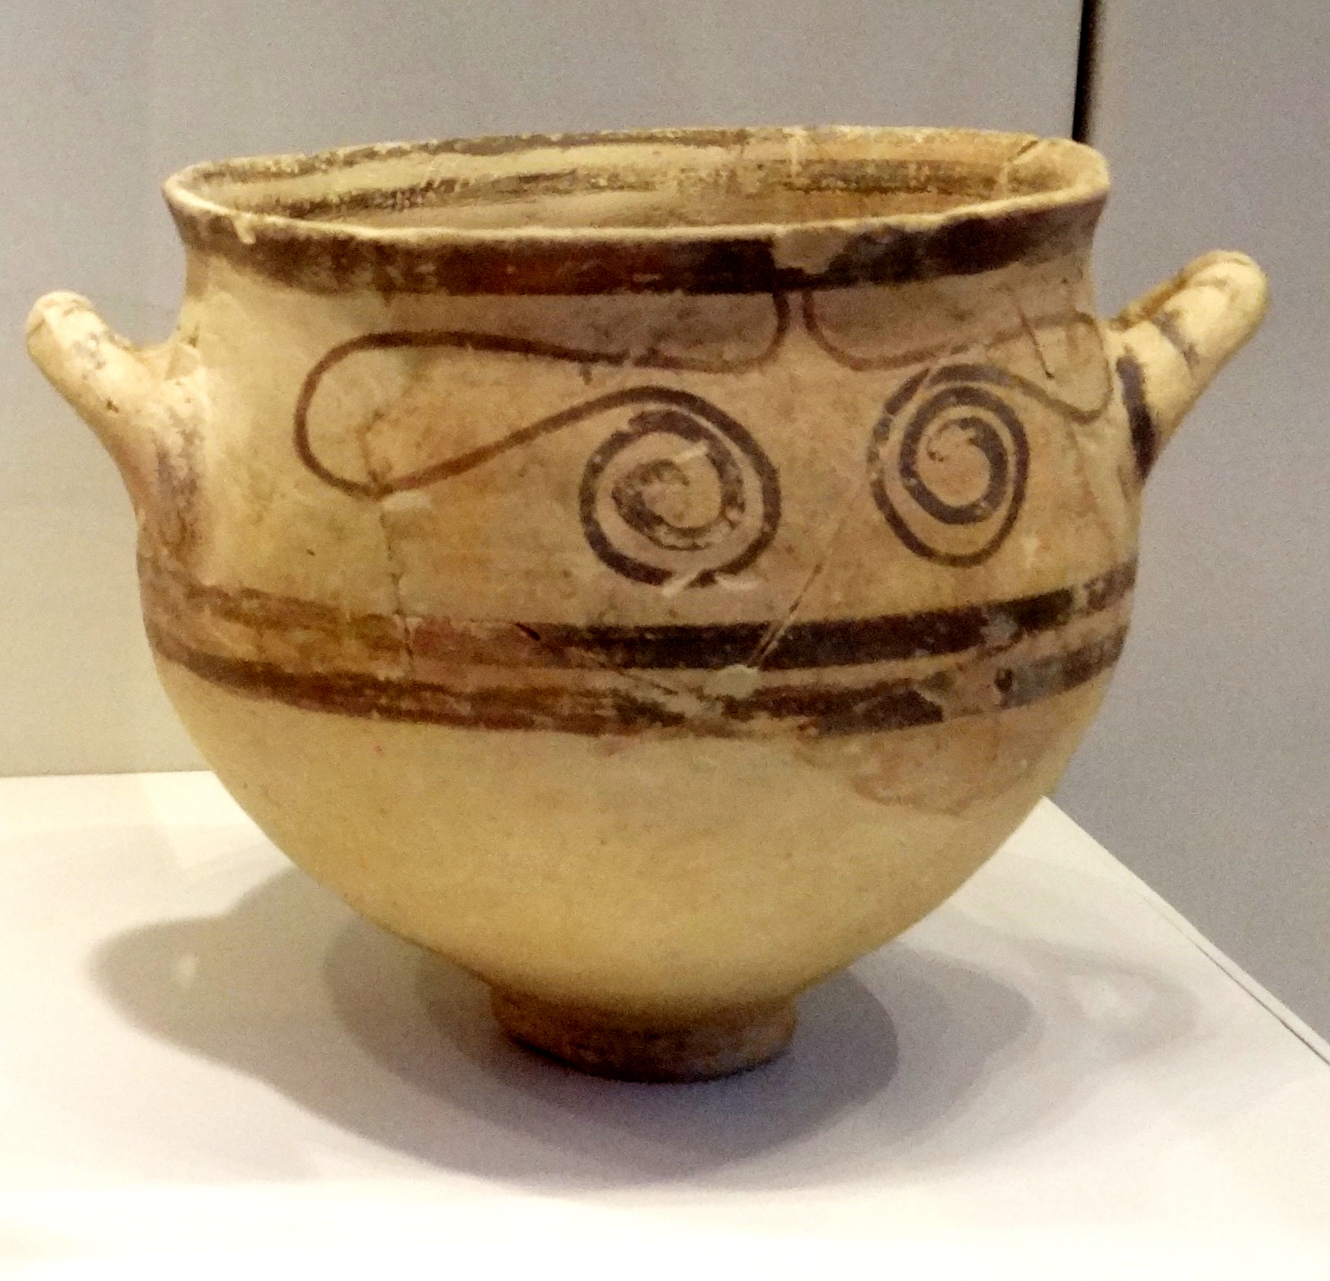

Translation:
Vessels for drinking (© Deutsche Bibelgesellschaft, Stuttgart by United Bible Societies)While many objects resembling a modern drinking cup have been found, people in ancient times often drank from something resembling a small bowl. In terms of historical development, the drinking bowl was probably first. The Hebrew word sefel refers to an implement that came after the drinking bowl. It had about equal height and diameter and had handles.
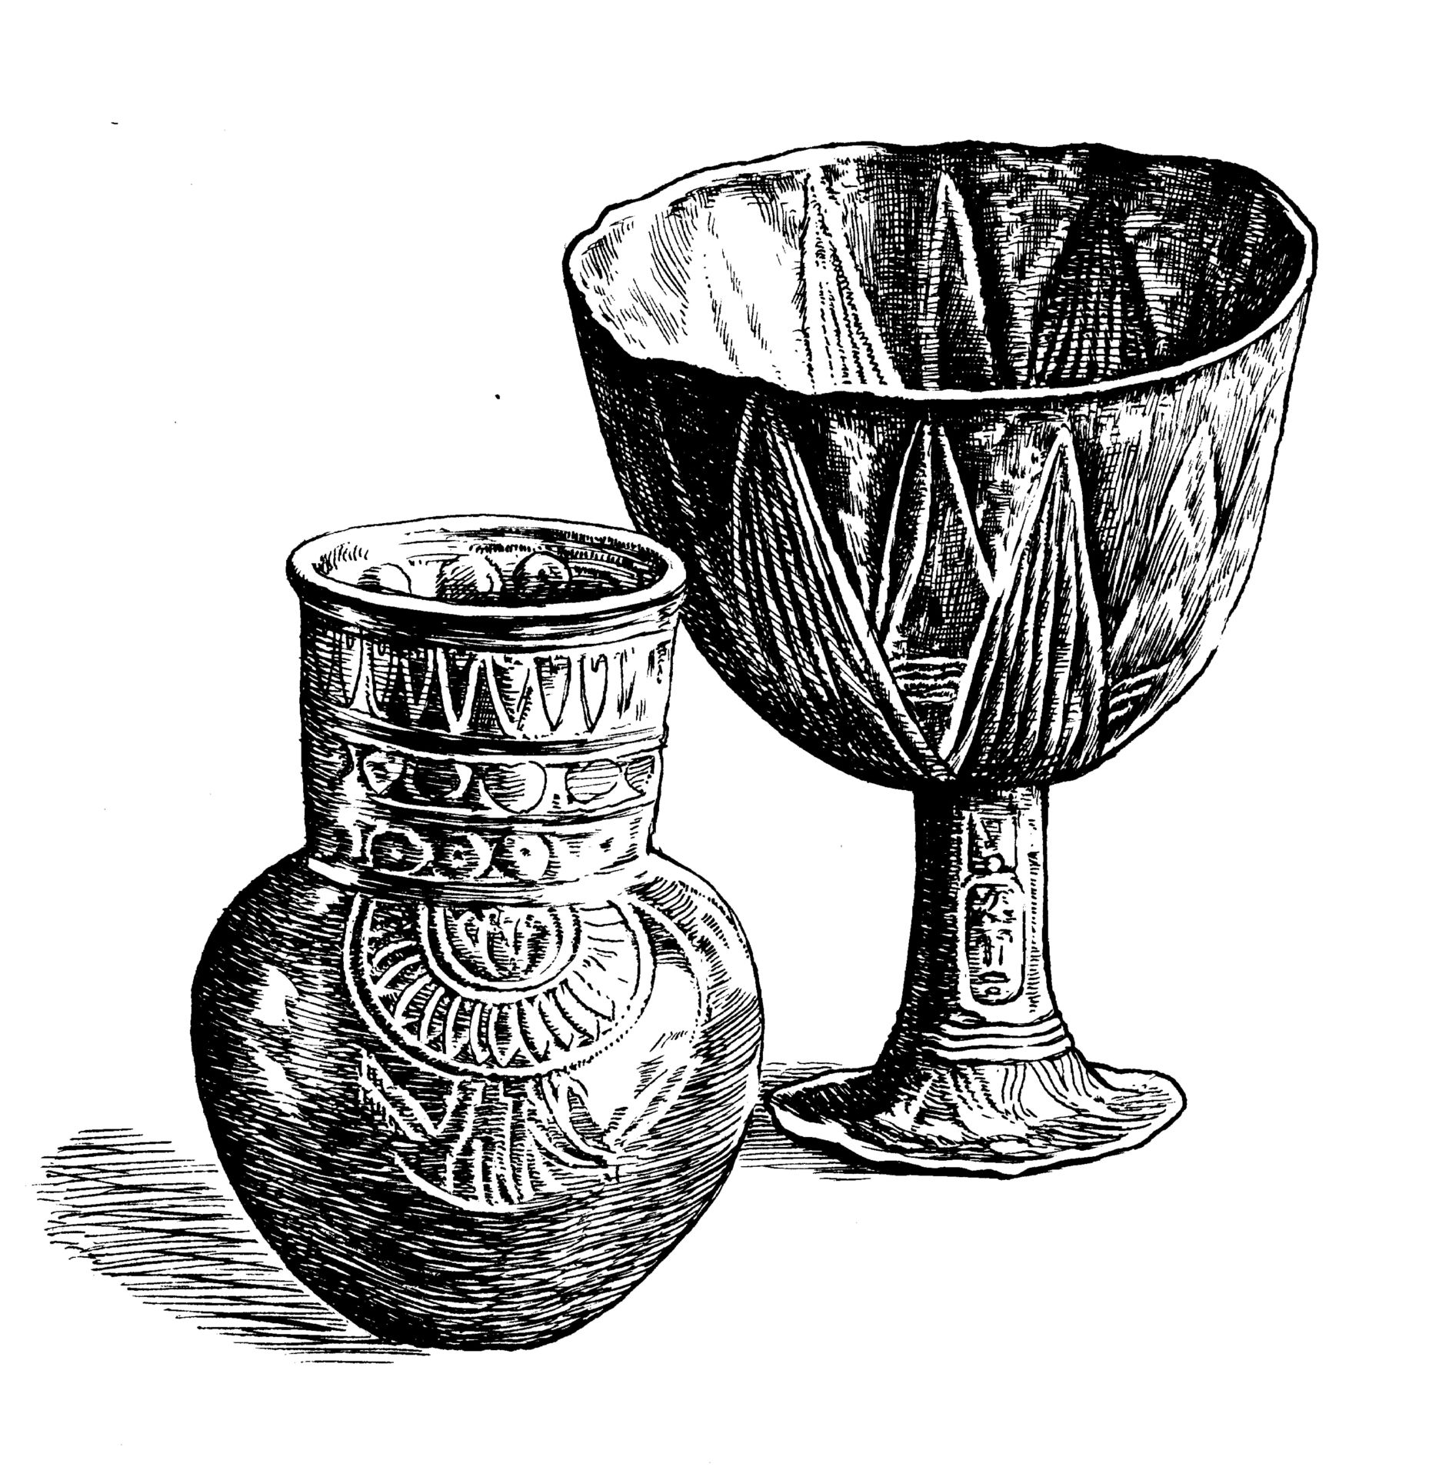
Several of the words listed above could equally well be translated “cup” or “bowl,” and this is reflected in the translations. Some translations say “drinking bowl.” However, a generic word for “cup” will be a close enough equivalent in most languages.
In GEN 44:0 the Hebrew word gavi‘a refers to a special cup, one that is explicitly said to be made of silver. In some cultures it will be necessary to choose a word that does not indicate a drinking vessel made of another substance, such as a gourd, or a cup made of wood or clay.
MAT 10:42; MRK 9:41: In place of the literal expression “cup of water” in MRK 9:41 (in which “cup” not only identifies the container but also indicates the quantity of water), some languages use the expression “water in a cup.” But it is even more likely that the typical equivalent of “cup of water” would be “drink of water” (GNT). In some parts of the world, the expression “cup of water” suggests something rather strange and foreign, so some translators might find that an expression like “gourd of water” would not only be more natural, but would also be the semantic equivalent of “drink of water.”
1MA 11:58 and 1ES 3:6 say literally “drink from golden.” The meaning is clearly “drink from golden cups” or “…golden vessels.”

Knife

5.20.4 Knife

References:Hebrew חֶרֶב, צוּר (cherev tsur)JOS 5:2, JOS 5:3Hebrew מַאֲכֶלֶת (ma’akeleth)GEN 22:6, GEN 22:10, JDG 19:29, PRO 30:14Hebrew שַׂכִּין (sakin)PRO 23:2

Description and usage:
Knife of iron and wood, Cave of the Letters, Nahal Hever (132–135 CE), Israel Museum (© Chamberi, CC BY-SA 3.0, via Wikimedia Commons)The knife was a small blade with a handle, used for cutting meat and other food.
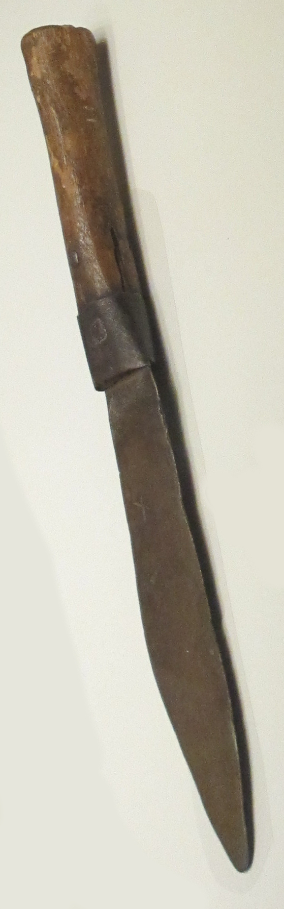

Translation:
The Hebrew words listed above refer to a sharp knife, which probably was also pointed. Translators should avoid a word that is limited to the rather blunt kind of instrument with which things are spread on bread.
JOS 5:2; JOS 5:3: The Hebrew word cherev normally refers to a sword (see 2.3 Sword<REALIA:2.3>). Here it is used in the context of the delicate operation of circumcision, so it is clear that a smaller implement is in view. The Hebrew modifier tsur indicates that this knife was made from flint, an extremely hard type of quartz stone. From ancient times tools and weapons were made from flint by chipping or flaking to produce very sharp edges.

