Resource: Human-made Things in the Bible
Human-made Things in the Bible © United Bible Societies, 2025. Adapted from: The Works of Their Hands: Man-made Things in the Bible, by Ray Pritz © 2009 United Bible Societies. This work is licensed under Creative Commons Attribution-ShareAlike 4.0 International (https://creativecommons.org/licenses/by-sa/4.0/).

Human-made Things in the Bible

Garland

6.9 Garland

Reference:Greek στέμμα (stemma)ACT 14:13

Description:
The garland was a wreath of wool to which leaves and flowers might be added and either wound around a staff or woven into a circle to be worn on the head.

Usage:
Wall painting from the west wall of Room L of the Villa of P. Fannius Synistor (Boscoreale, Roman, ca. 50–40 BCE) (Metropolitan Museum of Art, Public domain)Garlands were an important part of the ritual involved in the worship of pagan gods in the ancient world. As in ACT 14:13, the flowers were draped around animals to be sacrificed.
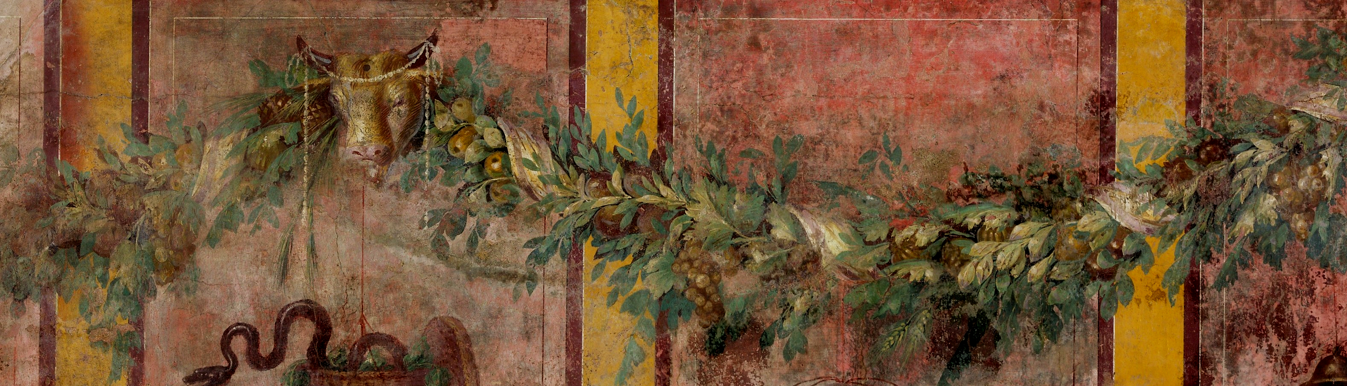

Translation:
“Garlands” in ACT 14:13 may be rendered “circles of leaves,” “rings of flowers,” or “wreaths of flowers.”

