Resource: Human-made Things in the Bible
Human-made Things in the Bible © United Bible Societies, 2025. Adapted from: The Works of Their Hands: Man-made Things in the Bible, by Ray Pritz © 2009 United Bible Societies. This work is licensed under Creative Commons Attribution-ShareAlike 4.0 International (https://creativecommons.org/licenses/by-sa/4.0/).

Human-made Things in the Bible

Sandal, shoe

6.13 Sandal, shoe

References:Hebrew נַעַל, נעל (na‘al)GEN 14:23, EXO 3:5, EXO 12:11, DEU 25:9, DEU 25:10, DEU 29:4, JOS 5:15, JOS 9:5, JOS 9:13, RUT 4:7, RUT 4:8, 1KI 2:5, 2CH 28:15, PSA 60:10, PSA 108:10, SNG 7:2, ISA 5:27, ISA 11:15, ISA 20:2, EZK 16:10, EZK 24:17, EZK 24:23, AMO 2:6, AMO 8:6Greek σανδάλιον (sandalion)MRK 6:9, ACT 12:8, JDT 10:4, JDT 16:9Greek ὑπόδημα, ὑποδέομαι (hupodēma, hupodeomai (verb))MAT 3:11, MAT 10:10, MRK 1:7, MRK 6:9, LUK 3:16, LUK 10:4, LUK 15:22, LUK 22:35, JHN 1:27, ACT 12:8, ACT 7:33, ACT 13:25, EPH 6:15, SIR 46:19

Description and usage:
Leather sandals from the northern palace at Masada, 73 CE (Gary Todd, Israel Museum, CC0, via Wikimedia Commons)The sandal was a type of footwear consisting of a sole made of leather (or possibly wood) tied to the foot by means of leather thongs or straps, and used as a shoe for walking.
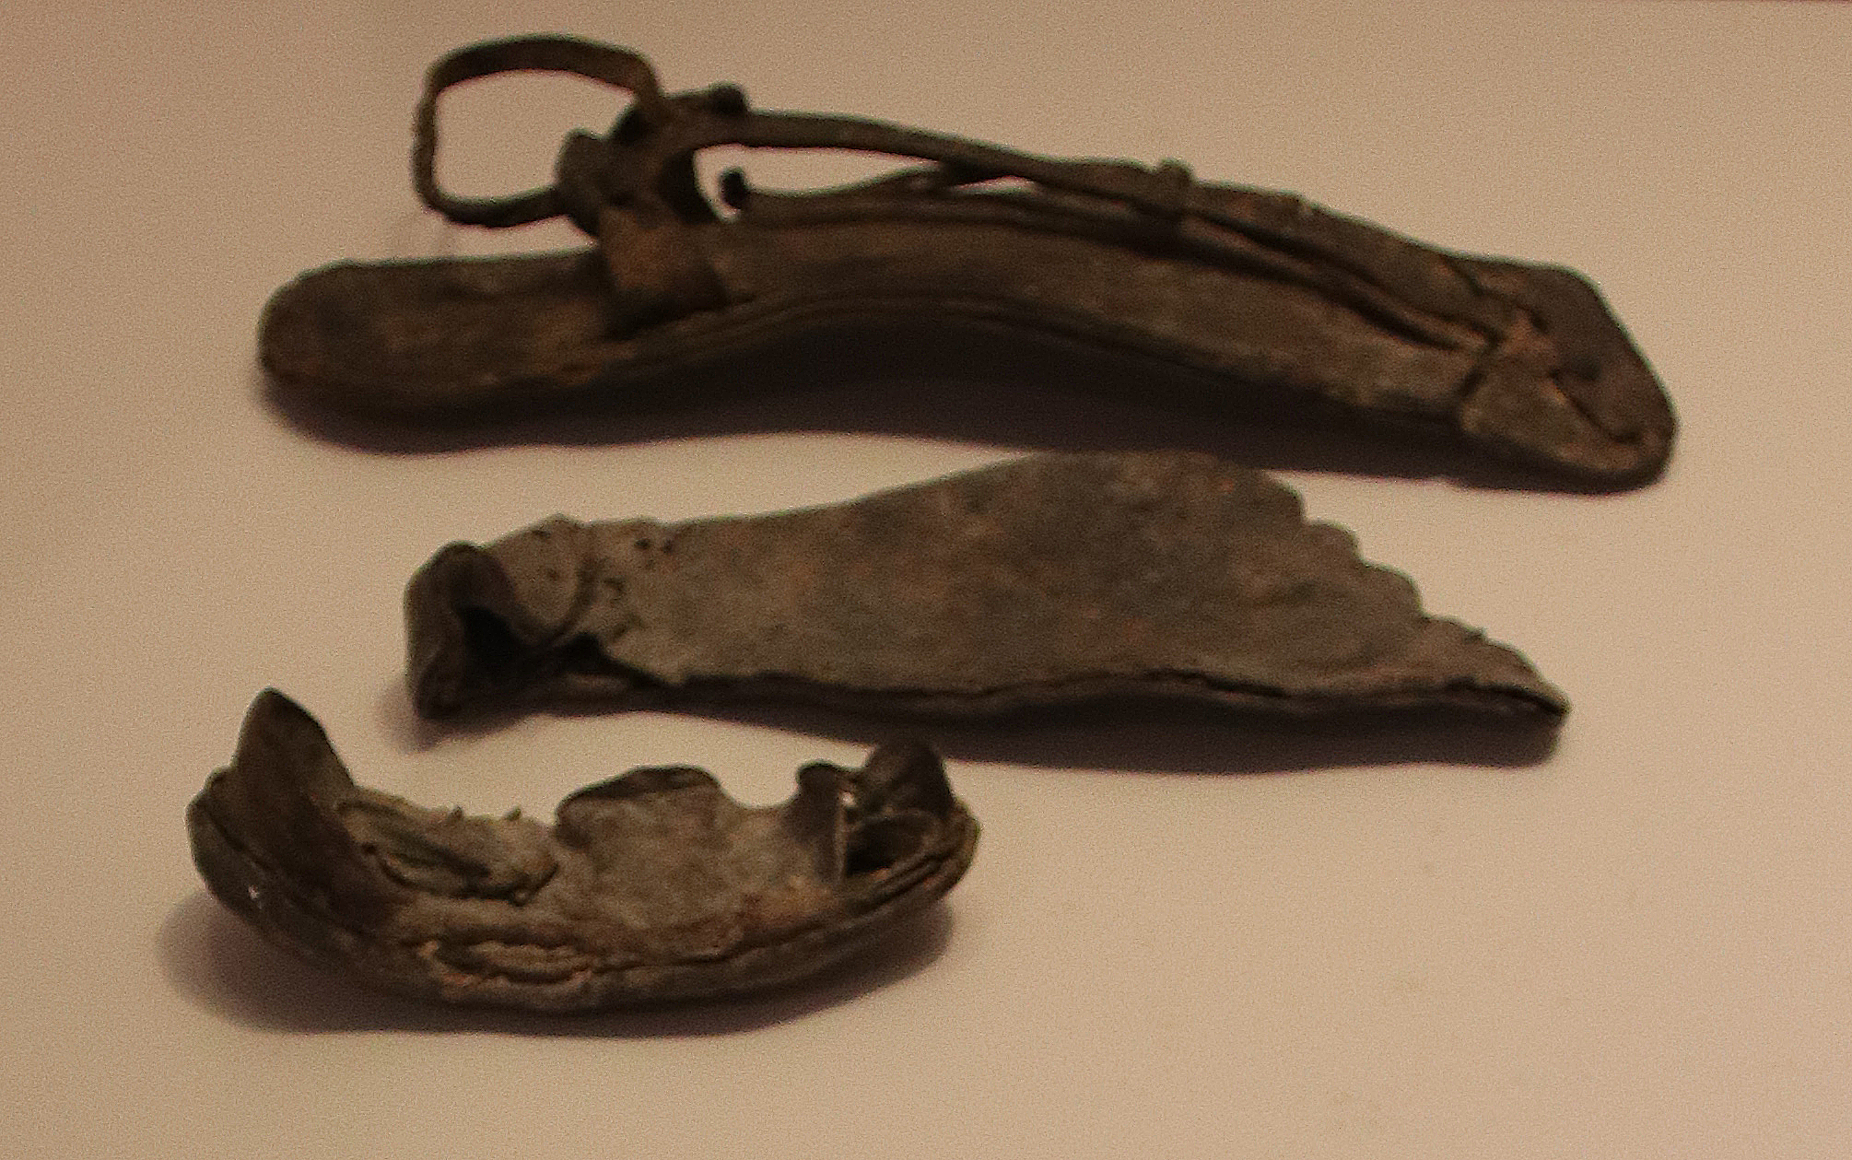

Translation:
Sometimes a term for “sandal” indicates the footwear of particularly poor people or, in some situations, footwear used only for recreation or sport. If this is the case, it will usually be better to use a general designation for footwear which would include sandals.
Leather sandals from the northern palace at Masada, 73 CE (Gary Todd, Israel Museum, CC0, via Wikimedia Commons)Sandals were not buckled, as is done with most modern sandals, but rather tied with straps that were wrapped around the ankles. In those passages that speak of putting sandals on or taking them off, translators should choose a word for tying or untying rather than one that indicates the use of a buckle.

Straps

6.13.1 Straps

References:Hebrew שְׂרוֹךְ (srok)GEN 14:23, ISA 5:27Greek ἱμάς (himas)MRK 1:7, LUK 3:16, JHN 1:27, ACT 22:25

Description and usage:
Straps were long, thin pieces of leather. They were put to many uses, including tying sandals, binding other things (that is, used like rope; see 1.14 Rope, cord<REALIA:1.14>), or wielding as a whip (1.1.3 Whip, scourge<REALIA:1.1.3>). See the illustrations at 6.13 Sandal, shoe<REALIA:6.13>.

Translation:
In a number of languages the Greek word himas may be rendered “leather string” or “strip of leather.” In JHN 1:27 the term may be absorbed within the total expression at the end of the verse, for example, “I am not worthy to untie his sandals” (implying the untying of the straps with which the sandals were bound). This may be done in MRK 1:7 and LUK 3:16 also.
In ACT 22:25 two meanings are possible for the Greek word himas. Luke may either be telling the reason why Paul was being tied up or the means by which Paul was being tied up. So translators may render the first clause in this verse as “they tied him up with thongs” or “they tied him up for whipping,” in which case himas would refer to an event, not to an object.

