Resource: Human-made Things in the Bible
Human-made Things in the Bible © United Bible Societies, 2025. Adapted from: The Works of Their Hands: Man-made Things in the Bible, by Ray Pritz © 2009 United Bible Societies. This work is licensed under Creative Commons Attribution-ShareAlike 4.0 International (https://creativecommons.org/licenses/by-sa/4.0/).

Human-made Things in the Bible

Wind instruments

7.3 Wind instruments

Wind instruments are instruments that produce sound through the vibration of air in, through, or around them. This category includes two types of instrument: (1) those where the lips of the player produce the vibration of air in the instrument (7.3.1 Horn, ram’s horn<REALIA:7.3.1> and 7.3.2 Trumpet, horn<REALIA:7.3.2>), and (2) those where the point of entry into the instrument produces the vibration of air (7.3.3 Flute, pipe<REALIA:7.3.3> and 7.3.4 Bagpipe (kettledrum, large drum)<REALIA:7.3.4>).

Horn, ram’s horn

7.3.1 Horn, ram’s horn

References:Hebrew יוֹבֵל (yovel)EXO 19:13, JOS 6:4, JOS 6:5, JOS 6:6, JOS 6:8, JOS 6:13Hebrew קֶרֶן (qeren)JOS 6:5, DAN 3:5, DAN 3:7, DAN 3:10, DAN 3:15Hebrew שׁוֹפָר (shofar)EXO 19:16, EXO 19:19, EXO 20:18, LEV 25:9, LEV 25:9, JOS 6:4, JOS 6:4, JOS 6:5, JOS 6:6, JOS 6:8, JOS 6:8, JOS 6:9, JOS 6:9, JOS 6:13, JOS 6:13, JOS 6:13, JOS 6:16, JOS 6:20, JOS 6:20, JDG 3:27, JDG 6:34, JDG 7:8, JDG 7:16, JDG 7:18, JDG 7:18, JDG 7:19, JDG 7:20, JDG 7:20, JDG 7:22, 1SA 13:3, 2SA 2:28, 2SA 6:15, 2SA 15:10, 2SA 18:16, 2SA 20:1, 2SA 20:22, 1KI 1:34, 1KI 1:39, 1KI 1:41, 2KI 9:13, 1CH 15:28, 2CH 15:14, NEH 4:12, NEH 4:14, JOB 39:24, JOB 39:25, PSA 47:6, PSA 81:4, PSA 98:6, PSA 150:3, ISA 18:3, ISA 27:13, ISA 58:1, JER 4:5, JER 4:19, JER 4:21, JER 6:1, JER 6:17, JER 42:14, JER 51:27, EZK 33:3, EZK 33:4, EZK 33:5, EZK 33:6, HOS 5:8, HOS 8:1, JOL 2:1, JOL 2:15, AMO 2:2, AMO 3:6, ZEP 1:16, ZEC 9:14Hebrew תָּקוֹעַ (taqo‘a)EZK 7:14Greek σάλπιγξ (salpigx)MAT 24:31, 1CO 14:8, 1CO 15:52, 1TH 4:16, HEB 12:19, REV 1:10, REV 4:1, REV 8:2, REV 8:6, REV 8:13, REV 9:14

Description:
(Image generated by ChatGPT using OpenAI technology)The horn was a wind instrument made from the horn of an animal, usually a male sheep.
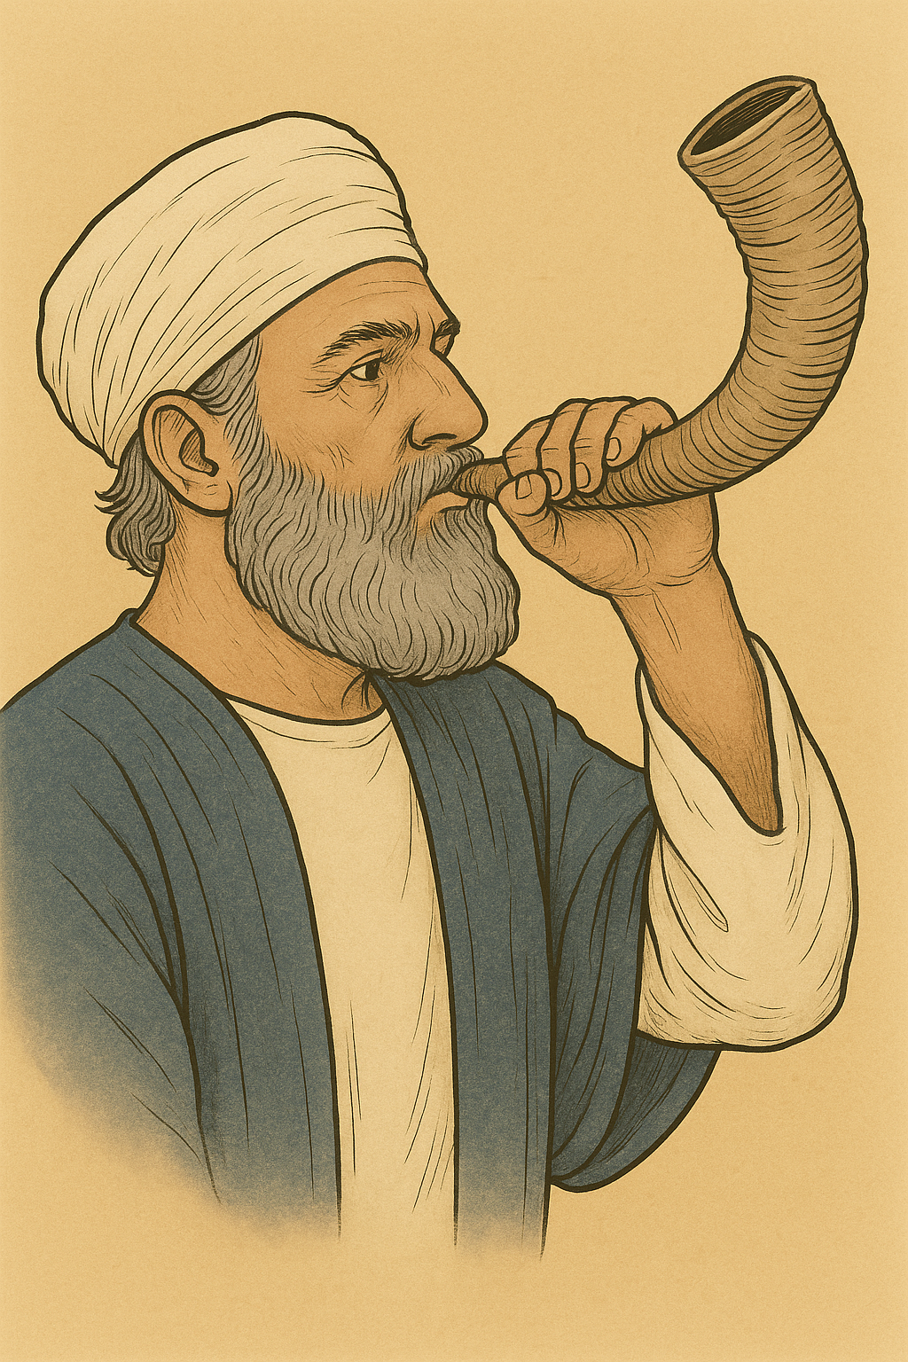

Usage:
The animal horn was softened so that it could be shaped. The point of the horn was cut off to leave a small opening through which the user blew. The vibration of the lips produced the sound.
Musical instruments made of rams' horns (© Pixabay)The ram’s horn served two general purposes:
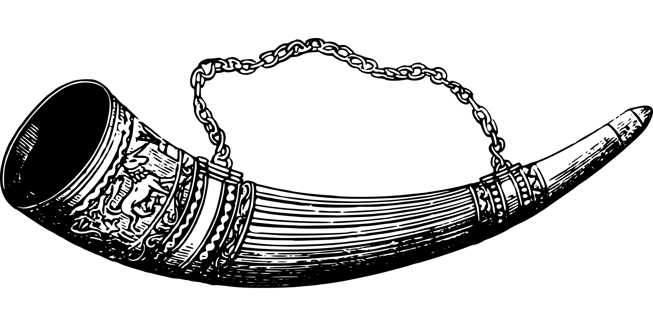
1. It was blown in certain religious contexts, not as musical accompaniment to worship but as a signal for important events. Some of these events were the giving of the Law on Mount Sinai, the Day of Atonement, the bringing of the Ark of the Covenant into Jerusalem, and the coronation of kings.
2. It also served as a signal or alarm when war was approaching. Such references are particularly common in the prophetic books, when the prophets are calling the people to repent (HOS 5:8; HOS 8:1; JOL 2:1; JOL 2:15; AMO 3:6).

Translation:
A small shofar made from a ram's horn (© Olve Utne, CC BY-SA 2.5, via Wikimedia Commons)In many passages the purpose of the ram’s horn called shofar in Hebrew was to sound an alarm. This will be easy to express in those cultures where the horns of animals are used as musical instruments to give signals to large groups of people. In other cultures it may be possible to find another instrument that is used for an equivalent purpose. In some languages, for example, instruments such as bells or drums are the warnings for war. Some translations have transliterated the word shofar. Unless the instrument is well known, such a borrowing should normally be accompanied by a footnote or a glossary entry.
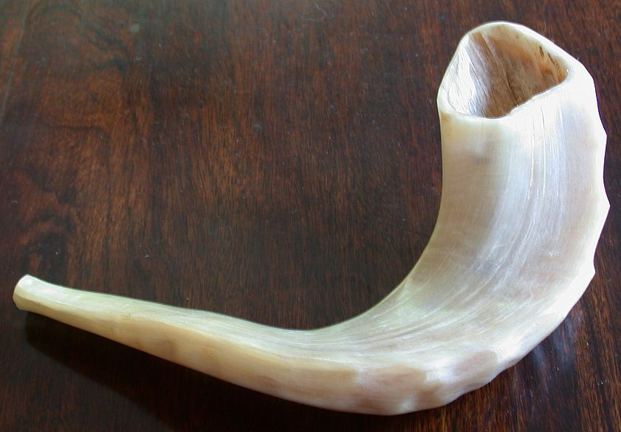
The Hebrew words yovel and qeren (literally “animal horn”) in EXO 19:13 and JOS 6:0 are used as parallel to shofar and can be treated as equivalent to shofar. Some scholars have suggested that the Hebrew word taqo‘a (literally “blowing”) in EZK 7:14 refers not to an instrument but to the town of Tekoa (compare JER 6:1). It is more likely, however, that the word refers to the object on which the alarm was blown, that is, the ram’s horn.
In some passages it will be necessary to expand the translation in order to indicate that the blowing of the ram’s horn was not just for music; for example, in EZK 7:14CEV has “A signal has been blown on the trumpet,” and GECL says “An alarm is sounded.”
It may be possible to follow NCV ’s descriptive phrase for “ram’s horn” in LEV 25:9, where it has “horn of a male sheep.”
In ZEP 1:16GNT has “sound of war trumpets,” which emphasizes the function of the ram’s horn, and in the same place NCV avoids a translation of the instrument with “alarms.”

Trumpet, horn

7.3.2 Trumpet, horn

References:Hebrew חצצר, חֲצֹצְרָה (chatsotsrah, chatsar (verb))NUM 10:2, NUM 10:8, NUM 10:9, NUM 10:10, NUM 31:6, 2KI 11:14, 2KI 11:14, 2KI 12:14, 1CH 13:8, 1CH 15:24, 1CH 15:28, 1CH 16:6, 1CH 16:42, 2CH 5:12, 2CH 5:13, 2CH 7:6, 2CH 7:6, 2CH 13:12, 2CH 13:14, 2CH 15:14, 2CH 20:28, 2CH 23:13, 2CH 23:13, 2CH 29:26, 2CH 29:27, 2CH 29:28, EZR 3:10, NEH 12:35, NEH 12:41, PSA 98:6, HOS 5:8Hebrew קֶרֶן (qeren)DAN 3:5, DAN 3:7, DAN 3:10, DAN 3:15Greek σάλπιγξ, σαλπίζω, σαλπιστής (salpigx, salpizō (verb), salpistēs)MAT 6:2, MAT 24:31, 1CO 14:8, 1CO 15:52, 1CO 15:52, 1TH 4:16, HEB 12:19, REV 1:10, REV 4:1, REV 8:2, REV 8:6, REV 8:6, REV 8:7, REV 8:8, REV 8:10, REV 8:12, REV 8:13, REV 8:13, REV 9:1, REV 9:13, REV 9:14, REV 10:7, REV 11:15, REV 18:22, SIR 50:16, 1MA 3:54, 1MA 3:54, 1MA 4:13, 1MA 4:40, 1MA 4:40, 1MA 5:31, 1MA 5:33, 1MA 5:33, 1MA 6:33, 1MA 6:33, 1MA 7:45, 1MA 7:45, 1MA 9:12, 1MA 9:12, 1MA 9:12, 1MA 16:8, 1MA 16:8, 2MA 15:25, 1ES 5:57, 1ES 5:59, 1ES 5:61, 1ES 5:62, 1ES 5:62, 1ES 5:63Latin tuba2ES 6:23

Description:
Trumpet, musical instrument (© Public Domain Harry Burton - Wikimedia Commons)The trumpet was a wind instrument, frequently used in signaling, especially in connection with war. It was made of metal (the trumpets mentioned in NUM 10:0 were made of silver). It was a straight, narrow tube, about 40–45 centimeters (16–18 inches) in length. One end had a mouthpiece, while the other end was widened into a bell shape.
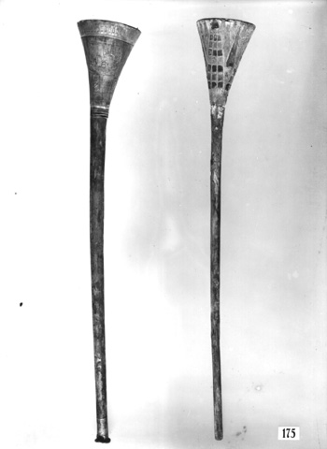

Usage:
(Image generated by ChatGPT using OpenAI technology)The sound on the trumpet was made by blowing into the mouthpiece in such a way as to vibrate the lips. The vibrations were magnified as they passed along the widening body of the tube.
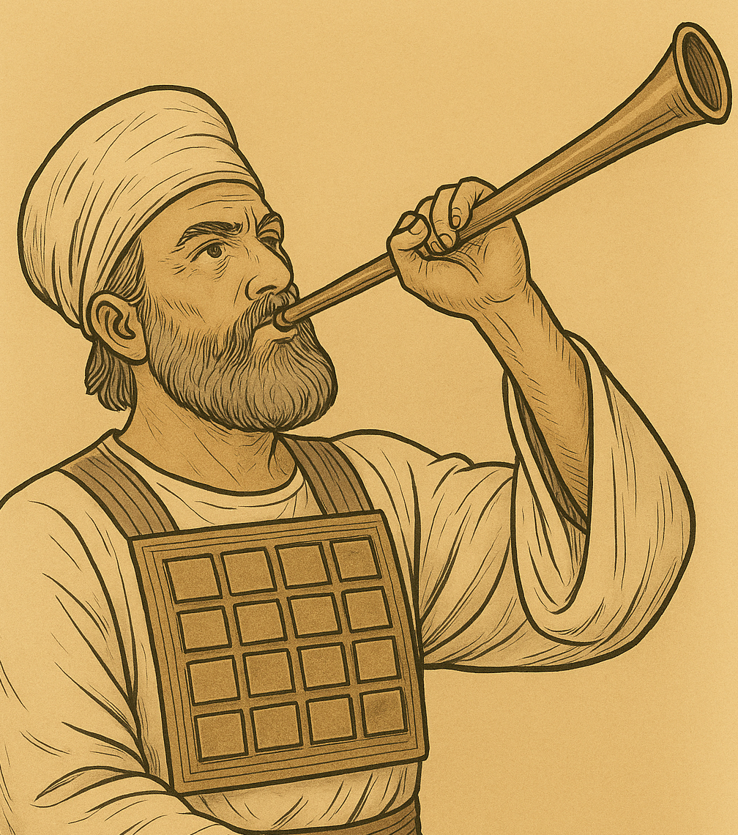
The purpose of the trumpet in Israel was primarily to signal. DAN 3:5; DAN 3:7; DAN 3:10; DAN 3:15; 1CO 15:52; 1SA 10:5; 1KI 1:40; ISA 5:12; ISA 30:29; JER 48:36 lists a variety of occasions in which the trumpets were to be used, including signaling the people to break camp, calling all of the people together for a meeting, calling only the leaders together, sounding an alarm at the beginning of a battle, and blowing them for liturgical purposes during certain festivals. It is significant that it was the task of the priests to sound the trumpets.

Translation:
Generally speaking, translators may distinguish between the Hebrew words chatsotsrah and shofar (see 7.3.1 Horn, ram’s horn<REALIA:7.3.1>) by rendering chatsotsrah as “trumpet” or “bugle” and shofar with a more generic word for “horn” or with “ram’s horn.” Note the following comment in A Handbook on Psalms (page 846) on JER 48:36: “In some languages it will not be possible to make a distinction between the two Hebrew terms translated \+u trumpets\+u* and \+u horn\+u*. In such cases the local term for a horn will be used. The Greek Old Testament used only one term.”
The exact meaning of the Aramaic word qeren in DAN 3:5; DAN 3:7; DAN 3:10; DAN 3:15 is debated. It probably refers to a brass wind instrument and is best rendered “horn.”
The present-day equivalent for the Greek word salpigx is “bugle.” A bugle is generally smaller than a trumpet and is often associated with the sounding of military signals.
PSA 5:1: It may be necessary to introduce an agent in the literal phrase “at the last trumpet” (RSV); for example, “when someone blows the trumpet for the last time.” Also possible is “when someone produces a noise on the trumpet for the last time”; however, any term for “noise” should imply a meaningful sound.

Flute, pipe

7.3.3 Flute, pipe

References:Hebrew חָלִיל (chalil)1SA 10:5, 1KI 1:40, ISA 5:12, ISA 30:29, JER 48:36, JER 48:36Aramaic מַשְׁרוֹקִי (mashroqi)DAN 3:5, DAN 3:7, DAN 3:10, DAN 3:15Hebrew נְחִילוֹת (nchiloth)PSA 5:1Hebrew עוּגָב (‘ugav)GEN 4:21, JOB 21:12, JOB 30:31, PSA 150:4Greek αὐλέω, αὐλητής, αὐλός (auleō (verb), aulētēs, aulos)MAT 9:23, MAT 11:17, LUK 7:32, 1CO 14:7, 1CO 14:7, REV 18:22, SIR 40:21, 1MA 3:45, 1ES 5:2

Description:

Flute, pipe

7.3.3 Flute, pipe

References:Hebrew חָלִיל (chalil)1SA 10:5, 1KI 1:40, ISA 5:12, ISA 30:29, JER 48:36, JER 48:36Aramaic מַשְׁרוֹקִי (mashroqi)DAN 3:5, DAN 3:7, DAN 3:10, DAN 3:15Hebrew נְחִילוֹת (nchiloth)PSA 5:1Hebrew עוּגָב (‘ugav)GEN 4:21, JOB 21:12, JOB 30:31, PSA 150:4Greek αὐλέω, αὐλητής, αὐλός (auleō (verb), aulētēs, aulos)MAT 9:23, MAT 11:17, LUK 7:32, 1CO 14:7, 1CO 14:7, REV 18:22, SIR 40:21, 1MA 3:45, 1ES 5:2

Description:

