Resource: Human-made Things in the Bible
Human-made Things in the Bible © United Bible Societies, 2025. Adapted from: The Works of Their Hands: Man-made Things in the Bible, by Ray Pritz © 2009 United Bible Societies. This work is licensed under Creative Commons Attribution-ShareAlike 4.0 International (https://creativecommons.org/licenses/by-sa/4.0/).

Human-made Things in the Bible

标题：皮革（leather）

1.13 标题：皮革（leather）

经文出处Hebrew 来：עוֹר (音译：‘or)GEN 3:21, GEN 27:16, EXO 22:26, EXO 25:5, EXO 25:5, EXO 26:14, EXO 26:14, EXO 29:14, EXO 34:29, EXO 34:30, EXO 34:35, EXO 35:7, EXO 35:7, EXO 35:23, EXO 35:23, EXO 36:19, EXO 36:19, EXO 39:34, EXO 39:34, LEV 4:11, LEV 7:8, LEV 8:17, LEV 9:11, LEV 11:32, LEV 13:2, LEV 13:2, LEV 13:3, LEV 13:3, LEV 13:4, LEV 13:4, LEV 13:5, LEV 13:6, LEV 13:7, LEV 13:8, LEV 13:10, LEV 13:11, LEV 13:12, LEV 13:12, LEV 13:18, LEV 13:20, LEV 13:21, LEV 13:22, LEV 13:24, LEV 13:25, LEV 13:26, LEV 13:27, LEV 13:28, LEV 13:30, LEV 13:31, LEV 13:32, LEV 13:34, LEV 13:34, LEV 13:35, LEV 13:36, LEV 13:38, LEV 13:39, LEV 13:39, LEV 13:43, LEV 13:48, LEV 13:48, LEV 13:49, LEV 13:49, LEV 13:51, LEV 13:51, LEV 13:52, LEV 13:53, LEV 13:56, LEV 13:57, LEV 13:58, LEV 13:59, LEV 15:17, LEV 16:27, NUM 4:6, NUM 4:8, NUM 4:10, NUM 4:11, NUM 4:12, NUM 4:14, NUM 19:5, NUM 31:20, 2KI 1:8, JOB 2:4, JOB 2:4, JOB 7:5, JOB 10:11, JOB 18:13, JOB 19:20, JOB 19:20, JOB 19:26, JOB 30:30, JOB 40:31, JER 13:23, LAM 3:4, LAM 4:8, LAM 5:10, EZK 37:6, EZK 37:8, MIC 3:2, MIC 3:3Hebrew 来：תַּחַשׁ (音译：tachash)EZK 16:10Greek 希：βυρσεύς (音译：burseus)ACT 9:43, ACT 10:6, ACT 10:32Greek 希：δερμάτινος (音译：dermatinos)MAT 3:4, MRK 1:6

描述
制革匠在加工皮革 (Deutsche Fotothek, Public domain, via Wikimedia Commons)皮革是按照特殊工艺来处理的动物皮，目的是去除皮上的毛和防止皮革腐烂或变脆。制作皮革的人称为皮匠或硝皮匠。
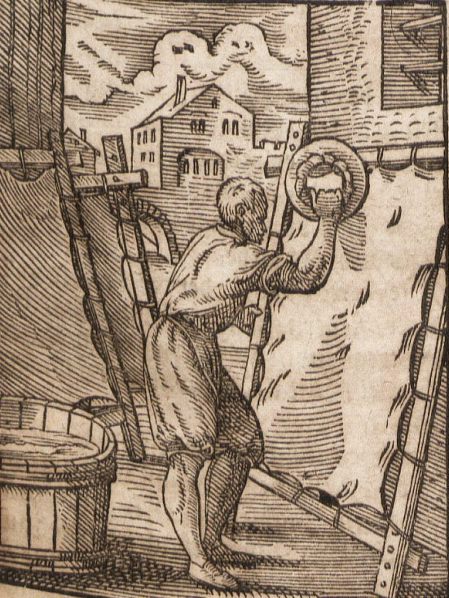

用途
皮革有很多用途，包括制作皮带和凉鞋等服饰，做成装水和葡萄酒等液体的容器，有时也用来制作牲畜的挽具和其他绳索。

翻译
有些语言会有一个专门表示“皮革”的词语，但许多语言会使用与动物的“皮”相同的词。
希伯来文tachash 指的是水生动物儒艮（参All Creatures Great and Small ，第42—43页）。圣经只在提到儒艮皮的时候才提到这种动物，所以它通常与希伯来文‘or 同时出现。EZK 16:10 省略了‘or ，但是tachash 在该处表示用这种动物的皮制成的精鞣皮革。

